

BA (Hons) Business Management
Module: Understanding Organizational Structure and Culture
The Role of Communication in the Business Environment

Component 2: Individual Report
Student Name: MOHAMMED ELSAYED ELSHARKAWY
Internal Verifier: Dr Anupam Mazumdar
Module Code: LCBB4009
Word Count: 1,500 words (approximately)
Submission Deadline: 26th July 2026

Table of Contents
1. Introduction 3
2. Communication and Methods 3
2.1 Defining Communication in Business 3
2.2 Communication Methods in Practice 4
3. Common Issues 5
3.1 Miscommunication and Information Overload 5
3.2 Cultural and Language Barriers 6
3.3 Hierarchical and Organizational Barriers 7
4. Recommendations 8
5. Conclusion 9
6. References 10

1. Introduction
Every organization needs to communicate effectively, without this communication, there would be disarray and no basis for delivering the intended outcomes of an organization. In a business setting, the process of communicating includes the exchange of information, concepts, and other forms of communication by two or more people or groups in order to accomplish overall business goals (Mullins, 2019). By having effective communication, employees will have a greater understanding of organizational goals, will be able to make decisions that are based on real-time information and will have an understanding of their organization’s expectations for their relationships with both internal and external stakeholders.
For Amazon, communication is a massive task given the difficult nature of operating in more than 100 countries and employing over one million people. The amount of information that Amazon communicates and how Amazon operates is critical, though Report provides an overview of key methods of communicating in Amazon, key issues related and outlines recommendations for improving communication.

2. Communication and Methods

2.1 Defining Communication in Business
In a business environment, communication can be defined as a two-way process of exchanging messages that are delivered and received between two or more parties involved in the transaction (Robbins and Coulter, 2021). The act of communicating is not just sending out information. It is also the responsibility of both parties to properly interpret what he or she intended to communicate. Baran et al. (2025) have noted that through effective communication, the organizational manager is able to positively impact productivity, to ensure the efficient flow of communication, and to increase the overall quality of decision making in an organization.
Two types of models can be used to explain how communication occurs and where it may fail. The first is the Shannon-Weaver Model (1949), which identifies communication as a one-way process involving a sender encoding the message, sending it through a channel, and the receiver decoding it with the possibility of "noise" interfering with this process at any point in time. This model is helpful for identifying where problems occur with the actual communication of messages.
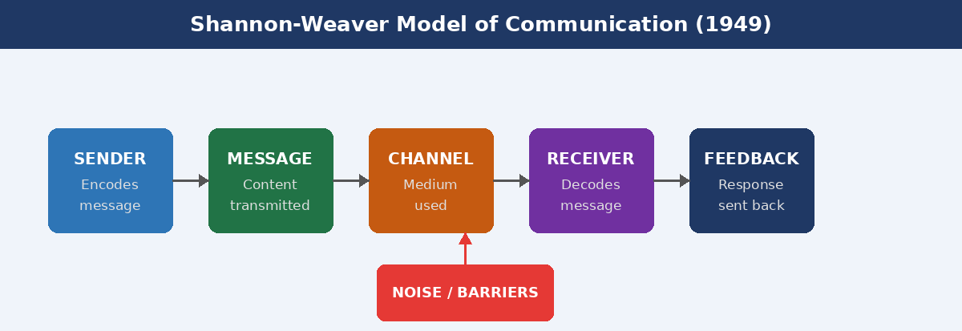
Figure 1: Shannon-Weave Model of Communication
The second is the Transactional Model, which shows communication as a two-way process occurring simultaneously via the sending and receiving of messages, and includes factors such as feedback from the communicator to the receiver, common history of experience or shared context, and the previous relationship(s) between the communicators (Barnlund, 1962). Because of the dynamic and ongoing nature of modern organizational communication, this model captures the true nature of how communication occurs.

2.2 Communication Methods in Practice
All organizations use different ways to communicate based on the nature of the message being sent, the audience who will receive it, and the level of urgency involved. The four primary methods of communication used in large organizations such as Amazon include:
Verbal communication encompasses all three methods of communication (face-to-face, telephone and video-conference) with the addition that it allows immediate feedback; conveys emotion and tone; and is preferred when used for either complex or clarification purposes. Amazon has near-daily team huddles and management briefings to share operational goals and performance expectations across all employees within the business.
Examples of written communications include emails, reports, memos and any other form of internal documentation. Written communications are formal and can be tracked and utilized to document policies, procedures and any other updates while providing a record of the written communication. Amazon has a large number of written communication tools used for internal communication and documenting processes, especially in warehouse and logistics operations (Baran et al., 2025).

The use of digital and technology-based communications is increasing in importance to global businesses. Applications such as Slack, Microsoft Teams and internal intranet tools provide real-time communication between team members, who may be working from different parts of the world. Chime is Amazon's proprietary internal system that allows all employees globally to communicate with each other in real-time, regardless of time zone.
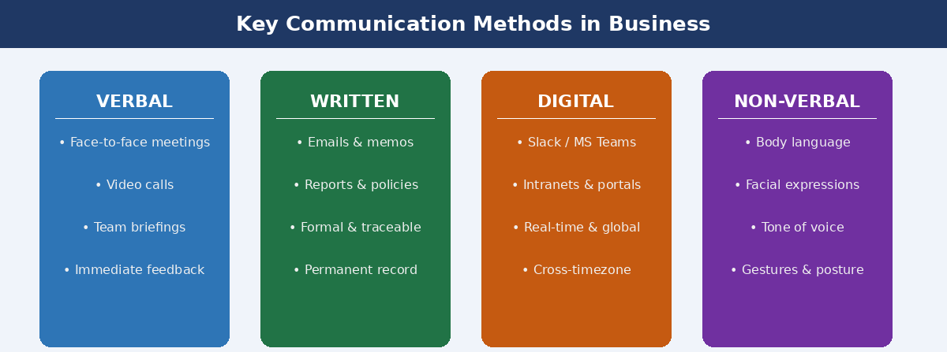
Figure 2: Types of Communication Model in Business

3. Common Issues

3.1 Miscommunication and Information Overload
Communicating incorrectly is one of the biggest problems that happen in large businesses, as it is very likely that the communication sent will not be received or interpreted in the same manner or way that the manager/leader intended it to be received or interpreted. In organizations such as Amazon, the communication is usually sent through several management levels before reaching the front line employees therefore, there are many opportunities for the original communication message to be distorted due to the number of managers involved in sending the messages. Robbins and Coulter (2021) refer to this distortion of messages due to the number of managers/management levels as 'serial distortion' as the original message travels through each management level, it can be altered more and more.
The next closely associated problem is oversaturation/overload of information. Employees who are receiving excessive amounts of communication from multiple sources may find it difficult to priorities and/or process the communications. The Economist Intelligence Unit (2018) conducted a study where 44% of respondents listed that the probable cause for the failure of projects was poor communication. Given the importance of operational speed to the success of Amazon as an example, when incorrect fulfilment of the order occurs due to communication failure, there is the potential for customer dissatisfaction, financial loss, or both to occur.

3.2 Cultural and Language Barriers
Over 20 nations have Amazon within their borders. Cultural/language barriers prevent effective communication. Hofstede (1984), through his cultural dimensions, has identified the three key dimensions of culture that affect communication, which are Power Distance, Individualism or Collectivism, and Uncertainty Avoidance. For example, many of Amazon's employees in a region with High Power Distance would feel intimidated to question or challenge their bosses when there was something wrong, therefore, information would not be communicated to people at the next level with management, as well as not communicating to other coworkers.
When companies have global teams communicating in different languages, different levels of proficiency in a corporate language will lead to misunderstanding (Baran et. al., 2025). Many corporate jargon/technical language may create miscommunication. Non-verbal communication adds more confusion to cross-cultural communications. Gestures, eye contact, and personal distance could be viewed in different ways by employees based on the employee's respective cultures (Mullins, 2019).
In some areas of Amazon, such as its operations & logistics, a tall hierarchical organization structure is established. Because of this structure, erosions in the free flow of communication have occurred. Employees at lower levels have become reluctant to raise issues/ideas to the upper levels of management, which has created a culture of silence that may exist.

3.3 Hierarchical and Organizational Barriers
Amazon is known for its tall, hierarchical organizational structure in certain divisions, particularly in operations and logistics. Such structures can impede the free flow of communication, both upward and downward. Baran et al (2025) provide evidence that having too many levels of management will slow down the flow of communication and alter the message as it passes through either the upward or downward side of the company structure.
With the increase of remote and virtual modes of communicating, this has become a more complex issue to manage. One of the disadvantages of virtual communication compared to face-to-face communication is the absence of non-verbal signals, without non-verbal signals, the tone and intention of a message can quickly become confused, particularly in written communication like emails or instant messages (Mullins, 2019).

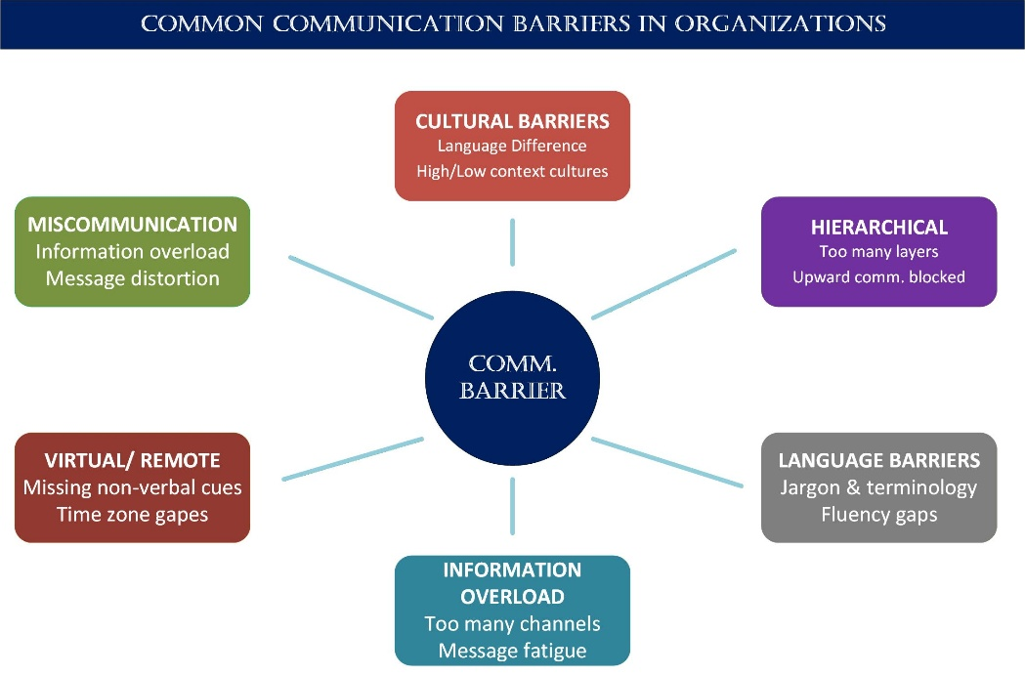
Figure 3: Common Communication Barriers

4. Recommendations
For organizations like Amazon to address the issues in communications that have been identified in this report, the following recommendations are available:
- Standardize Communication Platforms: Reduce the number of communication tools in use across the organization and consolidate all messaging into one, well-integrated platform. This will help reduce the number of messages that have been sent from the different communication channels, and will help to eliminate chances of messages getting lost between multiple channels.
- Cross-Cultural Communication Training: Given the global nature of larger organizations, all employees, but especially managers, should complete training on the differences between cultural communication styles. This type of training should include Hofstede's cultural dimensions, active listening skills, and how to provide culturally aware feedback to others. Cross-cultural training is expected to grow rapidly in the future, as more businesses are recognising the value of this type of training (Udext, 2025).
- Encourage an open feedback culture: Leaders should encourage all employees to engage in upward communication by creating safe environments where they can raise issues, provide ideas and offer input and feedback with confidence of having their contributions treated with consideration and care.
- Develop clear written communication procedures: All organizations should create and enforce a written communication procedure outlining expected communication response times regarding written communication, such as emails, formal report formats, and procedures to escalate unresolved issues.

5. Conclusion
This report has examined the role of communication in the business environment in relation to Amazon as an exemplary case study. It has demonstrated that communication has a critical role as a necessary but not only operational function that is necessary to promote and enable achievement of desired organizational outcomes. Organizations today have access to many different methods of communicating.
The frequent occurrence of misunderstandings, cultural barriers and hierarchical blockers, highlight the fact that communication requires both planned and systematic support in order to succeed. The impact of these barriers can have severe effects, leading to project failure or operational inefficiency, reduced employee morale and poor relationships with stakeholders.
Organizations that value communication as a key skill will be in a stronger position to achieve sustainable performance, to implement changes successfully, and to create resilient, motivated teams. For organizations of Amazon's size and complexity, the ongoing investment in a communication strategy is mandatory

6. References
Baran, D., Gorka, E., Cwiakala, M., Wojak, G., Grzelak, M., Olszynska, K., Mrzygłod, P., Frasunkiewicz, M., Reczajski, P., Slusarczyk, M. and Piwnik, J. (2025) The Role of Communication in Effective Business Management. Organization and Management Series, No. 228. Available at: https://www.researchgate.net/publication/396330715_The_role_of_communication_in_effective_business_management

(Accessed: 5 June 2026).

Barnlund, D.C. (1962) 'Toward a meaning-centered philosophy of communication', Journal of Communication, 12(4), pp. 197–211. Available at: https://onlinelibrary.wiley.com/doi/abs/10.1111/j.1460-2466.1962.tb01547.x (Accessed: 5 June 2026).

Economist Intelligence Unit (2018) Communication Barriers in the Modern Workplace. New York: Economist Intelligence Unit. Available at: https://4114118.fs1.hubspotusercontent-na1.net/hubfs/4114118/Resources%20Downloads/TPC%20-%20EIU_Lucidchart-Communication.pdf (Accessed: 6 June 2026).

Hofstede, G. (1984) Culture's Consequences: International Differences in Work-Related Values. Beverly Hills, CA: SAGE. Available at: https://www.scirp.org/reference/referencespapers?referenceid=2010603 (Accessed: 6 June 2026).

Mullins, L.J. (2019) Management and Organizational Behavior. 11th edn. Harlow: Pearson Education.

Robbins, S.P. and Coulter, M. (2021) Management. 14th edn. Harlow: Pearson Education.

Shannon, C.E. and Weaver, W. (1949) The Mathematical Theory of Communication. Urbana, IL: University of Illinois Press. 1-117. Available at: https://www.scirp.org/reference/ReferencesPapers?ReferenceID=1311827%20 (Accessed: 6 June 2026).

Udext (2025) Overcoming Cultural Barriers in Communication. Available at: https://www.udext.com/blog/overcoming-cultural-barriers (Accessed: 6 June 2026).

