Module: Digital Skills for Personal and Professional Growth
Module code: BMSW4008
Lecturer: Ffion Cumberpatch
Student ID: 2223775
Student Name: Katarzyna Mrotek
27.03.2024

Table of Contents
1 LinkedIn Profile 3
2 Story Telling 5
3 Questionnaire 8
4 Website and Marketing Material 11
4.1 Questionnaire Analysis 11
4.2 Website 12
4.3 Marketing Materials 15
5 References 17
6 Appendices 19

LinkedIn Profile
I am driven and passionate about making a difference and I plan to use technology in my work to achieve this goal.
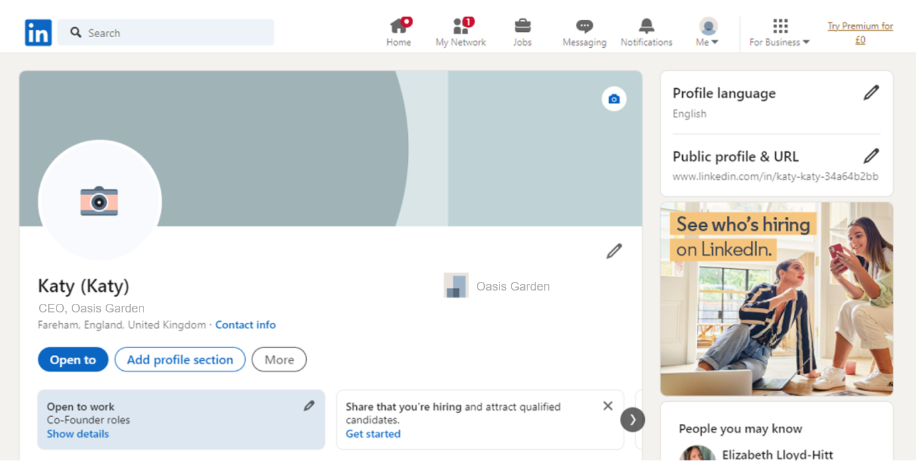
Figure 1LinkedIn Profile
This is my LinkedIn profile, and I am happy to have you here. I am Karty a CO-Founder of Oasis Garden, my aspiration is to acquire new knowledge, hone my skills, and keep up with developments in Oasis Garden with a passion for what I have studies and a knack for my expertise and previous experiences through the educational backgrounds of mine which includes 16 years of education. Given 4 years of fieldwork in my industry, my determination towards work have been honed and enriched throughout the years.
During my career journey, it was truly a blessed time for me to be part of a variety of teams who were working together on solving difficult problems in a myriad of ways. The core of my plan lies in the ability to trigger innovative thinking, to develop partnerships, and to go above par to provide outstanding results.
🔍 Exploring New Opportunities: At the present time, I am looking for positions that will offer me exposure and learning.
🔧 Skills & Expertise: I have a profile of skill-sets including determination, active listening, and I function best in environments which are always trying to further knowledge and growth.
🌐 Building Connections: One of the things I am most enthusiastic about is being engaged in creating solid relationships by extending my professional network. I am a collaboration lover. I support the collaboration with the professionals with similar views, experts in the field, and innovators who are ready to create a positive difference.
🎓 Continuous Learning: I take continual education seriously and am in the habit of the reading of books, articles, and journals of the recent period. I will be participating in trainings, pursuing certifications, and online classes among other things with the end goal of growing both my skill set and my knowledge.
🌱 Personal Values: Integrity, empathy, and staying strong in all situations are the foundations of the ethical system of my professional life. I endeavour to apply a high level of honesty to my performance, exhibit empathy towards the co-workers and clients and show resilience in adversity times.

Story Telling
The Appealing Factor of Storytelling in Brand Production
Telling the story does not mean just telling some facts, it can also be used as a strategic tool for building and promoting a brand. From storytelling that is focused on personal branding, to those curated for business promotions, it serves as the pivot of efficient communication that causes a deep connection with the audience, leaving memorable impressions. With the ever-growing digital addition, and short attention span of customers, learning the skill of good storytelling is one of the key factors for brands that want to offer that special something and connect with their customers.
Understanding the Brand Building through the Storytelling.
From the perspective of building a brand, narration processes by formulating stories which convey the brand’s essence, values & unique position in the market. This does not limit itself to just the marketing fluff or the technical specifications, but rather, the objective is to build up an emotional connection that connects with the consumer (Durmaz and Vildan 2016). Through storytelling brand humanize their identity with become relatable, authentic, and memorable.
Undoubtedly one of the fundamental aspects of storytelling, the orchestration of features like characters, plot, conflict, and resolution is crucial in coming up with the story that captivates the audience (Huseynli, 2022). Regardless which way, through written content, visual media, videos, or interactive experiences, emotionality, enables realizing curiosity and creates bond of connection between the brand and target audience.
Example: In 1988, Nike introduced its "Just Do It" Campaign, and the slogan made a remarkable impact on the athletic apparel industry's marketing strategies.
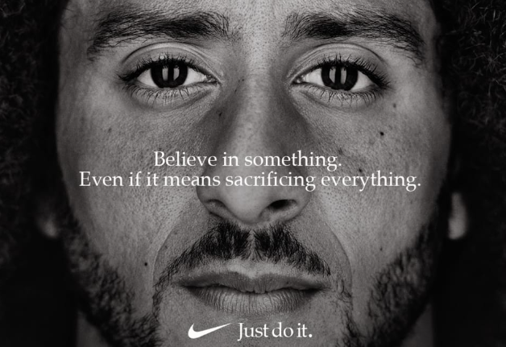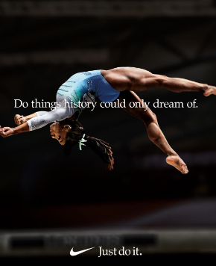
The narrative way of Nike in brand-building is the "Just Do It" campaign is exemplary. It dates back to 1988 when it began as a conventional advertising endeavour, and now it is a part of the culture where it carries the hope, the decree and the feeling of success one brings after overcoming challenges (Koch, 2020). Essential to the "Just Do It" campaign is a thematic thread promoting the notion of human nature and urging the people to defying all odds. By vivid and emotional adverts, which show people achieving their goals, Nike is presented as a brand, which is more than a sportswear company. It is more like an advocate of overcoming obstacles and spreading the power of sport to everybody.
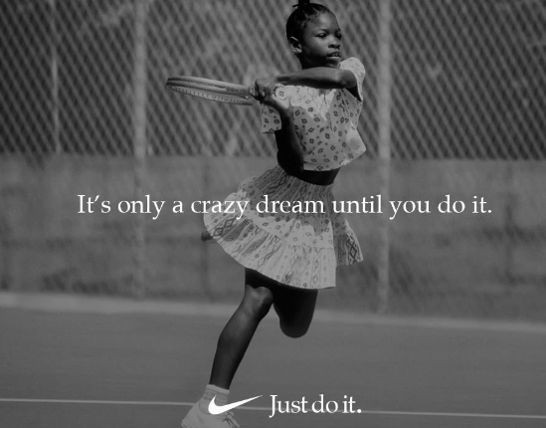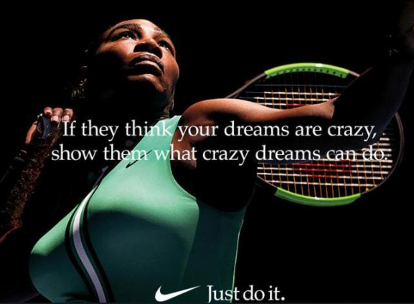
Perhaps you may contemplate the "Dream Crazy" advertisement, that was using the former NFL quarterback Colin Kaepernick starring in it. When given the spotlight that Kaepernick has now become, from controversial to a hero and socially and politically active figure, Nike had managed to declare themselves a significant part of the culture at hand, a trend for millions of talk and fighting (Yang et al., 2023). The ad successfully highlighted those values of the courage and determination and sticking through an overwhelming adversity to stand by your opinion, which indeed was a winning formula for Nike, putting it forward as a trendsetter and promoter of progress.
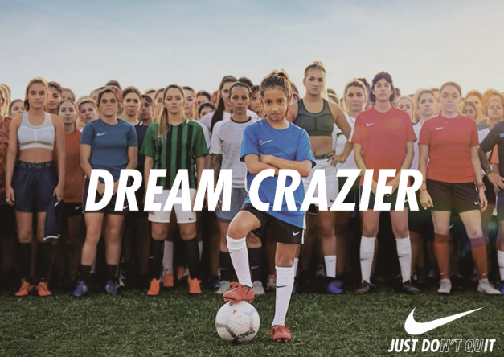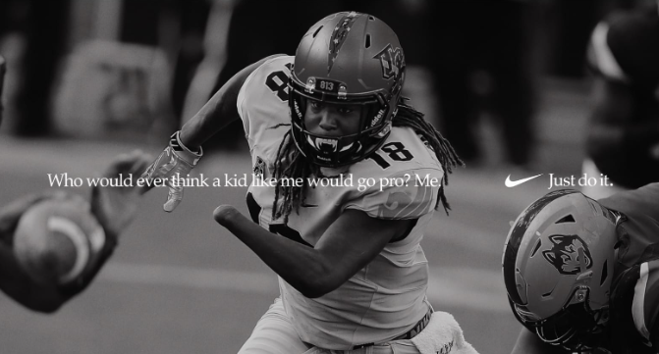
What characterizes Nike's brand storytelling is its ability to build such an emotional bond that people care much more about the invisible things such as style and performance. Instead merely of the constantly delivered athletic shoes or clothes, the Nike storylines are related to the ideas of the striving, empowerment, and self-expression. The personal perspective for people is the point of this narratives. In doing so, Nike harmonized its brand story with such big movements like sports athletes', and dreamers from all parts of the world which resulted in "Just Do It" become a common slogan (Södergren, 2021). In truth, the ad allowed Nike to ramp their brand equity up and create its brand iconic status as a cultural icon that transcends discipline and represents passion, perseverance, and the search for perfection. To sum up, storytelling is an inevitable part of brand building, through which companies are able to form emotional ties, create brand loyalty, and stand out from the pack of competitors. The marketing strategy by Nike which is the "Just Do It" campaign, symbolizes a brand as a source of inspiration, empowerment as well as social change. With the changing digital landscape, the art of storytelling will still be key strategy for brands who want to make the lifetime impressions and inspire people.
.

Questionnaire
The questionnaire survey was conducted related to the landscaping business from 20 participants. According to the survey the questionnaire analysis given below shows the interest level of participants in landscaping services in their area:
Question 1
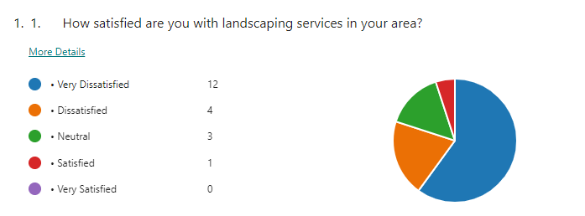
The first question was related to analyzing the satisfaction level of landscaping services provided in their area. According to the responses, 12 participants were very dissatisfied with the landscaping services in their area. The results show that 4 participants were dissatisfied while 3 participants showed neutral reactions towards the satisfaction level of landscaping services in their area. The survey analysis showed that only 1 participant was satisfied with landscaping services in their area.
Question 4
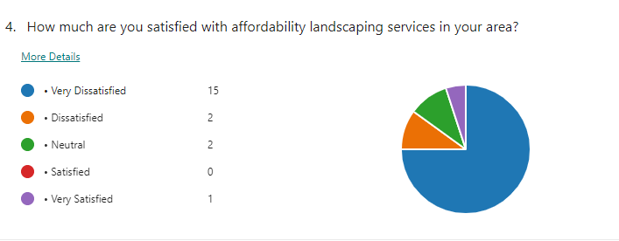
The fourth question of the questionnaire was related to the satisfaction level of the individuals to afford landscaping services in their area. Upon responding to this question 15 out of 20 participants were very dissatisfied with the pricing and affordability of the landscaping services as they are charging high prices for their services. The survey shows that 2 participants were satisfied and the other 2 participants showed neutral satisfaction levels towards the affordability of landscaping services. According to the survey analysis, only 1 participant was satisfied with the affordability level of landscaping services in their area.
Question 7
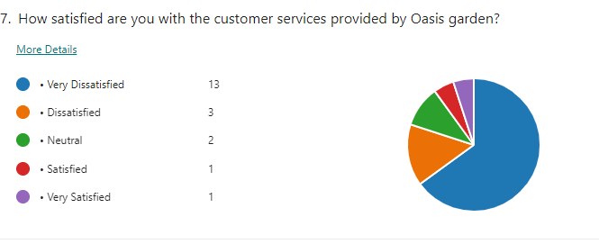
The seventh question of the questionnaire was related to analyzing the satisfaction level of customer services provided by Oasis Graden. The survey results showed that 13 out of 20 participants are very dissatisfied with customer services provided by landscaping services. Out of those 3 participants were dissatisfied and 2 of them showed neutral satisfaction levels towards the customer services of landscaping services in their area. Out of 20 participants, only 2 participants showed positive results 1 was satisfied while the other was very satisfied with the customer services provided by the landscaping services in their area.
Question 10
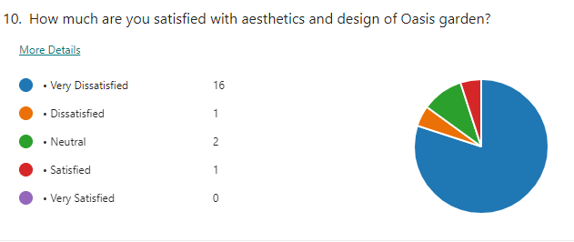
The last question was related to analyzing the satisfaction level of individuals with the aesthetics and designs of a landscaping company. The survey results showed that 16 out of 20 participants were very dissatisfied with the aesthetics and design of the landscaping company. Out of those 1 participant was dissatisfied and 2 of them showed a neutral satisfaction level towards the aesthetics and design of landscaping services in their area. Out of 20 participants, only 1 participant showed positive results that were satisfied with the aesthetics and design of the landscaping services in their area.

Website and Marketing Material

Questionnaire Analysis
The survey results into the landscape services responses have provided significant insights into how the respondents feel about different landscape aspects. The most respondents gave positive feedback regarding the landscaping services in the area as well as a pleasing remark about the industry at large. A majority of the people asked about the level of their satisfaction with their landscaping services provided a response of either "Satisfied" or "Very Satisfied," which might indicate that these communities are rated positively for landscaping services. The occupancy of the high level of customer satisfaction is the confirmation of the perceived value and efficiency of the efforts provided by the landscaping businesses based in that region. Furthermore, the interviewees factored out landscape as the most important thing. A lot of people responded that having different types of landscaping are either "Important" or "Very Important" to them. It further emphasizes the importance of choice and tailoring for the varied requirements of clientele. The request for landscaping options shows a clear preference for capabilities to fine-tune landscape solutions to accommodate personal requirements, no matter if it is for beauty improvement, functionality or nature.
Aside from landscaping choices, the survey also pointed out at the pro-environmental practices adopted by the landscaping industry. Interestingly, many of the survey participants indicated a tendency to choose a landscape company that incorporates green materials and processes. This manifests how consumers appreciate environmental sustainability and demand eco-friendly services in landscaping. Affordability also emerged as another important factor for respondents when considering landscaping companies. Even though the level of the satisfaction was high in general, some responders admitted that the cost of landscape service in their area bothered them. Although the largest portion of those surveyed had rated affordability either as satisfactory or strongly satisfactory, this suggests that the cost of these services may not be a barrier for low to moderate customers. Despite all these efforts, it still remains to be seen how addressing affordability issues will positively impact customer satisfaction and retention rates.
Among the factors that were named by respondents who were are of great importance for landscaping plans was personalization. For a sizeable proportion of respondents, personalized landscape designs based on their likes or dislikes were either "Important" or "Very Important" which implies how much their attention is directed towards landscaping services that are custom made to their specific tastes, lifestyles and the characteristics of their respective properties. Providing customized design services can, therefore, be an added benefit to landscaping entrepreneurs trying to acquire and keep customers. Other than that, the study had a typical consumer response with them willing to refer their favorable landscape company experience to others. A meaningful proportion of respondents responded that they would be likely or very like to recommend company to others and this can be considered as a component of a having the high-quality service and meeting the customer expectations. Providing good customer service encourages customers to talk about the landscaping business with their colleagues or family members, hence increasing its reputation and productivity.
Customer service also became the strongest factor determinant of the satisfaction levels observed in the respondents. Most of the participants testified to be happy with the customer services that landscaping companies provide, which therefore suggests that good and captivating relations with customers and positive interactions are an integral part of the generation of customer impressions and loyalty. That in addition, the conditions demonstrated the need for regular maintenance services and the comfort of the clients when having online scheduling for appointments and online payment options. Participants declared that they would prefer gardens supplying regular dors and online scheduling and payment platform, which means that the customers give importance to convenience and accessibility when they choose landscaping services. As well as that, as it happens the majority of the respondents was pleased with the appearance and design of Oasis Garden, which is a certain landscaping company. This shows that the Oasis Garden has been able to deliver tranquility and peacefulness to its customers due to its appealing aesthetics and design, gradually building a positive image about the place and increasing customer satisfaction.

Website

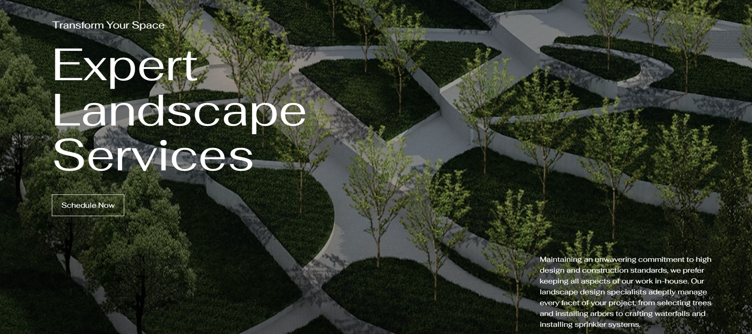
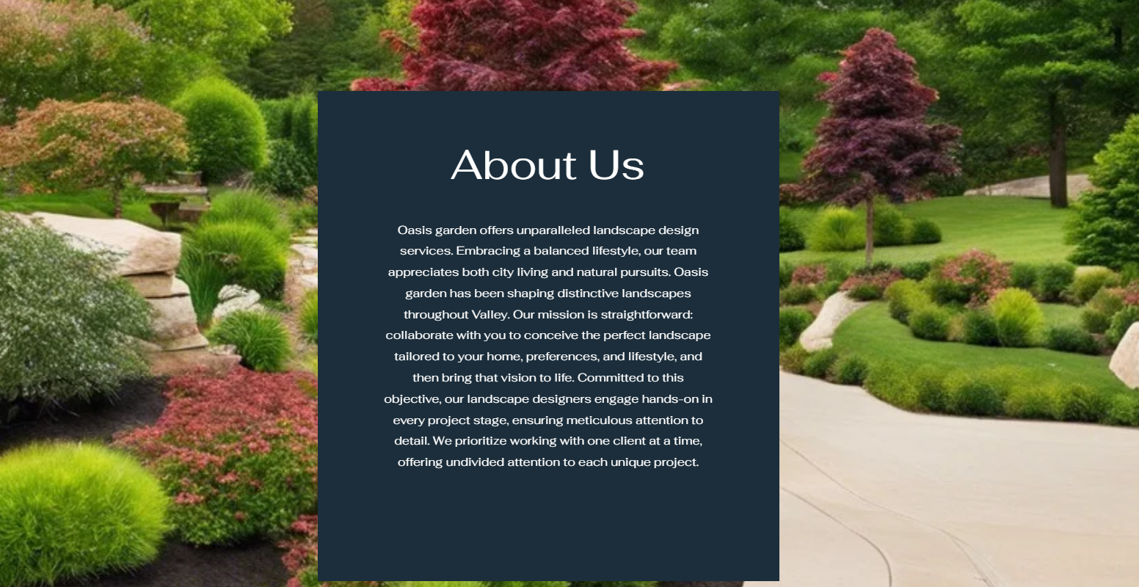
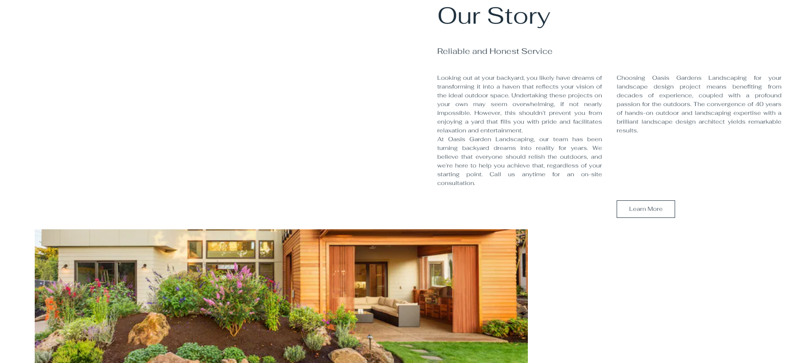


Marketing Materials

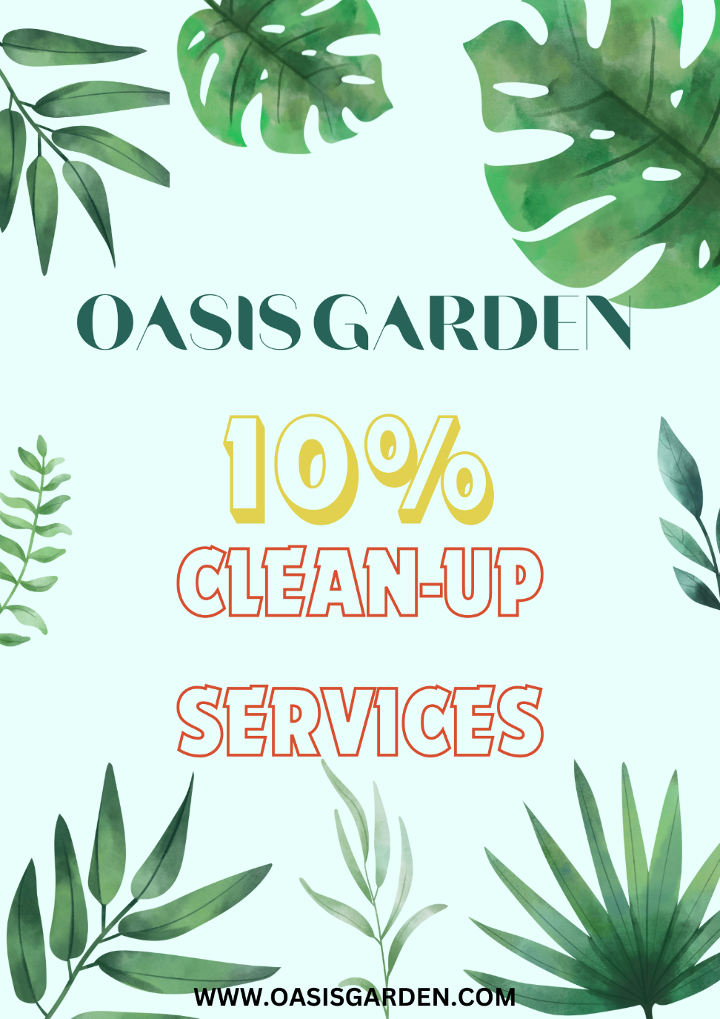
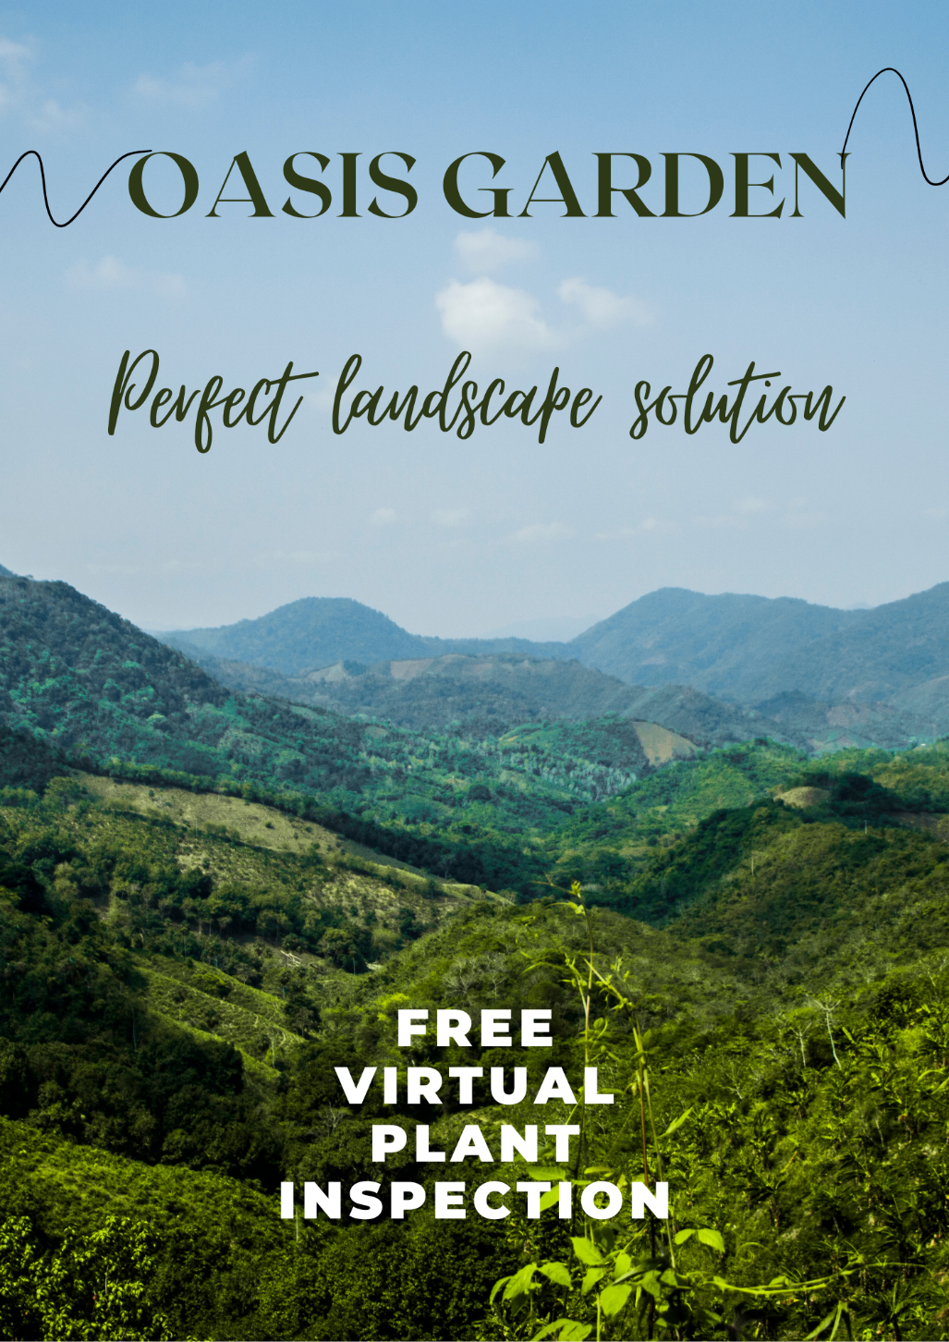

References
Banerjee, S., Shaikh, A. and Sharma, A., 2024. The role of online retail website experience on brand happiness and willingness to share personal information: an SOR perspective. Marketing Intelligence & Planning.
Canziani, B.F., Welsh, D.H., Dana, L.P. and Ramadani, V., 2020. Claiming a family brand identity: The role of website storytelling. Canadian Journal of Administrative Sciences/Revue Canadienne des Sciences de l'Administration, 37(1), pp.68-81.
Cipollaro, M., Fabbrizzi, S., Sottini, V.A., Fabbri, B. and Menghini, S., 2021. Linking sustainability, embeddedness and marketing strategies: A study on the craft beer sector in Italy. Sustainability, 13(19), p.10903.
Durmaz, Y. and Vildan, H., 2016. Brand and brand strategies. International Business Research, 9(5), pp.48-56.
Huseynli, B., 2022. Examining the relationship between brand value, energy production and economic growth. International Journal of Energy Economics and Policy, 12(3), pp.298-304.
Jois, A. and Chakrabarti, S., 2021. Globalization Journey of Brand by Creating Experience Wave. Academy of Marketing Studies Journal, 25(5), pp.1-22.
Koch, C.H., 2020. Brands as activists: The Oatly case. Journal of Brand Management, 27(5), pp.593-606.
Mingione, M. and Abratt, R., 2020. Building a corporate brand in the digital age: imperatives for transforming born-digital startups into successful corporate brands. Journal of Marketing Management, 36(11-12), pp.981-1008.
Philips, V., 2022. Digital marketing in nonprofits organization: essential techniques for the new era.
Pilz Sonnby, A. and Knutsson, P., 2022. Brand Building for Startups: A brand building framework for startups to establish a coherent and long lasting brand.
Quade, A., 2022. Brand building. Professional Beauty, pp.22-25.
Renu, N., 2021. Contribution of Brand Marketing in a Successful IPO. Journal of Marketing Management, 9(2), pp.30-34.
Sakas, D.P., Reklitis, D.P., Trivellas, P., Vassilakis, C. and Terzi, M.C., 2022. The effects of logistics websites’ technical factors on the optimization of digital marketing strategies and corporate brand name. Processes, 10(5), p.892.
Seelig, M.I., Sun, R., Deng, H. and Pal, S., 2021. Is it all for show?: Environmental brand identification on skin care and cosmetic websites. Journal of Marketing Communications, 27(4), pp.436-456.
Södergren, J., 2021. Brand authenticity: 25 Years of research. International Journal of Consumer Studies, 45(4), pp.645-663.
Wawrowski, B. and Otola, I., 2020. Social media marketing in creative industries: How to use social media marketing to promote computer games?. Information, 11(5), p.242.
Yang, J., Fang, J. and Su, J., 2023. Manufacturer encroachment in the presence of the store-brand. Kybernetes.

Appendices

Appendix 1 questionnaire
- How satisfied are you with landscaping services in your area?
- Very Dissatisfied
- Dissatisfied
- Neutral
- Satisfied
- Very Satisfied
- How much important is it for you to have landscaping options?
- Not Important
- Slightly Important
- Neutral
- Important
- Very Important
- How likely are you can hire a landscaping company that uses environmentally friendly materials and practices?
- Very Unlikely
- Unlikely
- Neutral
- Likely
- Very Likely
- How satisfied are you with affordability of landscaping services in your area?
- Very Dissatisfied
- Dissatisfied
- Neutral
- Satisfied
- Very Satisfied
- Do you consider it important to have personalized landscaping designs according to preferences?
- Not Important
- Slightly Important
- Neutral
- Important
- Very Important
- How likely you recommend landscaping company to others according to the work quality?
- Very Unlikely
- Unlikely
- Neutral
- Likely
- Very Likely
- How satisfied are you with customer services provided by Oasis garden?
- Very Dissatisfied
- Dissatisfied
- Neutral
- Satisfied
- Very Satisfied
- How important is it for you to regularly maintain services?
- Not Important
- Slightly Important
- Neutral
- Important
- Very Important
- How likely are you to choose landscaping company offering online sceduling and payment options?
- Very Unlikely
- Unlikely
- Neutral
- Likely
- Very Likely

- How much are you satisfied with aesthetics and design of Oasis garden?
- Very Dissatisfied
- Dissatisfied
- Neutral
- Satisfied
- Very Satisfied

Appendix 2


