Module title: Financial Management for the Hotel Industry

Module Code: BMIH5007

Student Name: Luminita Malanciuc

Student ID: 2211340

Module Lead: Tristan Hawkins

Word Count: 2000

Financial Management for the Hotel Industry
Executive Summary
The below report has critically presented a comprehensive comparison between two Corinthia Hotels and Ibis Hotels which are the two leading hospitality companies. Thus, it has evaluated various factors like the company’s performance and market position. However, it has also highlighted the total rate of revenue and potential related to the development in the context of CSR approaches. Moreover, various recommendations has been provided for both stated businesses.

Table of Contents
Introduction 4
Presenting the total Revenue of the Business Entity 5
Evaluating the total revenue of Corinthia Hotel Group 5
The total revenue of Ibis Hotels: 7
Assessing the Market Position of Corinthia Hotels and Ibis Hotels 10
Market Position of Corinthia Hotels: 10
Market Position of Ibis Hotels 11
Stating the Growth Potential of Companies Based on Various Components 14
Analysing the Growth Potential for Corinthia Hotels 14
Growth Potential for Ibis Hotels 15
Demonstrating the Financial Commitment for Operational Activity of CSR in the Hotel Industry 16
CSR Initiatives for Corinthia Hotels 16
CSR Activities for Ibis Hotels 17
Recommendation 19
Conclusion 20
References 21

Introduction
The hospitality sector is one of the leading industries in the dynamic realm and Corinthia Hotel Group and Ibis Hotels are two of the leading organisations in the sector. Thus, each company has distinctive target markets and financial performance. Corinthia Hotel Group operates luxury hotels and luring resorts in prime destinations. On the other hand, Ibis Hotels provides services to its budget-conscious customers with a huge network of economy and mid-range hotels. However, financial management has a great contribution to the success of this sector which is the main agenda of the report. Moreover, it significantly impacts various aspects which involve the room rates and operational expenses for establishing tactics and profit margins.

Presenting the total Revenue of the Business Entity

Evaluating the total revenue of Corinthia Hotel Group
Overview of revenue sources
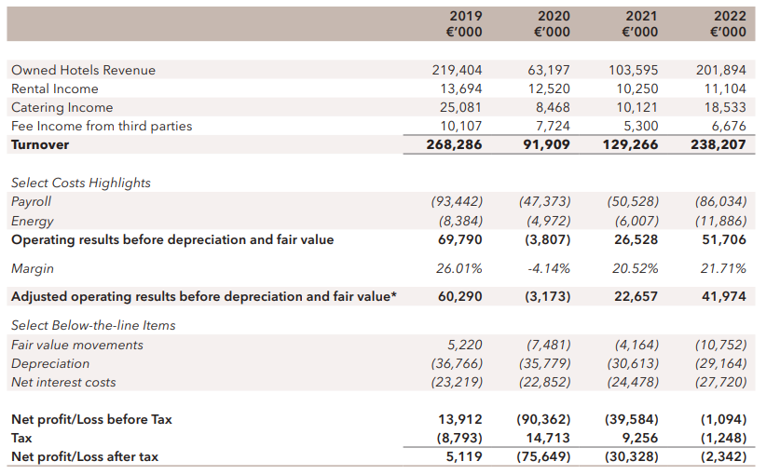
Figure: Presenting the P&L of Corinthia Hotel Group
Source: (corinthiagroup, 2022)
Corinthia Hotel Group is a multi-brand operator with a revenue of £ 240.39 million in 2022. Thus, it has the license to operate in prime locations like Europe, Africa and the Middle East. The companies generate revenue from various sources including room bookings, food and beverage services, spas, wellness facilities and event hosting as well (Elhoushy and Ribeiro, 2024). According to many reports, the company generates 70% of its revenue from rooms, 20% from food and beverages and 10% from additional services. However, it relies on a diversified revenue model for addressing the possibilities of risks and focuses on guest satisfaction to enhance its growth possibilities.
Trends in revenue growth or decline

Figure: Highlighting the revenue trends of Corinthia Hotel Group
Source: (corinthiagroup, 2023)
Corinthia Hotel Group has faced a significant development in revenue which can be a result of various factors like strategic expansion into emerging markets, focusing on customer demographics and dedication towards high-quality services. Due to the outbreak of the pandemic, the hospitality sector has to face a reduction of 55% which gave rise to many further implications and many travel restrictions (cbinsights, 2024). However, the company saw a sudden increase from 298.31 million pounds to 357.97 million pounds from the year 2021 to 2022. Moreover, the company is also entering new markets like Dubai and Saudi Arabia to expand its operations and introduce luring travel locations to its customers.
Factors influencing revenue
The revenue of Corinthia Hotel Group can be influenced by various factors which involve the global economic environment, travel trends and geopolitical aspects. Thus, the company’s revenue can also be significantly impacted by the shifts in customer confidence and travel patterns which generally demand tactical approaches to address the possibilities of uncertainty (Elhoushy and Ribeiro, 2024). However, it requires investments in marketing and branding initiatives which lead to enhancement in the customer base.

The total revenue of Ibis Hotels:
Overview of revenue sources
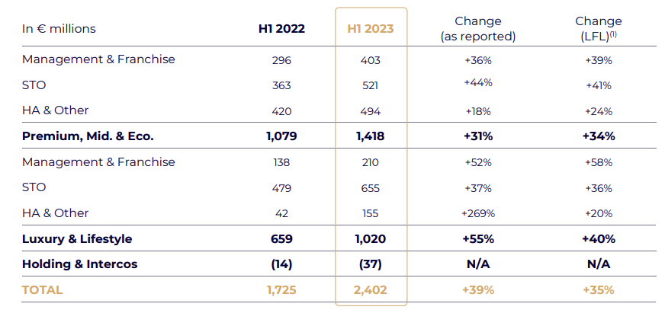
Figure: Presenting the Consolidated revenue statement of Ibis Hotels
Source: (accor, 2023)
Ibis Hotels is one of the leading companies in the economy which provides affordable services to its customers. Thus, the company will have a revenue of £ 3.60 billion in 2022 and will operate 1,218 hotels in 70 countries with 159,180 rooms (Nguyen et al., 2024). According to the research, the company generates 75% of its revenue from rooms, 15% from food and beverages and the remaining from Ancillary Services. Competitive rates and high occupancy rates are the two factors which enhance the revenue model of the company.
Trends in revenue growth or decline

Figure: Evaluating the revenue trends of Ibis Hotels
Source: (press.accor, 2023)
The company with its luring offering and effective operational structure has successfully maintained a consistent revenue growth. Thus, it presents the company’s potential for meeting the wants of its target customers. As a result of the economic recession, the company faced a temporary decline of 12% in 2020 but with the assistance of various health and hygiene initiatives, the revenue reached £ 2.73 billion in 2020 (corinthiagroup, 2022). Various factors like brand recognition, tactical expansion, digital transformation and cost-conscious approach helped in mitigating the implications of the pandemic.
Factors influencing revenue
The revenue of Ibis Hotels can be significantly impacted by various factors involving the economic conditions which influence the customer's spending and its operations. Travel trends also have a great contribution to impacting the operations of the company (Nguyen et al., 2024). Thus, the dedication of the company towards innovation and technology integration has a crucial role in maintaining its competitiveness in the hospitality sector.

Assessing the Market Position of Corinthia Hotels and Ibis Hotels

Market Position of Corinthia Hotels:
Market share analysis
Corinthia Hotel Group with its luxury hotel chain has a distinctive position in the market. According to many reports, the company has a market share of 1-2% globally and has a significant market share in locations like Europe and Africa 122.73 (Onyusheva, 2020). However, the company also has a RevPAR of 122.73 pounds in 2022 which exceeds the global average of luxury hotels of 110.80 pounds. Additionally, the company also generated a huge valuation of nearly 1.32 billion pounds along with a capital of 524.17 million pounds. Moreover, the price per share of the company is 0.39 pounds.
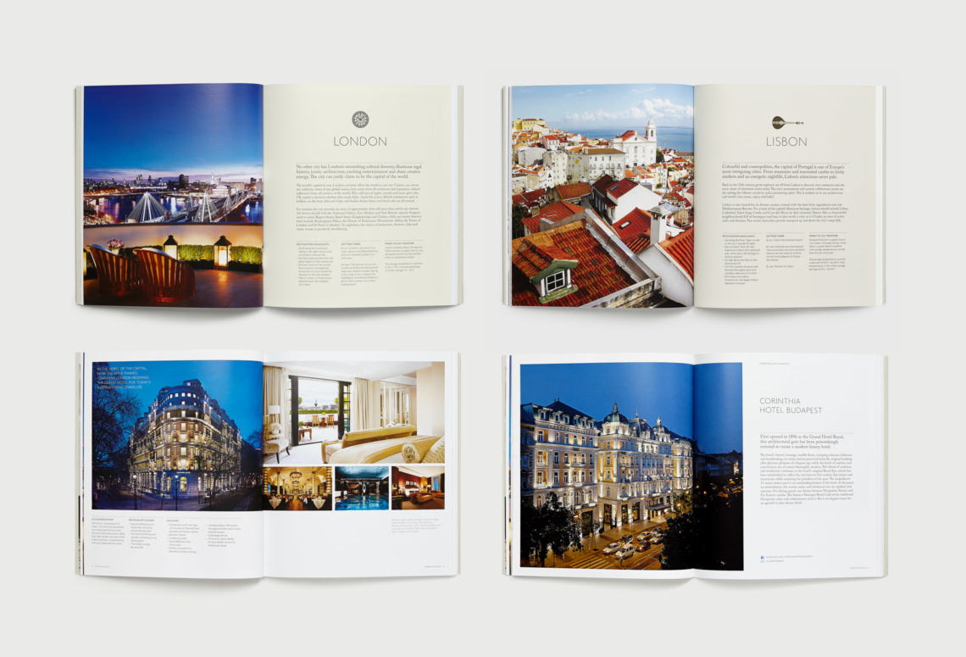
Figure: Corinthia Hotels brand identity
Source: (inaria-design, 2023)
Customer demographics
The respective hospitality sector is known for its luxury hotels and services. Thus, the brand generally attracts an affluent clientele with demands like exclusive accommodations, fine dining and personal services which age from 35-55 years. The company focuses on meeting likings like prime locations, extraordinary experiences and Michelin-starred dining (accor, 2024). Additionally, the hotels also serve as a compatible location for business elites, high-profile events and individuals with a high net value which ages from 45-65 years.
Brand perception
The dedication of the company towards excellence, focus on perfection and detail along with its concentration on architectural grandeur plays a significant role towards an optimistic brand image (Onyusheva, 2020). Corinthia with its elegance, personalised services, prime locations, cultural immersion as well as Michelin-Starred Gastronomy attracts a huge customer base.

Market Position of Ibis Hotels
Market share analysis
Ibis Hotels which come under the AccorHotels serves as a tactical opportunity in the budgets and mid-range hotel industry. The company has a significant market share of nearly 6-8% globally and is assumed as a leading company in the hospitality sector. Thus, the company also has a significant market share in Europe and Latin America (Paley, 2021). It operates nearly 1,200 hotels globally highlighting its huge network. The company also had a RevPAR of 42.62 pounds in 2022 which exceeds the global average of 38.35 pounds.
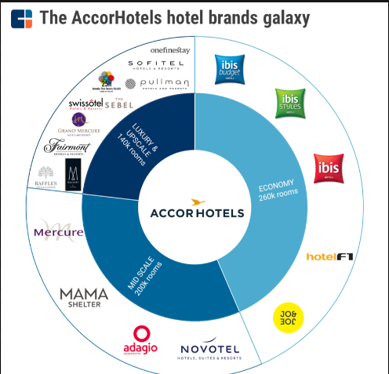
Figure: AccorHotels brand identity
Source: (cbinsights, 2024)
Customer demographics
The company mostly attracts a more diversified customer base and budget-conscious travellers. Thus, the company attracts business travellers, families and tourists who are seeking pocket-friendly but quality services which age from 30-45 years (accor, 2023). The company with its affordable offerings and effective operational mode concentrates on value which leads to a significant market position.
Brand perception
The respective hospitality company has a distinctive identity providing services to budget-conscious travellers with its huge network of comfortable and affordable services (Paley, 2021). The company with its affordable, convenient, reliable services and efficiency has established a successful market position. However, the company has to face many issues due to limited appeal and sustainability concerns.

Stating the Growth Potential of Companies Based on Various Components

Analysing the Growth Potential for Corinthia Hotels
Expansion strategies
The growth potential of the company is significantly linked with various expansion tactics which involve collaborations with high-profile real estate developments. Thus, it can help the company to develop a global presence in prime locations (Song et al., 2024). Additionally, the company is also expanding its branches in high-growth destinations which is associated with Asia Pacific and Africa which provides opportunities for brand development. The company is also focusing on resort development and digital innovation along with sustainable diversion. For example, Corinthia Dubai and Corinthia London’s Rooftop Garden are two of the new initiatives of the company.
Market opportunities
The respective company can determine various new openings providing a huge customer base with affordable services and personalised services (corinthia, 2024). The company with its new initiatives in destinations like Asia Pacific, Africa, Latin America and provides many new opportunities for development. With the development of digital technology, the company can enhance its digital presence by making digital innovation its primary focus.
Potential barriers to growth
Corinthia Hotels might have to face many issues associated with economic risks, the developing environment of luxury travel and geopolitical issues (corinthiagroup, 2022). Thus, the lack of brand awareness when compared with Four Seasons or Ritz-Carlton is another significant barrier to growth. The competitive landscape also impacts the company and its new initiatives which can restrict its potential.

Growth Potential for Ibis Hotels
Expansion strategies
Ibis Hotels which comes under the AccorHotels has various development opportunities which is significantly impacted by its operational efficiency. Thus, the company has focused on various high-potential travel destinations in new locations like Meknes, Morocco, Ibague and Colombia along with targeting urban centres (Song et al., 2024). The company has also established franchise models and focused on digital innovation like the "Ibis Budget Hacks" initiative. For example, Ibis Styles London Excel and Ibis Budget Toulouse Centre are two significant initiatives taken by the company.
Market opportunities
The respective company can determine various market openings with the increasing demand for pocket-friendly services (Tranter et al., 2014). Moreover, the company with its focus on eco-friendly services, community partnerships, digital innovation and tactical collaboration can gain many new opportunities for development.
Potential barriers to growth
Ibis Hotels has to face many issues which are responsible for factors like market saturation and establishing sustainability across its huge network (accor, 2024). With the growing operations, the company is required to focus on diverse cultural norms and ensure efficient services might serve as a significant issue for development.

Demonstrating the Financial Commitment for Operational Activity of CSR in the Hotel Industry

CSR Initiatives for Corinthia Hotels

Figure: Presenting the new business initiative of Corinthia Hotels
Source: (corinthiagroup, 2022)
Corinthia Hotels is significantly known for its luxury properties which employees' CSR approaches into its operational structures. Thus, the company significantly focuses on approaches like sustainability approaches which is associated with energy-efficient technologies, reducing waste and huge investments in developing infrastructure and employee training (Tranter et al., 2014). Some of the environmental sustainability initiatives involve the Planet 21 Program, Carbon Offsetting, Eco-friendly Design and Local Partnership. Additionally, the company also significantly focuses on community engagement with its initiatives like Corinthia Cares, skills development and cultural preservation. Moreover, training and development, health and safety along with diversity and inclusion are some of the aspects presenting the dedication of the company towards employee wellbeing.

CSR Activities for Ibis Hotels
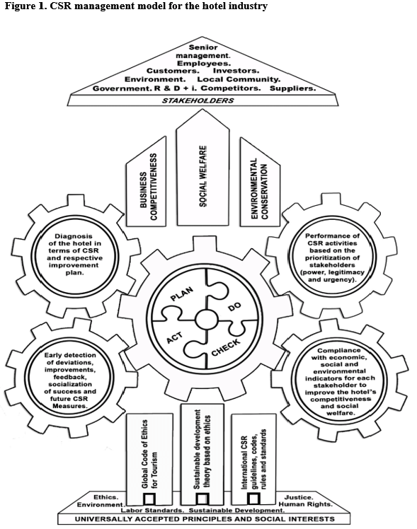
Figure: Corporate social responsibility model
Source: (accor, 2024)
The respective company is a leading mid-range hotel chain that has a significant focus on CSR approaches along with aspects like sustainability, community engagement and ethical business approaches. The company has attempted to establish new and refurbished hotels which employ sustainable designs like LED lighting, water-efficient methods and energy-saving approaches (Onyusheva, 2020). Additionally, the company also established various local partnership initiatives and guest engagement presenting its commitment towards environmental sustainability. Moreover, the company with its dedication highlights the value towards budget-conscious travellers and also leads to an optimistic reputation in the hospitality sector (Elhoushy and Ribeiro, 2024). For example, Ibis Budget Makassar in Indonesia, Ibis Styles Bangalore in India and Ibis Styles London Excel are some of the examples presenting the company’s commitment towards diverse CSR activities.

Recommendation
According to the above data, it is suggested that Corinthia Hotel Group is required to employ various tactical approaches for creating a diverse identity along with adopting for meeting the travel trends. On the other hand, Ibis Hotels is suggested to focus on its marketing positioning in the mid-range hotel industry (Song et al., 2024). However, both organisations need to maintain an effective CSR dedication along with ensuring ethical activities. Moreover, adjusting the marketing fluctuations, innovation and sustained financial initiatives in CSR approaches are some of the essential aspects which have a great contribution to establishing long-term success in the highly competitive hotel sector.

Conclusion
This particular report has been based on the operations of two leading hospitality sectors which involve a Comparison of Corinthia Hotel Group and Ibis Hotels. Thus, it has been critically analysed in the form of various aspects like total revenue, market position, growth potentials and financial commitment towards CSR approaches. Moving ahead, this assessment will analyse the financial performance of both companies. Their market position has also been assessed along with growth potentials and dedication towards CSR approaches. Moreover, it has also presented various graphs and charts for increasing the credibility of the data.

References
accor, (2023). Interim_Financial_Report_2023_. [Online] Available at: file:///C:/Users/SAGNIK%20GUIN/Downloads/Interim_Financial_Report_2023_Accor_vDef.pdf [Accessed 25 January 2024].
accor, (2024). VIBRANT HOTELS, CARING PEOPLE.. [Online] Available at: https://all.accor.com/brands/ibis.en.shtml [Accessed 26 January 2024].
Available at: https://press.accor.com/third-quarter-2023-revenue-ofe1286-millionup-13-like-for-like/?lang=en [Accessed 26 January 2024].
cbinsights, (2024). Reinventing The Hotel: How One Of The World’s Largest Hotel Chains Is Meeting The Airbnb Challenge Head-On. [Online] Available at: https://www.cbinsights.com/research/report/accorhotels-teardown-expert-intelligence/ [Accessed 26 January 2024].
corinthia, (2024). CORINTHIA DISCOVERY. [Online] Available at: https://www.corinthia.com/ [Accessed 26 January 2024].
corinthiagroup, (2022). CORINTHIA-ANNUAL-REPORT-2022_. [Online] Available at: https://www.corinthiagroup.com/wp-content/uploads/2023/06/37547-CORINTHIA-ANNUAL-REPORT-2022_WEB-min.pdf [Accessed 25 January 2024].
corinthiagroup, (2023). COMPANY FINANCIAL REPORTS. [Online] Available at: https://www.corinthiagroup.com/investors/financial-report/ [Accessed 26 January 2024].
Elhoushy, S. and Ribeiro, M.A., (2024). Socially responsible consumers and stockpiling during crises: the intersection of personal norms and fear. Social responsibility journal, 20(1), pp.180-203.
inaria-design, (2023). Corinthia Hotels. [Online] Available at: https://inaria-design.com/corinthia-hotels-resorts/ [Accessed 26 January 2024].
Nguyen, D.T.T., Diaz-Rainey, I., Roberts, H. and Le, M., (2024). The impact of natural disasters on bank performance and the moderating role of financial integration. Applied Economics, 56(8), pp.918-940.
Onyusheva, I.V., (2020). Exploring Foreign Market Entry Strategies as a Way of International Business Expansion. Вестник университета «Туран», (1), pp.9-14.
Paley, N., (2021). The manager's guide to competitive marketing strategies. Routledge.
press.accor, (2023). Third-quarter 2023 revenue of €1,286 million up 13% like-for-like. [Online]
Song, H.J., Yeon, J. and Lin, M.S., (2024). The more diverse, the better. Exploring the moderating role of hospitality top management team diversity on CSR-FP link. International Journal of Hospitality Management, 117, p.103650.
Tranter,K. Stuart-Hill,T. Parker,J. (2014) Introduction to Revenue Management for the Hospitality Industry, London, Pearson

