Symmetrical sandwich
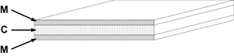

Symmetrical sandwich - flat explosives layer of mass C and two flyer plates of mass M each
A flat layer of explosive with two identical heavy flat flyer plates on each side will accelerate the plates as described by:
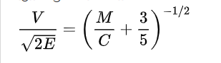
Symmetrical sandwiches are used in some Reactive armor applications, on heavily armored vehicles such as main battle tanks. The inward-firing flyer will impact the vehicle main armor, causing damage if the armor is not thick enough, so these can only be used on heavier armored vehicles. Lighter vehicles use open-face sandwich reactive armor (see below). However, the dual moving plate method of operation of a symmetrical sandwich offers the best armor protection.
Asymmetrical sandwich
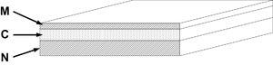

Asymmetrical sandwich - flat explosives layer of mass C, flyer plates of different masses M and N
A flat layer of explosive with two flat flyer plates of different masses will accelerate the plates as described by:

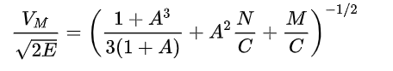

Infinitely tamped sandwich
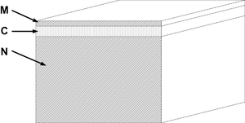

Infinitely tamped sandwich - flat explosives layer of mass C, flyer plate of mass M, and infinitely heavy backing tamper
When a flat layer of explosive is placed on a practically infinitely thick supporting surface, and topped with a flyer plate of material, the flyer plate will be accelerated as described by:
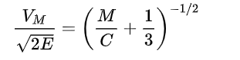
Open-faced sandwich
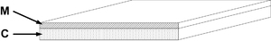

Open-faced sandwich (no tamping) - flat explosives layer of mass C and single flyer plate of mass M
A single flat sheet of explosives with a flyer plate on one side, known as an "open-faced sandwich", is described by:
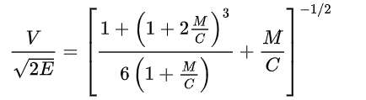
Open-faced sandwich configurations are used in Explosion welding and some other metalforming operations
References:
- https://www.revolvy.com/topic/Gurney%20equations&item_type=topic
- https://apps.dtic.mil/dtic/tr/fulltext/u2/a800105.pdf
- Extension of the Gurney Equations to Two Dimensions for a Cylindrical Charge by Benjamin A. Breech ARL-TR-5467 March 2011

