Community Engagement Assignment 1.

Fridah Kimani

Contents
Introduction 3
Homelessness Population in Wales 4
Figure 1: Homelessness in Local Authorities 4
Population of the Homeless 4
Homelessness in Swansea 4
Gender and Age Differences in Homelessness 5
Figure 2: Demography of the Homeless in the UK 5
Causes for Homelessness in Swansea 5
Figure 3: Causes of Homelessness 6
Health and Well-being Needs of the Homeless People 7
Health Issues Faced by the Homeless People 7
Education 8
Educating the Homeless Out of Drugs and Alcohol 8
Figure 4: Homeless Demand for Drugs and Alcohol Education 8
Crime 9
What Crimes do Homeless People Commit? 9
Crimes Committed on the Homeless People 9
Crime Rates 9
Figure 5: Overall Crime Trend over a 7-Year Period. 10
Figure 6: Crime rate in 2017. 10
Homeless Employment Rate 11
The Length of Time Taken for a Homeless to get Employment 11

Introduction
The aim of this report is to explore the needs analysis of homelessness in Wales giving a practical profile of issues and tools. More importantly, I will be focussing on Swansea as a specific area. It will focus on effectiveness, health and well-being, education, crime and employment. From the graph, Swansea has the highest number of Homeless households that has been recognised by the Local Authority.
With the Housing Act Wales 2014, councils within each area are required to make all steps possible to keep the households together. Households are identified by the Local Authority as homeless when meeting the legal definition of homelessness, the LA have the responsibility of giving people help on where to live, if this duty isn’t completed within the first 56 days then other housing duties are owed. The council goes on to decide regarding whether they are classed as a priority case or not and then from that duty for accommodation is decided. The households that have children are always automatically categorised as high priority(Gov.wales, 2015). Homelessness is not something that you can prepare for people who end up homeless they usually do so unexpectedly.
From my research for this report, I will be creating a drop-in style centre for homeless people. The centre will support the homeless with various forms of help. The help may be in counselling, housing, educational or personal. It will aim to cater to every need of a homeless person. It will also seek to assist the homeless people in the streets of Swansea. Proximity of Swansea to the rural west of Wales and the train end location contributes to the high number of homeless people as show in the figure 1 below(Poverty.org.uk, 2017).

Homelessness Population in Wales

Figure 1: Homelessness in Local Authorities

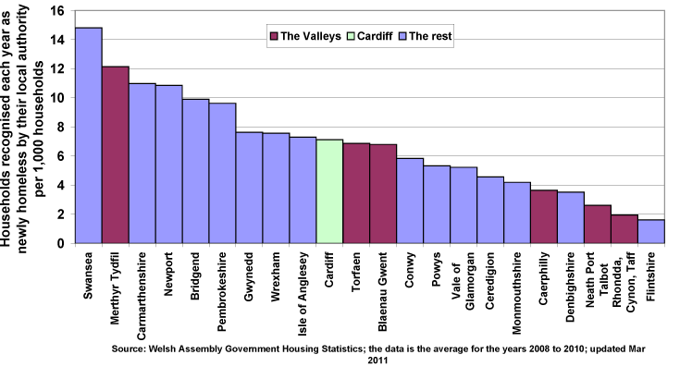
Figure 1: It shows the proportion of newly recognised homeless households by their local authorities and is an average from the last three years.

Population of the Homeless

Homelessness in Swansea
A 2016-17 Welsh government statistics indicated that 9,210 people would have become homeless in 56 days. Sixty two in a hundredeligible households (5,718),were saved from homelessness within 6 months. In the same period, 10,884 people were assessed as owed a duty of help for accommodation. Similarly, out of 2,076 unintentionally homeless households who had priority need, 1,674 were found a suitable housing. One thousand six hundred and seventeen (1,617) households in six months prevention failed whereas assistance to one thousand eight hundred and seventy two (1,872) homelessness-threatened households was withdrawn due to various reasons. 3% refusal of assistance and 5% failed to cooperate(Gov.wales, 2017).

Gender and Age Differences in Homelessness
Applicants in 2016-17 for accommodation assistance aged 25 years and above were 76%. Those who succeeded from homelessness release (under section 73) in the same age bracket contributed to 72%. Ages 18-25 made 21% of applicants prevented from homelessness. They also made a quarter of households relieved from losing their home under section 73 and those positively discharged as per section 75.
Consequently, cases of successful prevention composed of 2% of persons (Section 73) 16-17 years as well as 2% those positively discharged according to section 75. Females consisted 61% of all households in threat of being homeless within 56 days as per section 66. On the other hand, males were 56% of homeless applicants. Of those positively discharged, females consisted 66% and were categorised as a priority for having dependent children or for being pregnant. This contributed 47% of all cases assessed under section 75.

Figure 2: Demography of the Homeless in the UK
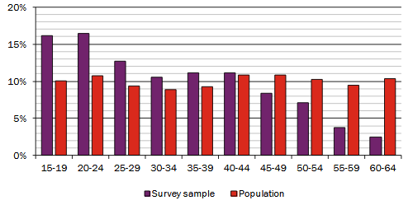

Causes for Homelessness in Swansea
Twenty-nine per centof the homeless under section 73 results from caregivers and relatives being unable or not willing to accommodate. Twenty-one per cent is because of broken relationships. Loss of shared rented housing accounts for 18%, whereas those leaving prison contribute 12%.
Homelessness as defined under section 75 has 27% contributed by parents and relatives no longer willing to accommodate. Another 26% is caused by lost shared tenancy and broken relationships account for 22%. Other reasons areill health and drugs addictions, lack and loss of employment (Benjaminsen and Bastholm Andrade, 2015, Johnson et al., 2015). Likewise, some people may be homeless after leaving the army or when they escape abusive relationships especially women. Health issues constitute 4% of the primary reasons and as a secondary factor, 10%.

Figure 3: Causes of Homelessness
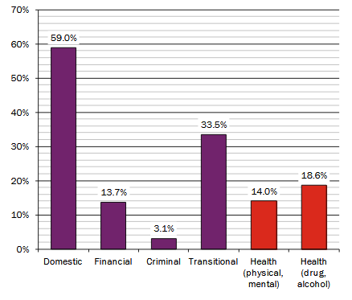
Figure 3: Reasons for homelessness categorised in major classes.
Domestic category includes people who become homeless when family is no longer able or unwilling to host them. It also constitutes of those people from over-crowded housing and relationships fallout.Rent and mortgage issues, reduction causes the financial related homelessness in financial ability and unemployment.Criminal category compromises of those who find themselves homeless after leaving prison and jails.Transitional group consists of young people in various stages of realisation and responsibilities(Cymorthcymru.org.uk, 2017).The physical, mental and emotional health state also contributes a great deal to homelessness as indicated by the figure 3 above.

Health

Health and Well-being Needs of the Homeless People
Cymorthcymru.org.uk (2017) observed that, health issues contribute to homelessness and equally results from one being homeless. The most prevalent health issues are the physical, mental, and drugs and substance abuse. Homeless people face challenges assessing medical care. For example, Thirty per cent homeless people are unable to secure appointments with doctors. Twenty-six per cent have to wait for a long time to get treatment. Others lack proper diagnosis causing long-term complications.
Equally, 40% of the street families live on less than two meals a day. Those who have not had a NHS check-up for over an year are over 40% of the homeless and more than half of eligible women did not get cancer screens. Sixty-seven out of hundred smokes and seventy are not vaccinated against hepatitis B besides lacking advice on safe sex and testing. Another 46% never exercised(Cymorthcymru.org.uk, 2017).

Health Issues Faced by the Homeless People
Averagely, each homeless person suffers from 2.29 physical health issues. Among the ill, 71% are receiving treatment on their particular issue, 26% are waiting for assistance to address their condition while another 10% require treatment but have not received any.

Education
Educating the Homeless Out of Homelessness
Homelessness is preventable when the young people are educated on leaving home, how to manage money and on the causes of homelessness (Mackie, 2011). The Wales Housing Act (2014) direction on local authority to intervene on those on the threat of homelessness before they get into the problem has had great impact on preventing homelessness. More research should be provided on homelessness, causes and consequences. There should also be training on renting ready for those aspiring to rent (Mackie, 2011).
Educating the Homeless Out of Drugs and Alcohol
The Welsh government (2016-2019) Delivery plan endeavours to reduce the drugs and alcohol mortalities. The plan raises awareness on the dangers of psychoactive substances (drugs). Since 2010, the awareness has caused a 30% reduction in deaths caused by drugs in Wales. Additionally, the government of Wales committed fifty-million pounds in programs against drugs, alcohol, and substance abuse(Gov.wales, 2015).

Figure 4: Homeless Demand for Drugs and Alcohol Education

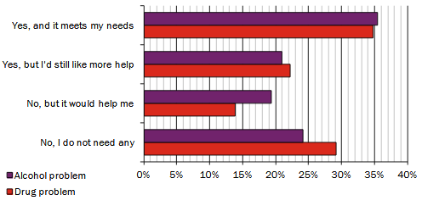

Crime

What Crimes do Homeless People Commit?
BBC reported that often, homeless people commit petty crimes to be accorded priority in accommodation. Such crimes include car theft, dangerous driving and assault(BBC News, 2013). In addition, one in five homeless people commit crimes that would take them to prison to escape living in the streets. Women may engage in prostitution seeking to leave the streets (Ramesh, 2010).

Crimes Committed on the Homeless People
According to England (2016), 35% homeless people were attacked and violated. Ten out of a hundred were urinated on, while those who were sexually assaulted constituted 7%. Half the population were threatened and intimidated. Thirty- four per cent had things thrown at them, while 54% lost their possessions theft, 59% received verbal abuse and harassment. More than half (53%) said that they would be ignored by the police when they reported mistreatment.

Crime Rates
The rate of crimes has recently increased,there was a 10% increase in all crimes, violent crimes rose by 18% and 26% for murder cases. Gun crimes accounted for 23% rise, while knife crime was at a seven year highest by 20%(Yeginsu, 2017).
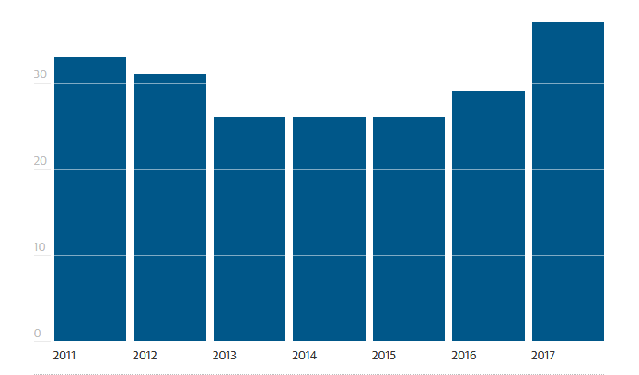

Figure 5: Overall Crime Trend over a 7-Year Period.

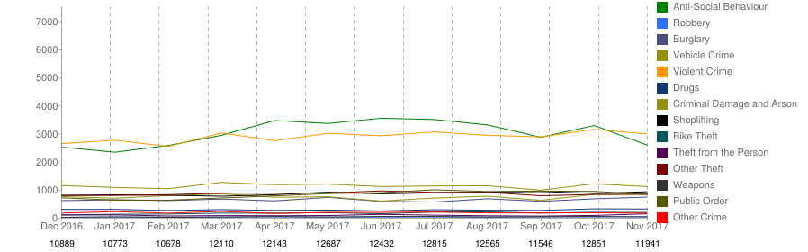

Figure 6: Crime rate in 2017.

Homeless Unemployment Rate
In 2015, Crisis organisation reported working with 8,545 homeless people, but only supported 681 to be employed. Five hundred and Fifty Seven were employed, a mere 28%. From the overall population, 72% remained unemployed(Fitzpatrick et al., 2015).

Figure 7: Population of Unemployed People in the UK

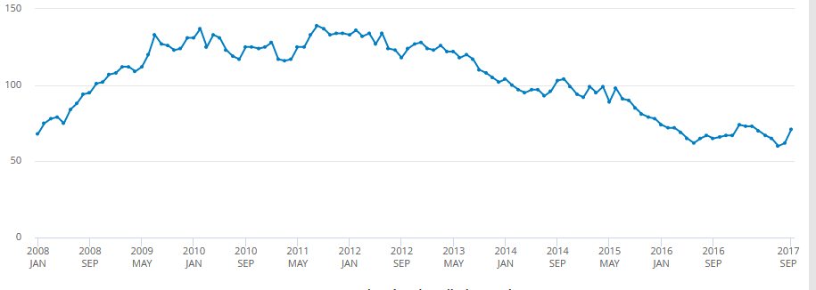

Source: International Labour Organisation

The Length of Time Taken for a Homeless to get Employment
Often, it is always difficult securing employment when homeless, whereas it is hard to have a home without a job. A homeless person could wait for five to ten years to be accommodated (Lewis, 2017).
Evidently, there are many homeless people in Wales especially in Swansea. This calls for an initiative to support them, particularly the youth, women and children who are most vulnerable. There are also many causes of homelessness but no one is immune. It is important to prevent homelessness, but when it happens, homeless people should be provided with an all-round support especially regarding their health and well-being. In addition, homeless people suffer from discrimination and other forms of abuse while in the streets. Instead, they need to be treated with dignity. Moreover, supporting them to get employment hastens the efforts to settle them.

References
Barry, S. (2017). Wales has one of the highest youth unemployment rates in the UK. [online] wale online. Available at: http://www.walesonline.co.uk/business/business-news/wales-one-highest-youth-unemployment-11814536 [Accessed 4 Jan. 2018].
BBC News. (2013). 'Crimes committed' for home priority. [online] Available at: http://www.bbc.com/news/uk-wales-24662292 [Accessed 4 Jan. 2018].
Bibbings, J., Evans, A., Bibbings, J., Jackson, R. and Bibbings, J. (2017).Eight things we learned this week from Welsh homelessness figures – www.sheltercymru.org.uk. [online] Sheltercymru.org.uk. Available at: https://sheltercymru.org.uk/eight-things-we-learned-this-week-from-welsh-homelessness-figures/ [Accessed 4 Jan. 2018].
Bowles, A. (2000). The Challenge of Educating the Homeless. [online] Nytimes.com. Available at: http://www.nytimes.com/2000/06/25/nyregion/the-challenge-of-educating-the-homeless.html [Accessed 5 Jan. 2018].
Cymorthcymru.org.uk. (2017).Cite a Website - Cite This For Me. [online] Available at: http://www.cymorthcymru.org.uk/files/1515/0108/8821/Cymorth_Cymru_Health_Matters_report.pdf [Accessed 4 Jan. 2018].
England, C. (2016). Homeless people are regularly urinated on, sexually assaulted, and beaten. [online] The Independent.Available at: http://www.independent.co.uk/news/uk/home-news/homeless-people-urinated-on-sexually-assaulted-and-beaten-by-members-of-public-survey-finds-a7494096.html [Accessed 4 Jan. 2018].
Fitzpatrick, S., Pawson, H., Bramley, G., Watts, B. and Wilcox, S. (2015).The homelessness monitor: England 2015.The Crisis, pp.2-16.
Fitzpatrick, S., Wilcox, S., Watts, B., Pawson, H., Bramley, G. and Wood, J. (2017). The homelessness monitor: Wales 2017. [online] pp.3-9. Available at: https://www.crisis.org.uk/media/237651/the_homelessness_monitor_wales_2017_es.pdf [Accessed 4 Jan. 2018].
Gov.wales. (2015).Welsh Government|Housing (Wales) Act 2014. [online] Available at: http://gov.wales/topics/housing-and-regeneration/legislation/housing-act/?lang=en [Accessed 4 Jan. 2018].
Gov.wales. (2015).Welsh Government Misuse of alcohol one of the main causes of homelessness. [online] Available at: http://gov.wales/newsroom/health-and-social-services/2015/homeless/?lang=en [Accessed 4 Jan. 2018].
Gov.wales. (2017). [online] Available at: http://gov.wales/docs/desh/publications/090724homelessnessplanen.pdf [Accessed 4 Jan. 2018].
Gov.wales. (2017).Welsh Government Key economic statistics. [online] Available at: http://gov.wales/statistics-and-research/key-economic-statistics/?lang=en [Accessed 4 Jan. 2018].
Griffiths, M. (2017).There's a 'worrying' rise in the number of homeless people in Swansea. [online] wale online. Available at: http://www.walesonline.co.uk/news/wales-news/worrying-rise-number-homeless-people-13300826 [Accessed 4 Jan. 2018].
Griffiths, M. (2017).There's a 'worrying' rise in the number of homeless people in Swansea. [online] walesonline. Available at: http://www.walesonline.co.uk/news/wales-news/worrying-rise-number-homeless-people-13300826 [Accessed 4 Jan. 2018].
Lewis, A. (2017). Homeless people have shared their experiences of living on the streets. [online] walesonline. Available at: http://www.walesonline.co.uk/news/wales-news/homeless-people-shared-experiences-following-13456333 [Accessed 4 Jan. 2018].
Mackie, P. (2011). Homelessness.Cardiff Case Studies, [online] pp.1-3.Available at: https://www.cardiff.ac.uk/__data/assets/pdf_file/0003/348636/Homelessness.pdf.
Mosalski, R. (2017). This is a heartbreaking look at homelessness in Cardiff. [online] walesonline. Available at: http://www.walesonline.co.uk/news/local-news/heartbreaking-look-homelessness-cardiff-12346493 [Accessed 4 Jan. 2018].
Poverty.org.uk. (2017).Wales: homelessness - The Poverty Site. [online] Available at: http://www.poverty.org.uk/w81/index.shtml [Accessed 4 Jan. 2018].
Ramesh, R. (2010). A fifth of all homeless people have committed a crime to get off the streets. [online] the Guardian. Available at: https://www.theguardian.com/society/2010/dec/23/homeless-committing-crimes-for-shelter [Accessed 4 Jan. 2018].
Wlga.wales. (2017). [online] Available at: http://www.wlga.wales/SharedFiles/Download.aspx?pageid=62&mid=665&fileid=1320 [Accessed 4 Jan. 2018].
Yeginsu, C. (2017). Crime in England and Wales Is Rising at Fastest Rate in a Decade. [online] Nytimes.com. Available at: https://www.nytimes.com/2017/07/20/world/europe/england-wales-crime-rate.html [Accessed 4 Jan. 2018].

Annotated Bibliography
Barry, S. (2017). Wales has one of the highest youth unemployment rates in the UK. [online] walesonline. Available at: http://www.walesonline.co.uk/business/business-news/wales-one-highest-youth-unemployment-11814536 [Accessed 4 Jan. 2018].
Wales Online is an online media platform for Welsh news. In this article, Sion Berry tackles the issue of youth unemployment in the UK focusing more on Wales. The article also analyses research statistics for the various regions and the significance of the youth unemployment currently and in the future.
BBC News. (2013). 'Crimes committed' for home priority. [online] Available at: http://www.bbc.com/news/uk-wales-24662292 [Accessed 4 Jan. 2018].
This article by the British Broadcasting Corporation report on the status of homelessness in Wales highlights the plight of ex-offenders in pursuit of accommodation. It also highlights the initiatives taken by the Welsh government to address the housing needs for the ex-offenders. In addition, it reports the conduct of repeat offenders in their attempt to ensure priority in getting accommodated.
Bibbings, J., Evans, A., Bibbings, J., Jackson, R. and Bibbings, J. (2017).Eight things we learned this week from Welsh homelessness figures – www.sheltercymru.org.uk. [online] Sheltercymru.org.uk. Available at: https://sheltercymru.org.uk/eight-things-we-learned-this-week-from-welsh-homelessness-figures/ [Accessed 4 Jan. 2018].
Jennie Bibbings and the team of writers at Shelter Cymru educate us on the reality of homelessness in Wales and the contribution done by the government to prevent this situation. Shelter Cymru being a public housing charity explains the effects of the recent homelessness policy, while also highlighting the status of the homeless in regards to the national statistics. In addition, it discusses the significance of the figures to the current and future needs for settling the homeless.
Bowles, A. (2000). The Challenge of Educating the Homeless. [online] Nytimes.com. Available at: http://www.nytimes.com/2000/06/25/nyregion/the-challenge-of-educating-the-homeless.html [Accessed 5 Jan. 2018].
The New York Times article written by Adam Bowles delves into the challenges of the homeless in getting education. Emphasizing the need for education especially for the children of the homeless, Bowles discusses interventions by well-wishers and educators responding to the various complex needs of the homeless.
Cymorthcymru.org.uk. (2017). [online] Available at: http://www.cymorthcymru.org.uk/files/1515/0108/8821/Cymorth_Cymru_Health_Matters_report.pdf [Accessed 4 Jan. 2018].
CymorthCymru is an organisation in Wales involved in sheltering the homeless and the accompanying welfare. This issue is a report on the health status among the homeless community in Wales. It highlights the issues as well as the needs of the homeless in Wales while auditing the available legislation on homelessness and the gains achieved. The report gives a comprehensive analysis of the homeless, causes, demographic representation together with their health issues. It emphasizes on the need for good health as preventative as well a solution for homelessness.
England, C. (2016). Homeless people are regularly urinated on, sexually assaulted, and beaten. [online] The Independent.Available at: http://www.independent.co.uk/news/uk/home-news/homeless-people-urinated-on-sexually-assaulted-and-beaten-by-members-of-public-survey-finds-a7494096.html [Accessed 4 Jan. 2018].
This article from the Independent media highlights the abuses met by the homeless while on the streets. England exposes the inhuman actions committed to the street families and appeals for understanding and compassion towards them. The report seeks to discourage discriminating and judging the homeless since most of them are victims of life.
Fitzpatrick, S., Pawson, H., Bramley, G., Watts, B. and Wilcox, S. (2015).The homelessness monitor: England 2015.The Crisis, pp.2-16.
The homelessness monitor is a publication of the Crisis organisation to highlight the status and the effects of homelessness in Wales. The study conducted in the Institute of social policies analyses periodically the economic contributors and effects of homelessness. In this issue of 2015, Fitzpatrick and the team presents the status of homelessness immediately after the 2014 homelessness policy.
Fitzpatrick, S., Wilcox, S., Watts, B., Pawson, H., Bramley, G. and Wood, J. (2017). The homelessness monitor: Wales 2017. [online] pp.3-9. Available at: https://www.crisis.org.uk/media/237651/the_homelessness_monitor_wales_2017_es.pdf [Accessed 4 Jan. 2018].
The homelessness monitor issue of 2017 reflects on the gains of homelessness law and the status of the issue. The study analyses the process of settling the homeless in Wales as well as the trends documented.
Gov.wales. (2015).Welsh Government Housing (Wales) Act 2014. [online] Available at: http://gov.wales/topics/housing-and-regeneration/legislation/housing-act/?lang=en [Accessed 4 Jan. 2018].
This is a government of Wales’s legislation that mandates the local authorities to employ measures to prevent people at risk of being homeless going to the streets. If further categorises the classes of homelessness while providing the intervention required.
Gov.wales. (2015).Welsh Government Misuse of alcohol one of the main causes of homelessness. [online] Available at: http://gov.wales/newsroom/health-and-social-services/2015/homeless/?lang=en [Accessed 4 Jan. 2018].
In 2015, the Welsh government released a report on the status of drugs abuse among the homeless communities and the intervention measures against the vice. It stresses the need for heightened campaign against the drugs by educating the homeless on the dangers of abusing drugs and alcohol.
Gov.wales. (2017). [online] Available at: http://gov.wales/docs/desh/publications/090724homelessnessplanen.pdf [Accessed 4 Jan. 2018].
This document is a publication of the Welsh government outlining their plans for the homeless communities from 2009-2019. It is a commitment by the Welsh authority to support the homeless population. It addresses the contributing factors in a preventative as well as curative initiatives.
Gov.wales. (2017).Welsh Government Key economic statistics. [online] Available at: http://gov.wales/statistics-and-research/key-economic-statistics/?lang=en [Accessed 4 Jan. 2018].
The government of Wales’s economic statistics outlines the trade as well as employment current condition. In regards to the homeless, this statistics emphasizes their plight since unemployment affects the homeless more than those already housed.
Griffiths, M. (2017).There's a 'worrying' rise in the number of homeless people in Swansea. [online] walesonline. Available at: http://www.walesonline.co.uk/news/wales-news/worrying-rise-number-homeless-people-13300826 [Accessed 4 Jan. 2018].
Megan Griffiths laments the rising number of the homeless especially in Swansea. In this article published by Wales Online, Megan offers the homeless the options to seek assistance for housing.
Lewis, A. (2017). Homeless people have shared their experiences of living on the streets. [online] wale online. Available at: http://www.walesonline.co.uk/news/wales-news/homeless-people-shared-experiences-following-13456333 [Accessed 4 Jan. 2018].
Anna Lewis highlights the plight of the homeless in the streets of Wales even as predictions indicate that this problem could escalate in the future. The article appearing on Wales Online shares experiences of several homeless persons as well as some organisations involved in resettling them.
Mackie, P. (2011). Homelessness.Cardiff Case Studies, [online] pp.1-3.Available at: https://www.cardiff.ac.uk/__data/assets/pdf_file/0003/348636/Homelessness.pdf.
Dr. Paul Mackie is a professor in Cardiff University. In this paper, Mackie explores the public perception of the homeless people, the causes as well as the solutions to the issue. He notes the unique causes of homelessness amongst the young persons and recommends a multi -dimensional approach to youth homelessness.
Mosalski, R. (2017). This is a heartbreaking look at homelessness in Cardiff. [online] wale online. Available at: http://www.walesonline.co.uk/news/local-news/heartbreaking-look-homelessness-cardiff-12346493 [Accessed 4 Jan. 2018].
Ruth Mosalski from Wales online highlights the hardships of the homeless and the dangers they face while in the streets. Mosalski appeals to the readers to consider assisting these needy people during the Christmas holiday season and the means to do it.
Poverty.org.uk. (2017).Wales: homelessness - The Poverty Site. [online] Available at: http://www.poverty.org.uk/w81/index.shtml [Accessed 4 Jan. 2018].
This is a UK website indicating the various problems in the region and the poverty index with elaborate facts and figures. The report indicates that homelessness is a major issue in the UK, therefore, confirming other studies.
Ramesh, R. (2010). A fifth of all homeless people have committed a crime to get off the streets. [online] the Guardian. Available at: https://www.theguardian.com/society/2010/dec/23/homeless-committing-crimes-for-shelter [Accessed 4 Jan. 2018].
Randeep Ramesh in the 2010 issue of The Guardian explores the lives of the homeless communities in the streets and their vulnerability to various crimes. It highlights the conduct of both homeless men and women asserting that a fifth of the population have committed one crime or the other.
Wlga.wales. (2017). [online] Available at: http://www.wlga.wales/SharedFiles/Download.aspx?pageid=62&mid=665&fileid=1320 [Accessed 4 Jan. 2018].
This is a recent document (November 2017) by the Welsh Local Government Association to evaluate the gains of the 2014 homelessness law. It reviews the government’s input in tackling the issues and concludes that local authorities have responded appropriately to the homelessness challenge.
Yeginsu, C. (2017). Crime in England and Wales Is Rising at Fastest Rate in a Decade. [online] Nytimes.com. Available at: https://www.nytimes.com/2017/07/20/world/europe/england-wales-crime-rate.html [Accessed 4 Jan. 2018].
CeylanYeginsu of the New York times analyses the crime trend in in England and Wales in the last decade. The report notes that the crime rate has risen immensely most recently as indicated by the National Statistics.
Figure 1: Homelessness in Local Authorities
The graph shows the varying population in the Wales local authorities. Notably, Swansea tops as the region with the highest homeless people.
Figure 2: Demography of the Homeless in the UK
This is an ages of the homeless in the UK as provided by the Crisis Organisation. The study shows that most youths 15-25 years constitute the homeless people.
Figure 3: Reasons for Homelessness
Homelessness results from many factors as summarised in this graph. As shown in the graph, majority of the homeless find themselves in the streets after fall out with their families and care- givers.
Figure 4: Homeless Demand for Drugs and Alcohol
There is a campaign to help the homeless out of drugs’ abuse. The initiatives to provide information is received differently as indicated in the graph.
Figure 5: Crime Rate in UK over a 7-Year Period
The graph shows the trend of criminal activities in the UK over a seven-year period. The statistics reported by The Guardian were sourced from the office of National Statistics. Notably, the rate of crime was highest in 2017.
Figure 6: Crime Rate in 2017
The data provided by the UK Crime Statistics analyses crimes committed every month of 2017 and the numbers of reported cases in each category.
Figure 7: Population of Unemployed people in the UK
This data from the International labour organisation highlights the trend in unemployment in the last decade for the UK.

