

Work Based Learning – Submission 4 – Reflective Journal



Student name and ID: James Cullen (P151951).
Course: Construction Management.
Company name and address: Dwr Cymru Welsh Water, 1st Floor, Glien House, Glien Road, Johnstown, Carmarthen SA31 3RB.
Contact name and number: Dai Kirk (Dave.Kirk@dwrcymru.com, 07881907532).

As per the learning contract this interim submission will focus on the period between 25/01/20 – 08/03/20, encompassing what was initially programmed to be the most productive timeframe of the scheme.
This period provided afforded opportunities for learning in a variety of fields. One such example was the increased workload and management of an increased number of gangs working in the area, which peaked at 6. Consequently this heightened the importance time management, organisation and communication, with each gang’s work having to be communicated to other stakeholders within DCWW. Below shows an example of ‘PDF 020 – Request for Shut off Mains’ completed during this time:

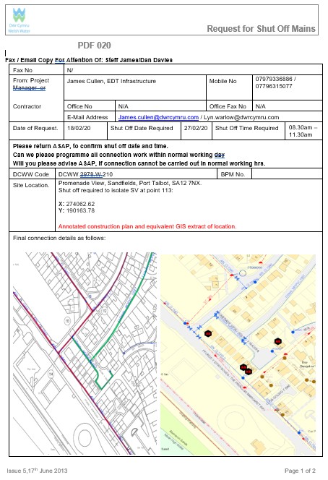

(Image 3: View of completed PDF 020 – Request for Shut off Mains – Promenade View, Sandfields, Port Talbot 18/02/20, DCWW, 2020)

Submitted to and signed off by DCWW’s operations department, these allow a section of water main to be isolated for a maximum of three hours for work to be undertaken upon it. At the stage of the scheme in question up to 7 of these were carried out per week and at times up to 4 a day. To allow the Network department to plan their resources and free up operatives to perform the ‘shut off’, the form must be submitted in a timely fashion to allow the vital work to go ahead.
Regularly however small events on site can lead to ‘shut off’s being delayed or postponed to a later date so it is imperative that this information is relayed the interested parties as soon as possible to lessen the affects of the delay. A similar process relates to obtaining water samples from lengths of water mains where work has been completed. The same factors must be considered for these operations also.
Furthermore, throughout the period, hygiene and health and safety audits had to continue to be undertaken to ensure compliance.
A highlight of this period was news that the meterage of water mains renewed had reached 13 thousand metres and therefore had surpassed the halfway stage of the scheme. This occurred around the beginning of March and while none of the operatives and staff involved in the project are under any illusions as to the fact that a lot of hard work is still forthcoming, the event did raise morale. The excerpt below demonstrates typical progress reports received from the contractor profiling meterage achieved:

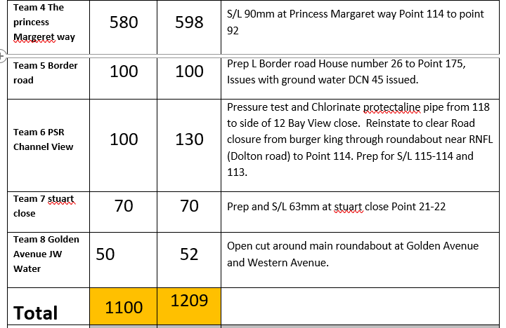

(Image 4: Extract of weekly progress report completed by contractor regarding G18 Zonal Study scheme, Sandfields, Port Talbot week ending 01/03/20, O Connor Utilities, 2020)

While this milestone proved that progress on the scheme was heading in the right direction, a lowlight of the period has been the realisation that the programme has slipped due to disruptions in work. This can be mainly attributed to effects of Storm Denis which necessitated a cessation to work while resources and men were diverted elsewhere. This in itself has provided a significant challenge for the team as a whole and as an individual to attempt to get the programme and production back to acceptable levels to ensure the project is completed in a timely fashion.
In general, the work undertaken during this time span does appear to deviate from what was originally set out in the learning contract for this time period. In reality, on the project the priorities were as described above and were relatively unforeseen. However, no less learning was obtained as a result. The aspects not focused upon will be revisited at a later stage.

Reference List

- Moore (2019), PN (3) 07 – Level 3 Procedure – Commissioning New & Refurbishment Mains, DCWW, UK.

List of images

Front page top:
- Image 1: DCWW (2019) Dwr Cymru Welsh Water logo, https://www.dwrcymru.com/, accessed 10/11/19.
Front page bottom:
- Image 2: UWTSD (2019) University of Wales Trinity Saint Davids logo, https://www.uwtsd.ac.uk/courses/, accessed 10/11/19.
- Image 3: Cullen (2020), Completed PDF 020 – Request for Shut off Mains – Promenade View, Sandfields, Port Talbot, DCWW, UK.
- Image 4: Harding (2020), Extract of weekly progress report completed by contractor regarding G18 Zonal Study scheme, Sandfields, Port Talbot week ending 01/03/20, O Connor Utilities, UK.

