Exploring the effectiveness of support and training programmes for employees at the workplace

Student Name: Iva Naydenova
Student ID: 1914746

Acknowledgement
The development of this current research has been made and completed with the assistance, direction and support of my teachers, family members, classmates and supervisors. I am able to complete this research with the support and direction of my supervisor and without the help of my teachers, peers and supervisor it would not have been possible to complete this research.

Abstract
In the introduction section, the importance of support and training programs is discussed with the inclusion of research questions, aims, objectives and reasons for choosing the topic. The support and training programs have assisted in increasing the efficiency of the staff and reducing the turnover rate. In the literature review section, the issues faced in relation to these programs such as the absence of employee engagement and workforce resistance are analysed. The literature review section is supported with the help of statistical data and pictures. In the methodology section, the techniques and approaches which have been used for conducting this research are mentioned. This research has been conducted by collecting both primary and secondary data therefore the researcher focuses on choosing relevant techniques for completing this research. The philosophy, approach, data collection method and ethical considerations of this research are also mentioned in this writing. In the findings and results section, a survey of 50 employees of Waitrose Ltd and an interview of 3 managers has been conducted for collecting the primary data for the research. A discussion has been mentioned for both the survey and interview which assists to understand the entire research topic clearly. In the conclusion and recommendation section, the future scope of choosing the research subject is analysed in a detailed manner and the recommendation to improve the motivation is interpreted in a detailed manner.

Table of Contents
Chapter 1: Introduction 6
1.1: Research Background 6
1.2: Aims and Objectives 6
1.3: Research Questions 7
1.4: Hypothesis 7
1.5: Problem Statement 7
1.6: Research Rationale 7
1.7: Structure of dissertation 8
Chapter2: Literature Review 8
2.1: Introduction 8
2.2: Importance of training and support programmes for Waitrose Ltd 8
2.3: The present support system in the workplace 10
2.4: Prevailing issues faced by the employees in attaining training 11
2.5: Recommendation to improve the working conditions 12
2.6: Conceptual Framework 13
2.7: Literature Gap 13
2.8: Summary 13
Chapter 3: Research Methodology 14
3.1: Research Philosophy 14
3.2: Research Paradigm 14
3.3: Research Approach 14
3.4: Research Methodology 15
3.5: Research Strategy 15
3.6: Sampling Methods 15
3.7: Research Design 15
3.8: Data Collection Methods/tools 16
3.9 Ways of interpreting data 16
3.10: Ethical Consideration 16
3.11: Limitations of Research 16
Chapter 4: Findings and Results 16
4.1: Quantitative Surveys 16
4.2: Qualitative interview 24
4.3: Discussion 26
4.3: Secondary Data (Secondary Thematic Analysis) 27
Chapter 5: Conclusion and Recommendations 29
5.1: Conclusion 29
5.2: Linking with the objectives 30
5.3: Recommendation 30
5.4: Future Scope 30
References 31

Chapter 1: Introduction

1.1: Research Background
As per the views of Park, et al., (2018), a training and support programme is denoted as the planned sequence as well as a combination of activities organized to equip staff with knowledge as well as abilities to become professionally successful. The various training and support programme prevalent in the organizations such as Waitrose Ltd is New Employee, Orientation, on boarding, Team Training, Leadership Training, Senior Executive Training, Technical Skills Training and Soft Skills Development. The research study focuses on the advantages of initiating support and training programmes in improving the performance of workers at the workplace in organizations like Waitrose Ltd. Waitrose & Partners is a brand of British Supermarkets initiated in the year 1904 by Wallace Waite, Arthur Rose and David Taylor. The main office is in London and it sells food to a total of 332 locations. As per the financial report, the total number of employees is 52,590 and the revenue is 7.043 billion pounds as per the financial report 2021 (Waitrose & Partners., 2022). Waitrose recently launched its online learning and development system in order to provide personal as well as team development training to its 47,000 staff.

1.2: Aims and Objectives
The research study aims to understand and interpret the consequences of the support systems in the welfare of the staff within the working environment of Waitrose Ltd and also to observe the way the training programme provides professional development for the workers functioning in the trading platform on an international basis.
Based on the aim, the following objectives of the research study have been evident in a detailed manner:
- To identify the prevailing issues being faced by the workers of the respective organisation regarding training and increasing performance standards of the workplace
- To analyse the relevant support system present in the business working environment of Waitrose Ltd
- To evaluate the importance of training and support programmes for the organisations such as Waitrose Ltd
- To recommend strategic measures in order to provide better working conditions in Waitrose Ltd.

1.3: Research Questions
RQ1: What are the relevant problems faced by the staff of Waitrose Ltd while taking part in their training programs?
RQ2: To what extent the present support system has helped to increase the performance level of workers in Waitrose Ltd?
RQ3: What is the importance of training and support in enhancing the performance standards of the employees of the concerned firm?
RQ4: How the suggestions given can improve the training and development programs of Waitrose Ltd in order to ensure the better working condition and increased performance?

1.4: Hypothesis
H1: To clearly understand and interpret the benefits of the support and training programmes in improving the performance level of the British supermarket chain Waitrose Ltd
H2: To recognize the limitations faced by the staff while attaining the support and training programmes in the respective supermarket organization

1.5: Problem Statement
From the above objectives, the problem statement that is evident is mentioned below in a detailed manner
Whether the strategies adopted by Waitrose Ltd in implementing the training and support program have been successful in improving the professional performance of the staff and therefore the productivity standards of the firm
According to Malek, et al., (2018), the respective organization has initiated a butchery course where the staffs is given knowledge as well as training on meat cutting, cooking techniques and butchery abilities. Therefore the respective training programs have assisted the firm to increase the efficiency of the staff, less the amount of wastage, reduce in turnover rate, bettering labour management connections and increased the level of motivation (Johnson, et al., 2018, p. 191). It has expanded the loyalty of the customers and helped them to attain an impressive increase in sales up to 7.54 billion pounds as per the financial report 2021.

1.6: Research Rationale
The reason for choosing the respective research topic is organizations in recent times are launching support and training programmes to inculcate dedication as well as motivation among the workers in order to fulfil the business objectives. One of the notable examples is Waitrose Ltd which has initiated an online learning and development system which gives the staff working from home the chance to learn about the progressive supply chain techniques used in manufacturing food products (Basterretxea, and Storey, 2018, p. 300).

1.7: Structure of dissertation
The dissertation is divided into 5 chapters starting from the introduction, literature review, research methodology, findings and most importantly the recommendations. The research topic is supported with the help of facts, figures and statistical data from relevant primary as well as secondary sources.

Chapter2: Literature Review

2.1: Introduction
As depicted by Buchanan, and Huczynski, (2019), in the present times, organizations are adapting support and training programs in order to expand the efficiency of the workers, reduce the turnover rate and improve the motivation level. The firms like Waitrose Ltd are taking up certain common types of Training Programs such as Orientation Training, Onboarding Training, Compliance Training, Product Training and Sales Training. In order to ensure a proper support system the firms such as Waitrose Ltd are given certain facilities such as work-from policy, life insurance, retirement compensation and most importantly education assistance. Therefore, the respective chapter discusses its need, the issues faced and the suggestion to upgrade it in order to increase sales.

2.2: Importance of training and support programmes for Waitrose Ltd
It is essential to implement training and support programmes for the supermarket chain companies such as Waitrose Ltd because it plays a vital role in refining the performance standards of the staff and hence assists them to achieve a commendable profit margin. For instance, Waitrose Ltd launched a butchery course that trains the workers to adapt the progressive techniques of cutting meat and inculcate in them certain cooking techniques. Additionally, the fishmonger course has assisted their staff in adapting knowledge about the various fish species, sustainability and skilled filleting techniques.
This course has encouraged somewhat 200 employees of Waitrose to provide personalized and satisfying service to the customers hence attaining revenue of 6373.3 million pounds as per the financial report 2021. As cited by Diamantidis, and Chatzoglou, (2018), therefore the need for training and support programmes is explained by applying the employee evaluation model that indicates three main factors. The application of this model has assisted the respective firm to attain an impressive training culture through the initiation of the cheesemonger programme and online learning as well as development programme. These programmes have helped the employees to achieve excellent knowledge about the testing procedures of selected food shops and also prosper in leading a team. Therefore customer loyalty towards the organization has expanded which is reflected in the increased operating profit of 15% as per the report in the year 2021.
The job-related factors such as communication and motivation have assisted the respective firm to ensure a proper support system by providing facilities such as an increase in the bonus by 2%, health insurance, work-from-home opportunities and a convenience fee after retirement. This led to reducing the level of turnover rate and delivery of excellent products reflecting the market share of 6.5%. The employment-related factors such as commitment and improving the skill through the training program have assisted the notable supermarket company to produce safe food products for the customers increasing their trust and hence achieving an improved debt ratio of 2.3% in 2021 which is better than 2020 (johnlewispartnership.co.uk, 2022).
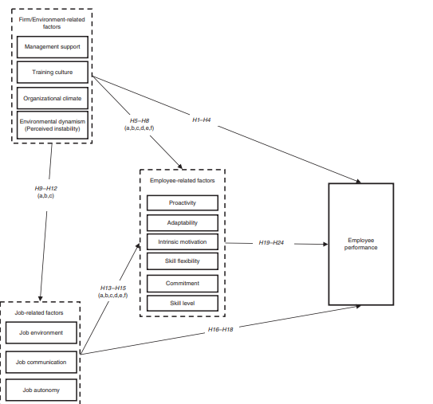
Figure 1: Employee Evaluation Model
(Source: Diamantidis, and Chatzoglou, 2018)
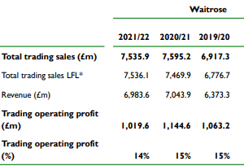
Figure 2: Impact of the training and support program on the growth of Waitrose Ltd
(Source: johnlewispartnership.co.uk, 2022).

2.3: The present support system in the workplace
As stated by Sekar, and Dyaram, (2020), support programmes are denoted as benefits program that plays a vital role in assisting the staff to solve their personal work-related issues that might affect their performance level, health and general well-being if left ignored. In order to effectively implement the support programmes the organizations like Waitrose Ltd provides certain facilities such as a work-from-home policy, paid holidays, vacation leave, paid sick leave, company store discount, pension plan, flexible schedule and life insurance. The staffs who has been working with the respective company gets a discount of 25% on buying products from the stores Waitrose as well as John Lewis & Partners. It gives bonuses to the employees who have increased by 2% as per the financial report in 2021 (johnlewispartnership.co.uk, 2022).
As opined by Grimani, et al., (2019, p. 5), these facilities have assisted them to expand the motivation standards among the 47,000 employees improving their productivity level which is reflected in the increase of profit by 11.8% as per the report in the year 2021. The inclusion of workplace physical activities as well as nutritional interventions that denote counselling, education as well as onsite group activities can encourage the respective supermarket chain to improve the mental health of the staff. As a result, the performance level of the firm has increased attaining a worth of over 1 million. As part of support programmes, the organization efficiently communicates with the staff through meetings and conferences respecting the opinions of every staff, therefore refining their abilities.

Figure 3: Impact of employee support programme on the sales of Waitrose
(Source: Jcphankins, 2021)
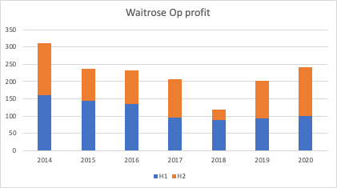
Figure 4: Impact of employee support programme on the operating profit of Waitrose Ltd
(Source: Published by Emma Bedford 2022)

2.4: Prevailing issues faced by the employees in attaining training
Organizations such as Waitrose Ltd has been successful in improving the performance level of the staff by implementing support and training programmes through online learning and development system, butcher course and fishmonger course. It has assisted them to increase their sales, revenue and operating profit by inculcating motivation through these programs (Pandita, and Ray, 2018). But they face certain issues while giving training through these programs that are mentioned below:
Lack of employee engagement: As per the views of Shipper, and Hoffman, (2020, p. 251), the lack of concentration and skill can restrain the workers of a company like Waitrose Limited to adapt correct training of delivering excellent work. Therefore, their interest towards working lowers addicting the sales as well as productivity standards of the concerned supermarket chain company.
Employee Roadblocks: Apart from training, ensuring a proper support system is essential and the absence of that can restrain firms such as Waitrose Ltd to attain an impressive market share and operating profits. For instance, Waitrose ltd during the pandemic situation was not able to provide salaries as well as facilities and therefore 1200 staff left their job resulting in a loss of 635 million pounds.

2.5: Recommendation to improve the working condition
According to Kremer, et al., (2019, p. 71), in order to improve the issues of the training and support programs the organizations like Waitrose Ltd are recommended to follow Transformational Leadership so that they can deliver knowledge about the changes taking place in the supermarket chain and the way they can increase the productivity standards both of themselves as well as company. Apart from it, the respective supermarket chain is suggested to ensure proper engagement of the staff through allowing them to grow, encouraging teamwork among them and most importantly providing them tools for success. Apart from it, they need to increase the motivation level of the staff by making the business a pleasant place, offering recognition for their work, giving them space to grow and sharing positive feedback in order to help Waitrose Limited to fulfil their business objectives and attaining an impressive profit (Johnson, et al., 2018, p. 191).

2.6: Conceptual Framework
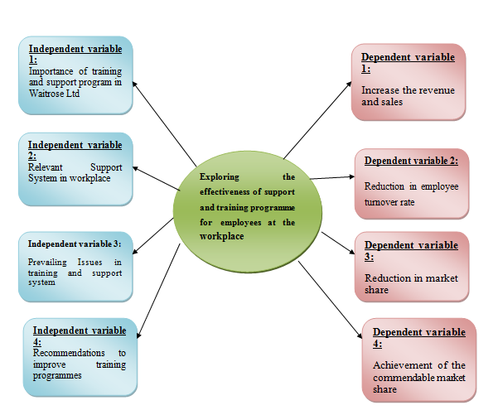
Figure 5: Conceptual Framework
(Source: Developed by Learner)

2.7: Literature Gap
The literature gap identified is it does not mention the strategies that are taken by the respective supermarket chain Waitrose Ltd to mitigate the issues of support and training programmes such as lack of employee engagement and employee roadblocks. Even though recommendations are given to improve it, it lacks a plan of action taken by the respective organisation to solve these issues.

2.8: Summary
In this respective chapter, the importance of the support and training programs is discussed in a detailed manner. The support and training program has helped the organizations such as Waitrose Ltd to increase the efficiency of the employees, reduce the turnover rate and increase the motivation level. The relevant support system of Waitrose Ltd is illustrated in an explanatory manner as it provides facilities such as life insurance, a discount of 25% as well as paid sick leave to the employers. This has increased the dedication level of the staff which is reflected in the operating profit and sales. The issues related to it are identified that include employee block roads and lack of involvement. The ways of mitigating it are also explained through attaining Transformational Leadership.

Chapter 3: Research Methodology

3.1: Research Philosophy
As per the views of Saunders (2019), research philosophy enables the researcher to focus on various types of methods which are appropriate for the research. Researchers use different types of philosophies for their research such as pragmatism, positivism, realism and interpretivism. In this research both interpretivism and positivism, research philosophies have been used by the researcher. As both primary and secondary data have been used in this research hence positivist philosophy assists the researcher to reflect on some theories and basic concepts which can be applied to meet the objectives of this research. On the other hand, interpretivism research philosophy focuses on observing the social world which has allowed the researcher to understand the reality of this research topic.

3.2: Research Paradigm
A philosophical framework that allows the researcher to imply the theoretical concepts properly and interpret the information properly so that the researcher's topic can be understood in detail is known as the research paradigm. Therefore, in this present research, both positivism and interpretivism methods have been used by the researcher to interpret the theories properly and use the findings from the primary data collection. As in this research, both primary and secondary data have been used therefore the chosen pattern has helped the researcher to use the theories properly and interpret the findings.

3.3: Research Approach
As stated by Adams (2014), a research approach is the collection of plans and procedures which allows the researcher to complete the research successfully. The main three types of research approach that has been used by the researchers are inductive, deductive and inductive. The researcher has used the deductive approach for this research so that only relevant and effective information can be used in this research. The focus of deductive research approaches is to explore an existing theory which is valid for the circumstances. Therefore, this approach allows the researcher to find already existing theories which are relevant for identifying the effectiveness of training and support programs for employees within the workplace.

3.4: Research Methodology
According to the views of O’Gorman (2015), a research methodology is a form of research work which is required for carrying out the entire research in detail. There are four types of research methodology such as observational, experimental, derived, simulation and experimental. The researcher has used the observational methodology for this present research as it can be easily applied in the process of evaluating the performance of the employees within the workplace under the present training and support systems. Hence, with the help of observational methodology, the researcher can easily observe the performance of the employees which can help the researcher to understand the role of training and support programs in motivating employees within the workplace.

3.5: Research Strategy
As stated by Dul (2008), research strategy assists the researcher to choose a proper data collection and data analysis method to enhance the outcome of the research. There are mainly two research strategies which are used by researchers which are qualitative and quantitative strategies. In this research, both qualitative and quantitative research strategy has been used by the researcher. As both surveys, interviews and thematic analysis have been done for this research hence qualitative strategy has guided the researcher to understand the experiences and emotions of people and the quantitative strategy has allowed the researcher to collect and analyse numerical data has been collected from the survey of 50 employees of Waitrose Ltd.

3.6: Sampling Methods
According to Denscombe (2014), sampling refers to choosing the group of people from which the data has been collected to meet the objectives of the research. In this research, a survey of 50 employees and an interview of 3 managers have been conducted. The information about these people has been taken from the official website of Waitrose and its stakeholders and the external information has also been taken from internet sources. The main two types of sampling methods which are used by researchers widely are probability and non-probability sampling, (Keegan, 2009). In this research, the probability random sampling method has been used by the researcher so that the 50 employees of Waitrose Ltd can be chosen without biases or personal preferences.

3.7: Research design
Five common designs which are used for conducting research are exploratory, diagnostic, explanatory, descriptive and correlational. In this research, both the exploratory and explanatory research design has been used by the researcher. The exploratory design has helped the researcher to investigate those research questions which are not discussed previously while analysing the primary data. On the other hand, explanatory research design has helped the researcher to discuss the already existing theories for better understanding while conducting the thematic analysis.

3.8: Data Collection Methods/tools
In this research, both primary and secondary data collection methods have been used by the researcher. An interview with 3 managers and a survey of 50 employees of Waitrose Ltd has been conducted for collecting the primary data for this research. Along with this different books, articles, journals and magazines are used as a part of secondary sources.

3.9 Ways of interpreting data
As both primary and secondary data have been collected hence both qualitative and quantitative methods have been used to interpret the data. The Quantitative method has allowed the researcher to deal with numbers which are collected from surveys and the Quantitative method has helped the researcher to deal with non-numerical data which are collected from different books, articles and journals.

3.10: Ethical Consideration
The ethical principles which have been followed for this research are informed consent, voluntary participation, and anonymity. As primary data has been collected through survey and interview hence a written consent form has been collected from the participants and the anonymity of all participants is maintained. Additionally, only authentic and reliable sources such as Google Scholar have been used for collecting secondary data and while using data credit has been provided to the author. The Data Protection Act 2018 has been followed by the researcher to protect all the valuable data which has been gathered from the research.

3.11: Limitations of Research
In this research, an interview with 3 managers and a survey of 50 employees has been conducted by the researcher. The researcher can increase the number of managers for interviewing so that more accurate and detailed information can be obtained. Hence, interviewing 3 managers of Waitrose Ltd can only be considered as a limitation of this research.

Chapter 4: Findings and Results

4.1: Quantitative Surveys
Q1. How far do you agree that employees of Waitrose Ltd faced contemporary issues which affected their performance?
Answers | Total number of participants | Number of respondents | Percentage
Strongly Agree | 50 | 21 | 42
Agree | 50 | 14 | 28
Neutral | 50 | 2 | 4
Disagree | 50 | 7 | 14
Strongly Disagree | 50 | 6 | 12
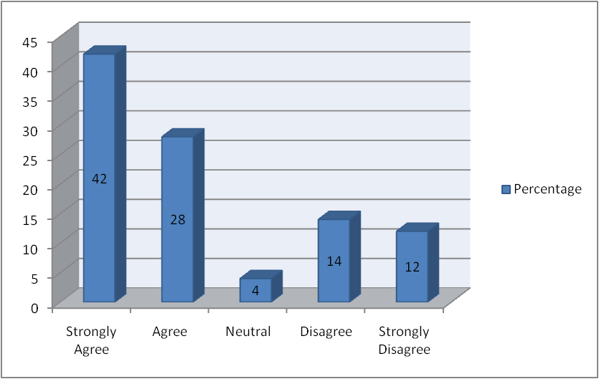
Graph 1: Employees of Waitrose Ltd faced contemporary issues which affected their performance
(Source: Developed by the author)
In response to the first question regarding the contemporary issues of employees in Waitrose Ltd 42% of the respondents strongly agree and 28% agree. However, 12% of the employees strongly disagree with this statement and 4% remain neutral.
Q2. To what extent do you believe that support systems play an important role to improve the performance of the employees within Waitrose Ltd?
Answers | Total number of participants | Number of respondents | Percentage
Strongly Agree | 50 | 24 | 48
Agree | 50 | 12 | 24
Neutral | 50 | 1 | 2
Disagree | 50 | 7 | 14
Strongly Disagree | 50 | 6 | 12
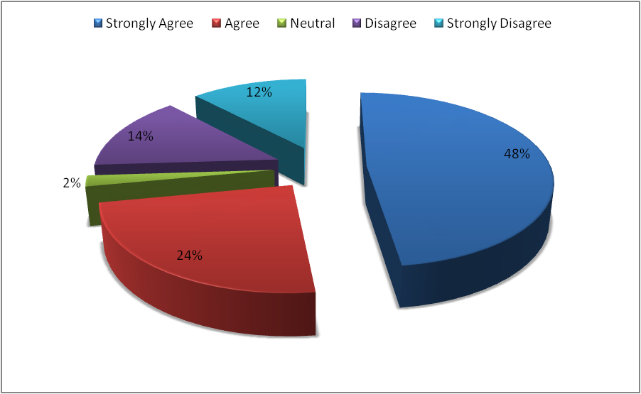
Graph 2: Support systems play an important role to improve the performance of the employees within Waitrose Ltd
(Source: Developed by the author)
The above-mentioned graph indicates that 48% of the employees of Waitrose Ltd strongly agree that support systems help to improve the performance of the employees. Although 2% remain neutral and 14% of respondents strongly disagree with this statement.
Q3. How far do you agree that training and support systems help the employees of Waitrose Ltd to identify the areas of improvement?
Answers | Total number of participants | Number of respondents | Percentage
Strongly Agree | 50 | 31 | 62
Agree | 50 | 11 | 22
Neutral | 50 | 1 | 2
Disagree | 50 | 4 | 8
Strongly Disagree | 50 | 3 | 6
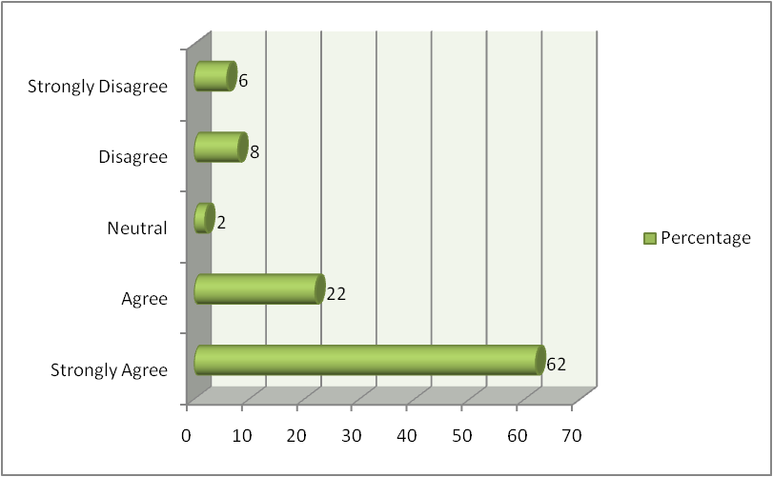
Graph 3: training and support systems help the employees of Waitrose Ltd to identify the areas of improvement
(Source: Developed by the author)
The above-mentioned graph shows that 62% of the participants strongly agree that support systems allow the employees of Waitrose Ltd to identify their areas of improvement. On the other hand, 8% of the respondents disagree with this statement and 2% remain neutral.
Q4. To what extent do you agree that employees of Waitrose Ltd can easily develop their skills with the help of the contemporary support systems of the company?
Answers | Total number of participants | Number of respondents | Percentage
Strongly Agree | 50 | 29 | 58
Agree | 50 | 11 | 22
Neutral | 50 | 1 | 2
Disagree | 50 | 6 | 12
Strongly Disagree | 50 | 3 | 6
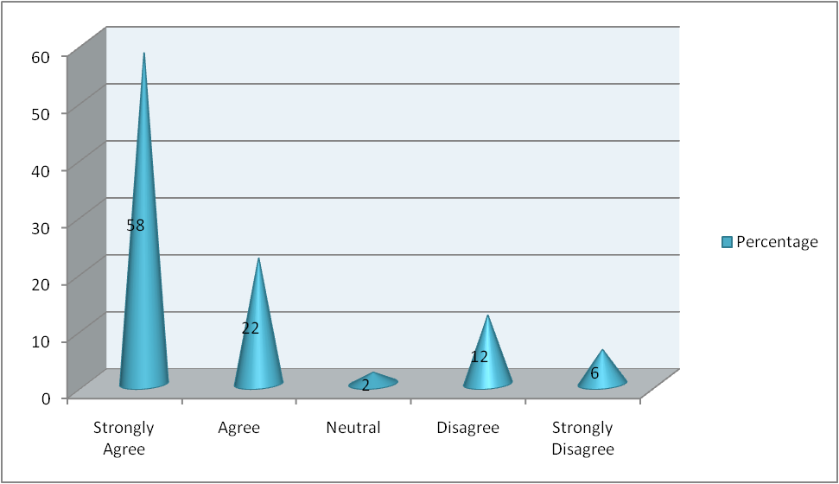
Graph 4: Employees of Waitrose Ltd can easily develop their skills with the help of contemporary support systems
(Source: Developed by the author)
In response to the fourth question, 58% of the participants strongly agreed that the employees of Waitrose Ltd can develop the required skills with the help of contemporary support systems. However, 6% of the employees of the company strongly disagree with this statement.
Q5. How far do you believe that modern support systems and training approaches are required for assisting the staff of Waitrose Ltd properly?
Answers | Total number of participants | Number of respondents | Percentage
Strongly Agree | 50 | 17 | 34
Agree | 50 | 23 | 46
Neutral | 50 | 1 | 2
Disagree | 50 | 5 | 10
Strongly Disagree | 50 | 4 | 8
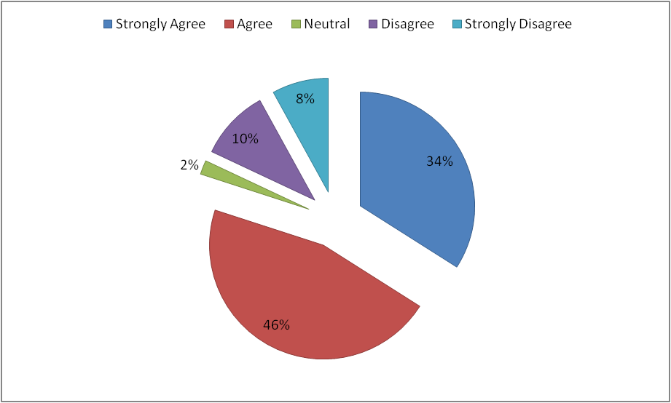
Graph 5: Modern support systems and training approaches are required for assisting the staff
(Source: Developed by the author)
The above-mentioned graph indicates that 46% of employees of Waitrose Ltd strongly agree that modern support systems and training are required for assisting the employees properly so that they can develop their skills. Only 8% of the respondents strongly disagree with this statement and 2% remain neutral.
Q6. To what extent do you think that employees can get better career opportunities with the help of training and support from Waitrose Ltd?
Answers | Total number of participants | Number of respondents | Percentage
Strongly Agree | 50 | 25 | 50
Agree | 50 | 15 | 30
Neutral | 50 | 1 | 2
Disagree | 50 | 4 | 8
Strongly Disagree | 50 | 5 | 10
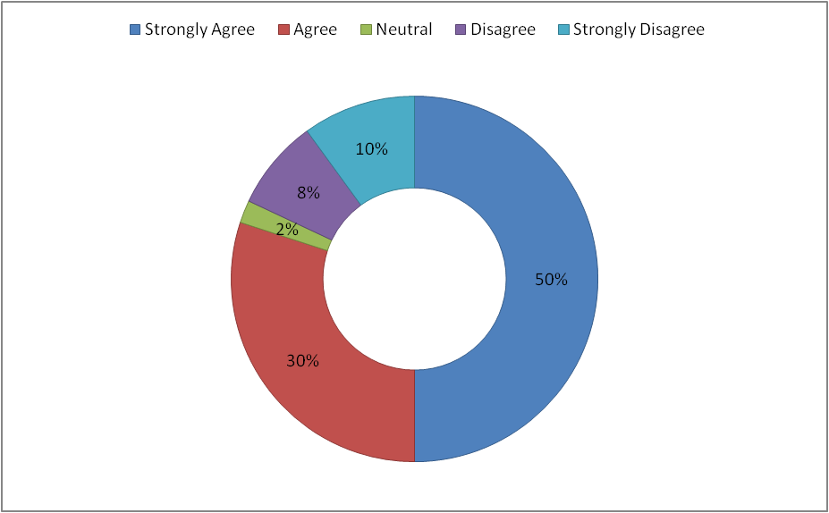
Graph 6: Employees can get better career opportunities with the help of training and support
(Source: Developed by the author)
In response to the sixth question, 50% of the respondents strongly agree that training and support help employees get better career opportunities and growth. However, 10% of the employees of Waitrose Ltd strongly disagree with this statement.

4.2: Qualitative interview
Q1. What is the importance of training and support programmes for improving the performance of the employees within Waitrose Ltd?
Manager 1: As per the views of manager 1, a proper training and support programme allows to boost the morale of the employees as they get the opportunity to develop their skills. Thus, by developing their skill, employees can also secure their job and get rewarded for their performance. Hence, a training or supporting programme is required for the employees so that they can understand the skills which are required for their job role and develop their performance.
Manager 2: According to manager 2, training and supporting programmes provides the opportunity for each employee so they can strengthen their skills and improve their performance to meet the desired goals of the company. A proper training programme helps the employees to identify their strengths and weaknesses while the supporting program allows them to overcome those weaknesses and use their strengths within the workplace for improving their performance within the workplace.
Manager 3: As per the views of manager 3, training programmes provide a framework to the employees regarding their tasks and job duties. Hence, they can have a clear understanding of their job roles and responsibilities which helps them to develop their performance. On the other hand, supporting programmes are important to guide employees properly so that they can improve their skills which gradually improve their performance as well as the productivity of the firm.
Q2. Which factors are maintained in the training and support programmes of Waitrose Ltd to support the employees within the workplace?
Manager 1: As per the views of manager 1, while recruiting new candidates Waitrose Ltd provided two-week training to the candidates so that they can easily understand their job roles and responsibilities. Along with this post-training quizzes and one-to-one discussions are also conducted so that employees get the required support for improving their performance.
Manager 2: According to manager 2, the focus of the training and support programmes of Waitrose Ltd is to guide employees so that they can perform their tasks appropriately and quickly. The support and training program also encourages problem-solving and team-based communication so that after the completion of the training programmes employees can gain the team working and problem-solving skills.
Manager 3: As stated by manager 3, the focus of the training and supporting programme of Waitrose Ltd is to set the objective for the employees so that they can easily prepare themselves in order to meet the objective. A detailed description of the company’s culture has been also provided to the employees during the time of training so that employees can behave as per the culture of the company.
Q3. What types of challenges are faced by Waitrose Ltd in its training and support programs while supporting employees?
Manager 1: According to manager 1, reskilling and up skilling for a digital workplace is one of the major challenges for the company. It also needs huge financial support to develop a digital workplace where employees get the proper training and support to improve their performance. Digital workplace also makes the training process much easier and employee-friendly but due to the financial loss during the pandemic, the company is unable to use all the latest and advanced technology in the workplace.
Manager 2: As per the views of manager 3, the trends and training methods are regularly updated hence it becomes difficult for the trainers to choose an appropriate training or supporting method that can help employees to develop their skills. Hence, it becomes a major issue to provide training as per the latest trends which affects the performance of the employees within the workplace.
Manager 3: As stated by manager 3, for implementing high-quality training materials Waitrose Ltd needs to spend a huge amount which can create financial issues for the growth of the company. Choosing the right person for providing the training is also important for developing the performance of the employees which is also a major challenge for the company.

4.3: Discussion
As opined by Amor et al., (2020, p. 170), training and supporting programmes allow companies to boost their sales and enhance job satisfaction among employees by improving their performance. Hence, training and support programs play an important role to improve the performance of the employees as these programmes provide opportunities to the employees so that they can identify the required skills and work to develop those skills. The survey also shows that employees of Waitrose Ltd believe that training and support programmes are essential for them as it helps to enhance their performance and keep them motivated. The majority of the respondents strongly believe that they are able to improve their performance and identify the areas of improvement with the help of training and support systems. However, as argued by Clark (2019), excessive cost and language barriers are two major factors that affect the training programmes which gradually influence the performance of the employees. Organisations need to manage its budget effectively so that they can arrange high-quality equipment for training and supporting purposes. Hence, it faces issues regarding managing its finances properly which may affect the programmes. The survey also shows that the majority of the employees of Waitrose Ltd strongly agree that modern support systems are required for support systems and training approaches for assisting the employees. However, some of the employees disagree with the statement that employees can develop their skills effectively with the help of training programmes and support systems. The interview of the managers also shows that the company is facing some financial issues regarding costly training equipment and trainers. Hence, it can be said that high cost and the latest technology and equipment are the key issues due to which employees are not getting appropriate training which affects their performance in the workplace.
According to the views of Duggan et al., (2020, p. 115), a proper training programme allows employees to develop their skills so that they can develop their careers and achieve success in the future. The majority of the respondents in the survey strongly agree with the statement that employees can have better career growth if they get the required training and support from the organisation. A proper training programme or support system helps the employees to understand their roles and responsibilities which allow them to develop their performance within the workplace. On the other hand, as opposed to Engel et al., (2020, p. 722), the inability to adopt the latest trends and latest technologies may affect the training programmes and support systems of the organisation. From the interview, it has also been observed by the managers of Waitrose Ltd that it is a major issue to adopt a digital workplace for guiding employees properly with the help of training and support programmes. Hence, it can be said that a digital workplace and modern technologies are needed to support and guide employees in this current situation. The majority of the respondents also agree that modern technology can provide better support and guidance which allows employees to develop their performance within the workplace. Hence, it can be said that adopting the latest technology and modern equipment is important to guide employees properly to motivate them and improve their performance.

4.3: Secondary Data (Secondary Thematic Analysis)
Theme 1: Importance of support and training programmes for the welfare of the worker in Waitrose Ltd
According to Haskins, et al., (2018), in recent times all firms are launching support and training programmes for their employees in order to expand their skills and hence achieving commendable productivity standards. The support and training programmes are illustrated as the systematic way of building the abilities among the staff through curriculum-based psychoeducational and cognitive behaviour interventions. It is essential because it plays a vital role in assisting the companies like Waitrose Ltd to attain increased customer satisfaction, loyalty and retention. Apart from it, it plays a crucial role in encouraging the supermarket chain to expand the efficiency of the staff, reduce the level of supervision, lowering of the turnover rate, and better the level of labour management relations and expansion of motivation. For instance, the launching of online learning and development system has assisted them to train approximately 47,000 employees about the benefit of personal and team development in their careers.
The concerned programme has encouraged the firm to give training about the progressive techniques used in the supply chain to the workers operating from work from home. The initiation of the butchery course has encouraged them to train the workers about the techniques of cutting meat and the development of butchery skills (Sonnenstuhl, and Trice, 2018). The launching of the fishmonger course has encouraged the respective organization to train the staff about the variety of fish species, sustainability as well as skilled filleting techniques. These programmes have helped somewhat 200 employees to offer a \more personalised service and satisfaction to the purchasers attaining a commendable operating profit of 15%. Hence as a part of the support programme, the respective firm provides facilities such as a 25% discount, paid holidays, an increased bonus of 2% and health insurance to inspire them to work hard and achieve commendable growth.
Theme 2: Various types of training and support programmes in organizations like Waitrose Ltd
The training and support programs are necessary for any firm like Waitrose Ltd to inculcate dedication among the staff and attain impressive sales by delivering high-quality food products. The various types of these programs are mentioned below in a detailed manner:
Orientation Training: According to Ozkeser, (2019, p. 806), an efficient employee orientation programme includes primary information that can assist the new hires to prepare for their roles. The major components of the orientation training involve online courses, data about the safety procedures and the techniques used to produce the product. This can assist the workers of the concerned supermarket chain to raise their confidence and increase their productivity level which is reflected in the increased attainment of the market share by 4.9%.
On boarding Training: It is the procedure of making the employees understands the fresh responsibilities, company culture and objectives of the business. The main components of on boarding training are online instructor, functional training and facilitated discussions. It can assist the firms like Waitrose Limited to provide training to the staff about financial performance and the ways that can sustain the position (Caldwell, and Peters, 2018).
Compliance Training: It is a workplace training program that educates the staff about the various legislative and regulative policies followed in the firm. The main elements of compliance training include diversity training and cyber security. This type of training can encourage the supermarket chain Waitrose Ltd to prevent the workers from participating in fraudulent activities and breaking the law of the company. As a matter of fact, it also guides them to retain the privacy of the information and not let any sales or revenue figures reveal to the rivalries.
Theme 3: Issues faced by the organization to implement support and training programmes
It is evident that companies like Waitrose Ltd have successfully attained a commendable financial performance by implementing proper support and training programs. This includes the provision of the facilities such as paid holidays, retirement benefits, life insurance and online learning and development system. But, the firm sometimes faces certain issues that restrain them from successfully implementing the programs.
Absence of employee engagement: The lack of confidence and attention can restrain the staff of the firms like Waitrose Ltd to lose interest in acquiring knowledge in the training programs (Ogbonnaya, and Valizade, 2018, p. 247).
Workforce Resistance: The workers of the concerned supermarket chain may sometimes feel afraid and causing confusion in adopting the new techniques of food production. This cause hurdle in the training programs and hence the staffs lack expectation lowering the market share of the company. Hence these issues have restrained the firm to attain praiseworthy growth and it remains a little backward in the U.K Supermarket chain.

Chapter 5: Conclusion and Recommendations

5.1: Conclusion
Henceforth it can be concluded that training and support programs in any firm are necessary because it improves the productivity standards of the staff and therefore adds to an impressive profit margin. It plays a vital role in encouraging the supermarket chain firms such as Waitrose Ltd to reduce the level of turnover rate and expand the motivation level. The organization has encouraged training and support programs with the emergence of online learning and development systems, butchery courses, retirement plans as well as employee discounts by 25%. The importance of these programs is explained with the help of the Employee Evaluation Theory in the literature review section. The relevant issues identified are the absence of employee engagement and workforce resistance along with certain recommendations given for adopting transformational leadership. Additionally, the research philosophy followed is both positivism and interpretivism and the information is collected through primary as well as secondary sources. In the data analysis portion, 50 employees have been surveyed and 3 managers are taken interviewed mostly supporting the need for training and support programs. The research is completed in a detailed manner with the help of statistical data and graphs.

5.2: Linking with the objectives
Objective 1 of this research is to identify the issues which have been faced by the workers within the company regarding training that have been met in the literature review and thematic analysis section. Objective 2 for analysing the relevant support system within the business working environment has been met in the literature review section. Objective 3 is to assess the importance of support systems and training for the organisation has also been met in the literature review section along with in the thematic analysis section. Lastly, objective 4 is to recommend some strategies to provide better recommendations for training and support systems has been met in the literature review part.

5.3: Recommendation
The strategy that can improve the training and support program of the supermarket chain Waitrose Ltd is adopting the pattern of Transformational Leadership. This can assist them in promoting motivation among their 47,000 employees, maintaining workplace integrity, defining a clear vision, encouragement of professional development and also lowers the turnover rate (O’Reilly, and Chatman, 2020, p. 17). Apart from it, the adaptation of Transformational Leadership can encourage them to train the staff to accept the change in an advantageous manner by encouraging their passion. It can assist them to engage the workers of the respective firm to learn about the fresh techniques of producing food products by clearly communicating the goals and purpose of the business. Additionally, in terms of research, it is evident that interviewing more managers in the future can assist in gathering authentic as well as correct information about the support and training programmes.

5.4: Future Scope
The respective research can assist in understanding the importance of the training and support program in the upcoming times. As a result, the organizations would keep a separate investment for launching these kinds of programmes in order to motivate the staff and hence ensure increased productivity level. The respective research study would assist in helping the firm in the upcoming times to reduce the turnover rate, a lower amount of wastage and ensure better labour management relations bringing a modification in the sales and profit margin.

References
Chapter 1
Books
Malek, K., Kline, S.F. and DiPietro, R., 2018. The impact of manager training on employee turnover intentions. Journal of Hospitality and Tourism Insights. https://www.emerald.com/insight/content/doi/10.1108/JHTI-02-2018-0010/full/html
Park, S., Kang, H.S.T. and Kim, E.J., 2018. The role of supervisor support on employees’ training and job performance: an empirical study. European Journal of Training and Development. https://www.emerald.com/insight/content/doi/10.1108/EJTD-06-2017-0054/full/html
Website
Waitrose & Partners (no date) Waitrose.com. Available at: https://www.waitrose.com/ (Accessed: December 21, 2022).
Journals
Basterretxea, I. and Storey, J., 2018. Do employee‐owned firms produce more positive employee behavioural outcomes? If not why not? A British‐Spanish comparative analysis. British Journal of Industrial Relations, 56(2), pp.292-319. https://onlinelibrary.wiley.com/doi/abs/10.1111/bjir.12247
Johnson, S., Robertson, I., Cooper, C.L. and Davison, N., 2018. Wellbeing in the John Lewis Partnership. In WELL-BEING (pp. 189-197). Palgrave Macmillan, Cham. https://link.springer.com/chapter/10.1007/978-3-319-62548-5_15
Chapter 2
Books
Buchanan, D.A. and Huczynski, A.A., 2019. Organizational behaviour. Pearson UK. https://books.google.com/books?hl=en&lr=&id=Y6ilDwAAQBAJ&oi=fnd&pg=PT30&dq=training+and+support+program+for+employees+of+waitrose+ltd&ots=dCPb3aTaKF&sig=hYFb7p5CXtNXfAng1PRS0UnScj0
Diamantidis, A.D. and Chatzoglou, P., 2018. Factors affecting employee performance: an empirical approach. International Journal of Productivity and Performance Management. https://www.emerald.com/insight/content/doi/10.1108/IJPPM-01-2018-0012/full/html
Hampden-Turner, C., Trompenaars, F. and Hampden-Turner, C., 2020. Riding the waves of culture: Understanding diversity in global business. Hachette UK. https://books.google.com/books?hl=en&lr=&id=9boLEAAAQBAJ&oi=fnd&pg=PT3&dq=Recommendation+to+improve+the+working+condition+of+business&ots=acdNIQucz6&sig=zkJ4eW7eP-kZY5-ArG0mrxIYcw8
Pandita, D. and Ray, S., 2018. Talent management and employee engagement–a meta-analysis of their impact on talent retention. Industrial and Commercial Training. https://www.emerald.com/insight/content/doi/10.1108/ICT-09-2017-0073/full/html
Sekar, S. and Dyaram, L., 2020. What makes employees participate in volunteering programs? The role of organizational support. International Journal of Organizational Analysis. https://www.emerald.com/insight/content/doi/10.1108/IJOA-11-2019-1939/full/html
Websites
Jcphankins (2021) John Lewis and waitrose – a changing business, theeqplanner. Available at: https://theeqplanner.wordpress.com/2021/03/15/john-lewis-and-waitrose-a-changing-business/ (Accessed: December 27, 2022).
John Lewis PLC and Tacit Knowledge (no date) Annual report & accounts, John Lewis Partneship. Available at: https://www.johnlewispartnership.co.uk/annualreport (Accessed: December 21, 2022).
Published by Emma Bedford and 3, F. (2022) Waitrose sales growth Great Britain 2021, Statista. Available at: https://www.statista.com/statistics/603429/waitrose-sales-percentage-change-great-britain-uk/ (Accessed: December 29, 2022).
Journals
Grimani, A., Aboagye, E. and Kwak, L., 2019. The effectiveness of workplace nutrition and physical activity interventions in improving productivity, work performance and workability: a systematic review. BMC public health, 19(1), pp.1-12. https://link.springer.com/article/10.1186/s12889-019-8033-1
Johnson, S., Robertson, I., Cooper, C.L. and Davison, N., 2018. Wellbeing in the John Lewis Partnership. In WELL-BEING (pp. 189-197). Palgrave Macmillan, Cham. https://link.springer.com/chapter/10.1007/978-3-319-62548-5_15
Kremer, H., Villamor, I. and Aguinis, H., 2019. Innovation leadership: Best-practice recommendations for promoting employee creativity, voice, and knowledge sharing. Business Horizons, 62(1), pp.65-74. https://www.sciencedirect.com/science/article/pii/S0007681318301459
Shipper, F. and Hoffman, R.C., 2020. John Lewis partnership approaching 100 years–what now?. The CASE Journal, 16(2), pp.227-271. https://www.emerald.com/insight/content/doi/10.1108/TCJ-08-2018-0095/full/html
Chapter 3
Books
Adams, J. (2014) Research Methods for Business and Social Science Students. New Delhi: SAGE Publications. https://books.google.com/books?hl=en&lr=&id=ifinAwAAQBAJ&oi=fnd&pg=PP1&dq=Adams,+J.+(2014)+Research+Methods+for+Business+and+Social+Science+Students.+New+Delhi:+SAGE+Publications.+&ots=kAbM8lcNVc&sig=FcvTqAUENbnP0SSjZaztVBSNLzI
Denscombe, M. (2014) Good Research Guide: For Small-Scale Social Research Projects. 5th ed., McGraw- Hill Education. https://books.google.com/books?hl=en&lr=&id=SMovEAAAQBAJ&oi=fnd&pg=PP1&dq=Denscombe,+M.+(2014)+Good+Research+Guide:+For+Small-Scale+Social+Research+Projects.+5th+ed.,+McGraw-+Hill+Education.&ots=lLe5YaZboe&sig=Oxb7cHAnOzq2twVuYKRkGMpS5SE
Dul, J. (2008) Case study methodology in business research. Oxford: Butterworth-Heinemann. https://books.google.com/books?hl=en&lr=&id=zMMsBgAAQBAJ&oi=fnd&pg=PP1&dq=Dul,+J.+(2008)+Case+study+methodology+in+business+research.+Oxford:+Butterworth-Heinemann.&ots=dR5VsHXOR5&sig=6AluAVjo9H1hDA_w7fzNQCh3q-c
Keegan, S. (2009) Qualitative research: good decision making through understanding people, cultures and markets. London: Kogan Page. https://books.google.com/books?hl=en&lr=&id=L5tsI4UrgLUC&oi=fnd&pg=PR4&dq=Keegan,+S.+(2009)+Qualitative+research:+good+decision+making+through+understanding+people,+cultures+and+markets.+London:+Kogan+Page.&ots=SGVgGc3bS4&sig=2htKrVooBid2HfsIvwkX6kCETAk
O’Gorman, K. (2015) Research methods for business & management: a guide to writing your dissertation. 2nd ed. Oxford, England: Goodfellow Publishers Ltd.
Saunders, M.N.K. (2019) Research methods for business students. 8th ed. Harlow: Pearson.
Chapter 4
Books
Caldwell, C. and Peters, R., 2018. New employee onboarding–psychological contracts and ethical perspectives. Journal of Management Development. https://www.emerald.com/insight/content/doi/10.1108/JMD-10-2016-0202/full/html
Clark, R.C., 2019. Evidence-based training methods: A guide for training professionals. American Society for Training and Development. https://books.google.com/books?hl=en&lr=&id=wMnKDwAAQBAJ&oi=fnd&pg=PT4&dq=training+and+development+book&ots=lJCpX8V9Ao&sig=l2lfwKf0EXe_rqk3nvYrJdoznKQ
Haskins, G., Thomas, M. and Johri, L. eds., 2018. Kindness in leadership. Routledge. https://books.google.com/books?hl=en&lr=&id=WnhQDwAAQBAJ&oi=fnd&pg=PT10&dq=Importance+of+support+and+training+programmes+for+welfare+of+the+worker+in+Waitrose+Ltd&ots=e7bS4w5l9I&sig=FMVi2GfQogjN5_GhvwVZrLeIO_c
Sonnenstuhl, W.J. and Trice, H.M., 2018. Strategies for employee assistance programs: The crucial balance. Cornell University Press. https://books.google.com/books?hl=en&lr=&id=ZrdcDwAAQBAJ&oi=fnd&pg=PP1&dq=employee+support+programs&ots=G3InqvRp0o&sig=HKz7xLfx7CR0Qba0MT6HMiA7c_4
PDFs and Journals
Amor, A.M., Vázquez, J.P.A. and Faíña, J.A., 2020. Transformational leadership and work engagement: Exploring the mediating role of structural empowerment. European Management Journal, 38(1), pp.169-178. https://www.sciencedirect.com/science/article/pii/S0263237319300775
Duggan, J., Sherman, U., Carbery, R. and McDonnell, A., 2020. Algorithmic management and app‐work in the gig economy: A research agenda for employment relations and HRM. Human Resource Management Journal, 30(1), pp.114-132. https://onlinelibrary.wiley.com/doi/abs/10.1111/1748-8583.12258
Engel, R.S., McManus, H.D. and Herold, T.D., 2020. Does de‐escalation training work? A systematic review and call for evidence in police use‐of‐force reform. Criminology & Public Policy, 19(3), pp.721-759. https://onlinelibrary.wiley.com/doi/abs/10.1111/1745-9133.12467
Ogbonnaya, C. and Valizade, D., 2018. High performance work practices, employee outcomes and organizational performance: a 2-1-2 multilevel mediation analysis. The International Journal of Human Resource Management, 29(2), pp.239-259. https://www.tandfonline.com/doi/abs/10.1080/09585192.2016.1146320
Ozkeser, B., 2019. Impact of training on employee motivation in human resources management. Procedia Computer Science, 158, pp.802-810. https://www.sciencedirect.com/science/article/pii/S1877050919312876
Chapter 5
O’Reilly, C.A. and Chatman, J.A., 2020. Transformational leader or narcissist? How grandiose narcissists can create and destroy organizations and institutions. California Management Review, 62(3), pp.5-27.https://journals.sagepub.com/doi/abs/10.1177/0008125620914989
Appendix
Appendix 1: Survey questions
Q1. How far do you agree that employees of Waitrose Ltd faced contemporary issues which affected their performance?
Q2. To what extent do you believe that support systems play an important role to improve the performance of the employees within Waitrose Ltd?
Q3. How far do you agree that training and support systems help the employees of Waitrose Ltd to identify the areas of improvement?
Q4. To what extent do you agree that employees of Waitrose Ltd can easily develop their skills with the help of contemporary support systems of the company?
Q5. How far do you believe that modern support systems and training approaches are required for assisting the staff of Waitrose Ltd properly?
Q6. To what extent do you think that employees can get better career opportunities with the help of training and support of Waitrose Ltd?
Appendix 2: Interview questions
Q1. What is the importance of training and support programmes for improving the performance of the employees within Waitrose Ltd?
Q2. Which factors are maintained in the training and support programmes of Waitrose Ltd to support the employees within the workplace?
Q3. What types of challenges are faced by Waitrose Ltd in its training and support programs while supporting employees?

