

LCMB7023
Human Capital Management

Strategic HRM for Technological, Demographic, and Global Workforce Challenges

Tutor Name: Gladius Kulothungan
Student Name: Rajesh Chaudhary
Student ID: 2433823
Table of Contents
Introduction 3
1. Technological Advancements and Their Impact on Labour Markets: Implications for HRM and IHRM 3
2. Demographic and Geopolitical Factors Shaping Employment Markets: Challenges for HR Professionals. 5
3. Strategic HRM Solutions to Address Skills Gaps and Talent Shortages in Critical Sectors 7
4. Reflective Report on International Workplace Readiness 8
Conclusion 11
References 12

Table of Figures
Figure 1: Persistent shortages in ICT skills despite digital upskilling efforts. 5
Figure 2: Number of Workforce Jobs in the UK, June 2006–June 2025. 6
Figure 3: Projected Working-Age Population Trends (2020–2060). 8
Figure 4:UK Sectoral Vacancy Trends (June–August 2025) 10
Figure 5:Priority-occupations growth 2025-30. 11
Figure 6:Projected Workforce Growth by Sector (2025–2030). 12
Figure 7: Projected Sectoral Employment Growth to 2030. 14

Introduction
The world labour market is changing at a very fast rate. 78 million jobs are projected to increase, and 92 million to be displaced by the year 2030 (World Economic Forum, 2025). Regarding the UK, 57 % of employers (in the private sector) are looking to employ early in 2025, versus 65 % in autumn 2024 (CIPD, 2025). In this report, this author discusses how technology, demographic and geopolitical factors will influence HRM and IHRM and strategies in managing skills, as well as the self-assessment of global workplace capabilities.

1. Technological Advancements and Their Impact on Labour Markets: Implications for HRM and IHRM
Technological Advancements and Their Impact on Labour Markets
The most notable changes to the labour market in countries and internationally are happening due to the rise in technological advancements, especially artificial intelligence (AI), automation and online platforms. These developments are causing trends in employment, skills, and organisational strategies, which directly affect Human Resource Management (HRM) and International Human Resource Management (IHRM).
Global Trends in Technology Adoption
The World Economic Forum (2025) forecasts that 75% of businesses around the world will be using AI technologies by 2027, and 50% of them will be integrating humanoid robotics into their business. This change is already affecting job functions: 44 % of the skills of workers are expected to be shaken in the coming five years, and analytical thinking is now the most sought-after skill, with one-fourth of employers surveyed identifying it by that name. Digital transformation also revolves around digital platforms, with 86 % of the companies strategising to implement cloud computing and 75 % of companies implementing big data analytics (WEF, 2025).
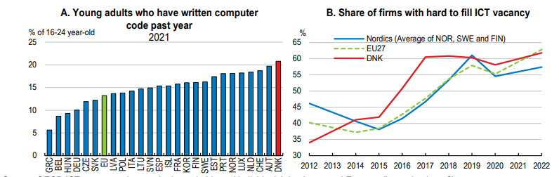
Figure 1: Persistent shortages in ICT skills despite digital upskilling efforts.
Source:(OECD, 2024).
In Figure 1, it is evident that although 70 % of companies have digitalised their workforce, 45 % of companies worldwide have skills gaps in ICT skills, which will continue to represent a skills gap (OECD, 2024).
UK Story: Digitalisation of the Public Sector.
The Chartered Institute of Personnel and Development (CIPD) points out in the UK that digitalisation is currently transforming HRM in the public sector. To illustrate, NHS England is currently experiencing a freeze on recruitment and is amalgamating with the Department for Health and Social Care, and communications are increasingly moving to the NHS app, and AI is being integrated into everyday operations (CIPD, 2025). This is indicative of a wider pattern of streamlining services and reducing the number of headcounts with the use of digital tools, which means that HRM needs to concentrate on workforce planning, reskilling, and change management.
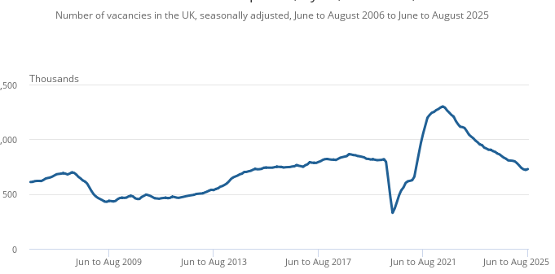
Figure 2: Number of Workforce Jobs in the UK, June 2006–June 2025.
Source: (Office for National Statistics, 2025).
The figure shows that total UK workforce jobs were 36.8 million in June 2025, down 182,000 (0.5%) from March 2025 but up 139,000 (0.4%) year-on-year, with health and social work increasing by 68,000 (1.3%), highlighting sectoral labour growth amid digitalisation.
International Examples
The labour participation reached a record in Japan in 2024, with digital participation and the involvement of more women and seniors (Jobs and Skills Australia, 2025). Korea experienced an increase of 193,000 jobs in March 2025, whereas New Zealand experienced 6.1% and 5.7% decreases in construction and administration, respectively. The employment rate in the UK was 7.4% (ONS, 2025).
Strategic Implications for HRM and IHRM
For HRM and IHRM, these trends necessitate strategic responses. Organisations need to invest in adaptive leadership, reskilling and digital literacy. The strategies to acquire talents should be focused on STEM skills, and the USA alone will need 1 million more STEM employees in 2033 (Jobs and Skills Australia, 2025). In addition, IHRM has to overcome global inequalities in digital preparedness and localise workforce advancement to technological maturity.
Overall, the transformation of the labour market is increasing rapidly due to technological change. To deal with digital disruption, agile workforce and inclusive access to emerging opportunities, HRM and IHRM need to evolve.

2. Demographic and Geopolitical Factors Shaping Employment Markets: Challenges for HR Professionals.
Demographic Factors Shaping Employment Markets
Demographic factors are now major forces shaping employment markets. For example, the global population aged 60 or over is projected to increase from about 1.1 billion in 2023 to 1.4 billion by 2030 (World Health Organisation, 2023). In parallel, one source shows that people aged 65+ in the U.S. labour force are projected to rise from 6.6 % of the labour force in 2022 to 8.6 % in 2032. This ageing of the workforce means HR professionals face fewer younger workers entering and more older workers staying on, which challenges succession planning, compensation structures and career-path design (Fry and Braga, 2023).
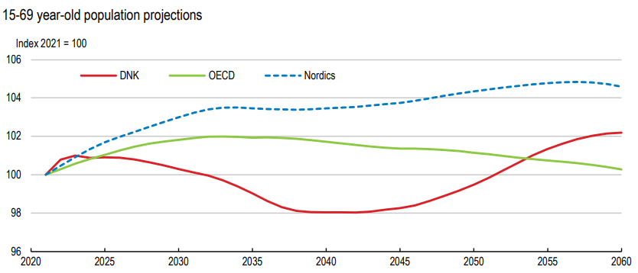
Figure 3: Projected Working-Age Population Trends (2020–2060).
Source: (OECD, 2024).
This figure shows that the working-age population is expected to decline between 2025 and 2040 due to ageing, slowing labour-force growth across OECD economies.
The working-age population (15-64) is decreasing around the world due to the drop in fertility rates (United Nations, 2024). According to the OECD (2025) data, employment rates among the age groups vary as older employees are becoming more retained. As a result, HR has fewer talent pools, increased expenses in hiring and must re-design jobs to accommodate ageing employees (UK Government, 2025). According to the 2024 ADP survey, the changing age- and region-specific worker expectations are calling for to adoption of inclusive and flexible policies in the workforce (ADP Research Institute, 2024).
Geopolitical Factors Affecting Labour Markets
On the geopolitical side, global employment growth is under strain. The International Labour Organisation (ILO) forecast for 2025 has been revised downward: job growth is now expected at about 1.5 % globally, equating to 53 million new jobs, roughly 7 million fewer than previously projected (International Labour Organisation, 2024). Meanwhile, the 2024 labour-market report shows that although the global unemployment rate held at about 5 % in 2024, job creation is slowing and youth unemployment remains high (around 12.6 %) (International Labour Organisation, 2024). These geopolitical pressures, trade disruptions, supply-chain shocks, and conflict zones affect the ability of organisations to plan workforce growth, as risk and volatility increase.
Migration and mobility are other geopolitical factors. Many countries rely increasingly on immigration to offset domestic labour shortages (especially in ageing societies). HR professionals must manage more cross-border recruitment, cultural integration, regulatory compliance and global talent mobility strategies (Barnes et al., 2023).
HR Challenges and Strategic Implications
In combination, these demographic and geopolitical factors create multiple HR challenges:
(1) recruiting sufficient numbers of skilled workers amid shrinking younger cohorts and rising older-worker participation;
(2) designing inclusive, flexible workforce policies addressing generational, cultural and mobility diversity;
(3) maintaining talent pipelines when job-creation growth is weak (e.g., only 53 million new jobs globally in 2025) and uncertainty is high;
(4) managing cost pressures, older workers may demand higher benefits or longer careers; younger recruits may have different expectations regarding flexibility, purpose and mobility;
(5) adapting to regulatory, trade and migration changes which influence where and how organisations source and retain talent (Chartered Institute of Personnel and Development, 2025).
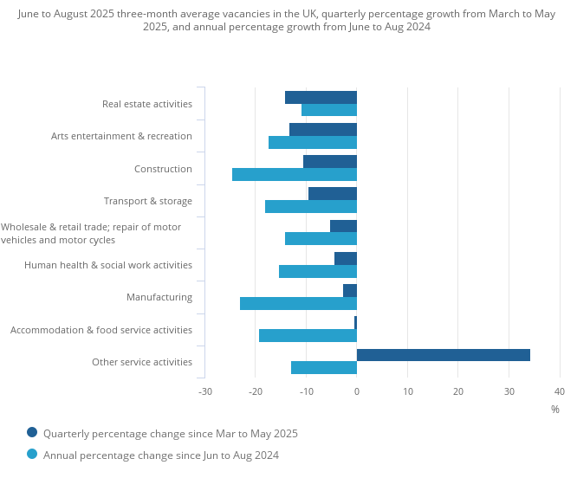
Figure 4:UK Sectoral Vacancy Trends (June–August 2025)
Source: (Office for National Statistics, 2025).
This figure shows that Construction (–25 %) and Manufacturing (–15 %) recorded the largest vacancy declines, setting the context for strategic HRM interventions.
In short, HR professionals must become more strategic and agile, using forward-looking workforce planning, upskilling and reskilling programmes, multigenerational engagement strategies and global talent mobility frameworks. Without this, organisations risk talent gaps, increased cost of labour, lower flexibility and diminished competitive advantage.

3. Strategic HRM Solutions to Address Skills Gaps and Talent Shortages in Critical Sectors
In the United Kingdom, job vacancies in June–August 2025 were estimated at 728,000, down 14% from a year earlier (ONS, 2025). Persistent skills gaps in critical sectors such as technology, hospitality, and healthcare require a strategic HRM approach anchored on four inter-linked measures: workforce planning, internal capability development, retention/redeployment, and external talent pipelines.
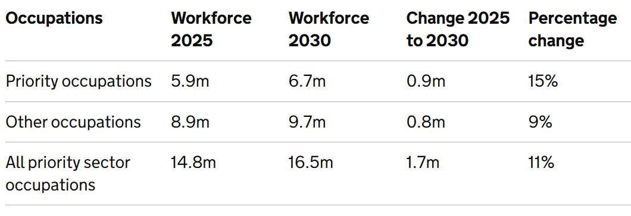
Figure 5:Priority-occupations growth 2025-30.
Source: (Department for Education (DfE), 2025).
This table shows that sectors such as Creative Industries (+0.25 m) and Digital Technologies (+0.15 m) account for most of the projected 0.9 million new UK jobs by 2030 (Department for Education (DfE), 2025).
Workforce Planning
Workforce planning is essential for addressing structural imbalances. In the UK, over 2.5 million workers (7.8% of the working-age population) are in “critical demand” occupations, including care-workers/home-carers (approx. 816,000) and software development professionals (approx. 561,000) (Department for Education, 2024). Globally, OECD data show acute labour-market tightness in ICT and healthcare (OECD, 2024).
HRM is recommended to map future skills needs per sector and plan recruitment and training budgets according to them in three to five years.
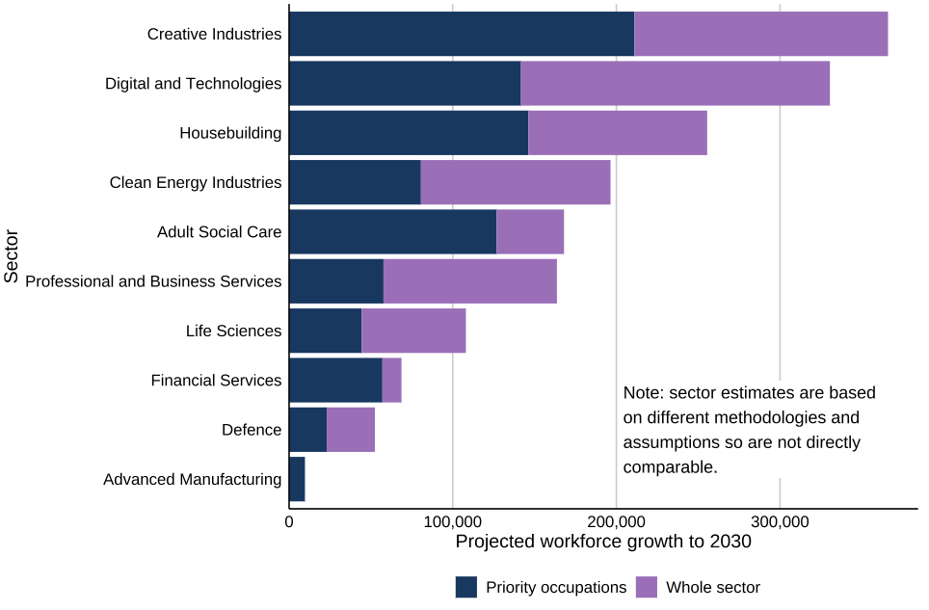
Figure 6:Projected Workforce Growth by Sector (2025–2030).
Source: (Department for Education (DfE), 2025).
This number indicates that the Creative industries and Digital Technologies areas will experience over 300,000 and 280,000 job growth by 2030, respectively, whereas Advanced Manufacturing will be virtually flat, which indicates the uneven development of sectors.
Capability Development
The development of internal capability minimises the use of outside recruitment. About 12% of employers in the UK said that they had an employee who was not fully proficient in their job, a drop from 15% in 2022 (Department for Education, 2024). Most of the unfilled vacancies are caused by internal skills and not the lack of applicants. To bridge gaps within an organisation, organisations should maintain skills inventories, identify adjacent career paths and adopt modular training or apprenticeship as a means of bridging gaps.
Retention and Redeployment
The turnover is the main problem of the lack of staff in the hospitality and healthcare sectors. Churn is minimised by strengthening retention measures, which include career paths, mentorship, wellbeing support, and flexible work. Redeployment of existing staff to high-demand regions in a strategic manner will save institutional knowledge and reduce time to competency. Upskilling programmes, internal job fairs, and cross-functional rotations should also be part of HR policies to maximise the use of the workforce.
External Talent Pipelines
Increasing the pipelines of external talent will create a continuous stream of qualified applicants. Companies are advised to collaborate with universities, colleges and bootcamp delivery teams, seek under-represented talent pools, and use selective international recruitment in situations where supply in the domestic market falls short (Department for Education, 2024). Projections show that jobs with a priority will increase at a higher rate than non-priority jobs, and this makes it important to plan the pipeline.
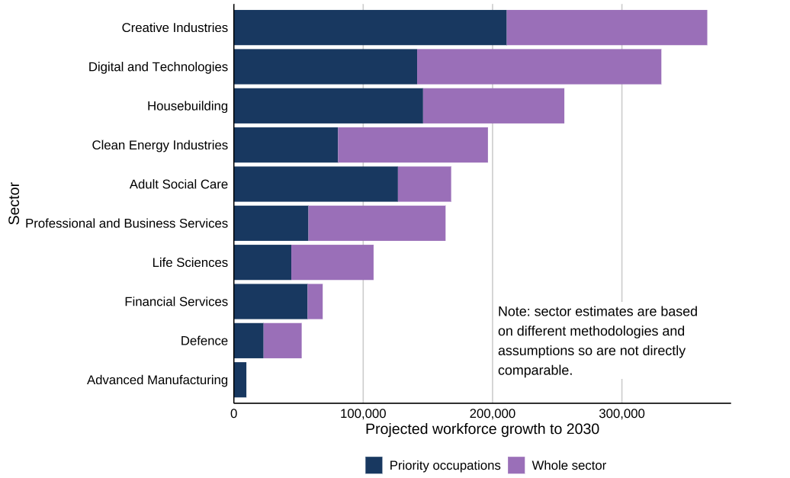
Figure 7: Projected Sectoral Employment Growth to 2030.
Source: (Department for Education (DfE), 2025).
As demonstrated above, there will be the fastest growth in employment demand in Clean Energy (77%), Housebuilding (42%), and no growth in Advanced Manufacturing. The most recent priority occupations in Digital Technologies and Adult Social Care play a major role as well, with more than 90,000 new care positions and 87,000 software development jobs expected. This is the immediate necessity of strategic HRM in high-growth areas.
Monitoring and Analytics
A connection between these pillars and measurable KPIs will convert reactive hiring to strategic workforce management. These can be the percentage of positions filled internally, turnover levels in key positions and the number of entrants through partner pipelines per year. Vacancy analytics, such as skill group occupation, investment in training, and promotion rates inside the company, help the HR leadership to make data-driven decisions.
Having workforce planning, internal capability development, retention/ redeployment, and external pipelines as a unified HRM system will enable organisations to tackle the skills gaps and talent shortages in technology, hospitality, and healthcare systematically, creating long-term skills resilience.

4. Reflective Report on International Workplace Readiness
The skill to work effectively internationally and to adjust to innovations is central in the contemporary globalised and technologically changing world of labour market. With the help of learning activities and case studies during this term, this reflection assesses my existing competencies in five areas: technology, communication, teamwork, leadership, and self-directed learning. The strengths, weaknesses, and intended improvements are analysed in a structured manner as illustrated below.
Technology
I have acquired communication skills with digital cooperation tools like Microsoft Teams and Google Workspace, and know strategic platforms like LinkedIn Talent Solutions and IBM Watson Talent to recruit and analyse the workforce, and my confidence in the application of AI in HR planning has been built through events like sessions about AI-assisted HR planning. The NHS Digital case study emphasised the benefits of e-recruitment systems in increasing efficiency, even though they do not compromise with data protection laws.
Aspect | Strengths | Areas for Improvement | Action Plan
Technology | Familiarity with digital tools; awareness of AI in HR | Limited hands-on experience with advanced HR analytics and AI integration | Pursue micro-credentials in HR analytics; participate in simulations applying data-driven decision-making

2. Communication
In international HRM, cross-cultural communication is a must. The cultural frameworks that were discussed during the classes enhanced my knowledge of the importance of national culture in workplace behaviour. These were reinforced through application in the class activities, including the analysis of Netflix's culture of transparency.
Aspect | Strengths | Areas for Improvement | Action Plan
Communication | Strong written and verbal skills; adaptable messaging | Need to refine tone for diverse audiences in high-stakes situations | Engage in peer feedback exercises; apply cultural frameworks in communication practice

3. Teamwork
My teamworking abilities were enhanced through group-based exercises, such as the simulation of HRP strategies and organisational culture. I was enlightened on the need to align the team roles with the type of organisational culture.
Aspect | Strengths | Areas for Improvement | Action Plan
Teamwork | Effective collaboration; meaningful contribution to shared goals | Occasionally take on excessive responsibility, limiting delegation | Apply structured role assignments; balance strategic contribution with team empowerment
4. Leadership
It also turned out that leadership became one of the primary aspects of influencing organisational culture and change (Jerab and Mabrouk, 2023). I showed leadership in leading discussions and taking part in strategic debates.
Aspect | Strengths | Areas for Improvement | Action Plan
Leadership | Strategic thinking: understanding leadership’s role in performance | Need to build confidence in conflict resolution and feedback delivery | Reflect on leadership models; seek mentorship in projects

5. Self-Directed Learning
The term further legitimised the need to engage in lifelong learning, especially in dealing with automation and global labour changes. I was able to go beyond readings, case studies, and activities to enhance my comprehension.
Aspect | Strengths | Areas for Improvement | Action Plan
Self-directed learning | High motivation; ability to connect theory to practice | Occasionally struggle with prioritising tasks under pressure | Track progress using SMART goals; apply HR analytics principles

My existing ability would enable me to work in cross-border and technologically oriented workplaces. To capitalise on the emerging opportunities, I would like to increase the levels of advanced technological fluency, intercultural communication and the ability to manage the situation in the leadership. My combination of course knowledge and implementation of strategic HRM models will help me become a globally competent, flexible, and strategic-sighted professional.

Conclusion
Strategic HRM has played a central role in mitigating technological, demographic and sectoral factors in the global labour market. This report concludes that resilience and inclusivity may be promoted through proactive, data-driven HR solutions, i.e., workforce planning, retention, upskilling, and academic collaboration. HR professionals will be able to create sustainable, innovative, and future-ready talent systems by promoting agility, cultural intelligence, and digital fluency.

References
ADP Research Institute (2024) People at Work 2024: A Global Workforce View – Summary. Available at: https://www.adpresearch.com/assets/summary-of-people-at-work-2024-a-global-workforce-view/ (Accessed: 7 November 2025).
Barnes, S.-A., Hogarth, T., Wright, S., Baldauf, B., and Cárdenas-Rubio, J. (2023, February). Labour market information and an assessment of its applications: A series of international case studies. Retrieved from: Labour market information and an assessment of its applications: a series of international case studies
Chartered Institute of Personnel and Development. (2025). Labour Market Outlook – Summer 2025. Retrieved from: Labour Market Outlook – Summer 2025
Department for Education (DfE), (2024). Employer Skills Survey: 2024. [online] Explore Education Statistics. Available at: https://explore-education-statistics.service.gov.uk/find-statistics/employer-skills-survey/ [Accessed 8 Nov. 2025].
Department for Education (DfE), (2024). Occupations in demand: 2024. [online] Explore Education Statistics. Available at: https://explore-education-statistics.service.gov.uk/find-statistics/occupations-in-demand/2024 [Accessed 8 Nov. 2025].
Department for Education (DfE), (2025). Assessment of priority skills to 2030. [online] GOV.UK. Available at: https://www.gov.uk/government/publications/assessment-of-priority-skills-to-2030/assessment-of-priority-skills-to-2030 [Accessed 8 Nov. 2025].
Fry, R. and Braga, D. (2023). The growth of the older workforce. Pew Research Centre. Available at: https://www.pewresearch.org/social-trends/2023/12/14/the-growth-of-the-older-workforce (Accessed: 7 November 2025).
International Labour Organisation (2024). Economic recovery losing steam, new ILO report says. Available at: https://www.ilo.org/resource/news/economic-recovery-losing-steam-new-ilo-report-says (Accessed: 7 November 2025).
International Labour Organisation (2024). Global employment forecast downgraded by 7 million jobs for 2025 amid rising uncertainty. Available at: https://www.ilo.org/resource/news/global-employment-forecast-downgraded-7-million-jobs-2025-amid-rising (Accessed: 7 November 2025).
Jerab, D. and Mabrouk, T. (2023). The role of leadership in changing organisational culture. Available at SSRN 4574324. ssrn_id4574324_code1647352.pdf
Jobs and Skills Australia. (2025, May). International labour market update – May 2025. Retrieved from: https://www.jobsandskills.gov.au/download/19771/international-labour-market-update-may-2025/3242/international-labour-market-update-may-2025/pdf
OECD (2024). Addressing labour and skills shortages in a fast-changing economy. [pdf] OECD Publishing. Available at:https://www.oecd.org/content/dam/oecd/en/publications/reports/2024/07/addressing-labour-and-skills-shortages-in-a-fast-changing-economy_0b6482dd/757311cb-en.pdf [Accessed 8 Nov. 2025].
Office for National Statistics (ONS). (2025) Vacancies and jobs in the UK: September 2025. Release date: 16 September 2025. Available at: https://www.ons.gov.uk/employmentandlabourmarket/peopleinwork/employmentandemployeetypes/bulletins/jobsandvacanciesintheuk/september2025 (Accessed: 7 November 2025).
Office for National Statistics. (2025, October 14). Labour market overview, UK: October 2025. Retrieved from: Get Britain Working: Labour Market Insights October 2025 - GOV.UK
Organisation for Economic Co-operation and Development (OECD) (2025). Employment rate by age group. Available at: https://www.oecd.org/en/data/indicators/employment-rate-by-age-group.html (Accessed: 7 November 2025).
United Kingdom Government. (2025, October 30). Get Britain Working: Labour Market Insights October 2025. Retrieved from: https://www.bing.com/ck/a?!&&p=6758454f210e57f595d650baa499cc5a66308c590704a1737be54ce4dda75ff6JmltdHM9MTc2MjQ3MzYwMA&ptn=3&ver=2&hsh=4&fclid=38237af4-2dad-6b6d-2994-691b2cab6a20&psq=UK+labour+market+pdfs+2024%2c+2025&u=a1aHR0cHM6Ly93d3cub25zLmdvdi51ay9lbXBsb3ltZW50YW5kbGFib3VybWFya2V0L3Blb3BsZWlud29yay9lbXBsb3ltZW50YW5kZW1wbG95ZWV0eXBlcy9idWxsZXRpbnMvdWtsYWJvdXJtYXJrZXQvc2VwdGVtYmVyMjAyNS9wZGY
United Nations Department of Economic and Social Affairs, Population Division (2024). World Population Prospects 2024: Summary of Results. Available at: https://population.un.org/wpp/assets/Files/WPP2024_Summary-of-Results.pdf (Accessed: 7 November 2025).
World Economic Forum. (2025, January 7). The Future of Jobs Report 2025: Digest. Retrieved from:https://www.weforum.org/publications/the-future-of-jobs-report-2025/digest/
World Health Organisation (2023) Population ageing. Available at: https://www.who.int/news-room/questions-and-answers/item/population-ageing (Accessed: 7 November 2025).

