CONCRETE FRAMED BUILDING ANALYSIS
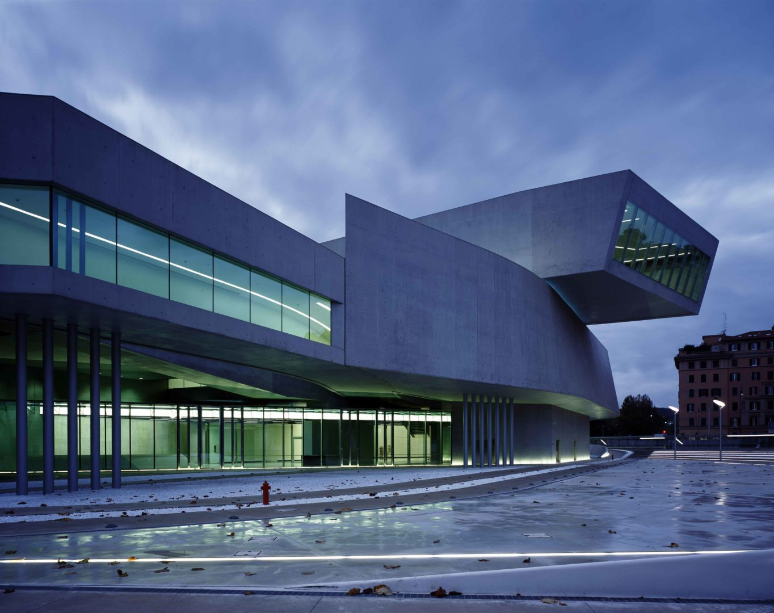
Case Study: MAXXI Museum (Zaha Hadid)

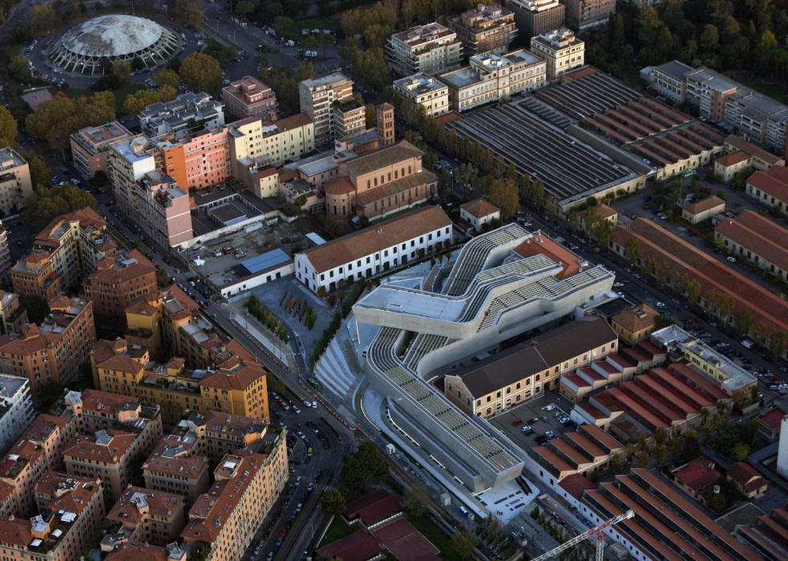
(Zaha Hadid Architects, 2010)

Module: Construction materials
Student Name: Harvey Dixon
Student ID: 2521025
Word Count: 2195

Contents Page
Contents
Contents Page 2
1. Introduction 3
1.1 Aim of Report 3
1.2 Building Overview 3
2. Original Design & Method of Construction 3
2.1 Architectural Concept 3
2.2 Structural System 3
2.3 Construction Method 4
3. Analysis of Framing Material 4
3a. Strength, Durability & Climatic Resistance 4
3b. Time, Labour, Programme & Cost Compared to Steel 5
3c. Ease of Assembly & Adaptability 6
3d. Integration of Services 6
3e. Demolition & End-of-Life Challenges 7
4. Negative Impact of Concrete Production 7
4.1 Environmental Impact 7
4.2 Community Impact 8
5. Conclusion 8
6.Sieve analysis 9
7.References 10

1. Introduction

1.1 Aim of Report
This report analyses the design, construction method, and performance of the MAXXI Museum in Rome. It will consider concrete as the primary material and examine the strength, durability, environmental impact, service integration, and end-of-life considerations which come with the elements of the building.

1.2 Building Overview
The MAXXI Museum is in Rome and begun construction in 1998 and was completed in 2009. This building designed by “Zaha Hadid and she was chosen from among 273 candidates from all over the world” (Royal Academy of Arts, n.d.). I chose this building as it is a notable example as to how concrete framed buildings can be constructed in unconventional ways.

2. Original Design & Method of Construction

2.1 Architectural Concept
Zaha Hadid focused on “presenting a field of buildings accessible to all, with no firm boundary between what is ‘within’ and what is ‘without’.” (Zaha Hadid Architects, 2010) This would suggest why the building features “confluent lines” and sweeping hallways and stairs to create an open space for displaying art, so the visitors have easy viewing and access to all art pieces.

2.2 Structural System
The MAXXI museum in Rome was built via cast in situ reinforced concrete and this allowed the structure to take on various shapes and smooth flowing features that was out of the ordinary. The whole structural system is made up of Load bearing walls, deep beams, floor slabs and interlocking horizontal and vertical ribbons. (Zaha Hadid Architects, 2010).
By using this structural system of reinforced concrete, it also allows the incorporations of longs spans and overhangs. The reinforced concrete is also a material that can achieve the complex curves and cantilevers designed by Zaha Hadid. This type of concrete was also chosen due to its plasticity that allowed the structure to be shaped to custom formwork.

2.3 Construction Method
The MAXXI Museum featured very congested reinforcement within the walls so for the builders to work around this challenge they had to use self-compacting concrete. To cater to the design there was a 3-SC mixture was developed to avoid bleeding risk and a particle size distribution of the aggregates. This mix was also self-curing concrete based on the use of shrinkage reducing admixture. As a result of this design, it was successful in producing a crack-free concrete surface even in the exceptionally long, curvilinear walls (Collepardi et al., 2022). There was also a challenge with the design of 14m high walls, which was solved by using CNC-fabricated 3D formwork and custom Vairo grider walls system, designed for fresh-concrete pressures up to 150kN/m2 (PERI, n.d.). The MAXXI also possessed a dedicated plant within the construction site, which made it possible to optimise production and quickly meet specific requests by both the contractor and the builder (Heidelberg Materials, n.d.).

3. Analysis of Framing Material

3a. Strength, Durability & Climatic Resistance
The reinforced concrete that was used in the museum is strong in compression and when put alongside steel reinforcement it can allow for long spans and heavy loads to be put on the beams. In the MAXXI, the combination of deep beams, loadbearing walls and interlocking “ribbons” of in-situ reinforced concrete enabled the sweeping cantilevers and complex geometries that define the building. (Zaha Hadid Architects, 2010; Inexhibit, 2022).

Durability is another key aspect for the MAXXI due to the number of exposed surfaces of architectural concrete. To overcome this the contractor used a bespoke 3-SC mix (Self-compacting, self-compressing and self-curing). Inspections took place 18 years later and found the long, inclined walls were crack-free and still maintained its aesthetically pleasing appearance. The few micro-cracks were mitigated by using a transparent coating to reduce carbonation induced corrosion (Collepardi et al., 2022; Heidelberg Materials, n.d.)

Romes’s climate features hot, dry summers and mild wetter winters. These conditions typically favour the cast-in-situ concrete particularly where cover and mix design are specified for the relevant exposure (Weather‑Atlas, 2026). The concretes thermal mass also limits daily temperature changes which helps the internal climate of the gallery remain constant which is good for energy efficiency (The Concrete Initiative, 2009).

From the perspective of standards, carbonation and chloride ingress remains the most prominent threats as the exposure class methodology (and the emerging exposure resistance class concept) link the minimum cover, cement type, and water to cement ration to design working life (Gil‑Martín et al., 2023).

3b. Time, Labour, Programme & Cost Compared to Steel
In the complex structures, in-situ concrete is typically slower to construct than a steel frame because of the processes like curing of the concrete. Whereas steels off-site fabrication and bolt-together erection can accelerate frames greatly and can also reduce weather delays that you would incur if using concrete (Andrew Steel industry contributor, 2024).

At the MAXXI, the intensity of the schedule was compounded by a custom 3-D model of the formwork and high fair faced finished requirements. PERI used a system called VARIO GT 24 which was engineered for SCC pressures up to 150 kN/m2 with 14m high curvilinear walls. As a result of all these elements in meant that the project was labour and coordination heavy (PERI, n.d.).

Following onto cost, the bespoke Formwork, site-batched special mixes, and skilled finishing raised the initial cost of the concrete. However, the concrete can gain back value in the fact that it is fire resistant which means that it avoids any additional cost of fire protection which is often required for steelwork framed structures, such as intumescent paint (SteelConstruction.info, 2024).

Overall, while using a steel frame might have shortened the primary structure of the programme, Zaha Hadid wanted to have a structure that featured smooth, continuous, and curved walls which consequently made reinforced concrete to be the most applicable as it allowed the architects to achieve their intents and does not compromise Zaha Hadid’s idea (Zaha Hadid Architects, 2010).

3c. Ease of Assembly & Adaptability
The ease of assembly difficult due to the variable wall inclinations and congested reinforcement demanding in depth surveys, Prefab curved formwork and slow pours which was essential for achieving the quality desired. Aiming to achieve surface continuity increased tolerances and rework risks if there was any chance of misalignment (PERI n.d.; Collepardi et al., 2022).

Due to the MAXXI being a concrete frame with curved load-bearing walls is less adaptable to a steel frame. If new openings were made it could be an overly complex process and can impair the structures behaviour. Despite this, internally the MAXXI has large clear galleries and bridged routes that provide internal planning flexibility for exhibitions without affecting the frame (Zaha Hadid Architects, 2010; Inexhibit). Overall, it is obvious that the concretes robustness and long-life design support any future developments or reuse of the structure even if modifications are difficult.

3d. Integration of Services
Provision of services would be difficult as for example, routing large ducts and risers through deep beams/ walls this puts a risk of any clashes with rebar, while the architect’s intent to have smooth exposed concrete also poses a problem as it limits the services being mounted on the wall itself. The solution to this problem which is commonly found in the industry is early BIM based coordination and pre-formed sleeves and box-outs. The additions of these methods ensures that all penetrations are compatible with the structural demand (Capstones Vikash Singh, n.d.)

The MAXXI’s curved walls and long spans increased the importance of service stacking and bridge-to-gallery transitions to preserve the clear volumes. This reinstates the need for the use of BIM models to detect clashes and preserve the clear and flowing access through the museum (Mars BIM, 2024). The integration of services is achievable however it is essential that procurement lock the MEP penetrations and sleeve schedules early, because if there were any post-pour alterations can pose as an eye sore but also be structurally costly.

3e. Demolition & End-of-Life Challenges
The demolition of reinforced is very energy intensive to break out, requires heavy plant and controlled sequencing. This is because they must separate the rebar using a magnet after the crushing of the concrete. With the majority the EU/UK practice, concrete is highly recyclable as recycled concrete aggregate (RCA) can be recycled into new concrete per BS 8500 definitions of CCA (Concrete centre, 2021)

The European Environment Agency notes that a considerable proportion of reported “recovery” of C&D waste remains low grade backfilling. Which suggests that there is still room for the improvement via design for reuse, selective demolition, and high-quality RCA streams. In the case of the MAXXI which is a one-off structure, the most applicable approach would be to focus on adaptive reuse for more sustainable end of life pathway which eradicates the option of demolition and retains the carbon that is embedded in the structure (European Environment Agency, 2020)

4. Negative Impact of Concrete Production

4.1 Environmental Impact
The cement is the main source of carbon that is embodied in concrete. “Each year, more than 4 billion tonnes of cement are produced, accounting for around 8 per cent of global CO2 emissions” This is down to the processes in the manufacturing stage such as calcination of limestone and the hot temperature kilns emissions that are produced from it. (Chatham House, 2018).

In the MAXXI, there is a high volume of in-situ concrete which implies that there is a high level of embodied carbon within the framework, despite the structure having a 3-SC mix that allowed for increased durability and reduced rework risk, this undermines the design tension between expressive concrete and carbon budgets (Heidelberg Materials, n.d., Collepardi et al., 2022).

4.2 Community Impact
The supply chain process has a damaging impact to the community, for example the mining of the materials that are in the cement can cause destruction to habitats through open-pit quarries which strips the vegetation and topsoil from the area. Heavy machinery such as lorries creates traffic, dust, and noise which pollutes the local areas and communities (UKGBC, n.d.).

Regarding the MAXXI, balancing the durability and strength of the structure to its embodied carbon and community impacts points to solutions such as slightly leaner sections, low-carbon binders and designing long service life and reuse to avoid any impact to the community and extend the longevity of the concrete in the structure. (Concrete centre, n.d.)

5. Conclusion
The MAXXI museum in Rome demonstrates how reinforced concrete can be used to achieve highly complex architectural forms, including 14m high walls, cantilevers and smooth curved surfaces that’s (Zaha Hadid Architects, 2010).

For this museum they had to apply bespoke 3-SC concrete and advanced formwork which helped deliver high durability and a consistent finish (Collepardi et al., 2022). Because of using concrete, the programme included very intense time and labour compared to what steelwork would have been. On the other hand, concrete also possesses fire resistance properties, which offsets costs and maintenance downstream as it does not require fire safety elements that a steel frame would require. (SteelConstruction.info, 2024).

As the structure uses deep framework it makes the integration of MEP services require early BIM-led coordination to maintain the exposed concrete finish, this would then suggest that if there are any future problems then it will have to be more internal reconfiguration rather than structural alterations. (Capstones Vikash Singh, n.d.).
Finally, the embodied carbon that is found in concrete remains the main dilemma we face when using concrete frames. Industry policies and legislations emphasise material efficiency, SCMs AND CCUS. However, concretes most powerful level that It has is its longevity and reuse. For the MAXXI, that means ensuring the frames service life and utility can justify its initial footprint, aligning architectural ambition with sustainability. (Concrete centre, n.d.)

6.Sieve analysis
Below is a table that I have filled out that demonstrates a concrete sample and the types of aggregate that it contains. I have analysed this sample based off its characteristics and highlighted what the data suggests about the sample.
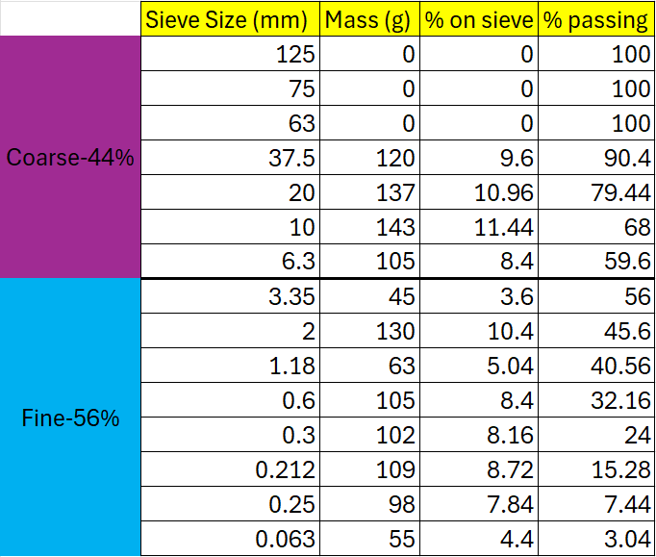

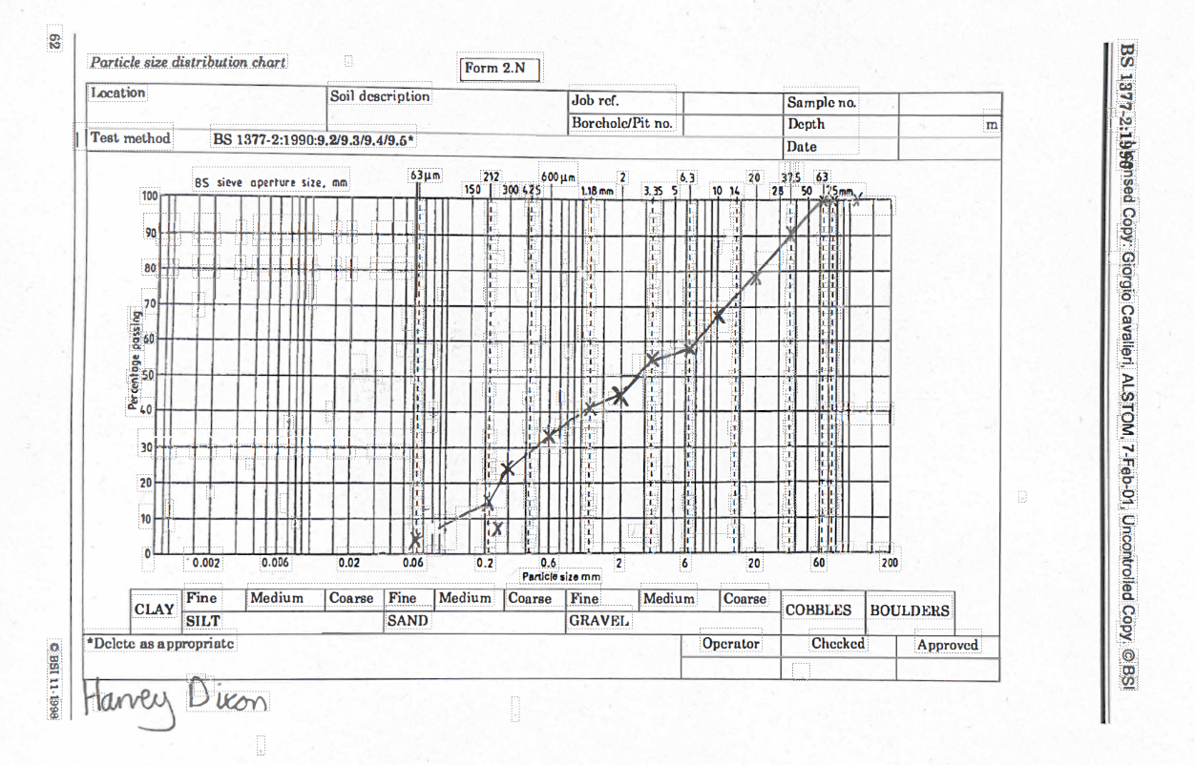
Overall, this dataset shows that the aggregate possesses 44% of coarse and 56% of fine. The range of the particle size distribution is from 37.5mm to 0.063mm, which effectively covers what a well-graded aggregate uses in concrete.
In the coarse percentage it begins at 37.5mm and no particles bigger than that. The most of the mass appears between 10-37.5mm, with gradual reduction in percentage passing for example there was 90.4% passing at 37.5mm, 79.44% passing at 20mm and 59.6% passing at 6.3mm This would suggest that the there is a normal coarse aggregate distribution as there’s a reasonable spread between 37.5mm and 6.3mm.
With regards to the fine percentage of 56% of the sample there’s a high proportion of particles that fall below 3.35mm to 0.063mm. The percentage passing steadily reduces from 56% at 3.35mm to 3.04% at 0.063mm. This suggest that the fine portion is well distributed, there’s also no sudden jumps in percentage retained which indicates no gap grading but more of a continuous gradation.
Overall, the suitability of direct use would be applicable for general concrete or structural concrete as the distribution shows good proportion of coarse to fine with continuous gradation, appropriate sizing, low silt content. Due to these characteristics this sample would have good workability and less demand for cement due to it being a well graded blend which has improved density and strength.

7.References
- Andrew. (2024). Steel vs. Concrete Construction: Which Is Faster? [Online]. structuralsteelfabricators.com.au. Last Updated: 3 May 2024. Available at: https://www.structuralsteelfabricators.com.au/steel-vs-concrete-construction-which-is-faster/ [Accessed 10 March 2026].
- European Environment Agency. (2020). Construction and demolition waste: challenges and opportunities in a circular economy. [Online]. European Environment Agency. Available at: https://www.eea.europa.eu/en/analysis/publications/construction-and-demolition-waste-challenges/cons [Accessed 10 March 2026].
- Heidelberg Materials. (n.d). Innovative cement solutions shape iconic museum in Rome. [Online]. Heidelberg Materials. Available at: https://www.heidelbergmaterials.com/en/reference-projects/maxxi-italy [Accessed 10 March 2026].
- Lehne, J. and Preston, F. (2018). Making Concrete Change: Innovation in Low-carbon Cement and Concrete. [Online]. Chatham House. Last Updated: 13 June 2018. Available at: https://www.chathamhouse.org/sites/default/files/publications/2018-06-13-making-concrete-change-ceme [Accessed 10 March 2026].
- Luisa María Gil-Martín. (2023). The Relationship between Concrete Strength and Classes of Resistance against Corrosion Induced by Carbonation. [Online]. MDPI. Last Updated: 13 May 2023. Available at: https://www.mdpi.com/2071-1050/15/10/7976 [Accessed 10 March 2026].
- Mario Collepardi. (2022). The MAXXI Building in Rome with the Long, Inclined and Curvilinear Reinforced Concrete Walls after 18 Years from their C. [Online]. American Concrete Institute. Last Updated: 1 July 2022. Available at: https://www.concrete.org/publications/internationalconcreteabstractsportal/m/details/id/51736085 [Accessed 10 March 2026].
- Mars BIM. (2024). MEP Coordination Checklist: A Comprehensive Guide. [Online]. Mars BIM. Last Updated: 18 September 2024. Available at: https://www.marsbim.com/mep-coordination-checklist-a-comprehensive-guide/ [Accessed 10 March 2026].
- PERI. (n.d.). MAXXI - Museo nazionale delle arti del XXI secolo Rome, Italy. [Online]. PERI. Available at: https://www.peri.com.sa/projects/maxxi-museum-rome.html#impressions [Accessed 10 March 2026].
- Riccardo Bianchini. (2015). Zaha Hadid – The MAXXI Museum Rome – part 2. [Online]. Inexhibit. Available at: https://www.inexhibit.com/case-studies/zaha-hadid-the-maxxi-museum-rome-part-2/ [Accessed 10 March 2026].
- Royal Academy of Arts. (n.d.). MAXXI National Museum of XXI Century Arts. [Online]. Royal Academy of Arts. Available at: https://www.royalacademy.org.uk/art-artists/work-of-art/maxxi-national-museum-of-xxi-century-arts-ro [Accessed 10 March 2026].
- Steel Construction.info. (2024). Fire and steel construction. [Online]. SteelConstruction.info. Available at: https://www.steelconstruction.info/Fire_and_steel_construction [Accessed 10 March 2026].
- The Concrete Centre. (2021). Recycling concrete. [Online]. The Concrete Centre. Available at: https://www.concretecentre.com/Performance-Sustainability-%281%29/Material-Effieciency/End-of-life-r [Accessed 10 March 2026].
- The Concrete Initiative. (2009). General guidelines for using thermal mass in concrete buildings. [Online]. The Concrete Initiative. Available at: https://theconcreteinitiative.eu/images/ECP_Documents/GuidelinesThermalMass_EN.pdf [Accessed 10 March 2026].
- The Concrete Centre. (n.d.). Concrete Compass: Circular economy. [Online]. The Concrete Centre. Available at: https://www.concretecentre.com/Resources/Concrete-Compass/Circular-economy.aspx [Accessed 10 March 2026].
- UK Green Building Council. (n.d.). Cement – Embodied ecological impacts. [Online]. UK Green Building Council. Available at: https://ukgbc.org/our-work/topics/embodied-ecological-impacts/cement/ [Accessed 10 March 2026].
- Vikash Singh. (n.d). Key Benefits of BIM Coordination Services. [Online]. Cap Stones. Available at: https://www.capstonees.com/blog/key-benefits-of-bim-coordination-services [Accessed 10 March 2026].
- Weather Atlas. (2026). Climate and monthly weather forecast, Rome, Italy. [Online]. Weather-Atlas.com. Available at: https://www.weather-atlas.com/en/italy/rome-climate [Accessed 10 March 2026].
- Zaha Hadid Architects. (2010). MAXXI: Museum of XXI Century Arts. [Online]. Zaha Hadid Architects. Available at: https://www.zaha-hadid.com/architecture/maxxi/ [Accessed 10 March 2026].

