Nathan Price (1700540)
25th November 2019
An Analysis of Pink Tourism: A case study on the travel motivations of gay men
Research Proposal

Contents
List of figures 2
1. Introduction 3
1.1 Rationale 3
1.2 Background 4
1.3 Aims and Objectives 5
2. Research Design and Methodology 6
2.1 Methodology 6
2.2 Research Philosophies 7
2.3 Research Approaches 7
2.4 Research Strategy, Choices and Data Collection Methods 7
2.5 Sample 8
2.6 Limitations 8
2.6.1 Ethical considerations 8
2.6.2 Reliability and Validity 9
3. Resources and Planning 10
3.1 Resources 10
3.2 Time Management 10
3.2.1 Gantt chart 11
4. References 12

List of figures
Figure 2.1 – The Research Onion (Saunders et al., 2006)
Figure 3.2.1 – Gannt Chart

Introduction
A critical analysis of Pink Tourism with specific case studies of the travel motivations of gay men will be provided within this research project.

1.1 Rationale
Decades ago, tourism was viewed as a luxury for elite members of society to partake in, where the rich and privileged enjoy the benefits of travel. However, in recent years, tourism has been prevailed as a necessity to global advancement and causing enrichment of life in terms of happiness and well-being – not just in developed nations, but in developing destinations also (McCabe, 2014).
This however relates greatly to heterosexual members of the public, who benefit from travel with ease; it has often been a different story for LGBT+ individuals (Scheyvens & Biddulph, 2018). In some destinations, even still today, the rights of this community are minimal, with some countries holding legal implications of death, torture and imprisonment for LGBT+ persons and queer acts.
Pink Tourism is an emerging niche market for UNWTO (UNWTO, 2018) and thus tourism organisations and destinations should be adapting to appeal to LGBT+ travellers and for reference for this research, to gay male travellers. A few travel companies tend to use niche markets as a marketing ploy to widen their customer base and target communities/those with share interests and this research project aims to question if this is the case here.
The research project will focus on Pink Tourism, with specific case studies of gay male travel motivations. This research is necessary due to ongoing developments in LGBT+ rights, but also consistent backlash of the community in destinations worldwide. An example of ongoing developments is shown by established and respected organisations such as the United Nations World Tourism Organisation. The legal body are regularly releasing documentation regarding the rise of the Pink Tourism market within the wider tourism industry (UNWTO, 2017), however, there is little research into the reason for this rise, why interest in this market is increasing and how gay male travel motivations (if specifically any) are being met.

1.2 Background
Pink Tourism is a niche market within the tourism industry designated to LGBT+ holidays, trips and travel services (Hughes, 2006). In recent years, the industry has seen has large rise in development and growth, in part due to steady global and legal acceptance of LGBT+ rights and normalisation of the community. With each progression and modernisation of LGBT+ acceptance in destinations across the globe, comes newfound confidence for individuals within the community to participate in international tourism activities (Austin & Wojcik, 2018).
In fact, progressions within society towards LGBT+ individuals date back to the establishment of the first Pride festival in 1972 and more recently, the Same-Sex Couples Act 2013 (Rosenbloom, 2014). However, there has always been LGBT+ travel since the inception of tourism as a means of leisure, regardless of legislation and acceptance by lawmakers; in 2011, an estimated £4.7 billion was spent on gay travel in the UK (Southall & Fallon, 2011).
Tourism providers and organisations are consistently chasing what is referred to as the ‘pink dollar’, the amount of disposable income that specifically gay men hold (Berezan et al., 2015). This is what makes the Pink Tourism market unique. Most heterosexual tourists have responsibilities such as families and financial woes that can affect how they travel, but it is often the case that LGBT+ travellers are not tied down with these issues.
It has often been regarded that Pink Tourism relates to sex and that LGBT+ travellers chase this when participating in tourism (Want, 2002), but this is not the case in the 21st Century climate. The increase within the niche market of Pink Tourism is primarily due to the acceptance and freedom LGBT+ individuals believe they now obtain; however, the motivations of these travellers is unclear. If sex and travel to destinations more accepting than their home being minimal factors influencing travel, then a new study is required to understand LGBT+ and more specifically, gay male, travel motivations.

1.3 Aims and Objectives
The aim of this study is to critically analyse the travel motivations of gay male tourists and investigate the demand for Pink Tourism.
To achieve this, several objectives have been set – these are:
- To examine prior academic and industry information to discover the appeal, growth and future of Pink Tourism with specific analysis of gay male travel motivations.
- To produce primary research to investigate whether Pink Tourism is a market in demand and if there are segments of the tourism industry which appeal to and are sought out by gay male tourists.
- To provide an in-depth conclusion of demand for Pink Tourism, along with similarities or differences in the wants/needs of gay male tourists, their heterosexual counterparts and wider LGBT+ community.

Research Design and Methodology
Research is defined as innovative work undertaken to increase knowledge, understanding and theories thus furthering thought and generating ideologies (OECD, 1993). Most research is done objectively, with the collection of new and existing data combining to solve research issues and provide facts (Ariola, 2006).

Methodology
‘The Research Onion’ is used internationally by researchers as an effective strategy to generate plans and determine modes of research to achieve goals, aims and objectives (Saunders et al., 2016). The ‘Onion’ can be seen illustrated in Figure 2.1. As shown, this form of research is depicted in layers and relates to each specified stage of research. To ensure good methodical practice, the ‘Research Onion’ will be used within the research project to propose a transparent route of research design. This will provide the researcher with the greatest feasible methodology in order to achieve high standards and accurate data and analysis.
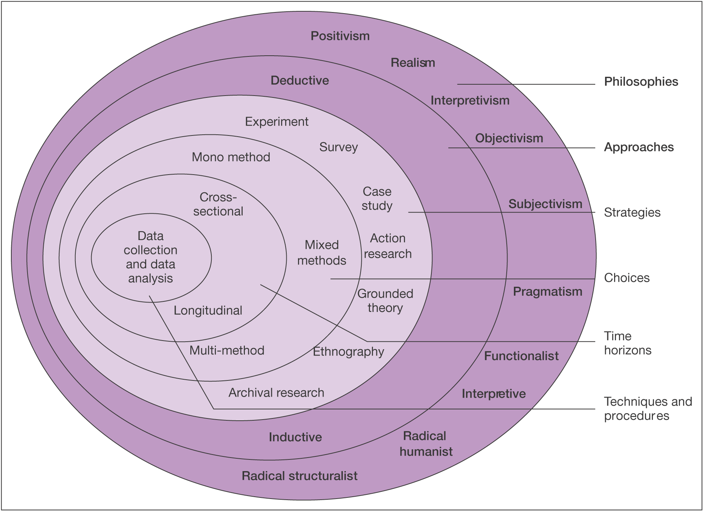
Figure 2.1 – The Research Onion (Saunders et al., 2016).

2.2 Research Philosophies
The first layer of the ‘Onion’ explains philosophies that can be used when undertaking a research document. It can be argued that positivism and interpretivism are the two main philosophical strategies for research (Saunders et al., 2007), and for the purposes of this research, interpretivism will be used. Interpretivism describes research that can be adapted and interpreted, as a social experiment where learning about other’s actions and ways of life is key (Oden, 2019).
Objectivism will also be used within the research as objectivism defines understanding differing opinions regarding the research question, aim and objectives (Saunders et al., 2016).

2.3 Research Approaches
For the purposes of this research study, an inductive approach will be used. Deductive research refers to usage of already established information and theories to reach conclusions, whereas the inductive approach allows the researcher to observe and highlight patterns within existing and new research (Ritchie & Lewis, 2003). As the research project is based around the travel motivations and interpretations of gay tourists, an inductive approach is necessary.

2.4 Research Strategy, Choices and Data Collection Methods
A mixed method of research strategies will be utilised within the research project, to produce triangulation and ensure the utilisation of all available research strategies to further understanding. The next layer of the ‘Onion’ helps to define the differing approaches to gaining primary research and the methods in which these will be applied (Saunders et al., 2007). Both qualitative and quantitative research will be gathered by the researcher, in the form of surveys and interviews, to grasp an overall understanding by members of the public regarding the research issue.
Qualitative research helps to explore the research topic via opinions and reasons, offering an insight in detail and allowing for a detailed outlook into the topic; whereas quantitative research is that of numerical data that can be used to create statistics and portray research results in a measurable fashion (Tonelli & Zambaldi, 2018). Qualitative research will be assembled via individual interviews with industry professionals, to grasp the impact of Pink Tourism and how gay men interpret and use the niche market.
Quantitative information will be collected with the publication of surveys, which will grasp a wide view on public perceptions of Pink Tourism and discover their travel motivations. This information will be adapted into visual aids e.g. graphs to aid the research and analyse further. The mixture of these forms of research strategies are hoped to culminate in results that are vast, varied and discover patterns/similarities to further discussion.

2.5 Sample
When undertaking primary research, it is vital to form a sample of populations as often, constraints such as time are overwhelming and hard to concur (Saunders et al., 2016). A convenience sample is expected to be used within the research project; a form of sampling that is non-random and selects subjects based around a certain aspect (Gall et al., 1999) – in the instance of this research project, the aspect is sexual orientation. It is believed that a convenience sample will help to benefit the aim and objectives set and achieve these with more ease, as a generalised sample could lead to unbeneficial results.
The sample of participants within the research project will consist of over 100 partaking in surveys and between three and five individual interviews as larger sample sizes generate greater understanding of public perceptions and opinion (Collis & Hussey, 2009).

2.6 Limitations

2.6.1 Ethical considerations
Saunders et al. (2009) refers to ethical consideration in research as correct practice and usage of those participating in the study, with specific mentions of their rights regarding information shared and used (Saunders et al., 2009). Over the past few decades, a great importance has been placed on ensuring ethical considerations are respected when partaking in a research study by students, government officials and more (Brooks et al., 2014). It is important for a research project to account for participants rights and anonymity, along with gaining trust and respect.
An ethics form will be completed with a plethora of information regarding the risks associated with undertaking the research. Contributors will be informed of their right to withdraw from the study at any time and that any details shared will be stored safely and in anonymity. Further details of ethical considerations can be found within the associated ethics form.

2.6.2 Reliability and Validity
It is crucial that there is consistent reliability within the research project in order to provide a non-bias and true piece of work. It is hoped and expected that results found from the research could be replicated if undertaken in the same manner; reliable information is always sought and desired during this research, as consistency is key (Merriam, 1995). Validity could be defined as the accuracy of which information meets the measures set (Thanasegaran, n.d.). Within this research, effective and thorough research methods will always be put into place to ensure reliability and validity.
Bias will be eliminated from the research, with interpretation of findings being disregarded for the good of answering the research question set - the primary aim. All those partaking in the primary research will have no close relationships with the researcher, to ensure new and uninfluenced information is gathered. Where questionable results and findings may arise, this research will be disregarded to further eliminate even small chances of unreliability and invalidity.

Resources and Planning

3.1 Resources
All available resources will be utilised for the purposes of this research study. These resources will be used to conjure primary and secondary research and provide analysis. The University of Wales Trinity Saint David has a wide variety of up to date resources available which will be used, including textbooks, journals, newspapers, books, academic reports and articles. Other online resources that will be used will include websites and travel organisation pages, which hold valuable information for this study.
The computer facilities at the university will be used to create the research project and thus Microsoft Office programmes on these systems will benefit the development of primary research greatly.

3.2 Time Management
Time management is key when undertaking large research studies, especially for students, as procrastination is known to be a severe issue for these individuals (Hӓfner et al., 2014). Time management is critical to achieving aims and objectives over a specific duration (Claessens et al., 2007), and to delay necessary work is a malfunction of self-regulation (Howell et al., 2006).
In order to fulfil high levels of time management, a Gantt chart has been formulated. A Gantt chart is a progress measurement tool designed to ensure definitive plans are executed with the advancement of time and within schedule (Clark, 1923).

3.2.1 Gantt chart
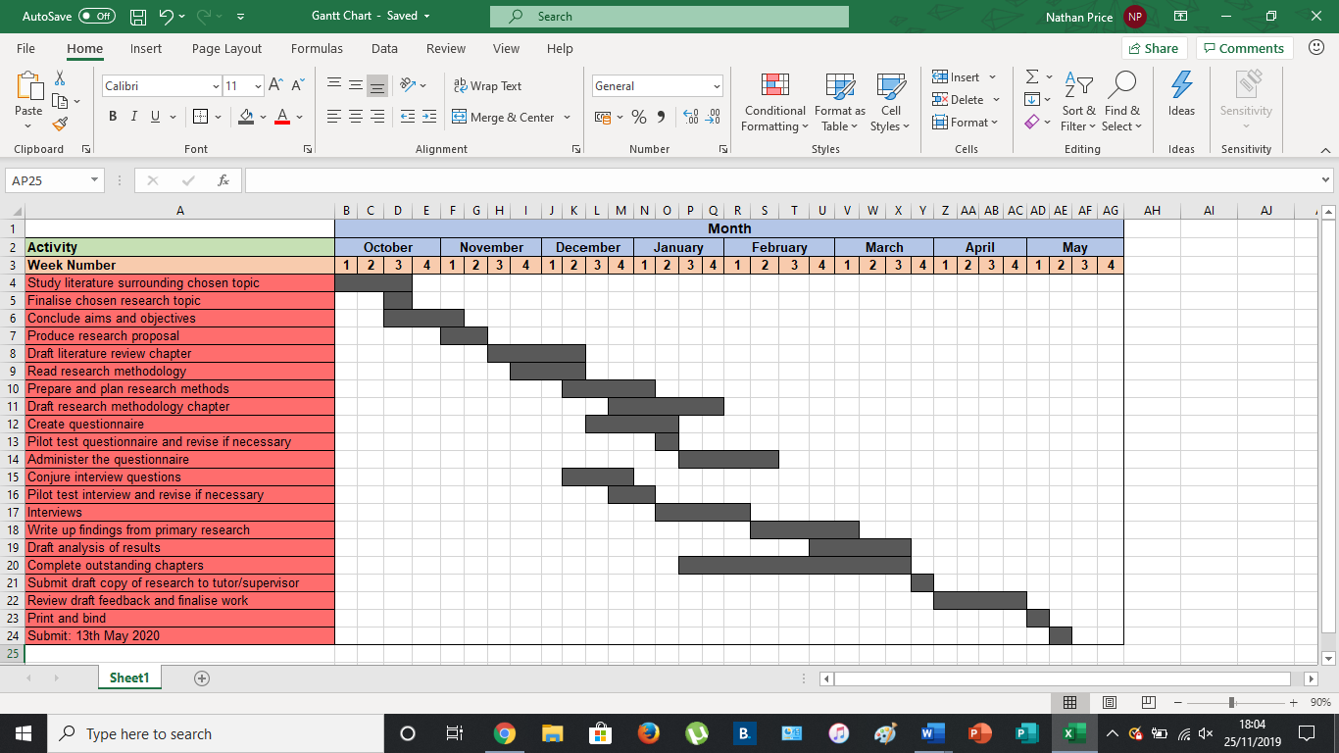
Figure 3.2.1 – Gannt Chart

References
Ariola, M. M. (2006), ‘Principals and Methods of Research’, Manila: Rex Book Store.
Austin, D. & Wojcik, M. E. (2018), ‘Freedom’s Frontiers: The Travails of LGBT Travelers’, Pólemos, 12:2, pp. 271-195.
Berezan, O., Raab, C., Krishen, A. & Love, C. (2015), ‘Loyalty Runs Deeper Than Thread Count: An Exploratory Study of Gay Guest Preferences and Hotelier Perceptions’, Journal of Travel & Tourism Marketing, 32:8, pp. 1034-1050.
Brooks, R., Riele, K. & Maguire, M. (2014), ‘Ethics and Education Research’, London: SAGE Publications.
Claessens, B., Eerde, W., Rutte, C. G. & Roe, R. A. (2007), ‘A Review of the Time Management Literature’, Personnel Review, 36:1, pp. 225-276.
Clark, W. (1923), ‘The Gantt Chart: A working tool of management’, (Second Edition), New York: The Ronald Press Company.
Collis, J. & Hussey, R. (2009), ‘Business Research: A Practical Guide for Undergraduate & Postgraduate Students’, (Third Edition), Basingstoke: Macmillan Publishers Limited.
Gall, M. D., Borg, W. R. & Gall, J. P. (1996), ‘Educational Research: An Introduction’, New York: Longman.
Howell, A. J., Watson, D. C., Powell, R. A. & Buro, K. (2006), ‘Academic Procrastination: The Pattern and Correlates of Behavioural Postponement’, Personality and Individual Differences, 40:1, pp. 1519-1530.
Hughes, H. L. (2006), ‘Pink tourism: holidays of gay men and lesbians’, Wallingford: CAB International.
Hӓfner, A., Oberst, V. & Stock, A. (2014), ‘Avoiding procrastination through time management: an experimental intervention study’, Educational Studies, 40:3, pp. 352-360.
Merriam, S. B. (1995), ‘What Can You Tell From An N of 1?: Issues of Validity and Reliability in Qualitative Research’, Journal of Lifelong Learning, 4:1, pp. 51-60.
Oden, C. (2019), ‘Research Methodology: Using Research Onion as a Framework’, [Online]. Available: https://www.projecttopics.org/research-methodology-using-research-onion-as-a-framework.html, Last Accessed: [2019, November, 20].
OECD. (1993), ‘Proposed Standard Practice for Surveys of Research and Experimental Development: Frascati Manual’, (Fifth Edition), Paris: OECD.
Ritchie, J & Lewis, J. (2003), ‘Qualitative Research Practice’, London: SAGE Publications Limited.
Rosenbloom, C. (2014), ‘The Evolving World of Gay Travel’, [Online]. Available: https://www.nytimes.com/2014/06/01/travel/the-evolving-world-of-gay-travel.html, Last Accessed: [2019, November, 21].
Saunders, M. N. K., Lewis, P. & Thornhill, A. (2009), ‘Research Methods For Business Students’, (Fifth Edition), Harlow: Pearson Education Limited.
Saunders, M. N. K., Lewis, P. & Thornhill, A. (2019), ‘Research Methods For Business Students’, (Eighth Edition), Harlow: Pearson Education Limited.
Saunders, M. N. K., Lewis, P. & Thornhill, A. (2016), ‘Research Methods for Business Students’, (Sixth Edition), Harlow: Pearson Education Limited.
Scheyvens, R. & Biddulph, R. (2018), ‘Inclusive tourism development’, Tourism Geographies, 20:4, pp. 589-609.
Southall, C. & Fallon, P. (2011), ‘LGBT Tourism’, Oxfordshire: CABI International.
Thanasegaran, G. (n.d.), ‘Reliability and Validity Issues in Research’, Malaysia: University of Putra Malaysia – Faculty of Economics & Management.
Tonelli, M & Zambaldi, F. (2018), ‘Qualitative Research, Quantitative Research, and Beyond’, Revista de Administração de Empresas, 58:5, pp. 449-450.
UNWTO. (2017), ‘UNWTO releases 2nd Global Report on LGBT Tourism’, [Online]. Available: https://media.unwto.org/press-release/2017-05-06/unwto-releases-2nd-global-report-lgbt-tourism, Last Accessed: [2019, November, 20].
UNWTO. (2018), ‘Second Global Report on LGBT Tourism’, Madrid: World Tourism Organisation (UNWTO).
Want, P. (2002), ‘Trouble in Paradise: Homophobia and Resistance to Gay Tourism’, London: Continuum.

