11/20/2020
Natalie Thomas
1712163
What Makes a Great Leader?
Featuring Jacqueline Gold CBE

Task 1
Introduction
Traditionally leadership can be interpreted in many different forms. However, to better reflect the leadership styles researched within this essay, this paper refers to the similar views of Rosari, (2019), whom refers to Bass (cited in Tracey & Hinkin, 1998) ‘Leadership comprises of influence, motivation, stimulation and consideration to form a relationship among leaders and followers who intend real changes that reflect their mutual purposes’. With that of Mullins, (2007) interpretation, leadership is increasingly associated not with command and control but the concept of inspiration, teamwork and creating a vision which other can identify.
To organise this discussion, this essay is divided into two parts, the first task introduces Jacqueline Gold CBE using Leadership theories and models to demystify the traits, styles and strategies and identify the critical attributes of effective leadership demonstrated within her achievements as the CEO of Ann Summers. The second task critically evaluates the personal ability of the author to fulfil key leadership responsibilities within a leadership role, including the context of Lewin’s established leadership styles and highlights Hersey and Blanchard’s Situational Leadership.

Gold’s Background and Past Influences on Leadership
Ballard, (2020) suggests ‘Since 1993, Jacqueline Gold CBE is regularly noted as one of the country’s most important retail leaders’. Born in 1960, Gold and her sister Vanessa lived with their parents in Kent (Jacqueline Gold, 2020a). During an interview with Channel 4 News, (2018) she describes a typical family life that consisted of ‘dad went to work, while mum stayed at home’. Gold, (1995) explains Beryl, her mother was a very controlling and protective mother, causing a strained mother/daughter relationship. Her father David Gold started life in extreme poverty and had faced numerous setbacks, until he became successful within the publishing industry. Setting his sights on a new challenge he recognised the huge potential of the Ann Summers concept, which quickly became part of his portfolio and later led to the families success (Profile/David Gold, 2018).
Gold, (1995) continues, at the age of 12, her parents divorced, resulting in horrendous troubles that caused the remainder of her childhood to be horrific. The author adds, as a teenager, Gold can be described as very ambitious and had become obsessed with the idea of making money to become financially dependent. As a young adult Gold hurdled through employment, until 1979 when she acquired a job at Royal Doulton. Gold, (1995) explains how inspired she was by the example her grandmother set as a fabulous hard-working independent woman, whom for the majority of her life worked three jobs to provide for three children while Gold’s grandfather spent many of year incarcerated. However, it was Gold’s father that was the major influence in her life, from whom has always been a wealth of inspiration to her, even though he treated her as he did everyone else and was very tough on her (for the right reasons), during the Channel 4 News, (2018) interview Gold asserts ‘it was very character-building’.
Unsure about her desires for the future, no management or business experience and with no other intention but to gain work experience alongside her part time job, at aged 19 Gold joined her father’s small lingerie empire, Ann Summers. With just four stores, Gold quotes in an interview with The Business Voice, (2014) “ it was a very intimidating male orientated industry”. Continuing the interview with Channel 4 News, (2018) which questions her earlier influences Gold explains this is where her main inspiration came from ‘the uncomfortable feeling she felt within the industry towards women which later led her to want to empower woman in business from that point onwards’.
Jacqueline Gold, (2020a) states during her career Gold has received many accolades for her achievements in leadership and business, including Barclay’s bank most inspirational business leader, and awarded a CBE for services to entrepreneurship, women in business and social enterprise.

Early Years
Gold, (1995) suggests it was during her early years at Ann summers, that she got an invitation to a Tupperware party, where she saw an opportunity to transform the way they sold products and increase the business’ competitiveness. An additional channel that would unknowingly lead to the success of the organisation today, ‘The Party Plan’.
Her journey to leadership can be seen while pitching the idea to an all-male board of executives, the proposal became a very lengthy and struggled process with the lack of support from her then piers. However, Gold’s passion and drive allowed her to push through the prejudice, she persevered by slowly chipping away at society.
Finally launching Ann Summers Party Plan in 1981, Gold’s response was enormous, and Ann Summers was reborn. It is during this time Gold examples Lewin’s autocratic leadership style, which as suggested by Fiaz, (2017) relied heavily on her own authority, manipulation, control power and hard work, to get the job done. In an interview with Penny Brohn UK, (2018) Gold expresses how she had to endure most things other business leaders never had to, including court proceedings against her, to which the author draws upon as an example of dominant control.
Shafique, (2017 p.136) suggests Lewin’s theory of leadership emphasizes on particular attributes that distinguish leaders from non-leaders. His research argues particular behaviours can describe a leadership style, described by Mullins, (2007) as autocratic, democratic, and laissez-faire. Although Gill, (2006) suggests it is a process that is ignored by the earlier work of trait theorists, which are developed from one’s own personalities. Many theorists have also regarded Lewin’s work as too simplistic. Billig, (2015) refers to some contradictions made by the psychologist during his work, one in particular is Lewin’s famous moto ‘there is nothing as practical as a good theory’, to which his theory is based upon, is too simple to fit the tensions between leadership research and his own views.
At this time of uncertainty Gold illustrates Lewin’s autocratic leadership style, with only a small group of subordinates no suggestions were taken on board and decisions were purely made by herself. Based on an analysis that measured the predictions of employees’ perceptions, research identified by Rast & David, (2013) identified in a time of uncertainty employees’ support and trust increased in an autocratic leader. The author concludes by proposing an autocratic leadership style proved appropriate and effective for Gold during this time.

Transforming the Business
From then the business continued to rapidly grow, in 1991 Gold was appointed director, with the progression to managing director and chief executive just two years later. During a speech at Virgin Setup, (2014) Gold’s explains how her first-year turnover of £83,000 has grown to over £149 Million to date.
Demonstrating a classic example of a transformational leadership as described by Mullins, (1999 p.281) in an Organisational sense, “as transforming the performance or fortunes of a business”. During a podcast interview, Tucker, (2020) introduces Gold, as a woman with a strong mission to empower woman, has revolutionised what once was a male-dominated business industry, using her passion, ambition, and creativity to transform the business into the success it is today.
The author also reflects upon a transformational style leadership within her successful achievements to empowering women. To which her commitment to empowering woman has, as white, (2018) asserts helped encourage, inspire, and motivate women to innovate and create change that will help them grow and shape their future success.

Later Years
As Ann Summers has grown, Gold continues to demonstrate some key traits of a highly successful leader. Alongside her commitment, energy and drive, the beliefs that she has developed form her own personal qualities contribute to the culture of Ann Summers today. Foremost at the start of her career, illustrating a committed and fearless leader, Gold pursued her idea, fighting the prejudice that surrounded it. Whilst talking to a group of new business leaders at Virgin Setup, (2014) she explained ‘female business leaders were far and few between’, whilst in her book Gold, (1995) states one board member replied to ‘the party plan pitch’ by stating ‘that will never work’.
It is during this time of her leadership that Gold’s non-coercive behaviour is exemplified, demonstrating Lewin’s democratic style leadership. As described by Shafique, (2017) building her team of subordinates, Gold began welcoming suggestions and proposals from subordinates to allow appropriate and effective decisions to be made. During the interview with The Business Voice, (2014) Gold suggests ‘when the strategy was put together it was important to have buy in from my team, keeping the team involved in decisions is vital’.
The author reflects on a term used by Adair, (2013 p14) ‘task need’, to which he explains there are times where a situation/task is too big for just one person to handle. Sharing an example Adair, (2013 p14) quotes ‘you can climb a hill or small mountain by yourself, but you cannot climb Mount Everest, you need a team for that’. Relating this theory to Gold’s democratic style of leadership during this time, suggests Gold understood the need to build a team of followers to participate in the decision-making process and broaden innovation within the business.
Motivation
Utilising her creativity Gold strongly encouraged creativity among her followers and believed she was highly engaged with her employees, with the understanding of motivation Gold, (1995 p76) quotes “we had more and more people working hard to achieve their goals, it soon became clear that we had to offer incentives for high flyers or we would lose them”. A form of extrinsic motivation as suggested by Gagne & Deci, (2005) a satisfaction that comes not from the activity itself but rather from the external rewards that induce motivational behaviours. The author draws emphasis to Vroom’s expectancy theory as an example of Gold’s attitude towards this form of motivation. Parijat & Bagga, (2014) explains Vroom’s theory was propounded with the belief that an individual is motivated to indulge in a higher level of effort if their efforts result in a higher performance and better rewards. However, Isaac et al, (2001) implies his theory mainly relies on extrinsic motivators and excludes behaviours that are derived as a consequence of internal factors, described by Ryan et al, (2020) as intrinsic motivators.
This form of leadership and motivation worked well for Gold, until 2009, when sales figures started to decline. In their article Gandolfi & stone, (2016) suggest when leadership is ineffective, the result is that organisations are impacted, sometimes in the most devastating ways.
Unsure at the time as to why, Gold made the decision to expose her organisation through the eyes of an employee by taking part in a television series known in the UK as ‘Undercover Boss’ (Undercover Boss- All 4, 2011).
From which the author recognises a combined level of leadership power demonstrated by Gold throughout the programme. Lunenburg, (2012) defines power in its simplest term, ‘Leadership power is the ability to influence someone else’. Buchanan & Huczynski, (2010) refers to Social Scientists French & Raven who in 1959 identified five bases of power, two of which are exhibited by Gold towards the end of the programme.
Referent power, Buchanan & Huczynski, (2010) explains is the person’s ability to influence others behaviour because they like, admire, and respect the individual, and is seen when Gold visits the stores. The admiration and respect shown by employees as she enters the stores and the influence of the visit when she leaves is a prime example of her referent power.
Concluding the programme Gold rewards those employees whom exceptional work was largely recognised and learnt upon in her aim at gathering employee knowledge to address the current issues the business was facing. A form of reward power described by Lunenburg, (2012) as the ability to influence others’ behaviours by providing rewards, such as, financial gains (pay or bonus’s), promotion or recognition.
However, the author also notes that the form of reward power, can also be drawn upon French & Raven’s form of legitimate power, defined by Bloisi, (2003) as the authority to command the actions of others. Williams, (2011) asserts ‘the response from this process, particularly based on rewarding selected employees, can be seen as a publicity attempt, adding, the response from the individuals’ was lukewarm and half hearted’. Suggesting a lack of emphasis on intrinsic motivation, Williams, (2011) continues, the process identified from the employees perspective, how Gold could have done more in regard to how her staff are motivated.
Present Years
Moving forward, it was evident the process encouraged a big U-turn in respect of Gold’s leadership style. Incorporating what had been learnt from this process and her leadership knowledge from past experiences, Gold transformed the organisational structure and culture of Ann Summers today, to incorporate both extrinsic and intrinsic motivators.
During an interview with The Business Voice, (2014) Gold explains her board of members now have been carefully selected and transformed as leaders themselves throughout the years at the business, consists of a balance of personalities and opinions. An example of leadership described by Daniel Goleman, who incorporated the concept of democratic leadership in his six leadership styles. Luenendonk, (2020) refers to Goleman’s definition of democratic leadership ‘as a leadership that is worked around the possibility of agreement through joint effort. With the intent of uniting individuals, improve correspondents and the sharing of ideas with the group to reach a consensus on the best approach forward’. Goleman, (2000) speculated that this would set up a climate where representatives feel more esteemed and in like manner, committed to achieving organisational objectives. Adair, (2013 p36) asserts ‘as a leader you must understand an individual’s inner needs (intrinsic), as a pose to just a combination of rewards and sanctions (extrinsic)’.
This was apparent during an interview with Jill Geoghegan at Drapers Online, (2020), where Gold explains how she has had to adapt very quickly in responding to the recent pandemic Crisis. Expressing the importance of keeping her team informed by initiating daily team meetings and closely working alongside all her subordinates and the British retail consortium was the only way to determine how the organisation would transform their four channels to ensure the sustainability of the business.
Driving transparency with channels of communication and methods of maintaining relationships with all of their followers, Gold concludes the interview with The Business Voice, (2018) by asserting ‘everyone feels valued and everyone knows and plays their part’. Demonstrating a firm sense of a psychological contract, defined by Muresanu, (2017) as ‘the set of promises that play the role of obligation between the employee and the organisation’.
Going forward
However, although it is evident that Gold’s most prominent style of democratic leadership is providing organisational success, it is important to note in the view of Luenendonk, (2020) ‘some personalities do not like the decision-making process and may even feel burdensome having to participate in such. Therefore, a democratic leadership style may not always be the most effective style to suit all situations. Johns & Moser, (1989) asserts latter studies suggested leadership varies from situation to situation with changes in leaders, followers, and situations. Adair, (2013 p.9) refers to the example of Winston Churchill as a situational leader, instituting he was a great leader in wartime, but not so good in peace.
To which the author proposes Gold’s leadership style could further benefit from complimenting Hersey and Blanchard’s Situational Leadership Model, described by Northouse, (2016) as a leader who compliments their style to that of the competence and commitment of subordinates in given situations.
Acquiring over 140 UK stores and over 10,000 employees (Jacqueline gold, 2020c), no single style of leadership may always be appropriate to all situations at Ann Summers. As with many other organisations within the retail business, the ability to continuously change and adapt to economic demands, and subordinates needs weighs heavy in the success of an effective leader. As Goleman, (2000 p.1) suggests ‘the most effective executives use a collection of distinct leadership styles- each in the right measure, at just the right times’.

Conclusion
This task establishes the brief understanding of the background surrounding Gold’s history. It is evident that early influences have partly empowered her leadership and can be identified within her drive and passion into the transforming the business into the successful organisation it has become today.
Although there are varying styles of leadership briefly illustrated throughout her experience as a leader. The most dominant style reflects that of Lewin’s democratic leadership, to which Gold has effectively exampled during the troublesome points in her career to transform the business and continues to utilise today to empower, innovate, and maintain organisational performance and success. Mullins, (1999) additionally hypothesizes the work of Lewin’s leadership styles, which depend on the presumption that subordinates are more likely to work effectively for managers who embrace a specific style of leadership than they will for managers who adopt alternative styles.
However, the author concludes that there is no evidence to suggest that these styles are adapted to meet the needs of given situations should they occur. Further proposing the future benefits suggested by Goleman of complimenting all the styles illustrated by Gold within this essay, to utilise Hersey and Blanchard’s situational leadership. Illustrated further in the next chapter.
Task 2
Introduction
During the research carried out in the previous task, the author recognizes the different approaches to leadership, and the strengths and weaknesses that affect them. Sethuraman & Suresh, (2014) explains leadership is defined using many definitions, however not all definitions will relate for all leaders and all situations.
Gleedon, (2016) proposes the importance of being adaptable and achieving successful leadership requires focus, perseverance and building a team that is accountable and designed to get results. For the purpose of self-reflection, the author agrees with the similar view by implying, a great leader will get subordinates to follow and understand their objectives, lead, and manage change, while demonstrating confidence.
There are many leadership theories to help determine and describe a leaders style. According to Miloloza, (2018) leadership theories are typically sorted into three key groups, (1) Leadership theories based on traits, (2) Leadership theories based on behaviours, (3) Situational theories and (4) Contemporary theories. Shazia et al, (2014) suggests early theories of leadership assumed that good leadership was based on traits, with many believing ‘that leaders are born not made’.
Until later years, in a paper comparing leadership styles Gandolfi, (2018) notes psychologist Kurt Lewin introduced a framework that categorizes three leadership styles; Autocratic, Democratic, Laissez-faire, which are based on the behaviour of the leader. Described by Northouse, (2016) an autocratic style of leadership is firmly centred around order by the leader and control of the followers. Leadership & Performance, (2019) claims, researchers find decision making was less imaginative under this style of leadership, and is typically seen as controlling, bossy and dictatorial. Northouse, (2016) continues, democratic leaders offer direction to individuals; however, they additionally take an interest in the group to permit contribution from different individuals. While laissez-faire leaders offer practically no direction to group members and surrender the process of decision making. Leadership & Performance, (2019) asserts research suggests delegative leadership like this is the most un-gainful of the three, adding group members often lack direction and motivation.
Gandolfi, (2017) suggests while many leadership styles have emerged since Lewin’s research, most if not all have their routes in one of his three categories. Luenendonk, (2020) draws attention to Daniel Goleman and his concept of six leadership styles, to which includes three of Lewin’s leadership styles.
In the view of Adair, (2013 p.5) there are some generic or transferable leadership qualities that you should recognise in yourself when determining your leadership style. Furthermore, Hansen, (2013) claims psychological and behavioural assessments have been statistically linked to current and future success in leadership.
Personal Leadership Style and Abilities
In light of these views the author suggests, understanding the personality type of one’s self would help the leader to see how personal traits, skills and behaviours are shaped. A great example of this is demonstrated by Steve Jobs, well known for his charisma. Singh, (2017) explains his charismatic attitude, risk-taking temperament and passionate demeanour define Steve Jobs’ personality and is what has made him known and admired today.
Sethuraman & Suresh, (2014) refers to the Myer Briggs Type Indicator (MBTI) to explain that ‘knowing one’s own MTBI type will enable the person to be aware of his or her leadership preference which in turn might help in identifying appropriate style of leadership to be adopted with followers’.
However, for the purpose of this task, the author firstly reflects upon the results gathered on completion of the conceptualising leadership questionnaire (see 1.2) to determine their own definition and beliefs that influence how they approach leadership. Northouse, (2012 p.11) explains the questionnaires inventory emphasis’ on trait, ability, skill, behaviour, relationship, and process to define how leadership will influence the way you practice leadership.
On comparing the score, the author is able to gain an understanding of the sense of leadership viewed as most and least important. The results indicate a high score of 19 on process emphasis, and 17 on relationship emphasis. Understanding Leadership, (2018) suggests process leaders direct their energies towards shaping people to accomplish something together. Characterising leadership as an influence process implies that its anything but a trait or ability that dwells in the leader, but instead an intuitive function that happens between the leader and the followers. From this viewpoint the author believes leadership is a process whereby an individual impacts a gathering of people to accomplish a shared objective (Northouse,2004: Hussain at el, 2018).
The methodology of relationship emphasis underlines that leadership is focused on correspondence among leaders and followers instead of on the special characteristics of the leader. Understanding Leadership, (2018) suggests thinking of leadership in this way, the author will feel the need to include followers and their interests in the process to leadership, increasing the possibility that leaders and followers will work together toward a common goal.
The author concludes the results from the questionnaire resemble a true reflection of their view to leadership. In addition to the conceptualising questionnaire, the author further seeks to distinguish their own personal leadership style using the leadership questionnaire (see 1.3), a survey particularly aimed at Lewin’s three styles of leadership.
Prior to completing the leadership style questionnaire, the authors assumed leadership style would result as a balance between autocratic and democratic styles, by reflecting on situations from past experiences, and the knowledge gained from the research that was conducted in the previous task.
A good illustration of this is exampled when the author as a team leader conducts a meeting, an autocratic (‘I am boss’) approach is taken and the decisions during the start of this process are made by the leader only. However, as the meeting continues the team leader understands the importance of ‘in put’ from subordinates and their opinions are always listened to, everyone is involved in the final decision-making process. This is evident in an example from the start of the year when sales figures began to drop. With the aim of resolving this issue, the team leader scheduled a meeting to gather all subordinates. Instructing the group of the time, location, and subject of the meeting. Giving no other options or gaining any opinions, the simple message was that all had to attend. The meeting began by expressing the importance of the issue and what the plans were going to be to resolve it, with no interruptions. Yet as the meeting advances the leader encourages the subordinates to contribute any ideas or concerns and finalises the meeting by gathering feedback. The outcome resulted in sales figures increasing, by utilising an idea that was put forward by a subordinate.
However, to the authors surprise the results from the leadership questionnaire identified this was not the case, scoring a high range clear score within the democratic style of leadership, the leader takes further time to reflect upon the outcome. Resorting back to the emphasis on process and relationship (from the previous questionnaire), the author asserts at times the assumption may be true. However, in most instances the author is drawn to a leadership style that reflects that of a democratic leader.
In an article Goleman, (2000) alludes to an example of autocratic leadership by a minister at a catholic school that was advised he needed to close it down. Utilizing an autocratic approach- he did precisely that. Be that as it may, this approach brought about debacle, guardians of the children documented claims, teachers picketed, and nearby newspapers ran articles assaulting his choice. It took a year to determine the debates before he could at long last close the school.
In this instance, the author speculates, if they had been in this position exemplifying a democratic approach may have been more appropriate. After learning the news, if the priest consolidated the community within the school to gather thoughts and ideas about how it would have been possible to come to a consensus and what could be done to aid those affected. By building a rapport within the community of trust, communication and respect, the outcome may have resulted differently for him.
As a mother the leadership approach taken is that of a similar view, the author continues, she will consolidate and ask for advice or opinions when unsure of how to deal with unknown problems. While as a student, leading a group task, she is always keen to encourage discussions, incorporate opinions and ideas with classmates to better any outcomes.
Democratic leadership can be seen as an effective style to leadership with many benefits, as Goleman, (2000) suggests, ‘a democratic approach is ideal when a leader himself is uncertain about the best direction to take and need guidance’. Mullins, (1999) reflects upon many theorists opinions to conclude ‘the factors of a democratic leader create resistance against purely autocratic styles of leadership’. However, the author pays particular attention to the emphasis made by Goleman, (2000) to situational leadership in task 1. Referring back to her earlier example of the team meeting, to which may have started off on the wrong foot had the had the subordinates option to attend or an input towards the time (everyone may have given a different preference). Therefore, at this time the direct approach was effective to get the attention of the importance to the meeting.

Conclusion
To conclude, the author reflects upon the findings of self-reflection to determine their ability to fulfil leadership responsibilities within a leadership role. To which democratic leadership can be identified as the most dominant of styles, however, there is evidence to suggest her ability of being able to adapt a leadership style to the appropriate level of complexity within a workplace. Therefore, in the authors view, the leadership style that can been seen to best reflect Hersey and Blanchard’s situational leadership. Creating an environment that is flexible, encourages innovation, collaboration, and motivation to drive change and achieve success.

Appendices
1.1 Jacqueline Gold CBE Timeline.
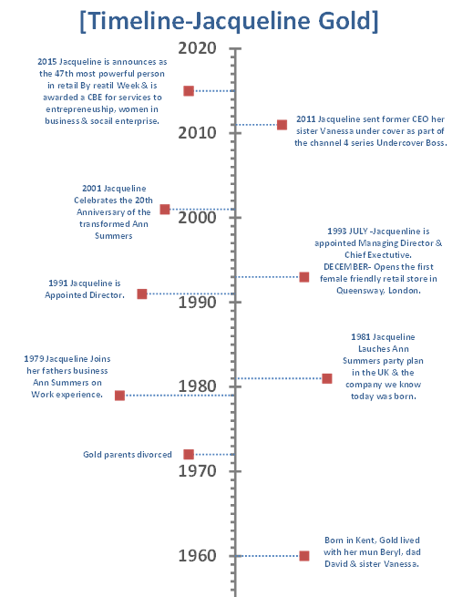

1.2 Conceptualising Leadership questionnaire
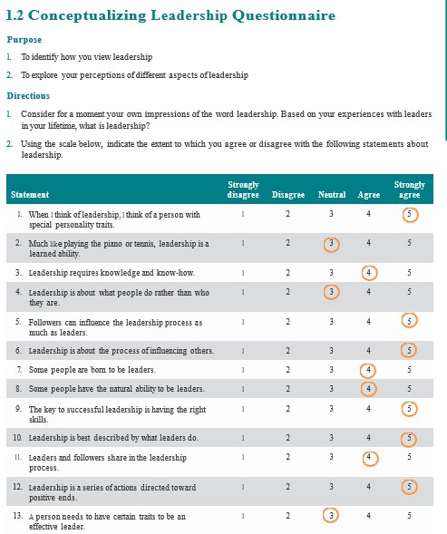
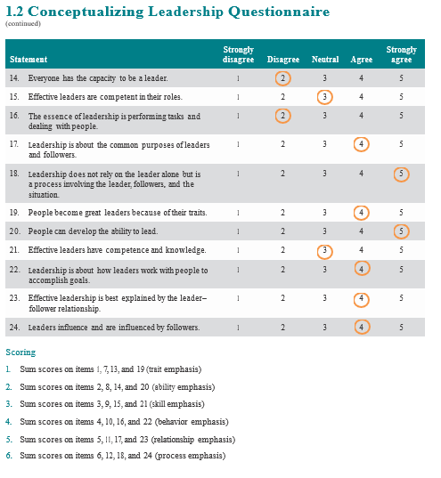
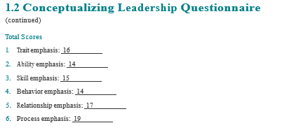

1.3 Leadership Styles Questionnaire.
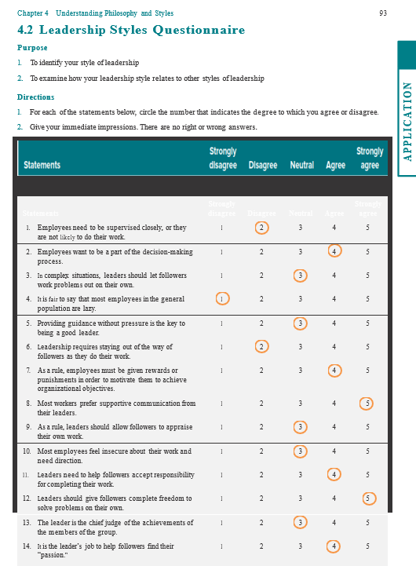
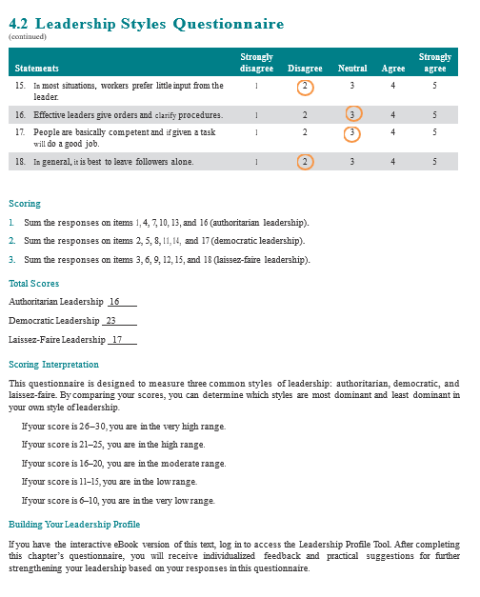

Reference List
- Adair, J (2013) ‘Develop your Leadership Skills’. 2nd Edition: Creating Success. London. Kogan Page.
- Ballard, O (2020) Who Are the UK's Top 32 Online Retail Leaders? | Business Leader News. [online] Business Leader. Available at: https://www.businessleader.co.uk/business-leader-magazines-top-32-online-retail-leaders/100800/ [Accessed 24 October 2020].
- Billig, M (2015) ‘Kurt Lewin's Leadership Studies and His Legacy to Social Psychology: Is There Nothing as Practical as a Good Theory?’ Journal for the Theory of Social Behaviour. 45(4) pp. 440-461.
- Bloisi, W (2003) Management and Organisational Behaviour. European Edition. McGraw Hill Education. Berkshire.
- Buchanan, D. A & Huczynski, A. A, (2010) Organisational Behaviour. 7th Edition. Pearson Education Ltd. Essex.
- Channel 4 News, (2018) Jacqueline Gold on Sexual Culture, Empowering Woman and What Holding Back the High Street. [video] Available at: https://www.youtube.com/watch?v=YTjpIKKu0i0&feature=emb_logo [Accessed 4 November 2020].
- Channel4.com, (2011) Undercover Boss - All 4. “Vanessa Gold, Ann Summers”. [online] Available at: https://www.channel4.com/programmes/undercover-boss/on-demand/50658-001 [Accessed 1 November 2020].
- Davidgold.co.uk, (2018) Profile | David Gold. [online] Available at: http://www.davidgold.co.uk/profile [Accessed 14 November 2020].
- Drapers Online, (2020) Drapers Connects: Talking Retail with Ann Summers CEO Jacqueline Gold. [video] Available at: https://www.youtube.com/watch?v=2cZsyNUtah0&feature=emb_logo [Accessed 17 October 2020].
- Fiaz, M (2017) ‘Leadership Styles and Employees’ Motivation: perspective from an emerging economy’. Journal of Developing Areas. 51(4) pp. 143-157.
- Gagne, M & Deci, E. L (2005) ‘Self Determination Theory and Work Motivation’. Journal of Organisational Behaviour. 26. pp. 331-362.
- Gandolfi, F & Stone, S (2016) ’Clarifying Leadership: High-impact leaders in a time of leadership crisis’. Review of International Comparative Management. 18(1) pp. 18-30.
- Gandolfi, F (2017) ‘The Emergence of Leadership Styles: A Clarified Categorization’. Review of International Comparative Management / Revista de Management Comparat International. 18(1), pp.18–31.
- Gandolfi, F & Stone, S (2018) ‘Leadership, Leadership Styles and Servant Leadership. Journal of Management Research. 18(4) pp. 261-269.
- Gill, R (2006) ‘Theory and Practice of Leadership’. London. SAGE.
- Gleeson, B (2016)10 Unique Perspectives on What Makes A Great Leader. [online] Forbes. Available at: https://www.forbes.com/sites/brentgleeson/2016/11/09/10-unique-perspectives-on-what-makes-a-great-leader/?sh=549fa7bd5dd1 [Accessed 6 November 2020].
- Gold, J (1995) ‘Good Vibrations: The Story Behind Ann Summers’. Pavilion. London.
- Goleman, D (2000) ‘Leadership that gets results’. Harvard Business Review. 78(2) pp. 78.
- Hussain, S. T, Lei. S, Akram. T, Haider. M. J, Hussain, S. H & Ali, M (2018) ‘Kurt Lewin’s Change Model: A Critical Review of the Role of Leadership and Employee Involvement in Organisational Change’. Journal of Innovation and Knowledge. 3(3) pp. 123-127.
- Hansen, J (2013) ‘Seven Steps for Effective Leadership Development. Human Resources Magazine. 18(5) pp.14-16.
- Tucker, (2020) Holly & Co: Conversations of Inspiration with Jacqueline Gold CBE. [podcast] Empowering women in the bedroom & in the board room with Jacqueline Gold CBE, CEO of Ann Summers. Available at: https://www.youtube.com/watch?v=Qb9WpGFJs_I [Accessed 24 October 2020].
- Isaac, R. G, Zerbe, W. J & Pitt, D. C (2001) ‘Leadership and Motivation: The Effective Application of Expectancy Theory’. Journal of Managerial Issues. 13(2) pp. 272-226.
- Jacqueline Gold, (2020a) Biography - Jacqueline Gold. [online] Available at: http://www.jacquelinegold.com/profile/biography/ [Accessed 14 October 2020].
- Jacqueline Gold, (2020b) Profile - Jacqueline Gold. [online] Available at: http://www.jacquelinegold.com/profile/timeline/#2008 [Accessed 14 October 2020].
- Jacqueline Gold, (2020c) Brand Values - Jacqueline Gold. [online] Available at: http://www.jacquelinegold.com/ann-summers/brand-values/ [Accessed 29 October 2020].
- Johns, H. E & Moser, H. R (1989) From Trait to Transformation: The Evolution of Leadership Theories’. Education. 110(1) pp. 115-122.
- Leadership and Performance, (2019) Lewin's Leadership Theory Explained - Leadership and Performance. [online] Available at: https://leadershipandperformance.com.au/leadership-development/lewins-leadership-theory-explained/ [Accessed 8 November 2020].
- Luenendonk, M (2020). Democratic Leadership Guide: Definition, Qualities, Pros & Cons, Examples. [online] Cleverism. Available at: https://www.cleverism.com/democratic-leadership-guide/ [Accessed 12 November 2020].
- Lunenburg, F. C(2012) Power & Leadership: An influence process. International Journal of Management, Business and Administration. 15(1). pp. 1-9.
- Miloloza. I (2018) ‘Analysis of the Leadership Style in Relation to the Characteristics of Croatian Enterprises’. Interdisciplinary description of complex systems, 16(2), pp. 249–264.
- Mullins, L. J (1999) ‘Management and Organisational Behaviour’. 5th Edition. Financial Times. London.
- Mullins, L. J (2007) ‘Management and Organisational Behaviour’. 8th Edition. Prentice Hall. Essex.
- Muresanu, D (2017) ‘Theoretical Approach to the Measure of the Psychological Contract of Employees’. Annals of the University of Oradea, Economic Science series. 26(2) pp. 405-410.
- Northouse, P. G (2004) ‘Leadership: Theory and Practice. 3rd Edition. Thousand Oaks. California. SAGE.
- Northouse, P. G (2012) ‘Introduction to Leadership Concepts and Practice’. 2nd Edition. London. SAGE.
- Parijat, P & Bagga, S (2014) ‘Victor Vroom’s Expectancy Theory of Motivation- An Evaluation. International Research Journal of Business and Management. 7(9) pp.1-8.
- Penny Brohn UK, (2018) In Conversation with Jacqueline Gold, CBE. [video] Available at: https://www.youtube.com/watch?v=U-_Qq2BNLgI [Accessed 6 November 2020].
- Rast, III & David, E (2013) ‘Self-Uncertainty and Support for Autocratic Leadership’. Self and Identity. 12(6) pp. 635-650.
- Rosari, R (2019) ‘Leadership Definition Applications for Lectures’ Leadership Development’. Journal of Leadership Organisations. 1(1) pp. 17-28.
- Ryan, Richard M & Deci, Edward L, (2020) ‘Intrinsic and extrinsic motivation from a self-determination theory perspective: Definitions, theory, practices, and future directions’. Contemporary educational psychology. 61. pp.101860.
- The Business Voice, (2014). Jacqueline Gold, CEO, Ann Summers With Anthony Gell. [video] Available at: https://www.youtube.com/watch?v=2eIJWJLHuk8 [Accessed 24 October 2020].
- Tracey, J. B & Hinkin, T. R (1998) ‘Transformational Leadership or Effective Managerial Practices?’. Group & Organisational Management. 23(3). pp. 220-236.
- Sethuraman, K & Suresh, J (2014) ‘Effective Leadership Styles’. International Business Research. 7(9) pp.165-170.
- Shafique, I, (2017) Shifting Organisational Leadership Perspectives: An overview of leadership theories. International Journal of Economic Perspectives. 11(4). pp. 134-144.
- Shazia, T. S, Anis-ul-Haq, A. M & Niazi, G. S. K (2014) ‘Leadership Styles: Relationship with Conflict Management Styles. International Journal of Conflict Management. 25(3) pp. 214-225.
- Singh, N (2017) 11 Personality Traits of Steve Jobs. [online] Linkedin.com. Available at: https://www.linkedin.com/pulse/11-personality-traits-steve-jobs-navrajvir-singh [Accessed 6 November 2020].
- Understanding Leadership, (2018) [pdf] SAGE Publications LTD, pp.1-19. Available at: https://us.sagepub.com/sites/default/files/upm-assets/96833_book_item_96833.pdf [Accessed 6 November 2020].
- Virgin Start Up, (2014) Jacqueline Gold At #Virginwow. [video] Available at: https://www.youtube.com/watch?v=62rU5G31KYY&feature=emb_logo [Accessed 24 October 2020].
- White, S (2018) What Is Transformational Leadership? A Model for Sparking Innovation. [online] CIO. Available at: https://www.cio.com/article/3257184/what-is-transformational-leadership-a-model-for-motivating-innovation.html [Accessed 16 November 2020].
- Williams, Z (2011) TV review: Undercover boss; True stories- Voices from the Killing Field. The Guardian, [online] Available at: https://www.theguardian.com/tv-and-radio/2011/jul/06/undercover-boss-tv-review [Accessed 21 October 2020].

Bibliography
- Cohen, W (2018) ‘Drucker And Principles of Success: Lessons that are still the basis of leadership success’. Leadership Excellence. 35(5) pp.58–62.
- Deventer, V, Cilliers, F & R, V, Eeden (2008). ‘Leadership styles and associated personality traits : support for the conceptualisation of transactional and transformational leadership’. South African Journal of Psychology. 38(2) pp.253–267.
- Gill, R (2011) ‘Theory and Practice of Leadership’. 2nd edition. London. SAGE.
- “The House I Grew up in, featuring Jacqueline Gold”. The House I Grew Up In. 13 August 2007. BBC Radio 4.
- Goleman, D (2006) ‘The Socially Intelligent Leader. Educational Leadership. 64(1) p.76-82.
- Rust, D (2013) Jacqueline Gold Completely Satisfying. Endeavour Magazine, [online] pp.6 - 9. Available at: http://www.jacquelinegold.com/wp-content/uploads/2013/11/Endeavour-Magazine-October-2013-6-7-low.pdf [Accessed 14 October 2020].
- Ryan, Richard M & Deci, Edward L, (2000). ‘Intrinsic and Extrinsic Motivations: Classic Definitions and New Directions’. Contemporary Educational Psychology, 25(1) pp.54–67.
- Uslu, O (2019) ‘A General Overview to Leadership Theories from a Critical Perspective. Marketing and Management of Innovations. (1) pp. 161-173.

