
APPENDIX GA36a

LEVEL 4 ASSESSMENT SPECIFICATION

Student name: | Adam David Moore | Student ID number: | 1004334
Programme: | BSc Applied Data Science
Module: | Software Development
Module code: | ACCA4017 | Contribution to Overall Module Assessment (%): | 70%
Lecturer: | Gaynor Thomas | Internal Verifier: | Michael Dacey
Assignment Title: | Programs in C and documentation – Part C | Word count (or equivalent): | 910 excluding annotated code
Submission deadline: | 2nd May 2019 | Return date of provisional marks & written feedback: | 20 working days after assignment deadline.

Contents

Solution Breakdown 3
Annotated Code 4
Program Testing 7

Develop a C program to allow the user to play a version of a popular card matching game.

Solution Breakdown

- The types of variables required to build such a program must be ascertained. It is perhaps not essential to add all of these in prior to commencing the coding of your program, it is certainly helpful to run through the program you are looking to build prior to commencing and pick out any obvious variables. This approach helps to build a picture of the program as a whole prior to coding it.
- Declare these variables. What appears obvious prior to commencing and what does not is dependent on the skill and experience of the programmer.
- Values to be stored in the array should be hard-coded in this example. There is no need to generate random numbers and assign them to each array element in this program. All we must do is ‘shuffle’ or mix the order of the hard-coded values within the array, so they are randomly ordered, just as cards are shuffled/mixed in a real-life pairs game.
- A short for loop and a few intermediary variables can be utilised to ‘randomly’ switch the position of each array element with another array element. Initialising this loop twelve times (size of array) would ensure that each array element has its value randomly switched with another array element. This process can be referred to as the ‘shuffling’ or randomisation of the order of our array elements. This ‘shuffling’ could be done several times.
- A ‘counter’ should be utilised to track the number of turns a player has taken (how many times they have initialised ‘playagain’ with the same set of shuffled cards).
- A series of ‘print’ functions should be used to engage with the user, demonstrating what the program is (card game) on a basic level and requesting values from the user. These values should be stored in variables. Parameters should be created to ensure user is advised of any reason their entry is not appropriate.
- Via if/else functions, print outcomes of users selections. Demonstrate whether a pair was matched or not. Add a counter for the outcome where the user does match a pair. This will enable the user to keep track of their total number of pairs found throughout the game.
- Offer the user a chance to playagain, if they elect not to, demonstrate the order of the cards (turn the cards over) so the user can see the random order.

Annotated Code

#include <stdio.h>
#include <stdlib.h>
#include <time.h>

int card1, card2, choice1, choice2; // declared variables to store selected card values and modified (-1) values (choice) to account for array.
int cards[12]; // Array to store card values in
int playagain; // Variable declared to enable playagain while loop
int i, randomindex, temp; // variables required to 'shuffle' or mix our hard-coded array values
int count = 0; // used as a counter for turns taken
int count2 = 0; // used as a counter for pairs matched

void main(void)
{
playagain = 1; // value determined prior to while loop to ensure program within while loop initiates at least once, user will be able to reset this value once the program has looped - choosing whether to re-loop (1) or exit (other value).

int cards[12]{ 1,1,2,2,3,3,4,4,5,5,6,6 }; // values are hard-coded, this is done as in this pairs game we know what we want the values to be (two series of 1-6) so all we then need to do is 'shuffle' or randomise the order/sequence of the array rather than generate actual random values.

srand(time(NULL)); // seed randomness (time)

for (i = 0; i < 12; i++) // for loop to ensure 12 rotations to randomise every position in array - this loop utilises intermediary variables to effectively 'switch' each element on the array randomly. The random index determines which element on the array will be 'switched' with the first, then second, then third (and so on) elements of the array until all twelve points have been switched.
{
int randomindex = rand() % 12; // generates random number between 0 and 11, effectively acts as selector
int temp = cards[i]; // stores value from each array element into temp in every individual loop
cards[i] = cards[randomindex]; // 'switches' array value with random index value
cards[randomindex] = temp; // 'switches' what is now the random index value, previously the value stored in the array element (cards[i]) with temp
}

for (i = 0; i < 12; i++) // Multiple shuffles
{
int randomindex = rand() % 12;
int temp = cards[i];
cards[i] = cards[randomindex];
cards[randomindex] = temp;
}

for (i = 0; i < 12; i++) // Multiple shuffles
{
int randomindex = rand() % 12;
int temp = cards[i];
cards[i] = cards[randomindex];
cards[randomindex] = temp;
}

while (playagain == 1) // while loop to ensure user can re-initiate program without exiting if desired
{
count = count + 1; // acts as counter to keep track of turns taken

printf("Please Select 2 Cards: \n\n"); // Engaging with user to request two values from them
printf("__________________________\n"); // Attempt to make program have very, very basic 'graphics' and add to game immersion - intended to make the values 'feel' more like actual cards
printf("1|2|3|4|5|6|7|8|9|10|11|12\n\n\n"); // Values stipulated to demonstrate the card sequence and subsequent 'selections' to user prior to making selection

printf("Let's see if you can find a pair!!\n\n"); // Engaging with user

int card1, card2; // variables declared for card selections

card1 = 0, card2 = 0; // values outside subsequent while parameters initially declared to ensure loops initialise at least once

while (card1 < 1 || card1 > 12) // ensuring user inputs values within the desired range (array)
{
printf("Enter your first card (1-12):\n\n"); // value requested
scanf("%d", &card1); // value stored in card1

if (card1 < 1 || card1 > 12) // if value input is outside parameters, user is advised of issue
printf("Oops! Your number didn't meet the parameters.\n\n");
}

while (card2 < 1 || card2 > 12) // same process as before, this time for card 2
{
printf("Enter your second card (1-12):\n\n");
scanf("%d", &card2); // value stored in card2

if (card2 < 1 || card2 > 12)
printf("Oops! Your number didn't meet the parameters.\n\n");
}

choice1 = card1 - 1; // twelve array values are actually stored 0-11 rather than 1-12, subtracting one from the requested value (1 to 12) aligns these values to array values.
choice2 = card2 - 1;

if (card1 == card2) // where the same card has been selected the program will terminate, the value will definitely be the same however the deck is shuffled if the same 'card' is being selected twice.
{
printf("You picked the same card twice!\n\nYou need to pick two different cards to play\n\n");
}

else
{

if (cards[choice1] == cards[choice2]) // if all prior parameters are satisfied and the values stored in the selected 'cards' or array elements are identical, the user has found a pair and wins!
{
count2 = count2 + 1; // adds one onto counter
printf("The first card you selected was a number %d and the second card you selected was also a number %d !!!!\n\n", cards[choice1], cards[choice2]); // demonstrates the values associated to the two selected cards, in this instance they are identical and the print function demonstrates this
printf("You did it!! That's a match!!\n\n");

}
else
{
printf("The first card you selected was a number %d and the second card you selected was a number %d .... \n\n", cards[choice1], cards[choice2]);// demonstrates the values associated to the two selected cards, in this instance they are different and the print function demonstrates this
printf("Sorry, no match this time. Try Again!\n\n"); // user is notified of failure to select a matching pair
}

}
printf("You have had %d turn(s) so far!\n\n", count); // demonstrates no of turns taken
printf("You have matched %d pair(s) so far!\n\n", count2); // demonstrates no of pairs matched
printf("\nWould you like to turn the cards over or play again?\n\nPlease Type '1' and hit enter to play again\n\nAlternatively, type 0 and hit enter to stop playing and reveal the cards.\n\n"); // offers user opportunity to re initialise program within playagain while loop

scanf("%d", &playagain); // stored value in playagain, if '1' the loop reinitialises, if anything else it terminates the program

if (playagain != 1)
{
printf("Here were the cards!: \n\n");
printf("_______________________\n");
printf("%d|%d|%d|%d|%d|%d|%d|%d|%d|%d|%d|%d\n\n\n", cards[0], cards[1], cards[2], cards[3], cards[4], cards[5], cards[6], cards[7], cards[8], cards[9], cards[10], cards[11]); // the cards are revealed as they were shuffled. This will demonstrate the randomised order of the cards that the user was previously unaware of.

}

}

}

Program Testing

Please note, green boxes have been placed around user-input values as a visual aid.

Test 1 – All values within specified parameters

1.1
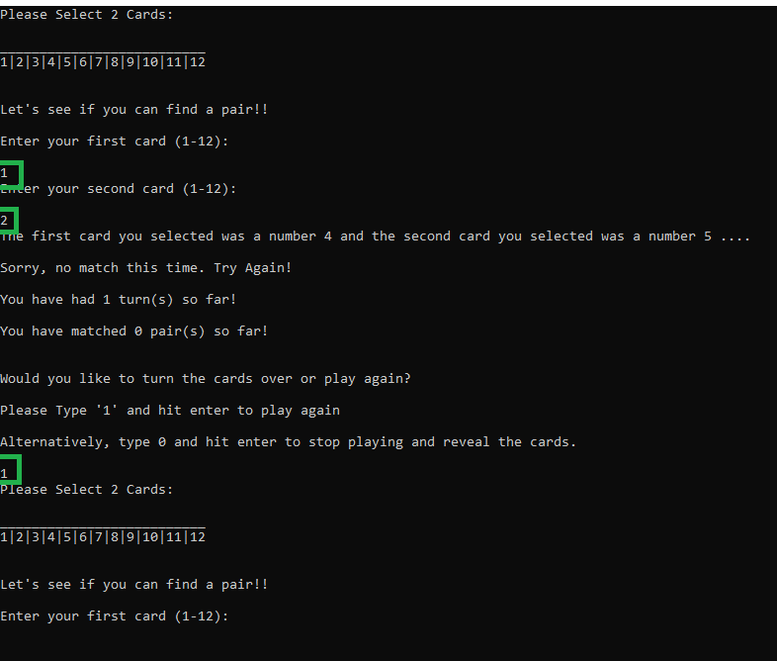

Outcome: Works as expected.

1.2
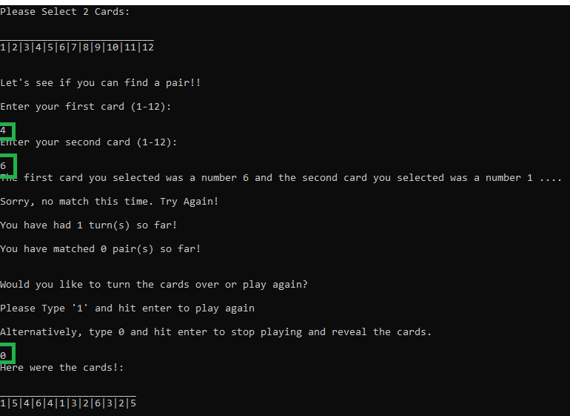

Outcome: Works as expected.

Test 2 – Numbers outside expected parameters

2.1
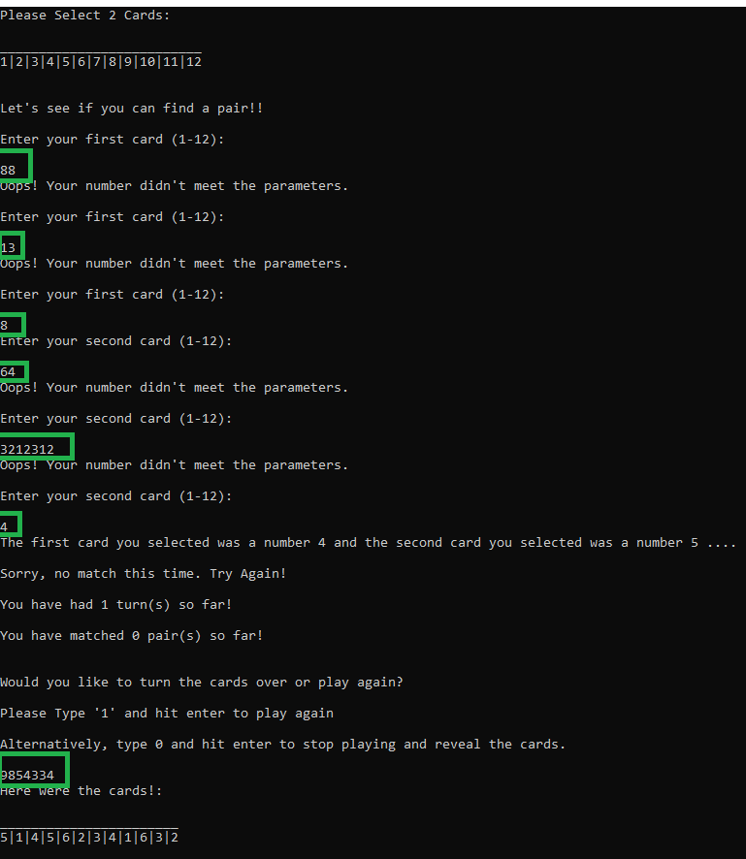

Outcome: Works as expected. Whole, positive values outside of specified parameters simply ask the user for another value. The ‘playagain’ variable is set so that any whole number other than 1 will reveal the ‘cards’ and end the game.

Test 3 – Negative values entered

3.1
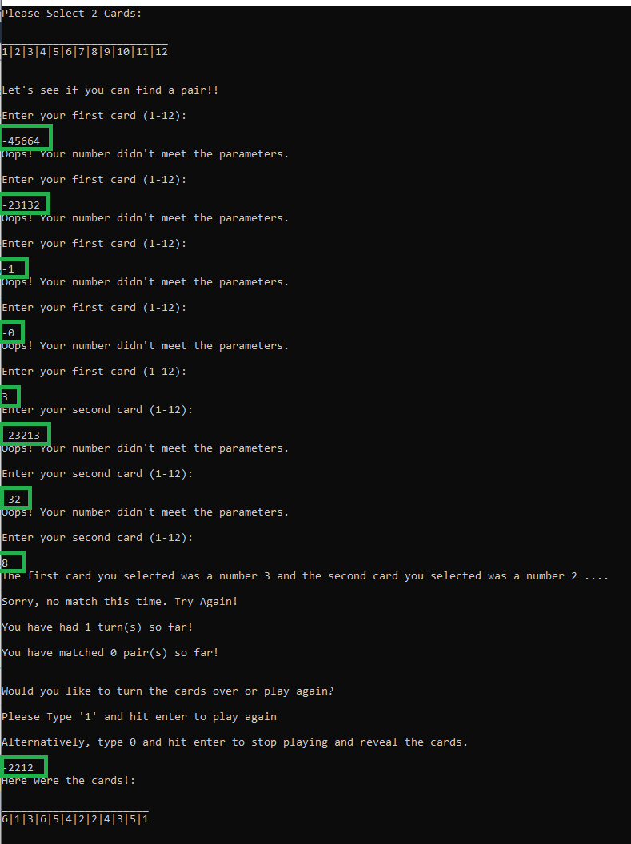

Outcome: Works as expected, values are simply outside of the parameters and so users are prompted to enter another. The ‘playagain’ variable is set so that any whole number other than 1 will reveal the ‘cards’ and end the game – this includes whole negative values.

Test 4 – Decimal or ‘float’ values entered

4.1

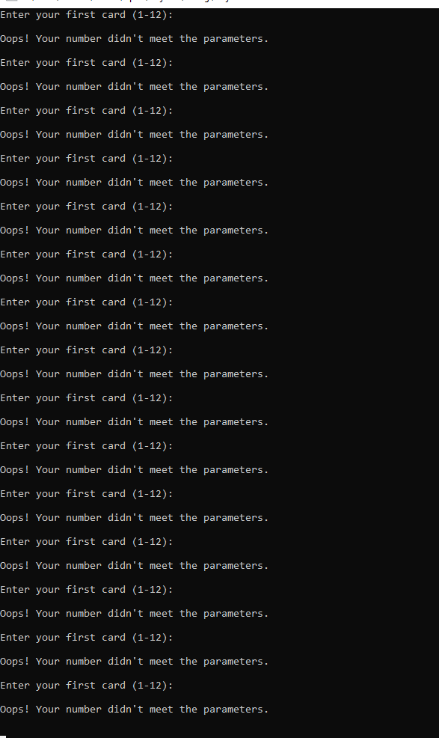

Outcome: Program error, infinite loop entered, and program must be terminated. This is true for ALL decimal values entered in ANY field within this program. Decimal values between 1 and 12, decimal values greater than 12, decimal values less than 1. This includes decimal values entered the ‘playagain’ function. This is because the program is being asked to store a ‘float’ variable type into an ‘integer’ variable type.

Test 5 – Character or ‘char’ values entered

5.1

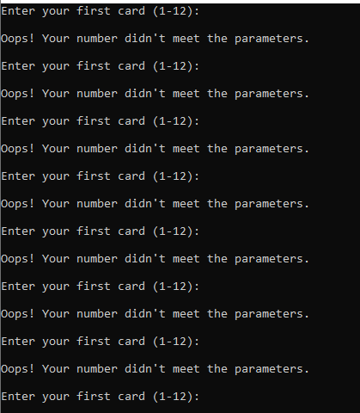

Outcome: Program error, infinite loop entered, and program must be terminated. This is true for ALL character values entered in ANY field within this program. This includes character values entered the ‘playagain’ function. This is because the program is being asked to store a ‘char’ variable type into an ‘integer’ variable type.

Test 6 – Symbols entered

6.1

Outcome: Program error, infinite loop entered, and program must be terminated. This is true for ALL symbols entered in ANY field within this program.

Test 7 – Same card selected twice (Would always be a pair)

7.1

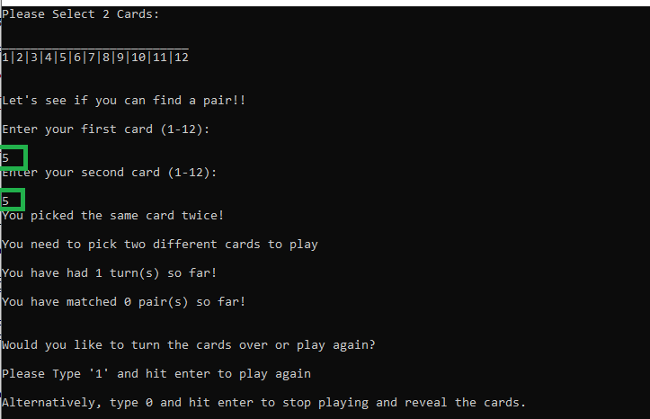

Outcome: Program ran as expected. The program prevents users from selecting the same card twice, thus always being guaranteed a ‘pair’ (we would be selecting the same array element twice, so the value is ALWAYS going to be the same).

Test 8 – Testing Counters

8.1

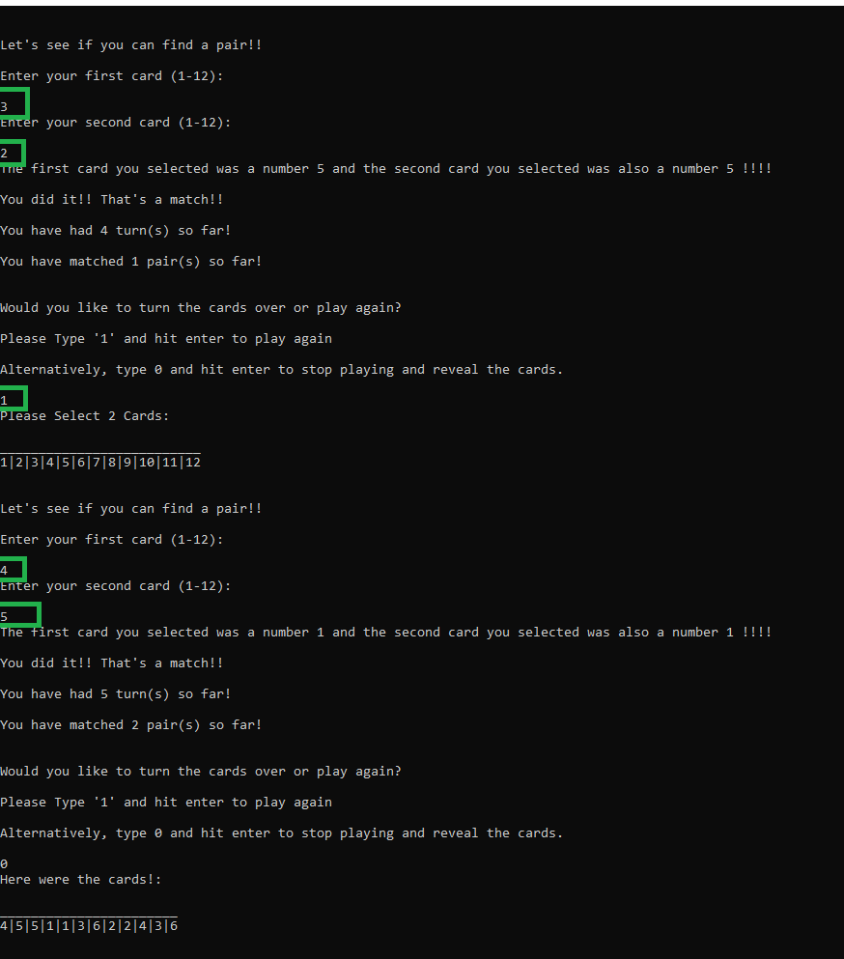
Outcome: Program ran as expected. Counters worked exactly as intended, with one counting each turn (3 turns were conducted prior to this screenshot) and the pairs also being counted each time a pair was matched.

Test 9 – Testing randomness of array order

9.1

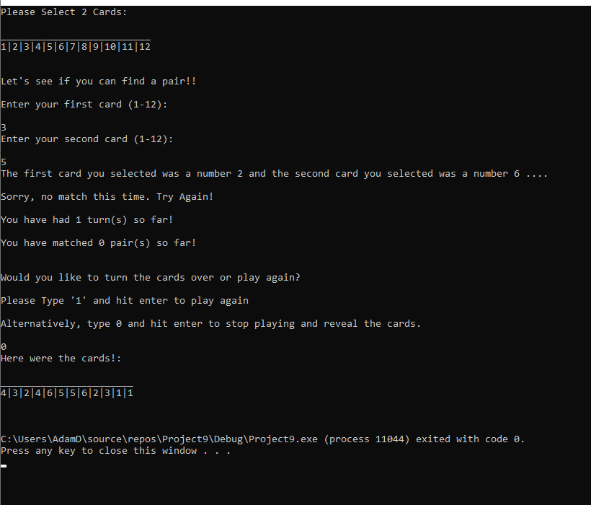

Outcome: Sequence appears to have been randomised.

9.2

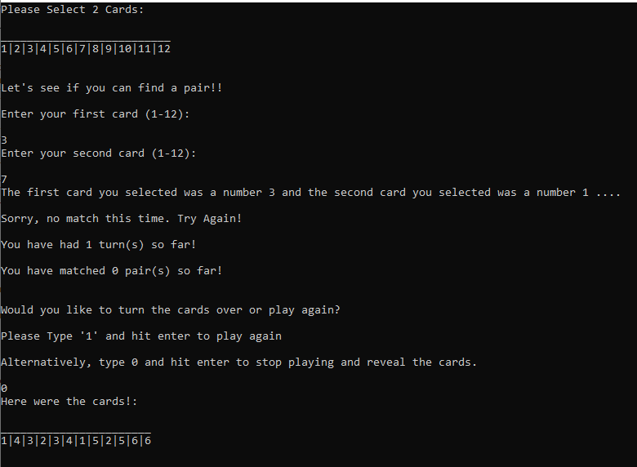

Outcome: Sequence appears to have been randomised.

9.3

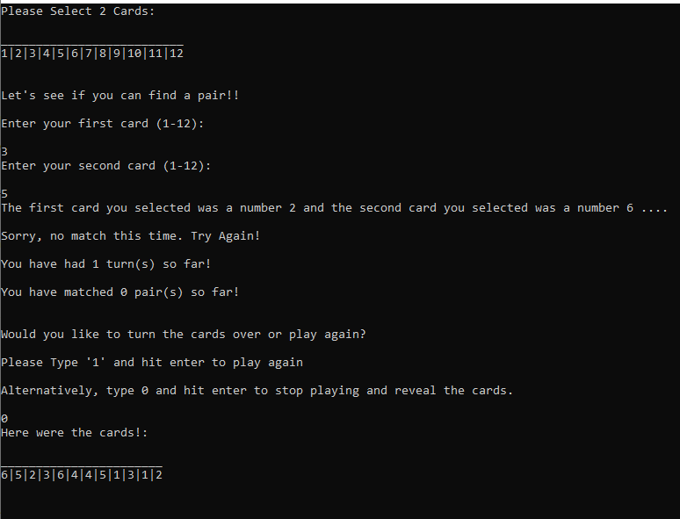

Outcome: Sequence appears to have been randomised. The array is in a different order each time the program is run, there is enough evidence to determine that the randomisation of order in the array works as expected.

Test 10 – Can the same pair be selected multiple times

10.1

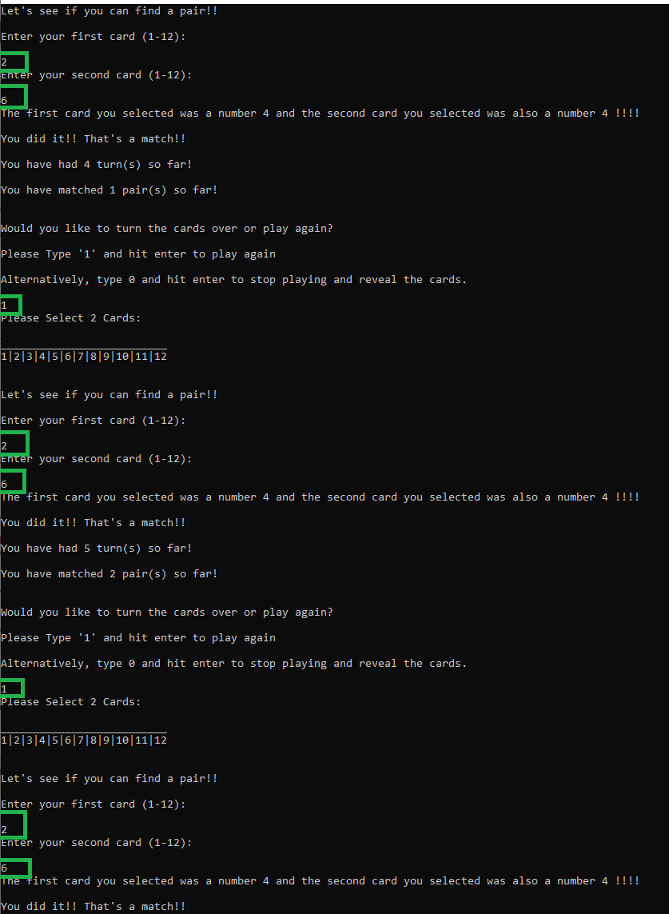

Outcome: Program is vulnerable to exploitation, there is nothing to prevent users from selecting the same pair numerous times and ‘achieving’ 6 pairs in very few turns.

