Your name: Stela Guriuc
Student number: 2239707

Title of Essay: A comparison of the marketing methods of two multinational hotel brands - Six Senses and Holiday Inn.

Module Tutor: Scott James
Submission date: 19.05.2023
Word count: 1500

This essay offer a big opportunity to analyse the marketing methods of two multinational hotel brands, Six Senses and Holiday Inn. These can be done by using a large variety of methods including digital marketing, internal and external marketing analysis, marketing mix, segmentation, targeting and positioning.
Holiday Inn slogan is” We keep it simple and smart”. (ihgplk.com- Holiday Inn Express)
That means – Holiday Inn is positioned in the mid-range segment of hospitality. They offer traditional experiences with a focus on comfortability, affordability and accessibility. Their important marketing effort is focused on brand recognition. They use different loyalty programs, for example, offer points that can be used for free stay and other benefits.
On the other hand, Six Senses is a luxury brand hotel positioned at a higher-end segment of hospitality. Their marketing methods focus on their unicity, wellnesses, and sustainability. Located in exotic places, they offer a unique experience that emphasizes harmony with nature and collaborating with other luxury brands like Audy, Net Jets- offer unique experiences.
Their slogan is” Feel more alive. Be part of a community. Play.”(sixsenses.com-about as.)
The first marketing method analyzed in the essay is SWOT. It helps the brands to increase their strengths, build new opportunities, work out their weaknesses and try to face well the threats for improving their market position.
Holiday Inn strengths make it well recognized- it is amazing that 9 out of 10 travelers have stayed in the Holiday Inn hotel, large worldwide expended- over 1200 accommodations, benefiting from its parent company's high brand value- IHG Group.
However, it has and weaknesses like a huge number of competitors- for example, Premier Inn, Ibis, Travelodge, that are more expanded and offer lower prices, bad revenue- from 2020 the guest feedback has not been that great anymore. They reviewed it as bad, poor and average (Trust Pilot, 2021).
A good opportunity for Holiday Inn is expanding to new destinations.
Because of the profitability of UK Holiday Inn Hotels, the IHG group, has approved the investments (2018) in opening the new hotels (for the next 15 years) in Germany, and other different worldwide destinations well-searched for travelers.
Their business faces lots of threats like again big concurrence, continuous modernization, and for the last few years it was affected as well by global lockdown and Ukraine’s war.
Future investments, development activities, and new hotel openings in Russia have been put on hold, and the company's Moscow office has been closed. However, the company is committed to supporting its employees during this time. The company has also offered temporary accommodation to refugees in neighboring countries, including Ukraine. In addition, the company made a substantial donation to both CARE International and the International Federation of Red Cross and Red Crescent Societies (IFRC) to help their efforts in providing aid, food, and water to refugee groups worldwide, including those in urgent need in Ukraine.
On the other hand, Six Senses developed strengths are their orientations on wellnesses- working out the feeling of being well in your body, mind and spirit, sustainability- the end of the plastic is only the start of the story, developing into so much more. And unique and fan way of doing things-surprising with a warm welcome, and birthday celebration. (sixsenses.com- plastic free)
Their big weakness is their willing to always be in trend, a trend-setter rather than a trend-follower. That involves continuously investing in modernization, finding new ideas and new exotic spaces for expansion. That makes them more expensive, too. Another weakness is the low number of accommodations- 21.
They have the opportunity to open new properties in the most searched places by travelers and offer a wider range of amenities to compete with the larger luxury hotel brands.
Different hotels and resorts with the same orientation- all green and sustainable popped onto the market. That makes it a threat for Six Senses, however, they continue to be in the first position, due to their approach to local specificity.
An External, PESTLE analysis can help our brands, Six Senses and Holiday Inn, by being well-informed about any political, economic, sociocultural, technological, legal and environmental modifications, to observe and implement any external opportunity and prevent threats.
Political factor affects both, Six Senses and Holiday Inn hotel occupancy rates, by any political instability (Ukraine’s war), by applying the visa and some additional taxes.
The economical factors which affect Six Senses and Holiday Inn hotels are the economic growth or downturn, which can increase their profitability or reduce the demand. As well the inflation rate, the exchange rate affects the hotel rates and revenue.
The sociocultural factors like-wellnesses, sustainability and local culture, make
people increase their demand for eco-tourism and experiential travel which affects positively the Six Senses hotel rates. But cultural changes, for supporting luxury, can negatively affect the hotel.
Holiday Inn is supporting any kind of cultural background and preferences. That increases the visitor's interest in the hotel. But as well the cultural changes which support travel and tourism can affect not so well their business.
Technological factors affect positively and negatively the evolution of these two brands. It can benefit them because of the new, performant technology creating a good guest experience. But that reduces the need for people's interaction, and the need for the hotels.
Legal factor affects the Six Senses and the Holiday Inn hotels, because of continuous changes in legal codes, laws and environmental regulations. To follow them, is quite expensive, sometimes, but to not follow them, can result in fines and legal actions.
The Environmental factor show that both hotels engage in sustainability, with a big emphasis- Six Senses, so a change in environmental regulation, can well affect them. As well natural calamities and climate have an enormous impact on hotel development.
Marketing Mix, called the 7 Ps of Boom and Bither helps to highlight the differences and similarities between the two brands using the tools: product, price, place, promotion, people, process and physical evidence.
That helps to understand that Holiday Inn is a mid-scale hotel with medium prices, and comfortable features, placed in convenient locations, that has a good promotion program, well-trained people and easy, standard processes. (Tab.10- Appendix)
When Six Senses, positioned at a high-end level, with high prices, orientated to unicity and wellnesses based on their focus on sustainability, located in beautiful remote places, has friendly, carefully trained people, the specific process for delivering wellness experience, creating a sense of tranquillity and relaxation. (Tab 9 Appendix)
A segmentation comparison strategy using Similar Web variables show that both gender, male and female are interested in these two hotel brands. Six Senses is more preferred by 18- 34 years old people-attracted by diversity and exciting occupations, bat Holiday Inn- by 35 and more- prefers stability and confidence. (Tab 1-2 Appendix)
It is visible that Holiday Inn hotel brand is more preferred by, US and UK, while Six Senses is by, France, India, Australia.
Behavioural, Holiday Inn is preferred by the people that look for confidence, affordability and a sense of community. While the Six Senses for sustainability, wellness and luxury. That information is mostly shared by capitaloneshoping.com, avionio.com, phunuketnoi.com on Facebook, Instagram, YouTube, etc. (Tab 5-6, Appendix)
A psychographic analysis of the Holiday Inn points to a preference for free breakfast, free WI-FI, and rewards for coming back. Bat the Six Senses people prioritize for organic cuisine, spa treatments, eco-friendly activities. On the Similar Web, we can see that the most useful sites for behavioral information are: ing.com; tripadvisor.com; google.com; portal.xpossible.com (Tab 4)
Analyzing the 4 types of targeting: Undifferentiated, differentiated, concentrated and customized, makes it well visible that the most suitable targeting type for Holiday Inn is differentiated one, when different products are offered to different segments of people- such as economic, standard and premium hotel rooms.
While, Six Senses is characterized by customized targeting, due to its unique type, proved by its orientation to a personalized approach to every guest, and offering unique experiences.
Positioning characteristics separates into objective that refers to measurable characteristics such as price, location, and amenities and subjective- emotional characteristics like- Brand Recognising, reputation, value.
Bowman’s clock is a good tool to see the objective difference between the two of brands. Holiday In positions on Low Price clock, being a mid-range hotel brand and attracting travelers with a limited budget. While Six Senses positions on Focused Differentiation position, by offering a luxury experience that incorporates sustainability, wellnesses, and local culture. (Tab 7, Appendix)
A good tool for subjective characteristics is "The perceptual positioning map”. (Tab 8, Appendix). Holiday Inn is a well-brand recognized and low value, while Six Senses is a good value and low brand recognized.
In conclusion, it is important to remark that all presented information was selected from credible sources, books, journals and sites.
Using the most important Marketing comparison methods such as SWOT, PESTLE, Similar Web, 7Ps, segmentation, targeting and positioning, makes it to understand properly what the real situation of these big brands looks like.
Both are recognized brands that offer quality hospitality services.
Holiday In being a common, standard, pleasant, which satisfies everyone’s expectations and the most importantly affordable.
Six Senses is a luxury, unique service that proves its high price with the highest quality in every single aspect.
A better opinion and understanding of the particularities of each brand can be discovered only by visiting them and personally seeing what they breathe. That could be a good point for every one of us.

References
1. Six Senses official website: https://www.sixsenses.com/
2. Holiday Inn official website: https://www.ihg.com/holidayinn/
3. "Six Senses: The Marketing Challenge of a Sustainable Luxury Hotel Brand" by Andreas Hinterhuber and Stephan Garaus, Journal of Hospitality and Tourism Insights, 2019.
4. "Holiday Inn: Case Study of Marketing Strategy" by S. S. Sreejesh and C. S. Hrishikesh, International Journal of Management and Strategy, 2016.
5. "Six Senses: A Case Study on Sustainability and Marketing of a Luxury Hotel Chain" by Hui Ling Chin and Siaw Fong Chung, Journal of Tourism and Hospitality Management, 2018.
6. "A Comparative Analysis of Marketing Strategies Adopted by Four and Five-Star Hotels: A Case Study of Six Senses and Ritz Carlton" by Ebru Güzel and Büşra Bilen, Journal of Tourism and Gastronomy Studies, 2021.
7. "Holiday Inn: A Case Study in the Effective Use of Social Media" by C. B. Bhattacharya and S. S. Sreejesh, Journal of Hospitality and Tourism Technology, 2016.
8. "The Marketing Mix of Six Senses Resorts & Spas" by Rajesh Kumar Yadav and M. M. Sulphey, International Journal of Hospitality and Tourism Administration, 2013.
9. "The Role of Branding in the Marketing Strategy of Holiday Inn" by K. K. Kirti and A. K. Gupta, International Journal of Marketing and Business Communication, 2016.
10. "Green Marketing: A Case Study of Six Senses Hotels Resorts Spas" by J. D. S. Yoshida and A. A. S. Ramos, Journal of Tourism and Leisure Studies, 2017.
11. "A Comparative Study of the Marketing Strategies adopted by Luxury Hotel Brands: A Case Study of Six Senses and Four Seasons Hotels & Resorts" by S. Agarwal and V. Jain, International Journal of Hospitality Management and Tourism, 2020.
12. "Holiday Inn: A Case Study in Effective Channel Management" by N. K. Jain and S. S. Sreejesh, International Journal of Hospitality and Tourism Systems, 2016.
13. "Marketing Strategies of Six Senses Resorts & Spas" by Anil Kumar and Arun Kumar Upadhyay, International Journal of Management and Social Sciences Research, 2013.
14. "Holiday Inn: A Case Study in Effective Revenue Management" by R. K. Srivastava and S. S. Sreejesh, Journal of Hospitality and Tourism Technology, 2017.
15. "Marketing Strategies of Luxury Hotels: A Comparative Study of Six Senses and Mandarin Oriental" by S. R. Singh and A. K. Singh, International Journal of Research in Tourism and Hospitality, 2018.

Appendix

Similar Web analysing grafs.

Tab 1- Demographic
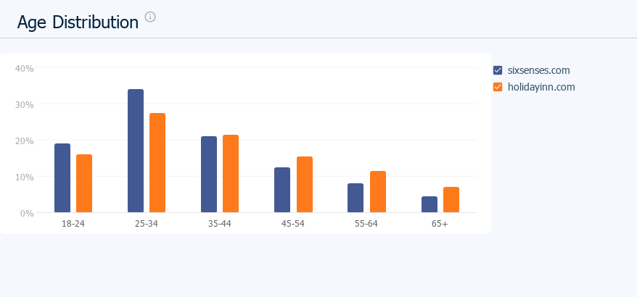
Tab 2
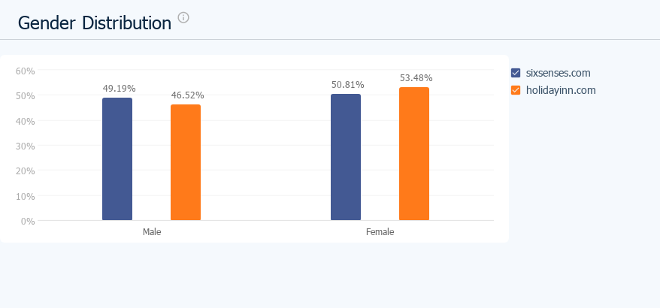

Tab 3 - Geographic graphics

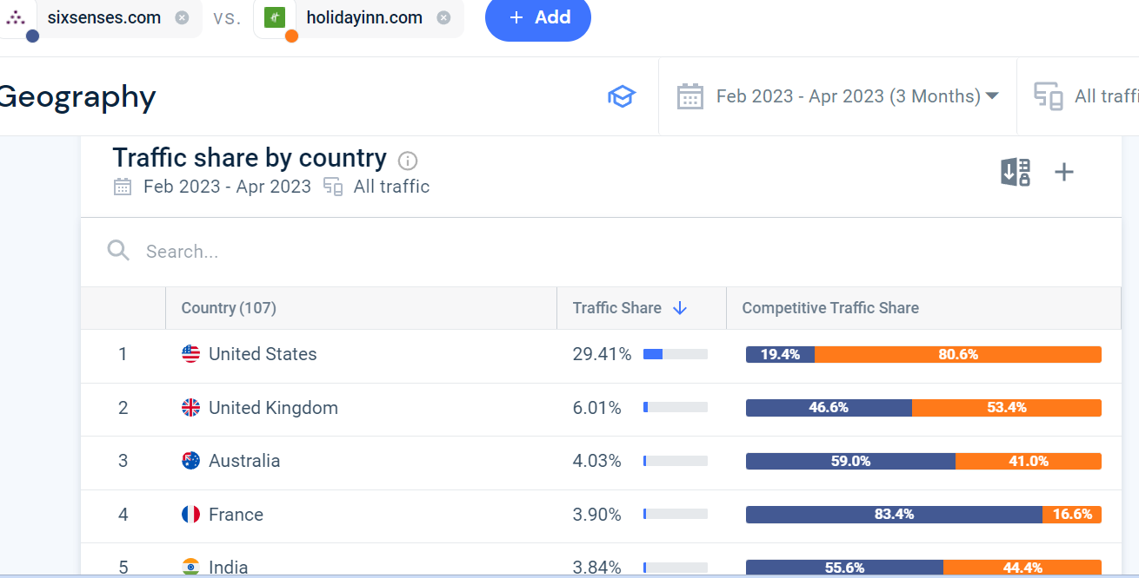

Tab 4 - Behavioural
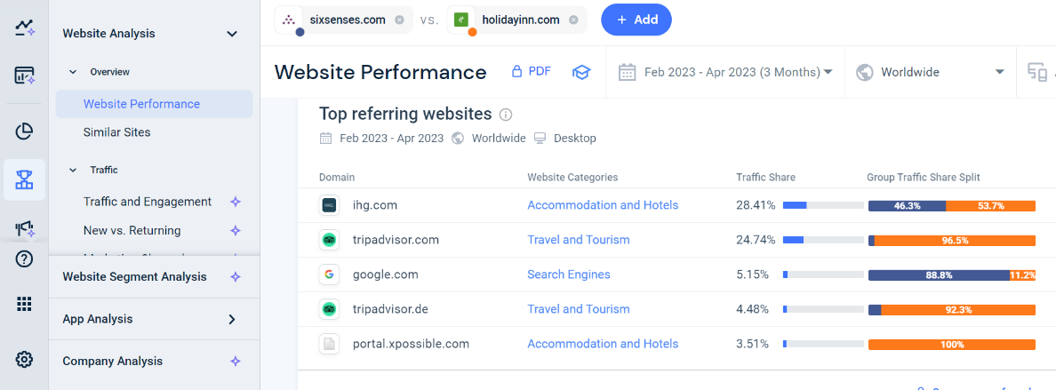

Tab 5 - Psychographic analysis
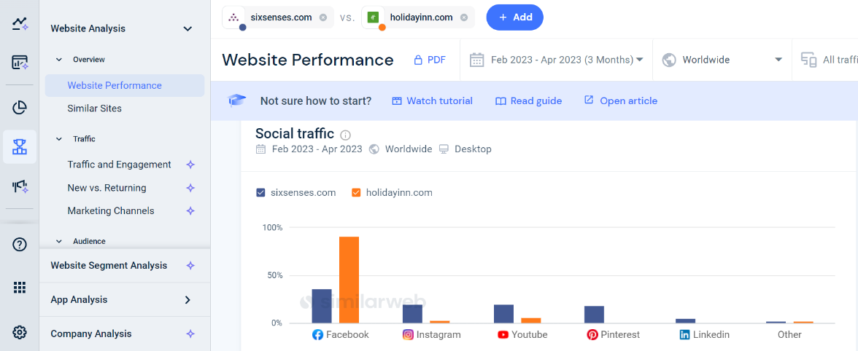

Tab 6
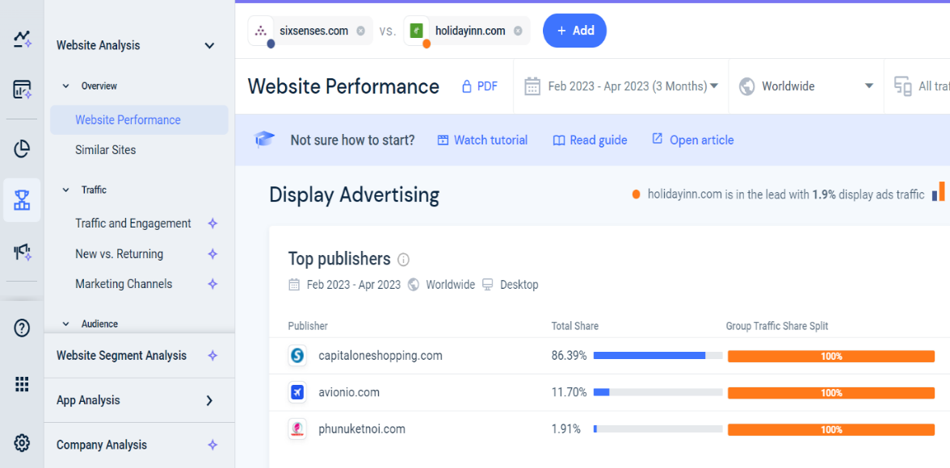

Tab 7 - Bowmans Clock
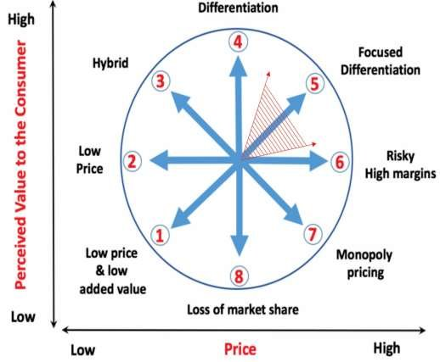

Tab 8 – Perceptual Positioning Map

High Brad Recognising

Holiday Inn

Value High Low

Six Senses
Low

The Marketing Mix
Six Senses brand personal picture (Tab 9)

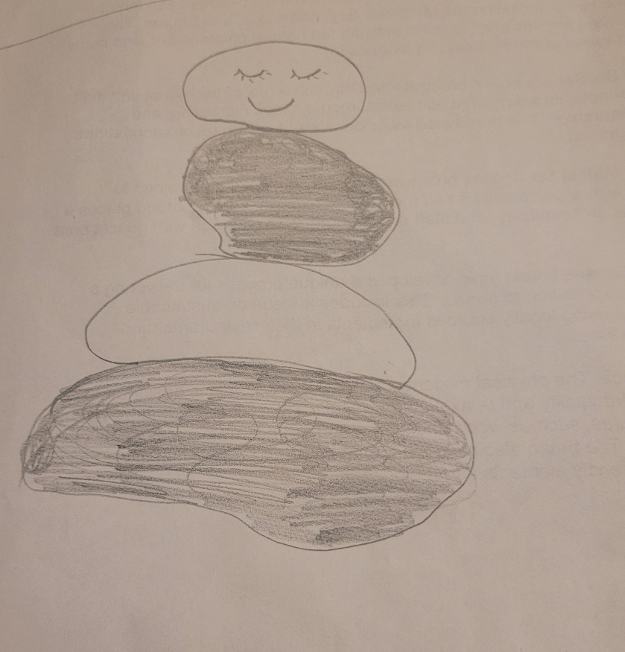
Holiday Inn brand personal picture(Tab 10)


