

Michael Sloan

Design of shaped charges

University of Wales Trinity Saint David
Advanced Physics for OME

BEng
Academic Year: 2025 - 2026

Supervisor: Prof Kelvin Dodd
January 2026

Contents
Abstract 2
Introduction 3
What is a shaped charge? 3
Uses of a shaped charge 3
History of the shaped charge 4
Results 6
Sketching 6
2D Model 7
3D Model 17
References 21
Abbreviations 24

Abstract
The given brief for the lab assignment was in two parts. First, to model, in ABAQUS, two designs of shaped charges in 2D and analyse the results. Second, to take one 2D design and undertake a 3D model, again analysing the results.
During the assignment’s literature review, a promising shaped charge design was discovered. [1] This was the basis for the 2D and 3D models and was simulated in ABAQUS in an attempt to recreate the results shown in the literature source.
The shaped charge design featured a bi-angle apex, in which the liner of the shaped charge is narrower at the apex of the cone and flares out part way down towards the base. This design was said to increase in penetration when compared to a typical shaped charge.
The two 2D models simulated varied in materials used in the liner. Advanced modelling techniques were attempted to generate an accurate 3D model. The model was unable to generate satisfying results, both the 2D and 3D models crashed before the inverting front of the liner reached the point where the angle widened.

Introduction

What is a shaped charge?
A shaped charge is defined by Meyer, Köhler and Homburg as an explosive charge with a hollow space facing the target [2]. Shaped charges lined in a conical shape can pierce steel sheets eight times as thick as the diameter of the charge [2].
Liners for shaped charges are made often made from metals such as copper or magnesium [3] and act as a carrier for the energy of the explosive charge which is then concentrated into a small cross-section of the target [2].
When the high explosive (HE) detonates, the liner material collapses inward and converges into a point at the centre of the charge. As this occurs, the liner divides into two parts: a larger portion that moves relatively slowly, and a smaller portion moving forward at an extremely high velocity. This rapidly moving mass forms a jet with exceptionally high concentration of kinetic energy and is responsible for penetrating the target [2]. The remaining mass is left behind as a molten slug.
A jet forms when two surfaces impact each other at high relative velocities and at the correct angle. This jet is made from the materials that have undergone plastic flow due to the intense pressure generated at the point of collision [4].

Uses of a shaped charge
Shaped charges, and the science behind them, have many applications across a range of industries in both civilian and military fields. Most academic sources available in the scientific community are focused on the civilian and economic applications of the hollow cavity phenomenon, albeit there is a small amount of literature available that view the shaped charge through a historical lens. Most information about their military applications is classified.
Mining
Shaped charges are widely used in the mining industry [1] [5] [6] [7] [8]. Shaped charges can be used to initiate fractures on the rock surface along a desired plane in a controlled manner, since the pressure cutting effect is highly directional.
Demolitions
Linear cutting charges works with much the same principles as a shaped charge, however they do not have the same conical shape. The device instead is shaped like a long straight bar with the high explosive packed behind a chevron shaped liner that runs the span of the charge. This continuous cutting length allows the charge to produce a straight cut through the targeted material. Linear Cutting Charges are widely used in demolition industry, to cut steel plates, structural components, and reinforced concrete [9].
Ordnance Disposal
Old bombs from World War 2 are still being discovered nearly 80 years later [10] and such events require the deployment of Explosive Ordnance Disposal (EOD) teams. Old explosives are highly dangerous and unsafe and must be dealt with immediately. To safely dispose of old ordnance shaped charges are used [8] to pierce the casing of the ordnance but still allow the gases of the explosive reaction to vent resulting in a safe deflagration as opposed to a detonation.
Armour Penetration
A High Explosive Anti-Tank (HEAT) round is used by militaries around the world to defeat armoured targets and utilises a shaped charge in its warhead. The penetrating effect of the shaped charge is in some cases the primary effect of the HEAT round, especially in older designs [11], however in more modern armaments the jet can merely be just a part of the munitions delivery system, drilling a hole through the armoured vehicles hull to deliver a HE-Frag grenade inside the hull of the vehicle [12].
Explosive Reactive Armour (ERA) in which key parts of the armoured vehicle is supplemented by slabs of high explosive enclosed in armour plating. When the HEAT round makes contact with the outer plating and the jet begins to form it pierces through and makes contact with the enclosed HE which subsequently detonates and the resultant force ejects the reactive armour plate from the tanks hull and protects the target [13] [14].
Advancements in warfare result in an arms race between the weapon and the defence against such weapon, tandem warheads are designed to counter ERA by having a smaller charge at the front of the warhead to initiate the ERA from a safe distance before a second larger warhead strikes the vehicle [15].
Recent developments in the war in Ukraine has resulted in the adoption of the “Cope Cage” and the “turtle tank”, both informal terms to different methods of providing additional external protection to armoured vehicles [16].
A cope cage refers to external armour using bars, slats, or a mesh cage, often constructed from either fibreglass or steel, to provide an additional layer of protection against one-way attack uncrewed aerial systems (UAS) [16]. A turtle tank similarly refers to a converted armoured vehicle has been up-armoured with crude field upgrades to prove a protective shed-like shell over the vehicle for added protection [17] [18].
Although designed primarily to counter drone attacks [16], these designs have proven effective against shaped charges as well, as although the HEAT round has no issue penetrating the improvised armour [17], accurately predicting the trajectory of the jet practicably impossible given the non-standard designs of these devices, greatly diminishing its effectiveness.
Explosive Welding
Using a similar concept to vacuum welding, where in a vacuum two pure pieces of metal fuse with one and other into one contiguous mass when brought together, the science behind the jet formation in a shaped charge can be applied to explosive welding. Two pieces of suitably clean metals, those that may be difficult to weld together under normal circumstances, can be accelerated together at the adequate angle with the aid of HE results in jetting the cleans the surfaces of protective oxides and the metals bond together [4] [19].

History of the shaped charge
The historical Petard [20], a bell-shaped device filled with gunpowder used for demolishing castle walls, may be one of the earliest examples of the concept of directing the energy released by an explosive, although gunpowder is not capable [2] of the reaction speed required to support detonation and merely deflagrates.
First demonstrated with high explosives in 1883 [20], the experiment was further iterated upon by Charles Munroe in 1888 [2] [20]. Further refinements in design during the early twentieth century lead to what can first be described as the modern shaped charge [20] during World War 2.

Results

Sketching
Using the design from the academic paper “Design of a Novel Linear Shaped Charge and Factors Influencing its Penetration Performance” [1], the bi-angle apex shaped charge was sketched in three parts: the liner, the fill, and the case. This three-component approach allowed for easier editing of the model in future and saved time not needing to redraw the who device when editing.
The first draft of the shaped charge had the scale out by a factor of 10⁴, instead of the charge being 17mm tall it was 170m. This error resulted in a rescale down to the correct size that was simple to do.
Once the scale of the model was in line with the correct values from the academic paper a consultation took place where it was decided to scale up the charge by a factor of 10 to be a more realistic size. With this new scale, the liner was extremely thick, so to assist the model the liner was redrawn, deviating from the design borrowed from the paper.
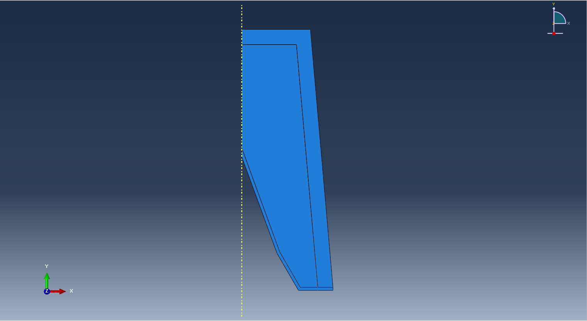
Figure 1 - Final 2D Design
This design would be the foundation for both the 2D and 3D model. The parts were assembled, a load was added, and the interaction conditions were defined before moving on to meshing the parts.

2D Model
The first attempt at the mesh was far too fine and caused the program to lag severely. A second attempt was better but could be optimised in future. The ideal mesh would be coarse in areas that the interactions at are unimportant to the results of the model, and finer where the detail of the jet forming is of interest.
To that degree, the case would have the coarsest mesh as its deformation is of no interest to the model. The case is of so little interest that a caseless model would still be feasible and was considered as the variation between the two 2D designs. This was ultimately decided against as a satisfying blast wave could be viewed after detonation that travelled through the fill and is reflected of the inner wall of the case.
The fill would have a varying mesh, being as coarse as the case on the outer edges and gradually becoming finer as the gradient nears the liner. The liner too would have a varying mesh, becoming even finer still at its apex. This singularity of nodes is required to accurately model the inversion of the cone and the formation of the jet.
Care was taken to ensure a smooth gradient between touching parts. The modelling software was prone to errors if the fine mesh and the course mesh interacted with each other.
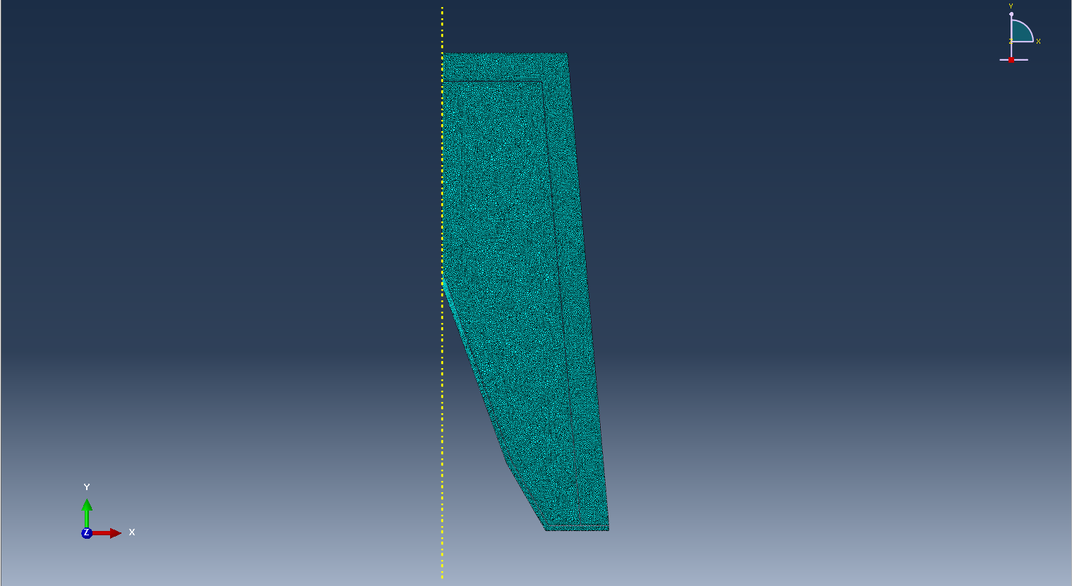
Figure 2 - Meshed 2D model
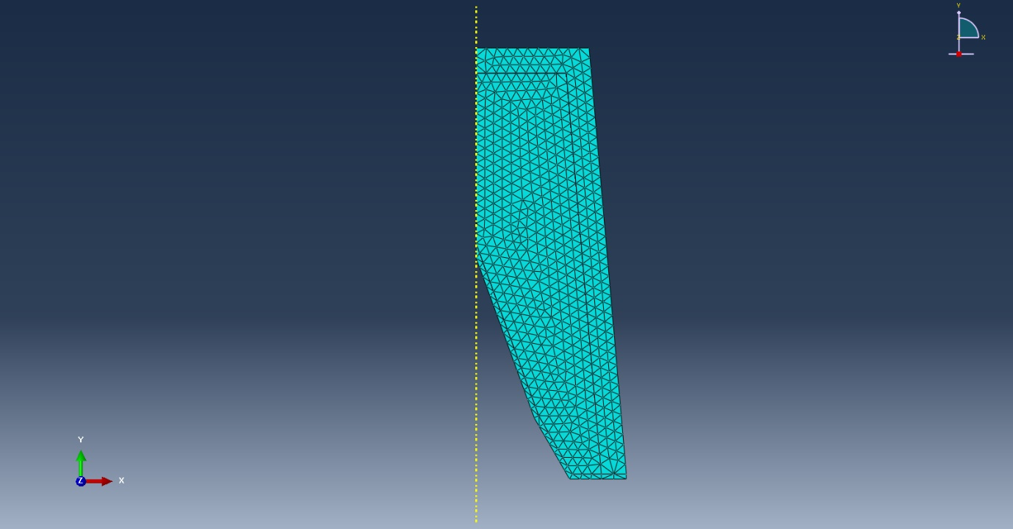
Figure 3 - Alternate 2D mesh
Materials were made and applied to the parts of the model, they consist of a steel case, the copper liner, and the HE fill. The values for these were gleamed from the literature review. The second 2D model replaced the copper liner with a steel liner, using the same material values as those used for the case.
The steel used was #45 Steel, the copper was OFHC Copper, and the HE used was TNT.
The following figures 3-7 give values for the steel case material [21].
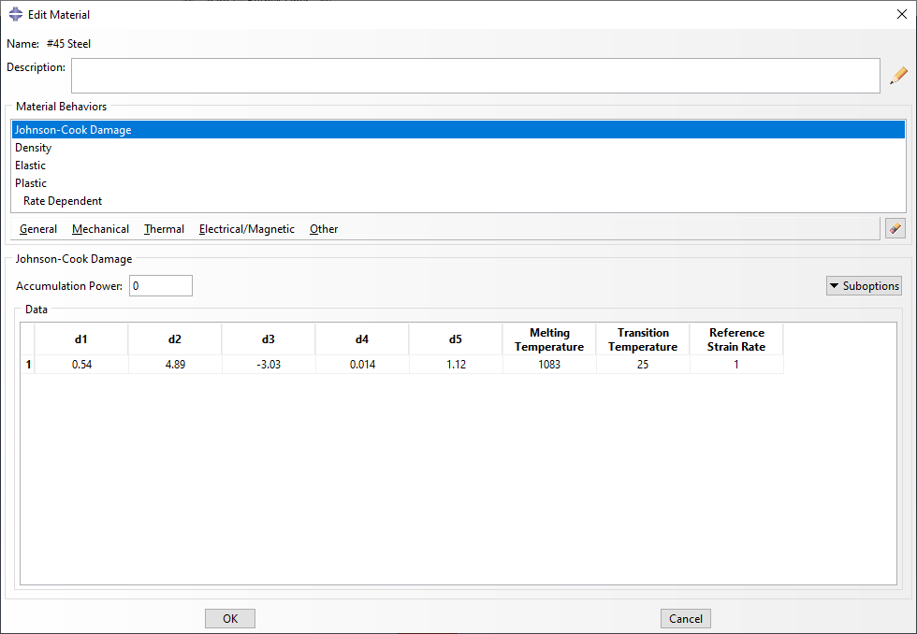
Figure 4 - Steel liner values for Johnson-Cook damage
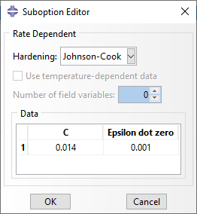
Figure 5 - Steel liner additional Johnson-Cook values
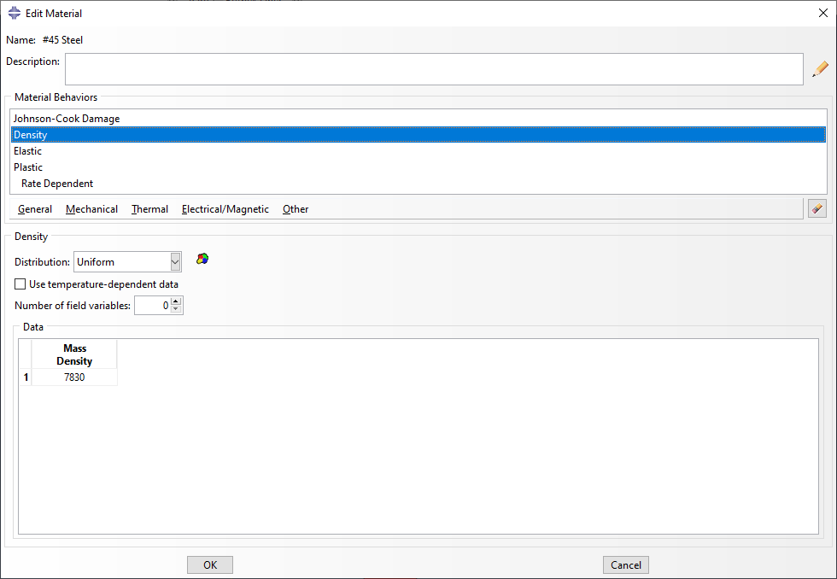
Figure 6 - Steel liner mass density
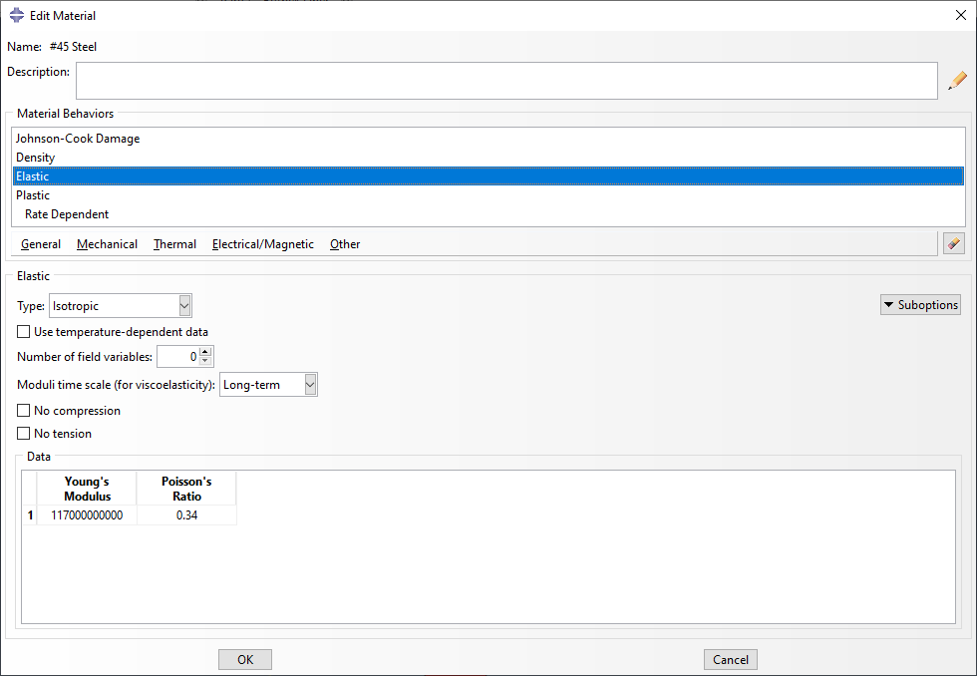
Figure 7 - Steel liner values for elasticity
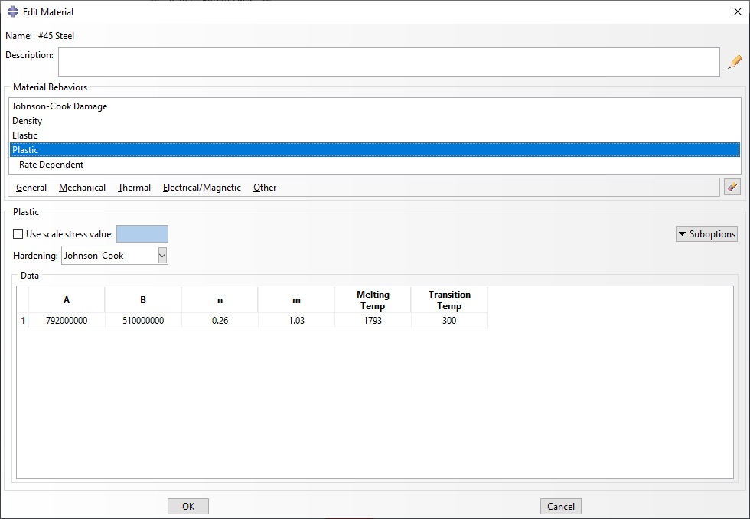
Figure 8 - Steel liner values for plasticity
The following figures 8-12 give values for the copper liner [22].
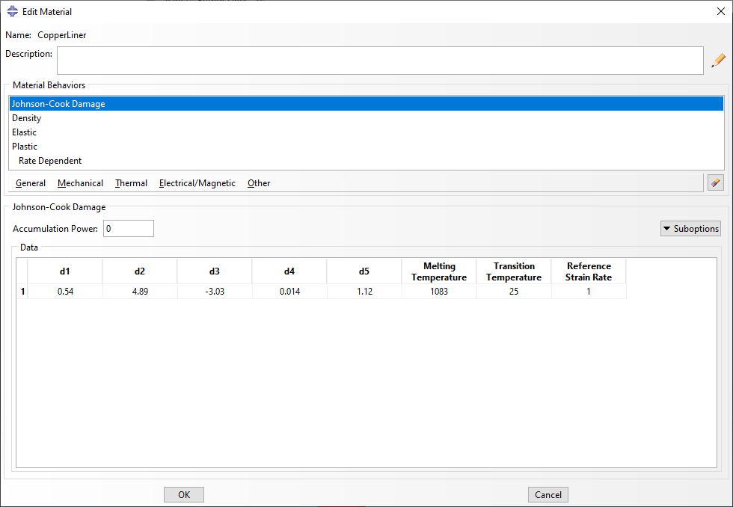
Figure 9 - Copper liner values for Johnson-Cook damage
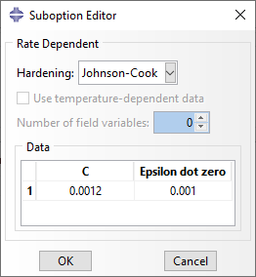
Figure 10 - Copper liner additional values Johnson-Cook
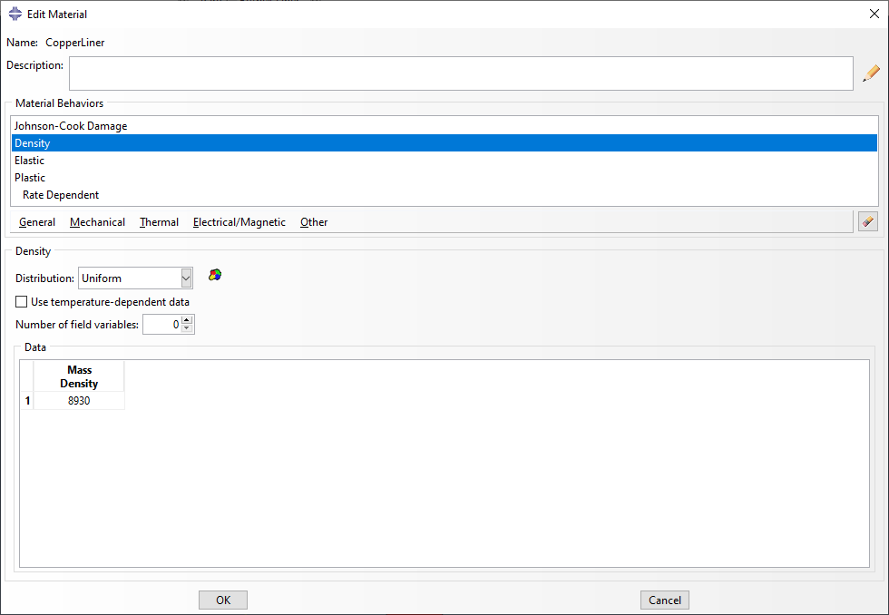
Figure 11 - Copper liner density
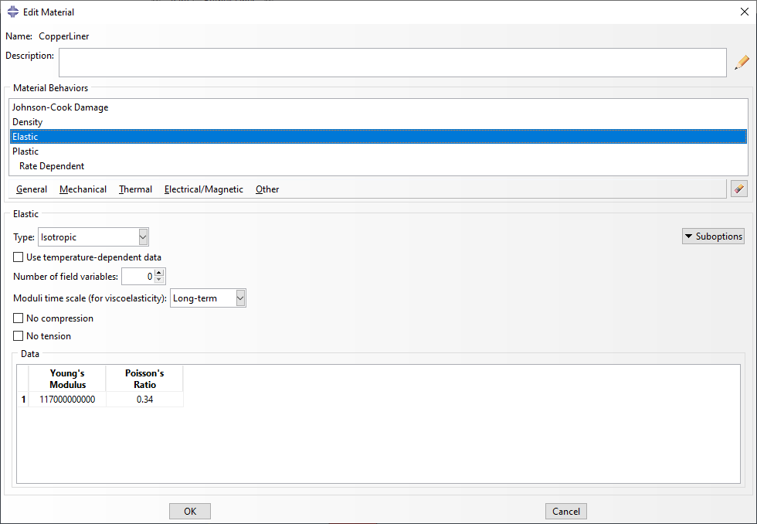
Figure 12 - Copper liner values for elasticity
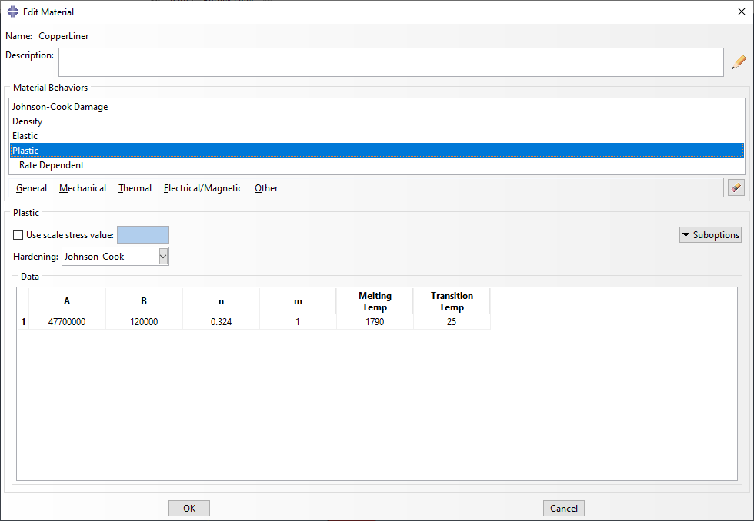
Figure 13 - Copper liner values for plasticity
The following figures 13-14 give values for the HE fill [23].
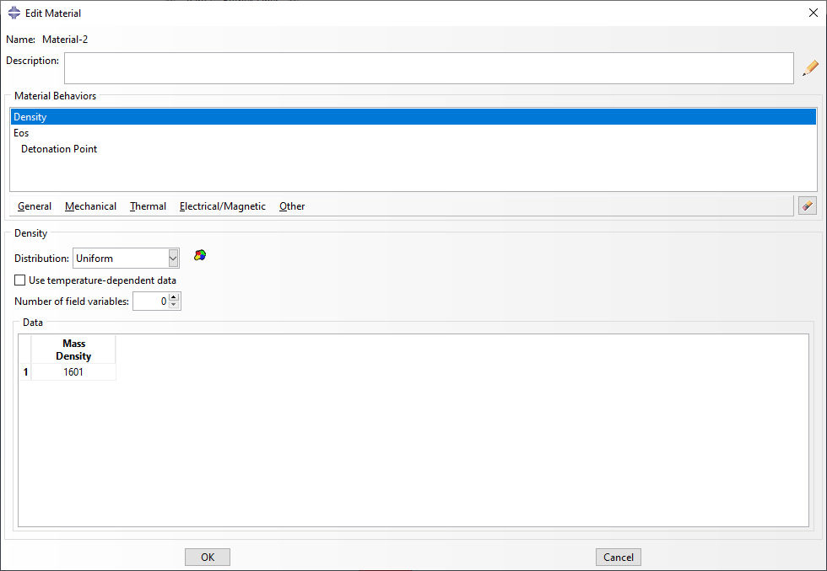
Figure 14 - HE fill density
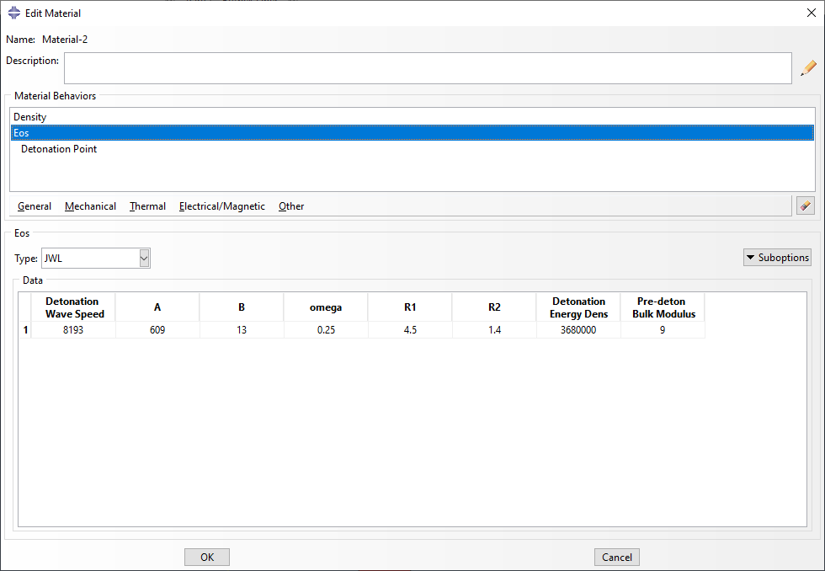
Figure 15 - HE fill equations of state values
Figure 16 shows the pressure as the detonation wave travels through the shaped charge. The case begins to deform as the explosive fill detonates, the pressure inside the charge builds and the steel undergoes plastic deformation. The blast wave is reflected off the inside of the case. Such a design for a charge may exist that the dimensions of the case are such that the reflected blast wave is amplified as it travels back towards the centre. The beginnings of a jet formation can also be seen.
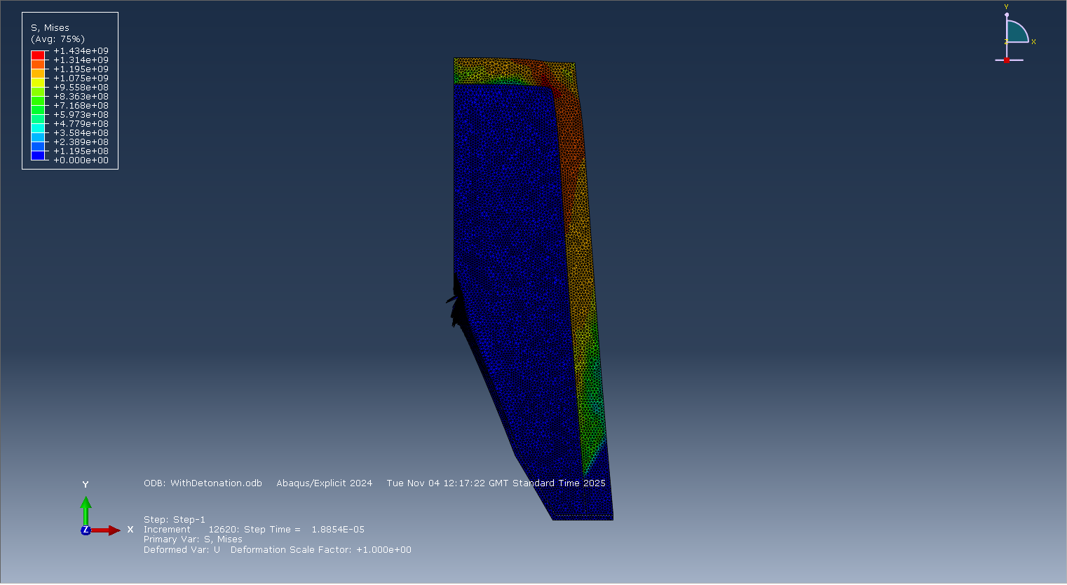
Figure 16 - Propagating blast wave
In figure 17, ABAQUS can be seen attempting to model the jet formation of the shaped charge. There is a tend towards the nodes forming the desired jet, but a lot of nodes are deforming due to errors. The case has further buckled under the pressure.
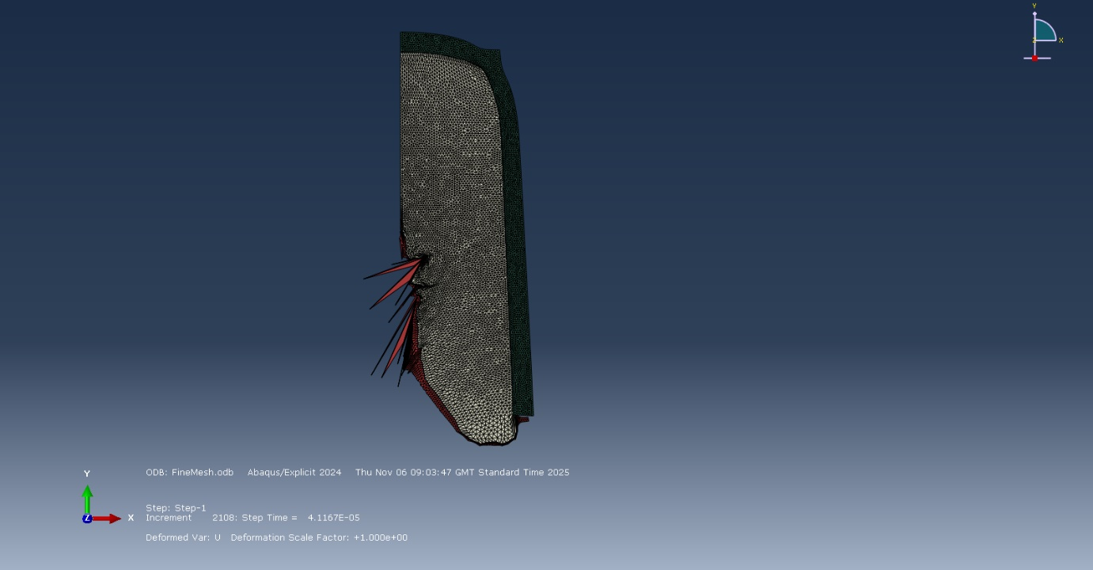
Figure 17 - Nodes deforming due to errors
Figure 18 demonstrates the velocities of a selection of nodes in the tip of the jet when the simulation crashes. The piercing front of the jet can be observed travelling up to speeds of 4500 ms⁻¹.
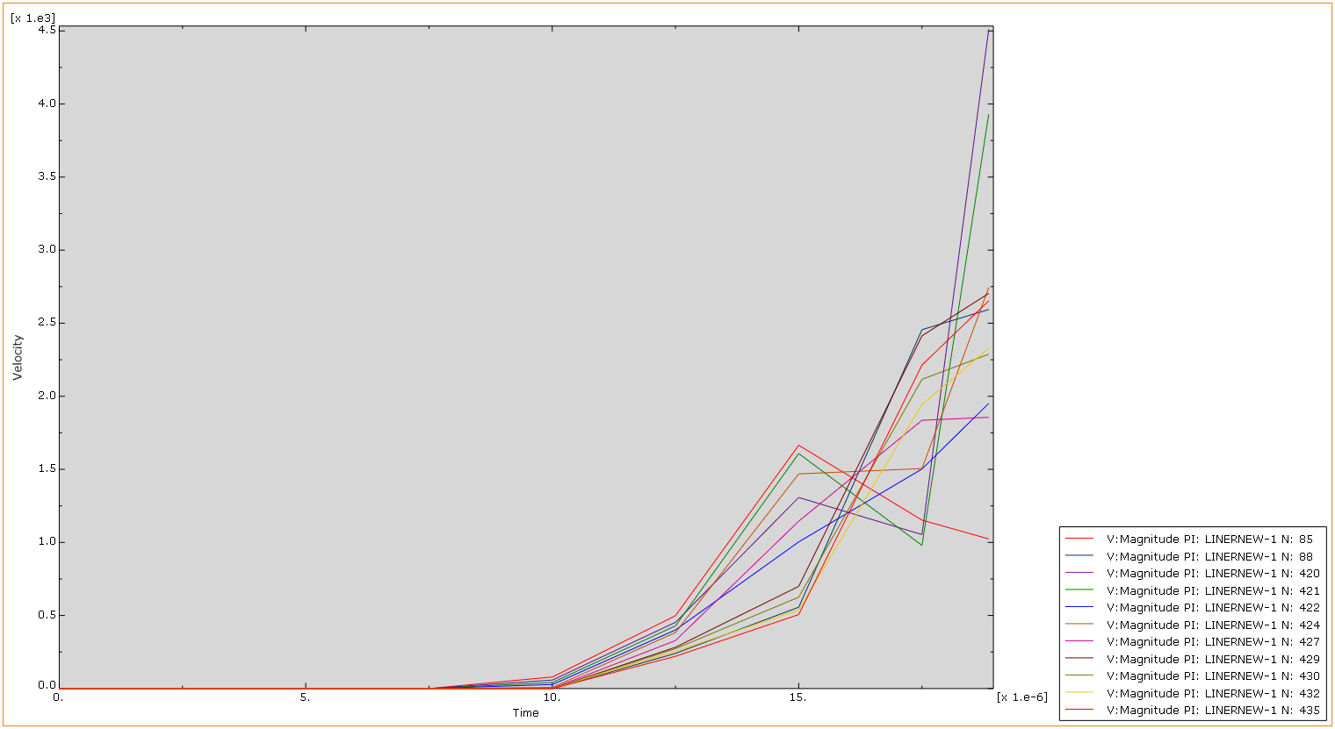
Figure 18 - Velocities of nodes in the jet

3D Model
For the 3D model, the 2D model that utilised OFHC Copper as the liner material was used as a basis. The 2D sketch was loaded and assembled in 3D before being meshed. Again, as with the 2D mesh, the mesh is much coarser at the case and becomes finer as the gradient approaches the liner. The apex of the liner, and where the fill is pressed against it, is once again the finest part of the mesh as this generates the most relevant points of data. The material values were kept the same as those for the 2D simulation.
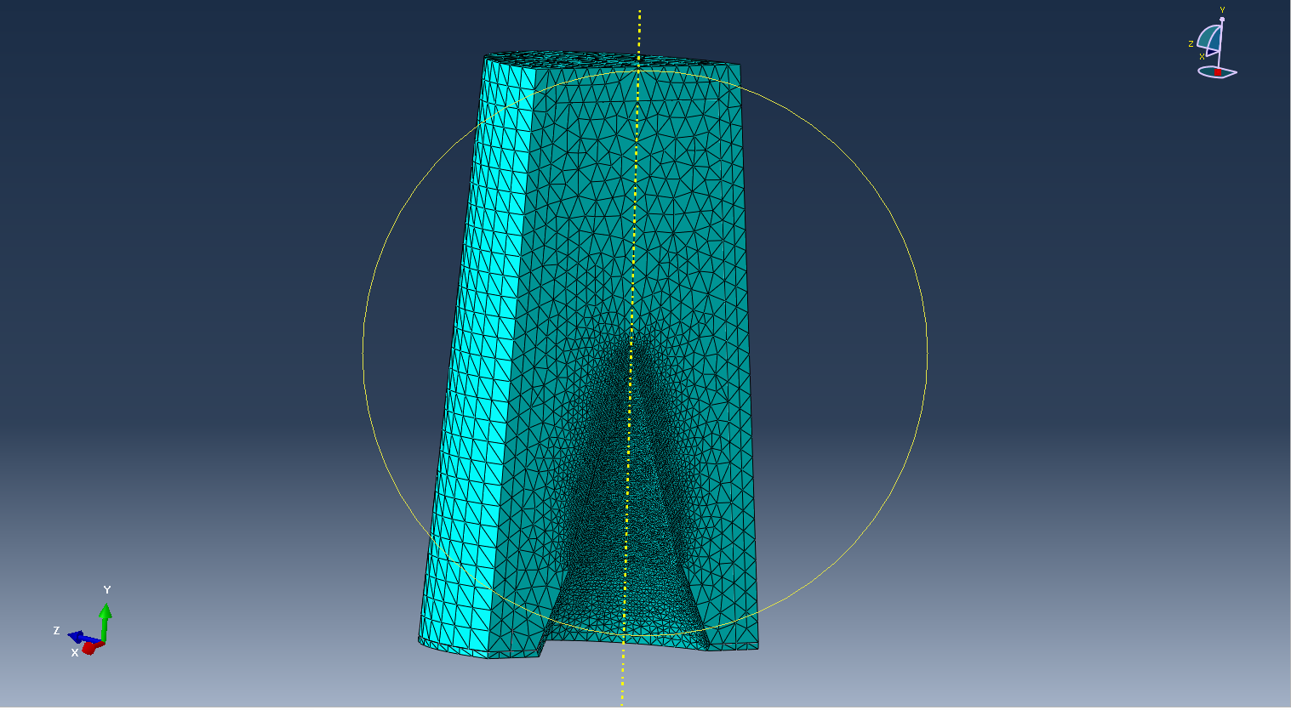
Figure 19 - 3D mesh
Adaptive meshing was attempted to improve the simulation of the 3D model. Adaptive meshing is a technique employed by ABAQUS that attempts to smooth out the simulation by checking for element distortion and moving the outlier nodes to maintain a topographically similar mesh [24].
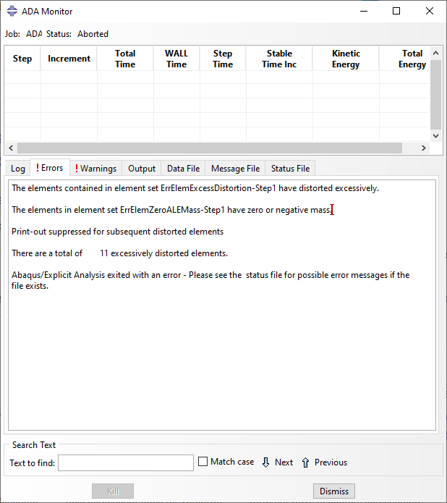
Figure 20 - Adaptive meshing error report
Smooth Particle Hydrodynamics (SPH) is a mesh-free method which attempts to simulate the nodes as fluids [25]. This is useful for this simulation as under the intense pressure of the blast wave, the liner acts fluidly as it forms into a jet.
SPH was attempted on the 3D model. Keywords were manually edited in the GUI but resulted in circular errors, where changing the parameter to what the error log suggested resulted in a different error claiming the parameter should be set to its original variable.
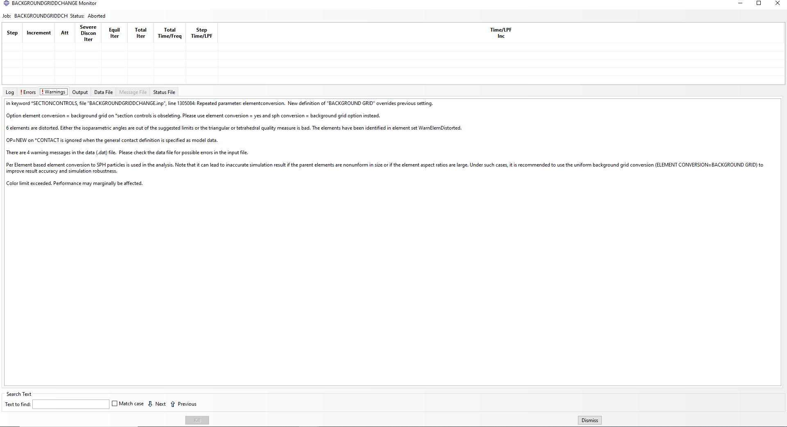
Figure 21- Circular error
In an attempt to counter act this, the amendments for SPH were entered in the command line to circumvent the GUI.
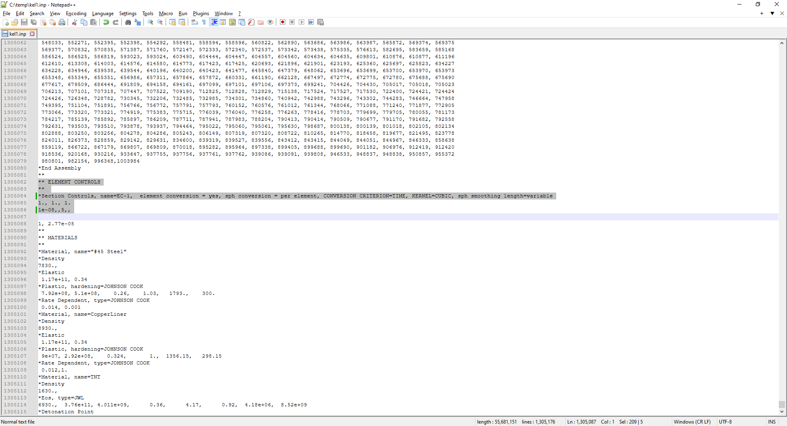
Figure 22 - Attempting SPH without ABAQUS GUI
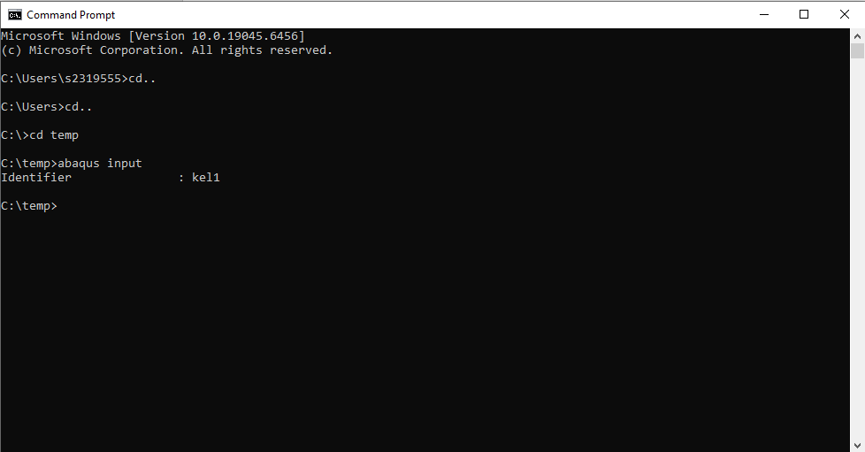
Figure 23 - Attempting SPH without ABAQUS GUI
This did not work.

References

[1] | X. Cheng, G. Huang, C. Liu and S. Feng, “Design of a Novel Linear Shaped Charge and Factors Influencing its Penetration Performance,” Applied Sciences, 2018.
[2] | R. Meyer, J. Köhler and A. Homburg, Explosives, Weinheim: Wiley-VCH, 2015.
[3] | “UXO Clearance,” Alford Technologies Limited, [Online]. Available: https://www.explosives.net/land-commercial-uxo-clearance/. [Accessed 2 January 2026].
[4] | P. W. Cooper, Explosives Engineering, New York: VCH, 1997.
[5] | C. F. Austin, “Lined-Cavity Shaped CHarges and Their Use in Rock and Earth Materials,” New Mexico Bureau of Mines & Mineral Resources, Sorocco, New Mexico, 1959.
[6] | M. G. Vigil, “Explosive Shaped Charge Penetration Into Tuff Rock,” Sandia National Laboratories, Albuquerque, 1988.
[7] | S. Zhao, Z. Xu, J. Zhong and K. Sun, “The Application of Shaped Charge Blasting Technology in Open-Pit Mining,” Mathematical Modelling of ENgineering Problems, vol. 3, no. 2, pp. 91-95, 2016.
[8] | J. Hall, “Shaped Charges: Harnessing Precision in Explosive Technology,” Alford Technologies Limited, 20 January 2025. [Online]. Available: www.explosives.net/shaped-charges-explosive-technology/. [Accessed 2 January 2026].
[9] | Alford Technologies Limited, “Demolition,” August 2024. [Online]. Available: www.explosives.net/land-military-demolition/. [Accessed 19 December 2025].
[10] | Ministry of Defence, “Unexploded bomb in Plymouth safely removed during complex disposal operation and major evacuation,” Ministry of Defence, 23 February 2024. [Online]. Available: https://www.gov.uk/government/news/unexploded-bomb-in-plymouth-safely-removed-during-complex-disposal-operation-and-major-evacuation. [Accessed 2 January 2026].
[11] | “RPG-2 Grenade Launcher,” Collective Awareness To UXO, [Online]. Available: cat-uxo.com/explosive-hazards/salw/rpg-2. [Accessed 4 January 2026].
[12] | “110mm Pzf-3 DM32 Rocket,” Collective Awareness To UXO, [Online]. Available: cat-uxo.com/explosive-hazards/rockets/110mm-pzf-3-bkf-dm32-rocket/. [Accessed 4 January 2026].
[13] | M. Ugrčić, “Criteria and evaluation of ballistic sensitivity of explosive reactive armor,” Scientific-Technical Review, vol. LIV, no. 1, pp. 17-26, 2004.
[14] | A. Helte and E. Lindén, “The Role of Kelvin-Helmholtz Instabilities on Shaped Charge Jet Interaction With Reactive,” Applied Mechanics, vol. 77, no. 5, p. 8, 2010.
[15] | “105mm PG-7R Rocket,” Collective Awareness to UXO, [Online]. Available: cat-uxo.com/explosive-hazards/rockets/105mm-pg-7r-rocket. [Accessed 4 January 2026].
[16] | J. Hill, “British Army tested two cope cage designs on Challenger 2,” 21 November 2025. [Online]. Available: https://www.army-technology.com/news/british-army-tested-two-cope-cage-designs-on-challenger-2/. [Accessed 2 January 2026].
[17] | M. Cazalet, “The most misunderstood weapon in the world: Mythbusting HEAT warheads and their countermeasures,” 20 June 2024. [Online]. Available: https://euro-sd.com/2024/06/articles/38841/the-most-misunderstood-weapon-in-the-world-mythbusting-heat-warheads-and-their-countermeasures/. [Accessed 2 January 2026].
[18] | S. Korshak, “Russia's 'Turtle Tank' - its Latest Battlefield Innovation to Combat Kyiv FPV Drones,” Kyiv Post, 19 April 2024. [Online]. Available: www.kyivpost.com/post/31373. [Accessed 2 January 2026].
[19] | Science DIrect, “Explosive Welding,” [Online]. Available: https://www.sciencedirect.com/topics/materials-science/explosive-welding. [Accessed 3 January 2026].
[20] | W. Walters, “A Brief History of Shaped Charges,” 24th International Symposium on Ballistics, vol. 1, pp. 3-10, 2008.
[21] | C. Su, H. Guo, Y. Zheng, J. Xie and H. Wang, “Formation Behavior and Reaction Characteristic of a PTFE/Al Reactive Jet,” Materials, vol. 15, no. 1268, 2022.
[22] | H. Liu, J. Zhang, X. Xu, Y. Qi, Z. Liu and W. Zhao, “Effects of Dislocation Density EVolution on Mechanical Behavior of OFHC Copper during High-Speed Machining,” Materials, vol. 12, no. 2348, 2019.
[23] | R. Liu, L. Tang, X. Jia, X. Jiao, R. Yan and X. Jiang, “JWL equation of state parameters for ideal detonation: A comparative study of literature reports, theoretical derivation, and artificial neural network prediction,” FirePhysChem, 2025.
[24] | “Defining ALE adaptive mesh domains in ABAQUS/Standard,” [Online]. Available: https://classes.engineering.wustl.edu/2009/spring/mase5513/abaqus/docs/v6.6/books/usb/default.htm?startat=pt04ch12s02aus73.html. [Accessed 7 November 2025].
[25] | “https://ceae-server.colorado.edu/v2016/books/usb/default.htm?startat=pt04ch15s02aus96.html,” [Online]. Available: https://ceae-server.colorado.edu/v2016/books/usb/default.htm?startat=pt04ch15s02aus96.html. [Accessed 7 November 2025].
[26] | K. T. Miers, N. R. Peterson, W. L. Perry, L. A. Lystrom, J. C. Sweitzer and S. E. DeFisher, “Modeling and analysis of a 66 mm shaped charge,” International Journal of Impact Engineering, vol. 206, 2025.
[27] | Z. Li, S. Shi, X. Zhang, Y. Wu, X. Yang, W. Gao and E. Song, “Optimization of axial shaped charge liner configuration and its application in tunnel smooth blasting,” Case Studies in Construction Materials, p. e05287, 2025.
[28] | E. J. Hearn, Mechanics of Materials 1, Oxford: Butterworth-Heinemann, 1998.
[29] | S. A. Zelepugin, R. O. Cherepanov and N. V. Pakhnutova, “Optimization of Johnson-Cook Constitutive Model Parameters Using the Nesterov Gradient-Descent Method,” Materials, 2023.

Abbreviations
EOD | Explosive Ordnance Disposal
ERA | Explosive Reactive Armour
HE | High Explosive
HEAT | High Explosive Anti-Tank
OFHC | Oxygen-Free High thermal Conductivity
SPH | Smooth Particle Hydrodynamics
TNT | Trinitrotoluene
UAS | Uncrewed Aerial System

