Name | Student Number | Date | Lecturer’s Name | Your score
Brooklyn Brooks | 2506870 | 23.10.25 | Daniel | To be filled by the marker  ___/40
You will have 75 minutes to complete this assessment. It is divided into three sections: note-taking, paraphrasing and writing a paragraph.
---------------------------------------------------------------------------------------------------------------------
1. Take diagrammatic notes from the passage below using the space provided:

As a student you've got a lot on your plate - academic work, social life, work commitments, career plans, relationships and finances - sometimes stress can get in the way of this juggling act. When you recognise that you have become overwhelmed with stress, adopt a few strategies to help you manage your triggers more effectively. Those strategies could include exercising; you simply need to get your heart racing, for example by going for a brisk walk or a bike ride. Another suggestion is to try mindfulness, a relaxation technique originating in Buddhism. It is used by clinicians to improve patients' physical and mental health as it can significantly lower stress levels. Thirdly, why not speak to your friends and family - they know you best and care about you the most. What's more, studies suggest that socialising with a friend just once a week can reduce your stress levels and improve your mood as much as therapy or counselling. Simple time management techniques can also help you to feel more relaxed and focused. Try creating a written schedule, breaking your tasks down into manageable chunks, planning accordingly and allocating yourself time every day to relax or socialise. Finally, an obvious but often overlooked solution: get enough sleep, as no one functions at 100% when they're tired.
Adapted from: https://www.prospects.ac.uk/applying-for-university/university-life/5-ways-to-manage-student-stress

Space for your notes (max 12 marks):
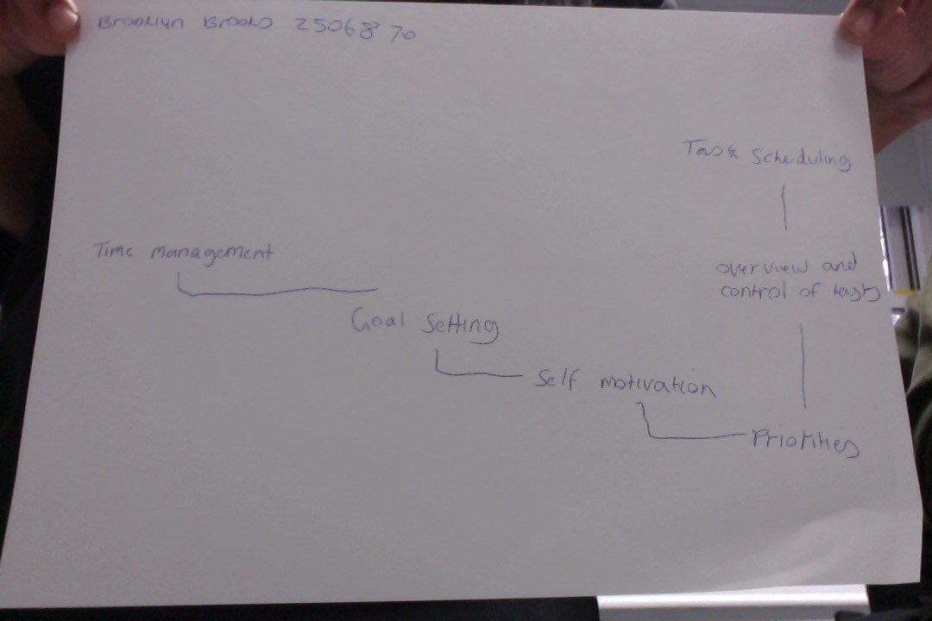

2. Paraphrase the following sentences (max 3 marks for each, max 12 marks in total):

a) Good time management techniques can help you feel more relaxed and focused.

To help you feel more relaxed and focused, it is good to have good time management techniques.

b) Speaking to your friends and family can significantly lower stress levels.
To help you lower stress levels you can speak to your family and friends

c) University life offers numerous opportunities for personal growth and development.
Numerous opportunities for personal growth and development are offered by university life.

d) Attending lectures regularly is crucial for understanding course material.

For understanding course material, it is crucial to attend lectures regularly.

3. Write a well-structured paragraph (8 sentences) on the following topic:

Strategies for managing a student budget and reducing costs while at university.

Your paragraph must be written in full sentences (no bullet points) and in an academic style.

(max 16 marks in total)

Managing money as a student can be tough, but a few simple habits can make a big difference. Start by setting a clear budget so you know exactly where your moneys going each month. Instead of eating out, try cooking food at home. It saves loads and can be fun with friends and family. Always check for student discounts on travel, clothes and food. It all adds up. Using free online books or buying second handbooks can save a fortune. Use a money tracking app to see where you’re overspending and adjust as you go. Picking up a part time job or side hustle helps cover extras without too much stress. With a bit of planning, you can stay on top of your finances and still enjoy university life.

