BA Business Management LCBB5001

Entrepreneurship
Assessment 2

Module Tutor: Nishi Ramsurrun
Student: Simona Tutui
ID: 2023029

Table of Contents

BUSINESS DESCRIPTION / MARKET OPPORTUNITY…………………………………..3
INDUSTRY ANALYSIS………………………………………………….…..4
Threat of new entry …………………………………………………………...4
Threat of substitutes………………………………………………….………..5
Bargaining power of customers…………………………………………….…5
Bargaining power of suppliers………………………………………………..6
MANAGEMENT TEAM……………………………………………………..7
Product…………………………………………………………………………8
Price……………………………………………………………………………8
Promotional Mix…………………………………………………………….9
Place……………………………………………………………………………9
Financial……………………………………………………………………….10
References……………………………………………………………………………..11

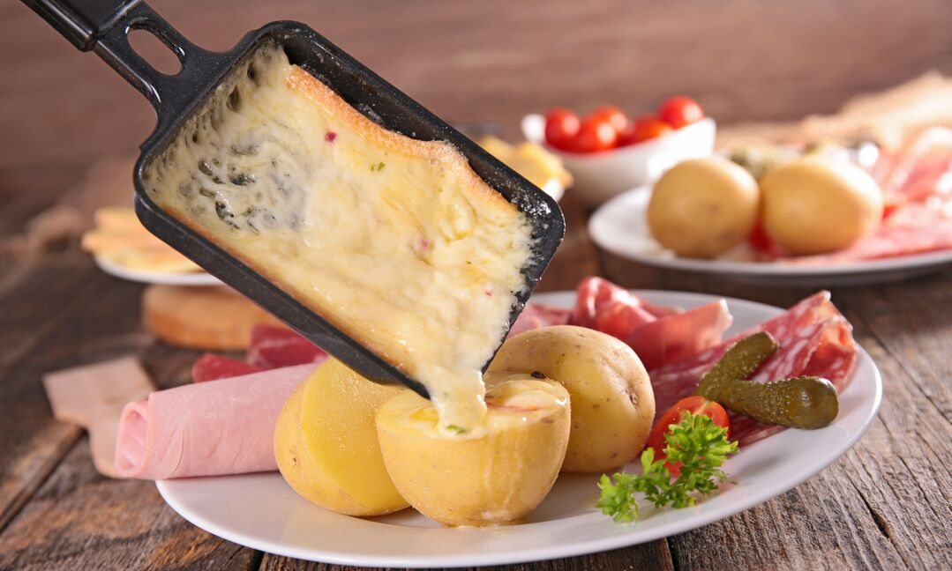
https://www.groupon.com/articles/how-to-raclette-guide

BUSINESS DESCRIPTION / MARKET OPPORTUNITY

This company a private limited company, starting as a family business that has the main goal to be compared and seen next to the big companies and eventually being able to sell as a francize. The aim of the business is to deliver products with incomparable taste and innovation is our main focus, as a result we encourage staff meetings each month in which every staff member has to come up with at least three new ideas in improving the process of his job, the recipes, our services, marketing and sales offers. With this our business will successfully create the filing of inclusion among staff members and also discover and develop new ideas. We are adopting a mixed type of leadership as for certain jobs or services the autocratic leadership is needed but when it comes to encouraging new ideas a democratic leadership is the best option. A new product manufactured using ingredients that are popular with the intended clients will be released by our company on the UK market.
The concept is to combine a main ingredient that is loved by a wide variety of customers with different elements that may be customised for the customers' satisfaction.

Raclette cheese is the major component of the product, which is made up of a variety of additives.
By melting cheese and scraping off the melted portion, raclette is a classic dish from Switzerland and Savoy. It is typically served with boiled potatoes, pickled cucumbers, and onions, although the recipes can be modified to suit the demands and preferences of the market.
Missions statement: Delivering innovative products with incomparable taste.

One of the marketing strategies of the company is to enlarge the market as much as possible. Therefore, the position of the restaurant is in a shopping mall where customers of all ages, rase, gender and especially buying power easily have access.

INDUSTRY ANALYSIS

Threat of new entry

Valuable
- Unique recipes
- Product customisation
- Highly trained employees

Rarity
- Registered patents of recipes

Inimitable
- The ingredients can be imitated but the product as a whole, sustained by own recipes will guaranty the uniqueness.

Organized

- The organisation of business will be based on strong leadership skills and will create a fast system of cooking and delivering
- Th company will train and grow the employees offering the high package salaries and bonuses.

Threat of substitutes

By raising prices, transferring costs upstream to other industry participants, or lowering the quality of the goods and services they offer, suppliers can exert bargaining power. Thus, strong suppliers can force profitability out of a sector that is unable to pass on cost increases through price increases (Porter,2007).

Iven though it may seem like any other fast-food and restaurant in the food industry can represent a threat, the fact that the star ingredient of our menu is melted raclette cheese represents a higher leverage when comparing to our competitors. The main reason for this is the fact that our cheese can be combined with a vast range of other ingredients while our competitors’ options are limited. Is more difficult to be innovative with burger meet or pizza.
The company is well aware that even if the product will be with a high success there also will be a decline. Our key in preventing or rejuvenating the product lies in our mission statement: innovation, which also can be seen a promise to our customers.
Newcomers to an industry bring with them fresh capabilities and a drive to expand their market share. An industry's potential for profit is constrained by the threat of new entrants. When competition is fierce, profits cannot increase significantly without luring new rivals. They can take advantage of current capabilities to upend the competition (Porter,2007).

Bargaining power of customers

Buyers' power refers to the ability and pressure of consumers to influence changes in food product pricing, quality, and terms of sale. Michael Porter initially used the phrase in 1979 as one of the five forces used to assess the competitiveness of any industry. Since then, it has been a crucial component of research that would assist businesses in satisfying potential clients by creating goods that are advantageous and competitive in the market (YANG; TREWN, 2003).
Although it is usually believed that negotiating power prevents dominant suppliers from raising prices at the expense of customers, it has become clear that in some situations it may cause serious competition issues.
Dobson and Inderst (2007) point out that when differential buyer power is used without limiting quantity, buyers and suppliers engage in bilateral negotiations. Depending on the bargaining strength of each party, each buyer bargains with the provider. The level of the individual discounts reflects the bargaining power of the buyer and the seller.
Porter (1980) established the Five Force Model, which clarified how competitiveness is determined in any company. One of the factors that affected whether a business succeeded was the negotiating power of the customers. He asserted that the buyer's actions indicated their capacity to switch to alternative items, their capacity to integrate backward, and their access to alternatives.

Bargaining power of suppliers

Threatening to increase prices or lower the quality of goods and services helps suppliers enhance competition. They therefore lower profitability in sectors where businesses are unable to pass on cost increases to consumers through higher prices. The ability to persuade another party to make a concession by threatening to impose a cost or withhold a benefit in exchange for the concession is known as the ability to bargain (Kirkwood 2005).

Competitive Rivalry:

Name of competitor | Differentiation
Fish and chips | We difference by having a variety of products served with cheese also by the type of cheese that is tastier.
Fast –foods | Having a healthier range of products makes us a better choice also

OPERATIONS AND MANAGEMENT TEAM
OPERATIONS

The main ingredient is the Raclette cheese that will be imported from Switzerland and the other ingredients will be purchase from local farms, as we are aiming to use only organic products. Will need a special instrument that melts the cheese and keeps it at the wright temperature, fridges, freezers, grill.

How would you generate revenue for your business? E.g., How would you prevent loss of revenue?

To increase revenue will focus on our customers, review our prices, boost marketing offers, sales promotions. Developing new products and associating with other brands will be our strategies to boost the volume of the sales. To prevent loss of revenue will focus on our customers by offering discounts, promotions, and rebates, communicate with them by sending newsletters, reminder emails and holiday cards. Updating them about new launches and special offers.

MANAGEMENT TEAM

Name | Skills | What do they bring to the firm
Manager | Leadership skills, organisational skills, Forward planning, and strategic thinking, Problem solving and decision-making. | Organisation, problem solving, leadership, teamwork, motivation, and enthusiasm, planning
Marketing officer | Ability to network, commercial awareness, creativity, writing and design skills, ability to juggle multiple projects. | Manages and develops marketing campaigns, conducts promotional activities. Organise and distributes financial and statistical information.
Financial officer | Knowledge of economics and accounting, analytical thinking skills, attention to details | Oversees the financial transactions of the company. Accounting, invoicing, financial audits
Chef and waiter | Creativity, adaptability, determination, customer service skills, ability to accept criticism and work well under pressure | Adapts to the needs and requests of clients. Will bring creativity and perfection in recipes.

MARKETING: The Four P’s will be used to describe our marketing strategy

Product

Raclette cheese is the key element in the product, which is a mixture of ingredients.
In Switzerland and Savoy, raclette is a classic dish that is produced by melting cheese and scraping off the melted piece. Although the recipes can be modified to meet the demands and preferences of the market, it is typically served with boiled potatoes, pickled cucumbers, and onions.

Price:
The process of figuring out a product's quantitative value based on both internal and external elements is called product pricing. Product pricing directly affects your company's entire success, including cash flow, profit margins, and client demand (Ackerman & Heinzerling, 2001).
The price of the main product will be 7,5 pounds, the price will cover direct costs 2 pounds, variable costs 1,5 and adding a gross profit of 4 pounds

Promotional Mix
Will develop a promotional mix in order to improve the communication with the clients, to build the trust between the customer and the brand.
To advertise and build a brand will use online advertising as nowadays majority of the population uses and prefers online platforms for advertising, such as Facebook, Instagram, Pinterest. To target elder population will use advertising on radio, papers, and fliers as a big percentage of this category it is not familiar with the use of social media. According to Kumar et al., (2016) the incorporation of online and offline marketing efforts, which evolved from integrated marketing communications, is thought to increase customer satisfaction, and strengthen and improve brand recognition. Examples of this include the incorporation of web advertising, mobile advertising, social media communication, in-store promotions, and distribution ease.
Utilizing social media and the internet to your advantage will promote your business and improve customer traffic in the digital age. Make a website for your restaurant including a menu, a nutritional breakdown, and any current specials or promotions. Customers' email addresses or home addresses are requested in order to add them to your restaurant's mailing list. You may also set up a Facebook page for your restaurant and invite clients to "Like" or follow it. Use these platforms to advertise sales or promotions, such complimentary appetizers or two-for-one offers (Higuera, 2022).

Place (Distribution strategy)
The degree to which clients frequent your restaurant depends in large part on the caliber of the food you serve. Distribution channels in the restaurant business often begin with the food source. You can buy your items and other supplies here. Selecting a reputable supplier is essential since building a reputation for serving subpar meals might ruin your company. Investigate various suppliers, then ask them for references, or seek advice from your relationships in the business (Higuera, 2022).
The product will be distributed using big delivery platforms such as Deliveroo, Uber Eats, Just Eat and also using our own delivery team.

FINANCIALS

Sources of funds: where would you be getting funds from?
Will start with an investment of 20000 pounds from our savings ,with the funds from Start-up will be able to buy the majority of the tools and the remaining of 30000 pounds will be loaned .

Use of funds

 | Month 1 | Month 2 | Month 3 | Month 4 | Month 5 | Month 6
Revenue (from your operations and marketing section) | 30000 | 30000 | 50000 | 60000 | 80000 | 80000
Fixed Costs  (List out your fixed costs) | 10000 | 20000 | 20000 | 20000 | 20000 | 20000
Variable Costs  (List out your variable costs) | 6000 | 7000 | 7000 | 9000 | 9000 | 9000
Profit | 14000 | 3000 | 23000 | 31000 | 51000 | 51000

REFERENCES

Ackerman, F., & Heinzerling, L. (2001). Pricing the priceless: cost-benefit analysis of environmental protection. U. Pa. L. Rev., 150, 1553.

Barringer, B., Ireland, D., (2019) Entrepreneurship: Successfully Launching New Ventures. Sixth edition; Global edition. Harlow, England: Pearson.
Benefit or Harm Consumers? European Competition Law Review Vol. 28; Issue 7, pages 393-400
Correa, G., (2020) ‘UENI’s 2020 Report on Gender and Small Business’ Available at https://www.latimes.com/business/technology/la-fi-tn-uber-ipo-travis-kalanick-cloudkitchens-20190509-story.html
Dobson, P. W. Inderst, R. (2007): Differential Buyer Power and the Waterbed Effect: Do Strong Buyers
Dumitriu, S., (2019) ‘Managemant matters’ The entrepreneurs network. Available at: https://www.tenentrepreneurs.org/research/management-matters

Higuera V. (2022) Chrone, How Can a New Restaurant Create a Good Distribution Channel?

Hisrich, R.D., Peters, M.P., Shepherd, D.A., (2020) Entrepreneurship. Eleventh edition, New York: McGraw-Hill
https://smallbusiness.chron.com/marketing-ideas-healthy-pet-foods-39295.html
Kumar, A., Bezawada, R., Rishika, R., Janakiraman, R., & Kannan, P. K., (2016), “From
PORTER, M. (1980) Competitive Strategy. Washington DC: Free Press.
Porter, M. E. (2007). Understanding industry structure. Harvard Business School, 13, 1-16.
social to sale: The effects of firm-generated content in social media on customer

