
Configure and manage the Virtualised Enterprise network
ASSESSMENT 2-Network Operating Systems and Services

December 16, 2025
University of Wales Trinity St David
LONDON CAMPUS

Programme: BSC Applied Computing
Module: Network Operating Systems and Services
Lecturer: Md. Sadeque Imam Shaikh
Assignment Title: Configure and manage the Virtualised Enterprise network
Student name: Nigist Eshetu

Contents
Introduction 1
1.Routing 2
2.Domain server/SWANSEA 7
3.Encrypted Connection between Swansea and London 11
4.User 12
5.Domain Membership 14
6.DHCP 17
7.Test and Troubleshoot 18
8.Disk Drive 20
9.IIS Server 22
10. Remote Desktop Services 24
Conclusion 26

Introduction
This project implements a secure and integrated Windows Server–based network infrastructure connecting the Swansea and London sites. It simulates an enterprise environment by deploying core network services that support centralized management, secure communication, and reliable connectivity. Routing is configured using Windows Routing and Remote Access Service (RRAS) with persistent IP forwarding, alongside customized firewall rules to ensure security. An Active Directory Domain Controller is deployed in Swansea with a domain forest named SWANSEA.ACCA, supported by strong password policies and a correctly configured DNS infrastructure. User accounts are created using PowerShell automation, and all systems are joined to the domain. A centralized DHCP server distributes IP addresses across both sites, with London acting as a DHCP relay. Final tasks include testing, storage setup, IIS deployment, and secure Remote Desktop Services.

1.Routing
Routing is the process of directing data packets between different networks or subnets, enabling devices to communicate efficiently. It determines the best path for traffic using routing tables and network configurations. Without routing, communication would be restricted to devices within the same local network, preventing inter-network connectivity.
In a Windows Server environment, routing can be configured using Routing and Remote Access Service (RRAS) or by enabling IP forwarding. These features allow a server to function as a router, directing traffic between multiple network interfaces or remote locations. Routing is crucial in multi-site networks to ensure secure and reliable communication between different sites.
Correct routing configuration provides seamless connectivity between networks, facilitates centralized services like Active Directory and DHCP, and supports advanced functionalities such as VPNs and remote access. Firewall rules are typically adjusted alongside routing to permit necessary traffic while maintaining security. Overall, routing is the foundation of inter-network communication and critical for creating scalable, secure enterprise networks.

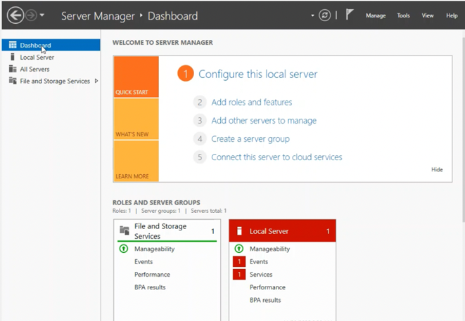
Click on add roles
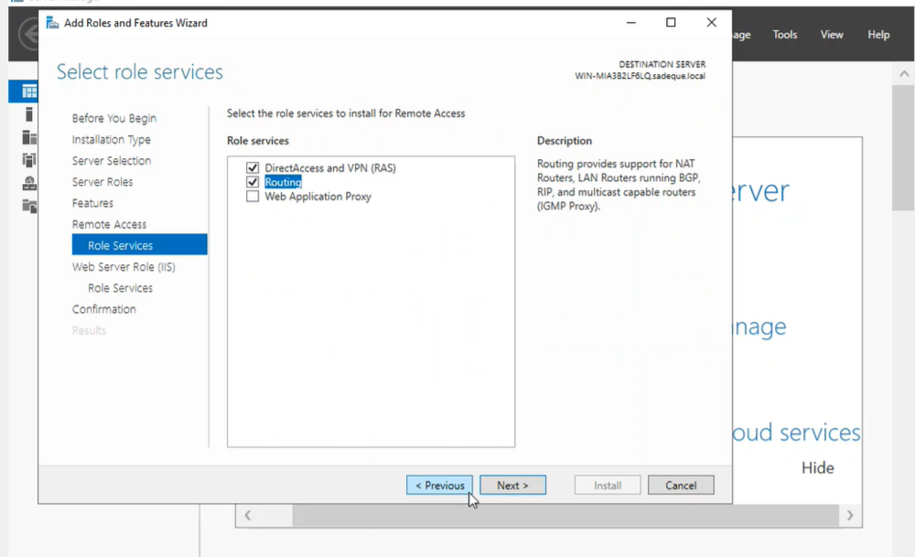
1.1 This screenshot shows installation of DirectAccess /VPN(RAS) and Routing
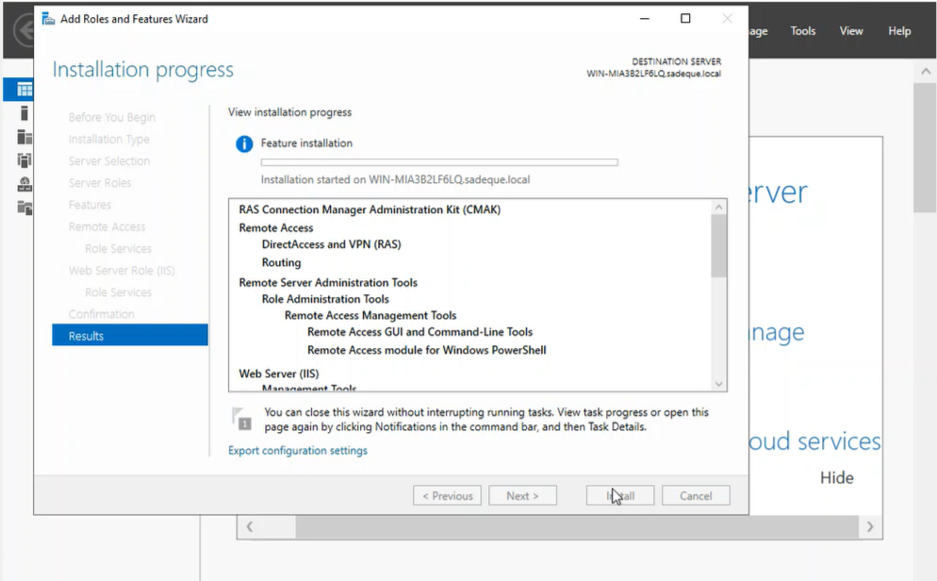
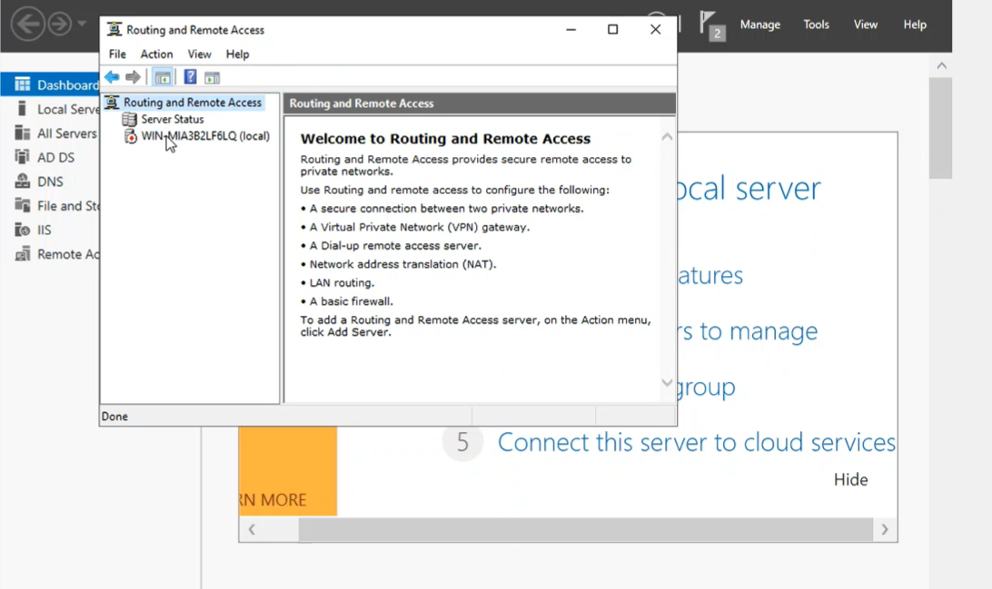
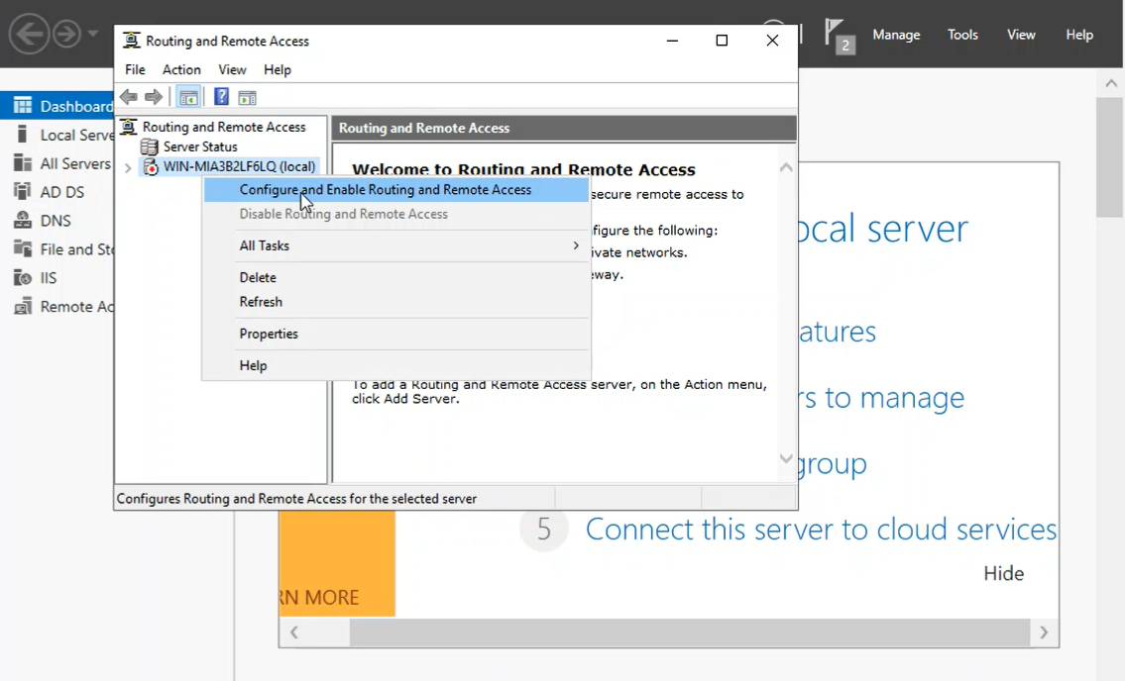
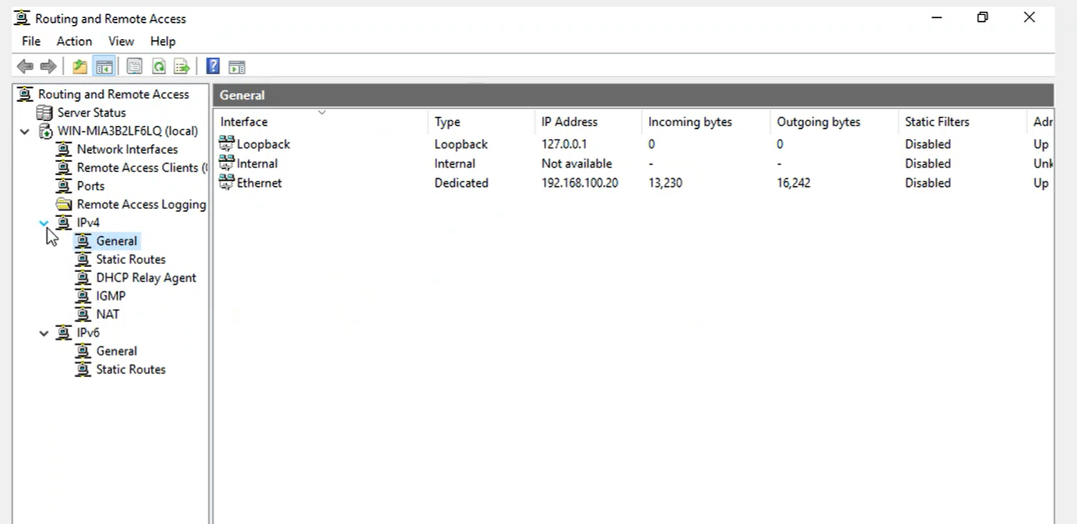
Setting up the fire wall
As We can see there is inbound filter and outbound filter, we can control both inbound and outbound communication on this server
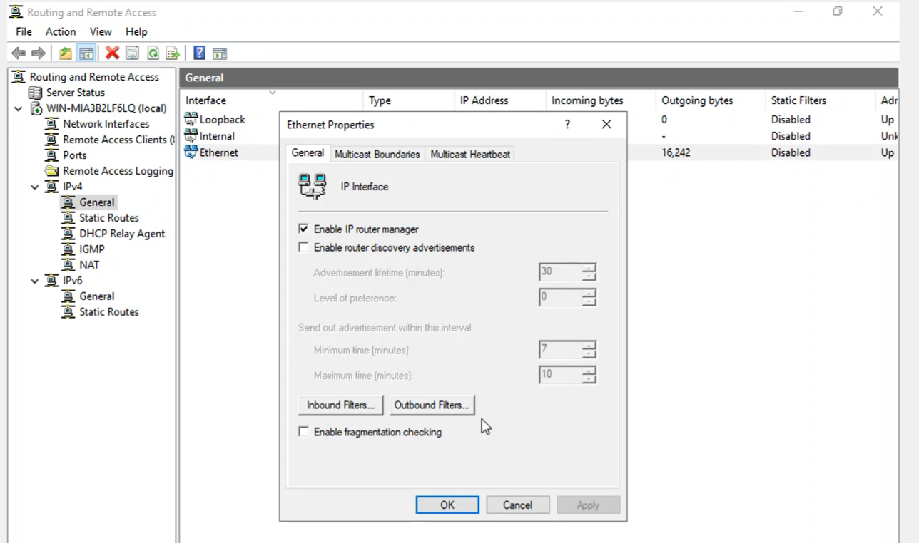
Inbound filter
By putting IP address, we can block the inbound packet that come from this given user.
That means we are using our server as a firewall.
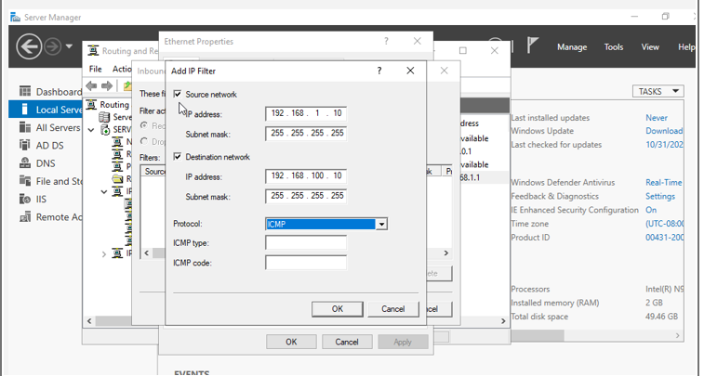
Outbound filter

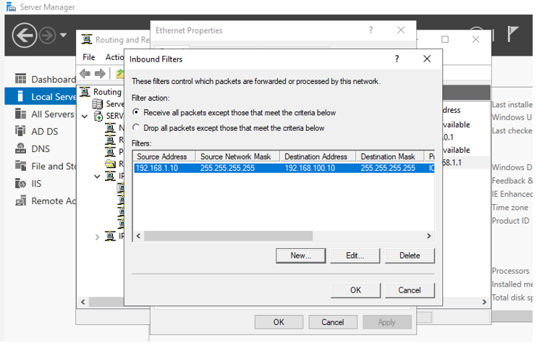

2.Domain server/SWANSEA
The Domain Server in Swansea is deployed using Windows Server with Active Directory (AD), establishing a domain forest named SWANSEA.ACCA. It is secured with robust password policies and supported by a comprehensive DNS infrastructure with forward and reverse lookup zones. The server provides centralized authentication, authorization, and policy management, ensuring secure, scalable, and efficient network administration across Swansea and London.
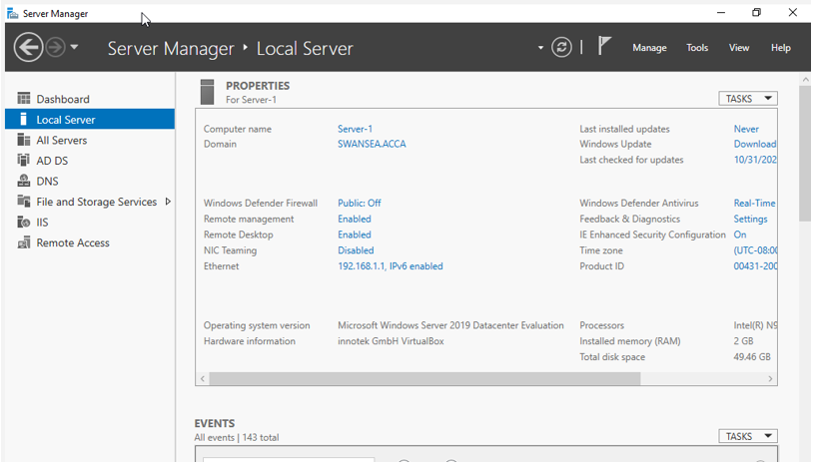
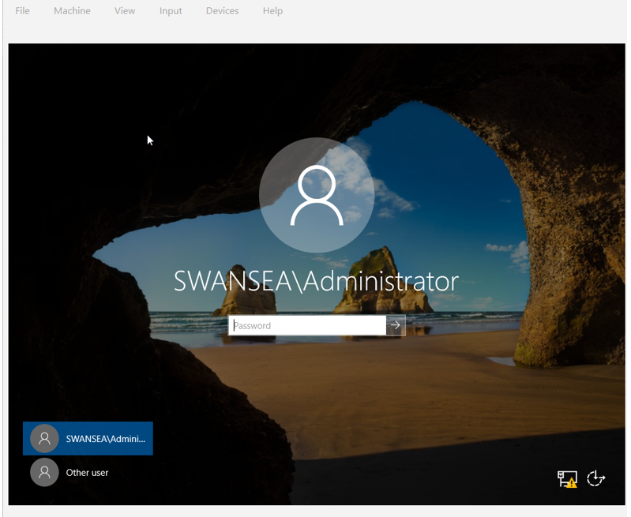
Creating a record for all servers on SWANSEA network
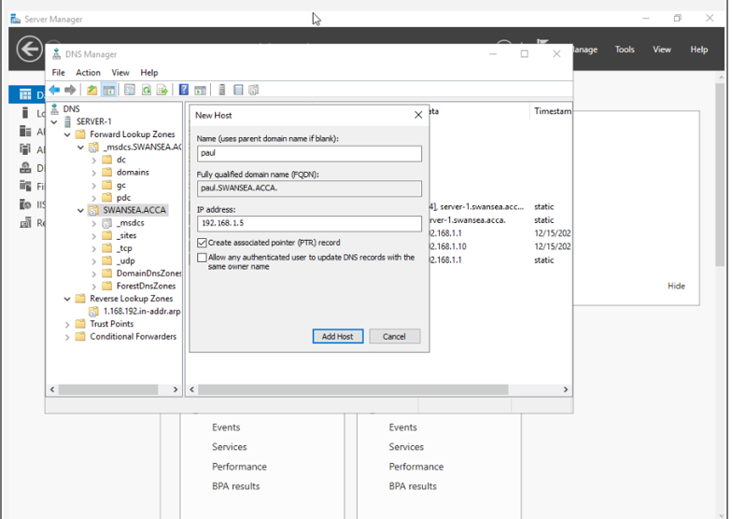
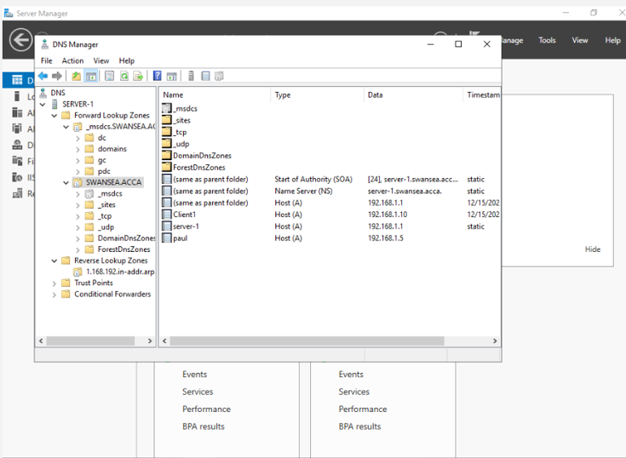
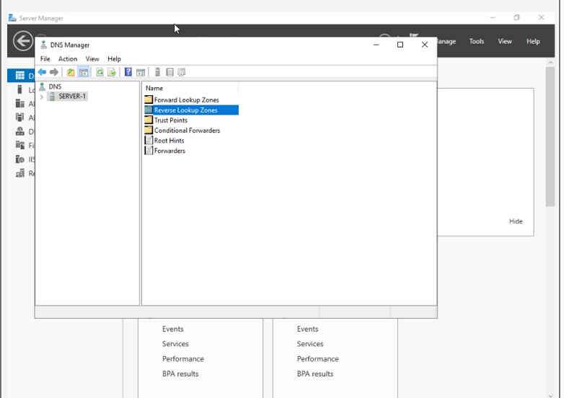
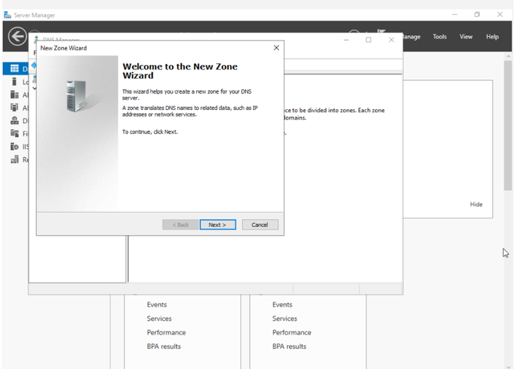
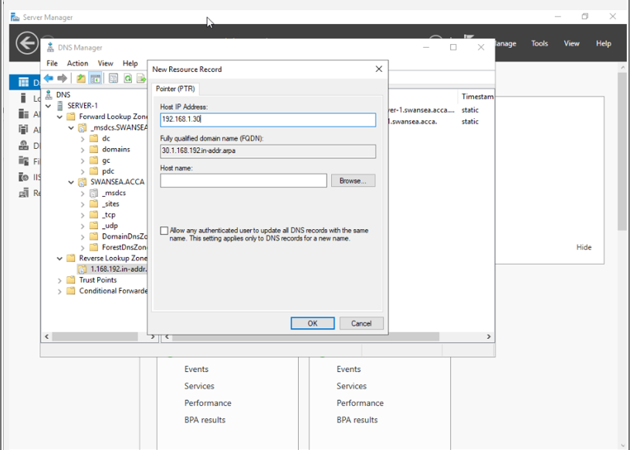
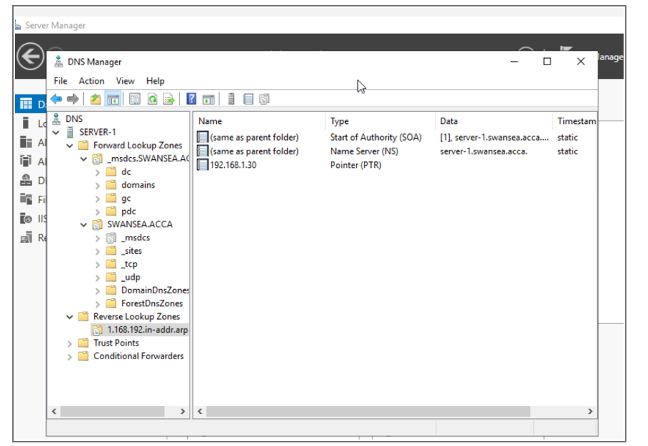

3.Encrypted Connection between Swansea and London
An encrypted connection between Swansea and London provides secure communication over untrusted networks, safeguarding sensitive data from interception or tampering. This project implements a Site-to-Site VPN to create a persistent, secure tunnel between the two sites, ensuring reliable, protected data transfer and seamless connectivity for network services and resources across both locations. VPN gateways at both sites use IPsec with IKEv2 for encryption and authentication. Routing is updated to direct inter-site traffic through the VPN, and firewall rules are adjusted. Connectivity is tested to ensure secure access to domain services and resources.
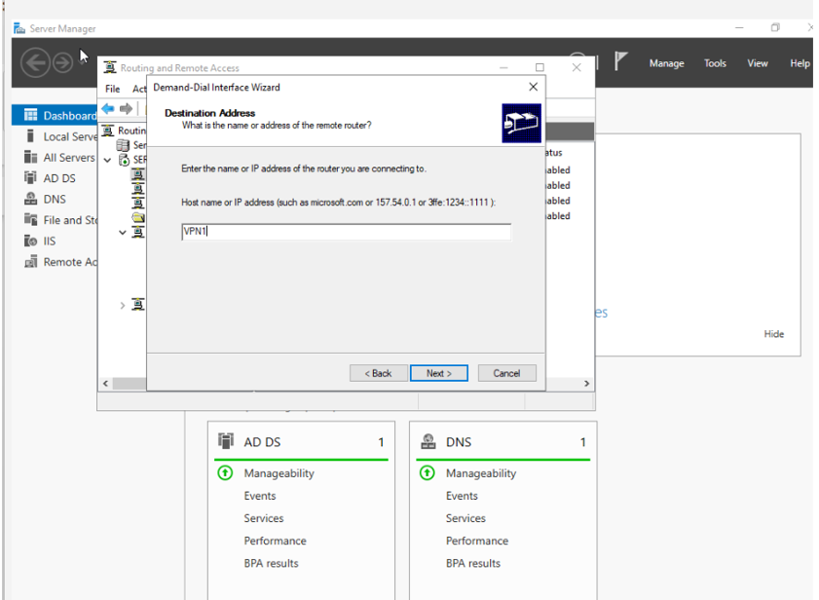
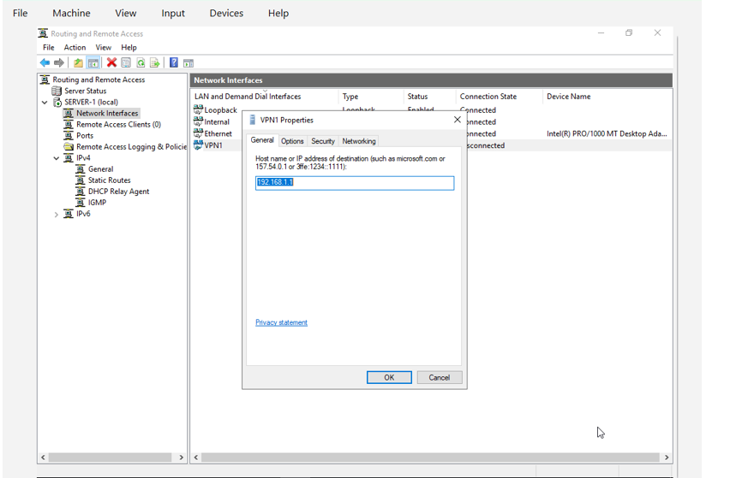

4.User
A user is an individual or entity that interacts with a computer system, application, or network. Each user is typically assigned a unique account with credentials, such as a username and password, which are used for authentication and authorization. Authentication verifies the user’s identity, while authorization determines the resources and services the user can access.
Creating a user account
Bulk-creating users with PowerShell is an efficient method to add multiple accounts to Active Directory (AD) without manual entry via ADUC. This approach ensures consistency, accuracy, and adherence to naming conventions, especially in large networks. Administrators prepare an Excel or CSV file containing user details such as first name, last name, username, password, and department, then import it using Import-Csv. The New-AD User cmdlet is used to create accounts with proper attributes, organizational units, and group memberships. Additional parameters enable accounts, enforce password policies, and streamline user management, reducing errors and saving time in enterprise environments.
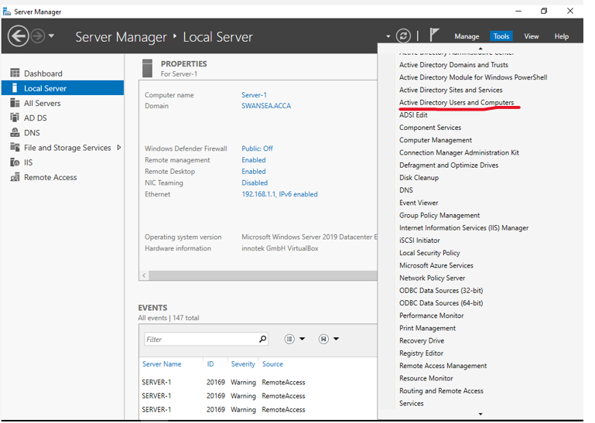
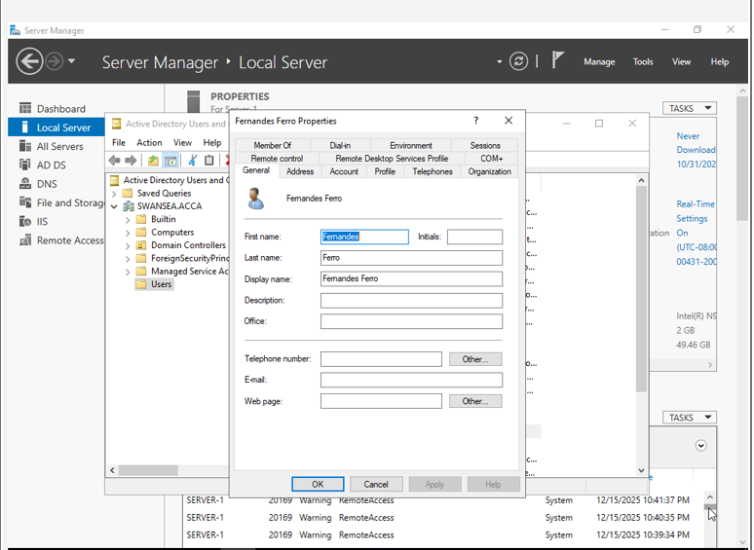

5.Domain Membership
In a Windows network environment, a domain like SWANSEA.ACCA provides a centralized framework for managing users, computers, and network resources. This structure, typically implemented using Active Directory (AD), allows administrators to control multiple devices and enforce policies from a single point, ensuring security and consistency across the organization.
Domain membership occurs when a computer is registered as part of the domain. In this scenario, L-CD, ClientS1, and ClientL1 are computers that will be joined to the SWANSEA.ACCA domain. Once joined, these devices can use domain credentials to log in, replacing the need for separate local accounts on each machine. This simplifies authentication and ensures that users have consistent access to network resources regardless of the device they use.
Joining the domain also enables administrators to centrally apply Group Policies and security settings to all three computers, ensuring compliance with organizational standards. Additionally, L-CD, ClientS1, and ClientL1 can securely access shared resources such as network files, printers, and applications, streamlining collaboration and productivity.
Overall, registering these machines in the SWANSEA.ACCA domain provides centralized management, enhanced security, and efficient access to resources, creating a controlled and unified network environment for all users and devices.
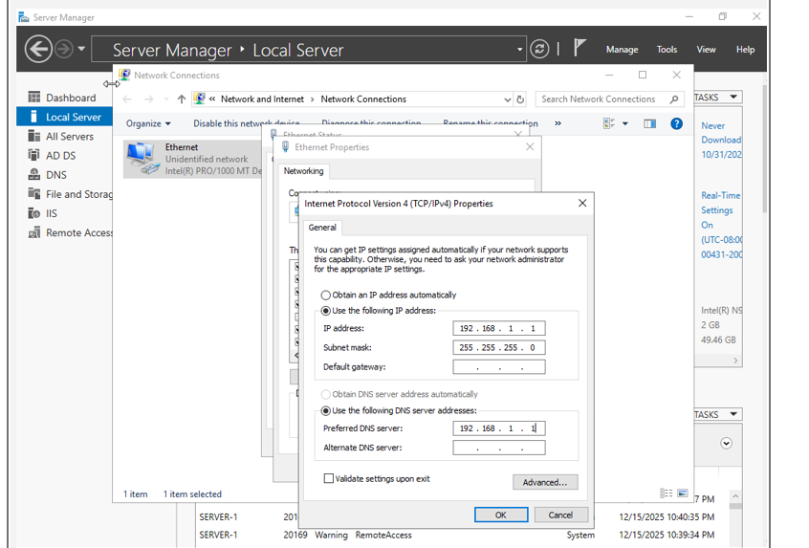
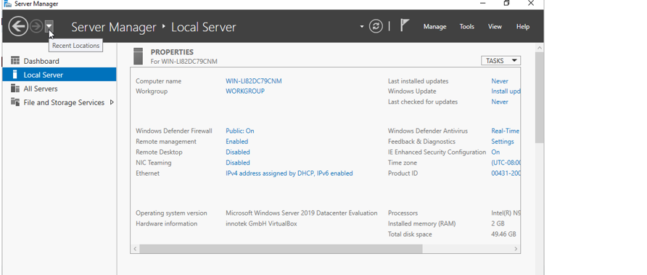
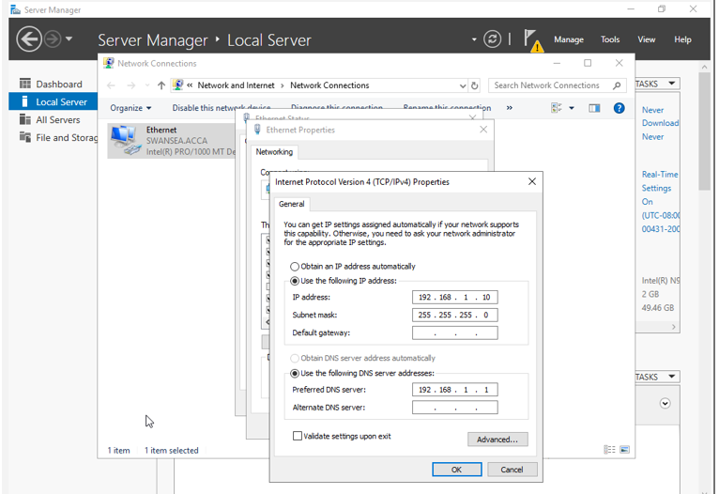
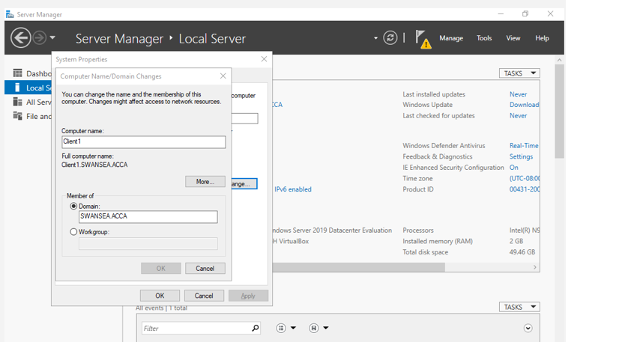

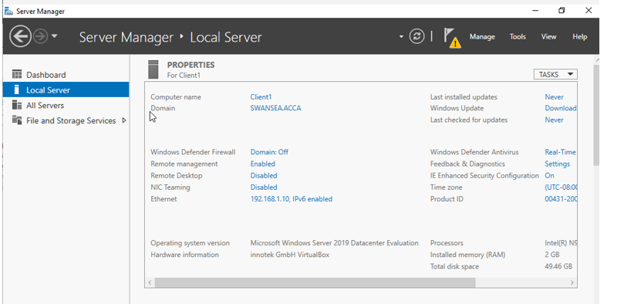

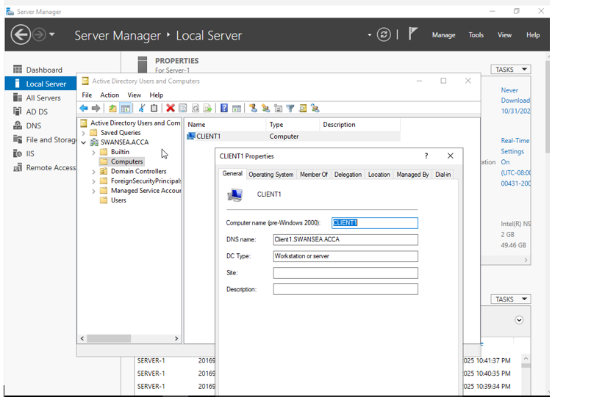

6.DHCP
In the absence of a DHCP server, each device would require manual configuration of these network settings. This manual process is not only time-consuming but also increases the likelihood of configuration errors, such as IP address conflicts or incorrect network parameters, which can disrupt network connectivity and performance.
When SWANSEA-DC is set up as a DHCP server, it automatically allocates IP addresses to client devices on the network, such as L-CD, ClientS1, and ClientL1. This allocation is managed through a defined scope, which is a specific range of IP addresses reserved for assignment. For example:
- Scope: 192.168.100.10 – 192.168.100.20
- Subnet Mask: 255.255.255.0
- Default Gateway: 192.168.100.1
- DNS Server: 192.168.100.2 (SWANSEA-DC)
- DNS Domain Name: SWANSEA.ACCA
The lease duration determines the period during which a client can use the assigned IP address before it must request renewal from the DHCP server. For instance, setting an 8-day lease allows IP addresses to be efficiently recycled among devices while ensuring continuous and stable network connectivity.
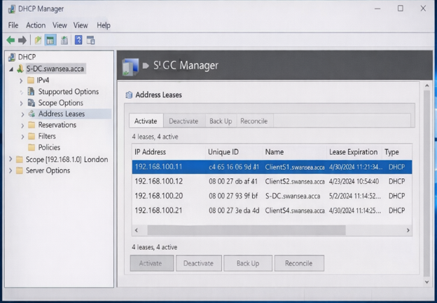

7.Test and Troubleshoot
To confirm that the Swansea and London networks are correctly interconnected and fully functional. Conducting network connectivity tests ensures that all devices can communicate effectively, access shared resources, and interact seamlessly with central servers, including SWANSEA-DC.
The initial test involves using the ping command, which sends ICMP echo requests from the client machines to the domain controller, routers, or other clients across both networks. Successful replies confirm that basic IP-level connectivity is established, indicating that devices can communicate effectively at the network layer.
Next, IP configuration verification should be conducted using the ipconfig /all command. This step confirms that each client has a valid IP address, correct subnet mask, appropriate default gateway, and accurate DNS server assignments. Correct configuration ensures that devices can interact seamlessly with the network and access required services.
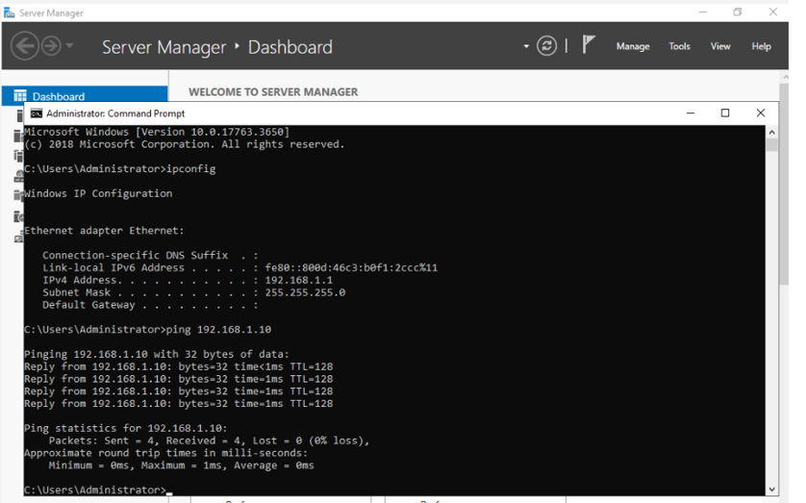
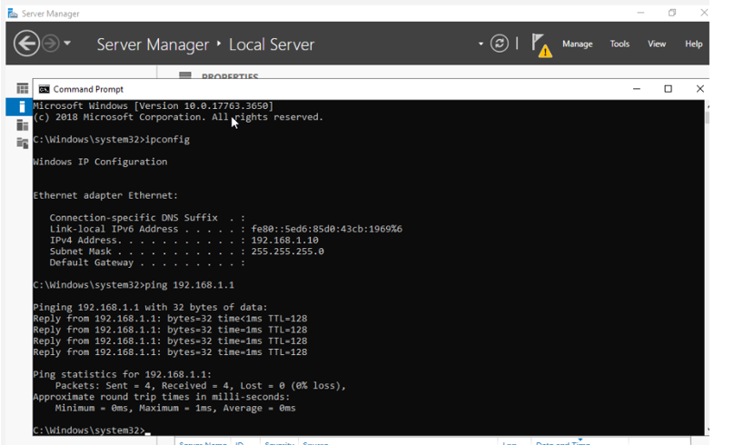

8.Disk Drive
To provide centralized storage accessible across both the Swansea and London networks, a second disk drive should be mounted to the server at the path E:\SwanseaFiles. Mounting the drive integrates it into the existing file system, allowing it to function as a dedicated folder for shared resources. This approach ensures that all authorized users can access the drive without requiring additional drive letters or complex network paths, improving organization and usability.
Once mounted, the folder should be shared over the network so that devices from both networks can access it. Proper sharing requires configuring permissions to maintain security and control over the data. In this configuration, Domain Users are granted full control, enabling them to create, modify, and delete files as needed for collaboration. Other network users are provided with read-only access, allowing them to view or copy files without making changes, which preserves the integrity of the data.
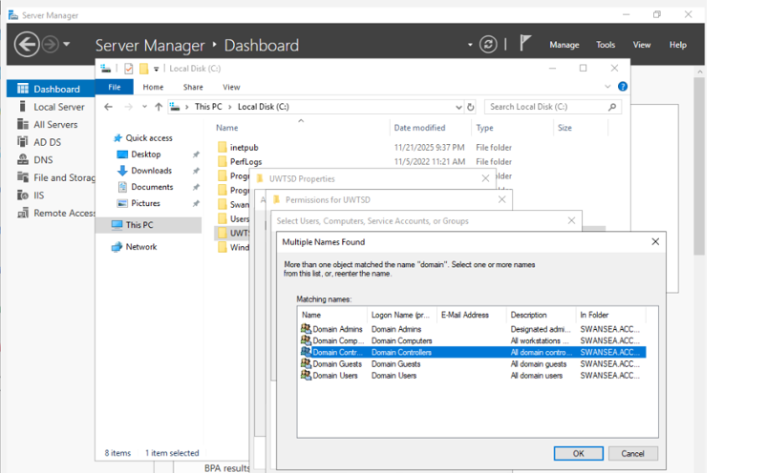
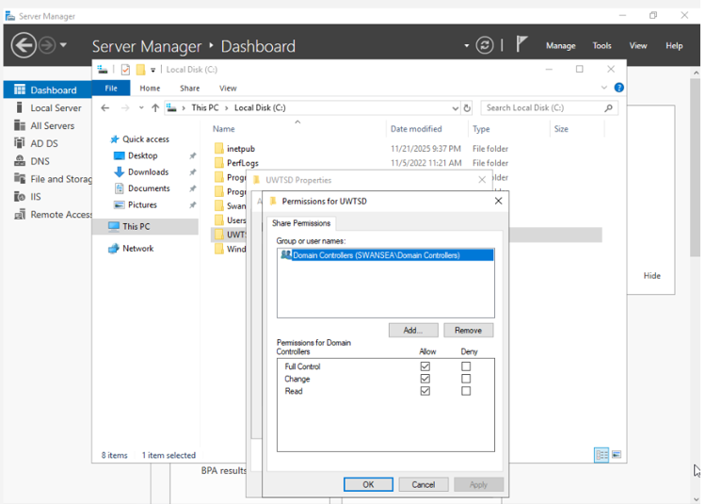
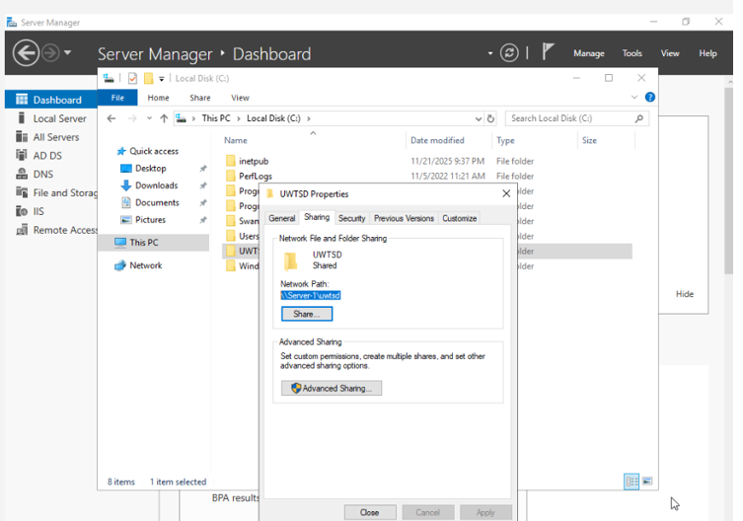
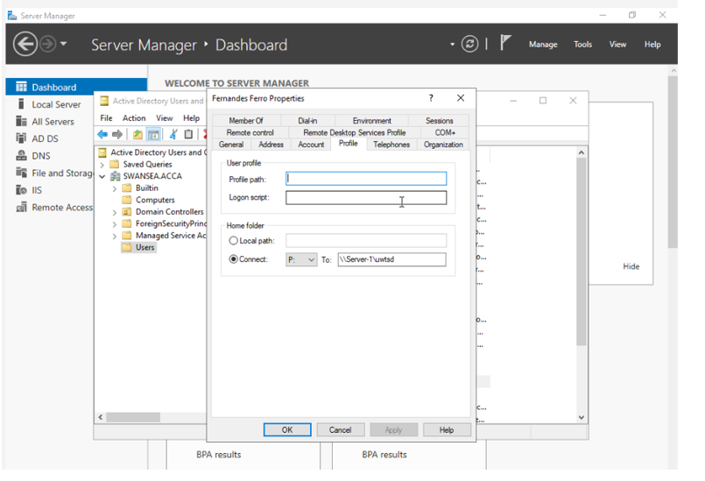
Client can access file as shown in the below screenshot /
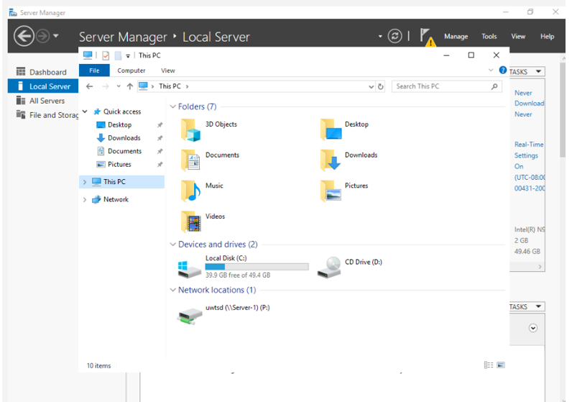

9.IIS Server
IIS (Internet Information Services) Server: - is a web server platform developed by Microsoft that enables the hosting and management of websites and web applications on Windows-based servers. It facilitates the delivery of web content over HTTP and HTTPS protocols and offers a wide range of features.
To create the website webs. SWANSEA.ACCA and enable Windows Internal Authentication, the process begins by installing the IIS (Internet Information Services) role via Server Manager using Add Roles and Features. After installation, IIS Manager is used to add the website, specifying the site name, physical path
(e.g., C:\inetpub\wwwroot\webs.swansea.acca), port (default 80), and host name. Windows Authentication is then enabled while disabling Anonymous Authentication to ensure that only users with valid domain credentials can access the site. This setup provides secure, controlled internal access, making the website suitable for intranet applications and internal organizational resources.
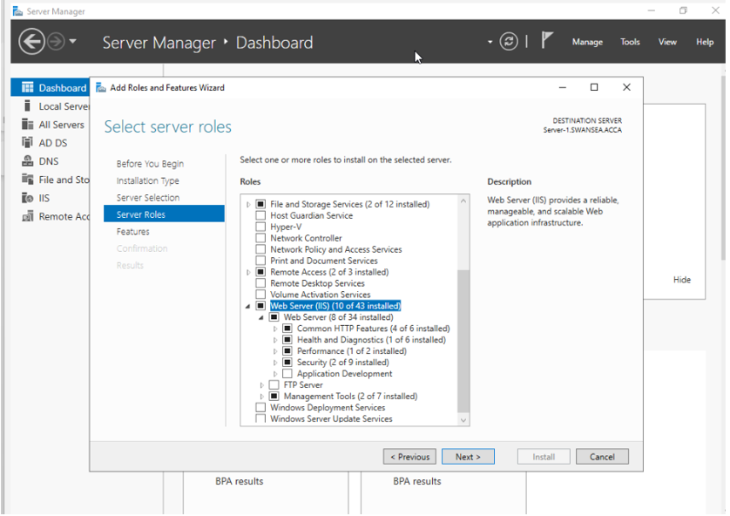
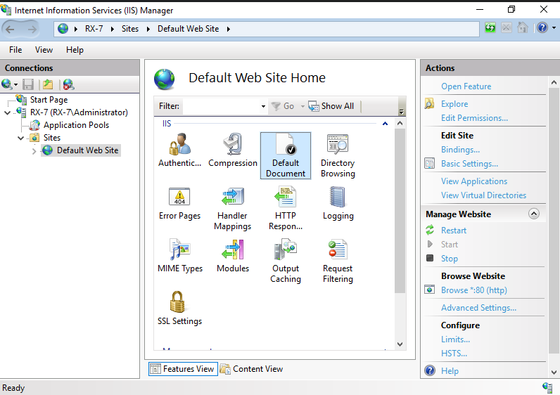

10. Remote Desktop Services
(RDS) Is a Windows Server feature that allows users to connect to and use desktops and applications hosted on a remote server through a network connection. By using the Remote Desktop Protocol (RDP). To enable secure access to Remote Desktop Services, the required RDS roles, including RD Session Host and RD Web Access, are installed on the server using Server Manager. A DNS host (A) record named rds. is then created to resolve the address rds. Swansea. acca to the IP address of the RDS server. An SSL/TLS certificate for rds. Swansea. acca is obtained from a trusted Certificate Authority and imported into the server’s certificate store. The certificate is assigned to the relevant RDS services to enable encrypted HTTPS communication. Firewall rules are configured to allow traffic on TCP port 443. Users can then securely access the RDS login portal via https://rds.swansea.acca using valid domain credentials.
Enable server Remot desktop Access
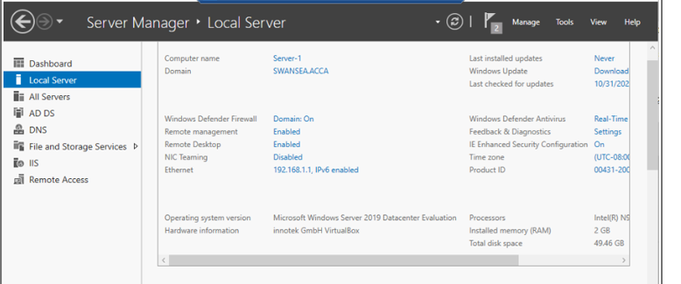
Enable client Remot desktop Access
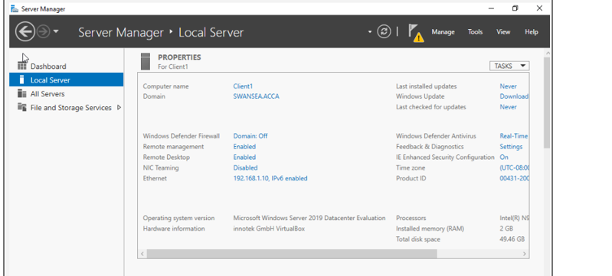

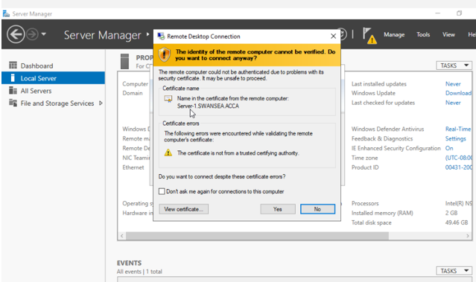
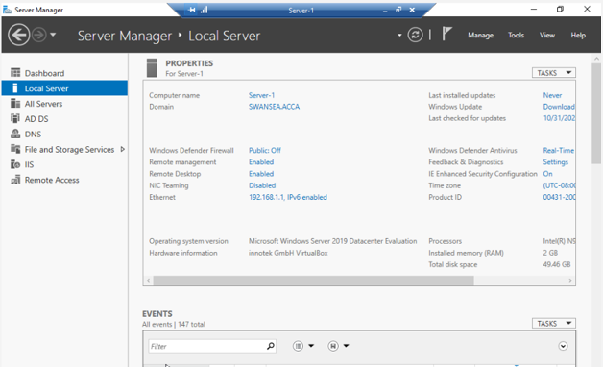

Conclusion
Overall, the project successfully established a well-structured Windows Server network environment, integrating key services such as Active Directory, DHCP, file sharing, IIS, and Remote Desktop Services. This configuration enabled centralized management, secure authentication, and seamless access to resources across both the Swansea and London networks. The implementation of domain-based security, Group Policy enforcement, and SSL-protected remote access ensured that network operations were both secure and reliable. Connectivity tests and troubleshooting validated the proper functioning of all components. The project demonstrates that careful planning and configuration of server roles and security measures can create a scalable, efficient, and secure enterprise-level network infrastructure.

