Professional Career Development in Health and Social Care (LCHS 4009)

ASSIGNMENT 2

Name of Student: AHOU ANNA YASMINE KRAMO

I.D. Number: 2437213

Name of Tutor: Christopher Mafuva

Acknowledgement of AI use: I confirm that I have / have not used AI to complete my work. (IF YES, ALSO WRITE I USED THIS SOURCE……. GIVE REFERENCE SUCH AS GRAMMERLY FOR EXAMPLE……TO………PROOFREAD FOR EXAMPLE).

Table of Contents Page Number

1.Introduction ……………………………………………………… 3

Task 1: CV (Social Worker) ……………………………………… 4

Task 2: Personal Statement …………....................................... 6

Task 3: SWOT Analysis …………………………………………...7

Personal Development Plan (PDP) ………………………………8
Task 4: Reflection (Gibbs Model) …………………………………9
References ………………………………………………………….11

Practical Portfolio

Introduction:
According to Bosch and Mansell (2025), a portfolio is a collection of work that has been developed and gathered over time. It allows individuals to showcase their skills and abilities by making their academic and professional learning clearer and more visible. Portfolios are used to evaluate learning in many fields such as art, graphic design, photography, education, nursing, and psychology. In this portfolio, to explore my expertise for a job as social worker, present my CV, a personal statement and SWOT analysis including a personal development plan. Also, present a reflection using Gibbs reflective model.

Task 1 of 4
According to the research (Reed.co.uk, 2026), I found that available job
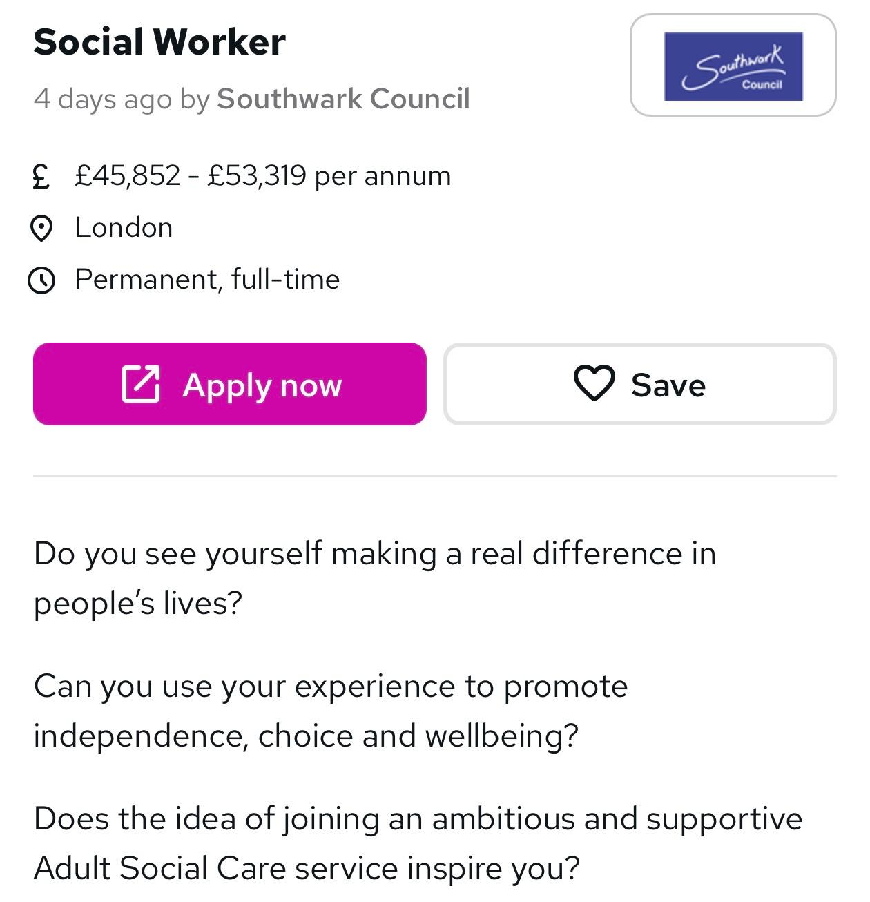
Curriculum Vitae

Social Worker

Name: Ahou Anna Yasmine Kramo
Email: annakramo07@gmail.com
Phone: 07577395507
Adress: Canary wharf, London

Personal Profile
I am a reliable currently studying BSc in Health and Social Care at the University of Wales Trinity Saint David. I have experience supporting vulnerable individuals through volunteering and working as a childminder. I am caring, patient, and have strong communication skills. I am committed to developing my skills and pursuing a career as a Social Worker.

- Education
University of Wales Trinity Saint David (UWTSD)
BSc (Hons) Health and Social Care (in progress)
Expected completion in May 2026
South Bank College, London
GCSEs in English and Math
February 2024 – September 2025
- Experience
Social Care Assistant (Volunteering)
King’s College Hospital, Denmark Hill London
2025-2026

- Supported vulnerable individuals and families

- Helped individuals access social services

- Provided support to pregnant women

Childminder (part-time)
Eden childcare Croydon, London
2023-2024

- Provided care for children in a safe environment
- Supported children’s development through play and activities
- Maintained daily routines (meals, hygiene, rest)
- Always ensured safeguarding

- Key Skills

- Communication skills
- Active listening
- Empathy and compassion
- Teamwork
- Problem-solving

- Training

- First Aid certificate: Mapal OS

- Interests and hobbies

- Volunteering in community support activities
- Supporting vulnerable individuals
- Reading about health and social care

Task 2 of 4

My personal statement

I am a motivated, caring person who wants to become a Social Worker. My goal is to support vulnerable individuals and families and help improve their wellbeing. I am interested in making a positive difference in people’s lives and supporting people in my community and country.
I am currently studying Level 4 Health and Social Care, which is helping me develop my knowledge of safeguarding, communication, and supporting individuals. Through my studies, permit to learned about how to helps people live independently and safely, especially those who are vulnerable. Also, I understand the importance of protecting vulnerable people and working professionally.

In addition, I have experience as a Social Care Assistant through volunteering. In this role, I supported vulnerable individuals and families and helped them access social services by my experience. I also supported pregnant women, which helped me understand different needs and situations. This experience improved my communication and teamwork skills.
Furthermore, I worked as a childminder, where I cared for children in a safe and supportive environment. I also supported children’s development through play and learning. This role helped me become more patient, responsible, and organised.

My main strengths are my ability to communicate effectively. I am a good listener, and I can build positive relationships with others more especially with children. Moreover, I am empathetic and understanding, which is important when working with vulnerable individuals.
I have developed important skills such as teamwork, problem-solving, and time management. I can stay calm patient in difficult situations and find solutions. I am always willing to learn and improve my skills.
Overall, I believe my education, experience, and personal qualities would be valuable to an employer because I believe I have the qualities needed to be a good social worker and meet the criteria for employability. In conclusion, I am motivated to start a career as a Social Worker, and I am ready to learn and develop in this role.
Task 3 of 4: SWOT Analysis (Social Worker)

According to (NHS Wales, 2025) we can identify that, a SWOT analysis looks at a person’s weaknesses, strengths, external opportunities and challenges. It is useful for understanding what skills I already have and what I need to improve. In this section, I will use a SWOT analysis to evaluate myself in relation to the Social Worker role.

Strengths | Weaknesses
- Good communication skills  - Empathy, patience and compassion  - Ability to build positive relationships  - Experience working with  children (childminder)  - Understanding of safeguarding | - Sometimes lack confidence in new situations  - Can be emotionally affected by difficult cases  - Still developing professional confidence in complex situations
Opportunities | Threats
- Studying Level 4 Health and Social Care  - Training opportunities (safeguarding, communication)  - High demand for social workers  - Work experience and volunteering opportunities (Hospital, school, homeless) | - High workload and stress  - Emotional challenges when working with vulnerable individuals  - Strong competition for jobs  - Risk of burnout  - Hostile environments

Personal development plan (PDP)

According to (Personal development planning, 2015) we can justify that, A Personal Development Plan (PDP) helps me understand my strengths and areas I need to improve. It also helps me set clear goals for my future career as a Social Worker. In addition, it allows me to develop my skills and check my progress over time.

Goals | Smart  Description | Importance | Development & Evaluation
1.Improve communication skills | - Practice speaking and listening skills during placement and class  - Participate in group discussions | Improving communication skills is important because it allows me to understand the needs of vulnerable individuals and provide the right support. In addition, it helps me build trust and positive relationship | - Take feedback from lecturers and other people and review my progress every 3 months  - Self-reflection after interactions  - Still practice with family or friends
2.Develop confidence and emotional resilience | - Attend training (stress management, communication)  - Learn how to manage emotions in difficult situations so observe experienced professionals and learn from them | Developing confidence and emotional resilience is important because it will help me work effectively with vulnerable individuals. It will also help me manage difficult situations and stay calm under pressure. | - I will review my progress every month  - I will identify my strengths and areas for improvement  - Use training to improve and learn more about resilience

Summary

My Personal Development Plan has allowed me to set clear goals for my future career as a Social Worker. These include developing my communication skills, gaining practical experience in health and social care, and improving my confidence and emotional resilience.

Focusing on these areas will help me provide better support to vulnerable individuals and improve my professional performance. I will track my progress by seeking feedback, reflecting on my experiences, and regularly reviewing my goals.

Overall, this plan will support my personal and professional development and help me prepare for a career in social work.

Task 4 of 4 Reflection (Gibbs Model)

Description
My Component 1 presentation, I made a presentation on a topic within health and social care, focusing on the importance of supporting vulnerable individuals. The purpose was to show my knowledge of the subject and my ability to share information in a clear way. I used PowerPoint slides to organise my ideas and included examples to support my points. After presentation, I received feedback from my lecturer highlighting both my strengths and areas that need improvement.

Feelings
At beginning, I was quite nervous because I am still developing my confidence when speaking in front of others. As the presentation continued, I started to feel more relaxed. I was pleased that I was able to complete the presentation. After receiving feedback, I felt motivated to improve my communication and confidence.

Evaluation
There were some positive aspects of my presentation. I was prepared, and my slides were clear and easy to follow. I was able to explain the main ideas and show my understanding of the topic.
However, there were also some weaknesses. I sometimes spoke too quickly, and I did not always make eye contact with the audience. I also felt that my lack of confidence affected my overall performance.

Analysis
This experience showed me how important communication skills are in health and social care. As a future Social Worker, I will need to communicate clearly and confidently with different people.
My nervousness affected how I presented my work, especially my speaking speed and confidence. This may be because I do not have much experience presenting. However, my experience as a Social Care Assistant and Childminder shows that I can communicate well in real situations, but I need to improve in formal presentations.
The feedback I received helped me understand that although I have good knowledge, I need to improve my confidence and presentation skills. This is also linked to my Personal Development.

Conclusion
In conclusion, this presentation was a useful experience that helped me to understand my strengths and weaknesses.

Action plan
In the future, I will work on improving my communication and confidence. I will practise speaking in front of others and ask for feedback from my tutor and classmates.

References

Bosch, B. and Mansell, H. (2015). Interprofessional Collaboration in Health Care. Canadian Pharmacists Journal, 148(4), pp.176–179. doi: https://doi.org/10.1177/1715163515588106. (Accessed 18 Apr. 2026)

Personal development planning (2015). Personal development planning. [online] Health Careers. Available at: https://www.healthcareers.nhs.uk/career-planning/developing-your-health-career/personal-development-planning.(Accessed 18 April 2026)

NHS Wales (2025). Improvement Cymru Academy Toolkit Guide. [online] Available at: https://phw.nhs.wales/services-and-teams/improvement-cymru/improvement-cymru-academy1/resource-library/academy-toolkit-guides/swot-analysis-toolkit/ .(Accessed 18 April 2026)

Reed.co.uk. (2026). Reed Jobs. [online] Available at: https://www.reed.co.uk/jobs/social-worker-jobs-in-london?multipleParentSectorIds=34.
(Accessed 18 Apr. 2026).

