Rebecca Aston

1802671

BMSP5008

Project Management for Sustainability

Assignment 1

Glenn Behenna

3,000 words

March 2019

Table of Contents

1.0 Executive Summary ………………………… 3

2.0 Introduction ………………………….4

3.0 Definitions of project management ………5

4.0 Project Management Techniques ………

4.1 Agile Project Management ……………6
4.2 Waterfall Project Management …….7
4.3 PRINCE2 Project Management………8

5.0 Project Management Tools ……………….

5.1 SMART Objectives ……………………….9
5.2 Gant Chart ……………………………………

6.0 Stakeholder Analysis ………………….10

7.0 Communication Analysis ……………..11

8.0 Risk Management ……………………….12

9.0 Conclusion ………………………………….13

10.0 References ……………………………………14

1.0 Executive Summary

There are many different tools and techniques that can be used by a project manager to assist in the development of a project and guide the project to its final success, namely;
- Agile,
- Waterfall and
- PRINCE2.
There are advantages to using these techniques but equally also disadvantages, as they are difficult to implement in real life business.
Project planning tools also exist which can be used to help a project manager clearly outline goals and objectives and also set a course/timeline for such a project.
There are other planning analyses that can take place to study the impact a project;
- One for stakeholders and how to approach prioritising them,
- A communications analysis can also be drawn up to decide the most productive way of communicating and
- A risk analysis is also recommended prior to the start of a project to eliminate the probability of any potential problems impacting the project and ultimately the organisation.

2.0 Introduction

The purpose of this critical business report is to analyse the usefulness of project management tools and techniques and then discuss the processes of project management as well as the factors impacted by it. The project management tools focused on in this report are the Waterfall method, Prince2 method and the Agile method; although it is worth bearing in mind that there are constantly growing lists of other tools available and being constantly developed to be used by organisations for their projects. Clearly it depends which tool suits their desired outcome and line of work most appropriately.
This report will analyse the life cycle of a business project as well as the project planning process, studying the importance of practical management techniques to exceed the potential for project success. The impacts on stake-holders’ involvement with an organisation through project management will also be highlighted as well as the factors of risk involved with project management techniques. A variety of academic business studies, journals and textbooks will be used in this report as well as up-to-date findings, statistics and articles to ensure a wide variety of sources are used to provide the most accurate understanding of project management and the importance of it in business.

3.0 Project Management

Definitions of project management vary from theorist to theorist as indeed do the definitions of a project. A project can be defined as a specific array of operations all working towards the same objectives and goals. These series of operations have a beginning, middle and end and are set to be completed in an agreed time scale (Institute, Project Management, 2019). Therefore, project management is utilising methodological management tools and techniques, knowledge and practical work skills to meet the needs and requirements of the project (Kerzner, 2015).

A project team can contain individuals or groups from different departments in an organisation where they are able to work collaboratively to achieve the most successful outcome, which is specific to that organisation. Individuals in the project team will have different attributes and knowledge from their said departments; this involvement of the range of departments is essential since without them the project may not consider or be unsure on the implications to each said department. In order for a project to have the best chance of success, theorists suggest there are requirements that must be met. Defined project objectives and commitment from all project team members, as well as time management and strong communication links between the team (Elbeik & Thomas, 2016). Crucially, for a strong productive project management team, there must be a project manager of a high quality, driving them with positive leadership so all aspects of the project can be drawn together to give the project best chance for survival.
A project itself has a lifecycle, beginning with the start up and initial planning of the project and ending with the desired completion of the project. This lifecycle is a sequence of the phases performed in the project in a logical order, so can vary between projects and how they have been managed as some projects have phases different to others. (R. Archibald, I. Di Filippo & D. Di Filippo, 2012).

Before any project can take place a project plan first needs to be created by the project manager. A project plan will consider and include any relevant factors that are involved in project implementation. The composite document will include factors like; cashflow, budget, product quality, schedule, contingency, resources, communications and stakeholder and risk factors (Institute, 2017). A project plan is the most efficient way of an organisation planning for an upcoming project because they are able to forecast their potential successes but more crucially identify early potential failures and how they can avoid them and the consequences of them.

4.0 Project Management Techniques

4.1 Agile Project Management

In order for a project to be productive and to achieve the desired outcome, firstly the project manager must decide which management tool they will utilise. There are a vast array of tools available to project professionals which are all valid and can guide success if fit for the purpose of that particular project.

Agile project management by definition is a management approach focusing on delivering incremental changes throughout the life cycle of a project to achieve success. It encourages flexibility at its core so by making changes little and often it allows a project to constantly be improving itself as it moves forward checking itself rather than waiting for the final product, where it ultimately measures the success of the project. (Association for project management , 2019). A simple project design allows a constant focus on excellence. Agile method insists on collaboration between stakeholders and project developers and ensuring all project members remain motivated throughout the project (CIO, 2019).

Agile methodology is a more modern approach to project management since it steps away from traditional methods where a very formal structure is in place to follow and where changes are made in less increments and conventionally wait until the end of the project.
It could be deemed more productive to constantly be flexible enough to make changes in a project as it can prevent money and time being lost on adaptations that may be found obsolete before release of the final product. Agile methodology focuses on the importance of the individuals and how they work together on a project rather than the more traditional thinking of just relying on process’ and tools which can impact the outcome of a project. By including positive relations with team members they are able to supplement management tools and techniques together with communication, since the tools are only as effective as the people using them.

There are obvious disadvantages to using the agile management tool since it can focus too much on making the small incremental changes and fulfilling those changes through the term of the project and therefore lose sight of the overall objectives of the final product.
This process is obviously expensive and very time consuming.
Another critical point with the agile management method is that it favours communication to be face-to-face which obviously is more personal and can allow a good rapport to be built. It does however limit how often communication can take place. To get all team members together for a team meeting may be possible however it would be more difficult to communicate with all priority stakeholders face-to-face on a regular basis.
Agile management is still a relatively new method that can also make it difficult to implement or introduce into a workplace due to its lack of identifiable success.

4.2 Waterfall Project Management

Unlike the Agile method, Waterfall project management is a more traditional approach to completing a project. This methodology focuses on a long-term project with one continuous linear timeline where the project matter is checked last thing before completion and if any changes are needed they are carried out at that final juncture. The linear fashion of the waterfall methodology means that the stages in the project are all executed one at a time before moving on to the next step or process. Unlike agile project management, where stakeholders have continuous insight on the project, the waterfall technique encourages and allows the potential customers to give their requirements and inputs at the commencement of the process, but no further along (Chavart, 2003).

With it being such a linear technique, projects using the waterfall method can be scheduled clearly and simply from the outset. This is a clear advantage as it allows for a more accurate timescale to be created, as users know what steps there are and roughly how long they may potentially take to complete. Another advantage with this linear structure is that it makes it easier for a project manager to measure the progress of the project and how it is progressing and fulfilling stages. The earlier point of customers not having continuous influence on the project can also be advantageous as it can avoid delays in the project where time may be spent collecting opinions and implementing changes.

A disadvantage with this method however is that with a lack of flexibility it closes itself off to adapting to changes in the business environment which could then subsequently impact the success of the project; with no product checks made until the verification stage, changes required at that late stage would certainly be very costly and time consuming. It would mean changes having to be made at all stages of the project again to change the final result. For those reasons this type of project management tool would not be suitable for long term or large-scale projects as if changes are needed to be made they would be on too large of a scale to make (The Telegraph, 2016).

4.3 PRINCE2

Prince2 is a leading project management technique where the project structures have a controlled start, middle and end. PRINCE2 has a process structure with different paths and seven stage processes:

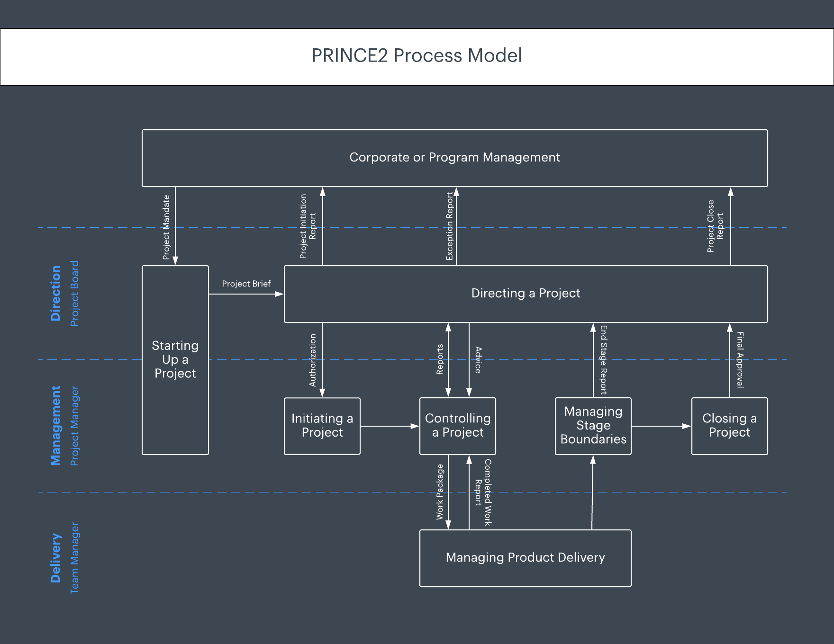
(Lucidchart, 2019)

The PRINCE2 approach works off seven core principles that the project must adhere to. These include continued business justification and planning work in manageable stages. One crucial principle with the PRINCE2 approach is that it can be tailored to meet the requirements of a project and can be changed to suit how an organisation operates.
This adaptability is a reason that makes it one of those popular methodologies used in project management. PRINCE2 is able to identify who should be involved in a project and in what capacity (Lucidchart, 2019).

There are advantages of using the PRINCE2 technique in that the project process is so strictly structured, each step-by-step stage can be closely monitored and changed if needed. It also standardises each stage of the project to avoid any miscommunication so can guarantee parties involved in the project know exactly what is happening. This also can protect time and money, as fewer mistakes should be made due to uncertainty. Standardisation also allows for less project time being wasted on identifying risks at the launch of the project, as everyone involved would then know exactly what was expected of them within the project. The obvious benefit is that it can be adapted and changed to the needs of the project and allows maximum opportunity for success of the project.

Disadvantages also exist with this technique as well. It focuses that the project manager themselves should only have influence over the project and not actually be physically involved in the day-to-day running of the project. This can potentially create a divide between staff and their project manager which could ultimately impact productivity and overall success of the project. Also, with this methodology being so strictly structured it doesn’t prepare itself f if anything goes wrong which in day-to-day business is a more than likely possibility (PMIS consulting , 2019).

5.0 Project Management Tools

Before any of the above methodologies can be implemented, project planning must first be completed. There are a variety of planning tools available to a project with many of them being useful in different ways.

5.1 SMART objectives
The scope of a project bridges the ambitions of the project and the work that needs to be done to achieve them (Moustafaev, CRC Press). Using SMART objectives a project is able to systematically break down the objectives of the project while taking into consideration realistic expectations and time constrictions. SMART objectives are specific, measurable, achievable, realistic and timebound expectations of what should be achieved by a project. This method of planning allows a project manager to consider a wide variety of goals for the project outcome before it begins, to avoid time and money wasting trying to change something once it has already begun (Lawlor, 2012). There are however disadvantages of using this planning tool as it is very in depth and can cover a vast amount of information which then may take productivity away from the project itself.

5.2 Gant Chart
A Gant chart is a method of visualising a project timeline in increments. This planning tool allows a project manager to see how long each stage will take relative to the permitted total project time. This simple chart can be very useful as it can been seen which milestones are completed at a certain time and to check if the project is on schedule for its finishing date. A project manager will be aware with the time constraints which stages need certain resources at what stages and so can ideally have those resources to hand at the right opportunities. This however is very optimistic thinking. If a certain resource isn’t available, then it can jeopardise the project scheduled finish, making the remainder of the Gant chart irrelevant. If used successfully though a Gant chart can be very beneficial to a project however it only works on the premise that no changes will be made, ensuring the project and the chart will be followed completely which is not realistic.

6.0 Managing Stakeholders

A stakeholder/s by definition is a party/parties with an interest in an organisation which may be affected both positively or negatively by completion of any project in said organisation (McGrath & Whitty, 2017). So in the business planning process an organisation needs to investigate how the decisions they make could potentially impact the parties who have the most influence on the business. Stakeholders can be divided into two groups; internal and external stakeholders. Examples of internal stakeholders are staff of the business, project sponsors, trade unions and external stakeholders are suppliers, consumers and investors (Alexander Brem, Éric Viardot, 2015).

To manage stakeholders correctly can help benefit an organisation to get support from the parties around them. Analysing the stakeholders and uncovering their impacts to and from potential projects can allow a business to prioritise its stakeholders when deciding on project aspects. A project manager can create a power interest graph to identify which stakeholders would be most impacted by changes in the company. This is done by evaluating the power those stakeholders have on a business and the level of interest they have in it.
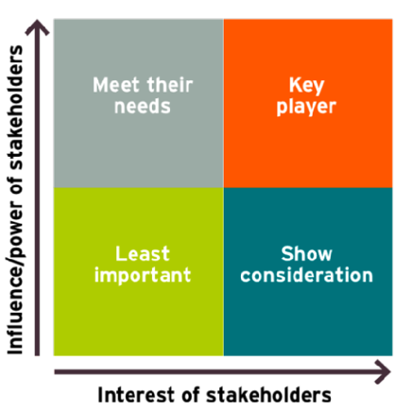

(J, Bryson, 1995)

A power interest graph will help a project manager then see which stakeholders are most important to maintain interest with and how considerate they should be to those stakeholders when planning projects. There are also other management tools used to analyse stakeholders, namely; Bourne’s Stakeholder circle and the stakeholder ‘salience’ model. Stakeholder circle focuses that the project success can only be achieved with the informed consent from stakeholders (Bourne, 2018). Although the tools differ the expected outcome of analysis is the same; to prioritise stakeholders in order to understand the impacts of project outcomes on them.

There is a downside to these models in that they don’t forecast unforeseen circumstances and their impact on stakeholder interest in the project. If there were to be an economic downturn, project sponsors may have different priorities for investment, meaning they would no longer be priority stakeholders for the organisation running the project and therefore could potentially put the project in turmoil.

7.0 Communications planning

In any productive project there will of course be essential and necessary communication between project members as they have to discuss changes, updates and developments in the project. Method and delivery of communications within a project can vary so a communications plan can be drawn up to ensure communication is consistent. .
An unstructured communications plan is drawn up subsidiary to a business plan and follows the influence of the ‘7 c’s of communication’ model. It states that for effective communication to take place there are 7 criteria that need to be addressed; clarity, credibility, content, context, continuity, capability and channels (Cutlip, 2009).If a communications plan is not fit for purpose or does not exist, a project can find itself wasting money and time on communicating data to the wrong parties or wasting resources to distribute information which will immediately be out of date. If information is printed onto a flyer and distributed while continuous development is still ongoing then the data on those flyers will be out of date as soon as a change is made. This would be waste and unnecessary drain on an organisation’s project budget and their time spent to be in focus. Below is a sample communications plan that would be useful to any universal project. Further criteria could be added, however that is dependant to the project and what sort of communications they desire to achieve.

Which team members/stakeholders need to be told? | What information do they need to be told? | How are they going to be told? | How frequently are they going to be told? | Date completed  dd/mm/yy

A communications plan however is not the most realistic expectation of day-to-day business running since workers will inevitably communicate amongst themselves while working on the project, during breaks and even outside work. This natural occurrence can lead to gossiping and false information circulating so even with a communications plan in place, it cannot be guaranteed that the correct and desired information is circulated. So while this model in theory is very effective in reality it may have the desired outcome.

8.0 Risk Analysis

With any project there will be an element of risk in some respect, whether this be the project directly or external factors. Similarly in the way that stakeholder analysis is completed, a risk analysis should be carried out prior to the beginning of project activities. By identifying risks and prioritising them, the project manager is able to evaluate which risks are more likely to occur and subsequently the way the project operates. Risk severity is measured in the formula of [probability x impact=severity] (Milosevic, 2003). Project managers can use this to then decide how they see fit to strategise how to address said risks and then ultimately monitor them for minimal opportunity of them impacting on the project at hand.
Risks can be measured in stages of low, moderate and high, in terms of their likelihood of occurrence and their impact. By performing a risk analysis the project manager is able to give the project a better chance of survival in theory as any potential problems have already been dealt with. This however, as with many of the other project tools, is not realistic in the business environment as there may be risks that were missed, not considered or not even present at the time of the analysis, which can still impact the business. Unless a risk analysis is ongoing during a project, it is not completely reliable. With constantly updating the risk analysis, it too takes away focus from the actual task at hand, the project.

9.0 Conclusion

In conclusion, the above report has given many examples of potential project management tools and techniques that can all be utilised when requiring completing of a project. No particular tools are superior of the others. It can be seen that they all have their own qualities and attributes and depending on what sort of project is taking place, they can be very useful in aiding the success of the project. The methodologies are only three of a proliferation of others available to a project manager and they all work in different styles, but all with the final goal of success of the project. The project planning tools also are only a number of what are available and can all make the project planning process much simpler for the project manager and ultimate running of the project.
A conclusion drawn on these methodologies and tools is that they are all very optimistic and work on the premise of nothing changing during the project. They leave no room for contingency and fail to take into account problematic occurrences that may occur at the least anticipated stage of the life of the project.

Stakeholder and risk analysis is also very beneficial to project managers; however it can also be concluded that circumstances changing could turn their analyses obsolete.

A communications plan also while seeming valuable on paper, when implemented, may not be as successful as initially hoped.

It would be reasonable to conclude therefore that all of the above, whilst being very appealing on paper, all come with disadvantages and risks. Chosen carefully and implemented correctly though, they can be fundamentally useful to the success of a project.

10.0 References

Alexander Brem, Éric Viardot. (2015). Adoption of Innovation: Balancing Internal and External Stakeholders in the marketing of innovation. London: Springer.
Association for project management . (2019, March). What is agile project management . Retrieved from Association for project management: https://www.apm.org.uk/resources/find-a-resource/agile-project-management/
Bourne, L. (2018). Project relationship management and the Stakeholder Circle. Emerald Insight .
Chavart, J. (2003). Project Management Methodologies: Selecting, Implementing, and Supporting methodologies and process for projects. Hoboken: John Wiley and Sons.
CIO. (2019, March ). Agile project management: A comprehensive guide . Retrieved from CIO: https://www.cio.com/article/3156998/agile-project-management-a-beginners-guide.html
Cutlip, S. (2009). Effective public relations . Prentice Hall.
Elbeik, S. M., & Thomas, M. (2016). Managing Projects in Human Resources Training and Development. London: Thompson Shore.
Institute, P. M. (2017). A Guide to the Project Management Body of Knowledge (PMBOK® Guide). Project Management Institute .
Institute, Project Management. (2019, March 19). What is project management. Retrieved from Project Management Institute: https://www.pmi.org/about/learn-about-pmi/what-is-project-management
J, Bryson. (1995). Strategic Planning for Public and Nonproﬁt Organizations. Power Interest Graph Image. San Fransisco.
Kerzner, H. (2015). Project Management 2.0: Leveraging Tools, Distributed Collaboration, and metrics for project success. Hoboken: John Wiley and Sons .
Lawlor, K. B. (2012). Smart goals:How the application of SMART goals can contribute to achievement of student learning outcomes. Developments in Business Simulation and Experimental Learning, 259-267.
Lucidchart. (2019, March 20). PRINCE2 Process Model Image. PRINCE2 Process Model Image. Retrieved from https://www.lucidchart.com/blog/what-is-prince2-methodology
Lucidchart. (2019, March). What is PRINCE2 Methodology. Retrieved from Lucidchart: https://www.lucidchart.com/blog/what-is-prince2-methodology
McGrath, S. K., & Whitty, S. J. (2017). Stakeholder Defined. Emerald Insight, 721-748.
Milosevic, D. Z. (2003). Project Management ToolBox: Tools and Techniques for the Practicing Project. Hoboken: John Wiley and Sons.
Moustafaev, J. (CRC Press). Project Scope Management: A Practical Guide to Requirements for Engineering . London: 2015.
PMIS consulting . (2019, March 21). 10 reasons PRINCE2 is not even close to best practice. Retrieved from Project Management Informed Solutions: https://www.pmis-consulting.com/10-reasons-why-prince2-is-not-even-close-to-best-practice/
R. Archibald, I. Di Filippo & D. Di Filippo. (2012). The Six-Phase Comprehensive Project Life Cycle Model Including the Project Incubation/Feasibility Phase and the Post-Project Evaluation Phase . PM World Journal, 1-40.
The Telegraph. (2016). Waterfall Project Management Explained . Online: The Telegraph .

