Managing Hotel Administration
BMIH6004
Syeda Shajna Begum
2128506
Guilia Chifari

Table of Contents

Introduction 3
Section 1: Reflection on Experience and Personal Development using Kolb’s Experiential Learning Cycle 3
Section 2: Critical Analysis of Work-Based Skills and Technical Knowledge 5
Section 3: Reflection on Organisational Issues 5
Conclusion and Action Plan 6
References 8

I confirm that I have not used any AI tools in the research and creation of this assignment. I can confirm that I have not presented any AI generated material as my own work. I can confirm I have copies of my drafts, notes, and other resources I used, which may be asked to provide in evidence.

Introduction
At Premier Inn, the administrative departments are one of the crucial factors that support the hotel services which include reservation, invoicing, and accounting. During my 10 weeks’ practical affiliation, I observed different activities in the Front and Sales Office based on the operations and customer relations of a hotel. In this position I was able to see the coordination functions that are very important in the everyday functioning of Premier Inn and improve my professional competencies in the sphere of effective functioning in the environment of a large and developing hotel company.
Learning Objectives:
- Acquire practical knowledge about how the Front Office and Sales Office work within an organization.
- Learn the application of professional skills in communications with guests and other employees.
- Optimising the prioritization of a task and the time management in the hotel setting.
- Discover what general abilities are important to know and practice in hotel management: from the use of a booking program to report instruments.
- Establish a basic knowledge about the supervisory element in the administration of hotel tasks.

Section 1: Reflection on Experience and Personal Development using Kolb’s Experiential Learning Cycle
Kolb’s Experiential Learning Cycle (1984) offers a structured approach to reflection through four stages (Hayes, Ninemeier and Miller, 2017). These are Concrete Experience, Reflective Observation, Abstract Conceptualization, Active Experimentation. I was able to use this model to reflect the practice I had whilst shadowing a supervisor at Premier Inn and come up with areas of both professional and personal development.
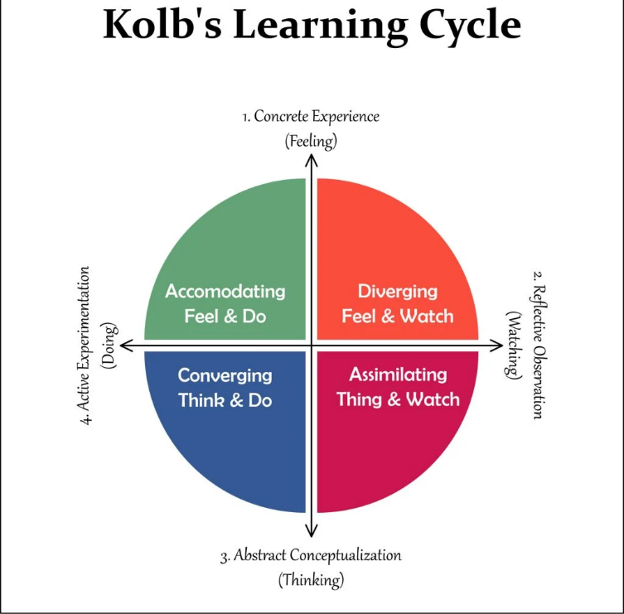
Kolb’s Experiential Learning Cycle (Huo et al, 2021)
- Concrete Experience: I had my placement in Front Office under a supervisor in which I used to study and engage in daily organizational functions. Such tasks included registering guests and checking out, responding to inquiries as well as confirming rooms’ readiness by coordinating with the housekeeping department. In the second company, which is called Sales Office, I discovered the process of monitoring room occupancy and creating materials for affiliated online booking services. This journey gave me an insight into some of the activities needed to achieve Premier Inn service delivery.
- Reflective Observation: It helped me understand how the supervisors carry themselves when they’re dealing with guests and the staff, so professionalism and consistency should be maintained all the time. Observing that my supervisor used to calm temper effectively, I also saw how he minimised guests’ anger when the room was not ready on time. I observed myself analysing how I could enhance my method in handling customer service to mirror the method they applied.
- Abstract Conceptualization: This helped to emphasize the effectiveness of communication when working in the administrative positions particularly while passing information from one department to another. They avoid confusion and help in providing positive management to guest expectations during the communication process. This is in line with the hotel’s objective to maintain an average level of guest satisfaction (Gallo et al, 2018). Moreover, this experience let me discuss, relying on Kolb’s model, such key aspects of service quality as guest-centred service and operations efficiency, which I studied during the courses prior to the practical one.
- Active Experimentation: Considering these observations, I ensured to change my communication behaviors and deliberately began to apply new behaviors such as questioning the needs of the guest and reiterate information to the guests. I also enhanced the working time management strategies where I had to align guests’ inquiries with other administrative responsibilities. These changes were helpful and established more confidence and flexibility, especially when the traffic is more at the front desk.

Section 2: Critical Analysis of Work-Based Skills and Technical Knowledge
The placement at Premier Inn reinforced many important work-related skills and technical knowledge applicable to administrational positions. Regarding task organizing and planning of responsibilities, communication, and high-pressure applications, all these were central in ensuring that consistent guest service delivery was achieved (Huo et al, 2021). For instance, when I was performing data analysis for Premier Inn’s booking system, I was recording the status of the guests and their respective rooms. Such technical efficiency is important in the hospitality industry where customers’ expectations of value depend primarily on correctness and speed.
Also, knowledge regarding customer service constructs including SERVQUAL which is a tool for measuring service quality based on five factors; reliability, responsiveness, assurance, empathy, and tangible attributes provided me with an idea of the Premier Inn’s standards we were striving to achieve. How my supervisor was able to meet each of the dimensions through enhancing communication with the guests and ensuring proper check-in showed applicability of the above-mentioned theory within the real world setting of hotel management.

Section 3: Reflection on Organisational Issues
During my placement, I encountered a recurring issue: a lack of coordination between the Front Office and Housekeeping when occupancy levels were high. This misalignment produced negative results in delays in room preparation and occasional guest complaints due to the delay. Therefore, front desk agents had to invite guests and help them to set their expectations, which strained the general team’s productivity and staff’s satisfaction.
This experience taught a lesson of integration where different departments within an organization must work hand in hand to ensure smooth flow of work. My supervisor approached this problem by setting up a manual system for real-time updates of rooms status though I think there is room for improvement here and fully automating the process would be even better.
Proposed Solution: My suggestion therefore would be to implement digital platform where Floor staff and housekeeping department could freely check room status. Such a solution would eliminate extra contacts by reducing the time guests have to spend waiting and increase satisfaction. Besides, using Tuckman’s stages of group development, it might also improve teamwork and communication so that people will not get annoyed or frustrated during high traffic periods (Bortoluzzi et al, 2020).

Conclusion and Action Plan
Remaining at the Premier Inn helped me to understand various skills and body of knowledge that are required in management posts in a hotel. The Kolb’s Experiential Learning Cycle helped me to understand the value of the experience and pointed to communication, flexibility, and performance of tasks as the significant aspects of an administrative position. This enabled me to understand the kind of challenges the officials in the hospitality sector face to apply the right strategies to overcome those challenges, which in turn has made me develop passion in the hospitality sector and focus myself towards attaining a position within the hotel operations and administration.
Bringing into use the skills that are acquired in the future, I must make sure I have mastered the operations of the property management applications that most hotels apply in their everyday operations. I shall also pay to interpersonal skills which are crucial in mediating guests and teams/individuals. Thus, I individualize the following areas for improvement so that I could successfully prepare myself for possible supervisory positions in hotel administration as well as make valuable contribution to future hospitality teams.
For enhancement, I will attend professional development courses relating to customer relations and communication with team members for enhanced ability to address guest relations as well as to coordinate the team’s efforts. I also will try to find supervisors to talk to and gain knowledge about important matters and how to manage operations and offering support to colleagues. Also, I should engage myself more in situational exercises and simulations of several usual incidences facing incumbents in administrative positions. These are long term goals that I will establish to be certain of making successive achievements in those fields as I foster my career in hotel management. I will set monthly goals for these ones to be sure what I am doing and modify them on the right track as I establish my career in hotel management.

References
Bortoluzzi, D.A., Lunkes, R.J., Santos, E.A.D. and Mendes, A.C.A., 2020. Effect of online hotel reviews on the relationship between defender and prospector strategies and management controls. International Journal of Contemporary Hospitality Management, 32(12), pp.3721-3745.
Fallon, M. & Rutherford, D., 2010. Hotel Management and Operations. London: Wiley.
Gallo, P., Timková, V., Šenková, A. and Karahuta, M., 2018. Use of dashboards in predicting the development of the company using neural networks in hotel management. GeoJournal of Tourism and Geosites, 22(2), pp.307-316.
Gido, J., Clements, J. and Baker, R., 2018. Successful project management. Cengage Learning.
Hagg, E., 2013. Internship Guide: Work Placements Step by Step. 5th Ed. The Hague: Eleven International Publishing.
Hayes, D.K., Ninemeier, J.D. and Miller, A.A., 2017. Hotel operations management. Pearson.
Huo, C., Hameed, J., Sadiq, M.W., Albasher, G. and Alqahtani, W., 2021. Tourism, environment and hotel management: an innovative perspective to address modern trends in contemporary tourism management. Business Process Management Journal, 27(7), pp.2161-2180.
Johnston, R., Clark, G. & Shulver, M., 2012. Service Operations Management: Improving Service Delivery. 5th Ed. London: Pearson.
Merli, R., Preziosi, M., Acampora, A. and Ali, F., 2019. Why should hotels go green? Insights from guests experience in green hotels. International Journal of Hospitality Management, 81, pp.169-179.
Nain, A., 2018. A study on major challenges faced by hotel industry globally. International Journal of Creative Research Thoughts, 6(1), pp.561-571.
Ouyang, Z., Wei, W. and Chi, C.G., 2019. Environment management in the hotel industry: does institutional environment matter?. International Journal of Hospitality Management, 77, pp.353-364.
Stojanovic, R., 2018. A qualitative exploratory study: Use of emotional intelligence by hotel managers for a more successful leadership. Colorado Technical University.
Vives, A., Jacob, M. and Payeras, M., 2018. Revenue management and price optimization techniques in the hotel sector: A critical literature review. Tourism economics, 24(6), pp.720-752.

