Module Title: Project Management
Module Code: LCLM5003
Student Name: Lorena Denisa Szolosi
Student ID: 2412292
Tutor Name: Xavier Matieni

Project Title: Emergency Reopening of Flood-Damaged Highways in Worcester Following the 2025 West Midlands Flood.

Table of Contents
Part A: Project proposal poster 3
Part B: Reflections from the feedback received from the tutor and peers 4
Part C: Project Management Plan 5
Introduction 5
Project description 5
Scope 6
Work breakdown structure 7
Quad Chart 8
Gantt Chart 9
Stakeholders' involvement 11
Allocation of resources 13
Risk Analysis 14
Conclusion 16
References 17

Part A: Project proposal poster
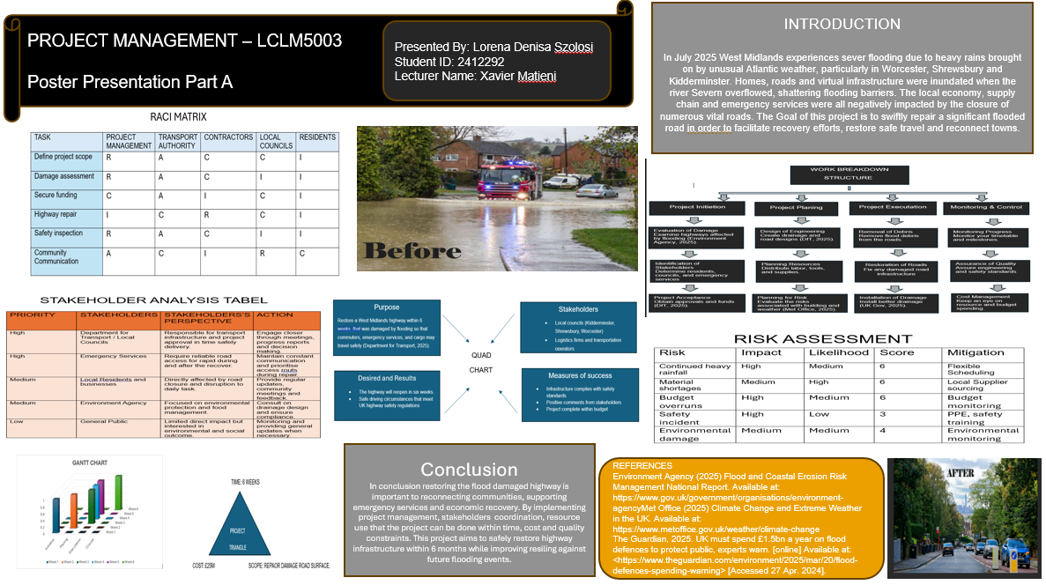

Part B: Reflections from the feedback received from the tutor and peers
The reflection below is about displaying the feedback of part a which is a project proposal. But the poster also seeks to develop a methodology for fluid recovery planning and highway restoration in particular. The tutor gave positive feedback on this poster, and it showed a big strength of the poster and has a small scope for improvement which is considered in terms of skill and performance.
The presentable and structured display was one of the motives for better presenting the poster. In this stage, I have gained skills for producing visually attractive content in the complicated nature of project management. This directly reflects in the betterment of my creative skills for giving thought to the graphics and approaches to represent them. Likewise, the above matrix, work breakfast, structure, risk analysis and stakeholder analysis were effectively used to present the evidence to support my project management skills. Here I have also displayed different information in a systematic way, which highlights my information planning and organising skill. These are part of employability skills, which directly supports problem solving and time management in the key project scenarios (Tushar and Sooraksa, 2023).
Likewise, implementation of tools have helped to effectively represent the flood recovery scenario which supported me to apply my theoretical knowledge into the practical application. This also supports my critical thinking and decision making which allows me to enhance my career (Hanscomb, 2023). In summary, this mix of methods have supported my transferable skills and technical knowledge.
But my teacher gave feedback that the poster was well presented but does not have depth. Similarly, the responses from peers also played a crucial role which indicates easy to understand the poster. Therefore this feedback shows that I have the skills to present and communicate knowledge in a professional manner. Moreover, it also demonstrates my creativity skills which are very important in the future work environment.
Although there are several positive aspects; there are certain skills that require improvement. But, I had high creative skill, but could improve my academic skill. As my poster was lacking for theoretical significance, which restricted it for a critical explanation. In this scenario, I would like to include literature from part C to support my decision making and demonstration, but not my knowledge. I will also concentrate on link factors. These abilities are important for assisting in writing and to improve the professionalism to manage complex projects.

Part C: Project Management Plan

Introduction
The extreme weather events in July 2025, the widespread flooding in the West Midlands, Worcester, Shrewsbury, and Kidderminster, worsened the vulnerability of UK infrastructure. The River Severn overflowed, and the months of rainfall resulted in a massive flood, which caused much disruption, damage to the transport system. Previous instances of such floods in the UK have already cost the country in excess of £1.3 billion in terms of the economy, which demonstrates how the disasters are getting more expensive, both in financial and social terms (Laidlaw and Percival, 2024). This reflects on the larger-scale climatic trends, where more and heavier rainfall related to climate change is being received in the UK (Stallard, 2026).
The following report is a response to a project that would be used to restore a key highway to reestablish connectivity and allow the economy to recover. The project management plan will be directed towards the implementation of a systematic approach to the attainment of effective planning, resource allocation and risk alleviation. The project management in the context of the disaster recovery scenarios will be key to support the coordination, minimise the delays, and align the stakeholders (Harake, 2025). This report is thus a critical outline of a plan that would bring a sustainable solution.

Project description
The proposed project is a restoration of a highway damaged during a flood in the West Midlands with a scheduled completion period of six weeks and a budget of £25 million. Although the poster introduces this as a fast recovery measure, a critical analysis indicates that the project needs reconstruction to resilience-based infrastructure building. According to the UK flood reports, recurring infrastructure failures are commonly caused by short-term plans which may not mitigate the vulnerabilities (‌Cavanagh, 2025). Thus, this project is oriented not only as a repair project to introduce long-term flood prevention strategies.
The ultimate goal is to reestablish safe and effective transport connectivity for commuters, emergency services. In addition realisation of this in a six weeks period, however, presents serious project management issues, especially in the trade-off between speed and safety. These are the factors which exemplifies the triple constraint of time, cost, and scope that exists in the literature on project management (‌Sun et al., 2026).
In the Work Breakdown Structure, the primary deliverables are the removal of debris, the reconstruction of roads, and the installation of improved drainage systems. Nonetheless, these deliverables require coordinated stakeholder participation because of uncertainties of resources. Similarly, the project demands a formal but adaptable management strategy, which is consistent with the PMBOK principles, which highlight integration of stakeholder (Zamri et al., 2023).

Scope
The project scope aims to improve highways damaged by floods in the West Midlands, which includes short-term repair and long-term resilience. The areas of scope are the clearance of debris, reformation of damaged roads, installation of creation of safety checks, which is displayed in WBS of the project. Such operations will be necessary to restore transport connections and adherence to UK highway safety regulations.
Nevertheless, a critical definition of scope needs the clear identification of exclusions as the out-of-scope items are large scale regional flood defence schemes, residential property repairs and wider environmental restoration schemes. Since the project has a duration of six weeks and will use £25 million as its budget, scope control is especially significant.
Financial constraints, time pressure and environmental uncertainty further constrain the project. The necessity to maintain transport connectivity could pose a conflict between speed and quality assurance, and thus should be prioritised carefully. Also, assumptions like the weather conditions remaining stable and the resources will be available in time are risky because continued rainfall or disruptions in supplies might drastically affect progress (Dong, Muhammad and Nauman, 2025).
Critically, it has to be flexible enough to adapt to challenges that might arise but at the same time have a definite boundary. Such a balance between control and adaptability is crucial to successful project delivery, especially in cases of disaster recovery when uncertainty is high, and the expectations of stakeholders are considerable (Demirci and Isik, 2026).

Work breakdown structure

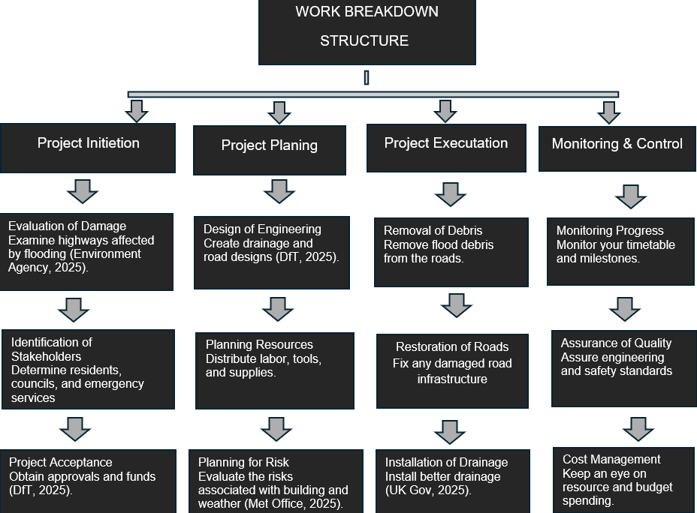

Figure 01: Work Breakdown Structure (WBS)
(Source: Created by the learner)
Evaluation: The above Work Breakdown Structure (WBS) illustrates an organised approach done in 4 phases; initiation, planning, execution and monitoring & control. Initiation phases such as the introduction of damage evaluation or stakeholder identification processes, practically work well because they can be analysed earlier, help to decrease uncertainty and ensure informed decision making (Prebanić and Vukomanović, 2023).
Such bold vision combines engineering design with resource allocation and risk assessment in the planning phase for marinating trust of stakeholders. Although risk planning is acknowledged, there is no clear prioritisation of risk or their linkage to specific mitigation strategies within the framework of a WBS which might constrain its practical effectiveness in uncertain situations for example when it continues to rain (TEMITOPE, 2024).
The execution phase accurately highlights primary deliverables, like debris clearance, road rehabilitation and evacuation works. Improvements in drainage have also been included, indicating a resilience-based approach yet without an indication of the dependencies between these tasks, holds a potential for inefficiencies during implementation.
Lastly, the monitoring and control phase expands the WBS with methods to track progress, assure quality and manage costs. This allows measurement of performance on an ongoing basis and is in line with best practice in governance projects (Kerzner, 2023).

Quad Chart
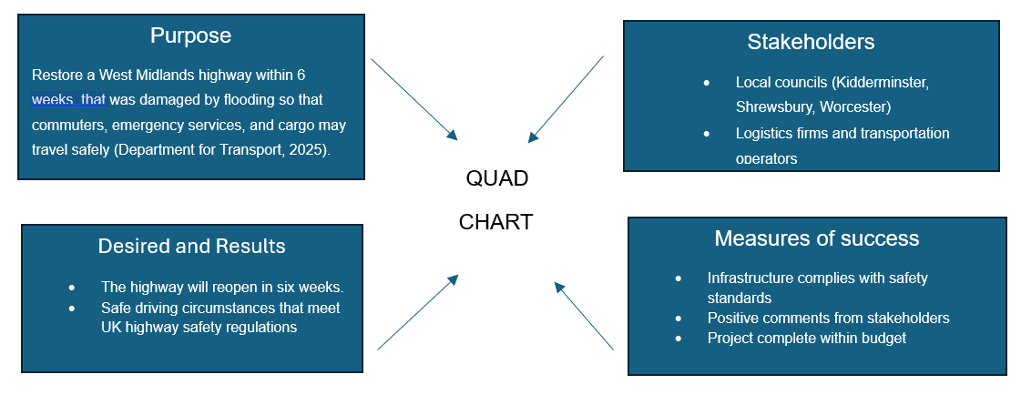
Figure 02: Quad Chart
(Source: Created by the learner)
Evaluation:
The Quad Chart will give you the strategic representation of the project by summarising the purpose, stakeholders, desired outcomes, and measures of success. In this project, the purpose of having the highway repaired in six weeks portrays urgency where Huang et al. (2024) stated that speed alone cannot determine success without considering quality and resilience.
The fact that key stakeholders, such as local councils and transport operators, have been identified underscores the multi-agency nature of the project. The alignment of stakeholders is crucial because the competing priorities may affect decision-making, e.g. the control of costs versus the resiliency of infrastructure (Mukhtar and Bahormoz, 2022). The Quad Chart helps in this alignment as it makes it clear on the objective and shared responsibilities.
Furthermore, accountability in the project is added by the introduction of quantifiable success criteria, including safety compliance and satisfaction of stakeholders. Nevertheless, such measures should be critically assessed, and oversimplified measures can fail to reflect long-term performance and sustainability. This justifies the need to define success beyond short term delivery results.
On the whole, the Quad Chart is a strategic communication tool that strengthens the clarity, helps to make the decision, and makes sure that the project goals are aligned with stakeholder expectations and the larger recovery goals (Secundo et al., 2022).

Gantt Chart
Activities | Start Week | End Week | Duration (in days)
Project Initiation & Assessment | Week 1 | Week 1 | 7
Damage assessment | Week 1 | Week 1 | 7
Stakeholders identification and funding | Week 1 | Week 2 | 14
Planning and design | Week 2 | Week 3 | 14
Execution phase | Week 3 | Week 5 | 21
Monitoring and control | Week 2 | Week 6 | 35
Closure and reopening | Week 6 | Week 6 | 7
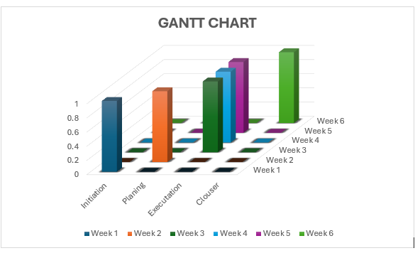
Figure 03: Gantt Chart
(Source: Created by the learner)
Evaluation:
The Gantt chart organises the project into consecutive but overlapping phases to achieve efficiency in delivery within the six weeks period. The damage assessment and project initiation during Week 1 develops a crucial background because it allows making informed decisions and decreasing uncertainty during the following steps. Identification of early stakeholders and allocation of funds (Weeks 1-2) are necessary to ensure the availability of resources and matching expectations because any delay in approvals may have a major effect on project timelines (Adewoyin et al., 2025).
Planning and design in Weeks 2-3 interpret initial assessments into action plans such as the engineering design and allocation of resources. The phase is also very critical to provide that the implementation is not only effective but also responsive to safety and resilience imperatives. The longest phase (Weeks 3-5) is the execution phase which shows the complexity of the physical reconstruction operations like the removal of debris, road repair, and installation of drainage.
It is important to note that monitoring and control are done during the same period (Week 2 to Week 6), indicating that they are proactive toward tracking the project progress, managing the costs, and the quality of the project lifecycle (Kerzner, 2023). Lastly, week 6 closure and reopening will guarantee that all deliverables are as per the standards before the highway is opened. On the whole, the staged architecture assists in ensuring the coordination, minimising the delays, and controlling the project according to time limits.

Stakeholders' involvement
Priority | Stakeholders | Stakeholder Perspective | Action
High | Department for Transport / Local Councils | In charge of infrastructure transport and project sanction to deliver safely and on time. | Actively engage in regular meetings, progress reports and involvement in decision-making.
High | Emergency Services | Need to have good road accessibility to respond quickly in and out of the recovery process. | Keep in touch continuously and give priority to access requirements when repairing.
Medium | Local Residents and Businesses | Directly influenced by road closures and interference with daily activities. | Offer frequent updates, community meetings, and feedback.
Medium | Environment Agency | Both environmental protection and flood management. | Advise drainage design and meet environmental standards.
Low | General Public | There is little direct influence, yet they are interested in social and environmental results. | Give overall updates and keep in touch where needed
RACI Matrix
Tasks | Project Management | Transport Authority | Contractors | Local Councillor | Residents
Define Project Scope | R | A | C | C | I
Damage Assessment | R | A | C | I | I
Secure Funding | C | A | I | C | I
Highway repair | I | C | R | C | I
Safety inspection | R | A | C | I | I
Community communication | A | C | I | R | C
Stakeholder management is one of the essentials to the success of this project especially because of the urgency and the social influence of infrastructure restoration. The project consists of a number of stakeholders who have different levels of influence and interest in the project and will need a structured engagement strategy.
The Department of Transport and local councils are considered to be high-priority stakeholders as they approve, fund and generally govern the project. Their immense power and influence imply that they should be closely engaged in the working process by arranging regular meetings and reporting on their progress to make sure that the decisions are timely and do not contradict the regulatory norms (Kidd and Reynolds, 2024). On the same note, emergency services are important stakeholders since they rely on the accessibility of the roads that have been restored to respond quickly. They need to have constant communication and prioritisation of their operational needs in the implementation phase.
The stakeholders that are of medium priority are the local residents and businesses, as their areas are directly impacted by the road closures and disruptions. They do not necessarily possess a more significant decision-making authority, but their interest is high, and frequent updates and integration with the community are considered to ensure the support of the population and limit opposition. The Environment Agency is also instrumental since it would make sure that the environmental standards and flood mitigation strategies are considered in the project.
Low-priority stakeholders, including the general population, do not have many direct impacts, but are significant in the context of social perception and responsibility. Having general updates would make things more transparent and would build confidence in the project results.
Most importantly, the stakeholder management of this project should strike a balance between conflicting demands, including cost effectiveness, delivery timelines and sustainability in the long run. Inability to engage key stakeholders effectively might lead to delays, conflicts or lower project effectiveness. Thus, the systematic implementation of the stakeholder engagement strategy is a good idea and corresponds to the best practices in project management and increases the chances of a successful project delivery (Vrečko, Tominc and Širec, 2023).

Allocation of resources
Resource allocation in this project should be efficient without compromising on time, cost, and complexity of operation. Human resources involve skilled project managers, and safety inspectors, and their coordination is needed to guarantee timely delivery. The budget available is limited with the available financial resources amounting to £25 million, and this necessitates the strict control of costs and prioritisation of essential activities that will include road reconstruction and drainage upgrading. Although this budget enables quick recovery, cost overruns are likely to occur due to unpredictable circumstances like fluctuations in material prices or long working hours.
The project uses construction machinery and drainage systems, and local materials in terms of equipment and materials. Especially crucial is resource optimisation, which could impact the project schedule due to delays in procurement or inefficient use of equipment. Local sourcing tactics may decrease lead time and lead costs and enhance efficiency. More importantly, resource allocation must be integrated throughout all the project phases to make sure that resources are employed in a strategic and not in a reactive manner. This raises productivity, reduces wastage and helps to deliver successful projects within the limited conditions.

Risk Analysis
RISKS | IMPACT | LIKELIHOOD | SCORE | MITIGATION
Continued heavy rainfall | High | Medium | 6 | Flexible Scheduling
Material shortages | Medium | High | 6 | Local Supplier Sourcing
Budget overruns | High | Medium | 6 | Budget monitoring
Safety incident | High | Low | 3 | PPE, safety training
Environmental damage | Medium | Medium | 4 | Environmental monitoring
Human resources involve engineers, construction workers, project managers, and safety inspectors whose collaboration is required to deliver on time within the six-week deadline. Nonetheless, bottlenecks in the workforce planning or skills shortage might become apparent in the rapid recovery initiatives, which is why clear coordination tools (RACI matrix) should be in place (Stamenkov, 2025).
On the financial side, the project runs under a £25 million budget, where essential tasks like road reconstruction and installation of drainage have to be prioritised. This budget allows the firm to deliver fast, but at the same time, it places pressure on the finances related to uncertainties arising like changes in material costs or prolonged work time. Cost monitoring must be continuous to avoid overrun (Osifo, 2024).
The project also relies on heavy construction and drainage infrastructure. The optimisation of resources is essential, where any delays during procurement or inefficient use of equipment may cause project delays. This combined strategy improves productivity, and reduces wastage in a limited environment.

Conclusion
To sum up, the project has showcased the structured project management methods used to respond to the urgent need to restore critical infrastructure after flooding in the West Midlands. The plan coordinates, optimises resources and controls risks through the integration of tools including the WBS, Gantt chart, RACI matrix and risk analysis. Importantly, to react to uncertainties and to the demands of the stakeholders, an active management approach is necessary. On the whole, the project offers a strategically oriented solution to underpin recovery and long-term infrastructure sustainability.

References
‌Adewoyin, M.A., Onyeke, F.O., Digitemie, W.N. and Dienagha, I.N., (2025). Holistic offshore engineering strategies: Resolving stakeholder conflicts and accelerating project timelines for complex energy projects. Int. J. Multidiscip. Res. Growth Eval, 6(1), pp.92-98.
‌Cavanagh, C. (2025). Flood and drought risk increasing in cities, according to study. [online] Bbc.com. Available at: https://www.bbc.com/news/articles/c5y2q0818xzo [Accessed 31 Mar. 2026].
Demirci, F.S. and Isik, Z., (2026). Developing a community responsive resilient contractor selection model for post-disaster reconstruction projects: a build back better approach. Engineering, Construction and Architectural Management, 33(2), pp.1702-1737.
Dong, R., Muhammad, A. and Nauman, U., (2025). The influence of weather conditions on time, cost, and quality in successful construction project delivery. Buildings, 15(3), p.474.
Hanscomb, S., (2023). Critical thinking: The basics. Routledge.
Harake, M.F., (2025). Strategic Project Management in Crisis Response: A Comprehensive Analysis of Rescue Agencies' Operations During Emergencies. PM World Journal.
Huang, J., Xie, D., Qiu, Y., Wang, J. and Song, J., (2024). Green supply chain management: A renewable energy planning and dynamic inventory operations for perishable products. International Journal of Production Research, 62(24), pp.8924-8951.
Kerzner, H., (2023). Project management metrics, KPIs, and dashboards: a guide to measuring and monitoring project performance. John wiley & sons.
Kidd, R. and Reynolds, C., (2024). Food policy coherence in local government: Who does what and why?. Food Policy, 129, p.102740.
Laidlaw, S. and Percival, S. (2024). Flood resilience: a review of evolving definitions. Natural Hazards, [online] 120(12), pp.10773–10784. doi:https://doi.org/10.1007/s11069-024-06627-9.
Mukhtar, S.M. and Bahormoz, A., (2022). An integrative framework for stakeholder engagement: Reconciling and integrating stakeholders’ conflicting CSR priorities in management decision-making. Journal of Decision Systems, 31(4), pp.407-432.
Osifo, E.O., (2024). Integrating compliance and cost control in public infrastructure and affordable housing construction contract management. International Journal of Engineering Technology Research & Management, 8(12), pp.439-443.
Prebanić, K.R. and Vukomanović, M., (2023). Exploring stakeholder engagement process as the success factor for infrastructure projects. Buildings, 13(7), p.1785.
Secundo, G., Elia, G., Margherita, A. and Leitner, K.H., (2022). Strategic decision making in project management: a knowledge visualization framework. Management Decision, 60(4), pp.1159-1181.
Stallard, E. (2026). UK rain: Are wetter winters and frequent flooding here to stay? [online] Bbc.com. Available at: https://www.bbc.com/news/articles/cvgjw0kpd89o [Accessed 31 Mar. 2026].
Stamenkov, G., (2025). Cloud service models, business continuity and disaster recovery plans, and responsibilities. International Journal of Organizational Analysis, 33(3), pp.437-451.
‌Sun, N., Ning, Y., Ke, Y., Zheng, F. and Li, Y., (2026). Cross-boundary tensions between the project owner and project manager in value creation. Project Management Journal, 57(1), pp.97-116.
TEMITOPE, A.O., (2024). Project Risk Management Strategies: Best Practices for Identifying, Assessing, and Mitigating Risks in Project Management.
Tushar, H. and Sooraksa, N., (2023). Global employability skills in the 21st century workplace: A semi-systematic literature review. Heliyon, 9(11).
Vrečko, I., Tominc, P. and Širec, K., (2023). Enhancing the performance of high-growth small-and medium-sized enterprises through effective project-management processes and stakeholder engagement: a systems perspective. Systems, 11(10), p.511.
Zamri, M.B., Dahri, N.A., Jaafar, N.A.N., Rahman, D.S.A., Haizal, M.K.H., Ismail, N.F.A., Halim, S.N., James, S.R. and Sulaiman, N.L., (2023). PMBok Knowledge Areas: Case Study of Project and Stakeholder Management Fail Lessons Learned. Applied Information Technology And Computer Science, 4(2), pp.2274-2281.

