

PROGRAMME: BSc (Hons) Health and Social Care
Module Code: BMHP6026
Module: Digital Transformation in the Health and Care Professions
Component 1: Written Report
Digital innovation/ Technology - NHS Remote Patient Monitoring (RPM) using wearable devices and apps

STUDENT NAME: RUTA EZRA
STUDENT ID NUMBER:2310803
LECTURERERS NAME: MARTIN SVEJDA

TABLE OF CONTENT

CONTENTS PAGES
1.0 INTRODUCTION 3
2.0 WORKFORCE 3
3.0 SERVICE DELIVERY 5
4.0 PATIENT/SERVICE USER 6
5.0 COMMUNITY 8
6.0 CONCLUSION & RECOMMENDATIONS 9
6.1 CONCLUSION 9
6.2 RECOMMENDATIONS 10
REFERENCES 11
APPENDICES 15

1.0 INTRODUCTION
Over the past ten years, the UK's health and social care system has undergone significant change, mostly due to digital innovation (Sheikh et al., 2024). Remote Patient Monitoring (RPM), which is provided through "virtual wards," is a significant advancement (NHS England, 2023a). According to Althobiani et al. (2025), over 487,000 patients in England were supported at home with digital monitoring between November 2020 and January 2023, showing rapid uptake in long-term care. Using wearable sensors, smartphone apps, and pulse oximeters, RPM enables physicians to monitor patients at home instead of in hospital (Michael, 2025).
RPM is important in meeting rising NHS demand, approximately 15 million people suffered from chronic illnesses before the pandemic, and 17 million hospital admissions took place each year (Bain et al., 2023). By encouraging care at home, RPM reduces reliance on hospitals. According to Table 1 (see appendix 1), the average stay increased from 7.3 to 8.3 days between 2019 and 2022, while emergency admissions increased by 15% (7.9 to 9.1 days) and voluntary stays reduced slightly (5.2 to 5.1) (Cavallaro, 2023). In 2023, virtual wards had grown to 10,000 beds and were providing in-home care for over 240,000 patients to ease these challenges (NHS England, 2023).
This report critically evaluates the UK’s experience with Remote Patient Monitoring (RPM), weighing both benefits and challenges. It will focus on:
- Workforce
- Service delivery
- Patient/Service User
- Community

2.0 WORKFORCE
The tasks and duties of the UK health and social care staff have changed because of the implementation of virtual wards and Remote Patient Monitoring (RPM) (Thomas et al., 2023). Digital technologies have made it possible for professionals to remotely monitor patients, which was formerly exclusive to hospitals (Field and Grigsby, 2022). According to NHS England, in 2023, over 240,000 patients received treatment at home (NHS England, 2024). Knowledge of digital technologies, data interpretation, wearable technology use, and cloud-based platform usage are among the new abilities required by this change. For instance, according to the Health Foundation (2024), more than 90% of nurses working in virtual wards said they needed more digital training. As allied health and social care workers adjust to remote communication and technology-enabled interventions, nurses increasingly analyse real-time health data, assist patients with technology, and escalate hazards quickly.
However, the ability of Remote Patient Monitoring (RPM) to increase productivity is a major advantage for the workforce. Clinicians can reduce the need for emergency admissions and free up resources to handle difficult patients by encouraging earlier treatments that stop deterioration (Serrano et al.,2023). According to reviews, patients on virtual wards stay in the hospital for 3 to 5 days less, which relieves emergency staff of some of their workload (Gallier et al., 2021). However, emergency admissions increased by 15% and the average hospital stay increased from 7.3 to 8.3 days between 2019 and 2022 (Cavallaro et al., 2023). An analysis of admissions shows that while the number of cases lasting longer than 14 days increased by 41,000 (8%), there were almost 562,000 (11%) fewer brief emergency stays in 2022 compared to 2019 (Marszalek, 2023). Approximately one-third of emergency admissions at the time (1.7–1.8 million) were zero-day stays. RPM and virtual wards, on the other hand, lessen these strains by safely cutting down on hospital stays, proving their worth in workforce planning (Greene et al., 2024). Compared to serial in-person monitoring, continuous patient data also improves clinical decision-making and lowers mistake risks. Figure 1 shows these patterns, demonstrating how the emergency admissions profile changed over time.

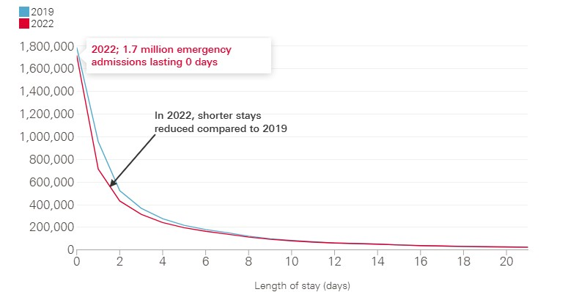
Figure 1. Changes in emergency admission length of stay in England, 2019–2022. (Cavallaro et al., 2023).
On the other hand, there are still challenges. Because workers must acquire digital and analytical abilities while still doing their usual clinical duties, the implementation of RPM has resulted in a strain (Shah et al., 2022). According to research, combining the responsibilities of remote monitoring with in-person treatment might cause "role strain" for certain practitioners (Klein-Cox et al., 2023). Staff members who must resolve problems in addition to their clinical responsibilities are further burdened by technical concerns, such as unstable connectivity or integration challenges with current NHS systems (Waterson, 2021).

3.0 SERVICE DELIVERY
The NHS has seen significant changes in everyday operations because of the implementation of virtual wards and Remote Patient Monitoring (RPM). Hospital-cantered care has given way to a more decentralized, home-based approach (Ferlie and Pettigrew, 2021). Instead of doing ward rounds, physicians must use shared dashboards to monitor patients and respond to warnings, necessitating new processes.
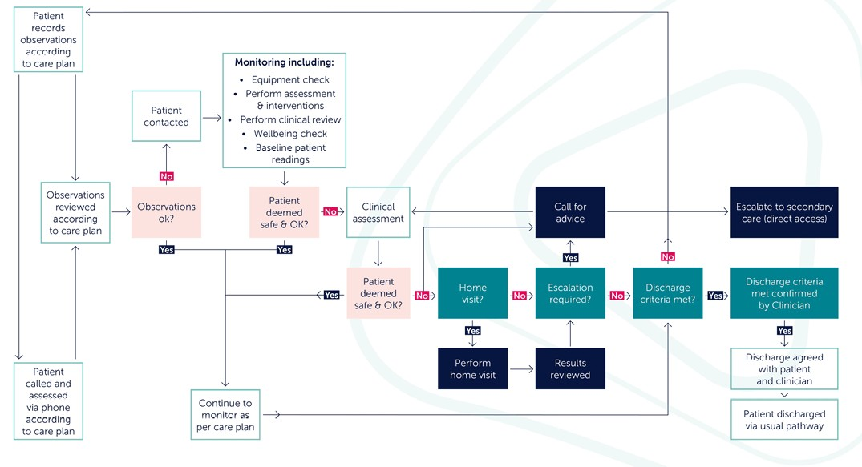

Figure 2. Monitoring process on a virtual ward. (NHS Confederation report, 2023).

This change is clearly illustrated in Figure 2 above, which outlines the monitoring pathway on a virtual ward. Patients record their observations remotely, which are then reviewed by clinicians according to the care plan. If concerns are identified, escalation can range from a phone consultation to a home visit or direct transfer to secondary care (NHS Confederation report, 2023). The process shows how communication and decision-making have been redesigned into a structured digital pathway, ensuring timely interventions while reducing unnecessary hospital visits.
Furthermore, the advantages are substantial. Because RPM enables doctors to take rapid action in response to early warning indications, it facilitates quicker reactions and improved coordination. According to national assessments, emergency admissions decreased by over 30% in certain regions, and virtual wards served over 100,000 patients in a single year (NHS England, 2023b). According to a case study conducted in Leicester, the NHS @Home initiative relieved acute teams of stress by saving more than 1,000 hospital bed days in just 6 months (Leicestershire Partnership NHS Trust, 2022). These results demonstrate how virtual wards may increase service efficiency and provide safer, preventative care.
However, there are still challenges. Expansion is hindered by the high expenses of digital infrastructure, such as wearable technology, platforms, and maintenance. challenges including inadequate connection and a lack of digital resources are particularly problematic for rural trusts (NHSX, 2021). Another difficulty with integration is that many physicians report consistency problems, which result in redundant labour since monitoring systems do not match electronic health records (Li et al.,2023). Additionally, even though virtual wards relieve hospital pressure, they frequently transfer duty to community services, where staffing levels are still high (NHS Confederation, 2023).

4.0 PATIENT/SERVICE USER
In the UK, the move to virtual wards and Remote Patient Monitoring (RPM) has drastically changed the patient experience by bringing treatment closer to home and lowering dependency on hospital services. According to NHS assessments, in early 2023, over 100,000 patients received treatment on virtual wards for ailments including heart disease, frailty, and respiratory illnesses in a single year (NHS England, 2023b). The benefit is also demonstrated by local assessments: a frailty virtual ward in West Hertfordshire decreased readmissions by 18%, while in Bradford, emergency attendances for COPD patients assisted by digital monitoring decreased by 20% (NHS England, 2022). These results highlight how well RPM works to reduce hospital demand while enhancing outcomes.

One distinguishing advantage is convenience. Patients may now submit daily readings using wearable technology and apps, eliminating the need for frequent hospital visits. Digital monitoring cut regular outpatient visits by 22%, reducing patients' travel time and Trusts' clinical capacity, according to a case study from NHS Dorset's Digital Access to Services at Home (D@SH) initiative (NHS Dorset, 2023). In a comparable manner, the COVID Oximetry @home service (UK-wide remote monitoring service set up during the COVID-19 pandemic) showed that prompt management through early hypoxia detection reduced mortality risk by 13% when compared to standard treatment (Boniface et al., 2022). These instances show how digital monitoring may lessen system burden while simultaneously enhancing therapeutic safety.
On the other hand, the advantages are not shared by everyone, though. One of the most critical problems is digital exclusion. According to Table 2 (see appendix 2) 18% of those 75 and older are not online at all, and approximately 49% of them struggle to do simple digital activities (Age UK, 2024). RPM is directly impacted by this, as it relies on dependable technology utilization. There is a chance that remote monitoring might exacerbate health disparities since, according to a Good Things Foundation report from 2022, patients in the most underprivileged areas were twice as likely to lack access to appropriate digital gadgets (Gann, 2022).
However, data security and privacy are also essential. Patients frequently worry about how securely their health information is maintained and who may access it. While 72% of patients in a qualitative study of COPD patients in Greater Manchester appreciated the daily monitoring's comfort, some participants expressed worry related to device malfunctions and the "constant reminder" of their condition (Green, 2023). These viewpoints emphasize the necessity of user-friendly, supporting systems that strike a balance between patient autonomy and safety.

5.0 COMMUNITY
Communities around the UK have been significantly impacted by the growth of virtual wards and Remote Patient Monitoring (RPM), especially in underserved and rural regions. Digital connectivity has a significant impact on the success of these advances, even if they promise to bring treatment closer to patients (Zeadally and Bello, 2022). In contrast to just 2.7% of urban isolated regions, 46% of rural deprived areas are categorized as 5G not-spots, according to Vodafone and WPI Economics (2023). Figure 3 illustrates this gap, which points to a structural barrier: patients in remote areas would not have access to dependable internet for real-time monitoring, increasing the likelihood of delayed reactions and worse health outcomes.

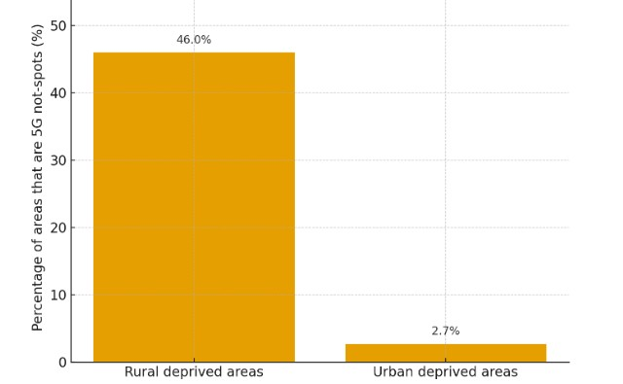
Figure 3. Rural vs Urban 5G Not-Spot Coverage in Deprived Areas in UK. Source: (Vodafone / WPI Economics, 2023).
However, RPM benefits families and caregivers, but it also adds new duties. More than half (55%) of caregivers are concerned that these models place more monitoring responsibilities on them, even if 56% of them think virtual wards increase comfort and 48% think they avoid needless hospital stays, according to caregivers UK (2024). Because of this dual impact, carers feel more burdened and more involved in clinical choices, especially in homes that are already burdened by health or financial disparities (Batool et al., 2023). However, earlier action through RPM can improve public health outcomes by reducing needless admissions and freeing up resources for more critical patients at the community level (Taylor et al., 2021).
Therefore, to adapt these services locally, collaboration between patients, families, and professionals has proven essential. NHS Cheshire and Merseyside, for instance, created virtual wards based on patient input, offering loaned gadgets and "digital buddy" programs to help those who are not comfortable using technology (NHS Cheshire and Merseyside, 2023). In addition to being clinically safe, this cooperative approach made sure that monitoring devices were easy to use, which increased patient participation and improved incorporation into community health networks.
However, differences continue to exist. According to Digital Inclusion UK (2025), an estimated 7.9 million individuals nationwide lack basic digital skills, with low-income households and elderly persons being disproportionately affected. These issues are made worse in rural areas by inadequate connectivity, a lack of training opportunities, and restricted access to reasonably priced gadgets. By favouring technologically advanced people while benefiting less vulnerable communities, RPM runs the danger of worsening health disparities in the absence of focused measures.

6.0 CONCLUSION & RECOMMENDATIONS

6.1 Conclusion
The introduction of remote patient monitoring (RPM) and virtual wards has altered the way health and social care are provided in the UK during the past 10 years. There is proof of improved patient experiences, improved staff collaboration, and creative community-based care models. But there are still problems with digital marginalization, rural infrastructure, and sustainable staffing. RPM is given as an example to show how new innovations may reduce hospital demand, but equitable, long-term adoption requires targeted investment and structural adjustments.

6.2 Recommendations
To maximise the benefits of RPM and ensure its long-term success, they following recommendations are proposed. These actions target workforce skills, infrastructure, equity, and sustainable funding, ensuring the innovation delivers value across all parts of the NHS.
- Workforce Training: Make digital literacy courses essential for nurses, general practitioners, and community workers. NHS "digital health champions" will help on the ground when virtual wards are implemented.
- Infrastructure and Connectivity: Prioritise government funding to expand 5G and broadband in rural areas, with annual progress audits to ensure communities are not left behind.
- Collaboration: Government should create national guidelines mandating that all RPM systems eliminate irrelevant input by integrating easily with NHS Electronic Health Records.
- Equity of Access: Create focused programs for digital inclusion, such as free monitoring device loans, subsidized data plans for low-income homes, and patient workshops conducted by general practitioners.
- Carer Support and Co-Production: Establish formal co-production frameworks to make sure patients and caregivers influence service design and enhance access to respite care to offset rising care needs.
- Sustainable Funding: To ensure uniform local service and reduce differences between regions, a ring-fenced national RPM budget should be established and disbursed through Integrated Care Systems (ICSs) (Charles et al., 2022).

REFERENCES
Age UK (2024) Internet Use Statistics June 2024. London: Age UK. Available at: https://www.ageuk.org.uk/siteassets/documents/reports-and-publications/reports-and-briefings/active-communities/internet-use-statistics-june-2024.pdf [Accessed 3rd October 2025].
Althobiani, M.A., Russell, A.M., Jacob, J., Ranjan, Y., Ahmad, R., Folarin, A.A., Hurst, J.R. and Porter, J.C., (2025). The role of digital health in respiratory diseases management: a narrative review of recent literature. Frontiers in Medicine, 12, p.1361667.
Bain, T., Al-Khateeb, S., Bhuiya, A.R., Jarvis, T., Mehta, V., Sood, T., Soueidan, S., Wang, A., Rintjema, J. and Wilson, M.G., (2023). Rapid synthesis: Identifying remote-monitoring technologies to enable existing level of care.
Batool, A. and Lopez, A., (2023). Healthcare Access and Regional Connectivity: Bridging the Gap. Journal of Regional Connectivity and Development, 2(2), pp.260-271.
Boniface, M., Burns, D., Duckworth, C., Ahmed, M., Duruiheoma, F., Armitage, H., Ratcliffe, N., Duffy, J., O’Keeffe, C. and Inada-Kim, M., (2022). COVID-19 Oximetry@ home: evaluation of patient outcomes. BMJ Open Quality, 11(1).
Carers UK (2024) Virtual wards including hospital-at-home: Policy briefing. London: Carers UK. Available at: https://www.carersuk.org/media/exsbe22x/carers-uk-policy-briefing-virtual-wards-including-hospital-at-home-updated-jan-2024.pdf [Accessed 4th October 2025].
Cavallaro, F., Ewbank, L., Marszalek, K., Grimm, F. and Tallack, C. (2023) Longer hospital stays and fewer admissions: How NHS hospital care changed in England between 2019 and 2022. London: The Health Foundation. Available at: https://www.health.org.uk/reports-and-analysis/briefings/longer-hospital-stays-and-fewer-admissions [Accessed 1st October 2025].
Charles, A., Wenzel, L., Kershaw, M., Ham, C. and Walsh, N., (2022). A year of integrated care systems. Reviewing the journey so far. London: The King’s Fund, 2009, p.2018.
Digital Inclusion UK (2025) Digital inclusion in NHS: Research report. London: Digital Inclusion UK. Available at: https://www.digitalinclusionuk.org/research/digital-inclusion-nhs [Accessed 4 October 2025].
Ferlie, E. and Pettigrew, A., (2021). Managing through networks: some issues and implications for the NHS. British journal of management, 7, pp.S81-S99.
Field, M.J. and Grigsby, J., (2022). Telemedicine and remote patient monitoring. Jama, 288(4), pp.423-425.
Gann, B., (2022). Transforming lives: Combating digital health inequality. IFLA journal, 45(3), pp.187-198.
Green, S., (2023). Occupation as a quality-of-life domain for vulnerable elderly people. The University of Liverpool (United Kingdom).
Greene, L., Rahja, M., Laver, K., Wong, V.V., Leung, C. and Crotty, M., (2024). Hospital staff perspectives on the drivers and challenges in implementing a virtual rehabilitation ward: qualitative study. JMIR aging, 7(1), p.e54774.
Gallier, S., Atkin, C., Reddy-Kolanu, V., Parekh, D., Zou, X., Evison, F., Ball, S. and Sapey, E., (2021). Applying a COVID Virtual Ward model, assessing patient outcomes and staff workload. Acute Med, 20(4), pp.266-275.
Health Foundation (2024) What do virtual wards look like in England? London: The Health Foundation. Available at: https://www.health.org.uk/publications/what-do-virtual-wards-look-like-in-england [Accessed 1st October 2025].
Li, E., Lounsbury, O., Clarke, J., Ashrafian, H., Darzi, A. and Neves, A.L., (2023). Perceptions of chief clinical information officers on the state of electronic health records systems interoperability in NHS England: a qualitative interview study. BMC Medical Informatics and Decision Making, 23(1), p.158.
Klein-Cox, A., Tobin, A. and Denby, R., (2023). When kinship caregivers became teachers: Role stress and strain from remote learning during COVID-19. Societies, 13(9), p.199.
Leicestershire Partnership NHS Trust (2022) Home. Available at: https://www.leicspart.nhs.uk/ [Accessed 3rd October 2025].
Michael, I. (2025) ‘Continuous remote patient monitoring using wearable IoT devices’, Journal of Digital Health and Care Innovation, 12(3), pp. 145–16.
NHS Cheshire and Merseyside (2023) Virtual wards – NHS Cheshire and Merseyside. Available at: https://www.cheshireandmerseyside.nhs.uk/your-health/virtual-wards [Accessed 4th October 2025].
NHS Confederation (2023) Realising the potential of virtual wards. London: NHS Confederation. Available at: https://www.nhsconfed.org/publications/realising-potential-virtual-wards [Accessed 3rd October 2025].
NHS Dorset (2023) Digital Access to Services at Home (D@SH) evaluation report. NHS Dorset. Available at: https://www.nhsdorset.nhs.uk/ [Accessed 4th October 2025].
NHS England (2022) Virtual wards: case studies from across England. NHS England. Available at: https://www.england.nhs.uk/virtual-wards/case-studies/ [Accessed 3rd October 2025].
NHS England (2023a) Supporting care with remote monitoring. NHS England, Transformation Directorate. Available at: https://transform.england.nhs.uk/ [Accessed 1st October 2025].
NHS England (2023b) World-leading NHS virtual wards treat 100,000 patients in a year. NHS England. Available at: https://www.england.nhs.uk/2023/03/world-leading-nhs-virtual-wards-treat-100000-patients-in-a-year/ [Accessed 2nd October 2025].
NHS England (2023) NHS delivers 10,000 virtual ward beds target with hundreds of thousands of patients treated at home. NHS England. Available at: https://www.england.nhs.uk/2023/10/nhs-delivers-10000-virtual-ward-beds-target/ [Accessed 1st October 2025].
NHSX (2021) Digital inclusion in health and care. London: NHSX. Available at: https://transform.england.nhs.uk/key-tools-and-info/digital-inclusion-in-health-and-care/ [Accessed 3rd October 2025].
Serrano, L.P., Maita, K.C., Avila, F.R., Torres-Guzman, R.A., Garcia, J.P., Eldaly, A.S., Haider, C.R., Felton, C.L., Paulson, M.R., Maniaci, M.J. and Forte, A.J., (2023). Benefits and challenges of remote patient monitoring as perceived by health care practitioners: a systematic review. The Permanente Journal, 27(4), p.100.
Shah, S., Gvozdanovic, A., Knight, M. and Gagnon, J., (2022). PMD35 remote patient monitoring in acute medical conditions; Can digital health solutions reduce clinician workload and ease the pressure on healthcare providers during the COVID crisis?. Value in Health, 23, p.S582.
Sheikh, A., Anderson, M., Albala, S., Casadei, B., Franklin, B.D., Richards, M., Taylor, D., Tibble, H. and Mossialos, E., (2024). Health information technology and digital innovation for national learning health and care systems. The Lancet Digital Health, 3(6), pp.e383-e396.
Taylor, M.L., Thomas, E.E., Snoswell, C.L., Smith, A.C. and Caffery, L.J., (2021). Does remote patient monitoring reduce acute care use? A systematic review. BMJ open, 11(3), p.e040232.
Thomas, E.E., Taylor, M.L., Banbury, A., Snoswell, C.L., Haydon, H.M., Rejas, V.M.G., Smith, A.C. and Caffery, L.J., (2023). Factors influencing the effectiveness of remote patient monitoring interventions: a realist review. BMJ open, 11(8), p.e051844.
Waterson, P., (2021). Health information technology and sociotechnical systems: A progress report on recent developments within the UK National Health Service (NHS). Applied ergonomics, 45(2), pp.150-161.
Vindrola-Padros, C., Singh, K., Sidhu, M.S., Georghiou, T. and Sherlaw-Johnson, C. (2021) ‘Remote home monitoring for COVID-19: a rapid national evaluation of implementation’, Health Services and Delivery Research, 9(45), pp. 1–136.
Vodafone / WPI Economics (2023) Connecting the Countryside: Closing the digital divide between town and country. London: Vodafone. Available at: https://www.vodafone.co.uk/newscentre/press-release/vodafone-report-digital-divide/ [Accessed 4th October 2025].
Zeadally, S. and Bello, O., (2022). Harnessing the power of Internet of Things based connectivity to improve healthcare. Internet of Things, 14, p.100074.

APPENDICES
Appendix 1
Table 1. Changes in admissions, mean length of stay, and total bed days in England, 2019–2022. Source: (Cavallaro et al., 2023).
Type of admission | 2019 – All admissions (N) | 2019 – Mean length of stay (days) | 2019 – Total bed days | 2022 – All admissions (N) | 2022 – Mean length of stay (days) | 2022 – Total bed days | Change in admissions (N, %) | Change in mean length of stay (days, %) | Change in total bed days (N, %)
Elective | 1,309,000 | 5.2 | 5,610,000 | 1,030,000 | 5.1 | 4,460,000 | –279,000 (–21.3%) | –0.1 (–2.7%) | –1,150,000 (–20.5%)
Emergency | 5,538,000 | 7.9 | 30,624,000 | 5,017,000 | 9.1 | 30,882,000 | –521,000 (–9.4%) | +1.1 (+14.8%) | +258,000 (+0.8%)
Total | 6,846,000 | 7.3 | 36,233,000 | 6,047,000 | 8.3 | 35,343,000 | –799,999 (–11.7%) | +1.0 (+12.7%) | –890,000 (–2.5%)

Between 2019 and 2022, total hospital admissions fell by 11.7%, driven mainly by a sharp drop-in elective care (–21.3%). In contrast, emergency stays became longer, with average length of stay rising by 14.8%, resulting in a slight increase in total emergency bed days despite fewer admissions. Overall, this indicates reduced hospital activity but greater pressure on emergency services.

Appendix 2
Table 2: Digital skills and internet use among older adults in the UK (2023–24). Source: (Age UK report, 2024).
Age Group | % not using internet | % unable to complete basic tasks | % relying on one device only
65–74 | ~9% | ~29% | ~17%
75+ | ~18% | ~49% | ~17%

Appendix 2 shows clear evidence of a digital divide among older adults. Nearly 1 in 5 people aged 75+ are not online, and almost half lack basic digital skills, compared with lower but still significant gaps in the 65–74 group. Around 17% in both age groups rely on a single device, limiting flexibility. These figures highlight barriers to using digital health tools such as Remote Patient Monitoring, particularly for the oldest patients.

