
BSc (Hons) Health and Social Care
Community Care Development
(BMHP 6022_London).

Violence affecting young people and Crime in London

Community Project Development: Sexual health and Mental Disorder affecting the Black ethnic minority group in Southwark.
Topic
Student name:​ Elizabeth Owusu
Student ID: ​1917244
Module name: Community Care Development
Module code: BMHP6022
Lecturer name: Liala​ Surani
Date: 10/12/2022

Table of Contents
Introduction 2
Overview
Southwark Demographic
Community Definition
Community Development
The Blac Minority Ethnic Groups in Southwark
Statistic of Impact and Cost
Approach to Community Development
The use of digital media and technology for community development
Principles that support community development
Theories
Legislation and policies that support the growth of the community
Barriers and obstacles to the community development
Recommendation
Conclusion

Introduction
STIs; sexually transmitted Infections have been highest in Southwark, Lambeth, and Lewisham. Southwark came in third followed by Lambeth, which had England’s highest rate of new STI diagnoses in 2017. The young generation is at risk, especially the black and minority ethnic groups (BAME), who make up a significant section of the population and whose median age is 25 to 34. The project is aiming for intervention and prevention measures with this initiative, creating and educating the community on matters concerning their health and well-being. Southwark is the third largest lesbian, gay, and bisexual population in England. A large proportion of the population is at risk of having poor sexual health (Southwark, 2018).
Approximately 47, 000 adults in Southwark, or almost one in five, are thought to be suffering from a common mental disorder. 3,800 people in Southwark suffer from severe mental illness, which has a prevalence of 1.4%. Black ethnic demographic groupings and older males are mostly affected by severe mental illness. A clinically diagnosed mental disease is thought to affect 1 in 10 children and adolescents nationwide between the ages of 5 to 16. This equates to 1,400 children in Southwark who are 5 to 16 years old and have an emotional illnesses like sadness and anxiety. Of 2,300 young people with conduct problems, 650 suffer from hyperkinetic conditions (ADHD). Boys can have issues with behaviour or hyperactivity. Emotional and anxiety issues affect girls. According to estimates, 95% of those who are incarcerated for crimes have mental health issues (Southwark, 2018).
The community development project effort offers respite to the poor sexual health and mental disorders facing the young and the black minority ethnic groups in Southwark. The program provides help and support for victims. Stakeholders and people that encourage those facing obstacles oversee the community development programs. A wide variety assesses to legal information, and medical support is also available. Support and opportunity are given to individuals involved by community organizers (Thompson, 2018).

Overview
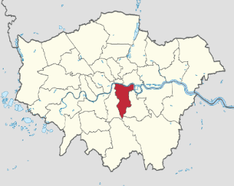
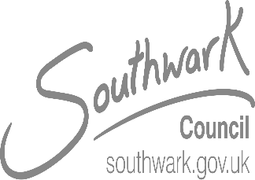
Southwark
Southwark

Code of arms
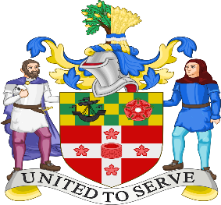

Southwark within London
Motto: United we serve
Lego

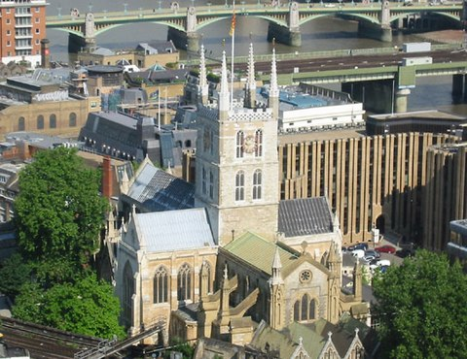
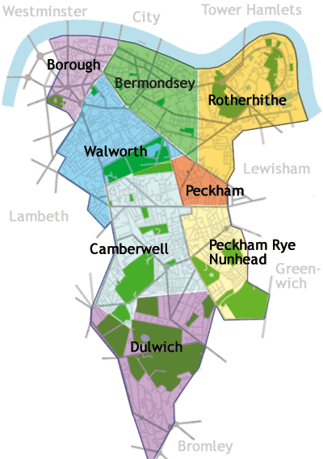
Southwark was one of England’s main population centers from 1601 to 1881, as well as a key transportation hub and industrial hub. Despite its significance, the long-term changes to the occupational structure of early modern Southwark have not been quantitatively examined (Field, 2018). Southwark, which is part of inner London, is rated 303rd out of 309 boroughs and has a total size of 11.14 square miles (28.85 km2). 318,850 people were predicted to be living there as of mid-2019, ranking 38th out of 309. 29,000 square miles and 11,000 km2) are dense. 54. 3 % of Southwark’s population of white 6.2%, is mixed. 9.5% is Asian, 26.8% is black, 0.8% is Arab, and 2.4% is other (Southwark, 2022).
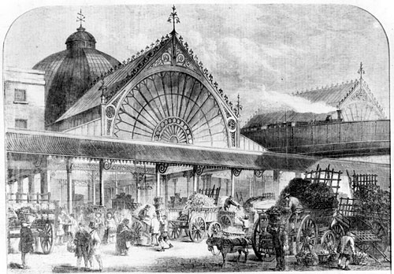

The Industrial Southwark in the 19th century.

Demographics
Southwark
Year | Population | Male | Female | Area (sq.km.) | Density per (sq.km.).
2018 | 317,256 | 50.00% | 50.00% | 28.6 | 10,993
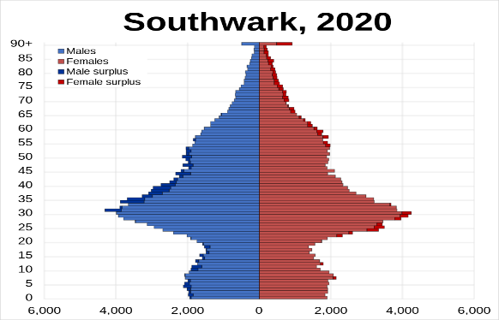
As of 2011, 57.9% of Southwark’s population was born in England, 2,34% in Scotland, 0.78% in Wales, 0.51% in Northern Ireland, 1.70% in the Republic of Ireland, 8.54 in other EU nations, and 29.5% elsewhere.
Southwark: Religious Makeup of the Population- 2011
Christianity | No religion | Not stated | Muslim | Buddhist | Hindu | Other religion | Jewish | Sikh
52.54% | 26.74% | 8.54% | 8.52% | 1.35% | 1.27% | 0.47% | 0.35% | 0.23%

Time zone | Summer (DST) | Postcodes | ONS code | GSS | Police | Website
UTC (GMT) | UTC+1 (BST) | SE | 00BE | E09000028 | Metropolitan police | http://www. Southwark.gov.uk
Region: London- Ceremonial county- Greater London: Created; 1 April 1965

Administration HQ | Gov. type | Body | Leadership | Mayor | London Assembly | MPs
Tooley street Southwark | London borough council | Southwark Borough Council | Leader& cabinet (Labour) | Barrie Hargrove | Marina Ahmad. | Harriet Harman (Labour), Neil Coyle (Independent, Helen Hayes (Labour).
Ethnic Group, Number & Percentage
[Southwark ethnic groups’ numbers and percentages are all in the Appendices]

Community

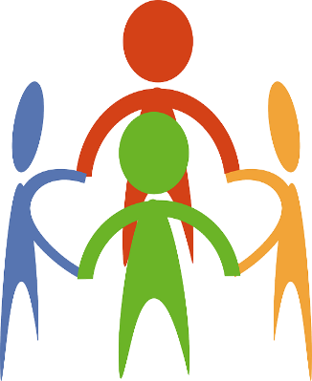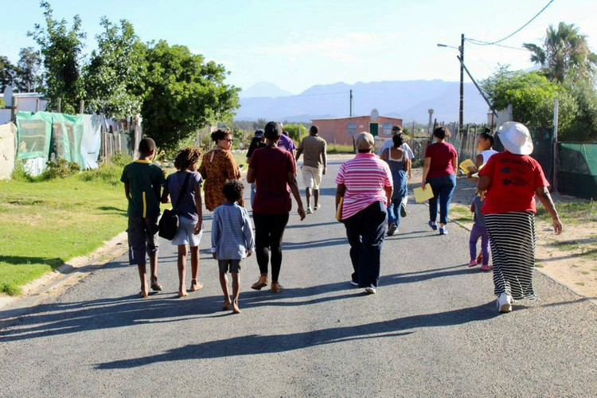
The definition of a community

A community is a collection of individuals who share a common location or set of traits, identities, and passions, and that bring them together or give them a sense of ownership over a location, a service, a culture, or an activity. It can be interest-based, identity-based, or affinity-based. People can change over time and in different social contexts since communities are dynamic and complicated. Communities typically fall into one of these three basic categories: locally or geographically: a shared experience or interest group made of individuals who shared a condition or issue, such as drug and alcohol addiction or cancer.



One’s mental and emotional health may benefit from belonging to a community, as involvement in community activities brings connectedness and belongingness. All communities have resources for promoting the health and well-being of their residents, including skills, knowledge, social competency, and personal commitment on the part of community members (Health, 2022).
Togetherness and Empowerment
Community Development
The process of community development involves people coming together to act on issues that are important to them. It aids communities in organizing themselves and identifying the problems they wish to solve or the chances they wish to pursue. Communities of location or shared identities can accomplish this; beginning with the conviction that everyone should have access to health, well-being, justice, wealth, and opportunity. Groups use their expertise and experiences to create positive change. The community develops by empowerment, promoting health and well-being, and influencing employment. It secures the future of the community and its residents. (Thompson, 2018). Local and national policies in England promote health and well-being and decrease health inequalities by empowering local communities and disadvantaged groups.
Our goals are to lessen health disparities, involve individuals who are at risk for ill health, give them more control over their lives and health, and build a connected, resilient, and cohesive community.
WE MAKE THE WORLD
The black minority ethnic group in Southwark

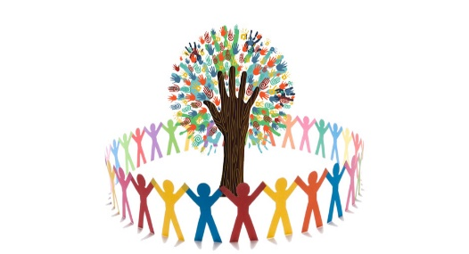

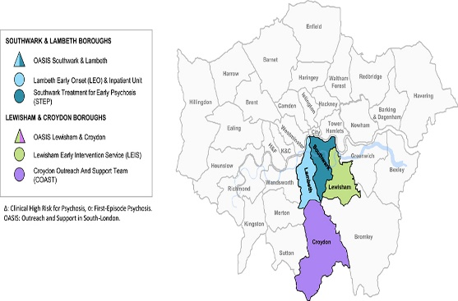
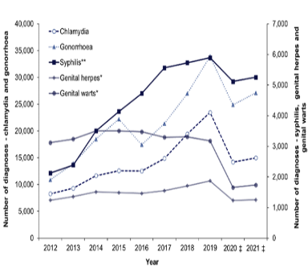
According to a recent survey, BAME populations are challenging to reach because of linguistic and cultural obstacles that underutilize services (NICE, 2017). An approach that considers prevention, as well as better access to and experience with mental health care for BAME groups, would be necessary to address disparities and mistrust within the community (Codjoe, 2019).
A higher prevalence of psychotic disease has continuously been observed in the black ethnic minority group and the migrant community in Southwark. One characteristic associated with a lower incidence of psychosis where ethnicity is shared is ethnic density, which is the percentage of an ethnic group-specific area (Schofield, 2011). A study done by Ajnakidinal, (2017), reveals how the longitudinal trajectory of psychosis in black service users often entails long periods of admission and mandatory re-admission (Codjoe, 2019). A review of England’s Mental Health Act was announced by the prime minister in October 2017. According to the Care Quality Commission, BAME individuals are four times more likely than white British individuals to be detained under the Act (Codjoe, 2019). Our goal is to ensure that all citizens are treated fairly and are empowered to benefit from all the community assets. Reducing the prevalence of problems people encounter will have a good effect on the community. According to the Annual Public Heath Report 2019, 30% of persons with long-term health illness, estimated 23,200, and 46% of those with a mental health issue, estimated 22,400, both have a long-term ailment (Southwark, 2022). According to Sexual Health Services, there has been a noticeable increase in the number of consultations during the past ten years with an increase in behaviour change (Health, 2016).
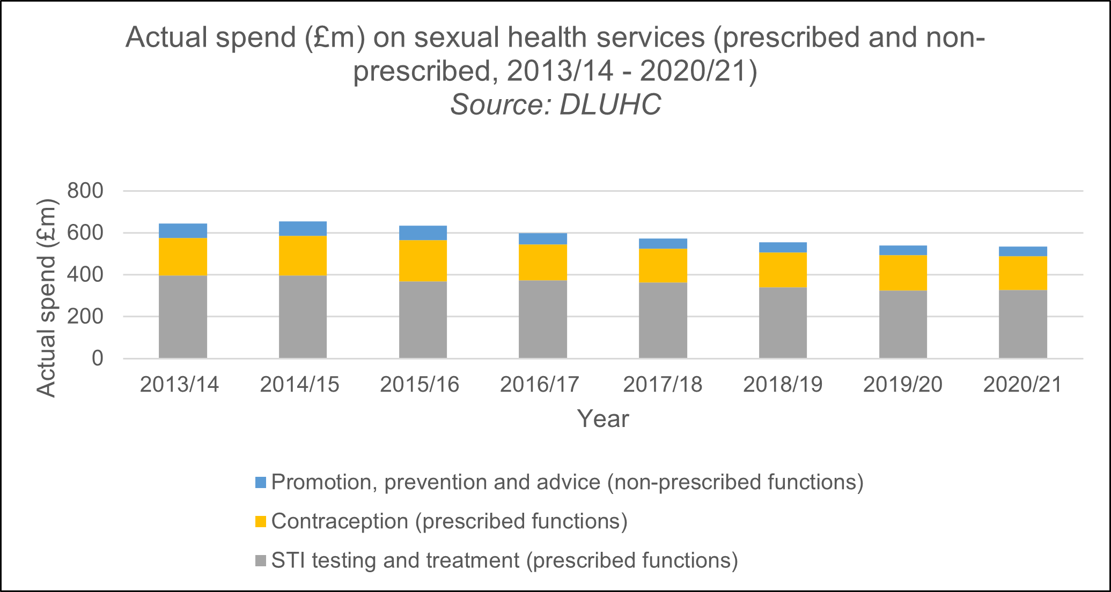
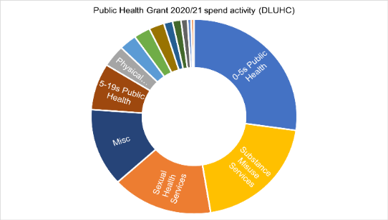
Statistic of impact and cost.
Health disparities are predicted to cost the economy between 40 billion pounds and 60 billion pounds annually in lost taxes, welfare payments, and costs to the NHS (LGA, 2022). Currently, councils spend more than 534 million pounds annually on services related to HIV and sexual health. Between 2015/2016 and 2020/2021, public health grant to local councils that funds sexual health services decreased by about one billion pounds (24%) (Southwark, 2018).
Glossary
Community Network Hubs

Social Justice
Stakeholders
Community development workers
Social exclusion
Community development learning
Community Sector Organization
Community capacity building

Community Activist

Voluntary sector
(Health, 2022).
The use of digital media and technology for community development

ICT (Internet Communication Technologies) advancements have opened new channels for the delivery of interventions for health promotion. Over 3.2 billion people utilize the internet currently. Online resources do help support health promotion (Jane, 2018). Several different social networking sites have emerged because of social interactions, and test messages. Facebook, which is currently used by 1.5 billion people, provides good advantages for health promotion interventions that are better able to target demographic segments.
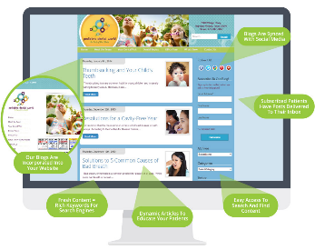
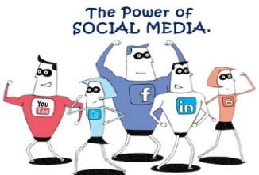
Our culture has adopted new behavior as well as new modes of communication and employment because of the expansion of technology. The advancement of technology offers tremendous opportunities for obtaining information about education, health, care, and services. It contains strong tools that open new opportunities for the creation of preventative, education, and health initiatives. Instagram and Snapchat are two recent innovations that have impacted public health in terms of social video and streaming (e.g., Facebook, and Google). Apps for social messaging (like (Messenger, WhatsApp, and Viber)






To engage young people, National Institute for Health and Care Excellence is said to have adopted Snapchat in 2017 before any other significant Public Health organization. In other to illustrate how quickly drug resistance emerges and how easily infections spread, NICE's communication team shared several ‘’Snap facts’’ throughout the day using images and emojis. Others have since followed suit, including Public Health England’s campaign to promote the use of condoms among young people by using Snapchat filters and promoting stories. Leeds NHS mental health campaign also uses Snapchat filters.
The new technologies, contribute to the improvement and promotion of health by making it easier to identify, diagnose, prevent, and treat diseases. They also help to manage lifestyles, increase our wellness, and enhance our quality of life (Ortega-Navas, 2017).

Principles that support community development

Community development, according to the United Nations 1985 is a process in which community members gather to conduct collective action and produce resources and knowledge, supported by encouraging members to make better use of their resources to enhance community life (: Harden, 2015). The community collaborates to make decisions and the delivery of services better. Fairness, and inclusively are crucial while making judgments.
Social change
Appreciating and respecting differences and diversity

Overcoming restrictive and discriminatory behaviours and attitudes

Addressing the issue of the distribution of power in groups and society

Committing to work for universal adherence to civil and human rights

Pursuing and promoting fair policies that advance equality while opposing those that are not.

Public Health policies and regulations
SDG3 Health and wellbeing
SDG 17 Partnership to support the goals
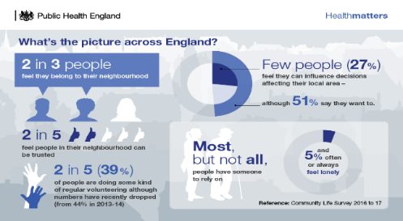
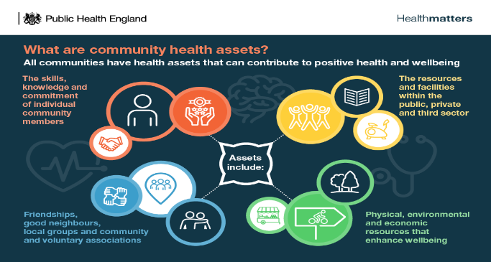
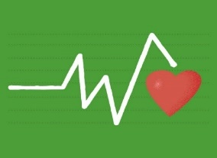

Community development may also be supported through regular community consultation, collaboration, community control, expanded facilities, community needs, cultural beliefs, and community leadership. Community development can be facilitated and supported by variables such as acceptance, participation, and self-determination of all people, regardless of age, culture, or status. Some of the principles that guide community development include respect for others, social justice, and equality of human rights (Akwugo, 2015).
Community life survey 2016/17, England.
Theories
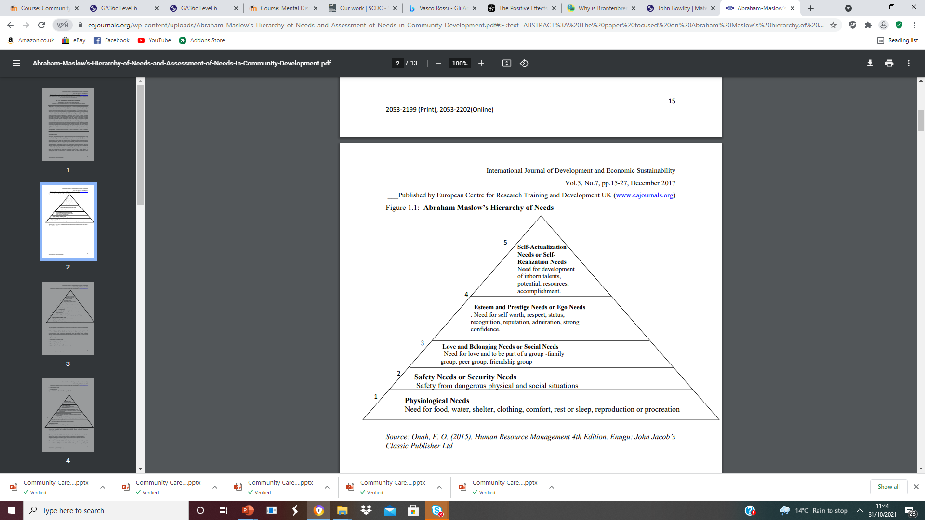
Abraham Maslow's hierarchy of needs
Theories offer a framework for comprehending human cognition, behaviour, and growth. Staff members who work directly with customers or communities frequently aim to modify behaviour. Abraham Maslow’s Hierarchy of Needs focuses on the five levels of needs that drive human motivation: psychological safety or security needs, social needs like love and belongingness, ego or pride and prestige needs, and finally self-actualization needs, which are related to most sustainable development objectives of the UN. People sense and need to identify with and belong to the community or the society when they are sufficiently safe and comfortable in their surroundings, this surely enables them to contribute to the growth of that society or community (Aruma, 2017).
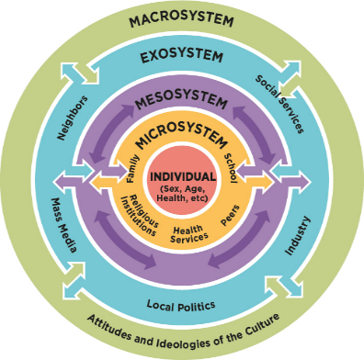
Bronfenbrenner's ecological systems theory.
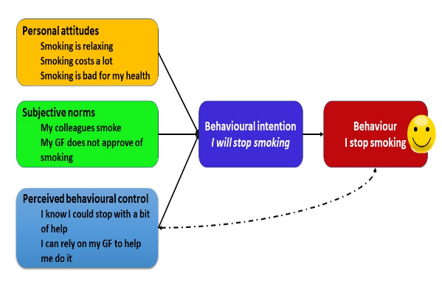
Bronfenbrenner’s ecological theory is a wide range of social, economic, and environmental factors that influence people’s health and are influenced by the distribution of power and resources at the local, national, and international levels that determine the circumstances of daily life. The amount to which various people have physical resources to set and attain objectives, meet needs, and deal with changes is important (Southwark, 2022).
The Theory of planned behaviour believes that humans can control their willpower. A range of health behaviours and intents have been predicted and explained with success using the Theory of Planned Behaviour (TPB).
The health belief model (HBM), developed by Hochbaum in 1958, Rosenstock in 1966, Becker in 1974, and Sharapova and Romas in 2012, is a cognitive model that claims that a person’s behavior is influenced by their beliefs about the threats as well as the efficiency and result s of specific actions or behaviors. HBM’s primary tenant is a perceived threat.

Legislation and policy, support, and growth of the community

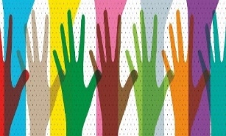
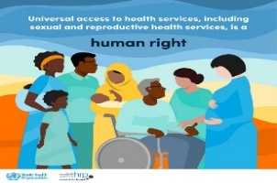
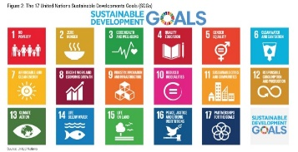
According to the equality Act 2010, no one should be discriminated against by any form of harassment, be it physical, emotional, or sexual (Southwark, 2022). The Public Health and Prevention team offers support for improvement in public health, assisting authorities in their efforts to address the larger determinants of health by using improvement techniques like access to shared learning, resources, case studies, networks, and community improvements (Health, 2016).All persons have the right to health and the means to maintain it, including access to clean water, sanitary facilities, food, and shelter. Right to the child’s education and other basic social and health services, including the right to live. The health industry cannot maintain people’s health on its own. In other to promote and maintain health, many sectors must cooperate. Human rights relate to partnerships, for instance, the right of everyone to pursue their interests, the advancement of science, and the right to privacy. Sustainable Development Goals, (SDGs), are set by the United Nations to sustain developments, and promote well-being at local, national, and international levels, without compromising the environment, society, or individual health in the long run. (Gov.UK, 2021).
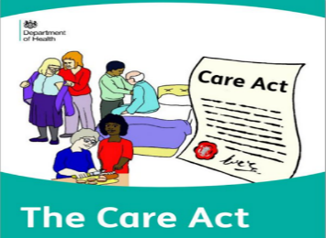
According to the Care Act of 2014, local governments have a broad obligation to advance people’s welfare when performing care and support tasks. Care is responsible to community developers. Safeguarding is everyone’s business. Six safeguarding principles are established in Care Act 2014 and are part of it: Proportionality; Empowerment; Prevention; Protection; Partnership, and Accountability.
Barriers and obstacles to the community development

Barriers and obstacles to community development can be a lack of engagement, lack of competence-based leadership, infrastructure, and communication/language difficulties. Lack of immediate and continuous funding. Community development may be hampered or blocked by a lack of stakeholder participation. Policy changes, physical limitations, misunderstandings, and cultural influences are a few more potential impediments and challenges.

Recommendation
As outlined in national guidance, tracking the prevalence of STI necessitates both disease-specific measures and broader actions at various levels. Building an honest and open culture is crucial, as is lowering the stigma associated with sexual health in the neighborhood (Health, 2019-24). Community development needs to delve deeply into its ideals and address the serious issues that communities are facing (Popple,, 2019).

Conclusion
Health-related factors have a higher impact on behaviour, genetics, and healthcare. As a result, it is crucial for public health to inform preventative measures and disease inequalities (Southwark, 2018). Technology can improve community development strategies for health, education, care, and prevention. Social media is viewed by many as a brand-new way to communicate with others. It encourages participation, growth, mobilization, and social change.

.

References

Appendices

Southwark Ethnicity Ethnic Group 2011
Ethnic Group, Number & Percentage
IN
White: Total 156,349 54.09%
White British | 114,534 | 39.3% | Irish | 6, 222 | 2.1%
White: Gipsy or Irish Travelers | 263 | 0.09% | Asian or Asian British | 27, 574 | 12.2%
White: Other | 35,330 | 12.2% | Asian or Asian British | 27,574 | 8.3%
Asian or Asian British: Indian | 5, 819 | 2.1% | Asian or Asian British: Pakistan | 1, 623 | 0.5%
Asian or Asian British: Bangladesh | 3,912 | 1.3% | Asian or Asian British: Chinese | 8,074 | 2.8%
Asian or Asian British: Other | 7,764 | 2.6% | Blac or black: British Total | 77,511 | 26.8%

Black or black British: African | 47, 413 | 16.4% | Black or Black British Caribbean | 17,974 | 6.2%
Black or Black British: Other | 12,124 | 4.2% | Mixed or British Mixed: Total | 17,778 | 5.94%
Mixed: White and Black Caribbean | 5, 677 | 1.9% | Mixed: White and Black African | 3,687 | 1.2%
Mixed: white and Asian | 3,003 | 1.4% | Mixed: Other mixed | 5,411 | 1.8%
Other: Total | 8,453 | 3.2% | Other Arab | 2,440 | 0.8%
Other: Any other ethnic group | 7,013 | 2.1% | Ethnic minority: Total | 131.934 | 45.91%
Total 288,283 100%

