Module Name – Researching and Analyzing Data
Module Code - EMPL4012
Student Name: Syed Sad Ahmed
Student number – 1605416
Module Lecturer – Dr Mushfiqur Rahman

Contents
Introduction 4
Articulated Question from The Article 4
Two sides of arguments 4
The first and positive side of argument 4
The another or negative side of argument 5
Primary data collection 5
Secondary data collection 6
Analysis 9
Graphical representation 13
Conclusion 15
Appendix 16

Executive summary
This report is a research project about the topic ‘whether company should adopt internet or digital technology or not’. The topic has been discussed from two points of view. One is that internet helps the companies to progress another is internet doesn’t contribute in the performances of company.
Some primary data has been collected by interviewing 50 people and secondary data is being collected also. Some statistical measures have been used to reach the conclusion and to analyze the data.
The secondary has been collected from internet, different articles and website, statistical project etc.
The results have been represented through graphical measure and interpretation has been given.

Introduction
In this modern era, every process and system are using digital technology and internet. Advanced technology and internet make the business more efficient and influences the productivity. Digital businesses are contributing to the economy of UK more than those of without technology. This report will serve the research and data analysing purpose based on the article of ‘City must wake up to digital growth, says tech investor’ published on ‘The Guardian’.

Articulated Question from The Article

Based on the article of ‘City must wake up to digital growth, says tech investor’ of ‘The Guardian’ (https://www.theguardian.com/business/2013/mar/01/city-wake-up-digital-investor), a question has arisen that whether the companies in the UK should wake up to the internet or not. In this era, every business and company became internet based or tech-based, which has a great contribution to the productivity and performance (Bhowal and Barua, 2008). Saul Klein, One of the UK's biggest tech investors, is on the mission to transform boardroom thinking about the digital business. According to him, digital business is more profitable, and it is high time that the business and companies wake up about internet and technology.
So, the main question is – ‘whether the companies should wake up to internet or be digital?’

Two sides of arguments
The argument is about whether the company should be digital or not. Here are the two side of argument with some evidence and findings-

The first and positive side of argument
This side of the argument is that the company should wake up about the internet and make the business digital so that the productivity increases (http://smallbusiness.chron.com). The first advantage of using internet and technology in business is that it empowers efficiency. For example- with the right disposal digital tool, employees can easily collaborate the departure time and location, using digital information system makes it easier to contact and share important policies and issues with employees. The second advantage is enhancing customer value. For example- by using digital technology company can gain a large insight about customer’s choice and preferences with the responses time. Lastly, digital technology empowers employees also with the company like- employees can work virtually that optimize time and increase value to the company. Some evidence and analysis about the benefit of being digital of companies that increase productivity have given below.

The another or negative side of argument
This side of argument refers that use of internet or digital business in not better for companies.
As internet or digital technology increases cost and often outdated very fast, it is not useful for the company. Installation of internet and technology requires huge cost and the maintenance cost is also high. Even, technology outdated too soon, so it needs to be replaced after quite some time that increases the cost even more. There are threats of digital crime, like- cyber hacking, spoofing etc. many confidential customer information, legal documents and data can be hacked, that will cause critical problem for the company (Bhowal and Barua, 2008).

Primary data collection
Here is the questionnaire for which we interviewed 50 tech managers and some researcher and analysts who have been investigating the companies being digital or the adoption of the internet by the businesses. The questionnaire is about the use of internet and digital technology that has been adopted by companies. The questionnaire is given in the appendix section (http://smallbusiness.chron.com).
We have conducted an interview of 50 people where there are 14 managers of different companies, 18 researchers and 18 analysts. We scaled their answers into 3 different dimensions – yes, no and partially yes.
From the questionnaire here is the frequency table made from the responses-
Responses | Managers | Researchers | Analysts | Total
Yes | 8 | 9 | 10 | 27
Partially yes | 4 | 7 | 7 | 18
No | 2 | 2 | 1 | 5
Total | 14 | 18 | 18 | 50

Here is the graph of this data-

Interpretation: here, we can see that most of the managers, researchers and analysts answer was yes, that the use of internet in the company will increase the productivity and useful for company survival (Corallo ep al., 2007).

Secondary data collection
Here is some analysis by ‘UK Digital Strategy 2017’ that shows the digital business growth rate is higher than from businesses without digital technology between 2010 to 2014.
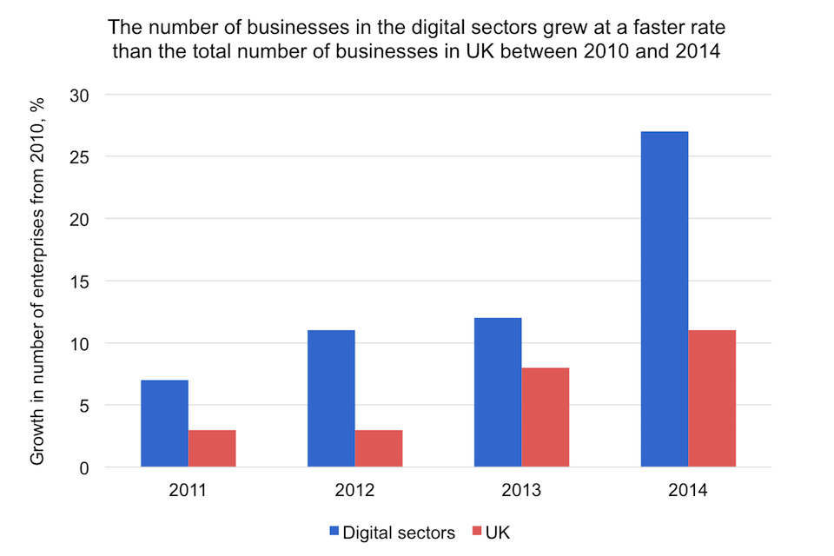

Source: DCMS Sectors Economic Estimates (Cumulative growth, Index 2010=0)

Secondly, here is the graph that shows the GVA of digital sectors is higher than the GVA of the businesses in the UK. The GVA of digital sectors increased by 21.7 % where the GVA of the business of UK increased by only 17.4 % (Digital Business, 2010). It means, the digital businesses growth rate is higher and they are making progress more speedily.
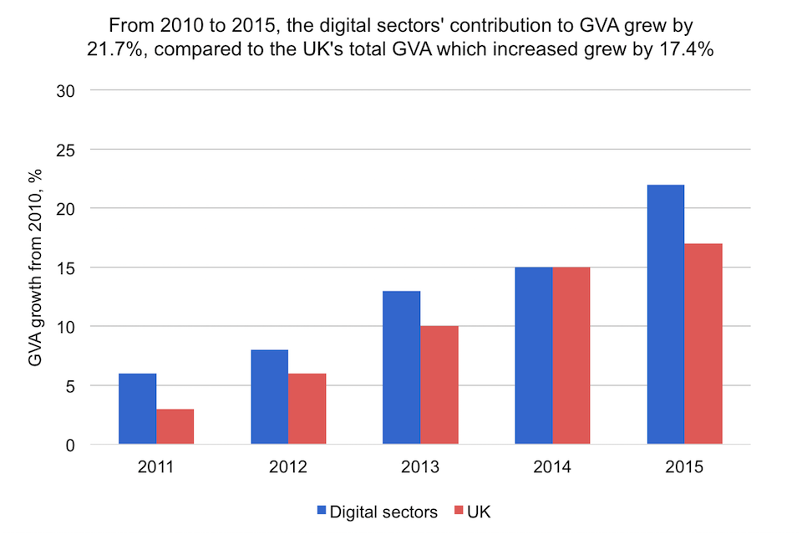
(Source: DCMS Sectors Economic Estimates)
The third graph shows that businesses in the UK are investing more in technology from 2011 to 2015, as technology is efficient to the production and performance of the companies (Corallo ep al., 2007).
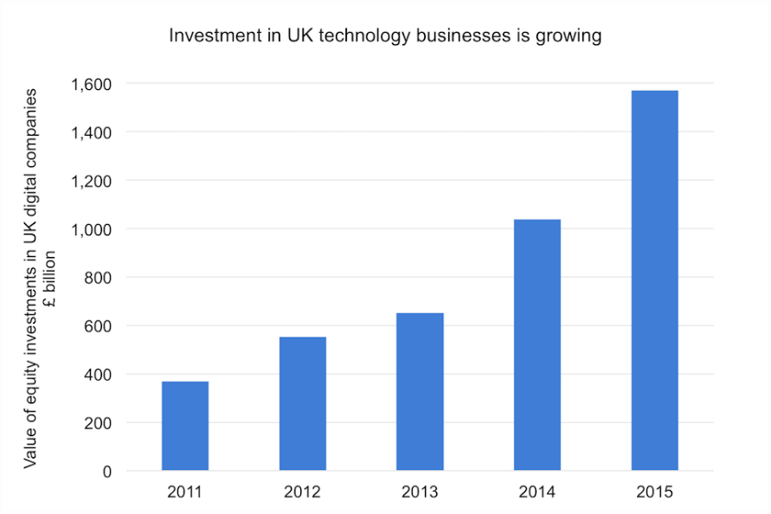

(Source: DCMS Sectors Economic Estimates)

Analysis
From secondary data and primary data, we can put the probabilities of being successful with internet from 3 different perspectives. Suppose, a company has this prediction of getting return in three economy perspective-
Economy | Pessimistic % | Normal % | Optimistic %
Use of internet
Yes | 40 | 25 | 14
No | 30 | 20 | 10

The probabilities of the economy being pessimistic or Normal or optimistic are given below-
Economy | Pessimistic | Normal | Optimistic
Probability | .30 | .50 | .20

Mean:
For yes- 40*.30 + 25*.50+ 14*.20 = 27.3
Foe no- .30*30 + .50*20 + .20*10 = 21
So, when the company use internet the average return will be higher even if there are 3 states of economy than from the situation without internet use.

Standard deviation:
For yes- $\sqrt{.30 {(40-27.3)}^{2 }+ .50 {(25-27.3)}^{2}+ .20 {(14-27.3)}^{2}}=9.30$
For no - $\sqrt{.30 {(30-21)}^{2 }+ .50 {(20-21)}^{2}+ .20 {(10-21)}^{2}}=7$
It shows that the dispersion of each outcome from the average is large when the company used the internet than of the without internet situation. Standard deviation shows the risk of using the internet. Using internet has higher risk but for the reward of taking high risk, the return is also high.

Here is the graph that the mean is higher if the company uses the internet, which means the average return will be high if the company use the internet. But the standard deviation is high, which refers that using the internet has a high risk but as well the return is high (Sternstein, 2005).

Now, here is another data set of using internet increases the revenue growth of some companies. The growth rate is different for different companies (https://www.techwalla.com).
Company | Growth rate % | Company | Growth rate %
A | 5 | E | 3
B | 3 | F | 2
C | 4 | G | 4
D | 2 | H | 3
 |  | I | 5

Mean: The mean is = 5 + 3 + 4+ 2+ 3+ 2+ 4+ 3+ 5 / 9 = 3.44
That means the average growth rate is 3.44%
Standard deviation: the variance = ${(5-3.44)}^{2}+ {(3-3.44)}^{2}+{(4-3.44)}^{2}+{(2-3.44)}^{2}+{(3-3.44)}^{2}+{(2-3.44)}^{2}+ {(4-3.44)}^{2}+ {(3-3.44)}^{2}+{(5-3.44)}^{2}/ 9$
= 1.14
So, standard deviation = 1.06
Median:
After arranging the data in ordered way –
2, 2, 3, 3, 3, 4, 4, 5, 5
Here the median is 3, which indicates that the growth rate will be expected to be 3.
The mode is 3, as it is the most frequent number in the data set.
The range is = 5- 2 = 3
Quartiles:
As the median is 3, the median of lower data set = 2, 3 = 2.5
The median of higher data set = 4, 5 = 4.5
So, Quartiles= 4.5 – 2.5 = 2

Here is last set of data of the growth rates of some companies without internet. The growth rates are given below-
Company | Growth rate % | Company | Growth rate %
A | 4 | E | 1
B | 3 | F | 2
C | 2 | G | 2
D | 1 | H | 3
 |  | I | 4

Mean: The mean is = 4+3+2+1+1+2+2+3+4/ 9 = 2.44
That means the average growth rate is 2.44%
Standard deviation: the variance = ${(4-2.44)}^{2}+ {(3-2.44)}^{2}+{(2-2.44)}^{2}+{(1-2.44)}^{2}+{(1-2.44)}^{2}+{(2-2.44)}^{2}+ {(2-2.44)}^{2}+ {(3-2.44)}^{2}+{(4-2.44)}^{2}/ 9$
= 1.14
So, standard deviation = 1.07
Median:
After arranging the data in ordered way –
1, 1, 2, 2, 2, 3, 3, 4, 4
Here the median is 2, which indicates that the growth rate will be expected to be 2.
The mode is 2, as it is the most frequent number in the data set.
The range is = 4- 1 = 3
Quartiles:
As the median is 3, the median of lower data set = 2, 1 = 1.5
The median of higher data set = 4, 3 = 3.5
So, Quartiles= 3.5 – 1.5 = 2

Graphical representation

Here is the graph that shows the mean and standard deviation in two situations of 18 different companies.

We can see, that with the internet the average growth rate is higher that is 3.44% than of the average growth rate of companies without internet which is 2.44%. That means companies with internet are having progress in their productivity and performance (Sternstein, 2005). The standard deviation is almost the same, so, it is better to use the internet as the return is higher with the same return.

The mode & median are the same for both the scenario, with and without internet. The mode and median are 3 for the companies with the internet (Digital Business, 2010). That shows the growth rates is higher in the companies with the internet, as the mode and median are 2 for the companies without internet. So, uses of the internet give higher growth rate to the companies which are very useful.

The range and quartiles are the same for both scenarios. It shows that the risks are the same with or without internet use (Digital Business, 2010).

Conclusion
From the above analysis, it can be concluded that the use of the internet is important for the company. The companies should adopt the digital technology to gain advantages in this era. Digital technology helps to increase productivity and make the processes of human resources, material management, scheduling, customer service and payment more efficient and quick (Sternstein, 2005).

References
Advantages of Using the Internet for Business. (2017). [Online] Smallbusiness.chron.com. Available from: http://smallbusiness.chron.com/advantages-using-internet-business-320.html [Accessed 30 Nov. 2017].
Bhowal, M. and Barua, P. (2008). Statistics. New Delhi: Asian Books.
Corallo, A., Passiante, G. and Prencipe, A. (2007). The digital business ecosystem. Cheltenham, UK: Edward Elgar Pub.
Digital Business. (2010). Springer Berlin Heidelberg.
Disadvantages of Using the Internet for Business | Techwalla.com. (2017). [Online] Techwalla. Available from: https://www.techwalla.com/articles/disadvantages-of-using-the-internet-for-business [Accessed 30 Nov. 2017].
Sternstein, M. (2005). Statistics. Hauppauge, NY: Barron's.
UK Digital Strategy - GOV.UK. (2017). [Online] Gov.uk. Available from: https://www.gov.uk/government/publications/uk-digital-strategy [Accessed 30 Nov. 2017].
What Are the Benefits of the Internet to Business?. (2017). [Online] Smallbusiness.chron.com. Available from: http://smallbusiness.chron.com/benefits-internet-business-316.html [Accessed 30 Nov. 2017].

Appendix

Questionnaire
(The use of internet in business)

- Name
………………………………………………………………………..

- Address
…………………………………………………………………………..

- Age
................................................................................

- Profession
……………………………………………………………………………..

- Do you think the internet is useful to business?
- Yes
- No
- No comment
- Partially useful

- Will productivity rise for this adoption?
- Yes
- No
- No comment

- Which sector is suitable for being digital?
…………………………………………………………………………………..

Define why?
…………………………………………………………………………………….
…………………………………………………………………………………….
……………………………………………………………………………………….

- Do customers think in a positive way about the company being digital?
- Yes
- No
- No comment
Define why?
……………………………………………………………………………………
………………………………………………………………………………………
…………………………………………………………………………………….
- What is the future of digital business?
…………………………………………………………………………………………
…………………………………………………………………………………………..

- Will company survive without the internet?
- Yes
- No
- No comment
Define why?
……………………………………………………………………………………………
……………………………………………………………………………………………….

- Is there any side effect?
- Yes
- No
- No comment
If yes, what is the side effect?
………………………………………………………………………………………………….
…………………………………………………………………………………………………..

- Won’t the cost increase for being digital a matter of concern?
…………………………………………………………………………………………………………
………………………………………………………………………………………………………….

Thank you

