In search of “Well temperament” in cloud-based data sonification and musical instrument design.
Author :Simon Kilshaw
Director of Studies Dr Catrin Webster (UWTSD)
Supervisor: Dr Jenn Kirby (UWS)

Introduction
This work exploits the creative synergies between the practice of sound design and the coding of programming-language software environments in the design and creation of new musical instruments. It sets out a particular data aesthetic, with a case study of NASA’s “Sounds of Jupiter” project, identifying some intrinsic musical, aesthetic and technical problems and exulanses associated with making music from data, for the composer’s, software designer’s and intended listener’s differing approaches.

Through the sonification of cloud based datasets in a hybrid of programming environments, new methodologies and creative approaches to instrument building are explored in the design of machine listening and learning neurals footnote (it is helpful to think of a collection of interconnected scripts and code or patches, as a means to create intelligent machine listening algorithms, neurals and generative models), demonstrating musically intelligent “tamed” (rather than trained) software models that introduce the idea of the well-tempered “dataphonic”. This paper serves as a commentary to the making of the album of the same name.

Chapter 1 An Aesthetic Stance

Musical output is, and has always been defined and bound by the compositional and performance tools (instruments). This inseparable relationship that all luthiers and instrument designers observe has transcended genre, social standing, geography and era, but evolves and is shaped by the emergent technology of the latter. Whether in the very early pipe instruments themselves documented by Homer (1) or the circa three millenia later musical instrument inventions of the futurist Russolo, Marinetti and associates (2). Interestingly, Russolo provocatively called the Intonarumori [3]“il scoppiatore”. This is a term usually used in Italian when referring to a bomb “going off” or war “breaking out”. It is to be seen as deliberately provocative and challenging. Italian Futurists, and specifically their experiments in, musical instrument design and performance instruction, benchmarks a useful reference for the start of this research project, not least because it demarcates a time in history where, empowered by the industrial revolution, where electricity (the currency of the Digital Luthier) began to expand (for the first time in centuries) the timbral possibilities with these earliest of electronic musical instruments.
From the 1913 publication of Luigi Russolo’s “Art of Noise” manifesto[4], the Futurists gave birth to an exuberant acceleration of audio-focused aesthetic design, production, system-based compositional protocols. Donin and Stieger[5] refer to this period of time as “the mechanical turn of music sensitivity” and it is in that spirit this work is made. The freedom of abandon in the creative process in this practice is highly desirable.
The focus of the practice although multifaceted, is driven (somewhat romantically) by a thirst for a new sonic aesthetic that has parched and afflicted all of my instrument-design Futurist predecessors who have sought to quench it. The work though, in no way aligns or relates to the early fascism associated with the Italian futurist movement.

Declaring that “The limited circle of pure sounds must be broken, and the infinite variety of 'noise-sound' conquered "(5), and helped soon after by the ability to record and replay audio content, there was an explosion of new “contemporary musical languages” and technology enhanced compositions (Raul Haussman[6], Tomaso Marinetti[7], Leon Theremin[8], Kurt Schwitter[9], James Tenney[10], Chowning[11], Scheaffer[12], Stockhausen[13], Cage[14] in the early half of last century as composers divorced themselves away from arguably stagnant baggage-ridden romantic sound-worlds and tired music making instruments, which inevitably sets challenges to how audiences may appreciate the work. Varese’s Ionisation [15] is almost a pre-pioneering example of a composition that more than hints at an electronic sound world as being sought by the composer. It is in this context that the practice, although systematically technical in nature, is similarly driven by a thirst for new sonic aesthetics, the genesis of new sounds and the creatively hybrid practice a digital luthier must engage with in order to generate them.
In this way the work presented is conceptually made by a neo-futurist luthier/composer, similarly driven by the technology, speed, intensity and youth inherent in Russolo’s scoppiatore. In my earlier electroacoustic training at music conservatoire, it was emphatically given that Music Technology should be termed with majuscule M, minuscule t.

Technological and computational and theoretical advancements in the latter half of last century, (Schaeffer’s Solfege de l’objets sonores(16), Eleckronishce studios Cologne[17] and Bell USA[18], became charted as significant research centres for the composition of electronic and electroacoustic music, and by association software/ hardware designers, technicians and synthesis modellers. (Similarly and more recently, current academic and research institutions can be seen in current creative software tool making, such as the Ircam suite[19], GrmTools[20], Beast-Tools[21], Pd2lork[22], and the open source audio manipulation softwares of Piquet and Belanger’s software[23], clearly aligning academic research with music making and sound and tool design. What they all share in common is the construction and manipulations of mathematical relationships between expressive sonic parameters that can be boiled down to the analysis and treatment of raw and pure data. What lends each of these tools individuality and usefulness when music making is how the technology’s interpretation of that data manifests itself in sound.
(Ref:Social Composition: Music Data Systems for Expressive Mobile Music )Hamilton 2011 p59)
“When designing an instrument, whether following a parallel design or maintaining two independent approaches, the physical and logical separation of the input device from the sound production necessitates multiple ways of processing and mapping the information coming from the input device. Mapping becomes therefore an essential element in designing new instruments.”
Miller Puckette’s “Puredata” [24] programming environment is a fundamental cornerstone of this creative hybrid chain, allowing for the acquisition, parsing, processing, through processing, function, manipulation and synthesis of any data representation, whilst at the same time keeping the artist acutely aware of the fully-duplex, simultaneous handshaking between the roles of researcher, software designer, composer, improviser, performer and mathematician.
At a recent Machine Learning & Music series webinar[25] (BitRate GrayArea workshop), I asked workshop leader Tero Parviainen {26} which of these roles does he see himself and his practice as being, and whether he is primarily focused on one or a simultaneous operating between these roles. A hesitancy in his reply soon revealed that primarily he was driven and informed by the software coding, it’s logic, functionality, and interestingly, his desire to hide that coding process from the intended listener/ user. Pleohn [27] makes quite an opposite observation in that if there exists enough nuance in the process and means by which the information is to be sonified, the sonic output itself can serve as a pathway into a particular sonic aesthetic representation of the world, especially if the map (or data model) it is linked to is manifestly exposed to contextualise the sonification or audification. This also means multiple data audifications, using different learning, listening and processing models can sit together as different doorways into a plurality of aesthetic representations of the world, in complex synthesis patterns.
In a lockdown performance of an avant-garde data remix of The Bee Gees “Night Fever”[28], expounds this idea further in my practice, by exposing, or even flouting the source code, the building blocks of the instrument, to the listener audience. Parviainen continued by affirming that he wanted the environments he designed to be intuitive as possible to the user. He seems to imply that it is a given from the outset that the user or listener perhaps is not nuanced or interested enough to comprehend the code or the building blocks of the instrument and the process should be abstracted from the art. The code-centric branch of “Music Technology” is a scribed a miniscule ‘m’ and a majuscile `t’. It is most interesting to note both from his answer and from the contents of the webinar workshop, that “music” itself was completely under-represented. Other presenters [29] at the webinar displayed an equally unrewarding, at best simplistic demonstration of the possibilities in sound creation, often resorting to linear coding methods to demonstrate the synthesis and basic sequencing of kick, snare, bass line melody, ultimately a dull musical experience.
There seems to be a frustrating disconnect between the practice of coding (scripting) music and coding musically at play here. Frustrating in the sense of being sonically unfulfilled. This can be observed further in each of the tutorial Git-hub resources examples that accompany that particular workshop. [30]. Development is of course the whole raison d’etre of the open source movement, and perhaps explains why most source code is packaged as libraries, where those connections are left to the artist to discover and uncover how musical that sonic experience will be, as a separated part of the jigsaw. Parviainen encourages developers to “explore the full potential of the system”. A more holistic approach is explored through the practice, and attempts to find a more common, at least appreciable, language and synergy between the two. These frustrations or challenges are perhaps a modern echo of Bach’s idiomatic Well-Tempered Clavier. [31]

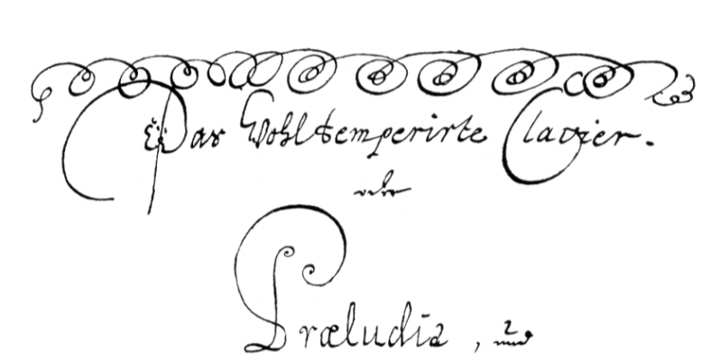

fig: From original Manuscript of the Well-Tempered Clavier. []

In Lehman’s study of Bach’s Well Tempered Clavier, (48 Preludes and Fugues) [32] he sought to determine if the spiral ornamentation scribbled on the header of the original score was somehow a “schematic” for Bach’s own definition of “well temperament”. What Bach actually meant by “well-tempered” is intriguing and still in debate. In any case, Bach’s squiggle was an attempt to convey that something was beyond the scope of the standard musical representation or definition. It was certainly unconventional, but equally revealing that he resorts to data visualisation techniques (an easier conduit for data than sonification) to convey his instruction. Aside the idea of a schematic itself, the notion of “temperedness” is particularly useful as it shares stylistically idiomatic parallels possibilities, frustrations, and creative challenges associated with data mapping and encoding. Whether Bach’s ornamentation represents somehow all of the keys (48 preludes and Fugues Each key in their major and minor), or perhaps refers to the notion of an omni-composition, or even if it alludes to an expansion of the tuning to alter the colour of his instrument, the notion of “tempering” feels appropriate to the process of musical data mapping in music, where data can be tamed, and sculpted with a musical ear by the composer. The composer needs to feel in control, a master to and not enslaved by the data (or instrument).

The sonification of data raises particular challenges in reimagining what it means to be a performing musician too. Kogan (33) articulates the notion of machine learning as an inevitable removing of the performer. But his ML4A toolkit (34) seems to speak more to a sonic facilitator for data, rather than a composer for performers. in his TensorFlow[35] implementation of DeepMind's WaveNet paper[36], one can acutely observe the lack of any mention of inane musically expressive parameters keenly sought by my practice, or indeed is it expressed in any way that a composer would find useful or approachable.
Particularly frustrating in this regard is the Magenta project[37], which promises to “close the loop between machine learning researchers, creative developers and traditional artists” but falls short of any sophistication in its mention of music beyond loops, melody and beats, and still requires a leap for the developer to think of “the user” as the listener. Of course, the application of these frameworks have some extremely creative possibilities for machine learning in other artistic disciplines too, and are designed to be applied by developers with all sorts of aesthetic or visualisation approaches and needs, not just sound based. (Data visualisation and associated generative artworks is not discussed within the scope of this paper).
Essl’s Realtime Composition Library (RTC_lib)[38] comes very close to a musically expressed architecture that is recognisably useful to the composer in its richness of contemporary musical language. His cross-platform library of abstractions, can be thought of as neurals that evoke expressive modelling of musical rudiments and techniques such as ritenuto, accelerando, transposition, scaling among many others. His scripts present a much more useful example of how the software abstraction relates directly to its musical function. Google WAVENETS Structures[39] or Ibab’s[40] open source version of the same Recurrent Neural Network (RNN) show advances in more musical stylistic machine learning, trained on data to create for instance completely modelled synthetic compositions in the style of any modelled composer (given enough initial material to train the system in the first place).One observes uncanny, similarities to Mozart’s cells in the 1793” Musikalisches Wurfelspiel”, dice composition. [41]
His methodology can be seen as some kind of precursor to pre-baked models as inter-related building blocks to a musical composition generate by a randomised input function. One accepts Mozart then, at least in this composition, as a musical facilitator, rather than our traditional perception of him as a composer. But even then, since the piece gives much away to chance it always works, and work musically. It is procedural in nature in that it takes random input (dice) to create a structured output. There are 759.499.667.166.482 or 759 trillion * 10^ 12 different possible compositions to be made from Mozart’s system.[42]
[[https://appadvice.com/app/mozart-dice-game/946580946]

Perhaps a more pertinent, or certainly a more intelligence-driven reflection may be that Mozart’s pre-baked building blocks could be seen as (non-machine) learned neurals, that have seemingly infinite possibilities that when variably combined, always produce a “well-tempered” set of data.

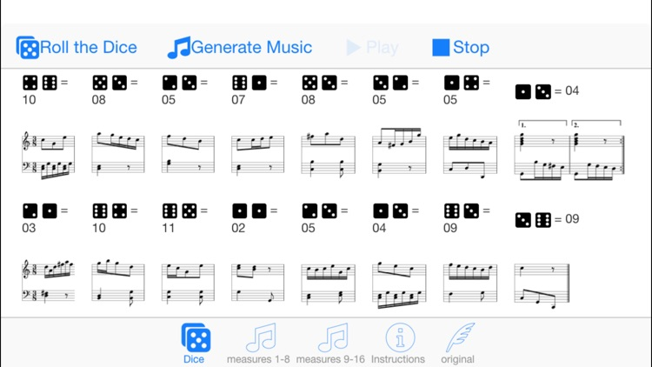

fig source: https://appadvice.com/app/mozart-dice-game/946580946, a mobile version of Mozart’s Musikalisches Würfelspiel.

Chapter 2 Data temperament.

Throughout the development of my practice, “tempering” (considered here as taming) data in wearables and tangible music making interfaces has explored a synthesis of software and hardware instrument design (using an array of microcontrollers and sensor IMUs[44]) to get away from traditional studio means of inputting data tangibly into a musical environment. (acoustic instruments, midi controllers, commercially available interfaces). These are invariably limited by the constraints of the system in general but especially by the ergonomic and physical parameters of any haptic physical or gestural musical interface. Moreover, the playability of the designed instruments is of equal value as the musical expressive parameters it evokes. It proved invaluable in my quest to gain control of data (not yet cloud-based), and learn to command that data musically, as well as improving the understanding and linguistic syntax, and indeed the “miltilinguicity” and inter relations of the hybrid code environment.

The Copedent Polyphonic Country Theremin

Album: Traddodiadol
Tracks:
Videos:
“ Traditionol “is a series of traditional Welsh traditional hymns performed and recorded on the “copedent polyphonic theremin” solo instrument. [49])

(The schematic for the hardware build instrument can be seen here[45]. Development work (learning to play the instrument and iterative adjusting of the mapping parameters) can be seen here[46], recordings were released here[47], was part of a performance set with the Swansea Laptop Orchestra[41] at the National Eisteddfod 2019[42], and was demonstrated at this research seminar[43]. The source code for this project is hosted here[48]

The term “copedent” is borrowed from the pedal steel guitar, and refers to a mechanical combination of rodded pedals and knee levers, depressed or physically engaged by the player, allowing a variation of string sets to be pulled above and below its resting frequency. Virtuosic players include Rhodes[50] and Drake[51] with notable transpositions for the b-bender acoustic guitar invented and virtuosically mastered by Parsons[52].

A particularly expressive characteristic of the pedal steel guitar is how the relationship between the mechanism of the instrument gives rise to the control of portamento, or glide time between chord states., as well as the smoothed pre-amped volume pedal operation , a combination of which affords the instrument the searing, floating glide of sound that is so distinctively recognisable.
The theremin has similar distinguishing sonic features in pitch bending, vibrato, volume swells, albeit limited to a monophonic output. For an instrument that is over 100 years old, Rockmore[53] and Kavina[54] are among only a handful of truly virtuosic concert players that have graced the concert platform. Both of these instruments are notoriously difficult for a player to master, requiring a specific virtuosity in the ability to make precise movement-based accurate pitches, time after time, with confidence. Even though the theremin has no useful visual reference clues to help, as we do in the chromatic pianoforte, it has attractive, creative possibilities in exploring “between the notes”, microtonally, or exploiting the portamento between desired pitches.

The CPCT is an electronic instrument that can be said to have pedal steel guitar-esque and theremin-esque qualities. The CPCT’s hardware is a handheld palm sized [photo] controller and the audio synthesis section is a frequency modulation model(55). The instrument is to be seen as a conjoined hybrid of code in the Arduino[56] and Puredata [57] coding languages, as well as the hardware sensors and processors themselves. The model is designed to exploit four of the theremin’s and pedal steel guitar’s shared musically expressive parameters namely, volume, pitch, vibrato and portamento. It is a motion tracking gestural controller built with an MPU6050[58] that has six degrees of freedom motion tracking accelerometer with I2c connection to an ardiuno nano[59] microcontroller as well as a hacked gamepad two axis joystick and integrated switch button.
Evaluation
A direct ”some to some” mapping approach[60], where each individual control dimension is equated to an independent sound control parameter poses some clear issues. Firstly, the serialised data stream provides nine control parameters at the input stages, but the audio model only predetermines four. In this mapping scenario one is instantly faced with what data is to be ignore let alone processed. Moreover, such an approach freezes matters and does not allow for the reflexivity of the relationship between the material itself, the composer (or at least the musical facilitator), and even the audience to emerge. [61]
A more complex “many to many” direct mapping approach, it is argued by Hunt[62] proves to be more useful and musically interesting by unfreezing the process, thus liberating the composer to explore more fulfilling sound worlds.

The immediacy in the playability of the instrument is manifested by the data string to be serialised to expose the sensor’s state at a high sensitive refresh “Baudrate” (115200), resulting in a real time responsiveness, that any instrumentalist, musical or not, would immediately appreciate. The learned models in the system are a set of pre-trained sequences, inputted (transcribed) manually from traditional SATB scores, a permissible cheat, where the systems already knows what note one needs to play next, as per the score. The performer or player of the instrument, doesn’t need to worry about pitching the note, but can concentrate on the other expressive parameters, namely vibrato, volume, portamento and timing of events (for example rubato, accelerando decellerando, ad liberta etcetera).
The CPCT is polyphonic to four parts, lending itself perfectly to SATB[63] scored repertoire and is rich in tonal harmonic content. By iteratively playing the instrument and through a practice regime equivalent to that of pianists, violinist guitarist etcetera, one feels a quite euphoric sense of sculpting invisible sound in a highly musically “always in tune” expressive way.
In this design of the CPCT model one can see where bias and weightings are applied (marked with ”$1”) and it is the control of these scaling or sensitivity parameters, mathematically, where I believe the notion of well temperament lies in this instrument:

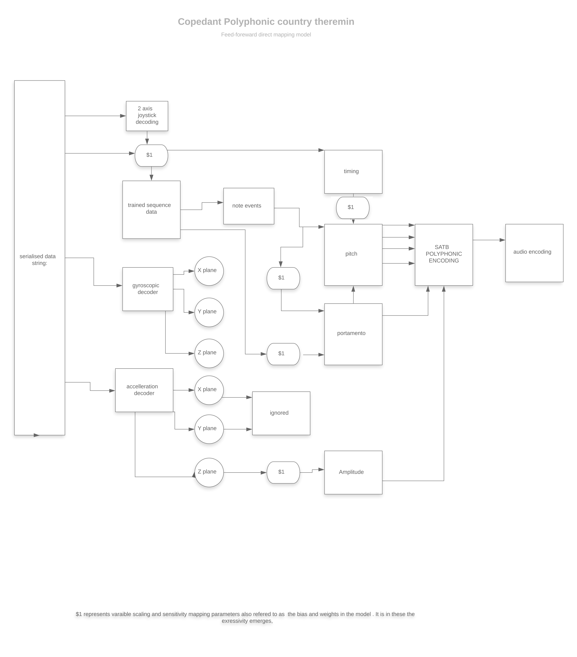
fig Feed-forward neural map of the CPCT

This lends a desirable flexibility for the instrument to be personalised to individuals, where technique and playability can feedback into the instrument by training and storing as bespoke presets. The notion of a no-fixed-state instrument becomes increasingly appealing in later projects in the practice. The identification and tuning the of weights and bias(“$1”) in the system of this particular this instrument, begins to show and audibly articulate an emerging characteristic of a very well-tempered data.

Cloud-data

Iterations and development of this gestural musical mapping in the practice can be seen here[64]. Although these tangibles yielded great confidence in the ability to feel in expressive control of data parameter, the focus of the practice shifted to being less concerned with tangibility and playability, driven by a technical thirst to explore the sonification of larger and more complex data streams, to begin to stretch the notion of tempered data, and a feeling of needing to have access to bigger and better opportunities of new and evolving instruments, namely cloud-data.
There are clear problems associated with making music from cloud-datasets. The notion of “cloud instruments” in particularly are often ethereal, intangible, sometimes unfathomable in the mind’s snapshot. Some data schemas have such depth in their nested schema that it is even challenging to visualise in its entity, let alone to imagine its sonified output. Indeed, in the recent course of creative application design, MCormack argues that computational evolutionary systems manifest a difficulty in achieving an aesthetically pleasing balance between the size of the dataset space, and its power of expressivity and breadth of aesthetic possibility. MCormack points to the instrument needing to be useful diverse in the pursuit of the aesthetic.[65]
(ref: Codeform A Balancing Act between Variation and Utility in Evolutionary Art LEONARDO, Vol. 49, No. 3, pp. 257–261, 2016 )
So as the dataset deepens in its architectural complexity, the paradigm of what data to ignore becomes exponentially amplified. Furthermore, the context and source of that datasets pose interesting challenges to the listener too, sometimes preconditioning a response to a sonification, even before it has been heard, manifest in the following exulanses:

- Contextually, listeners may fear seeming critical of “emotionally charged” datasets of, for example, climate change, global pollution, endangered species.

- Cloud-based data is, for the most part, empirical data. It does not veer from truth and the listener is forced to accept data as “unchallengeable”, and perhaps by inference, is robbed of the opportunity of musical critique and analysis.

- Some datasets are somehow “other-worldly” or of such an abstracted context or dimension that the listener is forced to give reverence, supplicating to the uninformed “wow factor” moment of unfathomability.

Case Study : The NASA Cassini Project

NASA's sonification of Jupiter Cassini project [66] is an interesting case in point, particularly when considering the role of the listener and how these exulanses have an affect on the appreciation of a sonified work. One of the protagonists of the project, Gurnett[67] states that “The oscillations discernible in the audio file are from ion-acoustic waves, which result from electrons moving in non-random patterns driven by a flow of energy. In this case, the energy flow probably comes from the heat of Jupiter's bow shock. The bow shock is similar to a sonic boom from a supersonic jet flying through Earth's atmosphere, except that the bow shock is caused by the supersonic solar wind being diverted around Jupiter's magnetic field.” There is an implication of some kind of untouched natural harmony, ostensibly devoid of human composition, implying almost that the audio we perceive is somehow by “the hand of god”[68]. Gurnett’s statement is another example where a ‘data to audio synthesis soundscape’ project is unable to approach or reference the work musically.
Of course Gurnett is a scientist, not a musician. But inspite and because of that, as an audience listener, one feels the sound creation here is a mere product of these seemingly mind blowing “wow-enhanced” cosmic happenings. This is amplified by the fact that the soundscape itself is merely referred to as “discernible oscillations” falling far short of the creative critical listening demanded by my practice. He clearly articulates what data needs to be mapped (at some length), but doesn’t seem to be able to (or want to) articulate the sonic parameters that they are to create, which for the composer sonifier, is the most interesting part. One can’t help being reminded of Bach’s ornamentation idiom as if something beyond is at play here.
Tantacurl [71] ridicules NASA’s data sonification projects as somewhat crass and “random sounding”, laughing off the idea that sonification can give us a better perception and understanding of the world that visualisation of data affords. Murray Schaefer, on listening, noticed an increasing deficiency in the listening ability of students (of sound[] while Walzer reminds us that it is only through a composer’s openness to a breadth of musical and non-musical application of listening, that a “profound sense of noticing” can emerge.

The NASA sonifications can be heard here[69]. The soundscapes serve as an interesting reminder of the works of early pioneers of electronic composition (Davidovsky Electronic Study No.1,[70] HughLe Caine’s Dripsoy [71], or the futurists IntonaRumori [72]and its array of "howlers, boomers, cracklers, scrapers, exploders, buzzers, gurglers, and whistles" (Dunn [73]). This composer is attracted to the charm of the NASA soundscapes, in a nostalgic way, purely for its primordial electronic simile. But the audio ultimately fails to fulfill the thirsty listener, as it belies the possibilities of a much richer sound world.

A suite of cloud-based instruments “The Exulanses” was created to invoke these paradigms, by deliberately targeting and processing data from APIs[] that were imbued with the aforementioned wow factor, provocatively emotive subjects, unfathomability factor, empirically unchallengeable and that could even purport to somehow be offering a certain perception of the world. The following are example vignettes, and short evaluation of this IoT[] suite.

“The Exulanses” S Kilshaw
1.UK Air Quality Index Sonification
Video: https://www.youtube.com/watch?v=ghNAjSxVx00
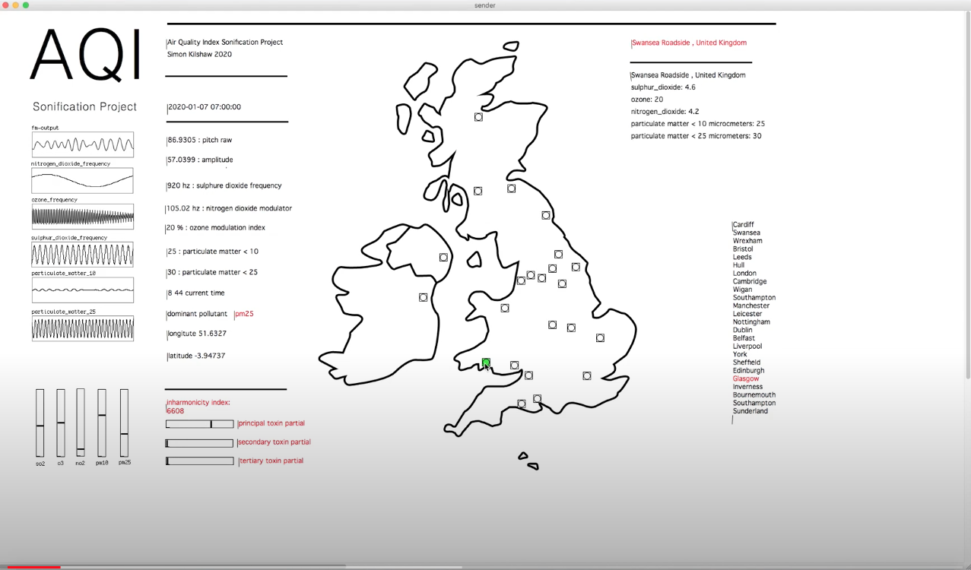
This vignette synthesises, in real-time, the pollutants data from the World Air Quality Index API https://api.waqi.info/feed/. The performer of this instrument can “check-in” on a given location for an auditory representation of measured CO2, SO2, Ozone, NO2, PM10 and PM25 present in the atmosphere. This instrument plays and feels and sounds like a synthesiser whose presets evolve every 15 minutes. The instrument then never stands still, but equally can go back in time (the data can be queued retrospectively). It’s impact

2.UK Carbon Intensity Synthesiser.
Video: https://www.youtube.com/channel/UCt3xpl_p0O0HEupokGE2k0w/videos
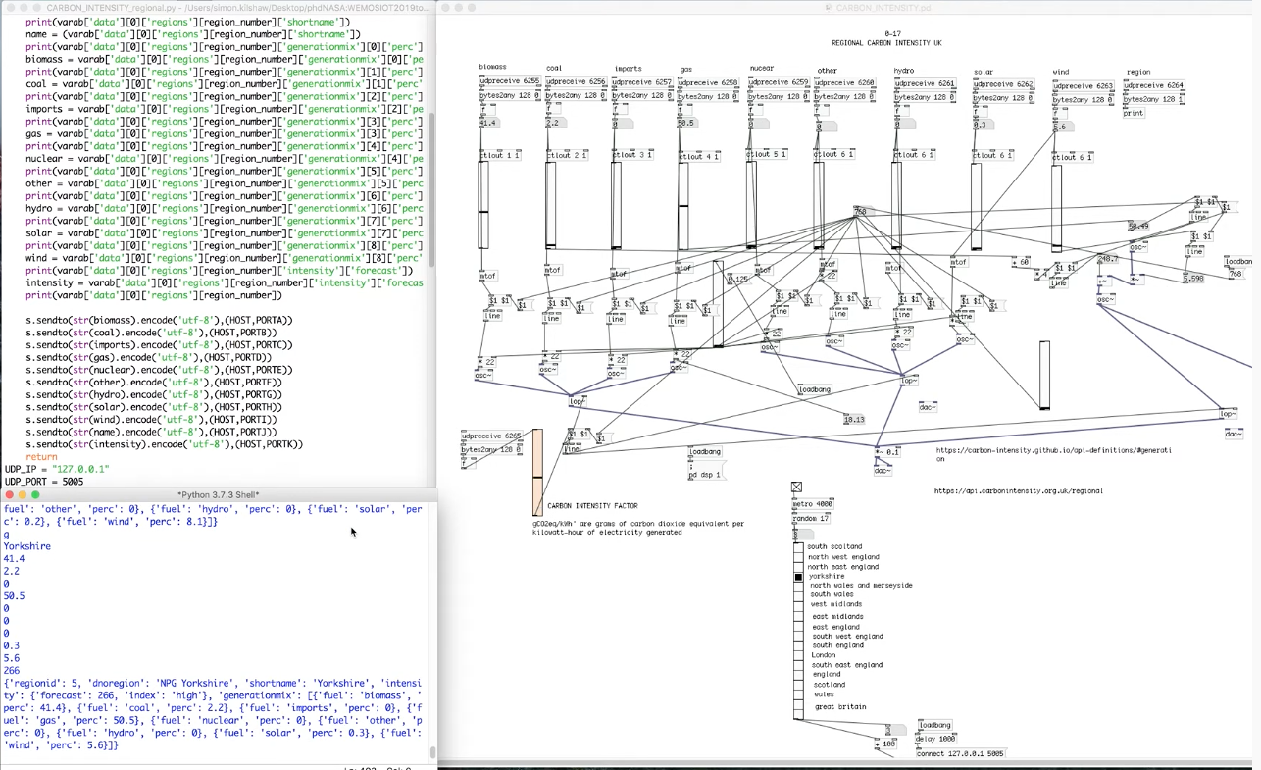
The purpose of the data set is “to enable consumers to optimise their behaviour to minimise CO₂ emissions, through an appreciation of the data.”[]
This vignettes is a realtime sonification of datasets from the API: https://api.carbonintensity.org.uk/regional. Energy consumption of biomass, coal, gas, nuclear, hydro, solar and wind in different regions of the UK. As the machine learning algorithm forecasts consumption projections over 96 hours, this instrument has a sense of being whimsically futuristic, useful particularly if the sonifier intends to advertise “the sounds of the future” as one of the exulanses to extort.

3)Flood monitoring tidal gauges audio tour of the UK.
Video:https://www.youtube.com/watch?v=j_t8GFaZzmw
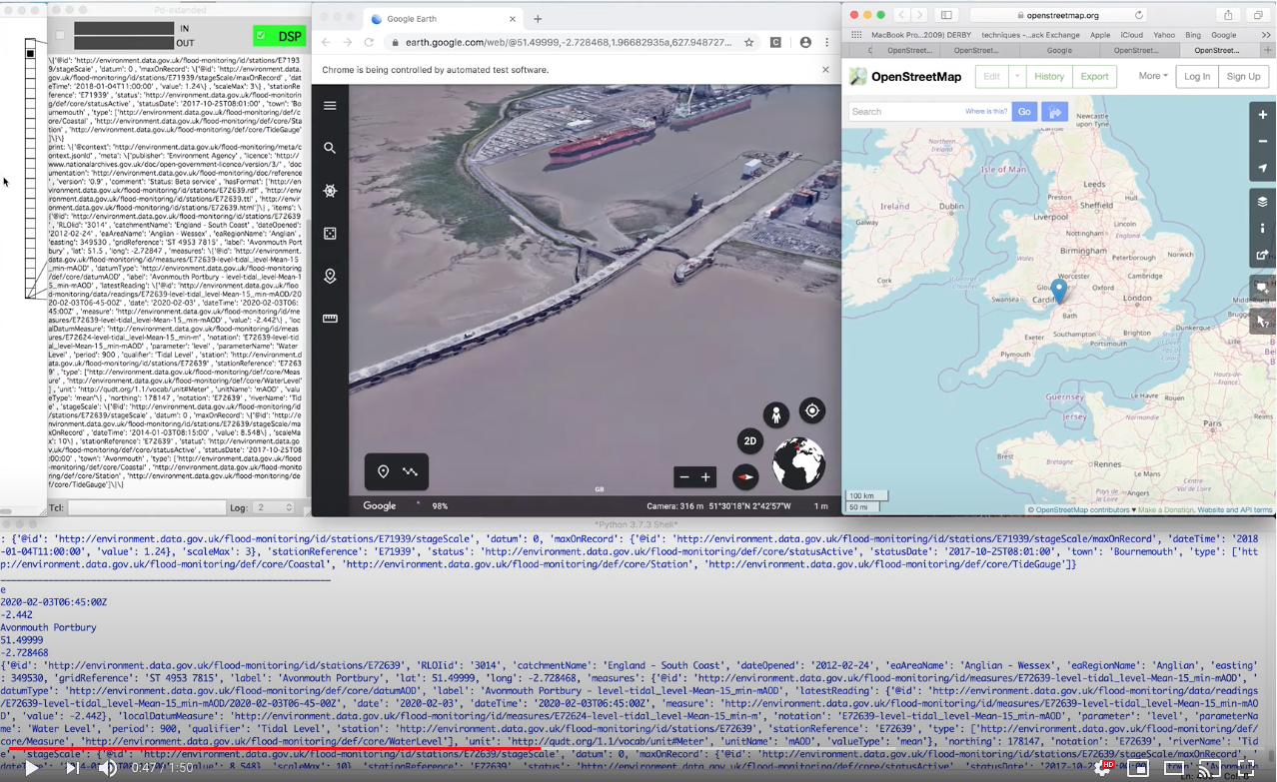
This etude is real time sonification of Defra’s Data Services Platform flood monitoring data (http://environment.data.gov.uk/API). It is a created as geo-location sonic extension of Google Earth, and embedded in WebPD[] running on a server. This excerpt drops in on Bournemouth, Avonmouth, Weymouth and North Shields. Data retrieved on Monday 3rd February 2020 at 7am.

4)The human genome sonification project.
Video: https://www.youtube.com/watch?v=NtkSFjf-IxE&t=19s
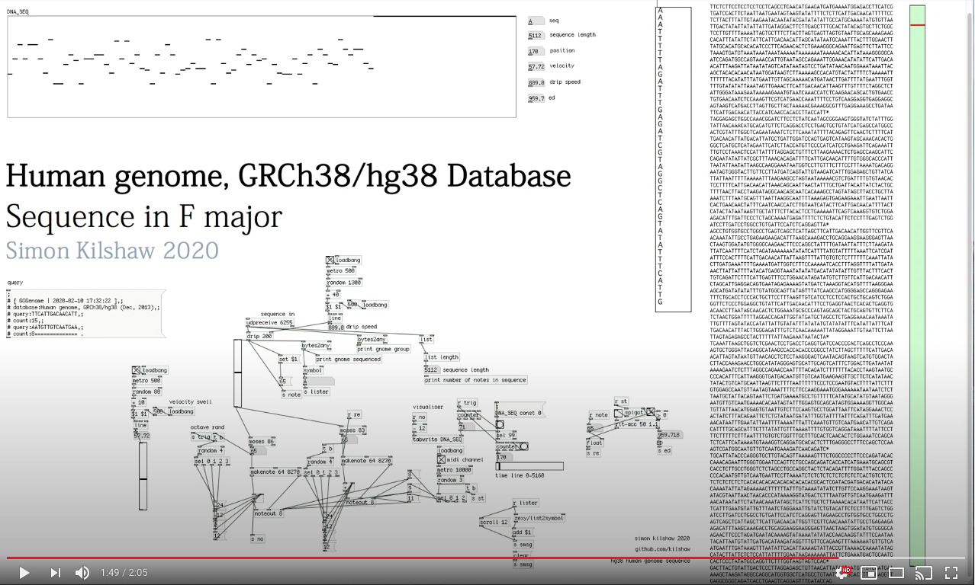
The sonification of this data set is a composition for synthesised piano trio. Python script to query requests from the GRCh38.hg38 Database at http://gggenome.dbcls.jp/hg38/. A serialised genome code is dripped into the system, scaled and mapped to sonify the data out to 3 pianos. The audio example provides a good example of an attempt to gain mastery of the notion of “well temperament” (conceived as “tamed” in this instance) constraining the mapping to F / Bb Major and C Minor Pentatonic cycles .

5) Endangered species population Synthesiser.
Video: https://www.youtube.com/watch?v=VQ0FEMo0Za0
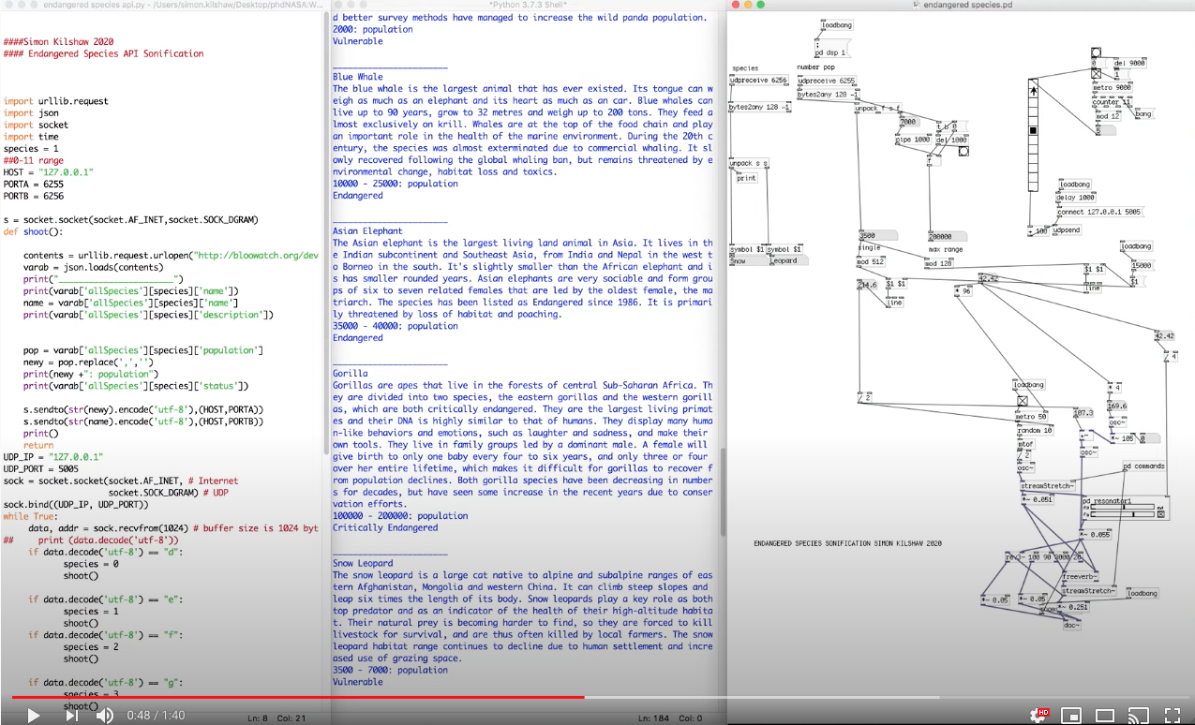
This vignette sonifies the tracking population of endangered species, (bloowatch.org) API. The soundscape is enhanced by convincing relationship between sound and context, promoting tensions in textures by stretching the partial streams. Spectral techniques have a unique ability to “slow down” the listener in a mild hypnosis, allowing the semantic meaning of the sonification to be evaluated.

The source code for these instruments can be downloaded here: https://github.com/kilshaw/

Evaluation
Perhaps my interpretation of temperament in data, is partly one of aesthetic palatability. There are some variability in (un)convincing relationships between sound and context. For instance, Data sonification can certainly enhance telling of a story, it’s listenability is important. To the sonifier, the ultimate challenge is if it doesn’t sound good, no one would listen, and any opportunity to raise awareness, educate, highlight a particular context or worthy case to be would be lost. To a sonifier, that also takes practice. At the same time, data sets from these contexts, have allowed a reason to compose the instruments. The exulanses as I sceptically perceived them are actually the very reason the instruments exist.
These digital installation vignettes display varying degrees of success is that sense of palatability, or as an overall sonic experience. As compositions within themselves, when played in real time, they derive their own structure automatically, ephemerally, without a start and end point. For my practice, what emerges from each of these works is the creative unleashing I found in the deconstruction of these sonifications into sound objects, gestural events, musical cells, where the structure and shape of the data, raw material, removed from emotive association, as an acousmatic experience, perhaps irrelevant of origin. This is proposed as the phenomenology of the “dataphonic”.

Chapter 3 The Dataphonic sound object
The phenomenological concept of composing sounds (as individual blocks) through reduced listening, manifested in by Pierre Schaeffer’s “solfege de l’objet sonore(1966)”, [] can be especially relevant to the data composer. It could be argued that an electroacoustic composer is primarily interested in the intrinsic musicalilty that may be directly manifest, or latent in a dataset, and the contextualisation of the origin of that data to the final intention of the musical work is secondary, if not irrelevant. In this context, the sound source is insignificant to the listener and in taking an acousmatic approach, “must be unknown and indeed unknowable.”[ Jonty Harrison Conditions of acousmatic music]. Chion affirms it is only then that the sound can be reduced down to its purest musical properties[Chion].
If it is a given that the origin and context of a sound source (in this case, datasets) is removed, what remains is a pure sound construct that has its own shape, aesthetic architecture and sonic characteristic. A dataset then could be conceived of as a “dataphonic” – an individual sound object, musical cell, micro-ingredients for a wider constructed audio canvas. When treated in this way, one becomes much more aware of gestural qualities that a dataset might present and the creative sound making opportunities that they can offer. My practice then becomes engaged with techniques of creation and representation of that dataphonic.

“Deep Mathematical Relationships ”Simon Kilshaw
Track: Deep Mathematical Relationships.mp3

The work “Deep mathematical relationships” is a system of recurrent neurals, machine listening and learning models that encode the data into a representation of harmonic content, counterpoint patterns, and compositional expressivity from three (seemingly random) integer numbers, that is said to be truly digitally harmonious[] whilst imposing a rich musical aesthetic to the data.
A pull request from the Restful[] numbersapi.com allows interesting mathematical facts to be drawn and ultimately translated to an audio dataphonic. The simple premise of the piece is that something (a construct of elaborate mathematical facts) equals something (dataphonic representation). For example,

“The sum of the squares of the first 8 primes & the smallest number that can be written as the sum of 3 squares in 9 ways & the number of ways of dissecting a regular 13-gon into 11 triangles =
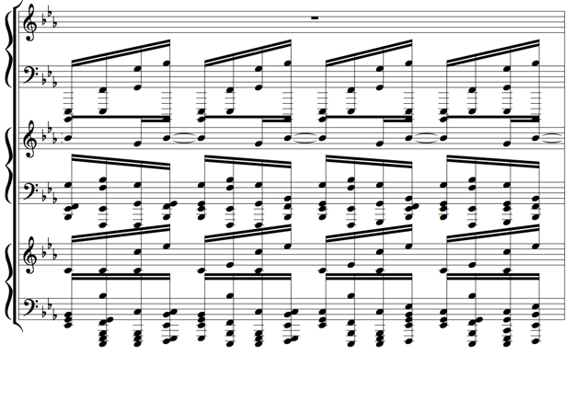
fig: A dataphonic of 1027, 614, 2282 (Deep Mathematical Relationships)

Aside the obvious fluidity in the order-concatenation and matrix connection of the neurals within the model, there are some demonstrable musical expressive patterning specifically in the weights and bias applied to the model.

fig model of the neurals “Deep Mathematical Relationships”

From each of the three integers (X,Y,Z) fed to the system, a 3x2x1 neural feed forward model is allowed to decode pitch to a twelve tone row model, decode a binary sequencing pattern that simultaneously scales to interval, retrogrades and inverts, which displays a well temperament to the treatment of the original data..
As an example, In a singular neural in this system, frequency time and pattern return a dataphonic that could be usefully expressed as:
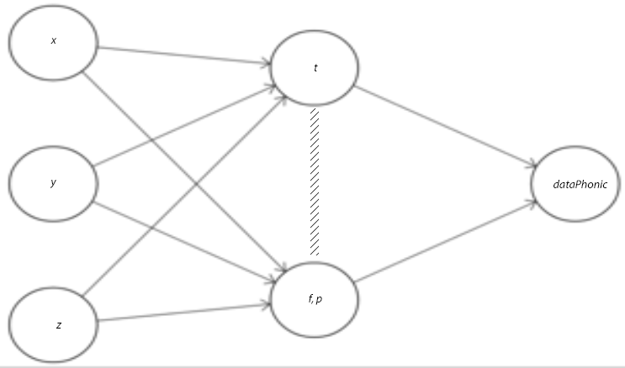
TIME= XYZ=[562, 914, 398]=[ 1000110010, 1110010010, 110001110]=[ p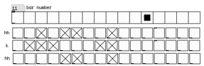]
Frequency= XYZ= [562, 914, 368]=[73.23,67.26, 81.65]=[ 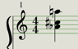] = [50-45-70] =[Cm7th]=[intervals 0,7,10]
fig (alternative expressions of a dataphonic)

By imposing a binary time pattern model to the learned chord of its original integer, a melodic counterpoint arpeggiation is realised in the synthesis model (in this piece, a synthesised stringed instrument). What emerges is a rhythmic version of the melody and a melodic version of the rhythm.
Using the first integer as an example 1821 = 11100011101(binary):
By interjecting (bit-segmentation) the binary at any node in the nth order traversal of the binary string (d₀×2⁰ + d₁×2¹ + d₂×2² + n), and recurrently feeding the model, the musical facilitator can expand the poly-rhythmicity in an everexpanding deep rhythmic grid sequence system.

The remapping of these as sub-outputs back into the model results in an increase in the expressive gaining and losing of poly rhythmicity and textural complexity, performing macro-variables of the original integer.
Transformation over time- line ramp time derived from the sum of the three integers results in transformations, ramping, (portamento) time between triggers (presets) by using feed-backward model with upward register shifting:
Trigger | (x+y+z) = timeslope

interval 9
interval 9 11
interval 8 9 11
interval 1 8 9 11
interval 1 7 8 9 11
interval 0 1 7 8 9 11
interval 0 1 7 8 9 11
interval 0 1 7 8 9 11…………etc

fig (console print of simultaneous portamento and chord construction)

Appoggiaturas, passing dissonances, are explicitly and expressively audible, much fuller in colour, musical decoration whilst passing through the bit- interruption model in-between API request calls. This is seen in bars 113-118:

fig: “Deep Mathematical Relationships” bars 113-118

Evaluation
The sonic output in the following example can certainly be describes as Schoenber-esque Wind Quintet, Op.26 (1924)) at least in its strict adherence to the serialist system , but with a fluidity in the system rules of Berg Violin Concerto (1935) and Webern String Trio Op.20 lyrical characteristics of Schumann’s Sehr Iangsam (1926-27), Rzewski (Coming together 2001)and with a listenability of Reich counterpoint minimalism (Different Trains 1987).

The outputted dataphonics in the composition, in their purest sense, are a representation of the musical relationship between three randomly generated numbers, but the tonality implied in each composed dataphonic (and constructed rich harmonious aesthetic) belies their random origin. In “Deep Mathematical relationships” a listener is asked to perceive the digital harmony that exists between the maximum number of regions a circle can be cut into by joining 11 points on the circumference with straight lines, the number of binary rooted trees with 15 vertices, and the number of integers with complexity 22. The fact that a musical cell can be represented as a ludicrously abstracted “musomatical” formula in this way, is a whimsical elaboration of artistic license, but in spite of itself, returns a very listenable, highly tempered construct of a dataphonic composition.

Conclusion and future trajectories.

Personal reflection The Artist/Researcher
This document has primarily been a vehicle by which to attempt to articulate a creative pathway of how a digital luthier can build tools and repertoire in the creation of a new body of work.
The process of compiling this document has been challenging but rewarding. It has provided a useful opportunity to collate, reflect on and showcase my practice and to annunciate the boundaries within which this work sits. But in this document, as well as attempting to contextualise the practice within a field, I have had to represent my work back to myself, and that has exposed particularly revealing weaknesses in me as a practitioner/researcher, as I have had to rediscover a truthful integrity (to myself) in my work.
My musical training and subsequent Music Technology teaching career have afforded me enormous opportunities to apply my practice as a music maker, and sonification of data is just one of those discrete “genres” or instruments associated with my discipline and is treated as a “current project” by me. Blindly, I have sustained an approach to contextualising my latest works (whatever they may be) internally, among other the applications and strands of my own creative practice, and to find connectivity between and within them technically and musically. A practice which I have always convinced myself of as a practice based personal quest for “a great sonic moment” now feels more like a comfort blanket, a vehicle for introversion that has exposed an occhiolism in my practice. Perhaps well-temperament is a metaphor for something this artist/researcher, and those like me, may be in need of.
This document has helped to move from an arguably deliberate de-contextualisation of my work to rediscovering a context in which it lies and recalibrating my practice as research.

The Practice
In one sense, this work can be seen as a (alternative) voice in re contextualising and imagining the Bach idiom of well temperament within the field of data sonification, and through creative data mapping and modelling strategies articulates and experiences the beginnings of the idea of the dataphonic sound object, where any data regardless of its source, once separated from its source is truly a pure and raw compositional tool.
In another, my practice and the personal interplay of the roles of composer/ improviser/ performer/ inventor/ instrument designer/mathematician in the pursuit a satiating aesthetic , is furthering its boundaries. Perhaps my initial question to Parviainen of his own personal analysis of his varying roles within his practice, was limited and limiting and evolves in such a way that, other than by means of a snapshot, could never be fully answered.
As a result this work , at this stage at least, is a snapshot of this data sonifier, making and playing sonic environments.

Future trajectories- Repertoire
“Some musical instruments successfully continue their evolution in the history of music. Whereas social, technological, sonic, physical and tangible features could have equally important roles in the survival of musical instruments, building and maintaining a repertoire for them reflects a historical practice to make this happen. “[]
The body of work presented here is an attempt to give life to the instruments and designed environments, and, going forward, a will for their longevity. Repertoire, in this context is represented by the compositions from these instruments, but they are nonetheless to be played and replayed by means of interacting with the instruments themselves. That sonic experience for the interactor/listener is transient, as it promotes “realtimeness”. But the practice has ambitions to re-contextualise that experience, re-score, the dataphonic for acoustic performance ensembles (away from computer MIDI instruments) and to reimagine the material through the limitations and virtuosity of symphonic, instruments and instrumentalists. Perhaps a chance for machine learning to re-invite the musician back to the work.

Idiomatic Composition Practices for New Musical Instruments: Context, Background and Current Applications
Juan Carlos Vasquez p174
FMOL: Toward User-Friendly, Sophisticated New Musical Instruments
Article in Computer Music Journal · September 2002 page 24

Development portfolio:
1)Early instruments and environments, sketches and experiments https://www.youtube.com/user/mrsimonkilshaw/videos

2) Data sonification demonstrations
https://www.youtube.com/channel/UCt3xpl_p0O0HEupokGE2k0w/videos

3)Audio: Dataphonic compositions. (attached with this submission)

