‘Do we have to attend lectures in the ‘stigma’ subjects?’ Developing a Model for Resilient Growth and Positive Adaption in Primary ITE Students ‘Arts’ Practice.

Iwan Ellis-Williams
Student number - P148355

Submitted to the University of Wales in partial fulfilment of the requirements for the Degree of Master of Education, University of Wales Trinity Saint David
2019

Abstract

This research seeks insights into the experience of entrants to Initial Teacher Education (ITE) as some feel quite severe discomfort and dissonance when engaging in arts lecture activity as part of their training. So much so that annually, attendance can be affected as students use avoidance strategies resulting in missed opportunities for developing pedagogical knowledge. With each new cohort intake, there are a number of students who are yet to rationalize the cognitive conflict existing between feeling of disliking engagement in an area of ITE learning and the impending necessity to teach it competently to children. The research asks what strategies may be effective in securing resilience and improved student engagement, so that more future primary teachers feel sufficient confidence in delivering high quality experiences for learners in schools. To this end, a model for growth and positive adaption is developed using action research. The research finds a significant number of entrants anticipating discomfort and lacking confidence for arts and mathematics lectures and future teaching. With a small intervention group, the research attempts to develop student self-efficacy and confidence to participate, by sharing the literature that supports each element of the model towards reducing discomfort and moving towards professional growth and positive adaption. The research also finds that further development in using the model and developing intervention processes in early ITE induction, is likely to yield positive benefit for some individuals in reducing student anxiety for improved engagement and attendance.

Declarations and Statements

STATEMENT 1

This dissertation is being submitted in partial fulfilment of the requirements for the degree of Master of Education

Signed: ………………………………………….. (candidate)

Date April 8th 2019

STATEMENT 2

This dissertation is the result of my own independent work / investigation, except where otherwise stated.

Other sources are acknowledged by footnotes giving explicit references. A reference list is appended.

Signed: ……………………………………. (candidate)

Date: April 8th 2019

STATEMENT 3

I hereby give consent for my dissertation, if accepted, to be available for photocopying and for inter-library loan, and for the title and summary to be made available to outside organisations.

Signed: ……………………………………… (candidate)

Date: April 8th 2019

Acknowledgements

I am most grateful to the Director and staff involved in teaching the MA.Ed course at UWTSD for their teaching which provided the most useful professional development along the way. I am particularly indebted to Sarah Stewart my tutor, who guided me through all stages of the process and also to my ITE colleagues for their willingness to listen, discuss and encourage. Finally, I am grateful to a fine cohort of ITE student participants for their invaluable assistance with special thanks to ‘the four’ for their openness and willingness to help with this research.

Contents Page

Introduction 7

Chapter 1 – Literature Review 10

Chapter 2 – Methodology 24

Chapter 3 – Presentation of data 33

Chapter 4 – Discussion of findings 38

Chapter 5 - Conclusion 54

References 57

Appendices 64

Tables and appendices

Figure 1. Model for ITE student ‘arts’ growth and positive adaption.
Figure 2. ITE Student friendly version of the ‘arts’ adaption model
Figure 3. Bar Graph - Participant perception of subject/area importance (high).
Figure 4. Bar Graph - Participant perception of subject importance (low).
Figure 5. Bar Graph - Participant feelings of discomfort towards prospect of ITE lecture activity.
Figure 6. Bar Graph - Feelings of comfort towards lecture activity.
Figure 7. Bar Graph - Participant discomfort for future teaching
Figure 8. Bar Graph - Participant comfort for future teaching.

Appendix 1. - Screen shot section of minutes of Staff Student Meeting BA Primary with QTS held on 17 February 2018.
Appendix 2. - Hattie’s Teaching ‘Mindframes’ for Visible Learning.
Appendix 3. Mansfield et al (2001) Four Dimensions of Teacher Resilience
Appendix 4. Mansfield et al (2015) BRiTE Framework for Building Resilience in Teacher Education.
Appendix 5. Initial Questionnaire for Year 1 ITE cohort
Appendix 6. Adapted Leuven Scale - (For student self-assessment – before and after intervention).
Appendix 7. Intervention presentation to participants.
Appendix 8. Possible vocabulary for discussion of compositional work
Appendix 9. Collated Questionnaire Responses.
Appendix 10. Paintings used for discussion in the intervention
Appendix 11. Participant’s practical pencil shading and colour mixing efforts.

Appendix 12. End of Intervention Interview - Questions and Responses
Appendix 13. Approved Ethics Form for Project
Appendix 14. First Year ITE Cohort Questionnaire Response Summary
Introduction

As a lecturer in Initial Teacher Education (ITE) at a UK University the researcher has observed anecdotally, a variance in disposition among student teachers, towards arts subjects and participation in activity in lectures. Whilst some express enthusiasm and enjoyment, others profess no great liking or expertise for the arts, although they recognize as student teachers, a need to grasp a fundamental understanding so as to be equipped to provide good experiences for learners in their future roles as teachers (Gu and Day 2007:1302). Of most concern to the researcher and the focus of this work, is a third group for whom participation in aspects of the arts seems a disturbing and hateful experience to be avoided. So much so that in the recent past, attendance on some arts module lectures has been low, causing the researcher to reflect on provision, making attempts at amending arrangements in an effort to provide a safe and supportive environment for all student teachers in this aspect of ITE. For the purposes of this research the arts are referred to in the contexts in which they are organised on ITE courses at the above mentioned University. In recent times and in response to National education policy (Learning Wales 2015), the arts are included in Primary ITE modules encompassing individual lecture experiences in art, music, and dance as part of a physical education (PE) curriculum alongside physical movement activities. In a time of further change, this definition is set to alter again as Welsh education policy and practice adapts again to a reviewed set of priorities (outlined below). The context therefore encompasses two similar yet different ways of arranging an arts curriculum.

Donaldson (2015:64) in reviewing the education curriculum in Wales, outlines that teachers will need to maintain an ongoing concentration on four main ‘purposes’ of education. These four centrally important features aim to develop ‘ambitious, capable learners, enterprising, creative contributors, ethical informed citizens and healthy, confident individuals’ (Donaldson 2015:29) in a distinct Welsh context, educating future generations for the demands of a changing global culture and economy. In reviewing ITE in Wales for the same context, Furlong (2015:19) points out the enhanced ‘expectations’ that there will be on teachers of the future in the light of the Donaldson (2015) review. It seems clear to the researcher therefore, that in the present context, student teachers will also need to be in command of the very same attributes as are intended for learners through the ‘four purposes’ of the new curriculum described above. If teachers of the future have to understand ‘the why, the how and the what’ (Furlong 2015:19) of curriculum content, then they will also need to be resilient in teaching as ‘The Creative and Expressive Arts’ is one of six equally weighted areas of learning identified as part of the Donaldson (2015) review arrangements. As Mansfield et al (2012:366) observe, ‘Teacher education should prepare intending teachers to deal with the realities of teaching including a range of diverse and adverse circumstances.’
Thomas (2017:2) in advising on introducing research, cites Booth et al (2003:228) in highlighting the need for the identification of ‘some condition of incomplete knowledge or understanding.’ For this project, the researcher is seeking to understand why a significant number of ITE students feel it necessary, to avoid engaging in this aspect of their training and what may be done to help them progress.
A critical incident occurred at a recent faculty staff/student meeting (Appendix 1), where one group representative reported that he had been approached by students to ask staff ‘do students have to attend lectures in the ‘stigma’ subjects’ by which was meant, arts, music, dance and PE. The incident reminded the researcher that the issue of student arts engagement and the problem of practice that is the focus of this research, remains present and the use of the word ‘stigma’ as a ‘mark of disgrace’ (Oxford English Dictionaries 2019) to describe some student’s feelings towards them, seemed indicative of students experiencing genuine difficulty. It is hoped that this study may provide fresh approaches (or modifications to existing ones) for personal arts lecturing practice that may enable those in this latter group of students, to gain sufficient confidence and comfort to enable then to engage in arts lectures with new professional purpose.
Lest readers form an early impression of oppressive lecturing on the part of the researcher, a number of strategies have been trialled as a result of an earlier small-scale study as part of the MA.Ed programme Ellis-Williams (2016), with a view to easing the experience of arts lectures for students. Firstly, each group of ITE students on entry, discuss and are invited to arrive at a ‘group agreement’ to be supportive of each other in recognition of the fact that individuals have differing abilities in all areas and that as student teachers, each ought to be interested in helping their peers feel comfortable so that each can make progress in a supportive and kind environment. Secondly, students are assured that there is no compulsion to participate physically in activities (as they may remember from school) although it is stressed there is a need to engage academically in the processes involved and not to sit at the side doing very little. Students are offered strategies such as observing others and engaging in discussion if they feel discomfort, or to stand alongside the lecturer as if in a ‘coaching’ capacity. Finally a metaphoric ‘pass card’ is made available to students that they can ‘play’ at any time enabling them to withdraw from active participation in any activity without having to explain their choice if they feel discomfort. Anecdotally, these seem have had some success but they have not solved the problem of the ‘critical’ group of each new cohort, that seem to experience very intense negative emotions at the thought of participation in some lecture activities.
At the staff/student meeting referred to above (Appendix 1), students were advised by senior staff to ‘overcome the problem.’ This advice received a hard edged approval from other attending ITE student representatives, indicating that those experiencing these problems should ‘suck it up’ and ‘get on with it,’ perhaps echoing a ‘controversial’ view (Beltman et al 2011:94) that ITE students unable to cope, ought not be on the course. The purpose of this research will be to work with a targeted group of students in looking for ways to help them ‘overcome’ the difficulties they are having in engaging with the arts aspect of their ITE course.
The objectives of this research therefore, are to identify new student participants recognising themselves as having negative feelings and discomfort with arts activity from a new cohort of ITE students and seek to create conditions that may positively influence the way they think about and engage in arts training opportunities. It is intended to explore what is known about related learning concepts, with a view to sharing some of this information with students in an attempt to formulate strategies about easing the challenge of participation in ITE arts. It is intended that strategies may help student teachers to ‘overcome’ any initial reluctance to engage and enable them to achieve a more positive approach to aspects of their training that contributes to their well-being as prospective participants in the teaching profession.

Chapter 1 - Literature Review

Background

The need for ITE students to gain confidence in the arts for educating future generations is not new or unique to an UK context. The Gulbenkian Report (1989:2) documents the then, ‘lack of confidence’ in teaching the arts among primary teachers and highlights the ‘bleak’ arrangements for preparing students for teaching the arts in primary education making far reaching recommendations for change. Faulkner and Reeves (2000:313) find that ITE student ‘self-perceptions of physical competence’ related strongly to their dispositions towards teaching physical education (which is included here because of its overlap with some arts areas such as dance and drama). They draw on Festinger’s (1957) theory of ‘Cognitive Dissonance,’ where a conflict occurs in the minds of individuals who simultaneously hold two states of mind (‘cognitions’) that sit together uncomfortably. This motivates sufferers to reduce the discomfort by avoiding the source (Metin and Camgoz-Metin 2011:131-132). Faulkner and Reeves (2000:313) cite as an example, a teacher who although aware of the importance of activity in relation to health, avoids the ‘dissonance’ caused by teaching physical activity, aligning themselves with views such as allocating a greater importance to other curriculum subject areas as relief from the stress/guilt of not providing healthy physical experiences for learners. Morgan and Bourke (2008:22) find complimentary negative findings that student teachers with poor memories of their own school physical ‘games’ experiences, form a ‘belief’ linking those memories with an ‘inability’ to teach this subject themselves. They call upon ITE institutions to include ‘teaching elements’ in their programmes to remedy this inaccuracy (Morgan and Bourke 2008:24).
A reduction of the status of the ‘arts’ has been noted in recent times. Smith (2013:31) reports that although necessary, literacy and numeracy interventions have become close objects of attention for schools making it difficult to engage in practice where creativity is encouraged and valued. Estyn (2015:13) recognise that quality in arts standards relies on the happy accident of having confident practitioners as part of a school’s staff. They further point out recent trends for schools to make arrangements for teaching the arts by using external providers, further reducing the need for teachers to embrace arts experiences as an intrinsic part of a holistic education (Estyn 2015:12). Hallam et al (2010:20) consider that teachers having to have a wide and shallow set of skills, may not take the potential of music with sufficient seriousness and Smith (2013:25) is in agreement, arguing that time on ITE courses is squeezed by increasing demands on training timetables. Current cohorts of ITE students are very likely to be products of this education system and may therefore lack the arts experiences that might provide a base of confidence and knowledge, enabling them to engage and participate in ITE arts programmes. ITE student arts confidence is also an international issue. Russell-Bowie (2013:61) finds that Australian ITE primary students lack confidence and competence in teaching music and drawing on the work of Kolb (1984), outlines some success in intervention using a ‘reflective and experiential’ approach. These findings are extended (Russell-Bowie 2010:77) in a study of five countries (modern western economies) indicating ‘widespread’ lack of confidence in the ‘visual arts and music.’ In this work, Russell-Bowie (2010:77) expresses similar motivations to this present study, aiming to enable future generations of teachers to deliver high quality ‘arts’ experiences for learners.

Visible learning

Literature reveals multiple sources with the potential to contribute towards positive ‘arts’ dispositions in ITE students. Hattie (2009) coins the term ‘Visible Learning’ (VL) in identifying multiple factors advancing achievement in education. Further, Hattie (2009:254) outlines that the purpose of education is ‘intervention or behavioural change.’ He further defines education (Hattie 2009:255) as a ‘moral’ and ‘ethical’ pursuit and offers a ranked ‘meta-analysis’ of over 800 features of learning and teaching, knowledge of which serves to enable teachers to ‘see’ what may be effective in learning and the pursuit of advancing it. Hattie provides a measurement of ‘effect size’ for each feature making a contribution, emanating from the ‘student, home, school, curricula, the teacher and teaching’ (Hattie 2009:18), along a continuum ranging from a ‘zero effect’ at a central point and a scale for ‘increasing’ and ‘decreasing’ achievement at either side (Hattie 2009:7). Hattie identifies the student as bringing the ‘greatest source of variance in learning to the classroom’ (around 50% of the total). His key point is ‘what teachers do matters’ (Hattie 2009:22) and writing on applying his VL concept to Higher Education (HE), he notes that teachers bring 20-25% of learning variance to the process (Hattie 2015:87). This indicates relevance in terms of this project, that the opportunity to influence a significant portion of factors affecting student learning exists in terms of what students and lecturers bring to learning processes together. Hattie (2015:80-81) highlights some very useful cautionary points for this project, in that in measuring the effect of many common intervention factors in education, he highlights a glut of ‘positivity’ in research, pointing up that ‘every method seems to work, relative to not implementing that method.’ He cites Tomcho and Foels (2008:288-291) in noting that methods in education create sample ‘bias’ as a result of interventions being implemented by teachers with ‘caring, willing and open dispositions to enhance their teaching.’ Thomas (2017:148-149) also points up similar concerns regarding ‘experimenter effects’ and the ‘Hawthorne effect,’ describing conditions in research, where groups of people change their behaviour as a result of the interest being shown by researchers, rather than the actual intervention being implemented. Hattie (2015:79) argues that in the context of HE, when lecturers look at learning from a student perspective and ‘students become their own teachers’ then this creates the optimal conditions for achievement. Finally and with further relevance for this project, Hattie (2015:89) underlines that the way the lecturer (my emphasis) thinks about teaching is a ‘critical moderator’ in determining outcome and in reviewing schemes. An effective place to begin he says, might be the examination of the ‘skills’ that participants need to succeed in learning and that ‘teaching each other’ is an effective aspect of student involvement (Hattie 2015:84) .

Language and Thinking

The language of these teaching exchanges highlighted by Hattie may well provide the ‘tools for thought’ (Adey and Shayer 2002:6) required for advancement in this project. Adey and Shayer (2002:2) outline the role of cognition and the possibility of accelerating learning in fulfilling potential. Drawing on the work of Inhelder and Piaget (1958) in developmental psychology and Vygotsky (1978) in socio-cultural psychology, Adey and Shayer (2002:4-6) provide six underpinning principles for their work in ‘cognitive acceleration.’ The first is the concept of ‘Schemata’ as human means of thought applicable in varied contexts. They describe the use of Inhelder and Piaget’s description of ways of thinking about formal maths operations as being the basis of Cognitive Acceleration in Science Education (CASE). The levels are described as ‘core strands’ such as ‘properties of number, multiplicative relations, expressions and equations functions and geometric relations,’ with ‘subsidiary strands’ of ‘shapes, orientations and data,’ Adey and Shayer (2002:102). The relevance for this work may be the cognitions or ways of thinking brought to arts lectures by ITE students and contributing to discomfort or ‘dissonance.’ The remaining principles are ‘Concrete Preparation’ where students acquire a vocabulary and key concepts within which to frame learning followed by ‘Cognitive Conflict.’ For this (Adey and Shayer 2002:5-6), they draw on Vygotsky’s concept of a Zone of Proximal Development (ZDP) whereby the human mind seeks a balanced state in coping with occurrences which are difficult to process. Thinking they observe, can be ‘stimulated’ by presenting ‘challenge’ for which support or ‘scaffolding’ must be provided. The resulting human interactions illustrate the fourth principle of ‘Social Construction’ where Vygotsky according to Jarvis (2005:28), established that building knowledge is largely a ‘social process.’ Returning to the idea of language being the ‘tools for thought’ referred to above, ‘Metacognition’ describes the worth of awareness of personal thinking processes and developing a lexicon for describing what processes are going on. Adey and Shayer (2002:6) usefully describe this as ‘making general thinking processes explicit, and thus more readily available for use on other occasions.’ The concept of ‘bridging’, completes the principles or six ‘pillars’ as a means by which new thinking frameworks become available for use in wider situations. They offer a ‘Three Act’ model for advancing learning where learners experience a ‘concrete preparation’ context, followed by a collaborative group experience to generate questions regarding the issues at hand followed by a whole group sharing of questions and knowledge to advance thought on the problems being discussed. Gouge and Yates (in Adey and Shayer 2002:133) have applied these principles in developing ‘higher levels of thought’ within Arts experiences for students, a subject area in which levels of expectation (in terms of intellectual challenge) may according to Gouge and Yates, be generally low . They emphasize the view that frequently, ‘operational thought’ can be ‘characterised’ as being in ‘judgement’ of their own artistic responses and that of others. Gouge and Yates (in Adey and Shayer 2002:137) believe that creativity and thinking creatively (in agreement with Dweck (2017), are not gifts with which some are bestowed and others are not, but rather human capacities that are developmental in nature. In terms of this work, it is interesting to consider the possibility of influencing any hitherto established personal judgements of arts ability by ITE students, by seeking situations where a ‘moderate cognitive conflict’ may be induced to positive effect, by challenging notions that ‘arts’ abilities are fixed forever following what may have been the ‘judgemental’ nature of school arts experiences for some students. Adey and Shayer (2002:8) speak of the need for a ‘shift’ in teaching methods that will lead to increased’ understanding and even ‘love’ for a subject discipline. Hattie (2009:23-24) also indicates agreement pointing out that this ‘passion’ and ‘love’ is one of the most ‘sought after commodities’ in teaching. It requires he says,

a love of the content, an ethical caring stance to wish to imbue others with a liking or even love of the discipline being taught, and a demonstration that the teacher is not only teaching but learning.
Hattie (2009:24)

In terms of this project, Hattie captures the problem at hand of creating conditions that will lead ITE students to recognize a personal imperative to engage in disciplines that have hitherto been avoided because of the discomfort they caused. The researcher desires these outcomes for ITE students, noting carefully the advice that lecturers must not only teach but also learn.

Challenge in Learning

Cognitive conflict is an element also given high value in the work of Nottingham (2017). In praise of Nottingham (2017:xvii), Hattie identifies learning as ‘being on the edge of knowing and not knowing.’ For Nottingham, it is necessary for learners to descend (in a supportive environment) from this ‘edge’ into a conceptual ‘Learning Pit’ in order to make sense of ideas that conflict. As with Shayer and Adey (2002), he draws on the work of Vygotsky (1978) in identifying a ZDP in learning (Nottingham 2017:3). He makes links with Hattie’s (2012) work on ‘Mindframes’ for teachers, as well as Dweck’s (2006) work on developing a ‘Growth Mindset.’ Hattie and Zierer (2018:44) appreciate the contribution made by debate of ‘mindsets’ calling for a more sophisticated conversation around how learning takes place and in turn Nottingham values the way Hattie’s work contributes to his efforts in making learning more ‘engaging’ (Nottinham 2017:2). As an example of the complimentary nature of ideas here, Hattie and Zierer (2018:v) identify the mindframe of ‘trust’ so that errors can be recognised as being useful as learners support each other, a concept akin to Nottingham’s (2017:155) description of learners helping each other through ‘the Pit’ and supporting each other as they ‘wobble’ (Nottingham 2017:3). Nottingham identifies a four-stage process for learning and teaching. A simplified language is also developed for the expression of ideas and emotions experienced by participants, in recognition that the nature of learning is difficult and requires considerable personal effort (Nottingham 2017:14). The term ‘the pit’ itself is part of this vocabulary and can be used by students to describe the ‘stage’ they are at (and what it may feel like) in their learning. Nottingham uses Festinger’s (1957) idea of ‘cognitive dissonance,’ (as do Adey and Shayer (2002) and ‘conflict’ is described as an inherently necessary part of the process (Nottingham 2017:11), as students recognize and mentally struggle together with ‘conflicts.’ The four stages begin with the identification of a ‘Concept’ of which little is known. Learners then generate questions that ‘Conflict’ with the original idea. Among examples to illustrate this are that although ‘stealing is wrong,’ one may be supportive of the actions of the mythical hero Robin Hood for stealing to help others around the UK town that bears the author’s name (Nottingham 2017:5). The resulting discussions are likely to begin identifying ‘patterns, relationships’ and more ‘precise understanding’ of the matters at hand in this ‘Construct’ phase. Finally, a ‘Consider’ period of reflection may allow the application of new learning to wider situations and contexts (Nottingham 2017:18). The implications of this may be that ITE students with low ‘arts’ confidence may benefit from the recognition of elements of the ‘Learning Pit’ process culminating in reflection and the application of learning to new situations.
For this study, it may be possible to utilize the conflict that may exist in the minds of some ITE students, that although they may consider themselves as ‘not good’ at aspects of the arts there still exists the reality that they will be required to teach them in a future professional context. Nottingham’s approach seeks to engineer moments of realisation that new learning has been found, described as an ‘Eureka’ moment of finding answers (Nottigham 2015). For this research, the level of this ‘conflict’ can perhaps be described as educational, in the sense that the moment of sudden realisation may be one of correcting a long held misconception. This might be described a moment of uncertainty when suddenly faced with a ‘surprise contradiction or obstacle’ (Sayce 2009:4) rather than more major psychological traumas that may be presented in psychological or medical fields.

Mindset

Dweck (2017) in the field of psychology, identifies two different mental states referred to as ‘fixed and growth mindset.’ These concepts, researched over the last decade have gained widespread popularity and according to Boaler (2013:143), constitute a ‘revolution’ in education practice. Designed to redress a perceived imbalance following what Dweck (2017:30) sees as the ‘failure’ of the ‘self-esteem movement’ in education, creating unrealistic perspectives of the self as a ‘special’ and ‘entitled’ individual, she describes an epiphany of realisation that there existed two separate ‘meanings’ to the term ‘ability’ (Dweck 2017:15). The first is the internally held notion that ‘ability’ is irrevocably ‘set’ and requires overtly to be ‘proven’ in social contexts. This belief within the individual, dictates consequential behaviours and actions that characteristically causes them to ‘avoid challenge’ that might ‘reveal uncertainty or ignorance’ (O’Brien et al 2015:470), presumably causing the experience of ‘cognitive conflict’ referred to above (Faulkner and Reeves 2000). The second was the concept internally held by some individuals, that ‘ability’ could be altered through effort and learning with the adoption of a ‘growth mindset’ (Dweck 2017:15). The ‘fixed mindset’ requires the demonstration of instant ‘ability and perfection’ and Dweck (2017:26) points up that western education systems have been established on the premise of the demonstration of such characteristics in the form of tests and assessments. Wrongly so according to Boaler (2013:145), who points up that the wide gap between ‘evidence and practice’ is ‘most clearly reflected in the ability groupings practices used in schools that communicate to children that their capacity is ‘fixed.’ It is further noted that learners absorb the implications of this system, that from an early age segregates, selects and labels individuals as either successful and ‘smart,’ or unsuccessful and condemned to lifelong mediocrity or failure (Dweck 2017: 6). Failure is often attributed to ‘external factors’ with this ‘fixed’ thought construct (Dweck2017:36). Dweck describes how ‘the system’ ingrains this belief and describes her own childhood experiences where ‘fixed mindset’ messages were reinforced for example by rewarding ‘high test achievers’ with the esteem and trust of teachers, in contrast with those that were unable (at that time) to thrive under these circumstances (Dweck 2017:6). She describes these arrangements (and the Intelligence Quotient (IQ) test in particular) as being allowed the ‘power’ of defining people’s abilities ‘now and forever,’ Dweck (2017:27). In contrast, ‘Growth Mindset’ describes dispositions with the potential for positively influencing lifelong individual development and learning. For those with the faculty to establish this way of thinking, personal attributes and abilities hold the capacity for change and are in a ‘constant’ state of development (O’Brien et al 2015:470). Learning behaviours for these individuals are in contrast to those with a ‘fixed mindset.’ These people tend to welcome ‘challenge’ and are ‘persistent’ when experiences are difficult. They view ‘effort’ as a means by which ‘mastery may be achieved’ and draw strength from criticism, feedback and the success of others (Dweck 2017:263). For this project, the researcher is drawn by the possibility of influencing ITE student ‘mindsets’ and personal beliefs about ability with ‘arts’ activity. Background reading indicates the international success of Dweck’s (2006) ideas (Boaler 2013 and Mangels et al 2006:45). In criticism, the widespread adoration and support for the success of ‘Growth Mindset’ initiatives, may share similar characteristics of other ‘psychological constructs’ holding the prospect of widespread social change. Luthar et al (2000:256) caution that the seeming sensibility of comparable movements such as ‘empowerment’ and ‘resilience,’ often gain greater popularity than may be empirically sustainable in the longer term, a factor which might be held in mind with the ‘mindset revolution’ as described by Boaler (2013). The tendency for the ‘core truths’ of some successful initiatives to appear to be later misinterpreted is acknowledged by Dweck (2017:254), who emphasises that for ‘Growth Mindset’ to bring benefit, there has to be a ‘journey’ containing four elements. The first is to accept that all individuals possess a ‘Fixed Mindset’ part to their personalities. Secondly, is to develop a personal knowledge of the conditions that ‘trigger’ the ‘Fixed Mindset’ tendencies and then literally to apply it a ‘name’ as if to seal a firm familiarity with the reality of its presence within the individual. Finally, Dweck advises that the named aspect of an individual’s nature is accepted as company for the learning ‘journey’ in question, but implies that it must be under the firm control of the ‘growth mindset’ side of one’s temperament, Dweck (2017:254-260).

Mindframes and Teaching

Hattie (2018:42) is supportive of Dweck’s long-term efforts at ‘precise and careful’ research and points out that the claim has never been made that ‘Growth Mindset’ is a ‘state of mind.’ Rather, it is described as a ‘way of thinking in a particular circumstance,’ that can be successfully ‘invoked’ to positive effect. This feature may prove useful in influencing ITE students in arts experiences, by considering that with a change in ‘mindset,’ it may be possible even to ‘love what they are doing’ even in ‘difficult circumstances,’ Dweck (2017:48). Hattie (2018:xxii) expresses the hope that his work on ‘mindframes for visible learning’ may help ITE students differentiate between ‘tricks and tips’ for teaching successfully in classrooms and more vitally ‘ways of thinking’ about teaching and assessment. He identifies ten such ways of thinking (Appendix 2) on the basis of his work referred to above, on ‘meta-analyses’ of influential classroom factors making learning ‘visible.’ Hattie (2018) identifies the need for teachers to ‘evaluate personal impact’ and to consider how assessment informs this as well as ‘next steps’ for learners. Additionally he urges a collaborative approach about teacher ‘impact and progress,’ demonstrating a belief that ‘all can improve’ and being an ‘agent for change,’ striving to ‘challenge.’ Further he urges teachers to promote understanding of ‘feedback’ and to act on feedback given to them, engaging in ‘dialogue’ with learners as opposed to appearing to be over enamoured of one’s own voice. The significance of demonstrating ‘what success looks like’ is emphasised along with the value of trust in relationships so that processes of drawing benefit from making errors can be valued. Finally in offering these ‘mindframes,’ Hattie (2018) outlines the significance of developing language that facilitates learning, underlining the value of Adey and Shayer’s (2002) and Nottingham’s (2017) points above, on the requirement of having specific language with which to think about and resolve problems. For present work with ITE students, this may be productive knowledge for ‘invoking’ (Hattie 2018:42) a positive frame of mind for arts lecture participation and a language with which to express difficulty, emotion and progress.
Sriram (2013:519) drawing on the work of Pizzolato (2004), reports ‘first year college students’ experiencing feelings of ‘incompetence’ and ‘fear’ in the presence of peers and lecturers. In a controlled intervention, Sriram found that influencing personal student ideas about the ‘malleable’ nature of ability and intelligence (by introducing the concepts of ‘Fixed and Growth Mindsets’) led to improved ‘effort’ outcomes for students described as being at ‘risk’ of academic failure. A brief process is described (Sriram 2000:523) whereby students are questioned on the idea that intelligence and ability can be moulded. They are introduced (via video) to a famous person with a ‘growth mindset success story to tell,’ along with questions to promote engagement. Although the intervention did not appear to increase achievement, it increased enjoyment and engagement of some groups. Hattie (2018:135) identifies ‘the IKEA’ effect indicating that the effort of self-assembling ‘flatpack’ furniture (such as may be available at this popular household retail outlet), leads to people giving their furniture items a heightened value as a result of the time and effort invested in building it themselves. He suggests (Hattie 2018:136) this has implications for education and ‘instruction.’ Linking once more to the work of Dweck, the importance of the keyword ‘yet’ highlighted as being under-utilised, in that there appears to be greater potential in statements and ‘mindsets’ indicating that something may ‘yet’ be achieved in comparison with ways of thinking that frame the likelihood of progress as being beyond reach (Hattie 2018:136).

Resilience and environments

In terms of this present study, Beltman et al (2011:186) coin an useful phrase in investigating how teachers may develop resilience and ‘thrive not just survive’ as they enter the education profession. Described (Gu and Day 2007:1302) as a state of being able after adversity, to ‘bounce back’ and ‘recover strength of spirit,’ Ungar (2011:4) advises that study of this area is problematic as the term describes not only the desired end product but also the processes of arriving at a state of being resilient. It is necessary according to Ungar, to examine the changes that take place as well as the ‘nature of the protective mechanisms that interact with risk factors to mitigate their impact.’ Beltman et al (2011:186) agree with this point as they review available literature on the topic in relation to teaching. Resilient teachers they note, have a ‘sense of self-efficacy, confidence and competence.’ Beliefs about ‘efficacy’ are affected at an early point in a teacher’s development (Beltman et al 2011:190) and are reportedly difficult to change once established. Amongst a range of ‘protective factors’ they list personal attributes such as, self-efficacy, coping skills, the ability to reflect and be self-caring as examples and share a range of implications for ITE programmes. They summarize that it may be necessary to prepare students to ‘seek and create support for themselves’ and to provide opportunities for reflection and developing ideas on ‘beliefs and values.’ Further (Beltman et al 2011:194) they advocate establishing ‘resilience building activity’ as part of ITE programmes with training on ‘empathy, social skills, assertiveness and self-regulation’ as key features of training ITE students to establish networks and relationships to sustain them in the first periods of their working lives. Masten (2001:235) writing on ‘human capabilities and adaptive systems’ supports such apparently readily available social solutions to developing a resilient nature and writes of the ‘power of the ordinary’ in accessing the resources to become resilient by using the support mechanisms and relationships that exist around individuals in daily life. She describes how individuals at vital times in their development, may actively ‘align’ themselves in ‘healthier’ circumstances, with appropriate ‘mentor’ figures in behaviour consistent with what she calls ‘niche seeking’ behaviour (Masten 2001: 233). In terms of this project, these points seem useful features for ITE students to aspire towards as they hopefully seek a means by which to ‘positively adapt’ to the challenges of arts participation and teaching. Mansfield et al (2012: 362) identify four dimensions to teacher resilience namely emotional, social, motivational and professional (Appendix 3). This work provides a useful analysis of factors that would ideally be in place to form resilient teacher characteristics. In agreement with Ungar (2011:6) they accept that the processes involved are a ‘complex and multi-dimensional phenomenon,’ and that little direction exists as to how these characteristics might be achieved. Mansfield et al (2012:366) usefully point out however, that ITE ‘should prepare intending teachers to deal with the realities of teaching including a range of diverse and adverse circumstances.’ They advocate a ‘multi-dimensional approach’ that the researcher would define as including the abilities and dispositions needed to teach the arts in a school context. In later work, Mansfield et al (2015:79) point out that there are no descriptions of ‘standards’ by which student teachers should ‘manage their emotions and well-being’ and that ITE should develop individual ‘capacity to mobilize resources’ such as ‘relationships, support networks and coping strategies’ for student ‘well-being and motivation.’ They offer a framework for ITE (Appendix 4) towards developing these capacities (Mansfield et al 2015:84-85).

Campbell – Sills et al (2013:595) draw on the work of Bonanno (2004) to highlight that ‘coping’ with difficult environments can lead to ‘growth and strengthening from adversity.’ In the context of this study it seems relevant to consider the environment in which arts lectures take place. Gu and Day (2007:1312-1313) point out that the environment impacts on teacher resilience by the ‘changing expectations about schools’ and the nature of individuals making up groups of students affecting their sense of ‘well-being and effectiveness.’ They point out (drawing on the work of Henderson and Millstein 2003) that ‘protective factors’ enabling individuals to cope with stressful situations are usually the ‘result of conditions that foster the development of these characteristics.’ Additionally, the ‘immediate environmental conditions’ (as well the factors which are causing the stress) act to shift the equilibrium of the disposition of individuals from one of ‘maladaption’ to one of more positive adaption and resiliency (Gu and Day 2007:1312-1313). From the point of view of this study it would seem appropriate to consider how the arts lecture environment (including the responses of students to each other) can be managed with a view to providing as many ‘protective factors’ for promoting resilience as possible.
Yeager and Dweck (2012:302) draw on Masten (2002) in defining resilience as allowing positive results to transpire ‘despite serious threats to adaption or development.’ They combine findings of research on resilience with that on ‘Fixed and Growth Mindsets.’ Individuals they note, hold ‘implicit theories’ about their own abilities that form what they think of as ‘common sense explanations’ for the events of daily life. These fall into categories of ‘entity’ and ‘incremental’ theories. The first reflects internally held beliefs that difficulty in life occurs as a result of ‘fixed traits’ and that this works against being resilient. For these individuals say Yeager and Dweck (2012:304), the world is about ‘measuring ability’ and is a ‘world of threats and defences.’ In contrast, the second ‘incremental’ belief is that development is always possible and that their environments constitute a ‘world of opportunity to improve.’ These beliefs can have serious effects following instances of ‘peer victimisation’ and can cause some to feel like ’permanent losers,’ Yaeger and Dweck (2012:307). It is conceivable that this may be a factor in some circumstances in terms of this present study. If students hold internal beliefs that their arts abilities have low worth exacerbated by the attitudes of peers, then this will act to impair the development of what is needed according to Yeager and Dweck (2012:312) which is ‘mindsets that see challenges as opportunities.’

Remaining areas of interest

Altan et al (2002) draw on the work of Costa and Kallick (2000) in studying ‘Habits of Mind’ in relation to established theoretical frameworks in education. They do so with a view to developing a framework to assist in establishing positive ‘dispositions’ in teachers. This latter term is attributed to the early work of Dewey (1922,1938) in developing early learning ‘habits’ according to Altan et al (2002:2). Dispositions they say ‘filter knowledge, skill and beliefs’ impacting on the actions of teachers in the classroom. Costa and Kallick’s Habits of Mind’ (Appendix 5) encourage the use of ‘intelligent behaviours such as ‘thinking flexibly,’ where learners have to exhibit the ability to change viewpoints and produce multiple options for possible action (Altan et al (2002:3). The outcome sought is a tendency towards behaving ‘intelligently’ when thought and emotion combine in the face of difficulty. Links are drawn between these behaviours or ‘habits’ and established theories, including Dweck and Yeager’s (2012) ideas on ‘incremental’ theory and mindset (Altan et al (2002:6). Other areas noted are ‘constructivism’ and the closely related ideas on learning of Piaget (mental structure) and Vygotsky (social interaction) (Ivic 1997:762), self-regulation (Zimmerman 2002), mindfulness (defined as having a focus ‘being’ in the present moment) and emotional intelligence (Goleman 1995). The implications of awareness of all these connections, although complex, promise advantage to ITE providers say Altan et al (2002:9), as ‘tutors’ can use established theory as a basis for developing specific positive student behaviours incrementally as teacher training programmes progress. These ‘habits’ are worth considering in relation to this present study, as teachers own idea of their ‘self-efficacy’ has a strong effect on learners own perceptions of ability according to Carpara et al (2006:474). Teachers with ‘strong beliefs’ on their own ‘self-efficacy’ perform better, provide more positive environments and work more effectively as part of teams they report (Carpara et al 2006:475). They also highlight the work of Tschannen-Moran and Woolfolk-Hoy (2001) and draw on Bandura’s (1997) ideas on the importance of ‘mastery experiences’ in noting that positive school environments promote strong self-efficacy (Tschannen-Moran and Woolfolk-Hoy 2007:946). They warn that many factors (such as asking too much and ‘isolation and alienation’) diminish senses of self-efficacy and are to be borne in mind with the present study into ITE student feelings and attitudes to arts participation.
For ITE students therefore, a situation is sought where they monitor and influence personal action as learners and ‘self-regulate’ according to Zimmerman (2002). In doing this he says, they ‘transform their mental abilities into academic skills’ that produce ‘self-generated feelings and behaviours towards setting goals,’ Zimmerman (2002:65). Three stages are identified where ‘self-regulated learners’ mentally engage in a ‘Forethought phase’ before embarking on a ‘Performance’ followed by a ‘Reflection Phase’ Zimmerman (2002:66). The tendency towards these responses lead to increased ‘life chances’ and ‘superior motivation’ (Zimmerman 2002:66) as students develop the ability to move from receiving individual feedback to being able to see how applying these lessons to wider contexts can be achieved (Hattie and Zierer 2018:83).
In considering the above literature, the researcher is reminded that learning is a complex process where multiple psychological and education factors converge in social settings (Daniels and Edwards 2004:1). Although reflections at this early stage are characterised by ‘certain uncertainty’ (Bolton 2014:24), it seems possible that a synthesis of many elements from background reading might arise, providing a framework or model with which to further examine the issues surrounding some ITE student’s difficulties with arts lecture engagement. This will be presented in the next chapter.

Chapter 2 - Methodology

The researcher is interested then in developing resilient growth and positive adaption in ITE students arts practice. In this chapter, it is intended to outline the synthesis of ideas arising from the reviewed literature and to present a possible model to assist in student growth and development in the field of the arts in ITE. It is also intended to highlight the rationale for the approach to the project and the choice of Action Research as the method of analysis (Thomas 2017:104) as a pathway towards professional improvement in ITE lecturing practice (Freebody 2003:87). If Action Research can be described as taking action and researching what occurs in education contexts, it can also be said to draw on aspects of ethnographic and Case Study methods according to Freebody (2003:85-87). It is also intended to convey an ontological perspective, defined as discussions around the nature of being (Oxford English Dictionaries 2019), in that the nature of social research involving the study of people is difficult to predict (Thomas 2017:122). In terms of this project, the study of the interaction of ITE students (some lacking arts confidence), who do not yet know and trust each other well enough to be comfortable but nevertheless need to engage collaboratively in arts training activities, is likely to be no less complex. If the researcher is to progress in relation to the project aims of helping individuals overcome reluctance and achieve an improved disposition towards arts training (and possibly other areas) and creating conditions enabling positive engagement, then it may be that an ‘interpretivist’ approach may provide a way forward. According to Thomas (2017:109) and ‘interpretivist paradigm’ recognises that knowledge is constructed socially and that validity may be found in analysis of human thought and action. Additionally he notes that interpretation as part of gaining knowledge, should recognise the researcher’s own ‘value position.’ Cohen, Manion and Lawrence (2007:25-26) drawing on the work of Bernstein (1974) further point out that a central feature of interpretation is the problem of the ‘power of some individuals to impose their own definitions of situations upon participants.’ This problem of participant perception of inequalities of ‘power’ may feature in this project as the researcher attempts to comprehend accurately the views, ‘feelings, thoughts and private perceptions’ of ITE students (Burke Johnson and Christensen 2014:300) as part of the research process.
As an experienced teacher and ITE lecturer, the researcher inevitably holds established values and beliefs about the field of primary education practice. From personal experience, the field where an individual may be considered to be an authority (Bolton 2014:23), the researcher holds the view that primary teachers need to embrace willingly and enthusiastically, a broad set of knowledge areas and skills in order to provide for the rounded development of children under their care. In view of the advent of Successful Futures (Donaldson 2015) this is likely to remain true for education in Wales. Brookfield (1995) in setting a context for critical analysis, advises that awareness of ‘paradigmatic’ assumptions are necessary and it seems important to recognise that ITE students may not yet share this educational value of the skills they may need in practice (Mills 2011:42). Further Brookfield (1995:32) warns of ‘prescriptive’ assumptions where the researcher in this case, may hold opinions about how students ‘ought’ to respond to developing skills and receiving training as future primary teachers. The students may of course hold different views. Brookfield (2008:32) also highlights the danger of ‘casual’ assumptions where the researcher might assume that lecture engagement will or should improve as a result of involvement in the project. The researcher wishes to follow the advice of Thomas (2017:128) in being cautious about the assumption of knowledge in attempt at critical examination of this problem of lecturing practice.
In pursuing the development of resilient growth and positive adaption in ITE students therefore and for this project, the researcher considered a framework whereby a new cohort of students might be surveyed in order to gain insights into their feelings of comfort or discomfort with some areas of lecture activity. It was hoped that this exercise might illuminate groups that held particular feelings of uncertainty regarding arts activity in particular, but also that it might illuminate contrasting dispositions towards various other school subject experiences. From this, it was envisaged that small group of participants with negative feelings towards one ‘arts’ area might be identified as possible consenting participants (BERA 2018:9) in an ‘arts’ intervention to investigate possibilities for resilient growth and positive adaption for future lecture activities as a result of the investigation.
Freebody (2003:76) draws on Denzin’s (1997) idea that ethnographic research is a pairing of approaches as the researcher observes a community at the same time as being involved in it and therefore being himself ‘observable’ as a part of the situation. Mertler (2014:12) usefully sums up ethnography as studying ‘social interactions in group settings.’ Cohen, Manion and Lawrence (2007:253) suggest a deeper involvement again on the part of the researcher describing them as an ‘integral’ part of the scenario. In relation to this research therefore, a Case Study approach was considered because of the proximity of the researcher to the social situation of ITE ‘arts’ lecture participation under study. Cohen, Manion and Lawrence (2007:256) suggest that among advantages are study of ‘strong reality’ that enable generalization to other settings and that it provides a way in to the taking of action as a result of interpretation. It can also serve they say, to ‘democratize’ the research making it available to wider audiences through the real (and not technical) language used in description. Among the weaknesses they point out are, that the applicability of solutions may be confined to situations involving the researcher only and that the study is less open to scrutiny and more prone to the bias of the researcher (Cohen, Manion and Lawrence 2007:256). A reality for the researcher here however was, that personal lecturing timetables did not coincide with the identification of appropriate ITE groups having timetabled arts experiences and therefore being potentially available as possible participants.
Cohen, Manion and Lawrence (2007:434) point out Merriam’s (1988) observation that case study is not ‘new’ and Elkland (in Boog et al 2008:42) shares a similar view of Action Research in crediting Aristotle’s ‘forms of knowing’ as a basis for modern validity in using this method. Elkland (2008:36) highlights the Greek terms for these forms of gaining knowledge of ‘Theôria (insight), Praxis (doing) and Khrêsis (using),’ stating that they remain relevant to modern research through the examination of trying out new ideas in practical situations (Freebody 2004:86). In improving on ethnographic and case study methods, Freebody (2004:86) goes on to highlight that Action Research is a purposeful taking of action or doing aimed at ‘solving a problem.’ It belongs to the researcher and involves a series of ‘iterations’ or repeating episodes bringing one closer to a solution (Oxford English Dictionaries 2019). It is aimed Freebody tells us, at ‘improving educational practice’ through ‘focussed collaboration’ (Freebody 2004:87). In agreement Thomas (2017:154) states that such Action Research is undertaken by teachers amongst others and aims at ‘change.’ Thomas credits Lewin (1946) as being the ‘father’ of this approach and among its advantages highlights ‘flexibility’ as ‘aims, assumptions, beliefs and practices’ are critically revised as part of the process (Thomas 2017:154). Further strengths are that it can be used in ‘local’ settings and may contribute to lifelong learning, integrating theoretical aspects in practical activity. It is also ‘democratic,’ giving professionals the authority to add to what is known in particular fields. It is inclusive of complexity and improves practice at individual institutions (Burke-Johnson and Chritensen 2014:74). These factors made the approach attractive as a method for this research due to its flexibility in identifying groups of students as possible participants and the ‘close to practice’ (BERA 2018:1) possibilities offered by the prospect of engaging ITE students in forms of the activities that were causing discomfort and possible deep concern.
A number of weaknesses of the approach must also be borne in mind. Burke-Johnson and Christensen (2014:75) list the following. Small scale studies they say, produce only limited amounts of knowledge that may not be applicable in other contexts. They may also be less robust in design than more formal scientific study and render ‘strong statements of cause and effect’ less effective. They may be less rigorous and lack validity in terms of formal quantification and suffer from problems in institution review board meetings as a result of the unpredictable and ‘fluid’ nature of the human events being studied (Burke-Johnson and Christensen 2014:75). Nevertheless for this project, Action Research seemed to offer the most plausible way forward.

The development of a possible model

The starting point for background reading for this project was Dweck’s (2017) ‘growth mindset’ concept, but following reflection on a critical mass of the relevant literature, it became apparent that a fusion of existing ideas about developing resilient growth and positive adaption might be possible, amalgamating elements of existing approaches relevant in the field. This resulted in the possibility of developing a model for ITE student adaption in arts practice (figure 1).
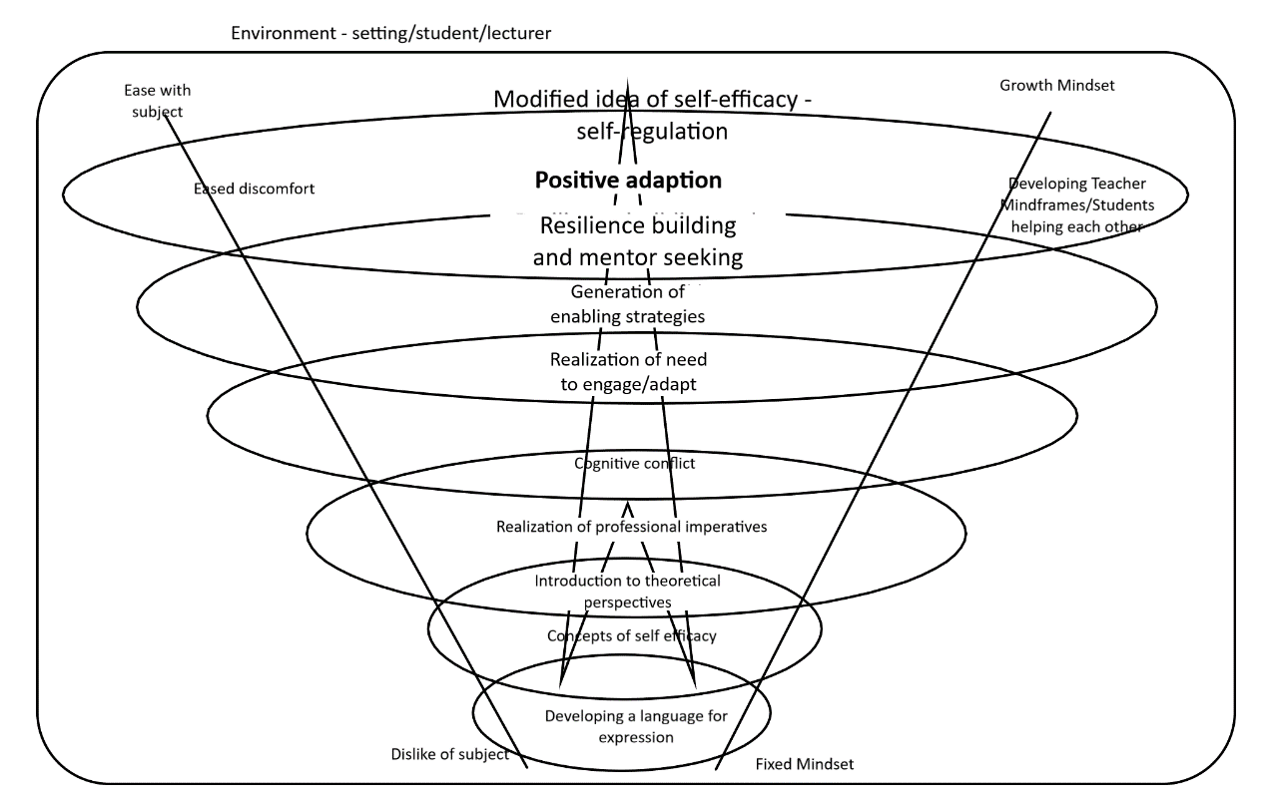
Figure 1. Model for ITE student arts growth and positive adaption.

The model (fig.1) attempts to convey a possible process pathway and setting, whereby ITE students may develop their understanding towards themselves and arts subjects. From the literature review, the surrounding environment draws on the work of Tschannen-Moran and Woolfolk-Hoy (2007) and begins with the need to establish a language of expression (Gouge and Yates 2002/Adey and Shayer 2002/Hattie 2009) to express thought and feelings regarding self-efficacy and individual history relevant to the area where discomfort is experienced. This might be followed up by gaining insight into relevant theoretical perspectives and concepts that may inform development and dissipate related feelings of isolation. These include Dweck (2017) on mindsets, Festinger (1957), Nottingham (2015), Adey and Shayer (2002) and Gouge and Yates (2002) on ‘cognitive conflict/dissonance,’ along with Hattie (2009,2015, and Zierer 2018, and Yeager 2012). It is hypothesized that, the professional realization of the need for change (in some students) may lead to the generation of personal enabling strategies for adaption (Masten 2011, Hattie and Yeager 2012) and begin to build resilience (Gu and Day 2007, Luthar et al 2002, Mansfied et al 2016), easing discomfort and building capacity to engage in ITE training opportunities.

Proposed Methodology / Research design

The researcher concluded that Action Research would be the most appropriate method to use in this case, and to include a mixed method element to provide ‘flexibility’ and an openness in using both quantitative and qualitative data in search of answers to research questions (Burke-Johnson and Christensen 2014:501). As the researcher had noticed a pattern of discomfort in arts lectures from recent years (Ellis-Williams 2016), it was decided to request participation from a current cohort of students at a UK university. With respect to ethics (Appendix 13), the researcher tried to minimize student discomfort and possible distress, by providing assurances that the intention was to diminish discomfort and enable engagement. Assurances were also provided that there were no links between the project and future assessment, indicating that only truthful responses held value and that responses aimed at pleasing the lecturer would not of their own be helpful to research outcomes. Above all the researcher was most concerned with the ‘maintenance of human dignity’ throughout the project (Cohen, Manion and Morrison 2007:58) assuring participants of their right to withdraw at any time (BERA 2018:18) without having to explain.

The proposed design was as follows.

Phase 1 - a) A questionnaire survey of a first year ITE intake to ascertain perception of feelings of discomfort/ discomfort in arts subjects (and Maths and Language) Using a 1 to 5 Likert Scale continuum (Mertler 2014:140) (see Appendix 5). Data was also sought in relation to student’s views on subject importance and feelings towards teaching that area in the future. Each participant was identified by a three-digit number on a register held by the researcher.
b) It was envisaged that this would identify an intervention group of students to approach for further involvement as a result of their expression of ‘discomfort’ with an arts area. Following the identification of this group the register with numbers was disposed of securely.

Phase 2 – a) The intervention group would be asked to provide a self-assessment through an adapted Leuven Scale (Laevers 2000:25) of feelings of well-being and involvement in the ‘arts’ area selected as a result of Phase1 data (Appendix 6). The 5 point scale ranges from a score of 1 for ‘extremely low’ with discomfort, negative emotions and avoidance actions, to a high rating of 5 for students feeling high confidence and comfort with the activity. It was intended that this would provide a personal baseline measurement as a starting point for each participant.
b) Intervention sessions - Based on approaches highlighted in the literature review, a short series of four intervention sessions were designed (see below), each to take about 30 minutes each.

Session 1 - As a starting point and drawing on the work of Sriram (2013:256), participants would be introduced to the research and the proposed model (a student friendly version, see Appendix 7 and below fig2.). The intention would be to involve participants in the research by introducing the hypotheses emanating from the literature, that in ITE student’s arts practice, ability may not be fixed. It was also intended to engage participants in the idea that a model as a possible pathway, was to be trialled as a means towards eased discomfort and improvement of disposition looking forward as ITE students to future training and practice.

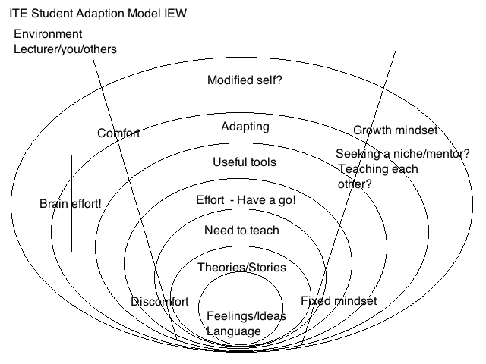

Fig.2 ITE ‘Student friendly’ version of the arts adaption model

Participants would be introduced to the work of Hattie (2017) on developing a language of expression and Gouge and Yates (in Adey and Shayer 2002:133) on the language of assessment in art being characterized as being ‘judgemental’ of the self.
Also in this session, participants would be introduced to concise summaries of theories informing the research (Dweck – Mindset, Masten – Resilience and Nottignham – Learning Pit, see Appendix7). A group interview and discussion was then planned to gather data by listening to participants reactions to the proposed research processes. It was intended that the group also view two short videos (see links in Appendix 7). The first was part of a presentation on ‘Creative Confidence’ (Kelley 2012). The researcher considered that this offered insights for participants through a story of the quashing of creative confidence in childhood and the work of the psychologist Albert Bandura in helping people overcome fears such as handling snakes. This was to be used as an illustration that the possibility may exist for participants to lessen their ‘arts’ lecture fear or discomfort. Drawing on the work of Sriram (2014:523) and as an illustration of a ‘growth mindset success story,’ participants would also watch a video (Legend 2014) illustrating the possible enabling power of effort for participants. Following this it was hoped that the group might agree to some practical involvement for the next two sessions interacting with the model.

Session 2 - The intention of this session would be to briefly recap the rationale and theoretical approaches being experimented with and to consider the starting points indicated on the model by exploring a language for thinking in this setting (Adey and Shayer 2002:6). Drawing further on Adey and Shayer (2002:6) participants were to be supported in developing ‘metacognition’ and language to assist in expressing thought about their ideas and to support and teach each other as a group seeking similar aims (Hattie 2015:84). Some language ‘prompts’ (Appendix 8) would be provided to assist participants in a discussion of some examples of renowned artistic compositions in rehearsal of a frequently used ‘arts’ lecture (and primary school) activity, intended to develop appreciation of the art in question.

Sessions 3 and 4 – It was intended that participants would agree on involvement in practical activities of their agreed choice in following the ‘need to engage/effort-have a go’ points in the model (figure 2). It is intended to record some data during these sessions, but mainly afterwards so key points and moments could be recalled with as much accuracy as possible. These sessions would be held in a room containing enough resources for the arts activity selected as a result of the Phase 1 data.

Chapter 3 Presentation of data

Phase 1 Questionnaire for ITE Year 1 BA.Ed students 2018-19

Out of a cohort of 80 students 71 participants agreed to respond. Analysis of the data highlighted the following.

Question 1 - Please place a value on how important you consider these areas of experience to be. 1 Important / 5 not at all important

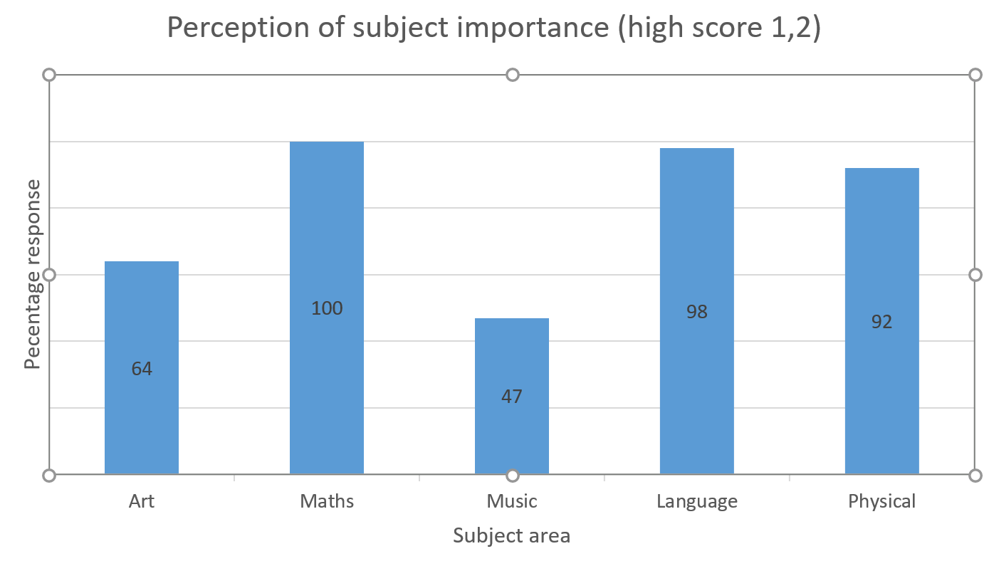
Fig.3 Participant perception of subject/area importance (high).

Figure 3 illustrates the percentage of participants who rated areas as being of high importance. Maths and language are rated highly by a great majority of participants whereas opinion is more divided on other areas. Physical was rated highly (92%) for importance whereas Art is seen as important by 64%. Less than half (47%) the participants rated music as being of high importance.

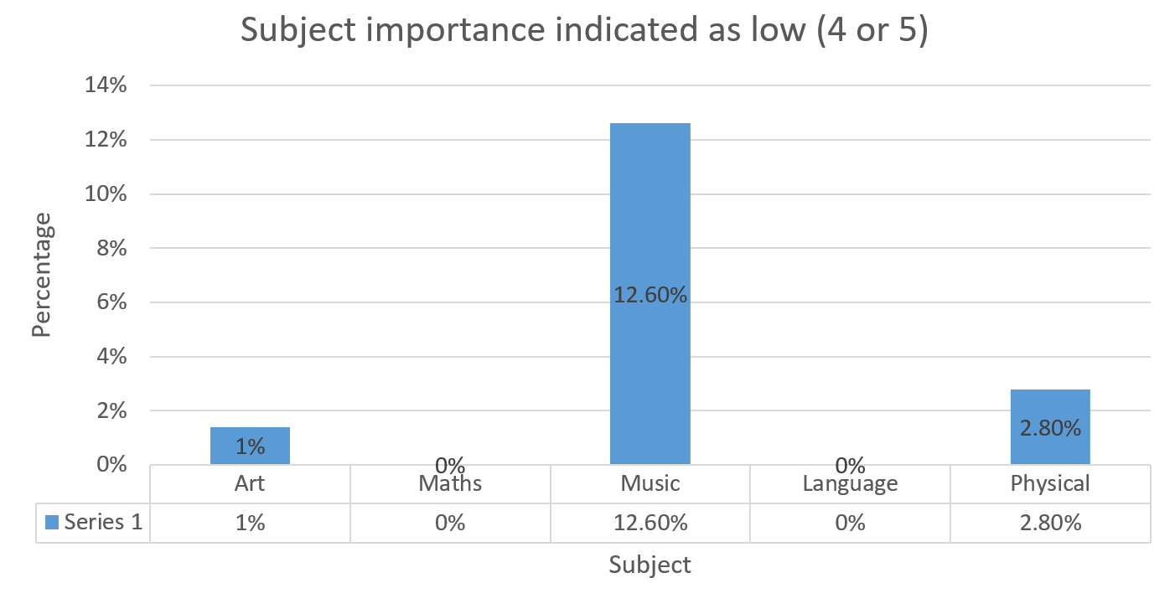

Fig.4 Participant perception of subject importance (low).

Figure 4 illustrates that of those who rated subject/areas of low importance, no participants included Maths and Language in this category. A small number (almost 3%) do not consider Physical experiences important and an even smaller number (1%) consider Art to be unimportant. A larger percentage (12.6%) expressed a low level of importance attached to Music.

Question 2 - How do you feel about engaging in the following ITE lecture activities? 1 Comfortable / 5 Very uncomfortable

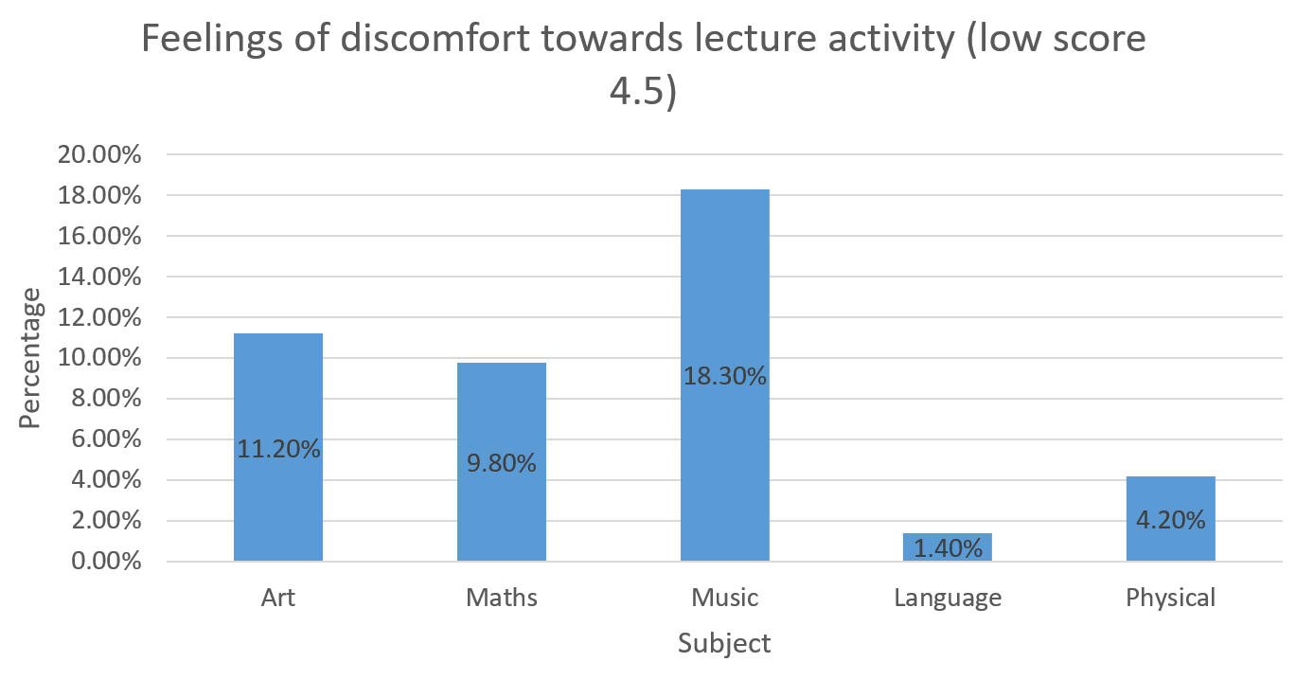

Figure 5. Participant feelings of discomfort towards prospect of ITE lecture activity.

Figure 5 indicates low feelings of discomfort towards Language (1.4%) and Physical (4.2%) lecture activity. It also shows significant discomfort for many participants with Maths (9.8%), Art (11.2%) and particularly Music (18.3%).

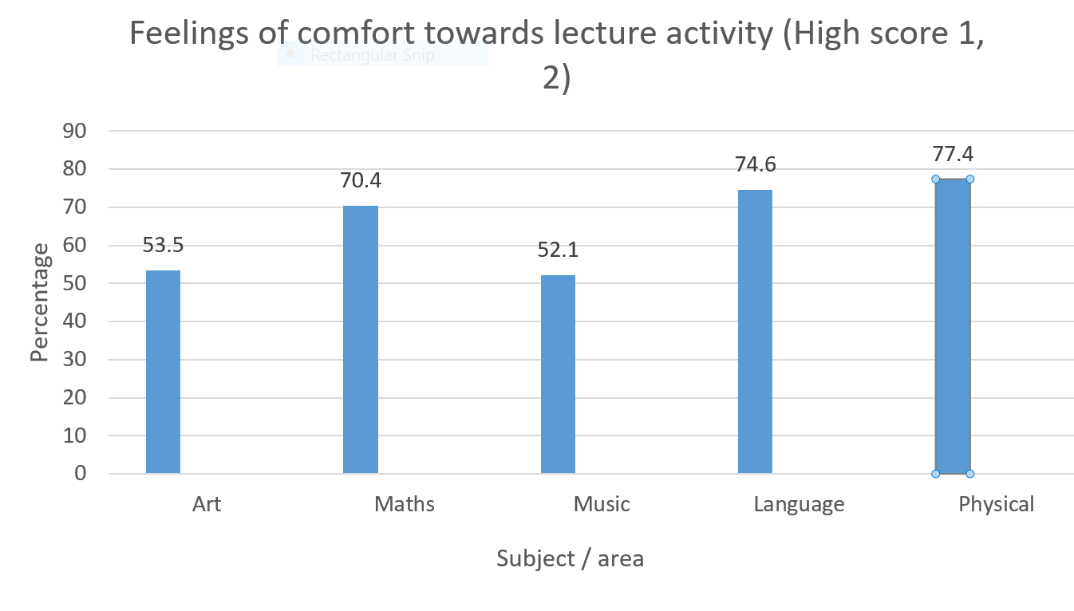
Fig 6 Feelings of comfort towards Lecture activity.

Figure 6 indicates that a majority of participants are comfortable with the idea of engaging in Maths (70.4%), Language (74.6%) and Physical (77.4%) lecture activity. However only just over half the participants feel high comfort with participation in Art (53.5%) and Music (52.1%).

Question 3 - How do you feel about teaching these areas to children in the future? 1 Comfortable / 5 Uncomfortable

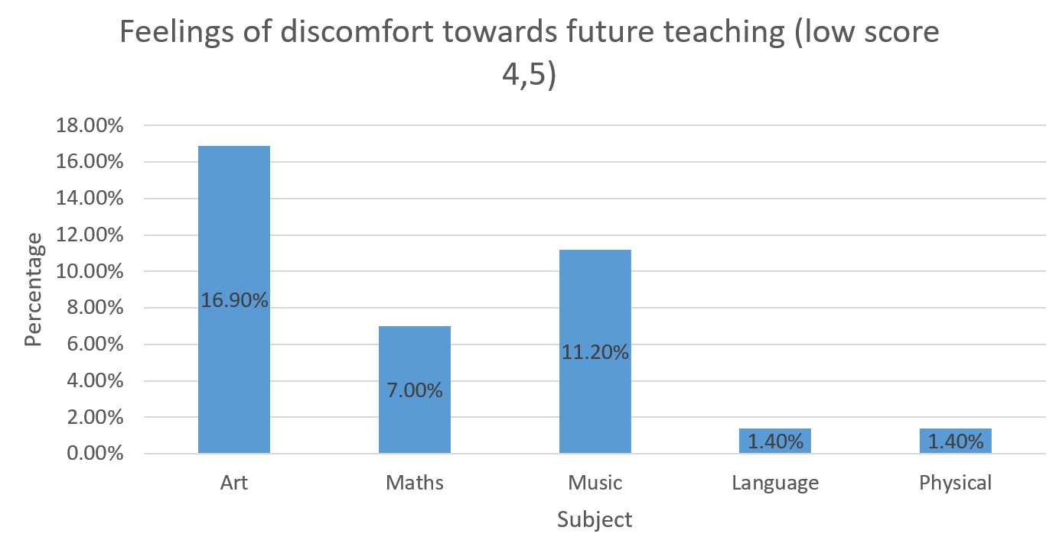

Figure 7. Participant discomfort for future teaching

Figure 7 indicates a relatively low percentage of participants who feel discomfort for future teaching of Language and Physical areas (both 1.4%) with a greater number for Maths (7.0%), Music (11.2%) and Art (16.9%).

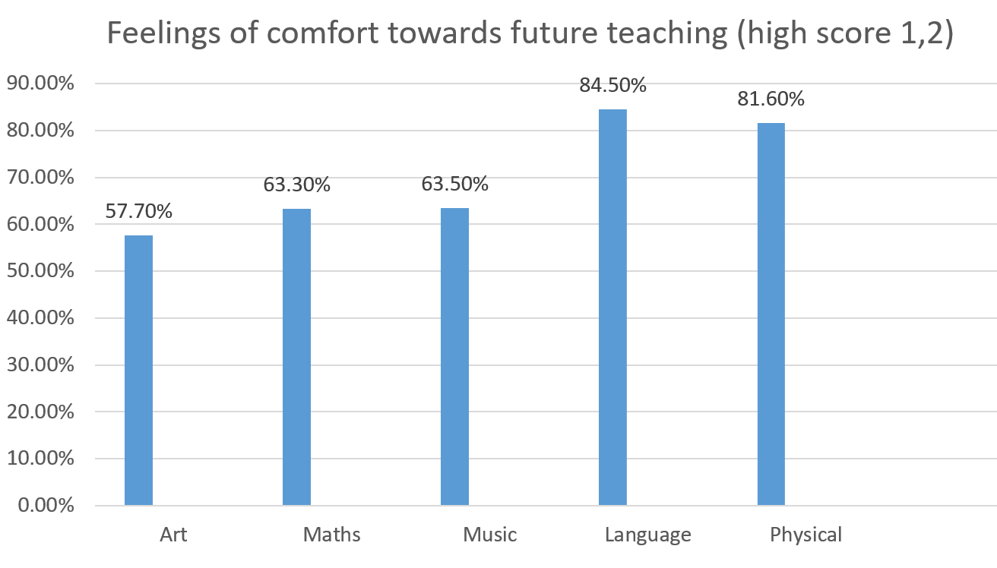

Fig. 8 Participant comfort for future teaching.

Figure 8 highlights a large majority comfortable with future Language teaching (84.5%) and Physical areas (81.6%). A lesser number (although well over half) participants indicated a high comfort for the future teaching of Maths (63.3%) and Music (63.5%). However the number of participants expressing comfort at the prospect of teaching Art was lowest of all (57.7%).

Phase 2 Intervention for group of participants indicating high discomfort.

Bearing in mind the objective of this research in identifying ITE students recognising feelings of discomfort associated with arts and for this second stage, it was decided to target the respondents associated with the 16.9% (see Figure 7) who expressed a high level of discomfort towards the prospect of future teaching of art to children. For this phase, the themes emerged over the series of intervention sessions and is perhaps best presented alongside the analysis of the phase 2 process described above. This is a ‘cyclical’ process of ‘Interim Analysis’ say Burke Johnson-Christiensen (2014:588), drawing on the work of Mills and Huberman (1994), whereby data is analysed and collected continuously over a period of time.
From the participants expressing concerns regarding art as part of ITE, 16 were approached requesting participation in the Phase 2 intervention. 5 students expressed willingness for further participation 4 of whom attended all intervention sessions.

Chapter 4 Discussion of findings

Use of methods

For the Phase 1 questionnaire, the Likert score responses for each participant and each question were collated (Thomas 2014:222). This created groups of numbers (1-5) indicating the level of importance attached to each subject chosen for the study (see Appendix 9). Initially, viewing these sets of figures provide an early impression of opinions held by the participants as a whole. This was then reduced to a more manageable form by calculating percentage responses and the graphs above (Mills 2011:129). The individual written comments from each questionnaire were transcribed on to a handwritten spreadsheet so that the researcher could view all responses. It was felt that this was more appropriate for ‘open ended’ questions (Cohen, Manion and Morrison 2007:348) providing the opportunity to gather a ‘tally’ of emerging themes from each question. A synopsis of this data has been included in the appendices (Appendix 14) , and respondents were number coded to protect anonymity (Mertler 2014:151). Content Analysis and Constant Comparison methods (Thomas 2017:251 and 245) were used in identifying emerging themes and these were recorded in the researcher’s project journal, Ellis-Williams (2019). For Phase 2, Discourse Analysis (Thomas 2017:251) was used as a means of extracting meaning from language use in the social context of the intervention group, where participant’s choice of words, ‘intonation’ and tone of voice could be taken into consideration. As part of this ‘interpretivist’ approach to the research, it was intended also to use ‘thick description’ as a means of both collecting and deriving meaning from the information collected (Thomas 2017:250). Using a similar term, Cohen, Manion and Lawrence (2014:300-301) outline that ‘interpretive validity’ may be achieved in qualitative research by the researcher using personal experience in empathizing with participant’s view’s stories and feelings. These methods were attractive to the researcher as they offered the possibility of deriving the ‘meaning’ being created by all participants in the project to include the researcher himself (Thomas 2017:245). With hindsight, it may have been more advantageous to record interviews and interventions electronically for deeper analysis of participant’s responses although attempts were made to follow the advice of Lofland (1971) (in Cohen Manion and Morrison 2007:260) in writing observations quickly after events in the attempt to retain accuracy in collected data.

Discussion of findings Phase 1

Emerging theme – Participant belief in the importance of Language and Maths

The responses to the importance of subjects indicated almost universal belief amongst participants in the importance of Language and Maths in education. The age profile of the sample of participants contained a high proportion of people recently into their age of legal majority. One might argue therefore, that they are products of the UK education systems that have prioritized literacy and numeracy, squeezing out time for arts subjects as noted earlier with reference to Smith (2013:31). The school lives of children (and teachers) since the 1960’s and 1970’s, have undergone a sea change of ‘regulation’ and factory type production involving National Literacy and Numeracy Strategies according to Turner-Bissett (2007:194). Further Turner-Bissett (2007:195) describes how ‘performativity,’ the process of spreading practices accepted for production in private industries to public service sectors, has permeated the lives of teachers and pupils. Drawing on the work of Ball (2013), Lingard and Sellar (2013:276) state that increasingly, global education systems seek to make education ‘calculable rather than memorable’ and have promoted performativity. It seems likely to have influenced many of the participants in maintaining their view of the importance of literacy and numeracy development, relative to ‘creative’ aspects of their education. Wilson and Holligan (2013:226) credit Lyotard (1984) for identifying this concept and agree that performativity values education as a ‘cost-benefit calculus to the state and society.’ For balance, the current performative global context seems driven in the political sphere, by a conviction that future prosperity lies in the hands of future of businesses where scientists, technologists, engineers and mathematicians (STEM) can create future wealth (Moss 2014).

Emerging theme – Participant belief in the low importance of music and a hierarchy of subjects.
Art is viewed by participants in this research as less important, but music seems to be held in particularly low esteem. It was interesting to observe that less than half of participants felt music had high importance in comparison with other subjects. The comments accompanying these scores may provide further illumination. Among the responses were one participant who commented ‘music is not a life skill, it is not essential.’ Another said that music was not ‘necessary like maths and language’ and another recalled ‘I did music until Year 9 and I don’t remember learning anything important.’ Although one respondent balances this by stating the importance of music and expression, the comments seem to echo reports of continuing long-term problems in UK music education. According to Lamont and Maton, (2010:64) difficulties with the subject can be traced over ‘decades’ with it being seen as ‘unimportant’ by secondary pupils and taught by ‘generalist’ primary teachers who ‘fear’ the experience. In agreement, Lord Black of Brentwood (Music Education 2018:33) in recent political debate in the UK House of Lords, warns of the demise of music education in schools as access to its benefits becomes dependent on the ability to pay privately, as it ‘dies out in the state sector’ Music Education (2018:33). He further points out the argument that arts like music, add value not only to broad educational skills but constitute ‘fundamental building blocks’ equal in importance to STEM subjects.
Participant responses also indicated ideas of division of a hierarchy of subjects with comments stating as examples, ‘it’s not as important (music) as other subjects – it’s a hobby.’ Another stated ‘academic subjects like maths and language are more significant than art and music,’ with other comments also highlighting a clear difference in values attached by participants to academic and creative (non-academic) subjects. Participants may not have considered that music is held by some to be a ‘powerful learning tool’ in education (Jackson 2009:6). Bleasby (2015:672) traces the same distinction back to the ancient Greek influence on modern western education that includes the ‘democratizing’ Case Study (Cohen, Manion and Morrison 2007:256) approach to research and the ‘Theôria /Praxis/ Khrêsis’ approaches adopted for this work through Action Research (Elkland in Boog et al 2008:36) referred to above. Bleasby (2015:672) states that higher values were given in ancient philosophy to ‘abstract subjects’ involving mathematics and reason over subjects involving the human body through arts and physical disciplines. Bleasby (2015:674) also notes the hierarchical idea that in ancient Greece, a ruling class was thought worthy enough to be educated in the ‘abstract’ whereas the ruled artisan world only might be educated in matters involving the body. Allen (2016:239) holds that the belief in the inherent ‘good’ of education from classical times remains so firmly entrenched in UK education, that it survives even continued attempts to reduce education down to a ‘measurable’ quantity in the ‘performative busywork that so characterizes education today,’ Allen (2016:239). This may also reflect the similar viewpoints held by participants further encapsulated by another statement that academic subjects ‘give you skills for work.’

Emerging theme - Participant perceptions on the importance of innate ability.

In relation to subject knowledge, individual single participants expressed that they did not enjoy sport and Welsh (finding this prospect ‘scary’). It was also noteworthy that participants expressed feelings of inadequacy and a perception that having ‘talent’ was significant towards some areas, saying that ‘I am not musical’ and ‘I am not natural at maths.’ One said that ‘not all enjoy music and acting – they feel uncomfortable’ expressing that ‘in front of others, they feel not good enough.’ These remarks are causes for concern in ITE if, as noted already in the literature by Beltman et al (2011:190) that ideas of self-efficacy, confidence and competence are influenced early on in the development of teachers. Also they may be indicative of Yeager and Dweck’s (2012) points that ‘implicit’ personal views of ability held by these students are ‘fixed’ theories, although some ‘incremental’ student voices appear to consider that a change may be possible and that challenges may present opportunities (Yeager and Dweck 2012:312) for future belief in one’s own self-efficacy (Carpara et al 2006).
Rather than responding directly to the subject importance question, many respondents have taken the opportunity to put emphasis on what they wanted to say (Freebody 2003:144). Perhaps so with the second question also, as similar themes appear in response to feelings about lecture participation. Discomfort is not confined to arts activity, with strong concerns raised regarding maths. One participant reports ‘maths is quite intimidating for me – it makes my self-esteem lower because I don’t feel smart enough.’ Figure 5 above shows that almost 10% of students indicated that they expected to feel significant discomfort in maths lectures and this is reflected in the number of comments made on this matter. Maths is ‘intimidating’ said one respondent and ‘maths lowers self-esteem’ said another. A number indicated low perceptions of self-efficacy with statements such as ‘I don’t feel smart enough,’ ‘maths is difficult’ and ‘I have never been competent at maths.’ ‘Pressure from peers’ was also noted. These themes are recognized by Brown, Brown and Bibby (2008:16) who in analysing reasons why 16 year olds choose not to study maths beyond the age where it is compulsory, find reasons that echo student respondents in this current project. They report one of their respondents saying they would ‘rather die’ (Brown and Brown and Bibby 2008:10) than continue maths. Participants helping this researcher reported nothing so serious but acute emotions are detectable in responses nevertheless. As possible solutions Brown, Brown and Bibby (2008:16) highlight possibilities for reducing teaching ‘hierarchies’ (setting by ability) as a means of reducing negative feelings. They also speak of strategies to dissolve feelings that individuals have ‘innate boundaries’ and to build confidence and ‘self-efficacy,’ a theme agreed by (Boaler 2013:144-145) who advocates moving away from ‘ability based practices’ towards arrangements that recognise the value of achievement through effort and ‘growth mindset.’ One of Brown et al’s (2008:10) respondents says ‘I despise the way maths is taught,’ and they highlight that UK maths teachers are held ‘accountable mainly in relation to attainment data.’ If this cohort of primary ITE students recall experiences similar to these, then it is unsurprising that they record feeling uncomfortable at the prospect of engaging in further maths as part of their training.

Emerging theme – Participant dislike of public performance.

Strong comments were made regarding discomfort with performing publically in front of student peers reminiscent of Festinger’s (1957) concept of ‘Cognitive Dissonance’ discussed above and Metin and Gamgoz’s (2011:131-132) discussion of the use of avoidance strategies for sources of discomfort. One participant perceiving a lack of personal creative talent, considered ‘participation would be hard because I did not excel at art and music.’ ‘I don’t like performing in front of others’ said another, with more indicating that their low ability in art, music (particularly the playing of instruments and singing) would make lecture participation difficult. Some also expressed an awareness of ‘peer pressure’ with one participant stating ‘I don’t like performing in front of people’ and another adding ‘people would judge.’
The experience of emotions of embarrassment seem a real part of ITE arts lecture participation for some students. Miller (2001:31) defines embarrassment as a state of acute ‘awkwardness’ on the part of individuals as a result of social occurrences that lead to a ‘threat of unwanted evaluations’ by others. Further, embarrassment is always ‘experienced in public’ and although intense, is generally not long lasting as an experience. In agreement, Choe (2013:17) draws on Goffman (1956) in pointing out that this public experience can be visible in terms of the physical reactions of ‘blinking, sweating, stammering and hesitance in speech.’ The feeling can be associated with ‘shame’ says Goodman (2017:27) where individuals feel ‘diminished, worthless or powerless and exposed.’ Goodman (2017:27) also points out of the ineffectiveness of deliberate strategies (used in North American school settings) used to induce ‘shaming’ for the purpose of control. Examples are ‘public data walls’ or being forced to apologise publically (Goodman 2017:28). For this project, Goodman’s observations also highlight the inadequacy of using ‘shaming’ in UK ITE settings, as reactively suggested by some more confident student peers of those suffering discomfort in arts lectures highlighted above (see Appendix 1). Miller (2001:31) points out that frequently, adults respond supportively to the embarrassment of peers, whereas young people are more likely act in ways that exacerbate acutely painful emotions for their class compatriots. It seems possible that many participants in this research are between these two positions of maturity and may remain particularly prone to emotional embarrassment in lecture situations. With reference to student embarrassment in social activities in Hong Kong, Dong et al (2013:2010) have experimented with the concepts of ‘losing’ and ‘saving’ face present in Asian but also Western cultures. They find that some strategies for ‘hiding’ the face (by offering sunglasses) and ‘restoring the face’ (by using restorative face cream) induced some supporting effects. This may suggest similar ‘symbolic’ options worth consideration in ITE arts contexts as a means of reducing anxiety, as Dong et al (2013:2011) highlight the success of the ‘face saving’ strategy in allowing the embarrassed party to ‘re-engage’ with the social activity. Perhaps a symbolic mask might compliment the ‘pass-card’ strategy currently used with a view to enabling students to retain comfort in activities they find uncomfortable, although Dong et al (2013:2011) caution this may not transfer to Western cultures.

Emerging theme - Participant perceptions of low competence and self-efficacy.

Personal perceptions of a lack of ability in arts subjects appears to be a strong feature of participant feelings towards engaging in lecture activity. ‘Participation will be hard…’ comments one respondent, ‘….because I don’t excel at art or music.’ ‘I am not creative therefore I will feel uncomfortable’ said another. Some respondents included ‘sport’ and ‘Welsh’ as areas of predicted discomfort with a number indicating that they were ‘bad at drawing’ and ‘I don’t play instruments.’ Wilson et al (2008:42) also find that primary teachers in Scotland are put off teaching music by the perceived ‘technical’ demands of the subject such as ‘musical notation’ and playing instruments. They also highlight teacher’s feelings of being unable to draw as an obstacle to positive attitudes. Lamont and Maton (2010:72) agree that for teachers, ideas on personal efficacy in music pivot around ideas about personal technical ability. These dispositions seem far away from points noted above in the literature from Carpara et al (2006:475) that strong ideas of personal self-efficacy lead to better performance from teachers. It seems important to note also that for these students, the establishment of a positive lecture environment that is not too demanding (Tschannen Moran and Woolfolk Hoy 2007:946) will be important if they are to develop the capacity to set personal goals for areas they find difficult and become more self-regulating (Zimmerman 2002:66). Encouragingly, among the negative responses were a portion of respondents who although professed to lack ability in maths, art or music, indicated a belief that with practice they felt sure to improve.
In relation to the third question of feelings towards future teaching, responses continued to echo all the themes outlined already. ‘Arts is a weak point of mine’ seems to encapsulate similar sentiments in a significant number of responses and that ‘not playing instruments’ excludes participants form being able to teach music. One participant expressed the sentiment that music would be ‘best taught by specialist teachers’ indicating perhaps an underdeveloped idea of the primary teacher role in the minds of some undergraduate student teachers and the need to engage in a wide range of Areas of Learning (including Expressive and Creative Arts) as will be required as the new curriculum for Wales becomes established (Donaldson 2015).

Discussion of findings on phase 2

The four participants in the intervention group (3 female and 1 male) completed the Adapted Leuven Scale (Appendix 6) in relation to their feelings of well-being/involvement for drawing/expression/creativity. All participants decided independently of each other that a low score of 2 on the (1 to 5) scale, best described their feelings about participation in art lectures agreeing to the statement, ‘2- low – the student is not at ease. The discomfort level is present but less marked than at level 1, the student feels discomfort but not continuously.’
First intervention session.
Participants were presented with a brief summary of the project’s aims and intentions (see Appendix 7). As outlined above, this included sharing a summary of the literature review and viewing two videos illustrating the potential to develop ‘creative confidence’ (Kelley:2012) and a positive ‘growth mindset’ story (Legend 2014).
Discussions of feelings and developing a language to express personal history.
In the first instance, participants were introduced to the concepts surrounding language as ‘tools for thought’ (Adey and Shayer 2002:6) as part of a collaborative approach to solving problems. They were also introduced to Hattie’s (2015:84) ideas on the skills students may need in teaching each other as outlined earlier. The group were invited to share personal experiences. They shared a feeling that in general, they had felt their own primary school experiences of art to be free of personal worry. In primary school, all participants agreed ‘you were allowed free expression with no negative feedback.’ By contrast, all reported that secondary school experiences were characterised by recollections of negative feedback bringing about a poor idea of self-efficacy as an ‘artist.’ This appeared very much like an existing fixed idea (Dweck 2017) of low artistic ability, described and talked about as if it were now a permanent trait in their own idea of personal competencies. One male participant described how by comparison with his sister, who was ‘recognized as having artistic flair and talent,’ he had very poor ability in this area. This seemed reminiscent of the findings of Morgan and Bourke (2002:22) in relation to poor physical experiences leading to poor self-image of personal ability.
All participants declared that it had been clearly demonstrated to them (often by teachers) that they had ‘no talent’ for art. There seemed a clear, unanimous feeling that all accepted this as a fact about their own idea of personal ability. Participants’ experiences were characterized by teachers ‘losing interest’ in them as possible future candidates in examination groups. This experience served to further entrench their own feelings of low self-efficacy in art and their subsequent lack of enjoyment of it, which they cited as the main reason why they did not continue with it after examination choices were made at the age of 14 (Wenchao. Muriel and Subieta 2010:26).
All participants reported the perception that art teachers in secondary school took ‘no interest’ in them as a result of their lack of talent. As pupil’s they will not have been aware of the pressures these teachers faced and as Dweck (2017:200) reminds us ‘teachers with the fixed mindset create an atmosphere of judging.’ This perhaps is reflective of the pressures leading to the lessening of the status of art as a school subject during the period participants were in secondary school as outlined by Smith (2013). According to Harland et al (2000:4) the ‘breadth and balance’ of the school curriculum was ‘undermined’ as policy makers sought to export arts activity outside the curriculum, to make room for more literacy and numeracy within it. Harland et al (2000:4) predict some of this current project’s participant responses, stating that policy has ‘implied a negative view of arts as a hobby or leisure activity.’
Two participants complained of the use of Assessment for Learning (AfL) strategies used in their secondary school for art, particularly the use of the self-assessment strategy ‘What Went Well – Even Better If…’ They recalled how they felt at the time, that having tried to identify ways of improving their art work, teachers seemed unable or unwilling to help them move forward and improve, again entrenching their negative self-image. One participant felt that the teacher could not tell her what actions to take in order to improve. Again, participants reported a sense that teachers were only interested in children who seemed to show promise for later examination groups. Participants felt ‘left to their own devices’ and reported very low confidence as a result of these perceptions of their experiences. Hargreaves (2005) in assessing the work of Black and William (1998), reports considerable confusion in interpretations of AfL strategies among teachers. It is possible that this may partly explain participant’s experiences, as teachers responded to pressure to use assessments that ‘everyone was required to use’ in response to ‘free market’ approaches to education promoted by UK left and right wing governments over the last decades (Hargreaves 2005:223).
Presentation of relevant theory to participants
Participants reported that the theoretical perspectives they were shown ‘helped put a perspective on it’ (Appendix 7). This seemed to ease feelings of fear and ‘dissonance’ (Festinger 1957) of this aspect of ITE and to realize that feelings were shared by other ITE students locally and internationally (Russell-Bowie 2013). Participants quickly started to use terms like ‘growth and fixed mindset’ (Dweck 2017) in conversation. ‘Some have natural talent and it comes easy to them’ said one participant ‘and others have to get there by effort.’ This comment was seen as useful by other participants. Participants commented on the usefulness of the Kelley (2012) video particularly in the way it illustrated an example of how the psychologist Albert Bandura (of whom participants had heard) helped individuals overcome a morbid fear of snakes to the point where in time, they did not mind touching them. This seemed to put a lesser perspective on participant’s fear of arts lectures.
Presentation of the modified student adaption model (figure 2) to participants
One participant reacted to the first view of the model with a look of mild ‘shock’ and explained when asked, that she was initially a little daunted by the diagram. The researcher attempted to demonstrate how the stages of the model drew on the literature review (as described in Chapter 2). After consideration, participants reported that it seemed encouraging to have a possible pathway to improvement and greater comfort laid out before them. They stated that they liked the promising journey that it offered. One participant commented that she ‘already felt optimistic’ and that ‘barriers were being broken down.’ In considering these encouraging responses and in view of Cohen, Manion and Morrison’s (2014:22) caution that action research ‘neglects’ power in relationships, it is important to recognise the fact that participants may have made these responses as a result of their perception of the power present in the student/lecturer relationship (BERA 2018:13). The researcher however derives some reassurance from these reactions albeit from a very small sample of participants.
Practical Intervention Session 1 -
The researcher started this short session with a very brief recap of the main theoretical points relating to the model. Participants were then provided with a simple vocabulary prompt sheet with key words (see appendix 8) taken from the Art National Curriculum for Wales (DCELLS 2008). Following the work of Gouge and Yates (in Adey and Shayer 2002:133) in developing ‘operational thought’ and ‘cognitive acceleration’ to be more than merely personal judgement, two paintings (see Appendix 10) were shown and participants were invited to talk about them. They described the contents and attempted to decode meaning from what they could see as part of the work, using the ‘art key words’ for support. Frequently used lecture strategies were emphasized, that every response would have value and that with this exercise there could be no wrong responses and each participant might find different sources of inspiration form the images. In analysing the paintings it wasn’t long before many participants began to get the idea and commented on a number of issues emanating from the paintings. Some participants described features and techniques very articulately and this affected the quality of other contributons. Describing this as a frequent ‘primary school’ art activity seemed to give the group confidence as they developed assurance that they could indeed engage with this task. The researcher emphasized that for teachers, knowing what to look for in artwork (with a view to providing positive developmental feedback) was a more important requirement than being able to create art personally. The imperative for all primary teachers to be able to engage with similar activities was also emphasized. Participants understood very quickly how to begin analysing the paintings and looking for clues in detail. The researcher was surprised how quickly they abandoned the vocabulary provided indicating that it was not necessary as they realized that they already possessed the abilities to articulate thought on art. It was unclear to the researcher that participants equated their ability to engage with this task with an improvement in self-efficacy at this stage.
Practical Activity 1
Participants agreed to engage in an experimental activity involving different grades of shading on a continuum from very dark to very light with a pencil (see Appendix 11).
The researcher modelled the drawing of some 3D shapes (Cube and Sphere) and emphasised that perfection of the shapes were not a requirement. During the activity participants however, retained a value for shapes that were close to perfect. Aiming at perfection was certainly an aim for some participants despite the researcher’s emphasis that it was not required. There was a palpable sense of nervousness as participants put pen to paper with occasional glances at others, reminiscent of Sriram’s (2013:519) participant’s experiencing feelings of ‘incompetence and fear.’ One participant commented on how ‘near perfect’ another participant’s sphere was. This participant remained ambivalent regarding this praise at this stage (this participant seemed to have particularly low art confidence). The researcher detected a sense of nervousness in participants. They could not prevent themselves from lifting their eyes from their own work to glance at the work of others. The impression was conveyed of an anxiety in comparing what they were doing with other participant’s efforts. At this point a sense of ‘dissonance’ (Festinger 1957) was detectable. The researcher indicated high satisfaction with the quality of participant’s efforts but each individual remained harsh in appraisal of their own responses as they were viewed together at the end echoing Gouge and Yates (Adey and Shayer 2002:133) experience of students thoughts on their own artwork being characterized as judgemental.
Two participants stated that they found the process relaxing and therapeutic. Most participants expressed a dissatisfaction with a lack of perfection in their shading efforts despite assurances that the work was experimental. This was reminiscent of Dweck’s (2017) ‘fixed mindset’ expectation of instant success. The researcher perceived a definite feeling that the participants did not like ‘mistakes’ despite assurances that they were likely to be of value. Participants had been asked not to erase errors but to either draw over them or to start again in an empty apace on their paper. An attempt was made to use this talk to try multiple circles and see if they improved. It may be possible to claim that some enthusiasm was generated in this group as later that week in relation to another lecture activity where a drawing was required, two participants proudly showed off their ‘poster efforts’ to the researcher in the corridor. It may be however that their outlook is developing purely because the researcher is taking an interest as in the Hawthorne Effect outlined in the first chapter (Thomas 2017:148-149). In discussion they agreed they would like to experiment with colour next time. The researcher found himself wanting to comment positively on everyone’s work but tried only to praise effort (Dweck 2017). At this point the researcher wanted to return to the usefulness of the model but participants were too involved in the activity to do so.

Practical Activity 2
For this session the activity was mixing of different colour tones with combinations of primary colours (red, yellow and blue) (Appendix 11). The researcher wondered if this was a ‘session too far’ as he had the sense that the atmosphere was different from the first. The group stated and agreed that they had already achieved an improved comfort with the environment (Gu and Day 2007) and the activities and each with other. Participants reacted positively to the activity and expressed positive feelings of improved comfort. In discussing ability in relation to the model, one participant articulately described her belief that despite her low opinion of her own art ability she considered that improvement was likely with effort. ‘Some get there by talent, but I have to get there with effort’ she explained, demonstrating a developing ‘incremental’ and resilient view of her personal prospects for improvement (Yeager and Dweck 2012:304). One male participant became quite pleased with his response which drew approval from others. He was visibly pleased by this. He took a photo, deciding to use the idea in a ‘micro teaching’ lesson he was having to plan. They expressed what they liked about the activity in articulate language and this time commenting using some of the (Appendix 8) curricular art vocabulary. One participant stated that she was now at this point, much more comfortable about lecture participation. By agreeing to participate, all participants have of course demonstrated a desire to develop and it is likely that there are others who were not yet confident to do so. Hattie’s (2018:35) ‘IKEA effect’ analogy, that buying into the experience of building furniture creates a sense of personal investment seems to ring true providing students are persuaded to make this investment in themselves. This seems to be the main purpose of the model developed for this research.
During this session another participant described how a primary teacher had reported to her mother at a parents evening, that she was ‘unable to colour in properly.’ She remembered this vividly and shared her memories of how at a parent/teacher meeting, her mother had taken the teacher to task on this point as being an unworthy remark regarding her daughter’s abilities. This incident reflects perhaps the ‘lack of confidence’ in teaching art which Estyn (2015:22) record can exist in relation to primary arts provision.’ With some satisfaction, the participant recalled that the teacher in question did not stay long at the school but the remaining emotional impact of the incident seemed evident in her description of it. She had been reminded of this by her mother as she shared details of the present research project that she had agreed be part of.
End of Intervention Interview (Appendix 12).
Participants were interviewed individually in a semi-structured interview regarding separate stages of the ‘student friendly’ model (figure 2).
Feelings/Ideas/Language and discomfort
In relation to developing language for talking about personal feelings and perspectives (Hattie 2018, Adey and Shayer 2002 and Nottingham 2017) one reported that the experience provided a sense of ‘relief’ but qualified that to describe it as a ‘weight lifted off’ would be too strong, but ‘relief’ certainly. Another reported not having thought about ‘talk’ as being important in similar contexts before but felt very positive about the experience. The male participant expressed that he had benefitted from talking and sharing feelings in the small group, but would be less willing to do this in a whole lecture group context. This would be important for the researcher to consider for future practice so that students don’t feel they are compromised or embarrassed (Miller 2001, Chou 2013) in revealing fears or histories too publically. He reported however that he felt this would improve as he got to know his peers better.
Theories/Personal Stories
Participants reported that being made aware of the literature on which the model was based was helpful. ‘I found this interesting, useful, in depth’ said one, ‘I didn’t realize there was so much in depth knowledge about these things. Deep theory.’ She felt this knowledge helped her move on. Another felt she had not considered this before and that it helped her make ‘sense’ of things. Additionally another felt the Kelley 2012) video was useful recalling it as ‘where people could touch snakes where they couldn’t before.’ One student chose this conversation to recognise her fear of judgement stating, ‘I was afraid of what others would think of my efforts I was glancing across at the work of others to compare.’

The need to teach
Participants were asked about their experience of ‘cognitive conflict’ (Festinger 1956, Adey and Shayer 2002 and Nottingham 2017). It seemed to the researcher that they framed this concept differently and responded in relation to their own internal conflicts about their own self-efficacy. One participant recalled ‘no particular conflict,’ and another recalled discomfort by comparing their work to others with the pencil shading but a feeling of greater comfort and freedom with the colour mixing activity. It may be possible that the numerical connection with recreating 3D shapes rekindled some dormant ‘maths’ discomfort that was not present in the colour mixing activity. Of the 3D shape shading activity, one participant remarked ‘I was judging myself – is mine wrong?’
Effort - Having a ‘go’
Two participants expressed a recognition of the need to practice and develop skills even from a perceived low base of ability. One said although nervous ‘I got into it’ and another admitted, ‘I quite enjoyed it.’ The male participant expressed that the colour mixing captured his interest in a ’cool’ way. He said he would like to know more about how colours interact with mixing. In relation to a student assignment and some artwork he had viewed as part of a subsequent ‘art’ ITE lecture (with another lecturer colleague) he added, ‘If you’re interested I did an art lesson plan for my assignment after a Matisse snail painting.’ The researcher of course, was indeed interested that some enthusiasm seemed to have been generated. In this same lecture, another participant expressed a liking for the provision of a menu of choices offered for ‘practical’ activity, which seems worthy of note for future practice.
Useful tools/strategies
Participants had less to say regarding this part. One reported that they used their skills in analysing artwork in the lecture mentioned above and they could see that this had been ‘useful.’ The male participant expressed a value for participation in activity but stated that he would not ‘seek a mentor’ (Masten 2011). He ‘preferred to rely on his own resources’ expressing the view that ‘you don’t know what other people think.’ The researcher will have to consider if this reaction may be shared by others or if it is the individual response of an independent personality.
Adapting
Finally participants were asked if they felt they were adapting. One participant stated (perhaps partly to please the researcher) ‘I have a different attitude – participation in this research has made me more confident.’ Another stated ‘I am adapting. I’m thinking about it positively, building confidence.’ This participant appreciated a realization of the absence of a ‘right or wrong way’ in relation to art a view that seems shared equally among all. Some remarked that they were making gains in their creativity (following lecture participation) and one noted that in the lecture experience, she did use peers to help her learn (Hattie and Zierer 2018).
Final participant thoughts on the model and reviewing Adapted Leuven Self-Assessment.
In returning to their self-assessments, two participants had moved themselves from a mark of 2 to a 4, placing aligning themselves with the statement , ‘4 - High - The student has satisfaction from engagement. Some dissatisfaction is outweighed by positive feelings.’ One was tentatively moving towards this description but thought that ‘3 - Moderate - The student is neutral about the activity feeling no negative or positive emotions comfort or discomfort’ was more reflective of her true feelings. One participant moved themselves from 2 to 4 but was considering ‘perhaps even level 5’ to describe her development.
One participant considered the model useful. The male participant expressed that ‘it was good to speak about the model first. It was good’ he said, ‘to go along the steps of the model quite quickly.’ He seemed to consider his personal development to progress as being quite brisk and expressed that he would not have liked the process to be slow. Another positive view expressed approval for the model by stating ‘The model flows and builds well. It shows you where it stems from’ and in contrast this participant expressed the view that quick progress might not occur. ‘You have to give it time’ she said. Perhaps this illustrates the personal nature of any journey towards improvement and that each individual will progress at different rates. The researcher is reminded of Hattie’s (2015:80-81) point that in education most interventions seem to work positively.

Chapter 5 – Conclusion

In returning to the ‘condition of incomplete knowledge or understanding’ (Booth et al (2003:228) in Thomas (2017:2) outlined in the introduction, the researcher has been asking why some ITE students seem to wish to avoid arts activities and what might be done to help individuals ‘overcome’ personal discomfort with lecture activity with what had been termed as arts ‘stigma subjects.’ What changes to personal lecturing practice might prove effective in enabling engagement and lessening the use of avoidance strategies and absence from ITE training opportunities?
It would seem to be a valid conclusion that a significant proportion of each new cohort of ITE students will arrive with an incomplete understanding of a primary teacher’s responsibilities in introducing children to a full range of areas of learning. It seems likely that some (although not all), imagine teaching at primary school to be more akin to their own recent memories of ‘performative’ culture in education, such as deskbound activities, revision, assessment pressures and so on (Wilson and Holligan 2013:226). As one participant said in relation to arts activities ‘I feel more comfortable with pen on paper.’ This culture seems a strong influence in student’s views, with a prevailing perspective that abstract skills for economic success in a global world is the overriding purpose of education. There may be a case for the researcher’s ITE institution to consider producing materials better illustrating the true nature of a career in primary education to prospective entrants.
For the researcher, it is surprizing that significant numbers express discomfort towards maths engagement and teaching. Also that many anticipate discomfort with music and hold its’ value and importance to be very low. It may also be concluded that embarrassment and social discomfort produce strong and uncomfortable emotions in some students (Miller 2001:31, Goodman 2017:27)) and that coping with these, presents genuine difficulty. Simply asking them to ‘overcome’ these problems would seem inadequate. It seems of value in personal ITE practice, to explore strategies for overcoming these emotions and that this may be further developed in discussion with students as opposed to deciding on strategies without consultation. A deeper understanding of student fears and insecurities has been a valuable aspect of this work for the researcher. The concepts of ‘saving’ or ‘restoring face’ (Dong et al 2013:2010) indicates that for some activities, the option to wear ‘sunglasses’ or a theatrical mask may be worth exploring further with students. It would seem that further gains may be made by a greater recognition by the researcher of the value of more open discussion with students, aimed at using language to solve problems (Hattie 2018, Adie and Shayer 2002 and Nottingham 2017).

Each year, it seems likely that each cohort will have varying proportions of students along a continuum of confidence and comfort for each area of learning. This seems set to remain the case until present education reforms (Donaldson 2015) begin to produce student teachers who embody these four qualities of being ‘ambitious, capable learners, enterprising, creative contributors, ethical informed citizens and healthy, confident individuals’ (Donaldson 2015:29). If schools are only now starting out in making these changes then it will remain some years perhaps before ITE institutions perceive differences in the quality of entrants.
In the meantime, the need to provide a safe yet challenging environment for all ITE students to grow and develop in arts lectures appears crucial (Gu and Day 2007). This will continue to include the agreement of already confident students, to be empathetic with those not yet so confident and for students to aim to teach and mentor each other (Hattie 2015, Masten 2001). There are implications for the researcher to consider choices of activity that further enable engagement for students. It would also seem sensible to engage students in talk about considering options for placing themselves in the company of other students for lecture activity as once seated, students can tend to remain placed for the lecture without moving.
The model proposed in this study for ITE student resilient growth and positive adaption in arts practice, seems to offer a possible pathway for diminishing discomfort that is worthy of further trial as a part of ITE induction arrangements and in personal lecturing practice. If presenting the model is beneficial, then it seems likely to work in personal ways and timeframes for the individual. The researcher believes it is valid to claim that the model offers a possible pathway to development that improves upon the advice offered at the staff/student meeting (Appendix one) that initiated the study and that it offers a possible tool that might be useful in helping affected students ‘overcome the difficulties.’ As such it seems worthy of further use and development in personal lecturing practice and for wider sharing in the lecturer’s ITE institution and other interested parties. The model will not provide a panacea for all student’s negative arts dispositions but with further research and development it may help create conditions for further individual improvement in ITE arts. As Rousseau reminds us,
Viewed as an art the success of education is almost impossible, since the essential conditions of our success are beyond our control. Our efforts may bring us in sight of the goal, but fortune must favour us if we are to reach it.

Rousseau (1762) in Emile (2013:6)

References

Adey P. and Shayer M. (Eds) (2002) Learning Intelligence: Cognitive Acceleration Across the Curriculum from 5-15 Years. Buckingham. Open University Press

Allen A. (2016) Out of weakness: The ‘educational good’ in late antiquity. Pedagogy Culture and Society. 2016. Vol. 24, No. 2, 239–254. Available at:
https://web-a-ebscohost-com.ezproxy.uwtsd.ac.uk/ehost/pdfviewer/pdfviewer?vid=1&sid=116dcd40-de59-49ee-a099-71c5b0765156%40sessionmgr4007
(Accessed 6.3.19)

Altan S., Lane J.F. and Dottin E. (2017) Using Habits of Mind, Intelligent Behaviors, and Educational Theories to Create a Conceptual Framework for Developing Effective Teaching Dispositions. Journal of Teacher Education. Vol 1. (2017). 1-15

Beltman S., Mansfield C. and Price A. (2011) Thriving not just surviving: A review of research on teacher resilience. Educational Research Review. Vol 6. (2011). 185-287

British Educational Research Association [BERA] (2018) Ethical Guidelines for Educational Research, fourth edition, London. Available at: https://www.bera.ac.uk/researchers-resources/publications/ethicalguidelines-for-educational-research-2018
(Accessed 2.9.18)

Boaler J. (2013) Ability and Mathematics:the mindset revolution that is reshaping education. Forum. Vol 55.5 No 1. 143-152.

Bolton G. (2014) Reflective Practice: Writing and Professional Development (4th editon). London. Sage

Brookfield S. (1995) Becoming a Critically Reflective Teacher. San Francisco. Jossey-Bass

Brown M., Brown P. and Bibby T. (2008) “I would rather die”: reasons given by 16-year-olds for not continuing their study of mathematics, Research in Mathematics Education, 10:1, 3-18. Available at: https://www.tandfonline.com/loi/rrme20
(Accessed 6.3.19)

Burke Johnson R. and Christiensen L., (2014) 5th edition. Educational Research - Quantitative, Qualitative and Mixed Approaches. London. Sage Publications

Campbell-Sills L., Cohan S.L. and Stein M.B. (2006) Relationship of resilience to personality, coping, and psychiatric symptoms in young adults. Behaviour Research and Therapy. Vol 44. (2006). 585–599.

Choe A.T. (2018) ‘Can anyone help her?’: Managing Student Embarrassment in the ESL Classroom. Hacettepe University Journal of Education (HUJE) 33(Special Issue): 16-35 [2018] doi: 10.16986/HUJE.2018038794

Cohen L., Manion L. and Morrison K. (2007) Research Methods in Education. 6th edition. London. Routledge

Daniels H and Edwards A. (2004) (Eds) The Routledge-Falmer Reader in Psychology of Education. London. Routledge-Falmer

Department for Children, Education, Lifelong Learning and Skills (2008) Art and Design in the National Curriculum for Wales Key Stages 2 and 3. Welsh Assembly Government. Crown Copyright

Donaldson G. (2015) Successful Futures: Independent Review of Curriculum and Assessment Arrangements in Wales. Crown Copyright

Dong P., X., Huang, and Wyer R.S. Jr. (2013) The illusion of saving face: How people symbolically cope with embarrassment. Psychological Science 24 (10) 2005 –2012.

Dweck C. (2017) Mindset: Changing the way you think to fulfil your potential.London. Robinson

Ellis-Williams I. (2016) MA.Ed. Programme Small Scale Research Assignment:What are the attitudes/perceptions of primary Intitial Teacher Training students to Participation in arts lectures? University of Wales Trinity Saint David

Ellis-Williams I. (2019) MA.Ed Programme Dissertation Research Journal

Elkland O. (2008) Aristotle, Validity and Action Research. In Boog B., Preece J., Slagter and Zeelen J. (eds) Towards Quality Improvement of Action Research. Sense. Rotterdam

Estyn (2015) Best Practice in teaching and learning in the creative arts at key stage 2. Cardiff: Crown Copyright.

Freebody P. (2003) Qualitative Research in Education: Interaction and Practice. London. Sage

Goodman (2017) The Shame of Shaming. Phi Delta Kappan International. Vol 9.2.2017.26-31. Available at:
https://journals.sagepub.com/doi/abs/10.1177/0031721717734186
(Accessed 12.3.19)

Gouge K. and Yates C. (2009) ‘Creating a Cognitive Acceleration Programme in the Arts: The Wigan LEA Arts Project,’ in Adey P. and Shayer M. (Eds) (2009) Learning Intelligence: Cognitive Acceleration Across the Curriculum from 5-15 Years. Buckingham. Open University Press

Faulkner G. and Reeves C. (2000) Primary School Teachers’ Physical Self-Perceptions and Attitude Towards Teaching Physical Education. Journal of Teaching in Physical Education. Vol 19. (2000) 311-324

Furlong J. (2015) Teaching Tomorrow’s Teachers: options for the future of Initial teacher education on Wales. Oxford. University of Oxford

Gu Q. and Day C., (2007) ‘Teacher resilience: A necessary condition for effectiveness.’ Teaching and Teacher Education. Vol 23. (2007). 1302-1316

Hallam, S. and Burnard, P. and Robertson, A. and Saleh, C. and Davies, V. and Rogers, L. and Kokotsaki, D. (2009) 'Trainee primary school teachers' perceptions of their effectiveness in teaching music.', Music education research. 11 (2). 221-240.

Harland J., Kinder K., Lord P., Stott A., Schagen I., Haynes J., Cusworth L., White R., and Paola R. (2000) Arts Education in Secondary Schools: Effects and Effectiveness. Slough. NFER

Hattie J. (2009) Visible Learning: A synthesis of over 800 Meta-analyses relating to achievement. London and New York. Routledge

Hattie J. (2015) The applicability of Visible Learning to higher education. Teacher Ready Research Review. Vol1. No.1. (2015). 79-91

Hattie J. and Zierer K. (2018) 10 Mindframes for Visible Learning: Teaching for Success. New York, Routledge

Ivic I. (1997) Lev S. Vygotsky (1896-1934) in Tedesco H.C. and Zaghloul M. (Eds) Thinkers in Education. Oxford. UNESCO

Jackson N. (2009) The Little Book of Music for the Classroom: Using Music to Improve Memory, Motivation, Learning and Creativity. (Ed) Ian Gilbert). Bancyfelin. Crown House

Jarvis M. (2005) The Psychology of Effective Learning and Teaching. Cheltenham. Nelson Thornes

Kelley D. (2012) How to build your creative confidence. [Video]. Available at: https://www.youtube.com/watch?v=16p9YRF0l-g
(Accessed 9.1.18)

Kolb’s Experiential Learning Theory. Australian Journal of Music Education. (2013) Vol 2. 46-23

Lamont A. and Maton K. (2010) ‘Unpopular Music: Beliefs and Behaviours towards Music in Education’ in Ruth Wright (ed.) (2010) Sociology and Music Education (SEMPRE Studies in the Psychology of Music), Basingstoke: Ashgate
Available at: https://www.researchgate.net/profile/Karl_Maton/publication/249335716_Unpopular_Music_Beliefs_and_behaviours_towards_music_in_education/links/0046351e528e58613f000000.pdf
(Accessed 1.3.2019)

Laevars F. (2000) Forward to Basics: Deep Level Learning and the Experientila Approach. Early Years. Vol 20:2. 20-29. Available at: https://www.tandfonline.com/doi/pdf/10.1080/0957514000200203
(Accessed 22.2.19)

Learning Wales (2015) Key Stages 2-4. Cardiff. Welsh Government. Available at: http://learning.gov.wales/resources/collections/key-stages-2-4?lang=e
(accessed 4.2.2019)

Legend J. (2014) Success through effort. [Video]. Available at: https://www.youtube.com/watch?v=LUtcigWSBsw
(Accessed 9.9.18)

Lingard B. and Sellar S. (2013) Globalization edu-business and network governance: The policy Sociology of Stephen J Ball and rethinking education policy analysis. London Review of Education. 2013. Vol 11, No.3, 265-280

Luthar S., Cicchetti D. and Becker B. (2000) The Construct of Resilience: A Critical Evaluation and Guidelines for Future Work. Child Development, May/June 2000, Vol 71. Number 3. 543–562

Masten A. (2011) Ordinary Magic: Resilience Processes in Development. American Psychologist. (2001). Vol 6. No 53. 227-238.

Malcolm R. (1989) The Arts in Primary School: Reforming Teacher Education. London: Calouste Gulbenkian Foundation

Mansfield C.F., Beltman S., Price A. and McConney A. (2012) ‘”Don’t sweat the small stuff:” Understanding teacher resilience at the chalkface.’ Teaching and Teacher Education. Vol 28 (2012). 357-267

Mangles J.A., Butterfield B., Lamb J., Good C. and Dweck C.S. (2006). Why do beliefs about intelligence influence learning success? A social cognitive neuroscience model. SCAN. (2006) Vol 1, 75–86

Mansfield C.F., Beltman S., Broadly T. and Wetherby-Fell N. (2015) Building resilience in teacher education: An evidenced informed framework. Teaching and Teacher Education. Vol 54. (2016). 77-78.

Metin I. and Camgoz-Metin S. (2011) The Advances in the History of Cognitive Dissonance Theory. International Journal of Humanities and Social Science. Vol 1. No.6. (2011).

Miller S. (2001) On the Primacy of Embarrassment in Social Life. Psychological Inquiry, Vol. 12, No. 1 (2001), pp. 30-33. Available at:
https://www.jstor.org/stable/1449300?seq=1&cid=pdf-reference#references_tab_contents You may need to log in to JSTOR to access the linked references
(Accessed 12.3.19)

Mills G. (2011) Action Research: A Guide for the Teacher Researcher (4th edition). Boston. Pearson

Morgan P., and Bourke S. (2008) Non-specialist teachers' confidence to teach PE: the nature and influence of personal school experiences in PE. Physical Education and Sport Pedagogy.Vol 13. 1. 1-29

Moss C. (2014) ‘Paving the way for future talent: STEM EDUCATION UK AWARDS: Following a century of discovery Chris Moss profiles the innovators and the Telegraphs’s new UK STEM Awards.’ Daily Telegraph. 12th April. Available at: https://search-proquest-com.ezproxy.uwtsd.ac.uk/docview/1515157791?accountid=130472&rfr_id=info%3Axri%2Fsid%3Aprimo
(Accessed 8.3.19)

‘Music education’ (2018) Education Journal, (353), pp. 33–35. Available at: https://ezproxy.uwtsd.ac.uk/login?url=https://search.ebscohost.com/login.aspx?direct=true&db=eue&AN=132610285&site=ehost-live (Accessed: 6 March 2019).

Nottigham J. (2015) James Nottinham’s Learning Challenge (Learning Pit) Animation. [Youtube]. Available at, https://www.youtube.com/watch?v=3IMUAOhuO78. Accessed 28.8.2018

Nottingham J. (2017) The Learning Challenge: How to Guide Your Students Through the Learning Pit to Achieve Deeper Understanding. London. Sage

O’Brien M., Makar K., Fielding-Wells J. and Hillman J. (2015) How Inquiry Pedagogy Enables Teachers to Facilitate Growth Mindsets in Mathematics Classrooms. In M. Marshman, V. Geiger, & A. Bennison (Eds.). Mathematics education in the margins. (Proceedings of the 38th annual conference of the Mathematics Education Research Group of Australasia),
pp. 469–476. Sunshine Coast: MERGA. (Accessed 16.8.2018). Available at
https://files.eric.ed.gov/fulltext/ED572476.pdf

Oxford English Dictionaries (2019) Oxford University Press. Available at: https://en.oxforddictionaries.com/?utm_source=od-panel&utm_campaign=en
(Accessed 4.2.2019)

Rousseau J.J. (2013) Emile. London. Dover. Original publisher London. Dent and Sons (1911)

Russell-Bowie D. (2010) Cross-national Comparisons of Background and Confidence in Visual Arts and Music Education of Pre-Service Primary Teachers. Australian Journal of Teacher Education. Vol.35. July (2010). 65-78.

Russell-Bowie D. (2013) Mission Impossible or Impossible Mission? Changing confidence and attitudes of primary pre-service music education students using

Sayce L. (2009) The Route to Cognitive Conflict: A Planning Toolkit for Teachers. National Centre for Teaching Excellence in Teaching Mathematics. Reading Borough Council

Tomcho J. and Foels R. (2008) Assessing Effective Teaching of Psychology: A Meta-Analytic Integration of Learning Outcomes. Teaching of Psychology. Vol 35 (2008). 286-296) Available at:
https://journals.sagepub.com/doi/pdf/10.1080/00986280802374575 (accessed 20.2.19)

Turner-Bissett R. (2007) Performativity by stealth: a critique of recent initiatives on creativity, Education 3–13, 35:2, 193-20. Available at: https://www.tandfonline.com/doi/full/10.1080/03004270701318007
(Accessed 1.3.2019)

Smith D. (2013) An Independent Report for the Welsh Government into Arts in Education in the Schools of Wales. Cardiff: Welsh Government.

Sriram R. (2000) Rethinking Intelligence: The Role of Mindset in Promoting Success for Academically High Risk Students. J College Student Retention. Vol. 15(4) 515-536, 2013-2014

Thomas G. (2017) How to do your research project: A guide for students.3rd edn. London. Sage

Tschannen-Moran M. and Woolfolk-Hoy A. (2007) The differential antecedents of self-efficacy beliefs of novice and experienced teachers. Teaching and Teacher Education. Vol 23. (2007). 944-956.

Ungar M. (2011) The Social Ecology of Resilience: Addressing Contextual and Cultural Ambiguity of a Nascent Construct. American Journal of Orthopsychiatry .(2011). Vol 81. No 1. 1-17.

Wenchao J., Muriel A. and Sibieta L. (2010) Subject and Course Choices at ages 14 and 16 amongst young people in England: insights from behavioural economics. Institute of Fiscal Studies Department for Education. Available at: https://assets.publishing.service.gov.uk/government/uploads/system/uploads/attachment_data/file/182677/DFE-RR160.pdf
(Accessed 18.3.19)

Wilson M. and Holligan C. (2013) Performativity, work-related emotions and collective research identities in UK university education departments: an exploratory study. Cambridge Journal of Education, 43:2, 223-241. Available at: https://doi.org/10.1080/0305764X.2013.774321 (Accessed 11.3.19)

Wyse, D., Brown, C., Oliver, S. & Poblete, X. (2018). The BERA Close-to-Practice Research Project: Research Report. London: British Educational Research Association. Available at: https://www.bera.ac.uk/researchers-resources/publications/bera-statement-on-close-topractice-research
(Accessed 25.2.18)

