Professional Career Development
[Date]
University of Wales Trinity Saint David

Akbor Ali
Student ID: 1709535

Executive Summary

Contents
Executive Summary 1
Introduction 3
1.0 Findings & Reflection 4
2.0 Self-Analysis/Awareness 4
2.0.1 Maslow’s Theory of Needs 4
2.0.2 SWOT Analysis/Self-Assessment 5
2.0.3 Skills Audit/Self- Assessment 7
2.0.4 Johari Window/Self-Development 8
The Kolb Learning Cycle / Self- Development 10
Smart Goals 13
Go Mad 14
Personal Development Plan 16
Recruitment & Selection 16
Conclusion & Recommendations 16
Appendices 17
Reference 19

Introduction

Findings & Reflection

Pt (1)
Reflection as defined by Morgan (2017), says that the process of considering what we do and how its done, with the idea to see if one can improve their selves.
In January 2018 I started the Cert HE Course at the University of Wales Trinity Saint David, with the intention to further advance in my chosen career.
The Cert HE Course was chosen mainly because it contains the right modules that will help me understand the skills that will be required to develop my own personal skills that I already possess, as well as a better and clear understanding of the foundations on how to be more employable.
I will reflect on the learning experience gained through this module, Professional Career Development.

2.0 Self-Analysis/Awareness

I will talk about the strategies, theories and the planning process in depth, as well as to demonstrate with several learning styles and models that will help me identify my development needs.

2.0.1 Maslow’s Theory of Needs

Maslow (1943) developed a theory on what motivates human behaviour, his work is best known as ‘The Maslow’s Hierarchy of Needs’, this concept was researched in the United States of America.
According to Morgan, (2017) Maslow’s theory sets out a platform with several levels in which motivation takes place. The concept is, to achieve the lower levels before progressing to the next.
Levels of motivation that Maslow indicates are as follows –
Maslow’s Theory of Needs
Source: Burton (2012) Fig 1

5 Creativity, self-fulfilment, morality, personal growth.
Self-actualization
Self-esteem
4 Achievement, confidence, reputation, respect.
Love and belonging
3 Family, friendship, intimacy, trust, acceptance.
2 Health, stability, freedom, employment.
Safety and security
1 Air, drink, food, warmth, shelter, sleep.
Physiological needs

I will evaluate the five levels of motivation around Maslow’s concept and give examples then a brief outline in to how I place myself within Maslow’s theory.
- Physiological needs-The basic human necessities of survival in which a person needs to live. The need for air, food and drink are essential so is the need for sleep and shelter, these are the basic amenities of life.
- Safety and security- Health, stability, freedom and a secure job can only be achieved if the physiological needs are fulfilled then the measures for security can be implemented to feel secure in one’s situation.
- Love & Belonging- The need for love, family, friendship, trust and acceptance, feeling wanted and a sense of belonging can only be met once the lower levels are satisfied.
- Self-Esteem- Maslow put these needs into two categories (I) esteem for one’s achievement, and (ii) the desire for respect and reputation from others example, status, or class. Maslow indicated that the need for respect or reputation is most important for children and adolescents and precedes real self-esteem or dignity, (McLeod 2017).
- Self-Actualization- Self-fulfilment, personal growth and to become everything one can become. This level is the highest in Maslow’s hierarchy of needs and can be met once all other levels are satisfied, (Professional Academy ,2018).
To understand my personal level within Maslow’s hierarchy, I have identified that the first three levels are satisfied this is because they are deficiency needs which has been met through my current standing. The forth level is where I am, and the desire for growth and to satisfy my needs to reach the next level has become stronger.
By completing this current course, it will enable me to develop my self and look forward to the next level of motivation as I can look for a better career in which I can have full satisfaction leading to higher needs.

2.0.2 SWOT Analysis/Self-Assessment

A (SWOT) is an analysis tool used to evaluate an organisation or can be applied to an individual in pursuit to achieve a better opportunity towards their career goals.
SWOT which stands for Strength, Weakness, Opportunities and Threats, was originally devised as a business tool by C. Roland Christensen, Kenneth Andrews, Edmund P. Learned and William D. Guth in the 1960s, (Martin, 2018).
I will conduct a SWOT analysis to understand my strengths and weaknesses, the opportunities and finally threats, this will give me a better insight on how I can use this tool to develop my awareness and apply necessary changes that will enhance my personal development.

Akbor Ali SWOT Analysis
Source: Burton (2012) Fig 2

Writing Skills
Qualifications
Commitments

WEAKNESSES
STRENGTHS

Confidence IT Skills
Problem Solving Organised
Communication Team Player
Social Skills Positivity
Experience Time
Leadership Management

INTERNAL

OPPORTUNITES

University courses are more widely available.
Family can share commitments.

Support classes are available to enhance writing skills.

People with qualifications are readily available.
New job seekers with less commitments.
Recruiters are more specific in selection process writing skills is a priority

THREATS

EXTERNAL

WEAKNESSES-THREATS
OPPOTUNITES- STRENGTHS
Commitments can slow my progress.
My writing skills could hinder my progress, as this is important to my career prospects.
Qualifications will be necessary for progression in my career.

Share commitments with family.
Finish current course to get qualifications.
Practice handwriting, by taking more notes in class.

COVERSION STRATEGIES

The SWOT Analysis and its results show that my weaknesses can be turned in to my strengths by converting them in to opportunities by reflecting on the threats they pose to me, and a more direct approach with further planning will be necessary to achieve this.
I need to develop those deficiencies and make them in to opportunities which in return can be my strength going forward.

2.0.3 Skills Audit/Self- Assessment

We all need some form of skills for us to succeed in whatever career we decide to follow. And by identifying the skills needed we can achieve our goals and be successful.
Most employers will look for skills that can be enhanced and transferable to what they require, the more skills that you have the better the chances are for you to be employable. It is very important to no what are the most wanted skills in the workplace because employers realise that it is a lot easier to train individuals who have transferable skills, that can be easily implemented to the organisation’s needs, (SkillsYouNeed 2018).
I will use, a skills Audit to find out what skills will be required for me to target my chosen career.
The Skills Audit will allow me to identify which skills I am more confident with, by rating my skills ability that I have, and skills that will be needed in the future.

Akbor -Skills Audit
Fig 3
Skills and Knowledge That I currently possess which are important to my current standing | Ability Rating (1-5)  1-No current competency  2-Some Awareness but not competent to use  3-Familier (some competency)  4-High level of competency  5-Fully competent
Confidence | 4
Problem Solving | 4
Communication | 4
Social Skills | 4
Leadership | 4
IT Skills | 3
Experience | 4
Team Player | 3
Time Management | 3
Skills and Knowledge that I consider important for my future career | Ability Rating (1-5)  1-No current competency  2-Some Awareness but not competent to use  3-Familier (some competency)  4-High level of competency  5-Fully competent
Numeracy | 3
Writing Skills | 3
Geographical Knowledge | 2
Chemistry Knowledge | 2
Research Skills | 3
Zoology Skills | 2

My results from the Skills Audit, indicates that, I am confident in most of the skills that I have but need to improve on a few important skills such as, Time Management, IT and Team Work, and need to better myself on certain skills such as, Numeracy, Writing and research skills. This will be possible by actively committing more time to my development.

2.0.4 Johari Window/Self-Development

The Johari Window, a tool created by Joseph Luft and Harry Ingham in 1955. It’s a useful psychological tool to enhance your understanding and a good training method to develop ourselves, (Self-Awareness 2013).
The Johari Window is made up of four quadrants, each with its own purpose. These four panels are categorized in sections that create a scenario of questions that enable a person to understand themselves better, as well as developing their self-awareness.
These are as follows-
- Arena - This is the first panel in which you are open about your behaviours, thoughts, feelings, skills and are aware of the capabilities that you may have, and this will also be known to all around you that have a connection with you whether it be friends, family or work colleagues, Baker (2012). Example: I know I can drive and so everybody around me can see this.

- Facade - This panel is an area which we tend to shy away and hide from others, whether it be a certain ability or skill that we decide not to share with others, or even habits that might be embarrassing, Baker (2012), but it is known to yourself and hidden from everyone else. Example: I like to give charity, but I don’t like telling anyone about it or that I am a shy person when it comes to talking to the opposite gender.

- Blind Spot - The Blind Spot is the area that is not known to ourselves but is known to others. This can be difficult to manage as others can see things in you that you can’t see, Mulder (2017), this can be several things like if you use the same word or repeat yourself in what you say and even behaviour patterns that you may not notice but others do. Also, in the work place you might have certain skills that others can see but you can’t. Example: I am unknowingly performing three to four tasks at the same time, others will notice that I can multitask, but I do not know that I possess this skill.

- Unknown - The last panel in the quadrant is the most difficult one to comprehend as this is the area where neither you or others can see, this undiscovered self may include good or bad things that might remain hidden forever , or may be discovered in a situation that may arise, alerting you to either, a new found quality or an unknown behaviour,(Changing Minds 2018). Example: I or others will not know that I would be able to sky dive unless I try this it will remain unknown.

Below I will demonstrate and apply the Johari Window model to better understand my self-development needs, to perform this I will be asking a family member and a friend to give their account of my personality traits or skills that I am unaware of.

Akbor Ali- Johari Window
Source, Morgan (2017) Fig 4
KNOWN TO SELF
NOT KNOWN TO SELF

BLIND SPOT
Clever Lose interest to
Mature quick.
Dependable knowledgeable
Helpful Self Centred
Kind
Blunt to the Point
ARENA
Good Communicator Resourceful
Helpful Responsive
Organized Well Spoken
Adaptable Friendly
Confident
Entrepreneurial

KNOWN TO OTHER

FACADE
Shy
Impatient
Find it hard to trust anyone
Judgemental
Not easily satisfied
Quick Learner

UNKNOWN
Hot Tempered
Tense
Sentimental

NOT KNOWN TO OTHER

The Johari Window has given me a deeper understanding of myself, and a platform on which I can develop and improve. The results will be useful for self-awareness, this is because the arears that where unknown to me and known to others were quite surprising to learn.

The Kolb Learning Cycle / Self- Development

David Kolb first published his experimental learning theory in 1984. His learning style theory is represented by a four-stage cycle in which the learner can learn through discovery and experience, McLeod (2017). It’s a reflective model that helps you learn from your experiences.
These stages include –
- Concreate Experience: The first stage of the cycle is when a person has an experience to
observe and then learns from the experience by actively participating and learning from it.

- Observation and Reflection on Experience: In the second stage, the person will reflect on the experience before making a judgement, notice should be taken for inconsistencies between experience and understanding, the purpose of this is that the individual should reflect on the matter and find an understanding on the experience, (eXplorance 2018)

- Theorising and Development of Concepts/ideas: This third stage is where the learner understands from the experience and tries to interoperate the events and links them together, reflects on what they know and may involve others such as, lecturers or even draw upon books to extract a theory to develop and learn.

- Active Experimentation: The fourth stage of the learning cycle is where the learner applies what they have learnt and puts this in to practice. Plan towards on how to apply this new-found knowledge actively and learn from it, (Learning Theories 2017).

The Kolb’s Learning Cycle is extremely effective only when all four stages are executed, only then can the model be used actively as a learning process.
I have applied the model to myself using an experience that I had, to give a clear understanding as to how this model works.
Below is a model of the Kolb’s learning Cycle as well as my personal experience within.

Kolb’s Model (1984) Morgan (2017) Fig 5
CONCREATE EXPERIENCE
At the age of 14, I was terrified of open water, so swimming was a scare, until lessons were given in school, and only then I had the experience of being in open water.

OBSERVATION AND REFLECTION ONEXPERIENCE
ACTIVE EXPERIMENTATION
As with the fear that I had for open water, I constantly try and learn from these experiences and take as much positives that I can from similar situations if they arise.
I had one of my biggest experience of my life solely because of this fear of open water, but once I stepped in It was a nice feeling to be able to have the courage to face my fear.

THEORISING AND DEVELOPMENT OF CONCEPTS/IDEAS
This meant that I am now able to approach open water because the fear has gone, and I have realized that learning how to swim with help from the instructor, was a step that I had to take to lose that fear.

Questionnaire -Honey & Mumford

The Kolb’s learning Cycle is an inspiration to many in the field of Learning Style Theorists, and here I’m going to talk about Peter Honey and Alan Mumford.
Peter Honey and Alan Mumford inspired by The Kolb’s Learning Style model, has developed a Learning Questionnaire based upon Kolb’s Model, they found that Kolb’s model was more direct and had low validity with managers, (The e Learning Network 20117), so instead of asking individuals directly how they learn, Honey and Mumford devised a questionnaire that probes the general behavioural tendencies of people, (The e Learning Network 20117).
Honey and Mumford learning tool was created in 1986 and identified four learning styles which are:
- Activist: If one falls in this category they usually are hands on and learn by involving themselves completely in what activity they do, example: Group discussions, Problem
Solving, events and other open activities.

- Theorist: A Theorist will usually demand an answer to every question posed, they will normally adapt and integrate observations into complex but logically sound theories. For a theorist its more about understanding through logical and rational means, Beever (2017).

- Pragmatist: A pragmatist is usually keen on trying out new ideas, they are practical and like to get on with things, act quickly and are down to earth. Their people who like a challenge and discover new ways to use their ideas.

- Reflector: In most circumstances a Reflector is usually the person who would observe before they talk in a discussion, they like to collect information or data before they give a conclusion and have a quite persona to them, Beever (2017). A more critical way of thinking,
and usually will stand back and observe before presenting their argument.

I have completed a Honey and Mumford Questionnaire which I will include in the appendices. The results show that I fall on both ‘Theorist and Pragmatist’ with equal points.
To me this is an accurate description based on my behavioural pattern and has given me a better understanding in what my preferred learning preference is.

Smart Goals

SMART goal setting is an important way of monitoring personal growth. SMART is an acronym and stands for Specific, Measurable, Achievable, Realistic and Time bound. SMART goals can be used in different settings, like personal use or business use, (Study.Com 2018).
The components are:
- Specific: The Goal needs to be specific and clearly defined
- Measurable: Goals should be measurable and have a clear finish line that gives tangible evidence that the goal has been accomplished through assessing progress, (Study.Com 2018).
- Achievable: A set goal should be realistic and achievable to be successful, the focus should be measured on how important a goal is to you, (Study.Com 2018).
- Realistic: you should be clear in your goals and realistic, they should be challenging but achievable as well as a benefit to you.
- Time Bound: You should have a plan in place as to when you will start this goal and also have a clear dead line to accomplish it.
I have done a SMART Goal on myself, for the career I have chosen to do.
Akbor Ali: SMART Goal
GOAL: To become a Marine Biologist

S  SPECIFIC | To be a Marine Biologist by completing a three-year course in University of Swansea and acquiring the relevant qualifications.
M  MEASURABLE | I will finish my course in three-years and I aim to become an active Marine Biologist on the fourth year.
A  ACHIEVABLE | I will have my qualifications then will start applying for the post at the Marine Biologist Centre.
R  REALISTIC | Becoming a Marine Biologist will give me financial benefit’s as well as, piece of mind, as this is my dream job.
T  TIME BOUND | After this current course I will undertake a three-year University degree in Marine Sciences with an aim to be an active Marine Biologist by the fourth year.

Go Mad

I will be using The GO MAD Results Framework to help me define my Career Goal as I did with the SMART Goals Table. The GO MAD Framework can be used to gain clarity, explore possibilities and build a plan of priorities, (GO MAD Thinking 2018).
To do this I will use my chosen career goal which is to be a Marine Biologist.

- S-Strengths
- I-Importance
- T-Task
- B-Buy in
- A-Achievability
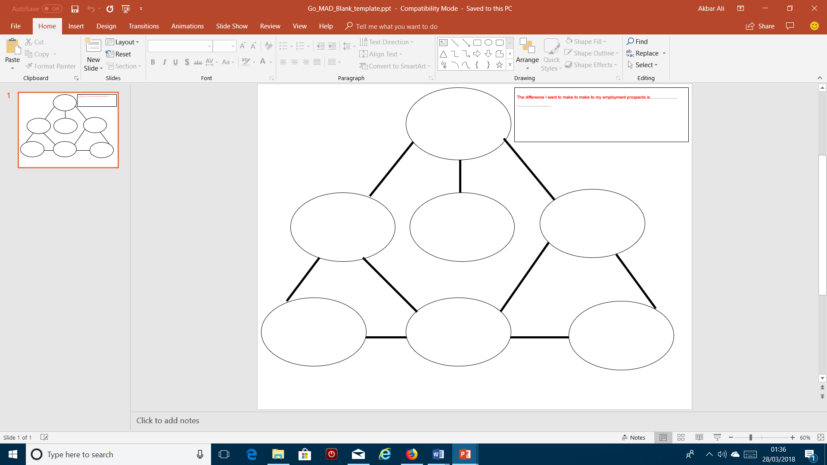
- C-Check
6-PERSONAL RESPOSIBILITY

The GO MAD Framework source GO MAD.com (2018)

I am at the first stage of my course in 1 years’ time I will be at the second stage which is enrolment. A further 3-year course will be done, by the fourth year I will be active in the field of Marine Science.
I believe the skills that I have like Problem Solving, Communication, and Experience will make it easier for me to complete my course and acquire the qualifications needed, as well as my commitment.
After completion of current course, take a science degree in university, and in three-years I aim to become an active Marine Biologist on the fourth year,
I
C
B
A
T
S
7-TAKE ACTION & MEASURE RESULTS

5-INVOLVE OTHERS

3-PLAN PRIORITES

2-DEFINE GOAL

1-REASON WHY

4-SELF BELIEF

My Commitment will be to attain all necessary qualifications and plan the 3-year course accordingly so that all time invested will be used wisely and efficiently.
To achieve goal, family members will need to support me emotionally, as well as fellow students and lectures within the campus academically.
To be a Marine Biologist by completing a three-year course in University of Swansea and acquiring the relevant qualifications. (Science Degree)
New Career path and job that I always wanted to do, and to transfer existing skills that I have will help me pursue this position of a Marine Biologist.
Commitment Experience
Confidence communication
Problem Solving

SELF BELIEF

Personal Development Plan

Recruitment & Selection

Pt (2)

Conclusion & Recommendations
I will need to plan and believe that once this course is complete I can further enhance my career prospects by enrolling in to another course that will enable me to gain further qualifications, that is necessary for my chosen career.
This module has given me knowledge needed to better my chance in attaining my goals and a clear strategy in how to develop my personal strengths and turn my weaknesses in to opportunities.

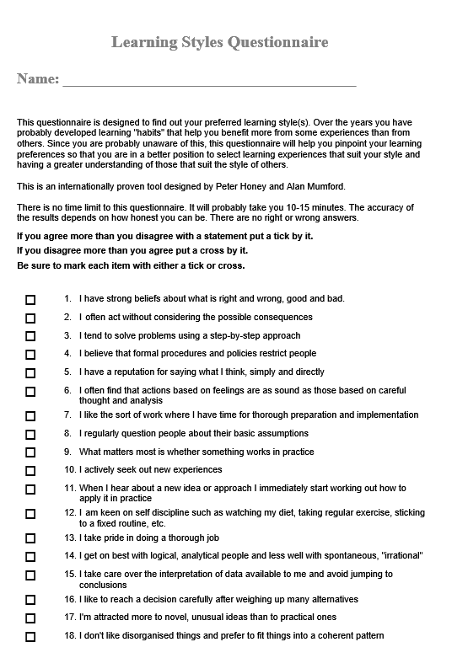
Appendices
Answers: 2, 6, 10, 17, 22, 26, 31, 33, 34, 35, 37, 38, 40, 46, 52, 54, 58, 61, 62, 64, 70, 71, 72, 74, 78, 79
1, 3, 4, 5, 7, 8, 9, 11, 12, 13, 14, 15, 16, 18, 19, 20, 21, 23, 24, 25, 27, 28, 29, 30, 32, 36, 39, 41, 42, 43, 44, 45, 47, 48, 49, 50, 51, 53, 55, 56, 57, 59, 60, 63, 65, 66, 67, 68, 69, 73, 75, 76, 77, 80

Akbor Ali

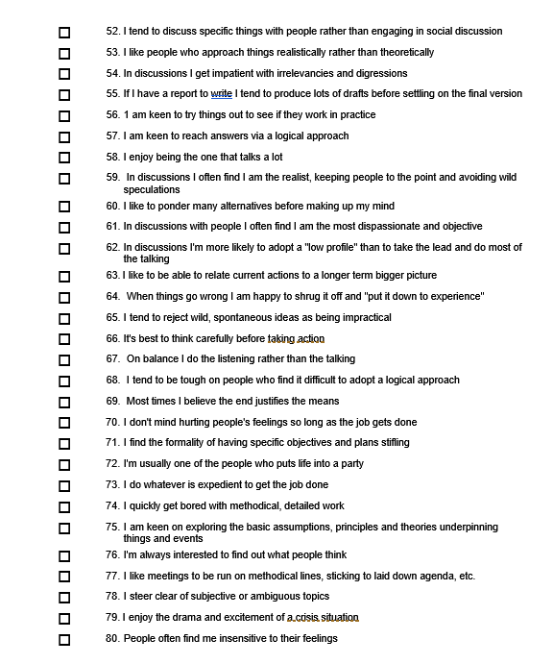

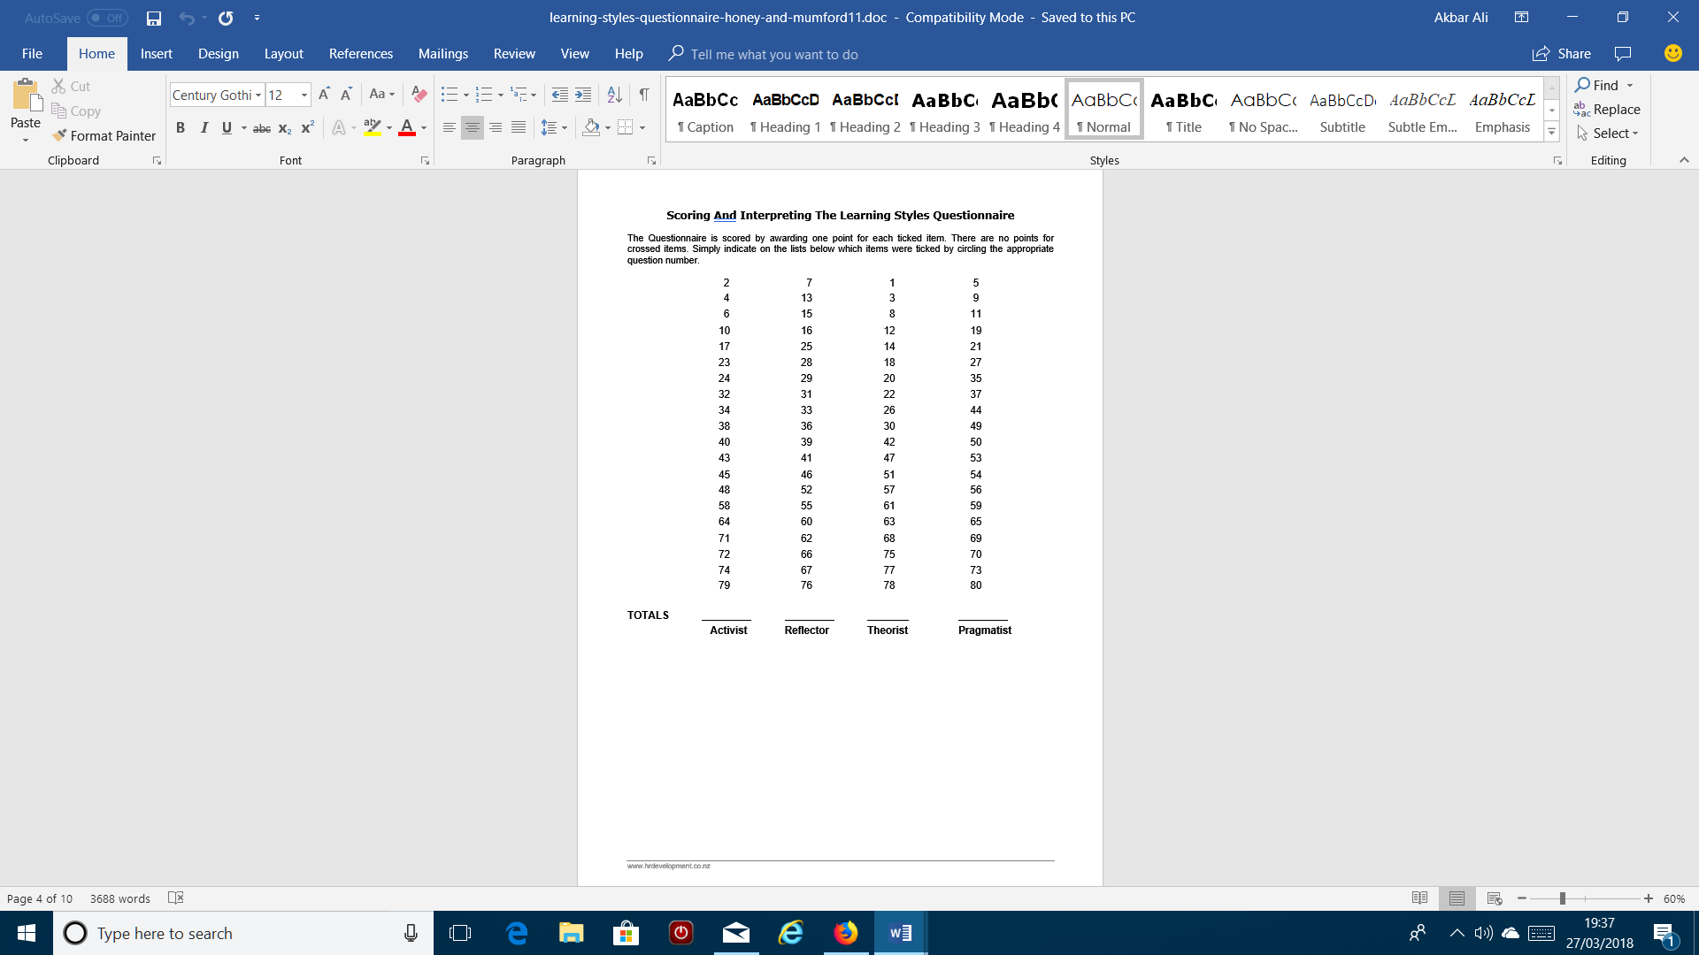
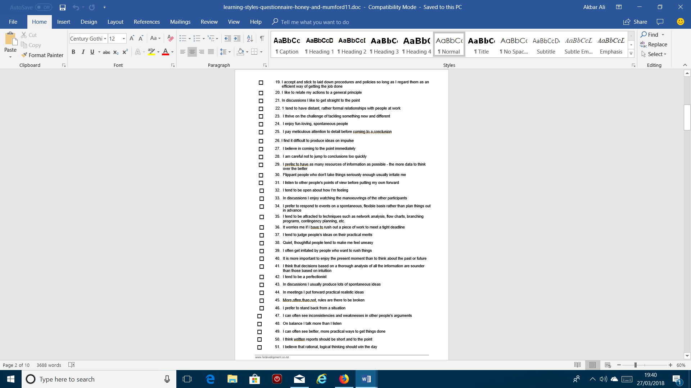
16

16

7

15

Reference

Baker, B. (2013)’ The Johari Window: How to build Self-Awareness & Achieve Success’[Online]. Available: http://www.startofhappiness.com/using-the-johari-window-for-self-awareness/, Accessed [25th,March, 2018]
Beever, G. (2017)’Peter Honey and Alan Mumford Learning Styles’[Online]. Available: http://extensionaus.com.au/extension-practice/peter-honey-and-alan-mumford-learning-styles/, Accessed [26th, March, 2018]
Burton , N.(2012) ‘Our Hierarchy of Needs’ [Online].Available: https://www.psychologytoday.com/us/blog/hide-and-seek/201205/our-hierarchy-needs ,Accessed[21st ,March , 2018]
Changing Minds. (2018) ‘The Johari Window’[Online]. Available: http://changingminds.org/disciplines/communication/models/johari_window.htm, Accessed [25th,March ,2018]
eXplorance. (2018) ‘I Do, and I Understand’-Kolb’s Experiential Learning Theory Explained’[Online]. Available: https://explorance.com/2015/02/i-do-and-i-understand-kolbs-experiential-learning-theory-explained/, Accessed [26th, March, 2018]
GO MAD Thinking. (2018)’Coaching & Facilitation’[Online]. Available: https://www.gomadthinking.com/accelerating-results/coaching-facilitation/, Accessed[27th,March, 2018]
Martin, M. (2018)’ conduct a Personal SWOT Analysis to Improve your Career’[Online]. Available: https://www.businessnewsdaily.com/5543-personal-swot-analysis.html, Accessed [22nd, March, 2018]
McLeod, S .(2017) ‘ Maslow’s Hierarchy of Needs’ [Online].Available: https://www.simplypsychology.org/maslow.html, Accessed [22nd , March , 2018]
Morgan, P. (2017), The Business Student’s Guide to Study and Employability, London: SAGE.
Mulder, P. (2017).’Johari Window Model’[Online]. Available: https://www.toolshero.com/communication-skills/johari-window-model/, Accessed [25th, March, 2018]
Professional Academy. (2018) ‘Marketing Theories-Maslow’s Hierarchy of Needs’[Online]. Available: https://www.professionalacademy.com/blogs-and-advice/marketing-theories-maslows-hierarchy-of-needs, Accessed [22nd, March, 2018]
Self-Awareness. (2013) ‘Understanding the Johari Window model’[Online]. Available: http://www.selfawareness.org.uk/news/understanding-the-johari-window-model, Accessed [25th , March, 2018]
SkillsYouNeed. (2018) ‘Employability Skills-Skills You Need for a Job’[Online]. Available: https://www.skillsyouneed.com/general/employability-skills.html, Accessed[25th, March, 2018]
Study.com. (2018)’SMART Goals for Students: Definition and Examples’[Online]. Available: https://study.com/academy/lesson/smart-goals-for-students-definition-and-examples.html, Accessed[27th, March, 2018]
The e-Learning Network. (2017)’Honey and Mumford Learning Styles’[Online].Available: https://resources.eln.io/honey-and-mumford-learning-styles/, Accessed [26th, March, 2018]

