Zach Port-Lincoln
P148020
Computer Games Development
Indie games development
02/02/2018

CONTENTS

Abstract:
In this report I will be giving you the controls and objective in the submitted game. I will also be talking about the layout of the game, what is included, what tools I have used, what models I have used and any further information needed.

Design:
Here I am going to give you a brief description of my game.
First are the controls on how to play and navigate the terrain.
- W, a, s and d will move your character around the map
- Space bar will make you jump
- The ‘P’ key will pause the game and bring up the pause menu where it will let you save you progress and load a previous save.
- Left mouse click will fire a rocket in the direction you are facing
What the objective of the game is, is to navigate through the map, past the skeleton who is roaming through its pre-configured waypoints and will chase after you if you get too close, till you find the ruby. Once you have found the ruby you will have to walk through it and the game will end.
You are able to shoot the skeleton but his health doesn’t go down. He will attack you but there is no animation for it but your health will go down.

Implementation:
Scripts;
- AI script will control everything to do with the AI, such as see if it can see me to shoot me, if I add enemy’s that will shoot me in the future. It is also got the code to see what waypoint it will travel to next
- Character script is a main class for other scripts to use as a base like the player script but it also has some health code where if the player tag gets hit with a collision then I will take damage of 1
- The End Game script is what the ruby’s collider will use, once I go through the ruby It will call the end game function and close the game, this will only look like it is working once the game is built as an exe
- Health script sets the max health and turns the health float into a percent so the health bar can use that to display part of an image
- Player script will check to see if I have pressed the left mouse click, also checks to see if you have less than 0 health if you do then it will end the game
- Rocket control script controls the rocket itself with the smoke coming out the back of the rocket and also it will destroy the rocket after a certain amount of seconds
- Saveload script will store your x y and z location into variables and the load will set your position as those variables [1]

- Stopmenu script will pause the game when the hot key is pressed and bring up the main menu so you can save and load from one place
- Uicontrol script will controle how big or small the health point bar will be in correspondence with your health. It will also keep log of how many rockets you have left
- Waypoint script will draw the lines between the waypoints you have put down and it will put an icon image down where the waypoint is
- Waypoint collection this is where it will get a random waypoint for the ai to travel to next.
I will no show you screen shots of the completed game.
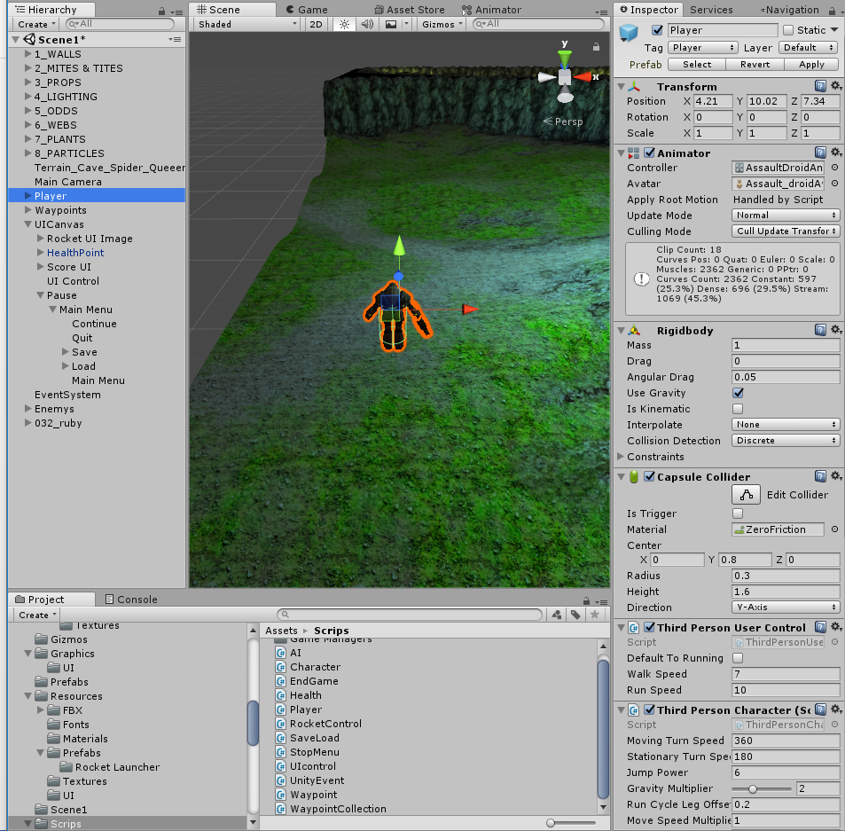
Here is the main character you control.

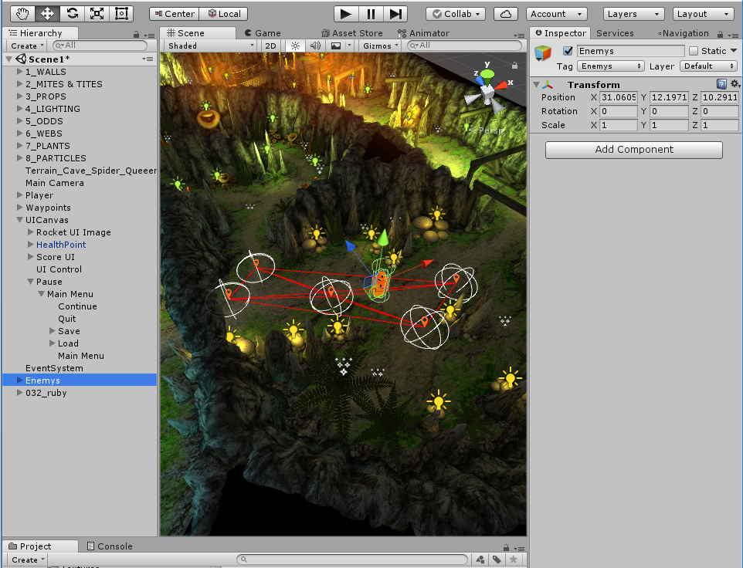
This is a picture of the AI and all its waypoints it will travel to.
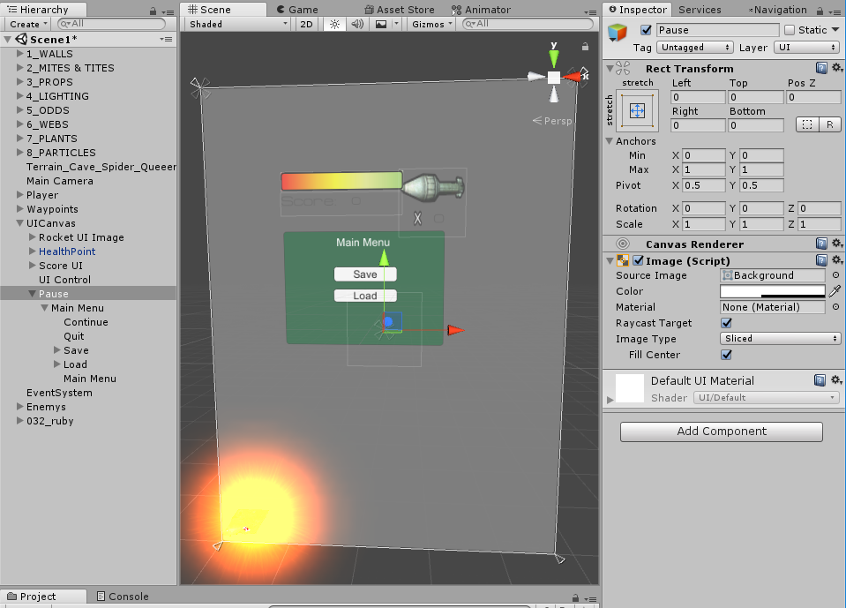
This is a picture of what the UI looks like and also what the main menu will look like.

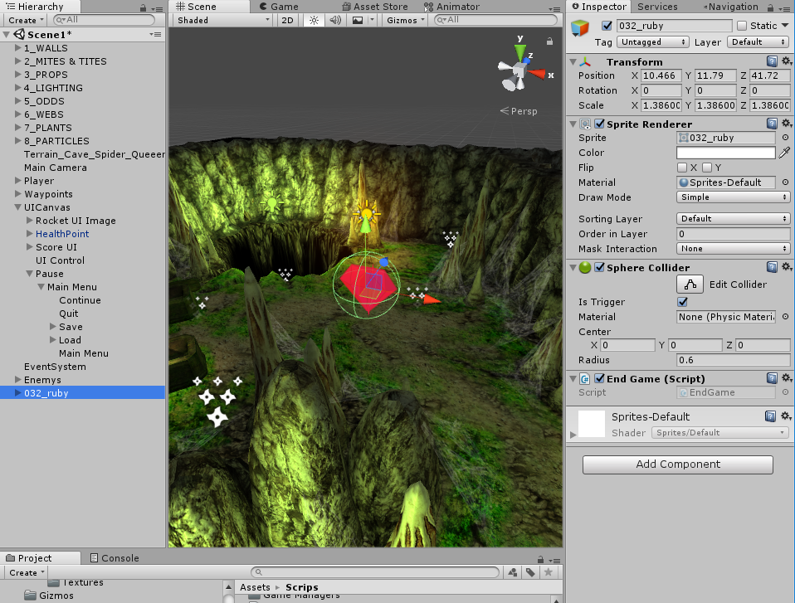
This is the ruby that you need to walk through in order to complete the game.

Evaluation:
Here I will put what challenged me the most and what were the most prominent errors.
The main challenge was getting the game to end when I walked through the ruby, as when I did it in Game mode the debug message I put in there would work but the game would never end, it was only till I looked into this issue is that I would find that the command I used would only execute when the game was built, so I build the game to test it and the game does in fact close when I go through the diamond.
Another error I found was that when I added the camera to the scene and attached the smooth follow script to it, setting me as the target I could only walk north with w, south with s, east with a and west with d. The only fix I had for it, as googling the issue was no help, I started a new project and moved my assets and everything across to the new project and then the directions worked.

My Game:
I believe my game is something anyone can pick up and play, it’s not too difficult, the mechanics work and getting to the end is fairly easy with a very visually pleasing terrain.
The enemy needs some work in order for me to kill the enemy and for the enemy to damage me, but that can be improved at a later revision.
The map is a little small with a not very challenging terrain to traverse but it does look nice and there are lots of different things such as particles and bridges, well placed lights and an overall dark creepy feel.
The pause menu does what is intended but I could add more buttons there to modify the settings or exit early or to resume without having to press the pause key.
The map itself could be improved by adding a wall to the edge of the map to stop you from falling off and nothing happening.
Overall I believe the game is a basic game but everything apart from the enemy dying working very well. [2]
The Future:
What I could do for the future is to extend the map, add more enemies that will attack and kill you. A different variety of enemies to kill.
I would like to add multiple levels to the game that get bigger and harder and ultimately end in a boss fight at the end that would kill me in far fewer hits.
I could add in loot chests that I could search for more health and better weapons and armour.
There are countless ideas that could be or would be good to add but these are the main points I would like to implement if I got to do this again.

References

[1] | "unity forum," [Online]. Available: https://forum.unity.com/threads/saving-and-loading-player-position-rotation-etc.328387/. [Accessed 02 05 2018].
[2] | "Moodle," [Online]. Available: https://moodle.uwtsd.ac.uk/.

marking criteria and Student FEEDBACK

This section details the assessment criteria. The extent to which these are demonstrated by you determines your mark. The marks available for each criterion are shown. Lecturers will use the space provided to comment on the achievement of the task(s), including those areas in which you have performed well and areas that would benefit from development/improvement.

Common Assessment Criteria Applied (Assignment 2) | Marks available | Marks  awarded
1. Research-informed Literature
Extent of research and/or own reading, selection of credible sources, application of appropriate referencing conventions.
Expand the scope of references consulted to help you improve the quality of your work. (Grade mark: 20.00%) | 5 | 1
2. Knowledge and Understanding of Subject
Extent of knowledge and understanding of concepts and underlying principles associated with the discipline.
Demonstrates basic understanding of the concepts and principles used to build a game. Some attempt has been made to reuse the concepts learnt in class, but unfortunately most of the functionality does not really work. Aim to improve your understanding of the basic concepts and especially how to integrate scripts and object functionality. (Grade mark: 40.00%) | 20 | 8
3. Analysis
Analysis, evaluation and synthesis; logic, argument and judgement; analytical reflection; organisation of ideas and evidence
A fair evaluation and discussion of the challenges faced has been provided, identifying some of the limitations of the submitted game. (Grade mark: 53.33%) | 15 | 8
4. Practical Application and Deployment
Deployment of methods, materials, tools and techniques; application of concepts; formulation of innovative and creative solutions to solve problems.
A fair attempt featuring a basic game. The main problem is the game does not currently present any real challenge or gameplay experience to the player. The main area for improvement is getting some of the basic functionality right and improving character interaction to provide a more interesting and challenging gameplay experience. (Grade mark: 40.91%) | 55 | 22.5
5. Skills for Professional Practice
Attributes in professional practice: individual and collaborative working; deployment of appropriate media; presentation and organisation.
The report is of average standard. See your report for suggested improvements. (Grade mark: 50.00%) | 5 | 2.5

Assignment Mark (Assessment marks are subject to ratification at the Exam Board. These comments and marks are to give feedback on module work and are for guidance only until they are confirmed. ) | Late Submission Penalties (tick if appropriate) |  | 42%
 | Up to one week late |  | 42%
 | 1st/2nd/3rd attempt? |  | 42%

