

SELF-REFLECTION

MODULE: FOREIGN LANGUAGES & CULTURAL AWARNESS
MODULE CODE: BMIH5003
STUDENT ID: 2212616
STUDENT NAME: VLAD DANCEANU
LECTURER: LISA BASSLER

Table of Contents
1 Introduction 3
2 Gibbs Reflection Model 3
2.1 Description 3
2.2 Feeling 3
2.3 Experiences 3
2.4 Evaluation 3
2.5 Analysis 4
2.6 Conclusion 4
2.7 Action Plan 4
3 Conclusion 4

Introduction
This research highlights the importance of foreign languages in the UK just because of the local and international customers. In this research, diversity in hotel and spa London is selected, and the importance of multilingualism is highlighted. It is obvious that the UK is the most successful country because of its hospitality industry, including hotels. Various individuals, including locals and internationals, prefer tourism, which impacts the overall performance of hotels positively. The challenging situation is the diversity of multicultural backgrounds because internationals are multilingual, so employees should have these language skills.

Gibbs Reflection Model
This Gibbs reflective model helps me to share my feelings and experiences, which I felt during the development of the presentation on this particular topic of foreign languages. In this research, the selected language is Modern European language – Dutch.
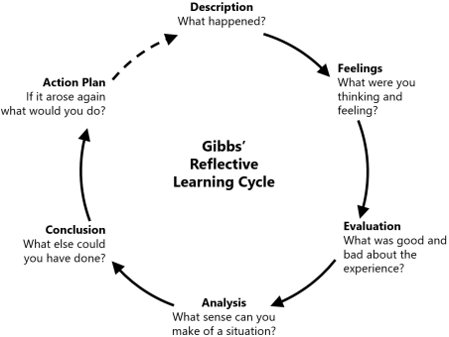
Figure 1: Gibbs's Reflective Cycle
(Source: Harithuddin et al., 2021)

Description
It is described that a diverse hotel and spa in London is highly successful because modern Europeans visit these hotels, so it is necessary that the Dutch language should be taught to the employees so that they can communicate with the customers and understand them.

Feeling
I felt that skill development is most preferred in the hospitality sector in order to gain the attraction, attention, trust and loyalty of the customers, and it is the responsibility of hotel management to fill the language between the hotel staff and the customers (Getachew et al., 2020).

Experiences
It is my experience that language skills alleviate communication barriers and help the management and the employees of the hotel to interact with the customers in order to make them happy. Happy customers are more satisfied, and there are more chances to engage them with the hotel for the long term.

Evaluation
I evaluated that customer satisfaction, retention and engagement result in better productivity of the hotels, which further results in a positive reputation in the global market. It helps the organization to increase profits, which makes financial stability more effective and also results in the development of economic growth. After all, the gross domestic product of the country increases, which is the biggest achievement for the hospitality industry (Gubbins et al., 2021).

Analysis
I analyzed that Dutch is the most effective and selected language as many customers speak this language. Management provides effective training to the employees so that they can learn this language and effectively communicate with the customers in order to attract them towards the hotel. It builds strong relationships between the customers and the hotel staff.

Conclusion
This reflective cycle is highly appreciated because it helps me to share my feelings and experiences one by one. It also helps me to highlight my strengths and weaknesses.

Action Plan
This language skill can be improved or developed by proper training, attending sessions, seminars, webinars, and effective courses.

Conclusion
It is concluded that language learning skills are most crucial and critical because it has great significance in the hospitality industry of the UK, especially in hotels. The major reason is that travellers and guests belong to different cultural backgrounds and are multilingual. So hotel management is responsible for giving proper training in language skills to the employees in order to communicate effectively.

References
Getachew, A., Ayele, M., Hailu, M. and Tuli, F., 2020. Effectiveness of soft skill training for students’ career development in higher education. Journal of the Social Sciences, 48(4), pp.1817-1832.
Gubbins, E.J. and Hayden, S.M., 2021. Professional development. In Critical issues and practices in gifted education (pp. 349-360). Routledge.
Harithuddin, A.S.M., 2021. A first experience of using a failure report as a reflective tool in engineering education. International Journal of Emerging Technologies in Learning (Online), 16(18), p.23.

