Carmarthen Wellbeing: An investigation into the need to develop a community-based Online Directory of Support services to combat Loneliness and Wellbeing Problems within Carmarthen Town



Samuel James Rossiter
Camarthen Business School
University Of Wales Trinity Saint David

This Dissertation is submitted for the Degree of
Business Management

September 2022

Declaration:

I would like to declare that this dissertation entitled ‘Carmarthen Well-being: An investigation into the need to develop a community-based Online Directory of Support services to combat Loneliness and Well-being Problems within Carmarthen Town’ is carried out by myself within the University of Wales Trinty Saint David. All information originating from the literature has been accredited in the text and the references list provided. No part of this dissertation has previously been presented for another degree or diploma at this or any other institution.

Samuel James Rossiter September 2022

Acknowledgements:

I should like to acknowledge all the people who made this dissertation possible. Firstly my warmest thanks to my supervisor Jessica Shore; her guidance and support carried me through my project, from helping me apply for my internship with Carmarthen Town Council to giving me the professional advice to form this piece of work.

I give my sincere credit to all staff members, from student support services to all the lecturers at the University Of Wales Trinity Saint David, who, without their help, guidance, cooperation and encouragement, I would not have been able to complete this dissertation work.

I would also like to thank Jenny Fox and Carmarthen Town Council for their excellent advice and for highlighting the issue of Loneliness and Well-being within Carmarthen Town, which is the topic my Dissertation work has been focused on.

Finally, I would like to give special thanks to my parents and sister, who have supported me morally. I’d like to also give my thanks to my family as a whole for their utmost support and understanding through the ups and downs of undertaking this work.

Thank you all,

Samuel Rossiter

Abstract:

What can be done to combat loneliness? Carmarthen Town Council identifies loneliness being a problem within their town. This dissertation will explore the possibility of creating a user-friendly directory of available services online and researching whether signposting individuals who require help because of loneliness to organisations purposely set up to help them will benefit the community.

The literature review explores academic research and theory in the context of loneliness and well-being and how academic concepts, such as Maslow's Hierarchy Of Needs theory, can be applied to this within the context of the Carmarthenshire area. Further research was sought into digital media and what role this has in the well-being of different communities.

The methodology explained the process of how the research was going to be conducted; the research questions were released via social media in the form of a questionnaire. This research was collected in form of a quantitative study which gathered 110 responses over 30 days. These results were compiled into descriptive analyses, which were inputted into this dissertation under chapter four’s Findings.

The Findings and Discussion explore evidence that the proposed online directory would be valued and accessed and would be of benefit to the community. The Conclusion summarises the findings and makes recommendations about the ‘next steps’ that could be taken by researchers following up on this initial study.

Table of Contents:
Chapter 1 – Introduction 7
What is the subject area? 7
Background: 7
Research Approach: 8
Aims and objectives. 9
Research Questions: 9
The Significance: 9
Limitations: 10
The Structure: 10
Chapter 2 - Literature Review 10
Definitions of Well-being: 10
Carmarthenshire Definition of Well-being: 13
Carmarthen and its rural communities: 14
Rural Challenges in Carmarthenshire, according to the BBC: 16
Abraham Maslow’s theory of self-actualisation for the enhancement of quality of life: 16
Loneliness and its effects on Well-being: 19
Communications theory 20
Digital well-being: 21
What are the health risks associated with too much screen time? 21
The role of support groups: 22
What kinds of support groups are there? How do they interact with rural and town communities? In what way do they make a difference? 22
Chapter 3 - Methodology 23
Quantitative VS Qualillative: 23
Philosophy of the methodological approach. 24
Research design – Strategies 24
Why was a questionnaire used? 25
Data collection: 25
Data Analysis: 26
Participants: 27
Reliability and Validity: 27
Procedure and Materials: 27
Ethics: 28
Limitations of the Research: 29
Research Bias: 29
Sample Size: 29
Knowledge and understanding of the subject or the research: 29
Chapter 4 – Findings: 30
Table one – What is your age 30
Table two – How do you identify?: 31
Table three: Which of the following categories best describes your employment status? 31
Table four: Which of the following areas do you live in? 32
Table five: How often do you have concerns about your well-being? 33
Table six: Which of the following do you associate with well-being? 34
Table seven: Can the Internet and social media play a part in tackling Well-being and loneliness problems? 35
Feedback on the Carmarthen Wellbeing online directory proposal: 35
Table eight: Can an Online Directory of support services help reach out to people who are Lonely in Carmarthen? 35
Table nine: Would you access support groups to improve your well-being? 36
Table ten: Do you feel The Carmarthen Wellbeing Directory will bring awareness to local businesses? 36
Chapter 5 – Discussion 37
Tables Four and Seven - The comparison between the Rural population and the internet’s role in well-being: 37
Tables five and nine - The comparison between well-being concerns and access to support groups: 38
Tables One and Six – The Comparison between Age and Association with Wellbeing: 40
Chapter 6 – Conclusion / Recommendations 42
Summary of Key Findings: 42
Limitations: 42
Implications for Theory & Practice 43
Recommendations: 43
Further Research 44
References: 45
Appendices: 48
Appendix One – Questionnaire : 49
Appendix Two– Ethics Form: 57
Appendix Three – 1st Comparison Graph 70
Appendix Four: 2nd Comparison Graph 71
Appendix Five: 3rd Comparison Graph: 72

Chapter 1 – Introduction

What is the subject area?
This dissertation will establish research within the field of loneliness within Carmarthen Town and its surrounding areas. Consideration will be given to whether the term loneliness links directly to ‘well-being’ and if looking after a person’s well-being by giving them access to local support services will help mitigate the loneliness problem that exists in the local area.
This dissertation will therefore investigate the proposal to develop a community-based Online Directory of Support services to combat Loneliness and Wellbeing Problems within Carmarthen Town.’ This would be a free digital local government directory that would signpost people to local organisations to help them with their particular problems concerning their well-being.

Background:

In the heart of South West Wales, Carmarthenshire is located in the middle of a region that is alive with contrasts and one that is full of natural beauty. As a result, there are a lot of breathtaking landscapes to discover, such as spectacular mountain ranges, golden beaches, peaceful valleys and vibrant markets, to name just a few (Visit Carmarthenshire, 2022).

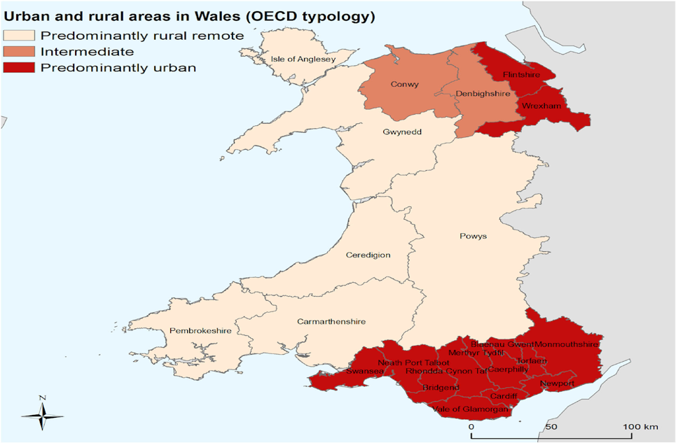
Source: (OECD, 2020).

According to the table above, Carmarthenshire has a predominantly rural character. Agricultural land makes up the majority of this area. However, this dissertation examines Carmarthenshire as a rural community because of a press release by Carmarthen Town Council in August 2021 with the deputy mayor stating:

The pandemic has brought the problems linked to loneliness to the fore, but of course, loneliness has affected very many people for a very long time. Our aim is to bring together people who wish to raise their concerns and to share their experiences about what can be done at a very local level to help people who feel lonely. Many groups and organisations already do a fantastic job of helping people who experience loneliness. Our aim here is to reach out to anyone who may need help and to make sure that any gaps in support that exist at the moment are closed and that people are made aware of the support that is available or perhaps things that we need to think about doing locally here in Carmarthen to provide more help (Carmarthen Town Council, 2021).

The deputy mayor highlights loneliness as a problem; this is why this research project will create a user-friendly directory of services available and research whether signposting individuals who require help because of loneliness to organisations purposely set up to help them will be beneficial to the community (Carmarthen Town Council, 2021). .

Research Approach:
The research for this dissertation will consist of a qualitative approach. Quantitative data will be extracted from the research to determine whether there is any demand for a community-based online directory listing support services. An ethics form will be completed to ensure this research is conducted within university rules and guidelines. Data will be collected using a questionnaire on google forms, extracted from google forms for analysis on both Microsoft excel and SPSS. From here, the data will be presented in the findings chapter and then later analysed and discussed in the discussion chapter.

Aims and objectives.
The aim of this dissertation is to explore the attitudes surrounding loneliness and well-being within the Carmarthenshire area. Therefore, the objective of this dissertation is to undertake research into whether or not residents of the Carmarthenshire area.

Research Questions:
The main research questions will help establish the demand for creating a user-friendly directory of available services online and researching whether signposting individuals who require help because of loneliness to organisations purposely set up to help them will benefit the community.

The main questions are as follows:
How often do you have concerns about your well-being?
Which of the following do you have concerns about your well-being?
Do you feel a Carmarthen Wellbeing Directory will bring awareness to local businesses?

Along with other questions posed to participants, the above three questions will provide a deep insight into answering this dissertation question.

The Significance:
The significance of this dissertation will focus on academic research and theory on loneliness and well-being and how academic concepts, such as Maslow's Hierarchy Of Needs, can be applied to this within the context of Carmarthenshire. Digital media and its impact on the well-being of different groups will be investigated.
Research questions were posted on social media as a questionnaire as part of the methodology. This research was collected as a quantitative study, and responses will be collected over 30 days. These results will be compiled into descriptive analyses and incorporated into this dissertation under chapter four’s Findings.
Results and Discussion will explore evidence that the proposed online directory would be valued, accessed, and benefit the community. The Conclusion will summarise the findings and make recommendations about the next steps that researchers could take following up on the outcome of this research paper on the significance of an online directory helping people combat struggles with loneliness and well-being.

Limitations:
Limitations of this research will be critically analysed in the methodology, discussion and conclusion of this research. The ethics form will be completed per university guidelines, and all research will be assessed for any bias or limitations throughout this report.

The Structure:
This dissertation will consist of six chapters. Chapter One will form an introduction, opening the dissertation with the research aims and objectives alongside a background to the study. Chapter two will consist of a literature review. This will rely heavily on research from various sources, from academic theories to organisations, including public bodies, to provide a better insight into well-being. Chapter three will create the methodology and introduce and build on the research proposal, such as how the questionnaire was created and factoring in the ethics form. Chapter four will comprise the research findings, which will set out the findings from the questionnaire. Chapter five will provide a deeper insight into the questionnaire by discussing the findings and comparing them to the literature review. Finally, a conclusion will be formed with recommendations going forward due to the research conducted.

Chapter 2 - Literature Review

Definitions of Well-being:
Wellbeing is a concept that the World Health Organisation (WHO) explicitly linked with health in the year of its foundation, describing health as "a state of complete physical, mental and social wellbeing and not merely the absence of disease or infirmity" (WHO, 1948). With this definition, the WHO moved away from traditional views that considered health to be the absence of disease, while medical diagnosis and practice were considered the sole means to preserve health - views that exclusively focused on human biology. The WHO model of health is 'biopsychosocial': an amalgamation of biology, psychology and societal factors, a positive state that can be achieved by individuals and communities when the appropriate resources are at their disposal and a model that emphasises the link between health and being a fully functioning member of society. The WHO’s ground-breaking definition led to significant changes in how health is understood and ensured that mental health quickly became a critical factor in Public Health. (QUOTE)

The WHO's definition eventually attracted criticism as being unrealistic because "it leaves most of us unhealthy most of the time" (Martino, 2017). Further research (Godlee, 2011) highlighted this as an "unhelpful and counterproductive" approach because it fails to take short-term ill health into account and considers people with chronic illnesses and disabilities, which contributes to increasing dependence on medication in society. In the same year, Huber et al (2011) formulated a new definition of health which recognised people's "ability to adapt and to self-manage" as crucial responses to any deterioration in their health. Huber also drew attention to the fact that the subjective nature of wellbeing makes it different depending on every individual's personality, context and needs, thus presenting wellbeing as highly individualistic and neither objective nor measurable. Huber also pointed out that well-being can be measured objectively based on assumptions about basic human needs and rights such as food, physical health, education and safety by asking individuals to report their current situation and even more objectively through local and national statistics (Martino, 2017).

In 2011 the United Kingdom (UK) Government published a strategy document entitled “No Health Without Mental Health”, and the National Health Service (NHS) has been working towards a recognition that mental health is a vital factor in physical health ever since. This insight was discussed in the report "Better Mental Health for All", published jointly by the Faculty of Public Health and The Mental Health Foundation in 2016, which among other things, set out examples of good practices to improve well-being in local populations. The literature came full circle in this report, echoing and reaffirming the definition of well-being declared by the WHO in 1948 (GOV UK, 2011)(GOV UK, 2011).

Applying knowledge about loneliness to people’s mental health and the services that provide support, care and treatment required researchers systematically to quantify well-being so that it can be studied within specific parameters.

There is a model of well-being that views it as an integral aspect of mental health, the "Single Continuum" model. Mental health sits on a single spectrum alongside Well-being: at one end of the spectrum are low well-being and mental illness, while the other extreme pairs up high well-being and mental wellness (Westerhof, 2009).
According to this theory, improving the mental health of any given population should be possible by improving overall levels of well-being in the population. The theory has proved successful with children and adults suffering mental health disorders (Goodman & Goodman, 2011; Veerman et al., 2009), but the evidence regarding severe and enduring mental illness is not adequate or conclusive, and the Chief Medical Officer's report 2013 [6] raised concerns about it as an approach to mental health promotion. However, the link has been established and shown to be effective for people with mental health disorders, suggesting that it might benefit Carmarthen's well-being; naturally, the care of patients with severe and enduring mental illness will predominantly be the responsibility of NHS Mental Health Services (Westerhof, 2009).

The Single Continuum model is complemented by the “Dual Continuum” model, which acknowledges a relationship between mental health and mental well-being but considers the two separate. Each has its own scale, ranging from mentally well to mentally ill and from flourishing to not flourishing (Queensland Government, 2021). Thereby emphasising views reported by Huber et al. (2011), who's research highlighted the "ability to adapt and to self-manage" and rise above circumstances. However, the dual continuum model has its basis in the view that mental illness cannot be recovered from and would therefore be unhelpful to decisions about implementing an online directory of support services.

In 2011 Seligman developed five strands or core elements of psychological well-being:
- Positive emotions
- Engagement
- Relationships
- Meaning
- Accomplishment
This was called the PERMA model of flourishing. It closely resembles the work of Cambridge University's Well-being Institute and its definition of well-being as "positive and sustainable characteristics which enable individuals and organisations to thrive and flourish." (Positive Psychology Centre, 2022). Even more specifically, the New Economics Foundation (2008) identified five actions that people can take in their daily lives that have been shown to improve well-being, known as The 5 Ways to Well-being, and they are:
- connect
- be active
- take notice
- keep learning
- give

The many definitions of well-being produced by various bodies and researchers have an identifiable theme - that well-being involves "feeling good and functioning well." There is now a general view that the concept of well-being lies at the heart of protecting and improving public health by focusing on proactively keeping people well rather than reactively treating illness as it arises (Positive Psychology Centre, 2022).

Carmarthenshire Definition of Well-being:
All areas of Wales now benefit from a law that has no parallel in the rest of the United Kingdom - the Well-being of Future Generations (Wales) Act, which became law in April 2015. The Act “requires public bodies in Wales to consider the long-term impact of their decisions, to work better with people, communities and each other, and to prevent persistent problems such as poverty, health inequalities and climate change” and identifies seven well-being goals (Future Generations Commissioner For Wales, 2015). These “Goals” embody the ambition to make Wales more prosperous, resilient, healthy, equal, cohesive, culturally vibrant and globally responsible. Public bodies across Wales have to demonstrate that they are working towards achieving all of the seven goals through “The 5 Ways of Working” that embody the implementation of the Act: emphasising long-term needs, striving for integration so that all 7 Goals are worked towards, involving and collaborating with a diverse range of people to meet goals and preventing problems from worsening or developing (Future Generations Commissioner For Wales, 2015).

The relevance of the legislation to this study lies in the impact of the statutory “Goals” and “Ways of Working” on loneliness, which is relevant to at least 4 of the Goals and 3 of the Ways of Working.

The Act came into force in May 2016 and required all public bodies to publish their plans for responding to the new law. In 2018 Carmarthenshire published its first “Well-being Plan” entitled “The Carmarthenshire We Want 2018-2023” (2018), stating that it was the result of “significant engagement with front line staff, residents of all ages, county and community councillors and other stakeholders” and promising “we will do all that we can to deliver this ambitious plan.” (Liles, 2018) (Liles, 2018).

Carmarthenshire’s Plan focuses on four objectives and alludes to loneliness in its section on “Early Intervention - to make sure that people have the right help at the right time; as and when they need it.” The Plan identified some challenges people face at different stages in their lives, and those relevant to the topic of loneliness include worsening physical and mental health, the collapse of social networks and relationships, and deteriorating economic circumstances leading to becoming trapped in a vicious circle of poverty (Liles, 2018). Getting help or support at the right time can make a massive difference to people’s well-being - and the implication is that not getting help at the critical moment can have a massive impact. Carmarthenshire’s short-term delivery Plan aims to “raise awareness and establish a single point of contact to access information” - targets that, on reflection, were central to the project conducted by this researcher into loneliness in the county. The medium-term ambition is “to develop a mechanism … to coordinate and share key information to enhance the capacity and capability of public service partners to support individuals to take early preventative action.” (Liles, 2018)

The Loneliness Research Project accomplished these aims by establishing a single point of contact in the form of a directory or database of services and organisations that can be contacted by people who need support and by taking a snapshot of the prevalence of loneliness in the county using the questionnaire (Liles, 2018).

Carmarthen and its rural communities:
The Carmarthenshire Well-being Plan highlights the following statistics about its rural communities:
60% of Carmarthenshire residents live in rural areas
23% of residents (or 1 in 4) are 65+, and by 2039, this will have risen to 31% (i in 3)
25% of residents have a limiting long-term illness
36% of households are living in poverty
13% of residents (24k) are unpaid Carers - of whom 30% (7k) give care for 50+ hours/week.
28% of residents suffer from mental health issues (Welsh Government, 2021).

The statistic that 60% of the County's residents live in rural communities opens a window onto the reality that nearly two-thirds of the population could suffer loneliness because of a range of difficulties that includes poor public transport leading to problems finding and accessing public services, most significant physical and mental health services. Transport restrictions in rural areas confine people to their homes more effectively than can be the case in towns where facilities are within walking distance, and a range of shops enables people to live less expensively. Opportunities for social interaction are fewer in rural areas, and the risk of being or just feeling isolated deepens with age (Welsh Government, 2021)

It is unclear from the Plan how much overlap exists between 28% of residents suffering from mental health issues and 25% with long-term ill health. However, these statistics could suggest that more than half of Carmarthenshire's residents are currently dealing with trials in their lives that would make loneliness a likely outcome. A different but connected issue relates to caregivers, who often sacrifice jobs and leisure time to look after someone and find their lives increasingly constricted and lonely.

Advancing age is also an acknowledged cause of loneliness, as people become less able to get out, possibly suffer increasing ill health, lose life partners and feel increasingly marginalised - and in Carmarthenshire, 23% of residents are over 65 years old, a figure expected to rise to 31% by 2039 (Welsh Government, 2021).

According to the Welsh Government's definition, a household with less than 60% of the median GB income is in poverty: and more than a third of Carmarthenshire's households (36%) live in poverty. Poverty deprives people of many opportunities for work, travel, housing, education and social activity. It almost inevitably triggers and drives loneliness.
It is easy to see why the county's research into loneliness and active measures to mitigate against it is so required (Welsh Government, 2021).

Rural Challenges in Carmarthenshire, according to the BBC:
The BBC reported in 2017 that Carmarthenshire had 186,500 residents, which comprised 6% of Wales' population. 61% of respondents lived in rural wards, compared to 33% of Welsh respondents who lived in urban wards. Of those in Carmarthenshire, 9.4% were young, compared to 11.3% of Welsh respondents who were young, and 23.3% of Carmarthenshire respondents were older than 65, compared to 20.6% of Welsh respondents (Messenger, 2019).

The BBC report also states that a task force has been formed to consult with communities. This is to make recommendations on how to tackle the rural challenges of the future. There are several recommendations, including:

- Creating new businesses or office space in vacant or disused buildings in rural towns and villages

- Establishing smallholdings in rural areas and evaluating their feasibility

- Bwcabus and similar projects need long-term funding, more electric charging points in the county, and the promotion of car club schemes.

- Establishing community energy projects with partners

- They are creating individual action plans for ten rural communities - Cross Hands, Kidwelly, Llanybdder, Laugharne, Whitland, St Clares and Llandovery (Messenger, 2019).

Abraham Maslow’s theory of self-actualisation for the enhancement of quality of life:
An academic theory which can be applied is Maslow's hierarchy of needs which is a motivational theory in attitude comprising a five-stage model of human needs, which is often portrayed as a pyramid labelling hierarchical heights as shown below:

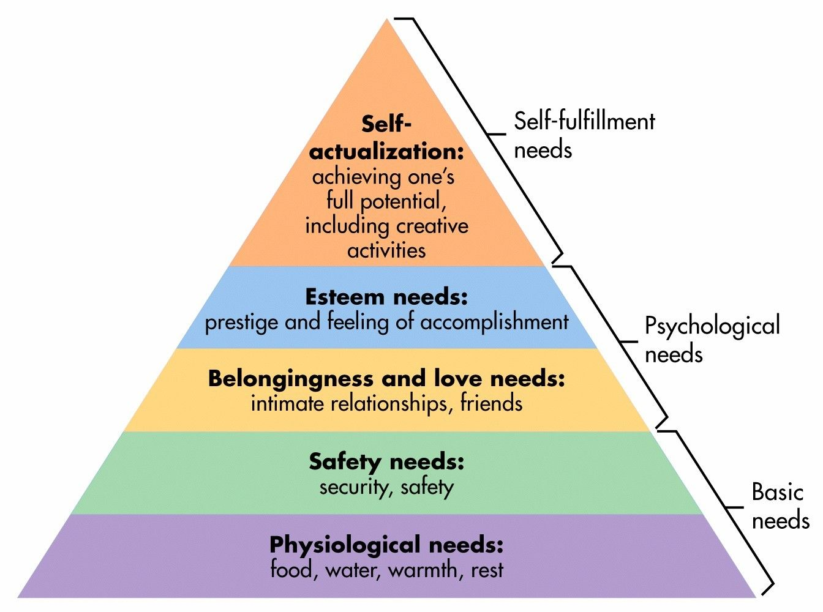
Source: (Mcleod, 2007)

The pyramid shows Maslow’s understanding of the motivational instinct in humans, emphasising that every individual acquires a motivational structure unconnected to rewards or unconscious desires. He believes that humans are determined and stimulated to accomplish certain necessities and that some needs take precedence over others. The essential need for every human is their physical survival, the first element determining individual behaviour. When the basic level is satisfied, the next stage motivates the individual, provides the urge to achieve the next stage, or stimulates the human/individual instincts (Mcleod, 2007).

The hierarchy of needs or the five-stage model includes:

Biological and Physiological needs:
Biological and physiological needs include air, food, drink, shelter, warmth, sex, sleep, excretion etc. Several basic needs for humans must be met for an individual to survive. If these needs are not met, the individual could die due to lacking these needs (Mcleod, 2007).

Safety needs:
A wide range of safety needs can be met by implementing safety measures, such as protection from the elements, security, order, law, stability, and freedom from fear. People feel insecure during disasters or times of disorder, like rebelling. When they are scared, children are more inclined to seek safety because they depend on others for such needs (Mcleod, 2007).

Love and belongingness needs:
It is a sign of belonging and a feeling of love to be part of a group, be it a family, a group of friends, a place of work, or a place of play. You need to escape isolation and alienation for many reasons, such as receiving and giving love, feeling accepted and acknowledged, and escaping isolation and alienation. Family members are usually able to meet each other's needs when it comes to love and belonging (Mcleod, 2007).

Esteem needs:
To achieve a sense of self-esteem, one must acquire mastery, independence, status, dominance, prestige, respect from others, and most importantly, self-respect. Many elements satisfy these needs, such as a sense of value in life, a sense of respect from others, and being highly esteemed by others. In the absence of esteem needs, a person may feel weak, helpless, weak and worthless, making them feel inferior, inferior, weak, and worthless (Mcleod, 2007).

Self-actualisation needs:
Self-actualisation realises one's potential, fulfilling one's potential, seeking growth, change, and development, or experiencing peak experiences. 'Self-actualization', or reaching one's fullest potential as a human being, is what Maslow called the fifth level of the pyramid. Once someone has met their deficiency needs, he/she can begin focusing on self-actualisation once his/her deficiency needs have been met. Nevertheless, Maslow emphasises that only a tiny percentage of people can reach the level of self-actualisation because self-actualisation requires several unusual qualities to be achieved, such as honesty, independence, awareness, objectivity, creativity, and originality (Tripathi, 2018).

Loneliness and its effects on Well-being:
It has become clear over recent years that loneliness is much more than a social difficulty - it also dramatically impacts physical health and life expectancy, giving an increased likelihood of mortality of 26%. Loneliness has similar effects on physical health to the adverse effects of cigarette smoking, is comparable with the effect of obesity and risks like high blood pressure, coronary heart disease and stroke are raised by loneliness which could be summed up by saying that it makes sufferers old before their time. Of course, loneliness is also a powerful driver of mental ill health, as it puts people at higher risk of cognitive decline and dementia; it also makes people more likely to suffer depression and to consider suicide.
Older people who experience loneliness are more likely to access the NHS and Social Care, so reducing loneliness would be a very effective way to protect vital health services. Lonely older people are, for example, 50% more likely to access emergency care services and 40% more likely to have high numbers of GP appointments (Campaign To End Loneliness, n.d.).

In October 2019, the Welsh Government published a report with the title: ‘Review of the impact of loneliness and social isolation on health and well-being and whether people who experience loneliness/social isolation have higher use of public services in an attempt to assess the impact of loneliness on health and therefore the cost to society of loneliness (Owens, 2019). The study relied on the technique of meta-analysis, with researchers using nine studies that met their stringent requirements, and the analysis concluded that "there was a small but significant association between loneliness and increased visits to a doctor" while indicating that other factors, for example, existing health conditions may have increased visits to the doctor.

Researchers found a variety of causes for loneliness which could readily inform the work of an online directory of support services:

Loneliness can begin in childhood when social inequalities might lead to social isolation, bullying and a lack of friends. The LGBTQ+ community can see their loneliness worsens when people feel discriminated against, judged or excluded. Older LGBTQ+ people strongly felt this (Ceatha, 2019).

Single parents can be socially isolated by childcare, exhausted, stressed and frustrated.
Refugees and asylum seekers can also be affected by the loss of family networks, distrust of authorities, and the impact of poor English skills often means accessing services and help only in emergencies. Disabled people can struggle with income and reductions in service provisions, poorly communicated changes to services, and lack of joined-up care cause loneliness (Owens, 2019).

Poverty is the factor that has the biggest impact. People who cannot afford to travel about have limited social interactions and reduced networks. People who have become carers do not recognise the support they are entitled to and miss out and suffer increased loneliness. They are then affected by reduced public services, lack of public transport and increasing isolation. Poverty is the biggest contributor to loneliness because it drives many areas of life out of reach (Owens, 2019).

Housing - a factor in loneliness for older people, care leavers, disabled people, refugees and asylum seekers. Limited availability of suitable, affordable housing and, in many cases, housing provided in unfamiliar areas where language difficulties further hindered integration into the community (What Works Well-being, n.d.).

“More than one-third of adults aged 45 and older feel lonely, and nearly one-fourth of adults aged 65 and older are socially isolated. Older adults are at increased risk for loneliness and social isolation because they are more likely to face factors such as living alone, the loss of family or friends, chronic illness, and hearing loss.” (Centre For Disease Control and Prevention, 2021).

Communications theory
S. F. Scudder proposed communication theory in the year 1980. It states that all living beings on the planet communicate, although the method of communication varies under the influence of various factors and variables. This is relatable to the dissertation because different humans have different levels of willingness to communicate with each other. Only some people will be forthcoming about (Juneja, n.d.).
A mother would never understand that her child is hungry unless and until the child cries. Crying is again a form through which the child communicates that he is hungry and needs food. If he is injured, he uses tears once more to communicate his pain and the need for immediate medical attention, so the communication lies in both the “speaker” and the “hearer” being able to interpret the other’s needs.
Thus, the collective decree of communication theory says that all living beings, whether plants, animals, or humans, communicate through sound, speech, visible changes, body movements, and gestures. In addition, they communicate effectively to make others aware of their thoughts, feelings, problems, happiness or any other information (Juneja, n.d.).

Digital well-being:
Mobile media play an essential role in supporting our autonomy. This technology allows us to access content, people, information and services anywhere and anytime. Furthermore, it challenges our autonomy: When, where, and how we connect and disconnect are subject to new struggles, decisions, and pressures. Excessive use of mobile technology can lead to people feeling a lack of balance because technology has begun to dominate their life. Digital well-being is a brand-new concept opposite to this feeling (Mariek, 2020).

Therefore, pursuing "digital well-being" is urgent (see Mason, 2018). According to Ardes, it has been described as the "rallying call of our time" (Ardes, 2018). This call is being met by a new industry devoted to digital well-being interventions.

What are the health risks associated with too much screen time?

Valley Wise Health Blog(2020) warns that spending too much time in front of a screen is harmful. Much time spent in front of a screen can negatively affect your health in many ways (Mosley, 2020), including:

- Obesity - Inactivity, such as watching TV or playing video games, can be a risk factor for obesity. It can also negatively affect the heart and increase the risk of diabetes, high blood pressure, and high cholesterol (Mosley, 2020).

- Difficulty Sleeping - Electronic devices emit light that interferes with the brain's sleep cycle and can make it challenging to sleep well. Therefore, turning off your screen at least an hour before bed is always recommended (Mosley, 2020).

- Depression and anxiety. It can affect your mental and emotional well-being if you spend too much time in front of screens. Increasing screen time is associated with depression, suicidal behaviour, and a reduced ability to read emotions, according to experts (Mosley, 2020).

These interventions include web-based detox programs, self-help literature, and technological tools. Ultimately, users can "regain control" over their screen time. Using dedicated digital well-being tools built into their operating systems, Google and Apple, for instance, offer users the ability to "set limits" on how much digital media they can use (Apple.com) to keep life in the forefront rather than the technology. There are, however, no conclusive studies on the effectiveness of digital well-being interventions as offered by the ‘big tech companies, which are reluctant to make significant changes to their profit-making algorithms (Mosley, 2020).

The role of support groups:
The second half of the twentieth century witnessed the growth of many 'self-help' groups as people gathered together to assist fellow sufferers of the disease, disability and social or interpersonal problems in finding solutions to their problems. These groups quickly developed to become strong support networks for people who needed information and emotional support, at least as much as they needed solutions. The social nature of belonging to such a group was by its nature able to begin meeting people's needs. In the 21st century, the role of support groups has been recognised so that existing services often organise as a known good and a quantifiable benefit (Kurtz, 1997).

What kinds of support groups are there? How do they interact with rural and town communities? In what way do they make a difference?
Support groups all involve giving and receiving support by, for example, sharing information and experiences, giving emotional support and providing opportunities for social interaction; usually, people are treated as all equally important, with no one being considered more of an expert than anyone else. This is known as Peer Support, and it has shown that it improves well-being by empowering people, reduces the length of hospital stays, improves self-esteem and builds social skills.
Peer Support can be run by volunteers or people motivated to reach out to others - many organisations and public bodies offer training for those who want to facilitate a support group. Variations on this might be one-to-one support or mentoring, where two people meet to discuss their recent experiences, how they are coping and whether goals need to be set. Online forums can fulfil the same role for those reluctant or unable to get out to a meeting, including those isolated in rural communities with no private means of transport or access to public transport (Kurtz, 1997).

Mentors and peer support groups can help with a wide range of concerns that affect society and individuals, including addiction, depression, divorce, bereavement, relationship problems and physical/mental health problems, among others.
The NHS offers many support groups through GP practices, as do mental health charities and other organisations that focus on specific needs, seeking to bring people together to address their specific needs while broadening their social skills and horizons. Many charities and organisations offer online support groups so people can share their experiences and concerns without abandoning someone they care for, making a costly and challenging journey, or putting themselves in a social situation that makes them anxious (Mental Health Foundation, 2022).

Chapter 3 - Methodology
Quantitative VS Qualillative:
Using quantitative data, researchers can quantify problems or answer questions such as "what" and "how many". This type of data can be counted or compared using numerical values. An example of this would be the number of young and old people with loneliness or well-being problems on a scale of 1-5. Instruments like questionnaires with rating scales are used to gather these data. Analysis of quantitative data is often performed using statistical analysis software, such as SPSS (Dewitt Wallace Library, 2021).

The process of collecting and interpreting non-numerical data constitutes qualitative research. The following sources provide qualitative data that can be used for research purposes:

- Conducting interviews
- Participation in focus groups
- Various documents
- Documents or accounts related to personal matters
- Records of cultural heritage
- Observation

As part of a qualitative study, the researcher may conduct interviews or focus groups to collect information not available in existing documents or records. Participants in focus groups and interviews can provide diverse or unexpected answers so that they may be conducted in an unstructured or semi-structured manner (Hoover, 2021).

Philosophy of the methodological approach.
Quantitative research focuses on ordinal data. Results are subjected to statistical analysis. Quantitative research is mainly gathered through questionnaires or surveys, and this is how the researcher has decided to proceed with the questionnaire to collect their data. This type of research technique could be seen as a more reliable type of research and data analysis because it is more factual when it comes down to analysing numbers as opposed to qualitative research, which is more open to interpretation through people’s experiences. It requires a process and structure for gathering research from a social setting, whether that is a focus group or an interview. (Skinner, 2000)

Research design – Strategies
Many kinds of surveys and questions can be included in a cross-sectional survey. A research design, or a cross-sectional survey as it is also called, is a method of designing and structuring a survey using various types of questions (Bryman, 2016)
To collect the necessary data for this study, Google Forms will be used to implement a web-based survey to access the views and circumstances of responders.

Cross-sectional surveys were used for observational studies. An additional advantage of cross-sectional studies is that they simultaneously measure exposures and outcomes in the study participants. Though cross-sectional studies cannot be used to determine causal relationships, they can be used as a facilitator to conduct further research (Dermatol, 2016).

Why was a questionnaire used?
The purpose of choosing an online questionnaire as part of the research methodology rather than qualitative interviews or focus groups is because, due to the sensitivity of the topic of well-being, people may not feel as confident speaking orally about their well-being compared to being anonymous and ticking a box online. Friendship is a human need that everyone wants to fulfil, which accounts for the 4th tier of Maslow’s Hierarchy of Needs is named “Esteem Needs”, so admitting to loneliness in a face-to-face encounter would be challenging (Mcleod, 2007)

However, this can draw out some contrasts and potential disadvantages in comparing quantitative and qualitative research; one of these examples considers “researcher is distant vs the researcher is close”. The researcher is remote (quantitative) vs the researcher is close is one of the main reasons a questionnaire was decided on. It could be difficult for a researcher to be close to a participant in an interview or focus group setting as it would have meant having to form a relationship with participants, leading them to perhaps open up to personal circumstances of well-being and health, which could have impacted the study. Being more distant from the participants in this particular research means one can get an overview or insight into the consensus of what wellbeing means to the participants without going into too much detail implicating ethics procedures with the university.

Data collection:
Data collection can be a systematic process that collects observations or measurements. The method of data collection depends on the aim of the research, the type of data, and the message and procedures you wish to collect. For this research, data collection will be carried out via a survey/questionnaire to help understand randomly sampled people's general characteristics and opinions. (Bhandari, 2020).

The purpose behind choosing the quantitative research method for this dissertation is to receive direct answers to questions such as age, gender, mental health status, geographical location and more. This allows the researcher to draw comparisons from the quantitative research to find a common theme which could help the researcher conclude whether a well-being directory would benefit the local community of Carmarthenshire. Furthermore, getting direct answers from collecting data centres such as age, gender and more means the researcher is collecting nominal data, which will be more straightforward to interpret.

Nominal data:
It is possible to derive several nominal data from the survey. These include the age of the respondent, the gender of the respondent, the location of residence, and the employment status of the respondent. This study will be based on nominal data, which will be used for analysis (Stevens, 2022).

Ordinal data:
In most cases, a question will be asked on an ordinal scale, and the respondent must place their response on a different scale, such as one to five, to assess the question (e.g. 1-5) (Stevens, 2022).

Data Analysis:
Data analysis concerning quantitative research is the analysis of research that is presented in a numerical form. Analysing data allows you to examine later and hold your results to conclude the questions and answers you have received from the questionnaire you have sampled to a chosen audience. (Question Pro, n.d.)

This research is intended to be analysed and accessed in a descriptive analysis layout. There are three main types of descriptive statistics, including the distribution of the frequency of each value, the major trend concerns the averages of the values, and finally, the variability or dispersal concerns how to spread out the values (Robson, 2011).

Participants:
The sampling process of selecting participants to participate in the survey is based on random probability sampling. This means that the selection of participants is entirely random, and therefore the population has an equal chance of being selected (Grey, 2022). Participants who take place in this survey will be chosen at random through social media. It will be expected to reach around 350 people, and it is hoped to attract a sample of about 100 completed questionnaires.

This survey does not explicitly target members of the Carmarthenshire communities. Consideration was given towards finding participants through snowball sampling. Snowball sampling is the selection of participants using networks; this means finding a group or organisations that could become part of a sample that could help conduct a specific research (Kumar, 2014).

Reliability and Validity:
Reliability is the consistency of the research conducted and the measurement of the extent to which the research is reliable (Bryman, Alan, 2021).

The reliability of the chosen research strategy of quantitive data is challenging to verify as participants are completing their questionnaires remotely from the researcher; however, the fact that over 100 individuals took the time to complete and return the questionnaire suggests that these people were entering into the process with good motives and intentions.

Validity is the degree to which a quantitative study measures a hypothesis. For example, a survey designed to explore well-being but measures anxiety instead would not be considered valid (Roberta Heale, 2015). The validity of the research is demonstrated in the ability of the researcher to draw meaningful conclusions from the responses received

Procedure and Materials:
To follow through with the materials and procedures, Google Forms was created to build a survey promoted for 30 days through social media. It was then necessary to export the data into Microsoft Excel, where variables and labels were changed to be used in SPSS in a subsequent step (SPSS tutorials, n.d.).

As soon as the data were exported into SPSS, it was put into an ordinal data format. Then a descriptive analysis was formed, which automatically provided the researcher with the results of the study.

Ethics:
According to the British Educational Research Association (BERA, 2018), there are five ethical rules that researchers should follow when conducting social science, better known as conducting research (British Educational Research Association, 2018):

- A democratic society is fundamentally based on social science, which includes different values, interests, methodological approaches, funders, and perspectives.

- Those engaged in social science should respect the rights of individuals, groups, and communities to privacy, autonomy, diversity, values and dignity.

- Conducting social science research with integrity requires using the most appropriate methods for the research purpose.

- Research should be conducted and disseminated following social responsibilities.

- Maximising benefits and minimising harm should be the goal of all social science.

By conducting their research to the highest standards, educational researchers can safeguard the integrity and reputation of education research. Researchers should use critical analysis and constructive criticism to improve their practices and enhance their knowledge to make the field a better place. For this reason, appendix two shows a completed ethics form for the university (University Of Wales Trinity Saint David, n.d.). This can be found in [appendix One]. The ethics form specifies that researchers must follow university guidelines to protect study participants from being targeted, such as vulnerable people and to avoid discrimination in any form (British Educational Research Association, 2018).

Limitations of the Research:

Research Bias:
An example of research bias occurs when researchers introduce systematic errors into their sample data to skew the data towards a particular result. This is considered a distortion of the whole process. Simply put, it is a method of manipulating the results of a systematic investigation to achieve the desired result. When the bias is introduced into a research project, the study's outcome deviates from the true outcome. This leads to the research project deviating from its objective. In addition, research bias can occur when a researcher's personal preferences or choices unduly influence the study's outcome (Formplus Blog, n.d.).

The research can also be influenced by the biases of the participants, as some people may be open to discussing their well-being less than they would like to. Lack of acceptance of the fact that they might have a problem with well-being or loneliness could again lead to a deviation in the actual outcome of the research.

Sample Size:
It is imperative to keep in mind that the sample size of a research study is determined by its nature. When the sample size of a data set is small, statistical tests cannot identify significant relationships between the variables in the data set. The results would likely have been more accurate if a larger sample size had been used. Compared to qualitative studies, quantitative studies are more likely to be impacted by sample size than qualitative studies are (Business Research Methodology, n.d.). Therefore out of a population of around 136,000, is 110 participants in the questionnaire a big enough sample size to get an accurate representation of the Carmarthenshire area?

Knowledge and understanding of the subject or the research:

When very little or no previous research has been done on a specific topic before creating the questionnaire, it may be necessary to develop an entirely rewritten questionnaire based on the existing literature. It is possible in this situation to use the discovery of limitations as an opportunity to identify literature gaps and to present the need for further research. This could be outlined in the recommendations of this dissertation (WordVice, 2022).

Chapter 4 – Findings:

Table one – What is your age
 |  | Frequency | Percent | Valid Percent | Cumulative Percent
Valid | 18 - 24 | 34 | 30.9 | 30.9 | 30.9
Valid | 25 - 34 | 29 | 26.4 | 26.4 | 57.3
Valid | 35 - 44 | 10 | 9.1 | 9.1 | 66.4
Valid | 45 - 54 | 16 | 14.5 | 14.5 | 80.9
Valid | 55 - 64 | 11 | 10.0 | 10.0 | 90.9
Valid | 65 - 74 | 6 | 5.5 | 5.5 | 96.4
Valid | 75 and over | 4 | 3.6 | 3.6 | 100.0
Valid | Total | 110 | 100.0 | 100.0

A total of 110 people took part in this survey; the biggest group by age which took part in the study was 18 to 24 year-olds, accounting for 30.9% of respondents. The next most considerable percentage with 26.4% was the 25 to 34-year-olds; combining both age groups shows the researcher that over 50% of the people who took part in the survey were young people, which could give an indication as to whether an online directory would be for the benefit of more youthful people rather than the older generation, who are less likely to be comfortable and familiar with the internet and associated technology.

Table two – How do you identify?:

 |  | Frequency | Percent | Valid Percent | Cumulative Percent
Valid | Male | 43 | 39.1 | 39.1 | 39.1
Valid | Female | 67 | 60.9 | 60.9 | 100.0
Valid | Total | 110 | 100.0 | 100.0

The frequency of gender within this research shows a split of 60.9% female and 39.1% male; this could show an example of the disadvantages of random sampling because it does not show an even split between genders and therefore means the research could be more biased towards males or females.

Table three: Which of the following categories best describes your employment status?
 | N | %
Disabled, do not work | 2 | 1.8%
Employed, full time | 47 | 42.7%
Employed, Part time | 17 | 15.5%
Unemployed, looking for work | 1 | 0.9%
Unemployed, not looking for work | 5 | 4.5%
Retired | 15 | 13.6%
Student | 23 | 20.9%

Employment figures with regard to employment figures could be significant. This is because there is potential to draw conclusions between comparisons of the well-being status of people in work and out of work. This could be signification because some literature says That there is less attention being paid to the health of people who are ‘economically inactive’ or ‘unfit for work’ (Emerson, 2018). The figures above show that around 57% of participants in this survey are employed in some way, meaning this research may not be reliable in answering questions surrounding well-being and employment status. This could therefore draw arguments that their research could have been structured with more of a snowball sampling. The percentage of retired respondents (13.6%) differs from the Carmarthenshire Well-being Plan’s assessment that 23% of its population is retired, which is probably a reflection of the decision to use online questionnaires via social media.

Table four: Which of the following areas do you live in?

 |  | Frequency | Percent | Valid Percent | Cumulative Percent
Valid | Rural | 72 | 65.5 | 65.5 | 65.5
Valid | Urban | 38 | 34.5 | 34.5 | 100.0
Valid | Total | 110 | 100.0 | 100.0

Table four shows that 65.5% of respondents who took part in the survey lived in a rural community, whilst the remaining 34.5% lived in an urban setting.
Location is a significant indicator for this research because the area of Carmarthenshire is mainly rural, which would suggest and give a good indication as to whether Carmarthen Wellbeing Online Directory will benefit the rural areas of Carmarthen and, as a result, could be the leading indicator of this research to decide whether an online directory signposting people to organisations which could help with their well-being could benefit the people of the Carmarthenshire area. The statistic this research found for rural residents of the county closely matched those found in the Carmarthenshire Well-being Plan, showing a high level of reliability in the research.

Table five: How often do you have concerns about your well-being?
 |  | Frequency | Percent | Valid Percent | Cumulative Percent
Valid | Every Day | 21 | 19.1 | 19.1 | 19.1
Valid | More than Once A Week | 32 | 29.1 | 29.1 | 48.2
Valid | About Once A Week | 17 | 15.5 | 15.5 | 63.6
Valid | More than Once A Month | 10 | 9.1 | 9.1 | 72.7
Valid | About Once A month | 14 | 12.7 | 12.7 | 85.5
Valid | Less Than Once a Month | 16 | 14.5 | 14.5 | 100.0
Valid | Total | 110 | 100.0 | 100.0

Table five shows the amount of time within a month respondents share that they have concerns about their well-being. The most popular result was ‘more than once a week’, which drew a percentage of 29.1%, second most popular was respondents having concerns about their well-being every day, which was 19.1%. The two most popular responses saw a cumulative percentage of just under half of the respondents at 48.2%

9.1% of respondents share well-being concerns more than once a month, whilst 12.7% confirm they share concerns about once a month and to conclude, 14.5% of respondents have well-being concerns less than once a month.

Table six: Which of the following do you associate with well-being?

 |  | Frequency | Percent | Valid Percent | Cumulative Percent
Valid | Financial Needs | 2 | 1.8 | 1.8 | 1.8
Valid | Mental Health | 10 | 9.1 | 9.1 | 10.9
Valid | Physical Health | 1 | .9 | .9 | 11.8
Valid | Social Needs | 1 | .9 | .9 | 12.7
Valid | Mental Health, Financial Needs | 2 | 1.8 | 1.8 | 14.5
Valid | Mental Health, Financial Needs, Social Needs | 1 | .9 | .9 | 15.5
Valid | Mental Health, Physical Health | 12 | 10.9 | 10.9 | 26.4
Valid | Mental Health, Physical Health, Financial Needs | 13 | 11.8 | 11.8 | 38.2
Valid | Mental Health, Physical Health, Financial Needs, Social Needs | 57 | 51.8 | 51.8 | 90.0
Valid | Mental Health, Physical Health, Social Needs | 8 | 7.3 | 7.3 | 97.3
Valid | Mental Health, Social Needs | 3 | 2.7 | 2.7 | 100.0
Valid | Total | 110 | 100.0 | 100.0

Table 6 shows ‘mental health, physical health and financial needs’ having the biggest valid percentage of 51.8%. It seems very significant that none of the various Needs referred to in the questionnaire received zero response – creating a strong impression that the research and the Online Directory are targeting needs that can affect people’s well-being.

Table seven: Can the Internet and social media play a part in tackling Well-being and loneliness problems?

 |  | Frequency | Percent | Valid Percent | Cumulative Percent
Valid | Yes | 73 | 66.4 | 66.4 | 66.4
Valid | No | 5 | 4.5 | 4.5 | 70.9
Valid | Maybe | 32 | 29.1 | 29.1 | 100.0
Valid | Total | 110 | 100.0 | 100.0

There is no doubt that the online directory of services will be a valuable resource and will meet the needs of a broad range of people in the future, based on the data of table seven, where 95.5% of the respondents have rated it as essentially positive. This is a clear indicator for the community that the directory will meet a wide range of needs in the future.

Feedback on the Carmarthen Wellbeing online directory proposal:

Table eight: Can an Online Directory of support services help reach out to people who are Lonely in Carmarthen?

 |  | Frequency | Percent | Valid Percent | Cumulative Percent
Valid | Yes | 71 | 64.5 | 64.5 | 64.5
Valid | No | 5 | 4.5 | 4.5 | 69.1
Valid | Maybe | 34 | 30.9 | 30.9 | 100.0
Valid | Total | 110 | 100.0 | 100.0

Is it possible to reach out to people who are lonely in Carmarthen by providing them with an online directory of support services? According to 64.5% of respondents, an online directory is a good idea, 30.9% believe it may help but are more unsure, and 4.5% say it doesn't help.

Table nine: Would you access support groups to improve your well-being?

 |  | Frequency | Percent | Valid Percent | Cumulative Percent
Valid | Yes | 49 | 44.5 | 44.5 | 44.5
Valid | No | 14 | 12.7 | 12.7 | 57.3
Valid | Maybe | 47 | 42.7 | 42.7 | 100.0
Valid | Total | 110 | 100.0 | 100.0

This confirms that increasing evidence supports the hypothesis that remote settings may be the most effective means of combating loneliness. This is due to the fact that they are very personal and sensitive.

Table ten: Do you feel The Carmarthen Wellbeing Directory will bring awareness to local businesses?
 |  | Frequency | Percent | Valid Percent | Cumulative Percent
Valid | Yes | 69 | 62.7 | 62.7 | 62.7
Valid | No | 4 | 3.6 | 3.6 | 66.4
Valid | Maybe | 37 | 33.6 | 33.6 | 100.0
Valid | Total | 110 | 100.0 | 100.0

The information produced by this study will help those businesses and organisations that are able to meet the needs outlined in the Directory of Online Services in order to plan the delivery of their services more efficiently.

Chapter 5 – Discussion

Tables Four and Seven - The comparison between the Rural population and the internet’s role in well-being:

Data was collected from two sampled questions: "Can the Internet and social media play a part in tackling well-being and loneliness problems?” and “which of the following areas do you live in?” [Appendix Three]

There were 66% of participants believed the internet and social media could be helpful. A majority of respondents (65%) live in rural areas and are at risk of being socially isolated as a result. Those findings suggest that there is a connection between people in rural communities believing that the internet and social media have a role to play in promoting health and wellbeing.

Despite the fact that 66% of people believe that the internet could help, it should be noted that research has demonstrated that digital well-being can help users regain control over the time they spend in front of their screens when compared to studies that have shown the opposite (Mariek, 2020). Consequently, it is necessary to take into account whether or not a web-based directory might be able to serve as a solution to the problem. In addition, the Internet can also be used to facilitate social interactions between individuals. Self-help groups are formed by people who share similar interests and who want to share their knowledge hence why an online directory would be beneficial to signpost support groups such as self-help groups (Mental Health Foundation, 2022).

The majority of participants believe that the internet can improve well-being, as established by the study. The internet can serve as a lifeline for rural communities with limited transportation options (Kurtz, 1997). Moreover, it has been shown that more than half of Carmarthenshire's residents suffer from personal trials that could cause them to feel lonely. This is according to statistics from the county council (Liles, 2018). This means a strong relationship exists between rural communities in Carmarthenshire and the demand for assistance online.

No matter where one lives, there is no doubt that digital well-being is an essential element of living a healthy life. However, could a well-being directory on the internet contribute to worsening loneliness if the internet itself can cause isolation? In rural populations, the use of the internet serves a more cohesive function, thus reducing the chance of unintended consequences as a result of its use.
According to (Liles, 2018), 60% of the people living in Carmarthenshire are living in rural communities. This confirms that 66% of survey respondents live in rural areas, even though the questionnaire was not specifically targeted at people living in Carmarthenshire. This could be considered a validity issue since it has been established that the research conducted for the purposes of this research did not specifically target Carmarthenshire residents.

Tables five and nine - The comparison between well-being concerns and access to support groups:

As a result of the research conducted, it has been determined that 63.7% of respondents reported having concerns about their well-being throughout the week, whether it was more than once a day or more than once a week. It was found that 42.7% of respondents believed that they might be able to access support groups. This is less specific about whether there is a link or demand for such a resource. In these cases, the individual may have stated that there is a stigma attached to discussing their well-being or that people are uncomfortable discussing their concerns about their well-being with others.

In order to understand where well-being concerns would fall in Maslow's hierarchy of needs and where they would be placed, it would be interesting to dig a little deeper into where they fall on that hierarchy. What is the level of well-being reported by the people in each part of the pyramid? In Carmarthenshire, it is possible to say that services are available to all individuals to satisfy their biological, physiological, and even safety needs within the county. Is it equally significant for them to access the love and belongingness they desire (Mcleod, 2007). Would it be possible to develop an online community directory that specifically targets helping people achieve self-actualisation by giving them the sense of love and belongingness they need to achieve self-actualisation? (Tripathi, 2018).

Reaching out:
Is it possible to reach out to people who are lonely in Carmarthen by providing them with an online directory of support services? It is clear that 64.5% of those who responded believe that an online directory can be of benefit. However, 30.9% are unsure whether it will benefit them, and 4.5% say it will not.

In addition to these findings, the fact that 60% of the County's residents live in rural communities lends credibility to the idea that about two-thirds of the population may suffer loneliness because of a variety of obstacles, including poor transportation that makes it challenging to locate and access public services, most notably physical and mental health. (Westerhof, 2009).In this regard, is it possible to consider other options which would be more proactive than providing an online directory to the people of Carmarthenshire, such as improvements to transport around the county as an alternative means to help the people of Carmarthenshire? Taking advantage of improvements in transportation, for example, would allow people to travel to organisations physically for help instead of looking at a signposted online directory to find the help they need (Kurtz, 1997).

As stated in Carmarthen County Council, (Carmarthen Town Council, 2021) receiving support or help at the right time can significantly impact people's well-being in a positive way. The flip side of this is that if you do not receive help at the right time, it can also negatively impact your well-being. The short-term delivery plan developed by Carmarthenshire County Council in line with The Future Well-being Act 2015 aims to promote greater awareness of the programme and to establish a single point of contact to facilitate access to information in a timely manner. This will likely help the 63.7% of participants who participated in the research, highlighting their weekly well-being concerns (Future Generations Commissioner For Wales, 2015). This comparison shows the content within Carmarthen Well-being Plan (Liles, 2018). Therefore, this could further explain the demand for action, which is why an online directory signposting support groups could benefit those living in the rural communities in Carmarthenshire (Welsh Government, 2021).

Tables One and Six – The Comparison between Age and Association with Wellbeing:

Almost 51% of the valid percentages in Table six can be attributed to mental health, physical health, and financial needs. Physically, loneliness has the same adverse effect on one's health as smoking cigarettes, and it has the same negative impact on one's health as obesity. Moreover, hypertension, coronary heart disease, and stroke can all be risk factors for those who suffer from the disease. In addition, they all have the possibility of becoming old before their time due to the ageing process. (Campaign To End Loneliness, n.d.) states that the respondents identified physical health as a 'symptom' related to loneliness and well-being issues, similar to what was described in the questionnaire.

Those who suffer from loneliness are also more likely to suffer from cognitive decline and dementia, as well as depression and suicidal thoughts. They also have a higher incidence of cognitive decline and dementia, as found in the literature review. As is evident from the statement extracted from the literature review, the question arises as to whether or not the older generation was adequately represented in this study (Centre For Disease Control and Prevention, 2021).
It is possible that there could be a debate concerning the amount of research that is done on the older generation. The fact that only 3.6% of the 110 people taking part in the survey were 75 years of age and older alone speaks volumes. This is not an accurate representation of the age groups, and it is also possible to argue that this is not a satisfactory way to confirm whether an online directory would benefit older people.

It has been established that even though plants, animals, and humans are capable of communicating through sound, speech, movement, and gestures, the fact remains that all living organisms, regardless of their species, communicate through these methods in some way. Moreover, they also communicate effectively to express their thoughts, feelings, problems, happiness, or any other information they wish to convey to others (Juneja, n.d.) (Juneja, n.d.). This can be comparable to association with well-being as it is clear from Table six that 'mental health, physical health and financial needs have the highest valid percentage of 51.8% in terms of valid percentages of validity. These can all be expressed through communication by expressing thoughts and feelings. As a result, it could be argued that a well-being directory could serve as a metaphorical bridge to give people an online directory which allows them to communicate with one another, which in turn enables them to find organisations or support groups that can help them improve their well-being.

In a BBC report on rural challenges, a task force was set up to make recommendations on tackling future challenges facing rural areas. The findings of the task force are highlighted. It was recommended that individual action plans be developed for ten remote communities, including Cross Hands, Kidwelly, Llanybdder, Laugharne, Whitland, St Clares, and Llandovery (Messenger, 2019).

Out of the 110 people who participated in this survey, the biggest group by age was 18 to 24-year-olds, accounting for 30.9% of respondents. This could weigh heavily when considering rural communities' challenges, as mental and physical health are closely related. These two things could be combined as part of an individual action plan to discover if an online well-being directory would benefit each remote area. As such further research with more in-depth questions targeted at ten remote communities in Carmarthenshire could drastically advance the needs required to tackle the rural challenges and also improve well-being across the communities of Carmarthenshire.

Chapter 6 – Conclusion / Recommendations

Summary of Key Findings:
As a summary of the key findings, almost 20% of the sample have concerns about their well-being "every day", and almost 30% have concerns "more than once a week". Among respondents, 51% said their well-being is related to their mental, physical, financial, and social well-being. In response to the question, the respondents were asked, 'do you value the idea of an Online Well-being Directory? 96% of the respondents answered "Yes" or "Maybe" to the question. In light of these findings, a conclusion can be drawn about how these findings informed the researcher.

Limitations:
The research had a sample size of 110 people. These people were selected at random and, as a result, may not have been associated with the Carmarthenshire area. Upon reflection, to get a more accurate representation of the need for a Carmarthenshire Online Directory of Support Groups to combat loneliness and aid well-being, the questionnaires would have been more effective if sent to Carmarthenshire residents and possibly by means as well as social media.
Upon further analysis and research into different sampling methods, a limitation to the research is that the sampling method may not be random but more convenience sampling. This is because, due to the limited time and access a student has, they may decide, such as in this circumstance, that it is more convenient to conduct the research in more of a comfort zone setting, such as their own social media rather than target specific groups as this could be more complicated and also time-consuming (Matthews, 2010).
The validity issue was established that the research conducted for the purposes of this research did not specifically target Carmarthenshire residents.

Implications for Theory & Practice
The pandemic and subsequent rise in mental health issues have caused a rise in loneliness, so plans have to be made as soon as possible to address the problems and equip people with a means of helping themselves, such as an online directory of available support and services.
The value of self-help groups for people who want more than just an online directory – there will be people who need to interact with others to move forward.
If this research was being taken forward, the researcher would need to consider re-drafting the questionnaire and targeting a different cohort of recipients – specifically from Carmarthenshire- and with an awareness of the social and economic profile of the county’s residents.

Recommendations:
This dissertation recommends creating an online directory to enhance recognition of the available services, support and organisations to benefit people’s well-being. The well-being project will mainly focus on Carmarthen town and the Carmarthenshire area;
This project would aim to develop an online well-being directory accessible via an online website. Local organisations and businesses will be listed alongside their website links, directing people to the appropriate services.
The Carmarthen Wellbeing Directory will consist of 8 categories of organisations, including physical well-being, mental well-being, financial well-being, youth groups, social groups, substance abuse groups, BAME/LGBT+ groups and faith groups.

Further Research

When very little or no previous research has been done on a specific topic before creating the questionnaire, it may be necessary to develop an entirely rewritten questionnaire based on the existing literature. It is possible in this situation to use the discovery of limitations as an opportunity to identify literature gaps and to present the need for further research. This could be outlined in the recommendations of this dissertation.

As a further research point, it could be conducted to conduct further research on the LGBTQ community and the BAME community in light of the fact that these communities were underrepresented in this study. A further study should be conducted in order to examine whether or not social pressures have an impact on the well-being of LGBTQ and BAME communities as a result of the stigmas they face. Is there any way more legislation can be put in place to help or invest more in social communities to raise awareness of issues such as loneliness and well-being that may be contributing to the worsening of these problems?

Conclusion:
The evidence shows that there is very likely to be solid demand for an online directory to signpost people to the most appropriate services to meet their needs,
and, therefore, the final recommendation is that the directory should be activated. Even the untargeted sample who responded give incontrovertible evidence of the needs of people for whom loneliness is a crucial negative factor in their lives and supports the creation of the online directory.

References:
Bhandari, P. (2020, June 5). Data Collection / A step by Step Guide with Methods and Examples. Retrieved from Scribbr: https://www.scribbr.com/methodology/data-collection/
British Educational Research Association. (2018). Ethical Guidelines for Educational Research, fourth edition. BERA.
Bryman, A. (2016). Social Research Methods. Oxford: Oxford University Press.
Bryman, Alan. (2021). Bryman's Social Research Methods. Oxford: Oxford University Press.
Business Research Methodology. (n.d.). Research Limitations. Retrieved from Business Research Methodology: https://research-methodology.net/research-methods/research-limitations/
Campaign To End Loneliness. (n.d.). Loneliness and physical health . Retrieved from Campaign To End Loneliness: https://www.campaigntoendloneliness.org/threat-to-health/
Carmarthen Town Council. (2021, August 18). Carmarthen Town Council Press Release. Retrieved from Carmarthen Town Council: http://www.carmarthentowncouncil.gov.uk/_UserFiles/Files/Press%20release%20Loneliness%20Eng%20060921.pdf
Carmarthen Town Council. (2021, August 18). Carmarthen Town Council Press Release. Retrieved from Carmarthen Town Council: http://www.carmarthentowncouncil.gov.uk/_UserFiles/Files/Press%20release%20Loneliness%20Eng%20060921.pdf
Ceatha, N. (2019). The Power of Recognition: A Qualitative Study of Social Connectedness and Wellbeing through LGBT Sporting, Creative and Social Groups in Ireland. MDPI.
Centre For Disease Control and Prevention. (2021). Retrieved from Centre For Disease Control and Prevention: https://www.cdc.gov/aging/publications/features/lonely-older-adults.html
Dermatol, I. (2016, June). Methodology Series Module 3: Cross-sectional Studies. Retrieved from NCBI: https://www.ncbi.nlm.nih.gov/pmc/articles/PMC4885177/
Dewitt Wallace Library. (2021, March 11). Quantitative vs. Qualitative Data. Retrieved from Dewitt Wallace Library: https://libguides.macalester.edu/c.php?g=527786&p=3608639
Emerson, E. (2018, March 27). The association between employment status and health among British adults with and without intellectual impairments: cross-sectional analyses of a cohort study. Retrieved from BMC Public Health: https://bmcpublichealth.biomedcentral.com/articles/10.1186/s12889-018-5337-5
Formplus Blog. (n.d.). Research Bias: Definition, Types + Examples . Retrieved from Formplus Blog: https://www.formpl.us/blog/research-bias
Future Generations Commissioner For Wales. (2015). Well-being of Future Generations (Wales) Act 2015. Cardiff: Welsh Government.
GOV UK. (2011, Febuary 2). No health without mental health. Retrieved from GOV UK: https://assets.publishing.service.gov.uk/government/uploads/system/uploads/attachment_data/file/213761/dh_124058.pdf
Grey, D. E. (2022). Doing Research In the Real World. London: Sage.
Hoover, L. (2021, June 1). What Is Qualitative vs. Quantitative Study? Retrieved from GCU: https://www.gcu.edu/blog/doctoral-journey/what-qualitative-vs-quantitative-study
Juneja, P. (n.d.). Communication Theory. Retrieved from Managment Study Guide: https://www.managementstudyguide.com/communication-theory.htm
Kumar, R. (2014). Research Methodology - A step by step guide for beginners. London: Sage Publications.
Kurtz, L. F. (1997). Self Help and Support Groups. London: SAGE Publications. Retrieved from Google Books: https://www.google.co.uk/books/edition/Self_Help_and_Support_Groups/wnZ7oGE3W0AC?hl=en&gbpv=1&dq=different+types+of+support+groups&printsec=frontcover
Liles, B. (2018). Carmarthenshire Well-being Plan: The Carmarthenshire We Want - 2018-2023. Carmarthen: Carmarthenshire Public Service Board.
Mariek. (2020). Digital Wellbeing as a Dynamic Construct. Communication Theory.
Martino, L. (2017). Concepts of health and wellbeing. Retrieved from Health Knowledge: https://www.healthknowledge.org.uk/public-health-textbook/medical-sociology-policy-economics/4a-concepts-health-illness/section2/activity3
Matthews, R. (2010). Research Methods, A practical guide for the social sciences. Essex: Pearson Education Limited.
Mcleod, S. (2007). Maslow's Hierarchy of Needs . Retrieved from Simply Pgychology: https://www.simplypsychology.org/maslow.html
Mental Health Foundation. (2022). Peer Support. Retrieved from Mental Health Foundation: https://www.mentalhealth.org.uk/explore-mental-health/a-z-topics/peer-support
Messenger, S. (2019, July 1). Rural future: 'Young need jobs and homes' . Retrieved from BBC News: https://www.bbc.co.uk/news/uk-wales-48787095
Mosley, A. (2020, October 10). The Negative Effects of Screen Time for Adults and Children. Retrieved from Valleywise Health: https://blog.valleywisehealth.org/negative-effect-of-screen-time-adults-children/
OECD. (2020). Understanding the Welsh territorial puzzle in the context of megatrends. Retrieved from OECDILibary: https://www.oecd-ilibrary.org/sites/8903c21a-en/index.html?itemId=/content/component/8903c21a-en
Owens, J. (2019). Review of the impact of loneliness and social isolation on health and well-being and whether people who experience loneliness/social isolation have higher use of public services. Cardiff: Welsh Government.
Positive Psychology Centre. (2022). PERMA™ THEORY OF WELL-BEING AND PERMA™ WORKSHOPS. Retrieved from Positive Physcology Centre: https://ppc.sas.upenn.edu/learn-more/perma-theory-well-being-and-perma-workshops
Queensland Government. (2021, June 17). The dual continuum of mental health and mental illness. Retrieved from Queensland Government: https://cspm.csyw.qld.gov.au/practice-kits/mental-health/overview-of-mental-health-1/the-dual-continuum-of-mental-health-and-mental-ill
Question Pro. (n.d.). Data Analysis: what it is, Types & Examples. Retrieved from Question Pro: https://www.questionpro.com/blog/what-is-data-analysis/
Roberta Heale, A. T. (2015, July). Validity and reliability in quantitative studies. Retrieved from EBN: https://ebn.bmj.com/content/ebnurs/18/3/66.full.pdf
Robson, C. (2011). Real World Research 3rd edition. Chichester: Wiley.
Skinner, D. (2000). Managers and Research. London: Sage publications.
SPSS tutorials. (n.d.). Preparing Data for Import into SPSS (Using Excel). Retrieved from Stattutorials: https://www.stattutorials.com/SPSS/TUTORIAL-SPSS-Prepare-Data-Excel.htm
Stevens, E. (2022). What is nominal data and what is it used for? How is it collected and analyzed? Retrieved from Career Foundry: https://careerfoundry.com/en/blog/data-analytics/what-is-nominal-data/
Tripathi, N. &. (2018). A valuation of abraham maslow's theory of self-actualization for the enhancement of quality of life. Retrieved from Indian Journal of Health and Wellbeing: https://www.proquest.com/scholarly-journals/valuation-abraham-maslows-theory-self/docview/2030131162/se-2
University Of Wales Trinity Saint David. (n.d.). Research Integrity and Ethics. Retrieved from University Of Wales Trinity Saint David: https://www.uwtsd.ac.uk/research/research-ethics/
Visit Carmarthenshire. (2022). Carmarthenshire - a Surprise Around Every Corner. Retrieved from Visit Carmarthenshire: https://www.visitcarmarthenshire.co.uk/
Welsh Government. (2021). Wellbeing of Wales: 2021 . Cardiff: Welsh Government.
Westerhof, G. J. (2009, August 26). Mental Illness and Mental Health: The Two Continua Model Across the Lifespan. Retrieved from National Libary of Medicine: https://www.ncbi.nlm.nih.gov/pmc/articles/PMC2866965/
What Works Well-being. (n.d.). About Loneliness. Retrieved from What Works Well-being: https://whatworkswellbeing.org/category/loneliness/
WordVice. (2022, November 2022). How to Present the Limitations of the Study. Retrieved from Wordvice: https://blog.wordvice.com/how-to-present-study-limitations-and-alternatives/

Appendices:

Appendix One – Questionnaire :
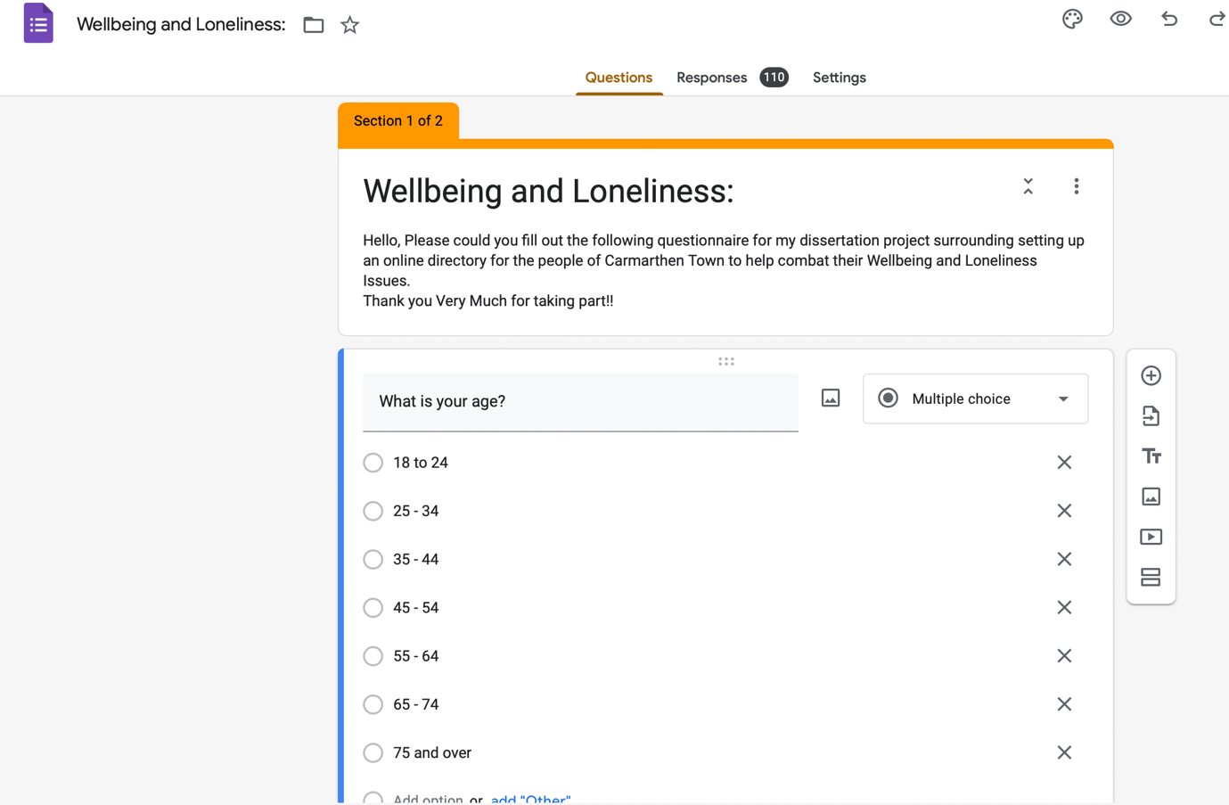

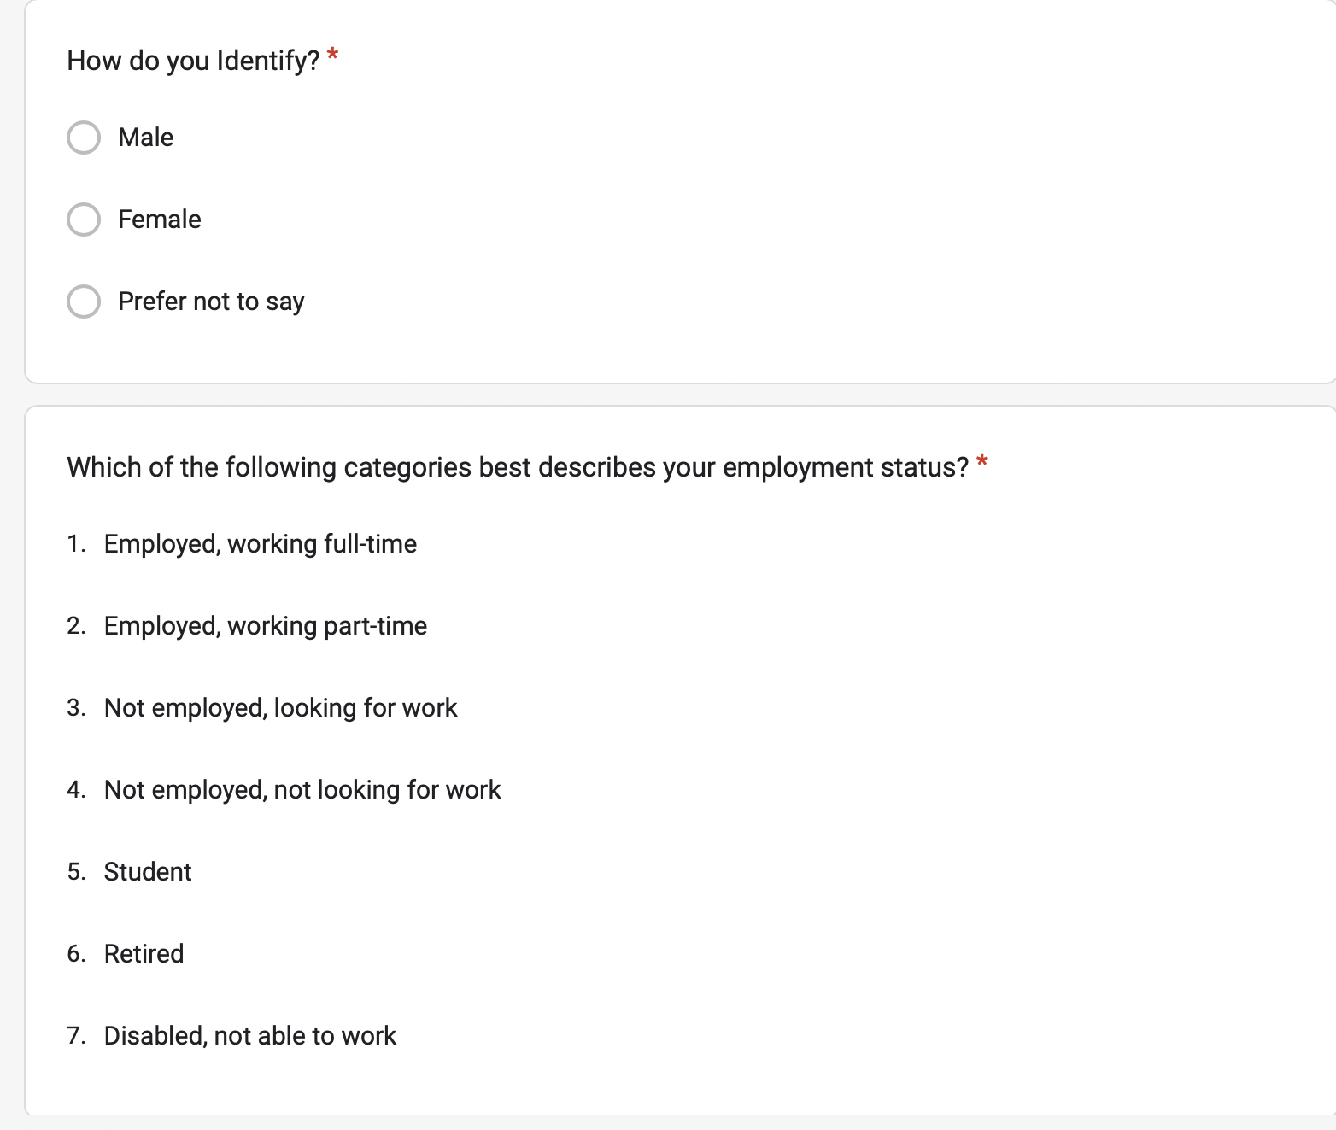

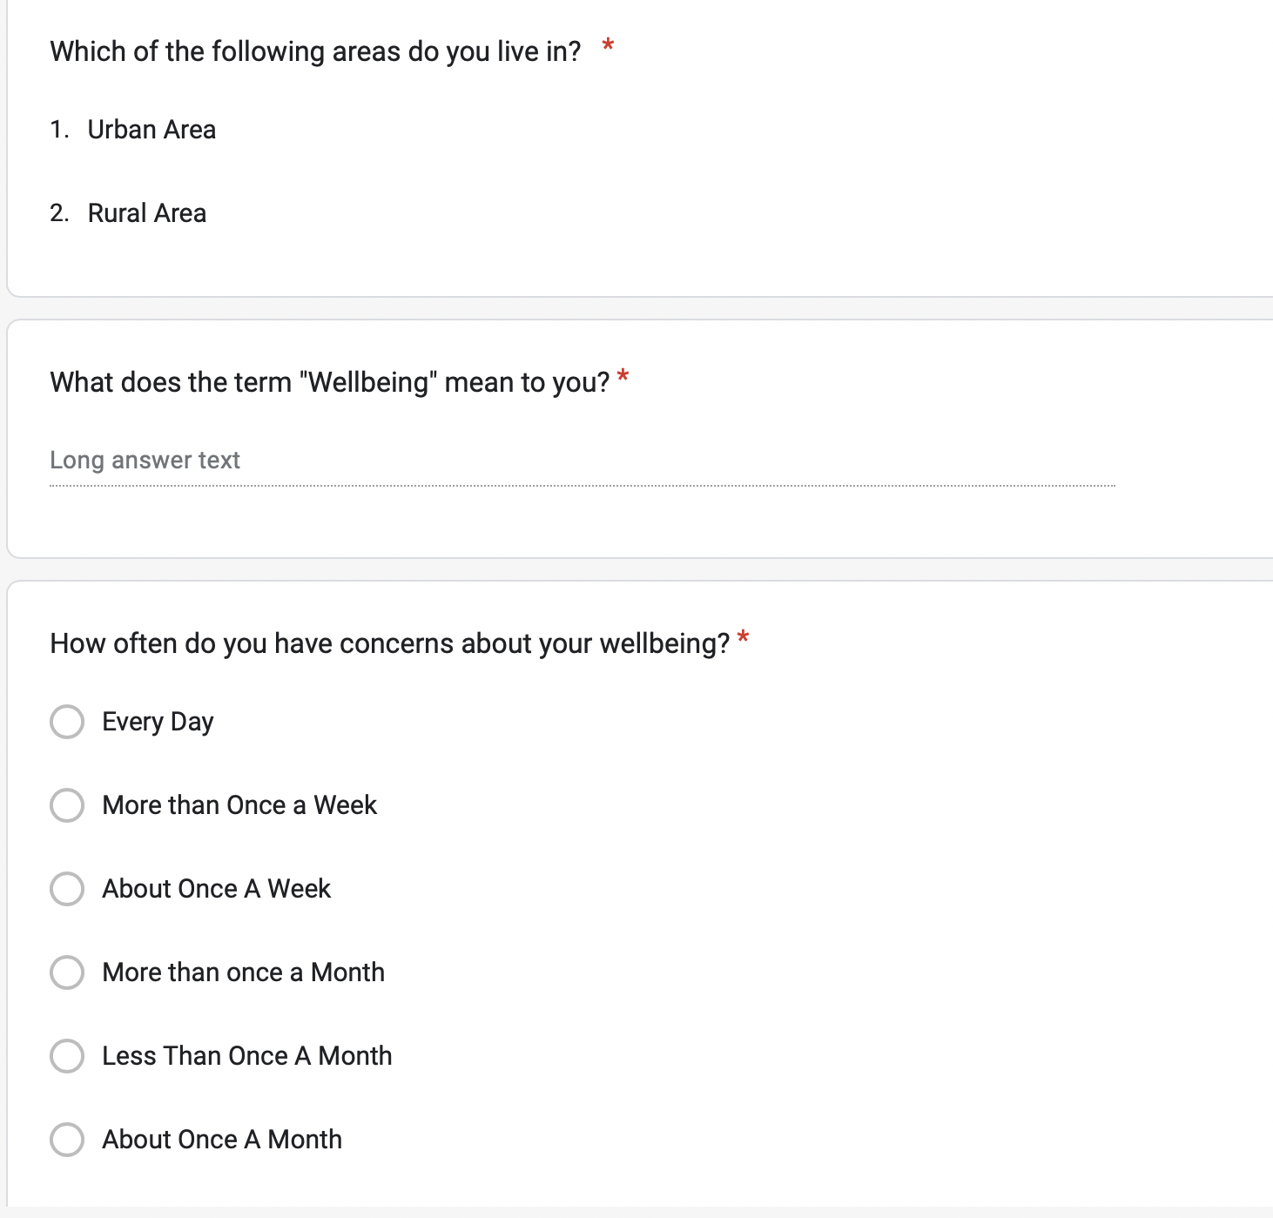

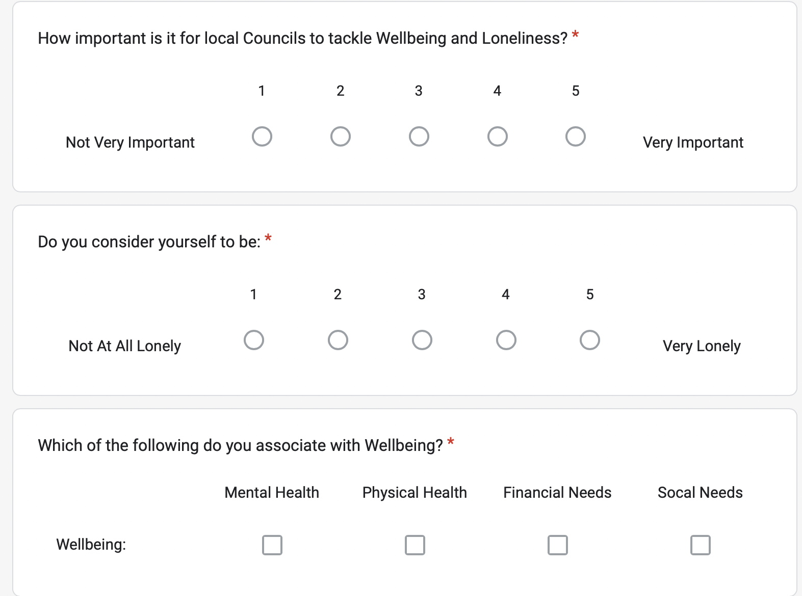

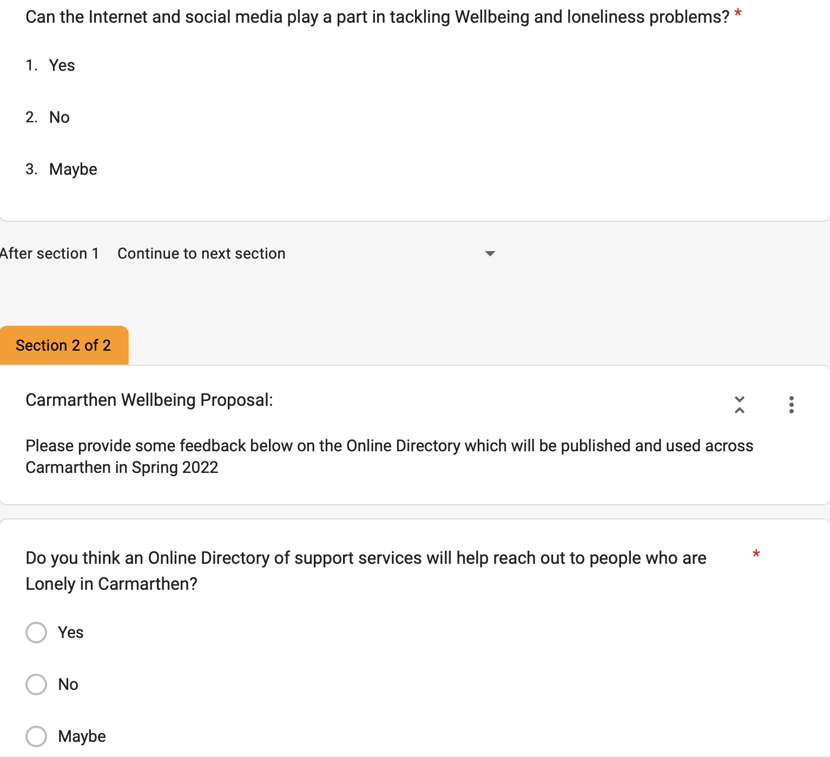

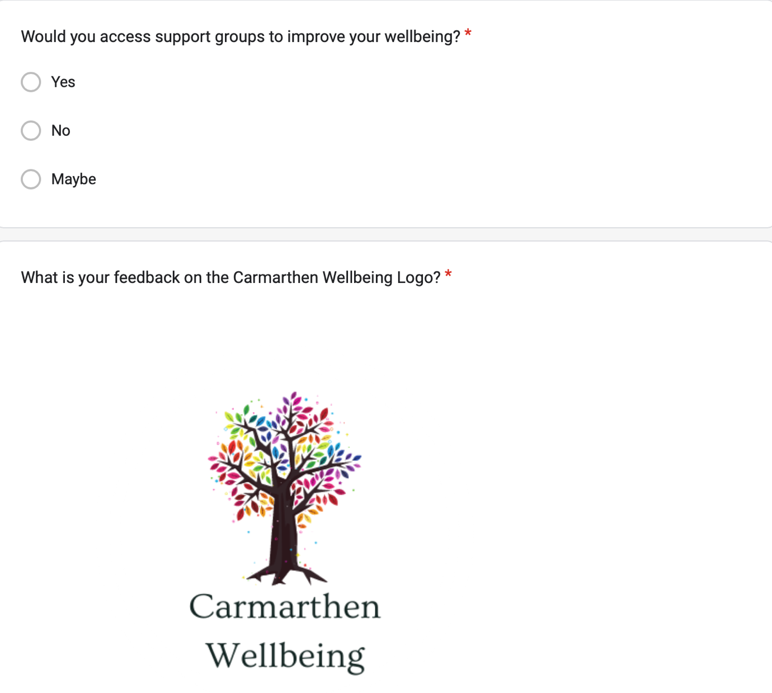

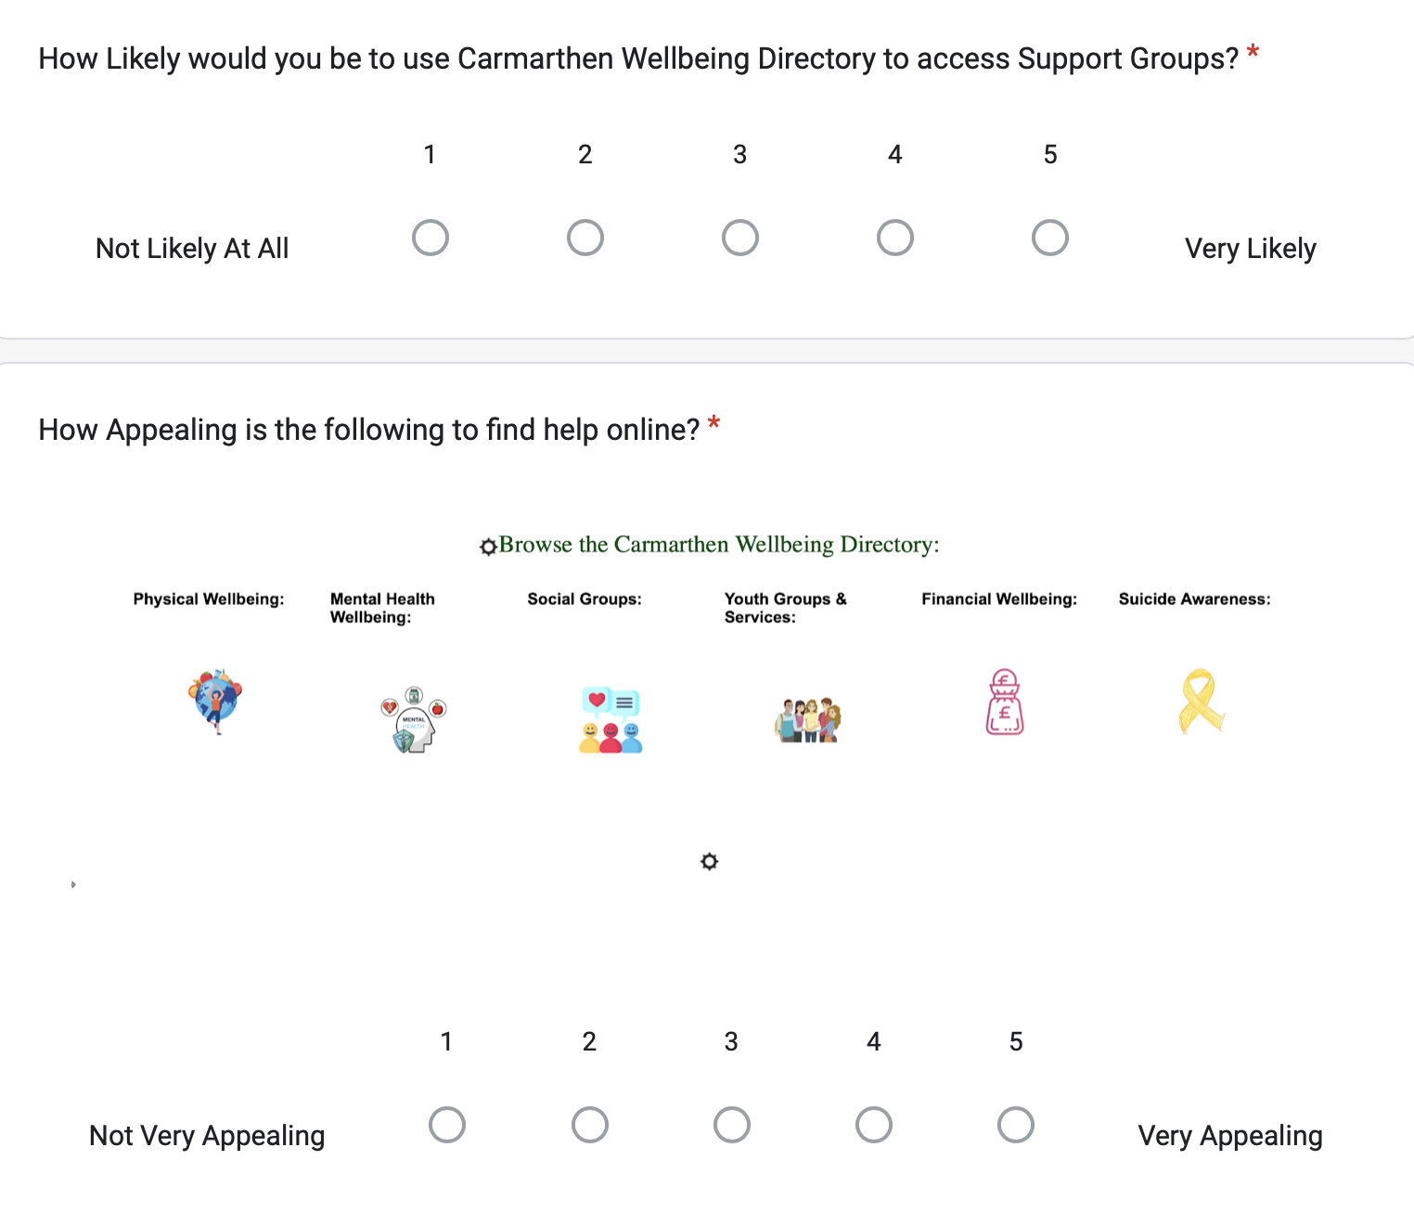

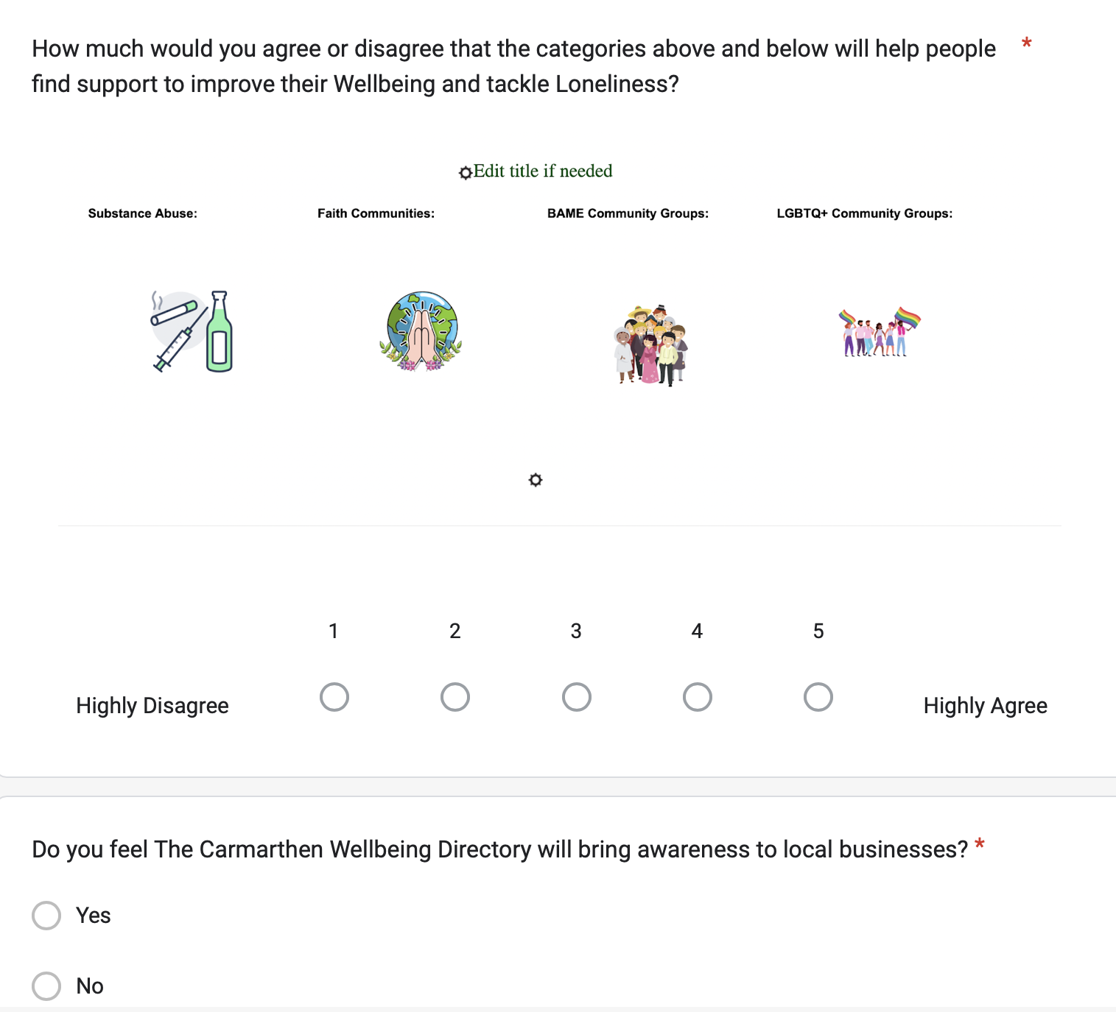

Appendix Two– Ethics Form:

APPLICATION FOR ETHICAL APPROVAL

In order for research to result in benefit and minimise risk of harm, it must be conducted ethically. A researcher may not be covered by the University’s insurance if ethical approval has not been obtained prior to commencement.

The University follows the OECD Frascati manual definition of research activity: “creative work undertaken on a systematic basis in order to increase the stock of knowledge, including knowledge of man, culture and society, and the use of this stock of knowledge to devise new applications”. As such this covers activities undertaken by members of staff, postgraduate research students, and both taught postgraduate and undergraduate students working on dissertations/projects.

The individual undertaking the research activity is known as the “principal researcher”.

Ethical approval is not required for routine audits, performance reviews, quality assurance studies, testing within normal educational requirements, and literary or artistic criticism.

Please read the notes for guidance before completing ALL sections of the form.

This form must be completed and approved prior to undertaking any research activity. Please see Checklist for details of process for different categories of application.

SECTION A: About You (Principal Researcher)
1 | Full Name: |  | Samuel James Rossiter
2 | Tick all boxes that apply: |  | Member of staff: | ☐ | Honorary research fellow: | ☐
 | Undergraduate Student | ☒ | Taught Postgraduate Student | ☐ | Postgraduate Research Student | ☐

3 | Institute/Academic Discipline/Centre: | University Of Wales Trinity Saint David
4 | Campus: | Carmarthen
5 | E-mail address: | Samuelrossiter99@gmail.com
6 | Contact Telephone Number: | 07496158093
 | For students:
7 | Student Number: | 1910129
8 | Programme of Study: | BA Business Management
9 | Director of Studies/Supervisor: | Jessica Shore

SECTION B: Approval for Research Activity
1 | Has the research activity received approval in principle?  (please check the Guidance Notes as to the appropriate approval process for different levels of research by different categories of individual) |  | YES | ☒ | NO | ☐
 |  |  |  |  | Date
2 | If Yes, please indicate source of approval (and date where known): Approval in principle must be obtained from the relevant source prior to seeking ethical approval | Research Degrees Committee |  | ☐
2 |  | Institute Research Committee |  | ☐
2 |  | Jessica Shore |  | ☒ | 02/02/22

SECTION C: Internal and External Ethical Guidance Materials
 | Please list the core ethical guidance documents that have been referred to during the completion of this form (including any discipline-specific codes of research ethics, location-specific codes of research ethics, and also any specific ethical guidance relating to the proposed methodology). Please tick to confirm that your research proposal adheres to these codes and guidelines. You may add rows to this table if needed.
1 | UWTSD Research Ethics & Integrity Code of Practice | ☒
2 | UWTSD Research Data Management Policy | ☒
3 | [List any other relevant documents here] | ☐

SECTION D: External Collaborative Research Activity
If there are external collaborators then you should gain consent from the contact persons to share their personal data with the university. If there are no external collaborators then leave this section blank and continue to section E.
1 | Institution
2 | Contact person name
3 | Contact person e-mail address
4 | Is your research externally funded? |  | YES | ☐ | NO |  | ☐
5 | Are you in receipt of a KESS scholarship? |  | YES | ☐ | NO |  | ☐
6 | Are you specifically employed to undertake this research in either a paid or voluntary capacity? | Voluntary | YES | ☐ | NO | ☐
7 |  | Employed | YES | ☐ | NO | ☐
8 | Is the research being undertaken within an existing UWTSD Athrofa Professional Learning Partnership (APLP)? | If YES then the permission question below does not need to be answered. | YES | ☐ | NO |  | ☐
9 | Has permission to undertake the research has been provided by the partner organisation? | (If YES attach copy)  If NO the application cannot continue | YES | ☐ | NO |  | ☐

Where research activity is carried out in collaboration with an external organisation
10 | Does this organisation have its own ethics approval system? | YES | ☐ | NO | ☐
 | If Yes, please attach a copy of any final approval (or interim approval) from the organisation (this may be a copy of an email if appropriate).

SECTION E: Details of Research Activity
1 | Indicative title:
2 | Proposed start date: | February 2022 | Proposed end date: | April 2022
Introduction to the Research (maximum 300 words per section)
Ensure that you write for a Non-Specialist Audience when outlining your response to the points below:
- Purpose of Research Activity
- Proposed Research Question
- Aims of Research Activity
- Objectives of Research Activity
Demonstrate, briefly, how Existing Research has informed the proposed activity and explain
- What the research activity will add to the body of knowledge
- How it addresses an area of importance.
3 | Purpose of Research Activity  The Research will be carried out using an anonymous questionnaire to gain an insight on the understanding on the term ‘wellbeing’ and ‘loneliness’ whilst also gathering feedback on an online directory.  This is for the purpose of gathering primary data for my dissertation.  (this box should expand as you type)
4 | Research Question  Carmarthen Wellbeing: An investigation into the need to develop a community-based Online Directory of Support services to combat Loneliness and Wellbeing Problems within Carmarthen Town  (this box should expand as you type)
5 | Aims of Research Activity  To find out the support and attitudes to an online directory.  (this box should expand as you type)
6 | Objectives of Research Activity  Collect primary data from potential users of the service.  (this box should expand as you type)
Proposed methods (maximum 600 words)
Provide a brief summary of all the methods that may be used in the research activity, making it clear what specific techniques may be used. If methods other than those listed in this section are deemed appropriate later, additional ethical approval for those methods will be needed. You do not need to justify the methods here, but should instead describe how you intend to collect the data necessary for you to complete your project.
7 | The method of questionnaire to collect primary data will be collected for the purpose to find out the support and attitudes of an online directory of access to support services.  (this box should expand as you type)
Location of research activity
Identify all locations where research activity will take place.
8 | All based on an online questionnaire using google forms with all personal information being kept anonymous.  (this box should expand as you type)
Research activity outside of the UK
If research activity will take place overseas, you are responsible for ensuring that local ethical considerations are complied with and that the relevant permissions are sought. Specify any local guidelines (e.g. from local professional associations/learned societies/universities) that exist and whether these involve any ethical stipulations beyond those usual in the UK (provide details of any licenses or permissions required). Also specify whether there are any specific ethical issues raised by the local context in which the research activity is taking place, for example, particular cultural and/or legal sensitivities or vulnerabilities of participants. If you live in the country where you will do the research then please state this.
9 | (this box should expand as you type)

10 | Use of documentation not in the public domain: Are any documents NOT publicly available? | NO | ☒
10 |  | YES | ☐
11 | If Yes, please provide details here of how you will gain access to specific documentation that is not in the public domain and that this is in accordance with the current data protection law of the country in question and that of England and Wales.  (this box should expand as you type)

 | Does your research relate to one or more of the seven aims of the Well-being of Future Generations (Wales) Act 2015? | YES | NO
12 | A prosperous Wales | ☐ | ☐
13 | A resilient Wales | ☐ | ☐
14 | A healthier Wales | ☒ | ☐
15 | A more equal Wales | ☐ | ☐
16 | A Wales of cohesive communities | ☒ | ☐
17 | A Wales of vibrant culture and thriving Welsh language | ☐ | ☐
18 | A globally responsible Wales | ☐ | ☐
19 | If YES to any of the above, please give details:
The research will help find out if there is support to bring together support services onto an online directory.

(this box should expand as you type)

SECTION F: Scope of Research Activity
 | Will the research activity include: | YES | NO
1 | Use of a questionnaire or similar research instrument? | ☒ | ☐
2 | Use of interviews? | ☐ | ☒
3 | Use of focus groups? | ☐ | ☒
4 | Use of participant diaries? | ☐ | ☒
5 | Use of video or audio recording? | ☐ | ☒
6 | Use of computer-generated log files? | ☐ | ☒
7 | Participant observation with their knowledge? | ☐ | ☒
8 | Participant observation without their knowledge? | ☐ | ☒
9 | Access to personal or confidential information without the participants’ specific consent? | ☐ | ☒
10 | Administration of any questions, test stimuli, presentation that may be experienced as physically, mentally or emotionally harmful / offensive? | ☐ | ☒
11 | Performance of any acts which may cause embarrassment or affect self-esteem? | ☐ | ☒
12 | Investigation of participants involved in illegal activities? | ☐ | ☒
13 | Use of procedures that involve deception? | ☐ | ☒
14 | Administration of any substance, agent or placebo? | ☐ | ☒
15 | Working with live vertebrate animals? | ☐ | ☒
16 | Procedures that may have a negative impact on the environment? | ☐ | ☒
17 | Other primary data collection methods. Please indicate the type of data collection method(s) below. | ☐ | ☒
 | Details of any other primary data collection method:  (this box should expand as you type) | ☐ | ☒
If NO to every question, then the research activity is (ethically) low risk and may be exempt from some of the following sections (please refer to Guidance Notes).

If YES to any question, then no research activity should be undertaken until full ethical approval has been obtained.

SECTION G: Intended Participants
If there are no participants then do not complete this section, but go directly to section H.

 | Who are the intended participants: | YES | NO
1 | Students or staff at the University? | ☐ | ☒
2 | Adults (over the age of 18 and competent to give consent)? | ☒ | ☐
3 | Vulnerable adults? | ☐ | ☒
4 | Children and Young People under the age of 18? (Consent from Parent, Carer or Guardian will be required) | ☐ | ☒
5 | Prisoners? | ☐ | ☒
6 | Young offenders? | ☐ | ☒
7 | Those who could be considered to have a particularly dependent relationship with the investigator or a gatekeeper? | ☐ | ☒
8 | People engaged in illegal activities? | ☐ | ☒
9 | Others. Please indicate the participants below, and specifically any group who may be unable to give consent. | ☐ | ☒
 | Details of any other participant groups:  (this box should expand as you type) | ☐ | ☒

Participant numbers and source
Provide an estimate of the expected number of participants. How will you identify participants and how will they be recruited?
10 | How many participants are expected? | 100 - 200  (this box should expand as you type)
11 | Who will the participants be? | General Public  (this box should expand as you type)
12 | How will you identify the participants? | Random through sharing questionnaire through social media.  (this box should expand as you type)

 | Information for participants: | YES | NO | N/A
13 | Will you describe the main research procedures to participants in advance, so that they are informed about what to expect? | ☒ | ☐ | ☐
14 | Will you tell participants that their participation is voluntary? | ☐ | ☐ | ☒
15 | Will you obtain written consent for participation? | ☐ | ☒ | ☒
16 | Will you explain to participants that refusal to participate in the research will not affect their treatment or education (if relevant)? | ☐ | ☐ | ☒
17 | If the research is observational, will you ask participants for their consent to being observed? | ☐ | ☐ | ☒
18 | Will you tell participants that they may withdraw from the research at any time and for any reason? | ☐ | ☐ | ☒
19 | With questionnaires, will you give participants the option of omitting questions they do not want to answer? | ☐ | ☐ | ☒
20 | Will you tell participants that their data will be treated with full confidentiality and that, if published, it will not be identifiable as theirs? | ☐ | ☐ | ☒
21 | Will you debrief participants at the end of their participation, in a way appropriate to the type of research undertaken? | ☐ | ☐ | ☒
22 | If NO to any of above questions, please give an explanation
 | (this box should expand as you type)

 | Information for participants: | YES | NO | N/A
24 | Will participants be paid? | ☐ | ☒ | ☐
25 | Is specialist electrical or other equipment to be used with participants? | ☐ | ☒ | ☐
26 | Are there any financial or other interests to the investigator or University arising from this study? | ☐ | ☒ | ☐
27 | Will the research activity involve deliberately misleading participants in any way, or the partial or full concealment of the specific study aims? | ☐ | ☒ | ☐
28 | If YES to any question, please provide full details
 | (this box should expand as you type)

SECTION H: Anticipated Risks

Outline any anticipated risks that may adversely affect any of the participants, the researchers and/or the University, and the steps that will be taken to address them.

If you have completed a full risk assessment (for example as required by a laboratory, or external research collaborator) you may append that to this form.
1 | Full risk assessment completed and appended? |  | Yes | ☐
1 |  |  | No | ☒
2 | Risks to participants  For example: sector-specific health & safety, emotional distress, financial disclosure, physical harm, transfer of personal data, sensitive organisational information
 | Risk to participants:  (this box should expand as you type) | How you will mitigate the risk to participants:  (this box should expand as you type)
3 | If research activity may include sensitive, embarrassing or upsetting topics (e.g. sexual activity, drug use) or issues likely to disclose information requiring further action (e.g. criminal activity), give details of the procedures to deal with these issues, including any support/advice (e.g. helpline numbers) to be offered to participants. Note that where applicable, consent procedures should make it clear that if something potentially or actually illegal is discovered in the course of a project, it may need to be disclosed to the proper authorities
 | (this box should expand as you type)
4 | Risks to the investigator  For example: personal health & safety, physical harm, emotional distress, risk of accusation of harm/impropriety, conflict of interest
 | Risk to the investigator:  (this box should expand as you type) | How you will mitigate the risk to the investigator:  (this box should expand as you type)
5 | University/institutional risks  For example: adverse publicity, financial loss, data protection
 | Risk to the University:  (this box should expand as you type) | How you will mitigate the risk to the University:  (this box should expand as you type)
6 | Environmental risks  For example: accidental spillage of pollutants, damage to local ecosystems
 | Risk to the environment:  (this box should expand as you type) | How you will mitigate the risk to environment:  (this box should expand as you type)

 | Disclosure and Barring Service
 | If the research activity involves children or vulnerable adults, a Disclosure and Barring Service (DBS) certificate must be obtained before any contact with such participants. | YES | NO | N/A
7 | Does your research require you to hold a current DBS Certificate? | ☐ | ☒ | ☐
8 | If YES, please give the certificate number. If the certificate number is not available please write “Pending”; in this case any ethical approval will be subject to providing the appropriate certificate number.

SECTION I: Feedback, Consent and Confidentiality

1 | Feedback  What de-briefing and feedback will be provided to participants, how will this be done and when?
I will thank them for taking part in the questionnaire.

(this box should expand as you type)
2 | Informed consent  Describe the arrangements to inform potential participants, before providing consent, of what is involved in participating. Describe the arrangements for participants to provide full consent before data collection begins. If gaining consent in this way is inappropriate, explain how consent will be obtained and recorded in accordance with prevailing data protection legislation.
All data is anonymous – nothing personal is asked.

(this box should expand as you type)
3 | Confidentiality / Anonymity  Set out how anonymity of participants and confidentiality will be ensured in any outputs. If anonymity is not being offered, explain why this is the case.
The questionnaire does not ask any personal information from people.

(this box should expand as you type)

SECTION J: Data Protection and Storage

 | Does the research activity involve personal data (as defined by the General Data Protection Regulation 2016 “GDPR” and the Data Protection Act 2018 “DPA”)? | YES | NO
1 | “Personal data” means any information relating to an identified or identifiable natural person (‘data subject’). An identifiable natural person is one who can be identified, directly or indirectly, in particular by reference to an identifier such as a name, an identification number, location data, an online identifier or to one or more factors specific to the physical, physiological, genetic, mental, economic, cultural or social identity of that natural person. Any video or audio recordings of participants is considered to be personal data. | √ | ☐
 | If YES, provide a description of the data and explain why this data needs to be collected:
2 | All data will be contained and secured by means of password protected access and will only be able to be accessed from one laptop.  (this box should expand as you type)
 | Does it involve special category data (as defined by the GDPR)? | YES | NO
3 | “Special category data” means sensitive personal data consisting of information as to the data subjects’ –  (a) racial or ethnic origin,  (b) political opinions,  (c ) religious beliefs or other beliefs of a similar nature,  (d) membership of a trade union (within the meaning of the Trade Union and Labour Relations (Consolidation) Act 1992),  (e) physical or mental health or condition,  (f) sexual life,  (g) genetics,  (h) biometric data (as used for ID purposes), | ☐ | √
 | If YES, provide a description of the special category data and explain why this data needs to be collected:
4 | (this box should expand as you type)

 | Will data from the research activity (collected data, drafts of the thesis, or materials for publication) be stored in any of the following ways? | YES | NO
5 | Manual files (i.e. in paper form)? | ☐ | ☒
6 | University computers? | ☐ | ☒
7 | Private company computers? | ☐ | ☒
8 | Home or other personal computers? | ☒ | ☐
9 | Laptop computers/ CDs/ Portable disk-drives/ memory sticks? | ☐ | ☒
10 | “Cloud” storage or websites? | ☐ | ☒
11 | Other – specify: | ☐ | ☒
12 | For all stored data, explain the measures in place to ensure the security of the data collected, data confidentiality, including details of backup procedures, password protection, encryption, anonymisation and pseudonymisation:
 | (this box should expand as you type)

 | Data Protection
 | Will the research activity involve any of the following activities: | YES | NO
13 | Electronic transfer of data in any form? | ☒ | ☐
14 | Sharing of data with others at the University outside of the immediate research team? | ☐ | ☒
15 | Sharing of data with other organisations? | ☐ | ☒
16 | Export of data outside the UK or importing of data from outside the UK? | ☐ | ☒
17 | Use of personal addresses, postcodes, faxes, emails or telephone numbers? | ☐ | ☒
18 | Publication of data that might allow identification of individuals? | ☐ | ☒
19 | Use of data management system? | ☐ | ☒
20 | Data archiving? | ☐ | ☒
21 | If YES to any question, please provide full details, explaining how this will be conducted in accordance with the GDPR and Data Protection Act (2018) (and any international equivalents, where appropriate):
 | (this box should expand as you type)
22 | List all who will have access to the data generated by the research activity:
 | (this box should expand as you type)
23 | List who will have control of, and act as custodian(s) for, data generated by the research activity:
 | (this box should expand as you type)
24 | Give details of data storage arrangements, including security measures in place to protect the data, where data will be stored, how long for, and in what form. Will data be archived – if so how and if not why not.
 | (this box should expand as you type)
25 | Please indicate if your data will be stored in the UWTSD Research Data Repository (see https://researchdata.uwtsd.ac.uk/ ). If so please explain. (Most relevant to academic staff)
 | (this box should expand as you type)
26 | Confirm that you have read the UWTSD guidance on data management (see https://www.uwtsd.ac.uk/library/research-data-management/) | YES | ☒
27 | Confirm that you are aware that you need to keep all data until after your research has completed or the end of your funding | YES | ☒

SECTION K: Declaration
The information which I have provided is correct and complete to the best of my knowledge. I have attempted to identify any risks and issues related to the research activity and acknowledge my obligations and the rights of the participants.

In submitting this application I hereby confirm that I undertake to ensure that the above named research activity will meet the University’s Research Ethics and Integrity Code of Practice which is published on the website: https://www.uwtsd.ac.uk/research/research-ethics/
1 | Signature of applicant: | S, J, Rossiter | Date:02/02/22

For STUDENT Submissions:
2 | Director of Studies/Supervisor: | Jessica Shore | Date:
3 | Signature: |  | Date:

For STAFF Submissions:
4 | Academic Director/ Assistant Dean: |  | Date:
5 | Signature: |  | Date:

Checklist: Please complete the checklist below to ensure that you have completed the form according to the guidelines and attached any required documentation:
☐ | I have read the guidance notes supplied before completing the form.
☒ | I have completed ALL RELEVANT sections of the form in full.
☒ | I confirm that the research activity has received approval in principle
☒ | I have attached a copy of final/interim approval from external organisation (where appropriate)
☒ | I have attached a full risk assessment (where appropriate) ONLY TICK IF YOU HAVE ATTACHED A FULL RISK ASSESSMENT
☒ | I understand that it is my responsibility to ensure that the above named research activity will meet the University’s Research Ethics and Integrity Code of Practice.
☒ | I understand that before commencing data collection all documents aimed at respondents (including information sheets, consent forms, questionnaires, interview schedules etc.) must be confirmed by the DoS/Supervisor, module tutor or Academic Director.

RESEARCH STUDENTS AND STAFF ONLY
All communications relating to this application during its processing must be in writing and emailed to pgresearch@uwtsd.ac.uk , with the title ‘Ethical Approval’ followed by your name.
You will be informed of the outcome of your claim by email; therefore it is important that you check your University and personal email accounts regularly.
STUDENTS ON UNDERGRADUATE OR TAUGHT MASTERS PROGRAMMES should submit this form (and receive the outcome) via systems explained to you by the supervisor/module leader.

This form is available electronically from the Academic Office web pages: https://www.uwtsd.ac.uk/academic-office/appendices-and-forms/

Appendix Three – 1st Comparison Graph

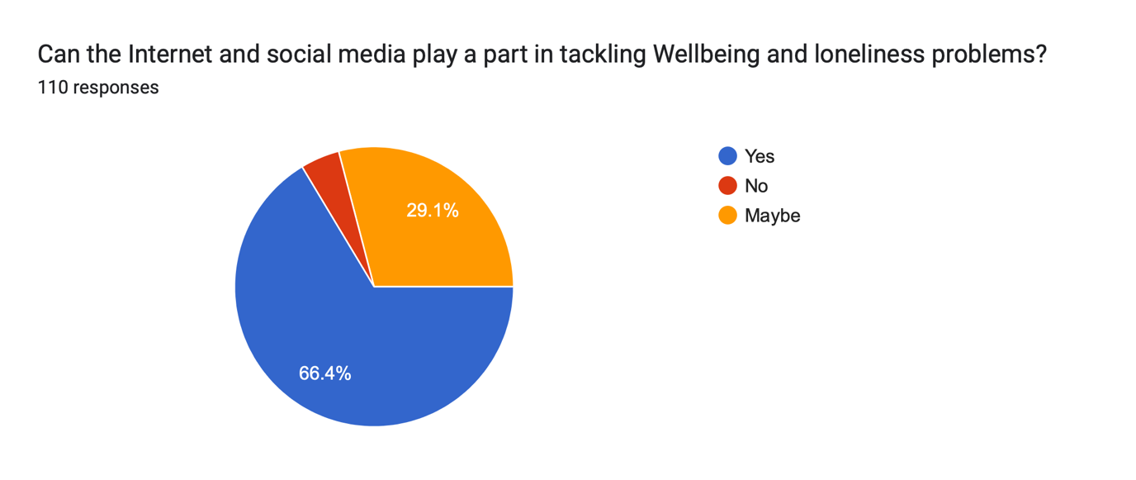
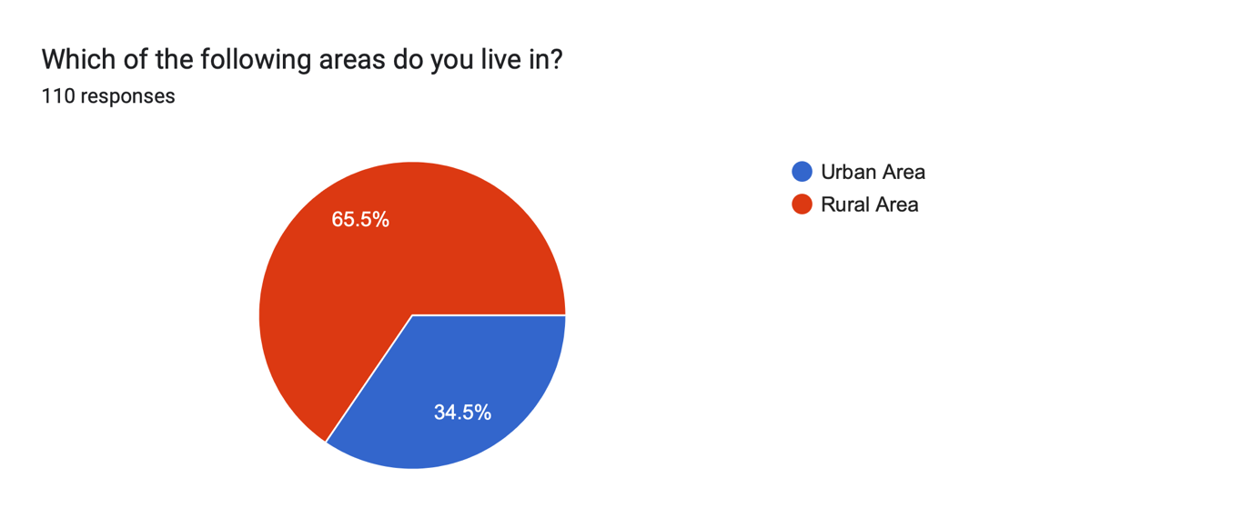

Appendix Four: 2nd Comparison Graph

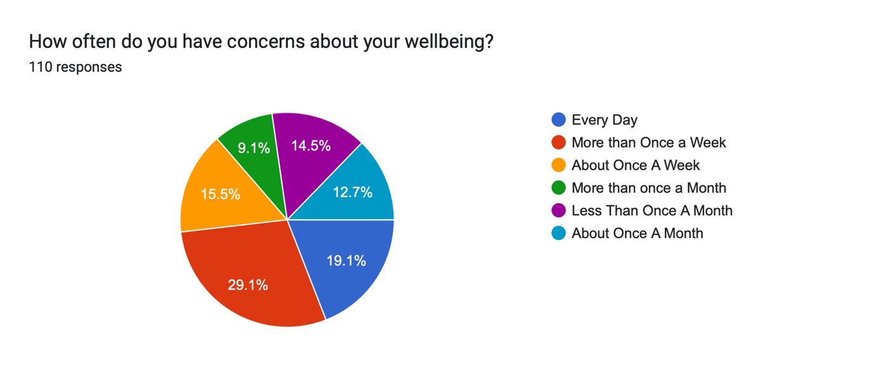

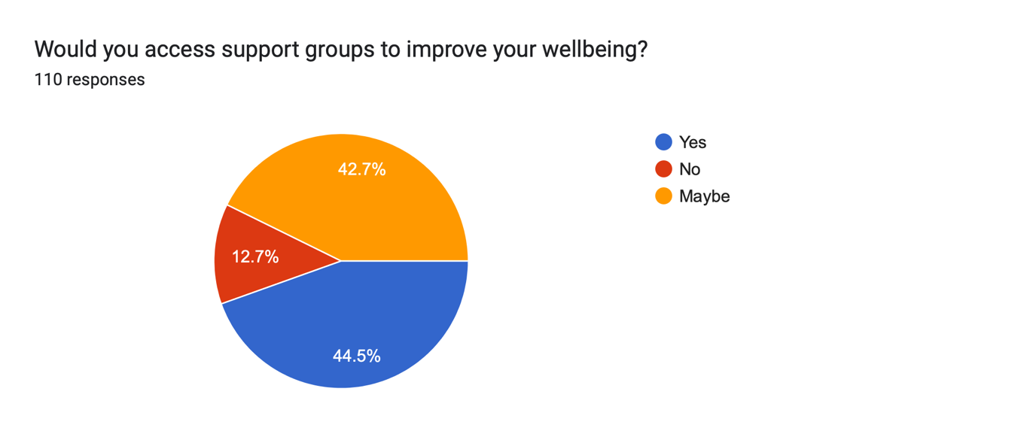

Appendix Five: 3rd Comparison Graph:



