Report Case Study: The City Hotel
BMIH5007: Financial Management for the Hotel Industry
Student Name: Rekha Begum
Student ID: 2125644
Lecturer: Tristan Hawkins

Contents
Introduction 4
Financial Performance Analysis (Past Three Years) 4
Revenue Trends 4
Expenses Trends 5
Profitability Analysis 5
Liquidity Analysis 6
Solvency Analysis 7
Key Reasons Behind Decline in Profitability 8
Turnaround Strategy Proposal for The City Hotel 10
Conclusion 13
References 14
Appendices 16

Table 1: Profitability Analysis 5
Table 2: Liquidity Analysis 6
Table 3: Solvency Analysis 7

Figure 1: Revenue Trends 4
Figure 2: Cost Structure 5
Figure 3: Profitability Ratios 6
Figure 4: Liquidity Ratios 7
Figure 5: Solvency Ratios 8

Introduction
The City Hotel has been in operation for many years as a leading hospitality business within a major city and has offered the local and traveling public with a restaurant, bar, and banquet services. Nonetheless, current financial statements indicate that there is slow revenue growth, low occupancy rates, and dissatisfied customers caused chiefly by increased costs, increased competition, and possibly customers’ unsatisfied expectations. In this paper, the hotel’s financial position is evaluated in an attempt to analyze its performance indicators, determine factors leading to poor performance and suggest a plan of action that would help the hotel improve its operations and regain its competitiveness.

Financial Performance Analysis (Past Three Years)

Revenue Trends
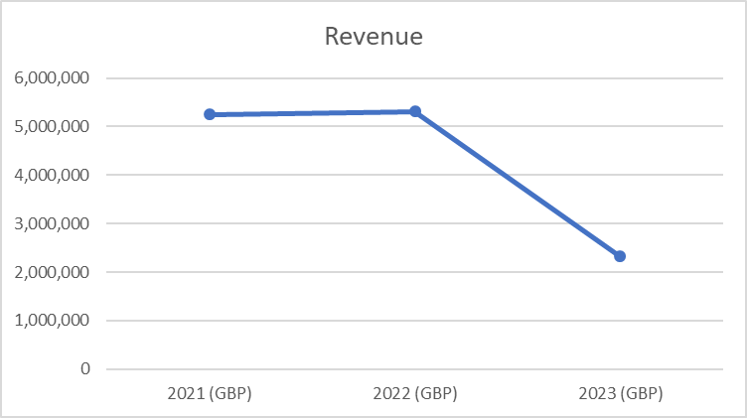
Figure 1: Revenue Trends
There have been big changes in The City Hotel's income over the last three years. It made about £5.25 million in 2021 and £5.31 million in 2022, a small rise from the previous year. But in 2023, sales dropped sharply, to about £2.32 million, which was less than half of what they made the previous year. This sudden drop might be because of a number of things, such as changes in how customers behave, more intense competition, and bigger problems in the economy, which could be made worse by inflationary pressures or changes in travel and hotel demand after the pandemic.

Expenses Trends
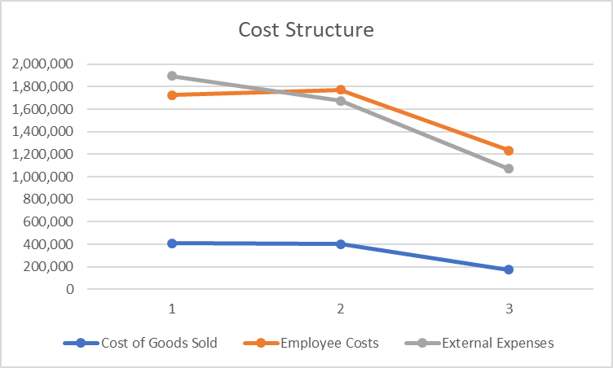
Figure 2: Cost Structure
The City Hotel's operational expenses have significantly changed within the past three years. In 2021, the largest expense remained at £1.72 million, which was related to staff. In 2022, they increased slightly to £1.77 million, but in 2023, they decreased significantly to £1.23 million. External costs also had a similar pattern, falling from £1.89 million in 2021 to £1.68 million the following year and finally to £1.07 million the following year. Between 2021 and 2023, it increased from £411,600 to £176,250. A decrease was also noted in the cost of goods sold (COGS). The precipitous decline in revenue, particularly in 2023, is probably causing these expenses to decline. In an effort to alleviate its financial woes, the hotel may be implementing cost-cutting measures.

Profitability Analysis
Gross Profit | 4,836,690 | 4,905,970 | 2,149,190
Operating Profit | 664,160 | 674,730 | -1,218,850
Gross Profit Margin= (Gross Profit/Revenue)*100 | 92.16% | 92.44% | 92.42%
Operating Profit Margin = (Operating Profit/Revenue)*100 | 12.65% | 12.71% | -52.41%
Table 1: Profitability Analysis
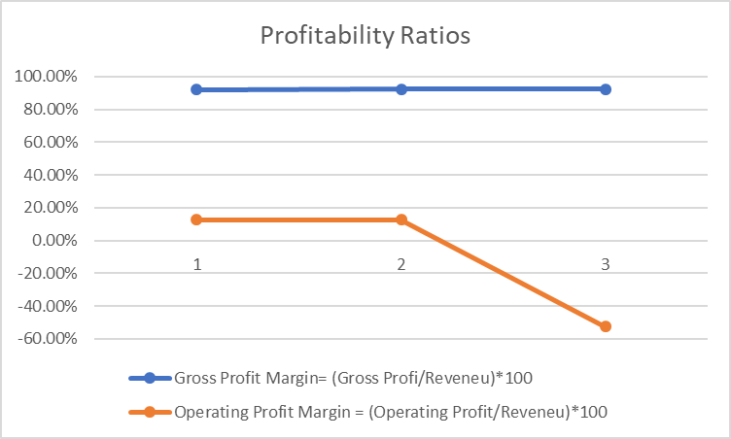
Figure 3: Profitability Ratios
The City Hotel's gross and operational profit margins reveal significant patterns and issues with its profitability. The hotel was able to retain its profits after deducting the cost of goods supplied from 2021 to 2023, as evidenced by a gross profit margin that remained above 92%. However, in 2023, the operational profit margin dropped to -52.41% from 12.65% in 2021. Due to the rapid decline in the operating margin, it is evident that organizational issues and unnecessary expenditure are intensifying. Efforts to reduce expenses resulted in negative operational profit in 2023 due to decreasing sales and ongoing costs. This indicates that there are major issues with profitability that require immediate attention in order to resolve them permanently.

Liquidity Analysis
Item | 2021 (GBP) | 2022 (GBP) | 2023 (GBP)
Current Asset | 1,891,970 | 1,965,340 | 1,285,880
Current Liability | 1,957,360 | 2,107,750 | 2,014,600
Inventory | 35,230 | 36,350 | 29,470
Current Ratio | 0.97 | 0.93 | 0.64
Quick Ratio = (Current Asset-Inventory)/Current Liabilities | 0.95 | 0.92 | 0.62
Table 2: Liquidity Analysis
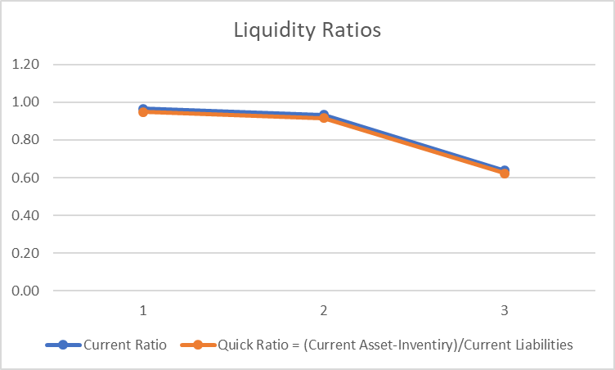
Figure 4: Liquidity Ratios
The City Hotel's ability to satisfy its short-term obligations has diminished during the previous three years, according to its liquidity assessment. From 0.97 in 2021 to 0.93 in 2022 and finally to 0.64 in 2023, the hotel's current ratio declined, indicating a decline in its ability to service its current debts with its current assets. Also, from 0.95 in 2021 to 0.92 in 2022 and then even lower to 0.62 in 2023, the quick ratio—which does not include inventory as present assets—went through a similar decline. A decline in these percentages indicates that the hotel is struggling to meet its short-term financial obligations. Due to the precipitous decline in 2023, the business may have to increase its use of short-term loans or seek funding from other sources.

Solvency Analysis
Item | 2021 (GBP) | 2022 (GBP) | 2023 (GBP)
Total Debt | 10,684,940 | 13,338,050 | 14,243,390
Equity | 2,256,180 | 2,583,030 | 1,410,580
Total Asset | 12,941,110 | 15,921,080 | 15,653,970
Debt-to-Equity (D/E) | 4.74 | 5.16 | 10.10
Debt-to-Asset (D/A) | 0.83 | 0.84 | 0.91
Equity Ratio (E/A) | 0.17 | 0.16 | 0.09
Table 3: Solvency Analysis
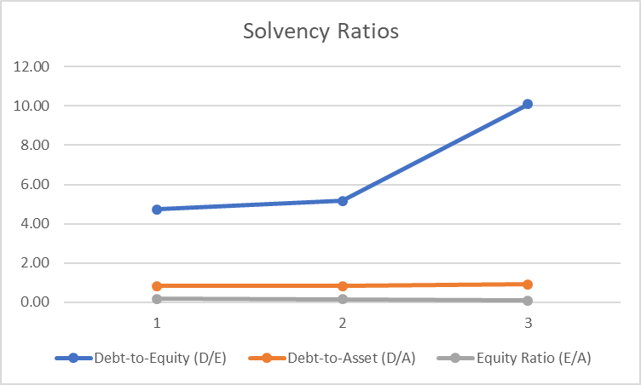
Figure 5: Solvency Ratios
The city hotel's solvency metrics from 2021 to 2023 show a worrying trend about how stable its finances are. In 2023, the debt-to-equity (D/E) ratio is 10.10, which is much higher than the 4.74 ratio in 2021. The fact that the hotel relies on debt financing instead of stock worries me about its long-term financial health. There has been an increase in the debt-to-asset ratio as well. An increase from 0.83 in 2021 to 0.91 in 2023 indicates that a larger portion of the hotel's assets will be financed through debt. The owners' authority over the hotel's assets is becoming increasingly limited as the Equity Ratio (E/A) drops from 0.17 in 2021 to a meagre 0.09 in 2023. The hotel's increasing debt levels, as shown by these solvency ratios, may make it increasingly difficult for it to satisfy its long-term financial commitments and may potentially threaten its overall financial health if this trend persists.

Key Reasons Behind Decline in Profitability
The decrease in the profitability of The City Hotel can be attributed to the following internal and external characteristics that need to be analyzed in the frame of the current real-life happening and present economic environment. This paper compares and contrasts the industry’s gross profit margin ratio and the operating profit margin ratio, which offer valuable information in these aspects.
- COVID-19 Aftermath: The global COVID-19 virus greatly affected the industry of hospitality, so occupancy and revenues decreased. The City Hotel recorded gross profit margin that was above the 92% for the years 2021 to 2023, although the operating profit margin greatly reduced from 12.65% in 2021 to -52.41% in 2023 due to negative operating cash flows inferring a problem in operational management even though the revenue is constant with the total amount of cost of goods sold. With the relaxation of COVID-19 travel limitations, hotel structures were unable to cope with alterations in consumer preferences thus affect demand (Rukmiyati, 2024).
- Increased Competition: Airbnb is another major threat because it provides cheap and flexible accommodation forcing this hotel to reduce on its prices. This is evidenced by a decrease in the income from £5.31 million in 2022 to £2.32 million in 2023 due to competitive price strategies (Ognjanovic et al., 2023).
- Rising Operating Expenses: Among the factors which have pulled down profitability levels include a significant rise in operating expenses especially on personnel and utilities. the employees expenses were still high influenced by escalating payroll constraints where expenses are increased than revenues in accord with Schalk-Nador and Rašovská, (2024). Some basic expenses were decreased even in 2023, however, such approach to the reduction of revenues does not look like a proper long-term strategy.
- Changing Consumer Expectations: As concerns for service quality and experience have risen, there has been a tendency in the decrease customer satisfaction levels. Although the hotel displays operational stability evidenced by constant gross profit margin, increasing depreciation, cost of sales owing to high standards of services reduce the general operating margin (Candra et al., 2023).
- Economic Uncertainty: Consumer behaviour trends also betray producers and general operational costs such as inflation, reduced on a discretionary basis items such as travel impacting on occupancy rates and profitability. The value of the operating profit margin has decreased showing that the hotel cannot properly manage the fluctuations in demand in this environment (Santa et al., 2023).
- Asset Management Issues: The hotel’s Debt to equity ratio is set to increase from 4.74 in 2021 to 10.10 by 2023 which is a clear show that the hotel relies so much on debt to finance its operations thus putting a lot of pressure on cash flows and operational efficiency. Creditors, therefore, argues that elevated levels of debt will cause high interest costs and weaken profit margins (KIWANGO, 2023).
Therefore, the results have shown that the poor profitability experienced in The City Hotel is due to the external and internal factors, which includes the effects of COVID-19, the intensification of competition, the increase in operating expenses, changing customer preferences, uncertain economic conditions. That was once a good sign of the hotel’s gross profit margin but the question is how much of that revenue the hotel has been able to utilise as operational profit; the revealing answer is very little and it has compounded the strategic problem of destination hotels that needs urgent corrective actions to guarantee competitiveness and profitability.

Turnaround Strategy Proposal for The City Hotel
A high level of strategic direction, revenue growth, operating expense reduction, and the customer value improvement, as well as the financial restructuring programmed is absolutely necessary to reignite the financial vitality, and restore credibility of The City Hotel. The following sections outline these components in detail:
Strategic Objectives
The key turnaround goals for The City Hotel should include:
- Increasing Revenue: Plan and execute more specific marketing activities that should generate at least 15% increase in revenues over the three-year period.
- Improving Cost Efficiency: Cut overhead expenses by 10% in the course of the first fiscal year by introducing the effective methods of selecting suppliers as well as through the optimization of different production stages.
- Enhancing Customer Satisfaction: Sustain a customer satisfaction rate not less than 85% as established from customers’ feedbacks and ratings.
- Restoring Brand Reputation: New and experienced customers need to be regained through a well-executed marketing campaign accompanied by bettering the quality of services offered.
Revenue Enhancement Initiatives
- Market Repositioning:
  - Choose certain kinds of clients for example businessmen, people who are oriented on ecotourism or families looking for cheap hotel rooms. Promotion strategies must be offered according to those segments’ needs for better results (Qiong, 2022).
- New Services and Offerings:
  - Zero down on more packages according to the requirement of the customers like weekend breakup, corporate house, family reunion etc.
  - Organize loyalty programs that could include provisions for free access to promising being spaces, access to the rooms without having to pay before, or free upgrades of certain kinds that customers frequent most.
  - Provide loyalty programs with local restaurants and tour operators or dealers to drive extra value added for guests and hotel (Wambua and Muthimi, 2024).
- Digital Marketing Strategy:
  - Strengthen the hotel’s internet profile, with a new website and improved booking system that adapts the page to the customers’ mobile devices.
  - Optimise website for search engines in an attempt to have high ranking on search engine results pages and consequently more traffic for the hotels’ website.
  - Increased and maximized presence in social media sites to promote specific advertising messages such as special services to be offered for public use as well as to respond to interested guests through constant feed updates (Martorell Cunill et al., 2024).
Operational Cost Reduction
- Resource Optimization:
  - Here, install energy-conserving programmes like LED lights and Energy efficient air condition systems to cut expenses on power consumption.
  - Reduce the cost of important products and services by concluding improved contracts with the providers.
  - Carry out a study of labour productivity in order to confirm whether existing staffing levels are sufficient, and exploring possibly the use of multi-tasking employees (Dureja, 2022).
- Process Improvements:
  - Simplify work performance in housekeeping with improved methods of cleaning and time management.
  - Increase the profitability of food and beverage service by improving the choice and minimizing loss.
  - Optimize event management schedules to achieve the best results in the delivery of an event free from excessive expenses (Rahmi et al., 2022).
Customer Experience Enhancement
- Service Quality:
  - Provide customer service staff training that enhances the overall guest relations service delivery, conflict handling abilities and hospitalities best practice to improve the visitors’ experience.
  - It is advisable that various facilities be kept clean and up to date as far as today’s standards are concerned primarily in a bid to counter some of the most common issues that are pronounced by customers specifically in regard to hygiene and service delivery (Aydogan et al., 2024).
- Feedback Loop:
  - Create an effective program that would allow collecting guest feedback including surveys, online reviews, and messages.
  - Maximize feedback data to assess for opportunities for change and development and enhance the appreciation that guests receive (Natarajan and Kumari, 2022).
Financial Restructuring
- Debt Management:
  - Look into being able to pay off existing debt and getting better interest rates that may help with payment.
  - As for the weak working capital position, offer creditors longer repayment periods or partial debt writeoff to increase the company’s cash flow.
  - Looking at the balance sheet, there are prospects of debt cutting through strategic or disposals of non-strategic or non-generating resources through selloffs (Hedén, 2024).
- Cash Flow Management:
  - Establish stronger cash flow regulation by controlling cash receipts and expenditures more keenly, and show expenses proportional to revenues (Deb and Ahmed, 2022).

Conclusion
The City Hotel has managed to record declined financial performance with deteriorating revenues, incrementing debt, and lowered profitability because of the increased competition, inadequate operation strategies, and changing consumer trends. To respond to these challenges, the proposed turnaround plan focuses on revenue replenishment, organizational rebranding, reduction of costs for operations, and customer satisfaction. If it is properly deployed, it seems rather sustainable given the current approaches on the market. Current priorities on the other hand include enhancing digital marketing in the first three to six months, followed by enhancing quality of service through a good feedback system. If the results are not enough after the year, other possibilities like a partnership or a sale, should be considered in order to get the best conditions for the owner.

References
Aydogan, M., de Esteban Curiel, J., Antonovica, A. and Cetin, G., (2024). Characteristics of crises resilient organizations in the hospitality and tourism industry. International Journal of Contemporary Hospitality Management, 36(4), pp.1432-1453.
Candra, P., Mahaputra, M.R. and Mahaputra, M.R., (2023). Service Quality and Customer Satisfaction Have an Impact on Increasing Hotel Room Occupancy Ratio: Literature Review Study. Greenation International Journal of Tourism and Management, 1(4), pp.400-412.
Deb, S.K. and Ahmed, S., (2022). Managing post Covid-19 crisis in the tourism and hospitality sector through sustainable recovery strategies. GeoJournal of Tourism and Geosites, 43(3), pp.993-1004.
Dureja, R., (2022). Survival Strategies during COVID-19-A Case Study of Stellar Hotel. Available at SSRN 4027178.
Hedén, S., (2024). Innovation strategies and corporate entrepreneurship in Northern Europe, Scandic Hotels: A case study of the pandemic effect on the Swedish revenue management. In Corporate Entrepreneurship and Innovation in Tourism and Hospitality (pp. 81-90). Routledge.
KIWANGO, A.O., (2023). EXAMINING THE IMPACT OF CAPITAL STRUCTURE ON THE PROFITABILITY OF TOURISM COMPANIES (Doctoral dissertation, IAA).
Martorell Cunill, O., Otero, L., Durán Santomil, P. and Gil Lafuente, J., (2024). Analysis of the effect of growth strategies and hotel attributes on performance. Management Decision.
Natarajan, V. and Kumari, R., (2022), December. Hospitality Industry 4.0-Customize and Optimize Real-Time Allocation of Rooms. In 2022 International Conference on Computational Science and Computational Intelligence (CSCI) (pp. 1895-1900). IEEE.
Ognjanovic, J., Dzenopoljac, V. and Cavagnetto, S., (2023). Intellectual capital before and during COVID-19 in the hotel industry: the moderating role of tangible assets. Journal of Hospitality and Tourism Insights, 6(5), pp.2484-2505.
Qiong, L., (2022). Turnaround strategies and performance of three-star hotels in Kenya (Doctoral dissertation, Strathmore University).
Rahmi, N.U., Wulandari, B. and Dewantoro, R.W., (2022). Sustainability Strategy Implementation by Hotel Management during Pandemic. NeuroQuantology, 20(15), p.2147.
Rukmiyati, S., (2024), May. Thriving Through Turbulance: A Case on Hotel Financial Performance Post-Pandemic. In THE 4TH INTERNATIONAL HOSPITALITY ENTREPRENEURSHIP AND INNOVATION CONFERENCE 2024 (p. 136).
Santa, R., Rodríguez Victoria, O.E. and Tegethoff, T., (2023). The role of quality in the hotel sector: the interplay between strategy, innovation and outsourcing to achieve performance. The TQM Journal.
Schalk-Nador, S.V. and Rašovská, I., (2024). Opportunities for the United States hotel industry to recover from COVID-19: a multi-period DEA analysis of key efficiency determinants. Journal of Hospitality and Tourism Insights, 7(1), pp.189-206.
Wambua, R.W. and Muthimi, J., (2024). Revitalizing Performance of Three Star Hotels in Machakos County, Kenya Through the Application of Turnaround Strategies. Journal of Strategic Management, 4(2), pp.32-49.

Appendices
Appendix 1: Income Statement and Profitability Ratios
Income Statement
Item | 2021 (GBP) | 2022 (GBP) | 2023 (GBP)
Revenue | 5,248,290 | 5,307,480 | 2,325,440
Cost of Goods Sold | 411,600 | 401,510 | 176,250
Employee Costs | 1,724,760 | 1,770,700 | 1,233,160
External Expenses | 1,894,720 | 1,675,410 | 1,071,030
Taxes and Duties (Excl. Income Tax) | 144,070 | 133,020 | 88,950
Depreciation & Amortisation | 409,190 | 634,030 | 661,590
Charges to Provisions | 5,960 | 17,950 | -55,550
Other Current Operating Income/Expenses | 40,520 | 25,030 | 41,100
Other Operating Income/Expenses | 34,780 | -11,000 | -216,650
Operating Income | 664,160 | 674,730 | -1,218,850
Profitability Ratios
Item | 2021 (GBP) | 2022 (GBP) | 2023 (GBP)
Gross Profit | 4,836,690 | 4,905,970 | 2,149,190
Operating Profit | 664,160 | 674,730 | -1,218,850
Gross Profit Margin= (Gross Profit/Revenue)*100 | 92.16% | 92.44% | 92.42%
Operating Profit Margin = (Operating Profit/Revenue)*100 | 12.65% | 12.71% | -52.41%

Appendix 2: Balance Sheet, Liquidity and Solvency Ratios
Balance Sheet
Item | 2021 (GBP) | 2022 (GBP) | 2023 (GBP)
Goodwill | 4,644,940 | 4,611,270 | 4,558,200
Other Intangible Assets | 1,774,590 | 1,865,250 | 1,874,250
Property, Plant and Equipment | 4,053,590 | 3,803,530 | 3,574,710
Right of Use | - | 3,100,830 | 3,621,810
Investments in Associates | 77,440 | 83,440 | 59,850
Non-current Financial Assets | 88,470 | 80,970 | 77,190
Other Non-current Assets | - | - | -
Deferred Tax Assets | 410,110 | 410,450 | 602,040
Total Non-current Assets | 11,049,140 | 13,955,740 | 14,368,100
Inventories | 35,230 | 36,350 | 29,470
Trade Receivables | 691,380 | 792,450 | 479,180
Current Tax Assets | 158,730 | 141,310 | 73,490
Other Receivables | 215,050 | 236,540 | 291,270
Current Financial Assets | 50,980 | 117,050 | 116,950
Cash and Cash Equivalents | 740,590 | 641,620 | 295,510
Total Current Assets | 1,891,970 | 1,965,340 | 1,285,880
Total Assets | 12,941,110 | 15,921,080 | 15,653,970
Share Capital | 2,620,370 | 2,620,370 | 2,620,370
Retained Earnings and Other Reserves | -801,550 | -452,820 | -151,050
Net Income for the Year | 333,930 | 304,650 | -1,134,950
Owners' Equity | 2,152,750 | 2,472,200 | 1,334,370
Non-controlling Interests | 103,430 | 110,830 | 76,210
Total Equity | 2,256,180 | 2,583,030 | 1,410,580
Long-term Borrowings | 8,113,710 | 7,755,840 | 8,290,570
Long-term Lease Debt | - | 2,844,970 | 3,353,260
Retirement Benefit Provisions | 93,690 | 114,630 | 124,160
Other Non-current Provisions | 33,670 | 40,650 | 35,930
Deferred Tax Liabilities | 451,420 | 447,010 | 345,760
Other Non-current Liabilities | 35,090 | 27,190 | 79,110
Total Non-current Liabilities | 8,727,580 | 11,230,300 | 12,228,780
Short-term Borrowings | 399,760 | 319,910 | 47,505
Short-term Lease Debt | - | 221,810 | 301,220
Other Current Provisions | 49,560 | 12,120 | 12,280
Trade Payables | 527,180 | 499,330 | 401,350
Current Tax Liabilities | 44,560 | 69,510 | 27,170
Other Liabilities | 936,300 | 985,070 | 797,640
Total Current Liabilities | 1,957,360 | 2,107,750 | 2,014,600
Total Liabilities | 10,684,940 | 13,338,050 | 14,243,390
Total Equity and Liabilities | 12,941,110 | 15,921,080 | 15,653,970
Liquidity Ratios
Item | 2021 (GBP) | 2022 (GBP) | 2023 (GBP)
Current Asset | 1,891,970 | 1,965,340 | 1,285,880
Current Liability | 1,957,360 | 2,107,750 | 2,014,600
Inventory | 35,230 | 36,350 | 29,470
Current Ratio | 0.97 | 0.93 | 0.64
Quick Ratio = (Current Asset-Inventory)/Current Liabilities | 0.95 | 0.92 | 0.62
Solvency Ratios
Item | 2021 (GBP) | 2022 (GBP) | 2023 (GBP)
Total Debt | 10,684,940 | 13,338,050 | 14,243,390
Equity | 2,256,180 | 2,583,030 | 1,410,580
Total Asset | 12,941,110 | 15,921,080 | 15,653,970
Debt-to-Equity (D/E) | 4.74 | 5.16 | 10.10
Debt-to-Asset (D/A) | 0.83 | 0.84 | 0.91
Equity Ratio (E/A) | 0.17 | 0.16 | 0.09

