

International Business Consultancy Report: Strategic Analysis of Associated British Foods plc's Market Entry into India
(LCMB7034)

Student ID:2437157
Student Name: Joseph Nirappel Mathew
Table of Contents
1. Introduction 3
2. Benefits and challenges of international operations 3
ABF as an MNC/TNC 3
Nature of ABF's Global Value Chain Operations 4
International Market Entry Modes 5
Key Benefits from International Operations 6
3. Critical analysis of OIL factors: ABF and India 7
Ownership Advantages 7
Location Advantages of India 8
Internalization Advantages 9
Synthesis and Entry Mode 9
4. Cultural differences and their impact on market entry and success 10
Individualism versus Collectivism 12
Uncertainty Avoidance and Risk Perception 12
Religious and Regional Diversity 13
5. Recommended SOP adjustments for India 13
Localized Human Resource Management and Organizational Architecture 14
Adaptive Product Development and Localized Supply Chain Architecture 14
Relationship-Centric Stakeholder Engagement and Institutional Navigation 16
6. Conclusion 17
References 18

1. Introduction
Associated British Foods plc (ABF) is one of the brightest examples of a diversified multinational company, which functions in over 50 countries and employs over 130,000 people (ABF, 2024). ABF was founded in London in 1935 and has five business segments: grocery, sugar, agriculture, ingredients, and retail, with the latter supported by the well-known Primark brand worldwide (ABF, 2024).
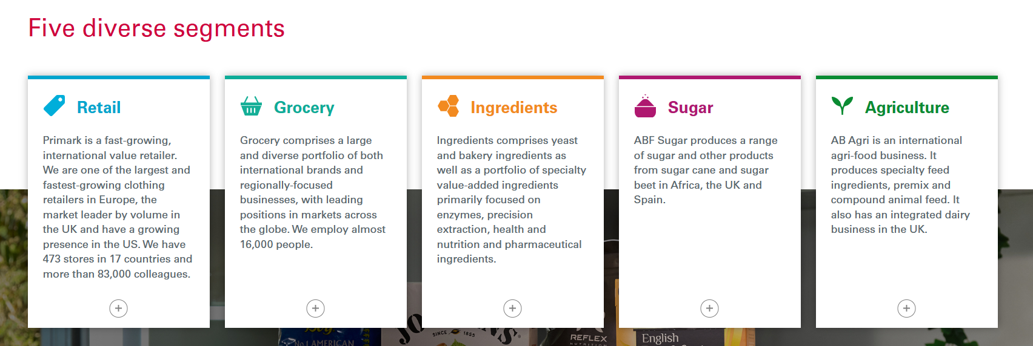
Figure 1: Five diverse segments
(Source: https://www.abf.co.uk/our-businesses)
The presence of an advanced integration of the value chain and a vast international presence that the corporation possesses makes it an interesting case study to study the dynamics of contemporary international business practices. The report specifically critically examines the multinational operations of ABF with specific reference to India, which is one of the fastest emerging economies in the world. With the systematic analysis of the global operation structure of the company, the application of the Eclectic Paradigm framework developed by Dunning (1980), and the assessment of cross-cultural issues between the United Kingdom and India, this consultancy report makes a strategic recommendation of how ABF can plan to succeed in its market penetration (Buckley, 2025).

2. Benefits and challenges of international operations

ABF as an MNC/TNC
The case of Associated British Foods plc is a clear-cut case of a multinational corporation according to the definitive criteria of a multinational corporation. According to Dunning and Lundan (2008), an MNC is a firm that ventures into foreign direct investment and owns or controls value-adding activities in over one country. ABF has operations in 53 countries in Europe, the Americas, Africa, and Asia-Pacific, with approximately 54% of total group revenue being international-based in 2023 (ABF, 2023). The company has a workforce exceeding 130,000 people around the world, which shows that the company has heavily integrated the workforce internationally. According to Rugman and Verbeke (2008), the true multinationals do not just exhibit presence, but strategic coordination across borders; the integrated value chains and centralised strategic planning in its London headquarters, as shown by ABF, illustrate a sophisticated multinational coordination, which differentiates it from other purely domestic firms that involve exports.

Nature of ABF's Global Value Chain Operations
The international activities of ABF consist of advanced value chain setups in the five business segments, which show what Porter (1985) referred to as competitive advantage via dispersion of strategic activity. ABF has developed specialised innovation centres in strategic locations in research and development to utilise regional expertise: AB Mauri, the ingredients division, has technical centres in the United Kingdom, China, Brazil, and Australia, where it specializes in the development of yeast technology and bakery solutions (ABF, 2023). The sugar division makes substantial investments in agricultural research, especially in Spain and Southern Africa, where it comes up with high-yielding crop varieties and sustainable farming systems (Gereffi et al., 2021).
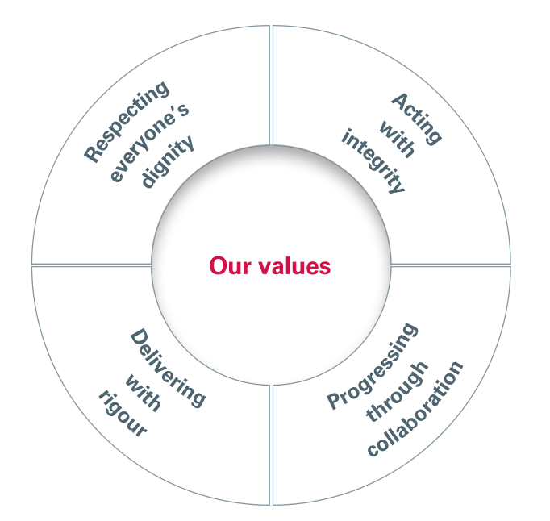
Figure 2: strategy and business model,
(Source: https://claude.ai/chat/ec163822-57db-4e1b-a878-ec680213ad69)
Geographical optimisation is echoed in sourcing strategies. The sugar segment is supplied by sugar beet farmers in the United Kingdom and Spain, and the sugar cane is supplied by African operations programs enhancing the out-grower schemes in support of the smallholder farmers (ABF, 2023). Primark has more than 1,000 suppliers in Bangladesh, India, China, Turkey, and Pakistan, which take advantage of the comparative advantage of cost without sacrificing the ethical standards of sourcing (Lund-Thomsen, 2022). The ingredients division procures raw materials regionally where possible, cuts down on the cost of transporting raw materials, and helps sustain the local agricultural economy.
The production facilities are characterized by strategic geographic dispersion in terms of market proximity and resources. ABF has 23 sugar factories in the United Kingdom, Spain, China, and Southern Africa, where about 17 million tonnes of sugar beet and cane are processed every year (ABF, 2023). The production model of Primark is quite different and involves contract manufacturers instead of owned facilities, and allows expansion of the company, capital-light but without compromising quality through strict supplier audit measures (Ivanov et al., 2021). The grocery division has manufacturing facilities located in the United Kingdom in the case of some of its brands, such as Twinings, Ovaltine, and Jordans, and selective production in major international markets.
The sales and distribution networks greatly differ depending on the segment. Grocery division distributes its products to retailers and wholesalers in more than 100 countries, and Twinings tea is available in more than 100 countries, which proves its wide market penetration internationally (Verbeke and Kano, 2016). Sugar and ingredients divisions are mainly B2B customers, with sales teams being assigned to the regions to help offer technical assistance as well as retain the customers. The structures of financing indicate centralised treasury management that is common with advanced multinationals.

International Market Entry Modes
ABF uses a variety of entry modes based on what Brouthers et al (2022) define as strategic fit in the capabilities of firms and host market characteristics. The most common mode of entry is wholly-owned subsidiaries, which will be the case with Primark retail expansion and sugar production enterprises. This would allow all the operations to be under control, which is important in ensuring that the brand remains intact and that operations are up to standard (Pan et al., 2000). The European expansion of Primark into France, Portugal, and Central Europe has been based on the use of wholly-owned stores consistently, to achieve a consistent customer experience and guard against the value retail positioning (ABF, 2023). Likewise, the sugar activity in Spain and China features fully-owned factories in production, facilitating the transfer of technology and quality control.
In the case of speeding up market entry, acquisitions are a major entry mechanism. With a 2016 takeover of Illovo Sugar Africa, ABF became the biggest sugar manufacturer on the continent of Africa, with direct access to long-standing operations in six countries, such as South Africa, Zambia, and Malawi (ABF, 2023). This acquisition approach is in line with studies by Ahern (2025), who shows that through acquisitions, it is possible to build capabilities in new markets very fast.
Joint ventures and strategic alliances, although less common, can be found in certain environments where they need local market expertise or regulatory maneuvering (Devarakonda et al., 2021). AB Mauri has traditionally used joint venture deals in new markets where knowledge of local bakery preferences and distribution is essential. The entry mode of grocery products is exporting, as the cost of transport is not too high compared to the value of the products, and local production does not provide significant benefits (ABF, 2023).
Franchising and licensing are noticeably absent from ABF's entry mode portfolio, indicating a strategic focus on control and quality assurance. This contrasts with competitors in quick-service restaurants and other retail sectors, but it is consistent with Primark's low-price, high-volume approach, which necessitates complex supply chain management that is difficult to replicate through franchising (Doherty 2009).

Key Benefits from International Operations
ABF gains significant and multifaceted advantages from its internationalization policy. Geographic diversification in terms of revenue greatly reduces the country-specific economic risks. This geographic diversification fits into the portfolio theory application of international business, where market-specific risk is decreased by imperfectly correlated market exposures (Saittakari et al., 2023).
Economies of scale are one of the core advantages, which is especially pronounced in the operations of Primark since the ability to negotiate volumes of over 1.8 billion items per year and negotiate with suppliers allows the company to obtain a high unit cost (ABF, 2023). The ingredients division is also enjoying the benefits of scale of production, where global manufacturing presence allows the division to have standardised processes and knowledge exchange across the locations, which led to lower per-unit costs but did not affect the quality of the products. The availability of cheaper factors of production, especially labour in the Asian manufacturing centres where Primark and African sugar operations are based, can boost competitive positioning based on cost leadership models (Verbeke and Kano, 2016).
The emerging economies offer a potential for revenue expansion that is beyond the mature markets in the West. The African sugar business of ABF benefits fast-growing populations that are highly consuming per capita, whereas Primark plans to enter Central and Eastern Europe with markets characterized by higher disposable incomes and larger fashion retail segments (ABF, 2023). The result of operating in different markets is learning and innovation benefits; consumer insights gained in foreign markets are used to develop products, and operational innovations created in regions are shared across all markets. International operations allow ABF to redirect resources and focus on the highest-paying opportunities, enhancing capital allocation efficiency within the portfolio (Ivanov et al., 2021). All these advantages have earned them a stable financial performance where adjusted operating profit stood at 1.4 billion in 2023 despite adverse macroeconomic conditions (ABF, 2023).

3. Critical analysis of OIL factors: ABF and India

Ownership Advantages
ABF has high ownership-specific benefits that have a huge effect on its entry mode choices in India. The most notable ownership strength of the company is the unique retail model of Primark called value fashion, which integrates quick recognition of fashion trends with highly competitive pricing based on effective supply chain management (ABF, 2023). The application of this model in India, however, has its complications. The ABF has a know-how of low-cost retailing, but Indian consumers have very different needs that demand a lot of adjustment.
The competitive brand portfolio of the company, especially Twinings tea, is a major asset in the large Indian tea-consuming market. The high-end brand image and 300-year experience make Twinings differentiated in the rising quality-demanding Indian market (Kulshreshtha et al., 2021). In the case of grocery products, the above ownership benefits imply that a complete ownership subsidiary or acquisition of an existing distribution channel, instead of a licence, would be better than a licence because brand equity needs to be maintained.
The ownership advantages of sugar and ingredients segments are presented as sophisticated farming methods and manufacturing technologies emerged due to operations in South Africa and Europe (Mabeta et al., 2023). The company has experience in sustainable sugar production and high-yield crops development, which can be transferred to the Indian sugar industry. However, the sugar industry in India is heavily regulated by the government, with price-fixing features and quotas, potentially restricting the capacity of ABF to take full advantage of these technological benefits (Kumar et al., 2024). This regulatory complexity implies that joint ventures with the existing Indian sugar players are perhaps a better solution than the fully owned business, allowing ABF to use the local political contacts and also provide technical experience.

Location Advantages of India
India has significant location benefits that appeal to FDI in various industries that are applicable to the operations of ABF. India will have a consumer market of over $4 trillion by 2025 due to the increase in disposable incomes and urbanization. This market size leverage is heavily biased to the need to establish a local presence as opposed to exporting to India (Joshi et al., 2018).
To the sugar business, India is the second-largest sugar producer worldwide with an estimated production of 35 million tonnes of sugar every year (Solomon et al., 2022). The ready availability of sugar cane in combination with the already developed agricultural infrastructures creates location benefits in processing operations, which are critical. Nevertheless, the sugar industry in India is experiencing certain problems, such as disjointed farm lands, fluctuating production seasonality, and government pricing support, which reduce profit margins (Kumar et al., 2024). These aspects indicate that location advantages are present but are insomely counterbalanced by the institutional constraints.
The increasingly favorable business climate in India, the growing position of 63rd in the Ease of Doing Business ranking by the World Bank, prior to being dropped, shows that fewer obstacles to foreign investment are present (World Bank, 2020). The government initiative of Make in India is an active attractor of manufacturing FDI by the creation of incentives such as tax holidays and streamlined approvals (Kulshreshtha et al., 2023). In the case of Primark, a manufacturing linkage in India would make use of the available garment production capacities and enjoy the preferential trade conditions on the exports to other markets.
However, there are still large location disadvantages. Infrastructure deficiencies in India, especially on logistics and cold chain amenities, have been the challenges associated with ABF food products that demand controlled storage environments (Mukherjee et al., 2021).

Internalization Advantages
The internalization theory implies companies will choose FDI over market-based options such as licensing when the cost of transaction in external markets is higher than the cost of internal coordination (Van der Straaten et al., 2023). With ABF entering India, high internalization benefits are more supportive of equity-based forms of entry in most business segments.
The internalization is the core of the Primark business model. The competitive edge of the organization lies in the fact that the company combines design, sourcing, logistics, and retail functions in a system of controlled operations that provide extremely low costs and, at the same time, guarantee tolerable quality (ABF, 2023). Franchising this model to Indian franchisees would jeopardize knowledge spill and create a problem with quality control. The informal aspect of the Primark operational excellence, such as buyer skills and trade logistics, is hard to capture in contracts (Tate et al., 2022). Hence, a fully-owned retail business is the best form, though limited by the FDI laws in India.
In the case of grocery products, the benefits of internalization are moderate. Although the quality of the brands is to be controlled, distribution is possible with the help of contracts with local distributors. Such corporations as Unilever have achieved success in using hybrid models in India, where the company retains control over manufacturing and uses third-party distribution channels (Contractor, 2021). This implies that ABF may create fully-owned production of such products as Twinings tea without engaging in collaboration with Indian dealers to enter the market.
Internalization advantages in sugar and ingredients are less strong because products are commoditized, and local relationships matter. Production of Indian sugar is a complicated process where local knowledge is crucial due to the interaction of farmers, government purchasing agencies, and regulators (Kumar et al., 2024). Joint ventures that allow ABF to inject technical and managerial skills and Indian partners to inject political networks and market intelligence will help level internalization advantages to preeminence demands.

Synthesis and Entry Mode
Integrating OLI analysis yields varied entrance strategies across ABF's business sectors. Primark's strong ownership and internalisation advantages, together with India's market potential, enable wholly-owned operations; however, regulatory limits may compel the first establishment of single-brand retail locations in large metros. For supermarket brands, acquiring an established Indian food firm with extensive distribution networks would allow them to capitalise on their ownership advantages while quickly gaining market access (Howard, 2021). In sugar and ingredients, joint ventures with Indian enterprises would best balance ABF's technical strengths against location-specific institutional knowledge requirements. This multi-modal approach reflects the complexities of India's economic environment and ABF's diversified portfolio, maximising benefits while minimising entrance risks.

4. Cultural differences and their impact on market entry and success
The cultural divide between the United Kingdom and India has important consequences for ABF's market entry strategy and possible success. Hofstede's (2011) cultural dimensions framework offers a systematic way to understand these distinctions, whereas recent research has focused on how cultural intelligence affects multinational organisation performance in emerging countries (Ang et al., 2007). The cultural divide between the United Kingdom and India presents itself in a variety of ways, each of which requires strategic consideration.
Power Distance and Organizational Implications
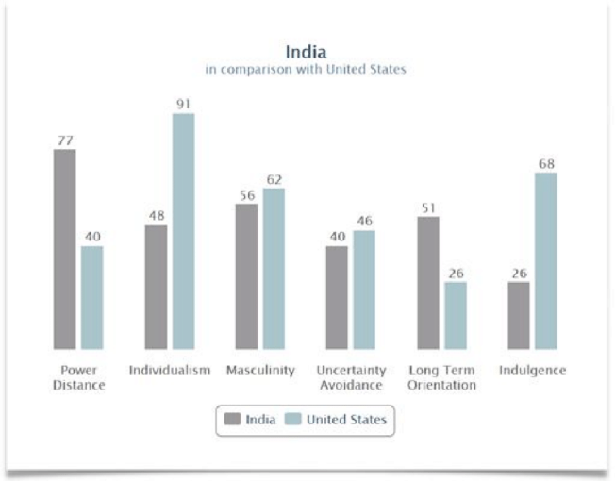
Figure 3: Hofstede's Cultural Dimensions: India
(Source: https://www.researchgate.net/figure/Geert-Hofstede-Cultural-Dimensions-India_fig1_318900652)
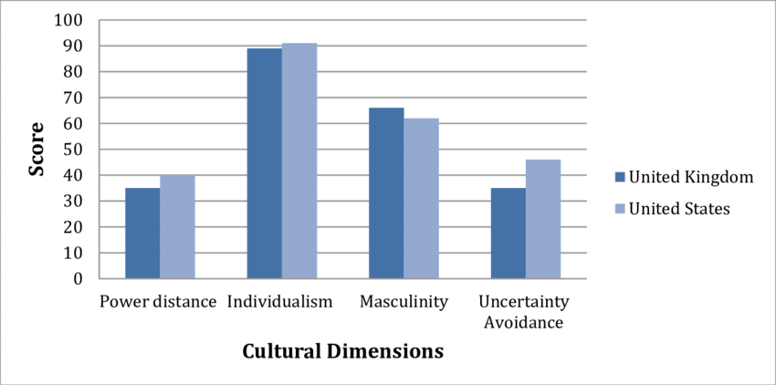
Figure 4: Hofstede's cultural dimensions: UK
(Source: https://www.researchgate.net/figure/Hofstedes-Cultural-Dimensions-for-US-versus-UK_fig2_336409478)
India has a higher power distance (77) than the United Kingdom (35), which means that people in this country tolerate the domination of power and inequality of its distribution (Hofstede Insights, 2024). This is a huge difference that has far-reaching implications for the organizational structure and management practices of ABF in India. The British management philosophies focus on flat hierarchy, participative decision-making, and open communication channels (Taras et al., 2010). But the employees of India usually desire to see clear hierarchies, titles, and autocratic styles of leadership where managers give clear instructions instead of coaching their employees (Cappelli et al., 2010).
In the case of the entry strategy by ABF, this cultural aspect implies that imitating the UK management styles is unlikely to be effective. The rather flat organizational structure of Primark, in which the responsibilities of store managers have significant autonomy, might need adjustment with the addition of more hierarchical tiers and strict lines of authority in India (Kumar et al., 2024).
The gap in power distance also affects the stakeholder engagement strategies. In India, business deals with the government and regulators should be established by learning how to abide by protocol, have respect towards authority, and be patient toward bureaucracy (Hilger, 2023). The entry strategy of ABF should invest heavily in government relations, which may involve senior leaders specifically to handle stakeholders, a role that is not as important in the UK's more open regulatory landscape.

Individualism versus Collectivism
The UK has a very individualistic culture (89), which is the opposite of India (48), but India is moving towards more individualism, especially in cities (Hofstede Insights, 2024). The difference affects consumer behaviour, employee relations, and marketing strategies. The buying choices of Indian customers are usually based on the family views and social acceptability, but British customers focus on their own preferences (Kulshreshtha et al., 2023). In the case of Primark's entry, it implies that marketing communications ought to focus on family value, social suitability, and group benefits instead of personal expression and personal style that are found in Western markets.
Collectivism affects patterns of loyalty and motivation in employment. Indian employees tend to exhibit high levels of in-group loyalty, and they demand the same level of organizational commitment, such as family benefits, such as lifetime health insurance and children's education (Budhwar and Varma, 2010). The compensation systems used in ABF, where performance bonuses focus on individual work but not on a team, might need to change to team incentives and family welfare benefits to match Indian culture. Proximal distance and community relationships are factors that job seekers tend to factor in when they accept jobs, implying that ABF should focus its talent acquisition approach on regional recruitment instead of anticipating high geographic mobility (Cappelli et al., 2010).
Collectivist orientation is also a factor in business relationships in B2B transactions in the sugar and ingredients division of ABF. The Indian business culture values long-term relationship development over transactional efficiency, where they value social interaction and personal bonding before conducting any business transaction (Holtbrügge et al., 2013). This cultural aspect implies that the entry mode of ABF must permit the long relationship-building processes and invest in the hospitality and relationship sustenance, which may be viewed as being extravagant in the UK context of a transactional business.

Uncertainty Avoidance and Risk Perception
India and the UK have moderate uncertainty avoidance scores (40 and 35, respectively), implying that they are both comfortable with ambiguity (Hofstede Insights, 2024). This similarity, however, conceals significant practical variations in the manifestation of uncertainty. Indian business contexts are characterized by high regulatory uncertainty, in which rules shift regularly and implementation differs between states (Hoskisson et al., 2013). This relative uncertainty in the institution is contrasted with the relatively stable regulatory environment that is present in the UK, and this means that ABF would have to make adaptable strategies and keep backup plans.
To penetrate the market, this uncertainty in the environment would imply gradual expansion strategies and not massive rollouts. The common Primark approach of having several stores within the new markets at the same time can be adjusted to sequential expansion city-by-city in India, with the opportunity to learn and adapt as regulatory as well as consumer response patterns are adopted (Jonsson and Foss, 2011). Developing sugar operations would also be helped by pilot projects to determine the level of regulatory cooperation between states before making major investment decisions.

Religious and Regional Diversity
In addition to the Hofstede dimensions, India is culturally diversified regarding religion, which does not occur with the UK, which is more secular. India is a diverse country with approximately 80% Hindu population, 14% Muslim, and large Sikh, Christian, Buddhist, and Jain minority groups. These religious identities significantly affect the consumption patterns that apply to the food businesses of ABF. The Hindu dietary restrictions, especially vegetarianism, followed by about 40 percent of the population, demand clear labelling of products and possible reformulation of recipes (Barrena and Sánchez, 2013). Muslim consumers want a halal certification, and Jain consumers do not consume root vegetables or some ingredients.
In the case of Primark, religious holidays such as Diwali, Eid, Holi, and Christmas are the key moments of sale that demand a range of merchandise and promotion models much broader than the holiday calendar of the UK, which is predominantly Christian in nature (Sharma, 2024).

5. Recommended SOP adjustments for India
There are significant distinctions between ABF's home market operations and the prerequisites for success in India, as demonstrated by the previous examination of OLI factors and cultural dimensions. These findings need deliberate changes to Standard Operating Procedures in essential functional areas. This section suggests three significant SOP changes that combine insights from the ownership-location-internalization paradigm with culture imperatives, giving ABF specific recommendations for Indian market success.

Localized Human Resource Management and Organizational Architecture
The existing HR strategies of ABF, which are oriented toward the Western markets, rely on the concept of the flat organization, the individual-based performance indicators, and direct communication styles typical of societies with low power distance (Budhwar and Varma, 2010). Nevertheless, India has a high power distance rating, which requires a basic recalibration of such strategies. The current SOP, in which the store managers or production supervisors have significant levels of autonomy in their decision-making making needs to be altered to have clearer hierarchical frameworks with well-defined reporting relationships and explicit levels of authority, as Indian employees find that formal designations give them a high degree of professional identity (Cappelli et al., 2010).
As an example, the rather informal Primark terminology, which uses the term team leader, should be substituted with the more official ones, like the Assistant Manager or the Deputy Store Manager, which would unmistakably indicate the hierarchy of the role (Sharma, 2024). This would be a change that would suit the cultural expectations of India, but does not interfere with the operational efficiency. Studies by Aycan et al. (2000) prove that alignment of organizational practices with cultural values plays a significant role in employee satisfaction and turnover, and in this context, recruitment SOPs need to be adjusted to highlight collectivist values, which are important in the competitive talent markets in India. The existing ABF systems that only target individual competencies must be extended to determine cultural compatibility and family considerations, noting that the Indian workers take family closeness and commitments as they accept job offers (Bjorkman and Budhwar, 2007).
Recruitment of top institutions such as the Indian Institute of Technology and the Indian Institute of Management should also be prioritized since the prestige of the institution holds a lot of weight in the education-sensitive Indian society. Moreover, the recruitment content should focus on organizational stability and long-term career development instead of personal success opportunities and appeal to the middle-range collectivism and long-term orientation of India (Hofstede Insights, 2024).

Adaptive Product Development and Localized Supply Chain Architecture
The standard product development and centralized supply chain planning that is effective in comparatively homogeneous Western markets at ABF needs some basic reconfiguration for the diverse consumer market and infrastructure limitations in India. The existing SOPs that focus on standardization of its products globally should be changed to high levels of localization without compromising on the quality standards and brand identity (Verbeke et al., 2022).
In the case of Primark clothing offerings, the product development SOPs will have to introduce small design parameters in terms of the cultural conservatism of India, especially beyond the major metros. The standard operating procedures must require all product lines to be culturally adequate: longer hemlines, higher necklines, and the coverage of sleeves that are longer than those used in the West (Wagner et al., 202). Also, there should be a creation of ethnic wear categories, such as kurtis, salwar kameez, and fusion wear, which need design skills, which are not available within Primark's European-centered departments. The process of fabric selection must be guided by the consideration of breathable fabrics that can be used in the already hot climate in India, as the garments that are used leave behind the heavy fabrics that dominated the European collections. Moreover, the sizing standards involve full recalibration because the Indian body shapes vary significantly compared to European averages on which the existing sizing is optimized (Khare et al.,2022).
The grocery branch of ABF has the same high product adaptation needs. Although Twinings tea enjoys the advantage of the Indian culture of drinking tea, it has to formulate masala chai mixes, cardamom tea-flavored variants, and higher grades of tea as favored by Indian consumers used to robust CTC teas more than delicate orthodox ones (Torkestani et al., 2024). The SOPs of the packaging should be adjusted to accommodate smaller packs and single-serving sachets because Indian buyers often shop in low volumes because of their low incomes and desire to consume fresh products. Food products will have to receive unequivocal vegetarian certification, and manufacturing processes must strictly separate vegetarian and non-vegetarian production lines as needed, even when there is a trace contamination, since it is of concern to Hindu and Jain consumers (Barrena and Sánchez, 2013).
SOPS of the supply chain require extensive localization in terms of the location benefits and infrastructure issues of India. The existing centralized procurement processes ought to be complemented with regional sourcing guidelines that will take advantage of the rich farming potential and manufacturing capacity of India (Jackovic, 2025). In the case of Primark, sourcing agreements with Indian clothes producers can support governmental policies of making in India as well as shortening the lead times. The qualification of suppliers should, however, be even stricter than the existing European standards, which should include comprehensive audits of the facilities, quality control tests, as well as an ethical compliance audit, since the manufacturing sector in India has a great variance in quality (Locke et al., 2007).
The design of the distribution network has to have a multi-level structure that will support the layered city system of India and the infrastructure constraints. The relative simplicity of the current distribution models at ABF will have to transform into complex networks, including regional distribution centers, hubs at the city level, and last-mile delivery relationships (Mukherjee et al., 2021). The SOPs governing the inventory management are to hold more buffer stocks than lean Western stock because the development of infrastructure unpredictability will lead to delivery uncertainties. Regulatory compliance processes are to be elaborated extensively in order to overcome the multi-layered approval process in India, such as Food Safety and Standards Authority compliance and differences in state regulations (Kumar et al., 2024).

Relationship-Centric Stakeholder Engagement and Institutional Navigation
The stakeholder engagement practices of ABF, which are influenced by the institutional environment of the UK, which is characterized by transparency and a rule-based environment, are not suitable in India because the business environment is institutionally challenging and characterized by relationships. The existing SOPs, which focus on the arm-length regulatory compliance and transactional business relations, must be fundamentally re-oriented to relationship development and institutional navigation (Holtbrügge and Baron, 2013).
Processes of government relations should start to change their mode of reaction to active interaction. ABF must set up special government affairs units at both the central and state levels and employ Indian nationals who have political contacts and institutional expertise (Svystunova et al., 2024). Regular courtesy meetings with concerned ministry officials, policy consultations, and involvement in industry associations such as Confederation of Indian Industry and Federation of Indian Chambers of Commerce should be made mandatory by standard procedures. Such relationship-building events, which may seem obtrusive to the British culture, are a necessary business infrastructure in the high-power distance culture of India, where individual connections have a substantial effect on regulatory results (Li et al., 2022).
CSR processes must be taken to the next level and made of strategic imperative and not the current voluntary and reputational approach that prevails in the UK. CSR is not discretionary but mandatory as a law that requires a firm to spend 2 percent of the average net profits on CSR activities, as required by law, because of specified thresholds (Government of India, 2013). In addition to the legal stipulations, CSR in education, health, and rural development creates a social license to operate and community goodwill that are crucial in achieving operational success (Balasubramanian et al., 2005). The SOPs of ABF ought to have systematic CSR planning that combines business strategy and plans where resources are directed towards education and skill development in line with the government priorities and stakeholder expectations.

6. Conclusion
As this consultancy report reveals, Associated British Foods has enough opportunities to successfully enter the vibrant emerging market in India, on condition of effective strategic adjustment of the operational processes. The above analysis supports the diagnosis that ABF is a complex multinational corporation with diversified operations in 53 countries, with its primary entry mode through wholly-owned subsidiaries to ensure the control of quality and operational superiority. High imperative of internalization supports equity-based entry position in most segments of business, but a joint venture is worth consideration to maneuver the intricate Indian sugar industry regulations.
Cultural analysis reveals considerable differences between the UK and India, especially in terms of power distance, collectivism, and religious diversity, that require much localization beyond generic adaptation. The three SOP changes suggested by OLI, such as a hierarchy of HR that reflects cultural value, local product development that has a strong supply chain, and stakeholder relationships with a focus on relationships, are synthesized to formulate actionable strategies. The issue of commitment to the true localization strategy by ABF, yet retaining the key competitive strengths, the use of the leadership of the Indian seniors, and long-term market development patience are absolutely crucial to the success issue. India has great potential for ABF, just as long as the strategic discipline goes along with the flexibility of operations in this culturally sensitive, institutionally difficult, and economically viable market.

References
ABF (2023) Annual Report and Accounts 2023. London: Associated British Foods plc.https://www.abf.co.uk/investors/annual-report-2023
ABF (2024) Annual Report and Accounts 2024.https://www.abf.co.uk/investors/annual-report-2024
Ahern, K.R., 2025. Multinational Firms and Cross-Border Mergers: Theory and Evidence (No. w34067). National Bureau of Economic Research.
Ang, S., Van Dyne, L., Koh, C., Ng, K.Y., Templer, K.J., Tay, C. and Chandrasekar, N.A., 2007. Cultural intelligence: Its measurement and effects on cultural judgment and decision making, cultural adaptation and task performance. Management and organization review, 3(3), pp.335-371.
Aycan, Z., Kanungo, R., Mendonca, M., Yu, K., Deller, J., Stahl, G. and Kurshid, A., 2000. Impact of culture on human resource management practices: A 10‐country comparison. Applied psychology, 49(1), pp.192-221.
Balasubramanian, N.K., Kimber, D. and Siemensma, F., 2005. Emerging opportunities or traditions reinforced?. Journal of Corporate Citizenship, (17).
Barrena, R. and Sánchez, M., 2013. Neophobia, personal consumer values and novel food acceptance. Food quality and preference, 27(1), pp.72-84.
Björkman, I. and Budhwar, P., 2007. When in Rome…? Human resource management and the performance of foreign firms operating in India. Employee Relations, 29(6), pp.595-610.
Brouthers, K.D., Chen, L., Li, S. and Shaheer, N., 2022. Charting new courses to enter foreign markets: Conceptualization, theoretical framework, and research directions on non-traditional entry modes. Journal of International Business Studies, 53(9), p.2088.
Buckley, P.J., 2025. Commentary on “The Emergence and Growth of International Business Thought as an Evolutionary Process”. In The Historical Evolution of International Business: Growth Trajectory of an Academic Field of Study (pp. 105-110). Cham: Springer Nature Switzerland.
Budhwar, P. and Varma, A., 2010. Guest editors' introduction: Emerging patterns of HRM in the new Indian economic environment. Human Resource Management: Published in Cooperation with the School of Business Administration, The University of Michigan and in alliance with the Society of Human Resources Management, 49(3), pp.345-351.
Cappelli, P., Singh, H., Singh, J. and Useem, M., 2010. The India way: Lessons for the US. Academy of Management Perspectives, 24(2), pp.6-24.
Contractor, F.J., 2021. The world economy will need even more globalization in the post-pandemic 2021 decade. Journal of international business studies, 53(1), p.156.
Devarakonda, S., Klijn, E., Reuer, J. and Duplat, V., 2021. Institutional differences and arbitration mechanisms in international joint ventures. Global Strategy Journal, 11(2), pp.125-155.
Doherty, A.M., 2009. Market and partner selection processes in international retail franchising. Journal of business Research, 62(5), pp.528-534.
Dunning, J.H. and Lundan, S.M., 2008. Multinational enterprises and the global economy. Edward Elgar Publishing.
Gereffi, G., Lim, H.C. and Lee, J., 2021. Trade policies, firm strategies, and adaptive reconfigurations of global value chains. Journal of International Business Policy, 4(4), p.506.
Government of India (2013) The Companies Act, 2013: Section 135. New Delhi: Ministry of Corporate Affairs.https://www.mca.gov.in/content/dam/mca/pdf/CompaniesAct2013.pdf
Hilger, A.M., 2023. The Internationalization of Central and Eastern European Companies-Foreign Market Entry Strategies and Human Resource Management (Doctoral dissertation).
Hofstede Insights (2024) Country comparison: India and United Kingdom. worlddata.info/country-comparison.php?country1=GBR&country2=IND
Hofstede, G., 2011. Dimensionalizing cultures: The Hofstede model in context. Online readings in psychology and culture, 2(1), p.8.
Holtbrügge, D. and Baron, A., 2013. Market entry strategies in emerging markets: An institutional study in the BRIC countries. Thunderbird International Business Review, 55(3), pp.237-252.
Howard, P.H., 2021. Concentration and power in the food system.
Ivanov, D., Tsipoulanidis, A. and Schönberger, J., 2021. Operations and supply chain strategy. In Global Supply Chain and Operations Management: A Decision-Oriented Introduction to the Creation of Value (pp. 87-124). Cham: Springer International Publishing.
Jackovic, R., 2025. Risk-Aware Supplier Selection in Multi-Tier Supply Chains (Master's thesis, Purdue University).
Jonsson, A. and Foss, N.J., 2011. International expansion through flexible replication: Learning from the internationalization experience of IKEA. Journal of International Business Studies, 42(9), pp.1079-1102.
Joshi, M. and Klein, J.R., 2018. Global business. Oxford University Press.
Khare, A. and Kautish, P., 2022. Antecedents to green apparel purchase behavior of Indian consumers. Journal of Global Scholars of Marketing Science, 32(2), pp.222-251.
Kulshreshtha, K., Sharma, G. and Bajpai, N., 2023. Conjoint analysis: the assumptions, applications, concerns, remedies and future research direction. International Journal of Quality & Reliability Management, 40(2), pp.607-627.
Kumar, J.S. and Shobana, D., 2024. Historical Trends in Sugarcane Area and Production in India: Analyzing Changes Over the Past Decades. International Journal of Research and Innovation in Social Science, 8(8), pp.1768-1784.
Li, Y., Cui, L., Meyer, K.E. and Fan, D., 2022. Strategic configurations and international performance of emerging economy multinationals. Management and Organization Review, 18(5), pp.924-957.
Locke, R.M., Qin, F. and Brause, A., 2007. Does monitoring improve labor standards? Lessons from Nike. Ilr Review, 61(1), pp.3-31.
Lund-Thomsen, P., 2022. Rethinking global value chains and corporate social responsibility. Edward Elgar Publishing.
Mabeta, J. and Smutka, L., 2023. Trade and competitiveness of African sugar exports. Frontiers in Sustainable Food Systems, 7, p.1304383.
Mukherjee, S. and Badola, S., 2021. Public financing of human development in India: a review. Indian Journal of Human Development, 15(1), pp.62-81.
Pan, Y. and Tse, D.K., 2000. The hierarchical model of market entry modes. Journal of international business studies, 31(4), pp.535-554.
Porter, M.E., 2008. Competitive advantage: Creating and sustaining superior performance. simon and schuster.
Rugman, A.M. and Verbeke, A., 2008. A new perspective on the regional and global strategies of multinational services firms. Management International Review, 48(4), pp.397-411.
Saittakari, I., Ritvala, T., Piekkari, R., Kähäri, P., Moisio, S., Hanell, T. and Beugelsdijk, S., 2023. A review of location, politics, and the multinational corporation: Bringing political geography into international business. Journal of International Business Studies, 54(6), pp.969-995.
Sharma, M., 2024. Comparative Study on Cultural Dimensions of Organisational Change in India and New Zealand IT Industry.
Solomon, S. and Swapna, M., 2022. Indian sugar industry: towards self-reliance for sustainability. Sugar Tech, 24(3), pp.630-650.
Svystunova, L., Muratova, Y., Fortwengel, J. and Edwards, T., 2024. Multinational corporations’ interactions with host institutions: taking stock and moving forward. Management International Review, 64(1), pp.3-33.
Taras, V., Kirkman, B.L. and Steel, P., 2010. Examining the impact of Culture's consequences: a three-decade, multilevel, meta-analytic review of Hofstede's cultural value dimensions. Journal of applied psychology, 95(3), p.405.
Tate, W.L. and Ellram, L.M., 2022. Transaction cost economics. In Handbook of Theories for Purchasing, Supply Chain and Management Research (pp. 94-105). Edward Elgar Publishing.
Torkestani, M.S., Dehdashti Shahrokh, Z., Bakhshizadeh Borj, K. and Jahedi, P., 2024. Diaspora Marketing Theoretical Framework with Meta-Synthesis Approach. Quarterly Journal of Brand Management, 10(4), pp.125-160.
UNCTAD (2022) World Investment Report 2022: international tax reforms and sustainable investment. Geneva: United Nations Conference on Trade and Development. https://unctad.org/system/files/official-document/wir2022_en.pdf
Van der Straaten, K., Narula, R. and Giuliani, E., 2023. The multinational enterprise, development, and the inequality of opportunities: A research agenda. Journal of International Business Studies, 54(9), pp.1623-1640.
Verbeke, A. and Kano, L., 2016. An internalization theory perspective on the global and regional strategies of multinational enterprises. Journal of World Business, 51(1), pp.83-92.
Verbeke, A. and Yuan, W., 2022. Rethinking intrapreneurship in the established MNE. Global Strategy Journal, 12(4), pp.738-758.
Wagner, C. and Delios, A., 2023. The determinants of inward FDI in India in the 2000s. Journal of Indian Business Research, 15(3), pp.431-465.
World Bank (2020) Doing Business 2020: comparing business regulation in 190 economies. Washington, DC: World Bank Group.https://documents1.worldbank.org/curated/en/688761571934946384/pdf/Doing-Business-2020-Comparing-Business-Regulation-in-190-Economies.pdf

