BMHP5014
Creativity and Value Creation
Component 2
Written Assignment (Report)

Student Name: Sharm Gill
Student ID: 2322794
Table of Contents
Poster 3
Title and Innovation Overview 3
The Gaps in Health & Social Care 3
Target Audience and Impact 3
Implementation 3
Timeline 4
Development and Regulations 4
Technology Integration 4
Dissemination 5
Conclusion 5
Pitch 6
Target Audience and Affected Groups 6
Impact on population health and wellbeing 6
Policy, legislation and professional resources 6
Technology connectivity and innovation 7
Promotion and Public Awareness 8
Value and Acceptance of Innovation 9
Reference List 10

List of Figures
Figure 1: AI and digital health tools 7
Figure 2: The Integrated Care System 8

List of Tables
Table 1: Brief timeline 4

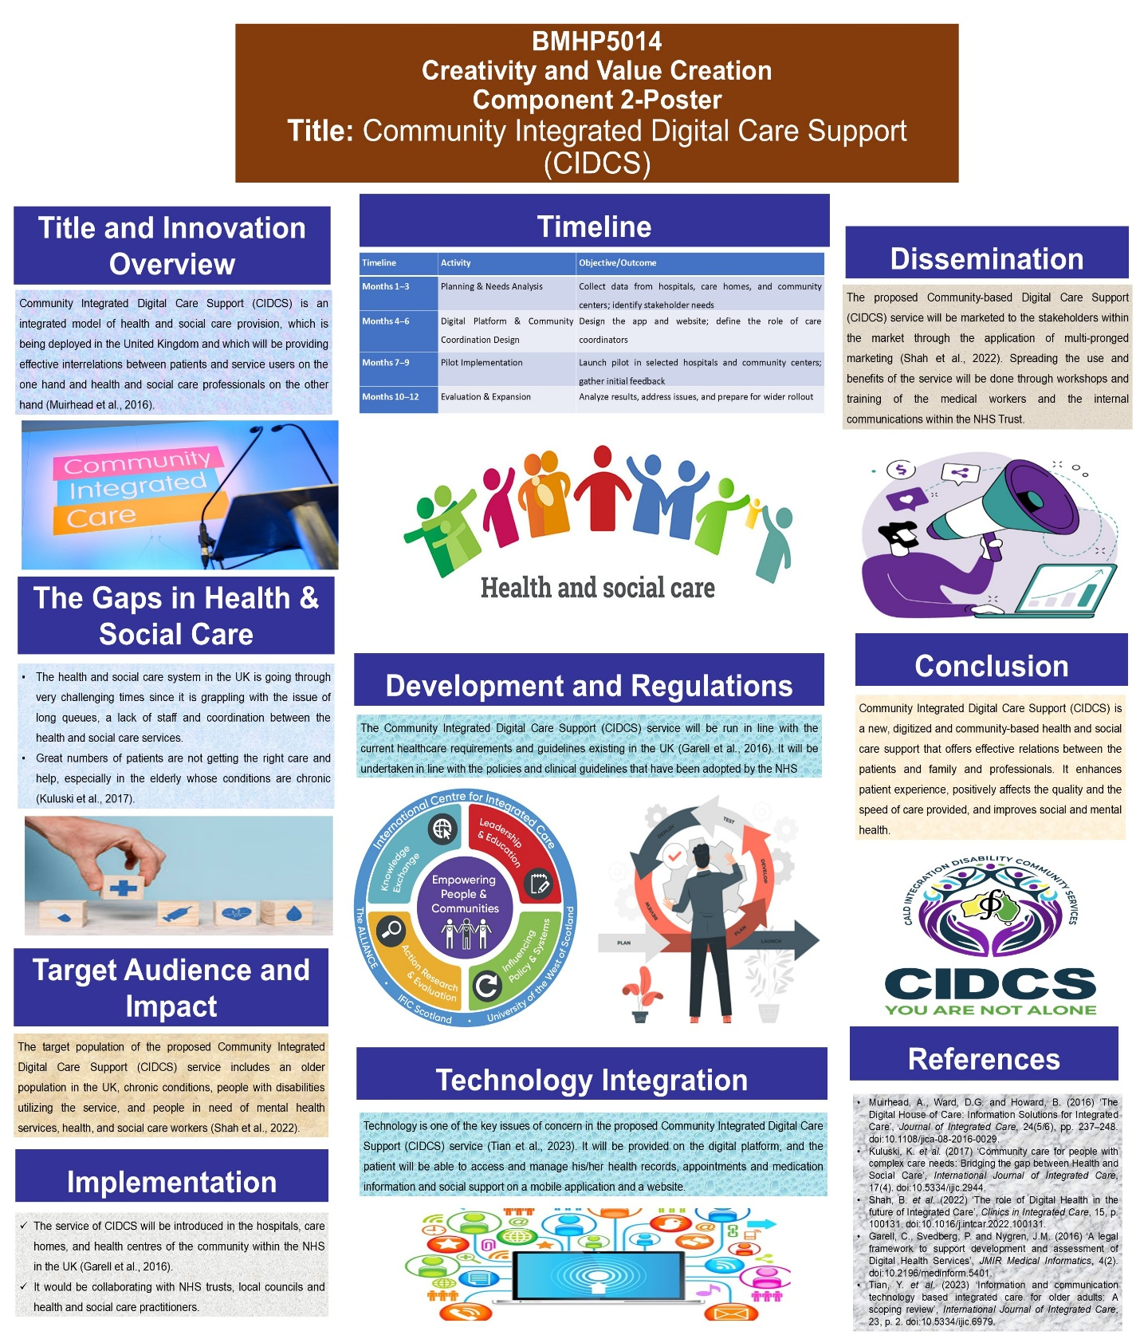

Poster

Title and Innovation Overview
Title: Community Integrated Digital Care Support (CIDCS)
Community Integrated Digital Care Support (CIDCS) is an integrated model of health and social care provision, which is being deployed in the United Kingdom and which will be providing effective interrelations between patients and service users on the one hand and health and social care professionals on the other hand (Muirhead et al., 2016). The service will also include medical, mental health support and social services, which will be founded on a digital platform (app and web) and community-based support. It is directed to enhance the patient experience, patient centring and integrating the health and social care system.

The Gaps in Health & Social Care
The health and social care system in the UK is going through very challenging times since it is grappling with the issue of long queues, a lack of staff and coordination between the health and social care services. Great numbers of patients are not getting the right care and help, especially in the elderly whose conditions are chronic (Kuluski et al., 2017). Simultaneously, the distance of the information and services delivery complicates the situation for the patient and makes the burden on the professionals. These actual challenges warrant the introduction of an integrated and patient centric and technology based innovation service that will transform the efficient and accessible health and social care.

Target Audience and Impact
The target population of the proposed Community Integrated Digital Care Support (CIDCS) service includes an older population in the UK, chronic conditions, people with disabilities utilizing the service, and people in need of mental health services, health, and social care workers (Shah et al., 2022). The innovation unites the medical, social support and information digitally and on the communities' support in such a way that the patients can still get taken care of within a shorter time, feel less isolated and have control over their health. It also enhances interaction of coordination among professionals, and this enhances high standards of care and also has a positive influence on the health of individuals, both health-wise, mentally and socially.

Implementation
The service of CIDCS will be introduced in the hospitals, care homes, and health centres of the community within the NHS in the UK (Garell et al., 2016). It would be collaborating with NHS trusts, local councils and health and social care practitioners. Health information of the patients, appointment and social support organization will be organized using a digital platform and care and health worker coordinators will then work directly with patients and families at the community levels. This type of hybrid will make the available services fast and patient-focused.

Timeline
Table 1: Brief timeline
Surce: (Tian et al., 2023)
Timeline | Activity | Objective/Outcome
Months 1–3 | Planning & Needs Analysis | Collect data from hospitals, care homes, and community centers; identify stakeholder needs
Months 4–6 | Digital Platform & Community Coordination Design | Design the app and website; define the role of care coordinators
Months 7–9 | Pilot Implementation | Launch pilot in selected hospitals and community centers; gather initial feedback
Months 10–12 | Evaluation & Expansion | Analyze results, address issues, and prepare for wider rollout

Development and Regulations
The Community Integrated Digital Care Support (CIDCS) service will be run in line with the current healthcare requirements and guidelines existing in the UK (Garell et al., 2016). It will be undertaken in line with the policies and clinical guidelines that have been adopted by the NHS, Care Quality Commission (CQC) standards of services and the Health and Social Care Act, which would make the service safe, effective and of good quality. Concurrently, UK GDPR and the Data Protection Act 2018 will be strictly followed to ensure that the personal information of the patients remains safe, consequently, making the storage and utilization of information secure.

Technology Integration
Technology is one of the key issues of concern in the proposed Community Integrated Digital Care Support (CIDCS) service (Tian et al., 2023). It will be provided on the digital platform, and the patient will be able to access and manage his/her health records, appointments and medication information and social support on a mobile application and a website. Its inanimate characteristics will include automatic reminders, predicting health risk as well as customised instructions depending on the behaviour of the patient. In addition, the data protection will ensure that the personal information of the patients will be kept safe under the GDPR and the Data Protection Act. Such technology has its task to maximize the efficiency of services - patients obtain the necessary and correct information in time.

Dissemination
The proposed Community-based Digital Care Support (CIDCS) service will be marketed to the stakeholders within the market through the application of multi-pronged marketing (Shah et al., 2022). Spreading the use and benefits of the service will be done through workshops and training of the medical workers and the internal communications within the NHS Trust. The social media awareness will be through social media, community health awareness, newsletter and online advertising.

Conclusion
Community Integrated Digital Care Support (CIDCS) is a new, digitized and community-based health and social care support that offers effective relations between the patients and family and professionals. It enhances patient experience, positively affects the quality and the speed of care provided, and improves social and mental health. The novelty is required as soon as possible to combat the issue of the shortage of staff, inefficiency of the service and the breakdown of the data. Consequently, it can be used and be considered as the viable, safe and patient-focused solution within the range of the UK health and social care system in the long run.

Pitch

Target Audience and Affected Groups
Community Integrated Digital Care Support (CIDCS) will be the main target of the service provision to the older people, long-term sick patients, persons with mental health issues and disabled service users within the UK (Wen & Tian, 2024). The health and social care professionals will also be the direct beneficiaries since nurses, care coordinators, and social workers will be the direct beneficiaries. The service will also facilitate good coordination with the patients and professionals, including the rapid exchange of patient data, appointment booking, and access to medical history and contact with social support services, most conveniently. This will assist the target group in saving time and the inconvenience of searching for health services.

Impact on population health and wellbeing
CIDCS can be used to enhance the physical and mental health of patients. The patients will be presented with an opportunity to utilize and manage health records, medication history, appointments and social support plans through a single platform (Lim et al., 2024). This will decrease the level of stress, bearing in mind that the patient will not have to start searching to locate the information in the various agencies and documents. Furthermore, health professionals will be given a chance to oversee a treatment plan and social support of a patient simultaneously, which will decrease health risks and the necessity. The frequent assistance of the care coordinators at the community level helps to eliminate feelings of loneliness, enhances the process of socialization, and improves the mental health of the population, which results in a better quality of life and healthcare effectiveness.

Policy, legislation and professional resources
The CIDCS service will be fully in line with the UK healthcare regulations and legislation. It shall also be in operation within the NHS policy, Care Quality Commission (CQC) standards and Health and Social Care Act. The protection of the patient's personal data will be of great concern to the UK GDPR and the Data Protection Act 2018 (Baltaxe et al., 2019). Besides that, the supply of professional staff training, protection of the policies and clinical governance will make the service safe, legal and of high quality. Operating in the confines of the rules and regulations of the professional registration organisations like the HCPC or the NMC will help in gaining credibility among the patients and families.

Technology connectivity and innovation
The Community Integrated Digital Care Support (CIDCS) service has been transformed into one of its main and innovative elements of technology (Taiminen et al., 2018). With the help of an entirely digital platform, which can be accessed through mobile applications and websites and that allows patients to manage their health records, medication details, appointments, and social support all in one place, this will be possible. The data presented on the site will also contain the AI-driven data with the automated notifications, prediction of health hazards, and instructions based on the patient's behaviour and history. This adds to the treatment given to the patients being more personalised, effective and prompt.
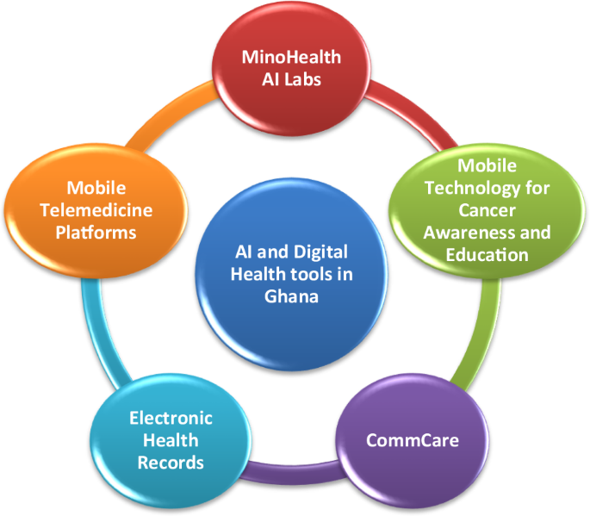
Figure 1: AI and digital health tools
Source: (Lim et al., 2024)
The patients and the professionals can also access it easily through technology. The health workers will also have the opportunity to promptly confirm the information with patients and make informed choices and cooperate with other social support organisations. Besides this, the data analytics will be in a situation to reveal the health trends in large populations, thereby enabling the policy and administration plan better in health and social care (Muirhead et al., 2016). Moreover, the personal information of a patient will be safe, and it will not be used by untrustworthy practitioners because of the accessibility of the data protection systems (based on the GDPR and the Data Protection Act 2018). The community level of technology use will assist in ensuring that the community will be in contact with the patients and families that will be involved in the services provided and offer regular updates and reminders as well as enable effective communication of the coordinators of care with the patients. The new form of coordination through the utilisation of technology will immensely enhance the quality, reliability and effectiveness of services that will eventually have a positive influence to the health and social care system.

Promotion and Public Awareness
The Community Integrated Digital Care Support (CIDCS) service cannot work without an integrated marketing plan to make it work and gain its acceptance. This will guarantee the familiarisation and practical skills to the professionals in the healthcare by the workshops, training sessions and internal NHS communication channels. Nurses, care coordinators and social workers can use the digital platform with the help of training and, and therefore, these specialists will be able to better plan how patient care should be arranged.
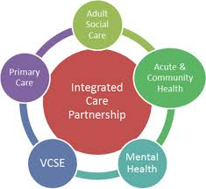
Figure 2: The Integrated Care System
Source: (Wen & Tian, 2024)
The awareness will be generated through different forms of media, including social media campaigns, digital advertising, local community-based health programs and newsletters, among many others. The campaign will target the patients and their families on the benefits and availability of the service (Baltaxe et al., 2019). The general population and volunteers will also be encouraged to join the campaign, as they will be able to take part in receiving the service, as well as in providing feedback and health awareness creation to the population. The community-level campaign will also be operational in engaging the patients in the health and social care system. The awareness programs will be conducted in liaison with the local community centres, care homes and hospitals, where awareness about the time required, facilities and the support that they provide to the patients can be easily received. It will lead to the fact that the service will be more accepted, patients will have improved health and mental wellbeing and the role of health awareness and social support in the community will be recognised.

Value and Acceptance of Innovation
CIDCS is a developing service, which is integrated and patient-centred and will overcome the current issues in the health and social care system, including long waiting times, staff shortage and service fragmentation. It will unite patients with professionals and communities to enhance the quality of health and social care, enhance mental and social wellbeing and make a positive contribution to the quality of life of the population in the long-term perspective (Taiminen et al., 2018). This adoption and adoption of this service will make the resultant system of healthcare more efficient, technological, and safe.

Reference List
- Baltaxe, E. et al. (2019) ‘Digital Health Transformation of integrated care in Europe: Overarching analysis of 17 integrated care programs’, Journal of Medical Internet Research, 21(9). doi:10.2196/14956.
- Garell, C., Svedberg, P. and Nygren, J.M. (2016) ‘A legal framework to support development and assessment of Digital Health Services’, JMIR Medical Informatics, 4(2). doi:10.2196/medinform.5401.
- Kuluski, K. et al. (2017) ‘Community care for people with complex care needs: Bridging the gap between Health and Social Care’, International Journal of Integrated Care, 17(4). doi:10.5334/ijic.2944.
- Lim, C., Fuchs, C. and Torous, J. (2024) ‘Integrated Digital Mental Health Care: A Vision for addressing population mental health needs’, International Journal of General Medicine, Volume 17, pp. 359–365. doi:10.2147/ijgm.s449474.
- Muirhead, A., Ward, D.G. and Howard, B. (2016) ‘The Digital House of Care: Information Solutions for Integrated Care’, Journal of Integrated Care, 24(5/6), pp. 237–248. doi:10.1108/jica-08-2016-0029.
- Shah, B. et al. (2022) ‘The role of Digital Health in the future of Integrated Care’, Clinics in Integrated Care, 15, p. 100131. doi:10.1016/j.intcar.2022.100131.
- Taiminen, H.S., Saraniemi, S. and Parkinson, J. (2018) ‘Incorporating digital self-services into Integrated Mental Health Care: A physician’s perspective’, European Journal of Marketing, 52(11), pp. 2234–2250. doi:10.1108/ejm-02-2017-0158.
- Tian, Y. et al. (2023) ‘Information and communication technology based integrated care for older adults: A scoping review’, International Journal of Integrated Care, 23, p. 2. doi:10.5334/ijic.6979.
- Wen, X. and Tian, B. (2024) ‘How does digital integration influence the mental health of low-income populations?’, Healthcare, 12(24), p. 2593. doi:10.3390/healthcare12242593.

Apendix
Service/Innovation | Target Audience | Key Benefits / Impact
Community Integrated Digital Care Support (CIDCS) | Elderly individuals, long-term patients, people requiring mental health support, and users of infirmity services | Makes healthcare and social care more reachable; reduces mental stress; improves quality of life; expands coordination among healthcare establishments
Digital Platform (App & Website) | Patients and healthcare authorities | Consolidates health records, appointments, and social sustenance in one platform; enables faster decision-making and information sharing; intensifications service efficiency
Community Care Coordinator | Patients, families, and local health & social care networks | Provides regular contact and guidance, diminishes isolation, coordinates social support and medical care, and progresses patient involvement and mental wellbeing

