
Assignment 2:
Operating Systems
CertHE Computing Skills for Workplace

Computer Architecture and Operating Systems. ACCA4022_LON
DR. Redhwan Al-Amri (Lecturer)
University of Wales Trinity Saint David
(London Campus)
Student Name:
Student Number:
Group: 01
Date:

Table of Contents
Introduction 1
1. Key functions of general Operating Systems 1
1.1 Process and Processor Management 1
1.2 Memory Management 2
1.3 File System Management 2
1.4 Security and Protection 2
2. Use of Windows OS CLI commands. 3
3. Use of Linux OS CLI commands. 4
4. Use of Windows OS scripts. 4
5. Use of Linux OS scripts. 5
Conclusion 5
References 5
Appendices 5

Introduction

1. Key functions of general Operating Systems

1.1 Process and Processor Management

Process: Process is one of the many things within an operating system. When an application is stored within a disk, it becomes static. When a user opens an application, the data is loaded as memory and is executed. This is what is called as the process. If the same program was to be opened multiple times by the user, then there would be multiple processes created following the same instructions. [1]

Processor management: One of the key functions of an operating system is processor management. This is because the operating systems manage the usage of the different programs and processes that have been used throughout the user’s usage. When the system starts running many applications at once, the system decides which program/process requires the most usage from the processor and for how long. This is done through the CPU scheduling. This makes sure that the apps run efficiently without one singular program taking all of the resources from the processor. [2]
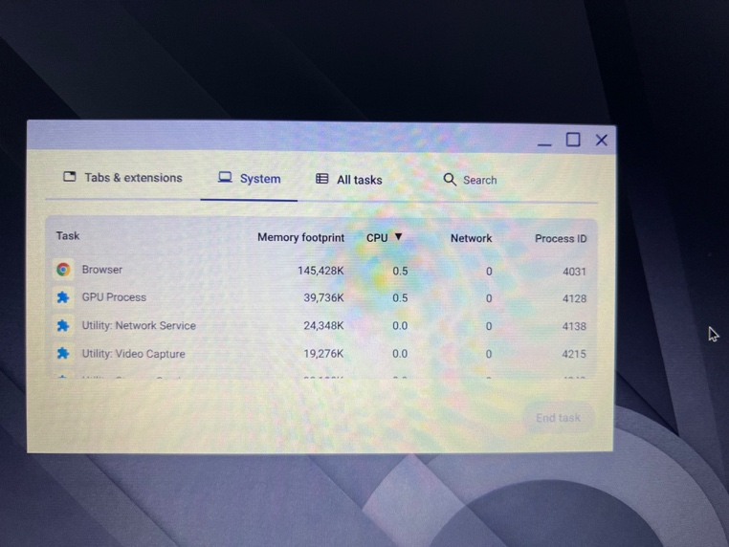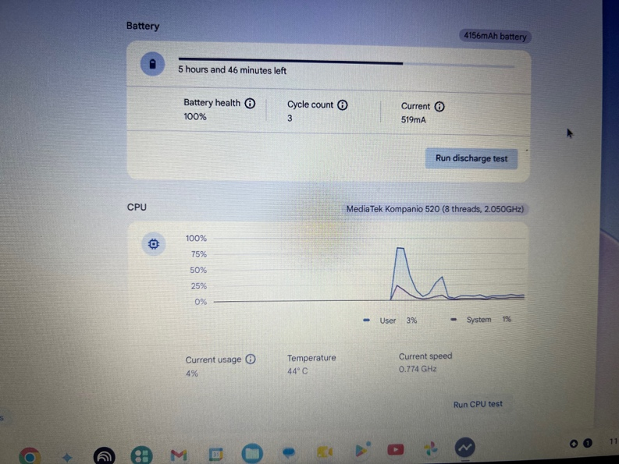

1.2 Memory Management

Memory management is the process of controlling and organizing the memory of a computer by allocating it into portions called blocks. This helps improve the overall performance of the system as it helps execute different programs. It also helps with the managing of the main memory of a computer. It allocated the memory to the programs when needed and then releases it when it is done and not needed anymore. This helps the system to run multiple applications at once without having any sort of interference. The operating system also manages the amount of memory that is being used by the program and if needed it would provide virtual memory when there is not enough memory left in the RAM. [3]

1.3 File System Management
When it comes to the file system management, the operating system has a role for it. This system has the function of controlling how the folders and files are stored, accessed and organized within the device it is stored in. The OS system keeps a track on the files locations and allows its users to move, copy, rename, create, and delete folders and files. The file system management also manages the permissions for users and programs to determine who has access to certain files that may be confidential. [4]
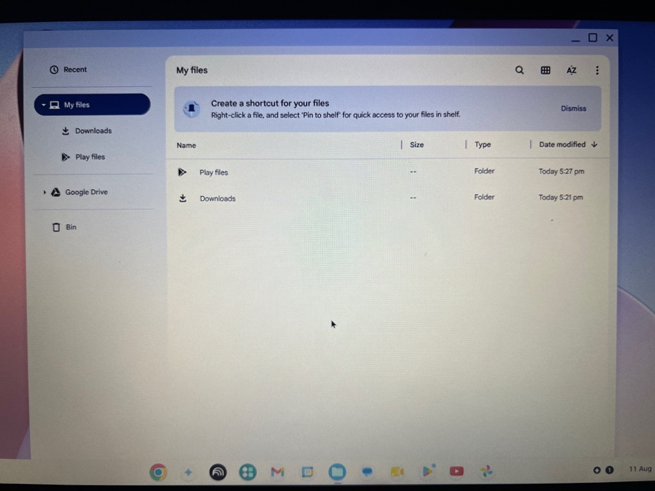

1.4 Security and Protection

The security and protection of an operating system is very crucial and important. It has a very important function. This function allows the computer to be protected and all the data within it. For example, the files and the users of the systems will be prevented from unauthorized access. The OS system uses security like usernames, passwords, permission and user accounts to control the access that can be given to attain certain resources. From the protection sense, there are security features like the antivirus protection, encryption and firewall settings to help keep everything safe. By having these security features, it allows the users to be prevented from making unauthorized changes to applications that are important.

2. Use of Windows OS CLI commands.

Process management
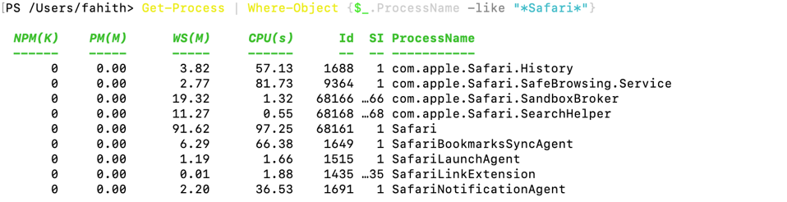
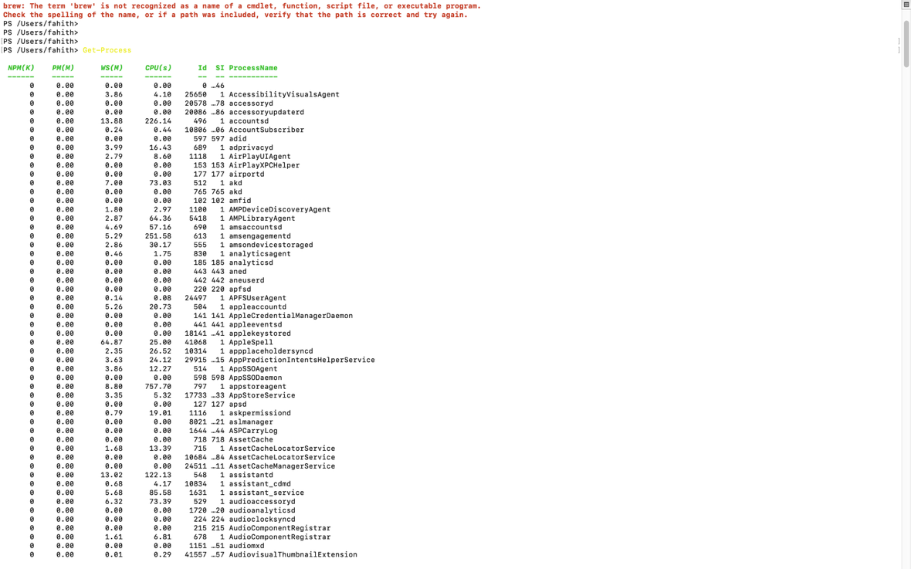
Picture 1 – second code
Picture 2 – first code
The codes used for the process management commands are only used to see and manage the programs that are running on the system currently. The command that I used shows the lists of processes that are active and gives the information about the names like process ID and process name. This is very useful as it allows users to see what the programs are using from the resources of the system. The second command that I had used it used to find specific process. This makes its more easier in terms of finding the specific app needed rather than looking through a very long list. The process could also be stopped through the process management command. This is used to make see if the program stops responding. [5]

File & directory management
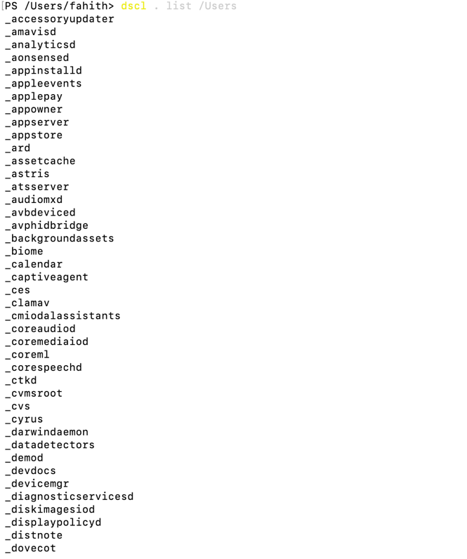
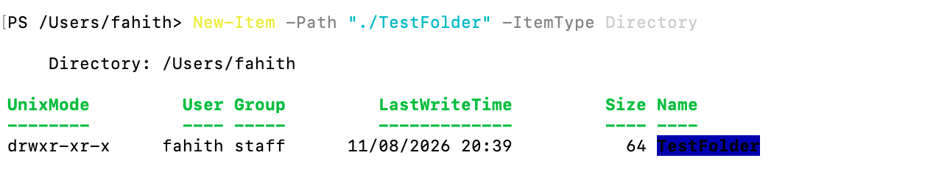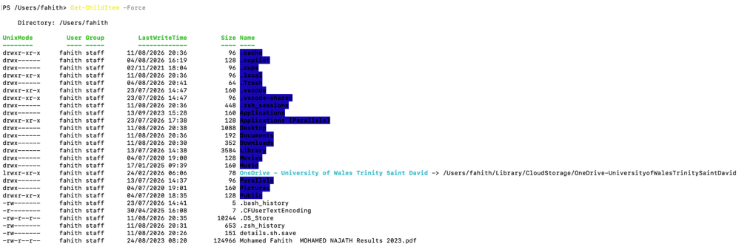
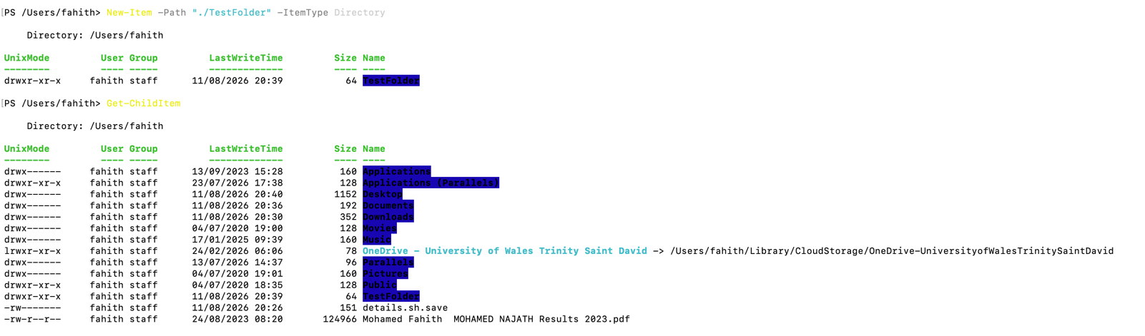
From the file and directory commands are used by users to manage the folders and files on their system. The command code that is used to list the items shows the folders and files within the location. There is also an option that can be used to show hidden files that would normally may not be shown. The other command that was used is to create a folder. This can be checked by using the commands from the directory listings. When a folder is created, a newer file can be created within it. The commands that I have used shows the file management that has been carried without having to use the finder( my mac books file) or any other graphical interface. [6]

Network testing/monitoring
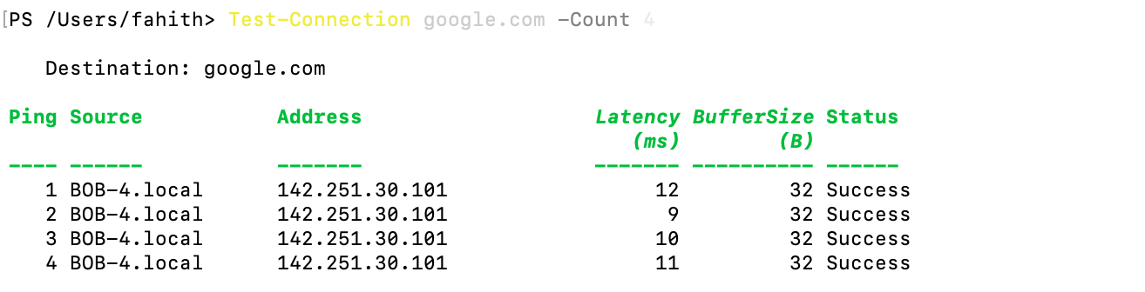
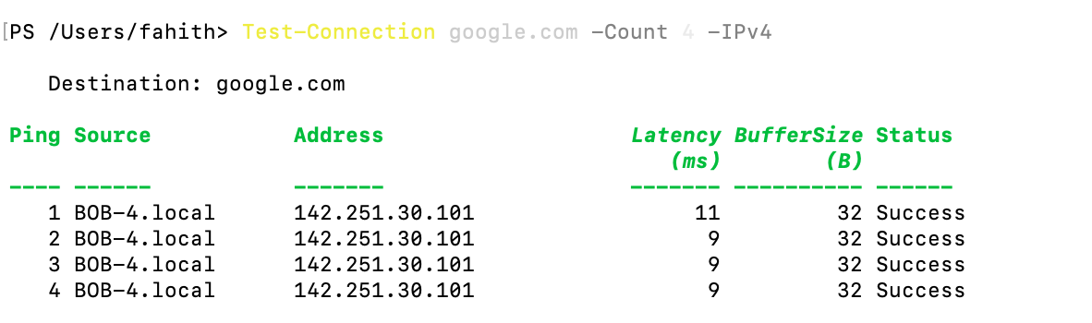
The commands that I have used for network commands are used to check whether the system can communicate with other websites or devices. The connection tests will send the requests to the required device or website, and see whether the response was received or not. It would also show the response time. This would help show how well the internet connection is working.
User management

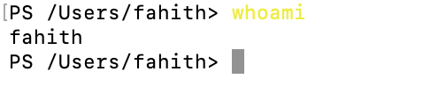
The user management command codes that I have used to find the information about the user accounts on my Mac. The command that I have used shows the username that I using which I am currently logged in with. This helps shows the available accounts and help show the current users on the device by identifying.

Task scheduling
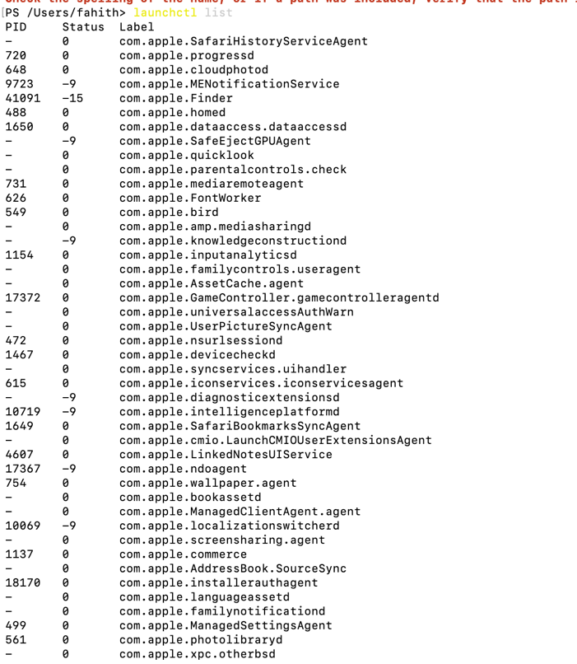
The task scheduling commands that I have used help view the background tasks and service that are running on the background of my macOS. The commands use the Mac’s launched system, which manages the services and processes that can run automatically. This command allows the user to monitor the tasks that are occurring in the background without needing to opening the individual apps.

3. Use of Linux OS CLI commands.

4. Use of Windows OS scripts.

5. Use of Linux OS scripts.

Conclusion

References

Appendices

