LCBB4005
Global Business Environment
Assessment 2

Contents
1. Introduction 3
2.0. Macro environment analysis for Tesco PLC from retail industry 3
3.0. Organisational operations in Covid-19 5
4.0. Organisational restructuring during covid-19 in Tesco 6
5.0. Sustainability of changes and recommendations 7
6.0. Conclusion 7
References 8

1. Introduction
A business organisation has to deal with different macro and micro factors for achieving business objectives. Any change in the business environment can bring changes in the whole organisational operation. Covid-19 was the major highlight of 2020 that brought different industrial changes. Brexit has become the second factor impacting on business because of Covid-19. This report is to present an overview on how Covid-19 and other macro factors impacted Tesco PLC. Retail industry is an inseparable part of the economy. Tesco is the largest contributor to this economic side. Therefore, there have been some revolutionary changes impacting particularly in the retail industry. The UK entered the first lockdown in March. Everything was shutdown including retail stores. A plenty of customers needed to shift from traditional shopping to online shopping due to this period. This gave opportunities for companies like Tesco PLC who have prior strong online campaign. Again, there is a threat from new entrants. Local businesses got the opportunity to compete with large enterprises for the first time of organisation’s life cycle. This is threatening for Tesco PLC and other organisation. These firms have faced the threat because of the hamper in supply chain management too. It was challenging to maintain both the supply chain management and distribution channel management. For distribution purpose, it required preparing a plenty of issues. Rather than salesmen, deliverymen became more important (Wood, 2020). Therefore, a lot of changes have been witnessed in the covid-19 pandemic. The article will cover a thorough discussion on this issue.

2.0. Macro environment analysis for Tesco PLC from retail industry
Macro environment is a necessary factor that has strong influence on business operations. PESTEL is a popular framework to underpin the macro changes impacting on Tesco PLC. The following section of this report is to give an overview on PESTEL factors for Tesco PLC in the post-covid-19 period.
2.1. PESTEL
Political: Businesses have to deal with different political decisions for ensuring the maximum business profitability. Maximisation of business revenue is dependable on the ongoing national situation. The government may take emergency steps if the situation starts worsening at some point of business operation. In the covid-19 situation and post pandemic situation, it was necessary for the government to ensure that every business was following hygiene issues. Tesco faced challenges to keep the price stable despite the increment of cost for customer’s protection (Traver, 2020). The UK government enforced the law for businesses to operate in a certain environment that will not affect human health. Therefore, Tesco faced challenges in getting expected profitability after the covid-19 situation.
Economic: Economic factors are highly impactful. Majority of 2020 went through lockdown phase. There were sudden job cuts and increment in the unemployment rate. Growth of unemployment will ease business organisations to increase the productivity (Sweney, 2020). If unemployment increases, the wage will decrease. Tesco will be able to appoint more workforce to the organisational operation (Susskind, 2020). This is a positive impact from the covid-19 situation. The disposable income has decreased ever since this pandemic attacked the world. People are stocking more as well as saving more. This reduces investment in the economy. Large enterprises like Tesco PLC are being affected from such operation.
Social: Social issue includes consumer preference. If Covid-19 and Brexit affected at least one sector, that will be the consumer preference. People have shifted their shopping experiences. Their consumption journey has been changed too. Cashless is the first priority for any type of purchase. This provoked Tesco to secure online transactions and similar factors. Consumer preferences went through certain changes because of the change in social factor (Sheth, 2020). People are looking for sanitisation facilities in every outlet. Disinfectant entrances were installed to ensure customers are disinfected. This led to the social benefit.

Fig: PESTEL Analysis (Donthu and Gustafsson, 2020)
Technology: If one sector was particularly impacting during the covid-19 pandemic on business, it was technology. Businesses became more dependable on technology than any time before. Tesco had an online ecommerce site for a long time. 88% of the shoppers in the UK were shopping online. It reached to 100% during the lockdown. High technical support and proper marketing approaches helped developing the situation for business. Technology induced the marketing, human resource management and accounting factors during the covid-19 pandemic in business.
Environmental: Significantly, environment was damaged during the covid-19 pandemic. Due to home delivery, the consumption of plastic wrapping increased in that period of time. The second factor impacting on the business operation was the overproduction with less human resource. People required consuming and stocking more during this period of time. Overconsumption caused different types of challenges (Onita, 2020). It was not possible to maintain a consistent flow in this period of time.
Legal: Legal factors affect the business operation at every phase. As majority of the business operation in and after covid-19 was held over the internet. Data Protection act-2018 were required following at every phase of the business operation. The general Data Protection Regulation was another factor affecting the business largely. In some issues, Tesco had to take decisions on dismissing employees from the work (Peng, 2020). As the cost of operation increased and sales were not happening at initial stage, dismissal was necessary.
These were the macro sector that impacted Tesco and retail industry at the initial stage of business operation.

2.2. Competitive analysis
As stated earlier, covid-19 created an equal field for organisations of all sizes. Everyone was applying online formula to continue business operations. The competition increased. Tesco faced competition too. The following is a Porter’s five forces analysis to analyse the competitive position of the firm.
Supplier’s bargaining power: Suppliers could not deliver products due to the initial embargo on traffic. Therefore, the price hiked to maintain the supply chain in the beginning. Tesco was at disadvantageous period in this point of time. Supplier’s bargaining power was higher than Tesco during covid-19.
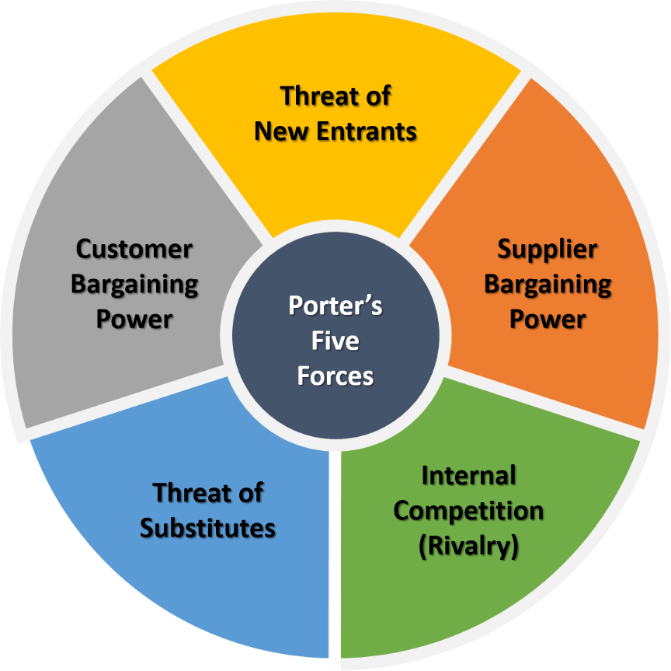
Fig: Porters Five forces analysis (Sheth, 2020)
Buyer’s bargaining power: Buyers get to purchase from online. They could choose any firm. However, Tesco has a brand recognition. Such reputation is the key to generate better business possibilities. Online prices are fixed and supplies were limited. This implies that buyer’s bargaining power was lower than Tesco. Tesco PLC was at the competitively advantageous situation.
Competitive rivalry: Competition increased at a tremendous rate. This affected the business and competitive scenario for businesses (Hill and Hult, 2020). Tesco competed with M&S, ASDA, Sainsbury’s and John Lewis Partnership. For product variants and overall presentation of products, Tesco was at a better state in competitive rivalry.
Substitute threat: Online products are visibly similar. Therefore, identifying substitute was not difficult for consumers during the covid-19. However, not all the products are generic. Tesco has some signature quality of their products (Donthu and Gustafsson, 2020). This threatened the entire business operation of Tesco. It had to change the strategy of product differentiation.
New entrant threat: This was an imminent challenge for Tesco PLC. New businesses were entering and penetrating the business at a large scale. The market share of Tesco were greatly affected and the impact was difficult to cover within short period. New entrants were emerging fast for cheap marketing facilities (Donthu and Gustafsson, 2020).
In short, Tesco’s business competitive advantage was moderate during this session. This was the key reason that the firm had to specialise in digital marketing and online experiences to create competitive position.

3.0. Organisational operations in Covid-19
Covid-19 is a global factor affecting businesses at every corner. Organisational operations were affected highly because of this pandemic. Product strategy, HR strategy, and operations were the major areas which were impacted. Tesco experienced different types of issues during this stage. These are stated in the following:

3.1. Product strategy and portfolio
Retail industry is a large sector with multiple genres of product. Pandemic is an emergency situation. People reduces consuming luxury products and increases consuming retail products (Davis, 2020). Therefore, specialisation of product was mandatory for Tesco PLC. The firm continued producing in-house grocery and daily requirements. Most of the products they sold were daily necessities. Grocery is on the top of the list for product necessity. Specialisation of products created a special market situation. Broad market was covered with a certain price level. As the operation was held through online operations, it reduced external costs. Tesco provided plenty of opportunities for their customers to grab the chance for maximising utility and reducing the overall result.
The strong side of product strategy is identifying mass requirements. Not all products had similar type of demand in the market. It led Tesco to choose different aspects of products for continuing development. Tesco had to reduce premium and luxury products considering the market situation. This was another factor for maintaining the emergency requirement. In product strategy, Tesco used a particular method to continue. They put the maximum effort in daily products. This increased the value of the firm’s contribution during the product development (Carr, 2020).
In a nutshell, premium products with higher profit margin were withdrawn for short-term and daily necessaries have been increased in the production sector. It impacted the whole business and product strategy of Tesco PLC.

3.2. HR Strategy
Tesco was physically shut to follow government’s decision. Therefore, the firm had to shift to a completely new way to operate business with virtual HR setup. The first thing impacted on the dismissal policy. Marketers acquired digital skills to generate value through online marketing. The corporate behaviour was affected due to this change. Working from home through online reduces office politics. However, it was difficult to measure the impact of employee power during this period. The organisational structure of Tesco started flattening in this stage of business operation.
Inducement were given to the workers in production sector. They had to work under risk of getting affected. Bonuses were announced along with health benefits for people who worked.

3.3. Operational processes
Tesco had to create virtual form of the entire business to run operations. The inventory management and overall distribution management has been arranged virtually. Warehouses are being monitored. The positive side of applying such factor is getting accountability form the point of view of Tesco (Butler, 2020). The negative side is reduction of market share and competitive advantage. This was an issue that brought changes to the entire situation of Tesco PLC.

4.0. Organisational restructuring during covid-19 in Tesco
Tesco has been mainly challenged because of their products from premium brands. Some were perishable. The firm had to withdraw these perishable premium products and discontinued their business operations (Alon, 2020). In case of acquisition, Tesco acquired some small enterprises to continue the supply operations. Covid-19 impacted these small businesses to run their in-house operations. Tesco influenced their stakeholders how this would add value for them. For example, buyers will consider getting fresh products during pandemic if a local firm is acquired by the firm. At the same time, shareholders found it a new way to optimise business operation.
The organisational operation moved from hierarchy to divisional organisational strategy. Covid-19 changed the employee engagement in this segment.

5.0. Sustainability of changes and recommendations
Covid-19 surely impacted business operations. Sustainability of these changes is a factor to consider. From the above discussion, online marketing and virtual business operation will remain in the business scenario for a long time. Electronic HRM is a new way to deal with the workforce. The firm now knows dealing with a large distribution channel even at the most vulnerable stage. The aggressive acquisition will also be available as a major concern in this case. The structural and behavioural changes are not sustainable. In order to make them sustainable, Tesco has to follow below recommendations:
1. Tesco must introduce HR Training on virtual business more effectively to continue with development trends (Alon, 2020).
2. The firm has to restructure the organisation in two segments, physical business and digital operations. This will induce the business operation in a vivid calibre.

6.0. Conclusion
Tesco PLC occupies a large section of the retail industry of the UK. It will need to continue development of the business along with the situational changes. The best way to sustain in the business is to know the contingent decision-making. Till date, Tesco is handling covid-19 situation positively for business purpose. It will need to create some sustainable organisational decisions for the long run operations.

References
Alon, I. (2020). COVID-19 and International Business: A Viewpoint. FIIB Business Review, p.231971452092357.
Butler, S. (2020). How Tesco’s “doomsday exercise” helped it cope with the coronavirus. The Guardian. [online] 3 May. Available at: https://www.theguardian.com/business/2020/may/03/how-tesco-doomsday-exercise-helped-it-cope-with-the-coronavirus [Accessed 27 Dec. 2020].
Carr, C. (2020). Global oligopoly : a key idea for business and society. Abingdon, Oxon: Routledge.
Davis, V. (2020). Covid schmovid : 19 ways to get your small business booming. Auckland: The Goat Farm.
Donthu, N. and Gustafsson, A. (2020). Effects of COVID-19 on business and research. Journal of Business Research, [online] 117, pp.284–289. Available at: https://www.sciencedirect.com/science/article/abs/pii/S0148296320303830.
Hill, C.W.L. and Hult, T.M. (2020). Global business today. New York, Ny: Mcgraw Hill Education.
Onita, L. (2020). Tesco profits surge during pandemic. The Telegraph. [online] 7 Oct. Available at: https://www.telegraph.co.uk/business/2020/10/07/tesco-profits-surge-pandemic/ [Accessed 26 Dec. 2020].
Peng, M.W. (2020). Global business. Mason: South-Western.
Sheth, J. (2020). Business of business is more than business: Managing during the Covid crisis. Industrial Marketing Management.
Susskind, D. (2020). A world without work : technology, automation, and how we should respond. New York, Ny: Metropolitan Books/Henry Holt And Company.
Sweney, M. (2020). Tesco and Morrisons to repay £850m of Covid business rates relief. The Guardian. [online] 2 Dec. Available at: https://www.theguardian.com/business/2020/dec/02/tesco-to-pay-back-585m-of-covid-business-rates-relief [Accessed 27 Dec. 2020].
Traver, K.C. (2020). E-COMMERCE 2020-2021 : business, technology and society, global edition. S.L.: Pearson Education Limited.
Wood, V. (2020). Tesco rations ‘essential products’ and tells customers: ‘Please shop normally.’ [online] The Independent. Available at: https://www.independent.co.uk/news/uk/home-news/tesco-ration-quota-supermarket-shortages-b1777882.html [Accessed 26 Dec. 2020].
‌

