A Report On Team Working And Communication Within The Workplace

Effective Team-Working And Communication

Stefan-Adrian Burhala 1908805

Professor: Melanie Squire

Purpose
This report was written to come with a way of improving an already very successful business which has done well so far but in order to go to the next level it needs a more professional touch to the way it runs itself.

Introduction
The business on focus is a grocery store in the city centre of Swansea. The business grew five times in only one year, and this report will tackle two aspects of a successful business: teamwork, through the work of two popular theories, Belbin’s and Tuckman’s, as well as communication. This will present an alternative way of running the business, one that will not only make it look more efficient, but it will help staff and managers be prepared for a continuous expansion.
Findings
The biggest finding that can be drawn from this report is that in order to become a more professional company, money needs to be spent into professionals that can help your business. Someone with experience that brings results can be costly, but in the long run it can bring a lot more money into the company than the business invested in them. Another takeaway is that the systems that were invested in need to be always ready to adapt to the company evolving and the trading environment changing. From the first two employees to the thousandth, communication is key for the business’ success. The employees are the heart of the company so they are always worth investing into, and keeping in mind that a happy employee makes for a thousand happy customers.
Following the communication, Belbin and Tuckman theories, as long as a business follows the models precisely and guides the staff into the right direction the business is bound to be successful.

Contents
1.
In Bruce Tuckman’s theory, there are four stages of group development:
- Forming, when new team members meet
- Storming, when leadership gets questioned and different opinions become more apparent,
- Norming, when the team works together in solving their differences
- Performing, which results from the other stages and the team is already working at its highest potential. (Morgan, 2017 p. 210, 211)
The other theory used in this report is Belbin’s team roles theory that came after a study to solve the mystery of ‘’why some teams are higher performing than others’’ (Isaac and Carson, 2020)
and team roles are as follows:

- Shaper and coordinator for identifying needs
- Plant and resource investigator for finding ideas
- Monitor and specialist for formulating plans
- Resource investigator and team worker for making contacts
- Implementer and coordinator for establishing the organisation
- Complete finishers and implementors for following through. (Morgan, 2017 p. 207, 208)
With these two theories in mind, the best course of action for a company with expansion being its primary focus would be to hire a Human Resources Manager with its first task being to test out every employee.
Based on this test, the Human Resources Manager will be able to form three separate teams comprised of one Shift Manager, five Sales Assistants, one security guard, and one cleaner. The team can be broken down into three team roles: leaders, strategists and workers. This will give flexibility as the staff works part time, having three separate teams on three different shifts will fit well into the team dynamics. It is important to keep in mind that cleaners and security guards also need to take the test as it is important to have good chemistry and trust with the rest of the team. Following this test the Human Resources Manager will be able to identify the current stage of development of each individual group, and present the shift manager with advice on how they should handle situations.
While a good HR Manager can cost anywhere between £15.000 to £30.000, it is a fruit bearing investment as proved by many companies who intend to increase their human resources head count. (Fig1)
A Human Resources Manager can also put training out, relieving the responsibility from the manager on duty on the first shift of a new colleague and they could develop and advise the business owner on the new training policies. Through training, the business must set a common goal, and the Human Resources Manager helps with that.
Another use for the Human Resources manager is setting schedules and dealing with holidays, work schedules and time off requests, as well as logging hours to be sent to the accountant.
Another investment in the future of the company would be promoting one sales assistant in each team to the position of assistant manager, an investment that could be either free or could cost the business anywhere between £0.25 to £1 per hour but it is a necessary investment in the future, since an expanding company means more staff being brought on there would be a need of managers. Identifying a shaper or coordinator, two team roles essential for the success of the company but also the most suited to be in leadership roles and then promoting them will boost staff morale, as employees will see the possibility of a promotion in the future. This will build loyalty to the company as well. (Empxtrack, 2020)

To make profit, you need to invest, and a good investment is one you make into more professional, qualified staff, one that will make your company more efficient, will develop your teams and it will allow you to get into the Performing group stage. (Craig, 2020)

2.
Belbin and Tuckman’s theories only work with well established means of communication, which are classified into verbal and non-verbal.

Non Verbal Communication
It is important to focus on a few ways of Non Verbal Communication within a company that can help a company become more professional
- Symbols and signs in the store
Signs and symbols are important within the store, from everything such as a wet floor sign to general grocery signs to indicate where different products are. This makes verbal communication a lot more effective, for example if one customer asks where the frozen products are, and the store has a sign of a snowflake on top of the frozen product isle, the sales assistant can point at it and it helps the customer find what they need without needing too much help, allowing for a more productive sales assistant since they won't spend too much time with the customer, and will give the customer a sense of trust in other signs and symbols if they may need help with something else.
- Uniforms
Uniforms can be used as a form of Non Verbal Communication, since a customer can easily differentiate a staff member and, if needed, ask for help.
It creates a professional business image, it promotes the company or brand and it takes you logo out into the world and it imprints into the customers mind. (PositiveBranding, 2020)
- The Store Presentation
The way a store is presented to the customer is truly important in a business, when everything is arranged in a tidy way, and a customer can go in and out of the grocery store in a fast and efficient manner, coupled with great customer service will make the customer choose this grocery store over other high street mainstream brands.

Verbal communication
- Setting a greeting formula
Setting a personalised greeting formula custom tailored to the
business’ brand can form customer loyalty and a feeling of consistency and professionalism.
- Social media group chats
Social media group chats can be set up for free to allow management and employees to communicate fast and efficiently from anywhere at any time, and removing the face to face factor it helps interlocutors communicate more effectively.
- Monthly meetings
Having a monthly meeting with all staff to communicate statistics, achievements, improvement points and to congratulate the team is a good opportunity to increase staff morale, to reward employees and to build more trust and loyalty from employees.
- Fortnightly one on one meetings
Each designated team leader or manager can have a meeting every two weeks with each employee to give feedback on the work they're doing, if there's any need from improvement and potential guidance if needed. It is also a good time to receive feedback from employees as it is more comfortable for people to put out ideas when it's in a safe environment and also a good opportunity for management to see if there's a common opinion between sales assistants in regards to an internal issue and it could be considered and solved.
- By-annual team building meetings
Another cheap per ensemble team building solution is taking the teams somewhere outside the work environment and doing something entertaining. This can work very well with the expansion of the company and having new team members being constantly added to teams, it can help with the Storming stage of group development. (Fig2)
- Improvement on e-Pos system
It is important to future proof the business with a more efficient ePos system. This system is made of an electronic till with a hand-held terminal connected to a Windows Personal Computing accessing a Wider Area Network (Old.businesscasestudies.co.uk, 2019). It helps the company make sure the levels of stock are well taken care of, it helps provide a wider variety of products that are in demand and ensures the freshness of their different products.
It also helps build customer loyalty by providing them with fresh products at all times, and it helps the business provide a more competitive price . It helps identify buying patterns and see what products can be bought in higher numbers and the opposite. (Business Case Studies, 2019).
A new ePos system can save a lot of money from waste, since it allows the business to order exactly how much the business needs and it can provide patterns that can be analysed year by year, month by month, week by week, and it can provide very accurate predictions on sales. This can be seen in the increased revenue of another retailer since it introduced the new ePos system, Mark & Spencers. (Fig3)
But the EPOS system did not come without any risks. A first draw back consists of the maintenance costs as well as the staff training costs for its usage. Another very stressful risk is its vulnerability from hackers, since every attack will definitely have a very bad impact on a company, resulting in financial and market credibility loss, but more importantly, it could result in customer data, such as credit card details being stolen and used without customer agreement. For example, in 2016 there has been an attack on an American fast-food chain that affected over 300 restaurant locations, resulting in the customer information being stolen, and hundreds of thousands of dollars have been stolen from the customers’ credit cards. (InfoSecurity, 2019)

Conclusion

The company has a lot of room to grow. The fact that it expanded five times in the last year is proof that it has what it needs to get even bigger, proof being the fact that the owner asked for a professional opinion. After careful consideration and allocation of resources from management and ownership, the company can continue to expand for the foreseeable future.

Appendices
Fig1
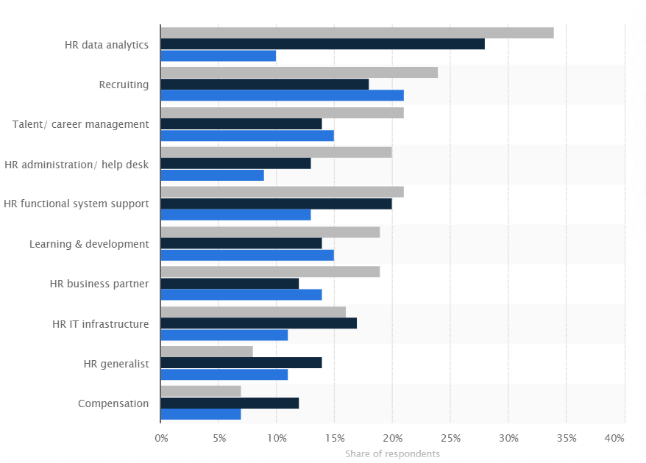
Fig2
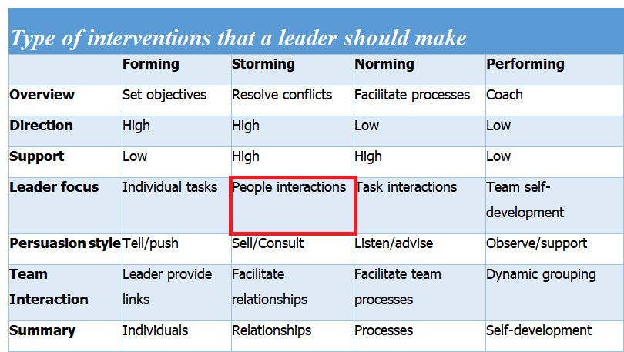

Fig 3
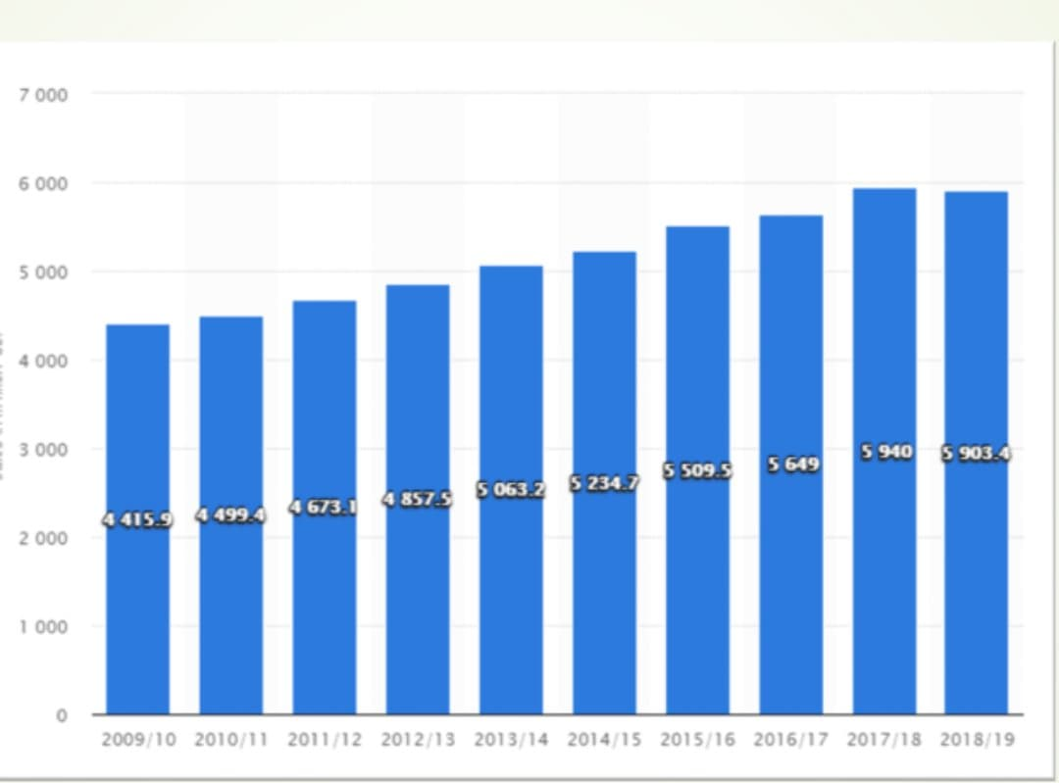
Fig4
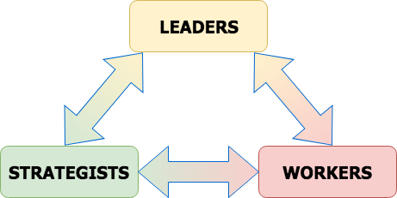

References
Morgan, P. (2017). Business student's guide to study and employability. Los Angeles: SAGE, pp.210, 211.
Isaac, M. and Carson, K. (2020). A guide to Belbin Team Roles: how to increase personal and team effectiveness. p.11.
Empxtrack. 2020. 5 Ways HR Can Help Increase Employee Loyalty. [online] Available at: <https://empxtrack.com/blog/hr-can-help-increase-employee-loyalty/> [Accessed 3 April 2020].
Craig, W., 2020. Making Strategic Investments In Employee Development Is Crucial For Success. [online] Forbes. Available at: <https://www.forbes.com/sites/williamcraig/2018/07/31/making-strategic-investments-in-employee-development-is-crucial-for-success/#42873aca140c> [Accessed 3 April 2020].
Embroidered & Printed Clothing Suppliers in London - Positive Branding. 2020. Positivebranding. [online] Available at: <https://www.positivebranding.co.uk/the-benefits-and-psychology-behind-wearing-work-uniforms/> [Accessed 3 April 2020].
Old.businesscasestudies.co.uk. (2019). A time for change - Marketing solutions via technology - Marks and Spencer | Marks and Spencer case studies and information | Business Case Studies. [online] Available at: https://old.businesscasestudies.co.uk/marks-and-spencer/marketing-solutions-via-technology/a-time-for-change.html [Accessed 3 April 2010].
Business Case Studies. (2019). The Importance Of Quality In Creating Competitive Advantage - Business Case Studies. [online] Available at: https://businesscasestudies.co.uk/edition-10-the-importance-of-quality-in-creating-competitive-advantage/ [Accessed 3 April 2020].
Bridgeman, D. (2018). The 6 Characteristics Of Effective Teams — As Revealed Through Escape Rooms. [online] Medium. Available at: https://medium.com/@davidbridgeman/the-6-characteristics-of-effective-teams-as-revealed-through-escape-rooms-12fe515df53f [Accessed 3 April 2020].
Seals, T. (2019). Wendy's Point of Sale Hack Grows Bigger. [online] Infosecurity Magazine. Available at: https://www.infosecurity-magazine.com/news/wendys-point-of-sale-hack-grows/?fbclid=IwAR0ANEGdqoondgHgm5esAtUaNXfA5KjDT1rMvS-tSw8vs4XQqMfprTUEqeQ [Accessed 3 April 2019].

