Academic and career success hinge on a combination of essential skills that enable individuals to navigate challenges, collaborate effectively, and adapt to evolving environments. These skills, often referred to as "soft skills," complement technical knowledge and are critical in both educational and professional settings.
Communication
Effective communication encompasses listening, writing, and speaking. It allows individuals to articulate thoughts and ideas clearly, facilitating understanding and collaboration. Employers value professionals who can convey information effectively and engage in active listening to build strong relationships and resolve conflicts. [1]

Problem-Solving and Critical Thinking
The ability to analyze issues, make sound decisions, and overcome problems is vital. Critical thinking enables individuals to assess situations, ask pertinent questions, and develop innovative solutions, which are essential in both academic pursuits and the dynamic workplace. [2]

Teamwork and Collaboration
Working effectively and respectfully with others is crucial in most environments. Teamwork involves bringing out the best in colleagues, understanding diverse perspectives, and contributing to shared goals. Employers seek individuals who can collaborate seamlessly and foster a cooperative work atmosphere.

Adaptability
In a rapidly changing world, adaptability is a key skill. It involves being open to new ideas, adjusting to new conditions, and handling unexpected challenges with ease. This flexibility is essential for continuous growth and success in various contexts.

Leadership
Leadership is not confined to managerial roles; it involves using interpersonal skills to guide and develop others, motivate teams, and delegate tasks effectively. Demonstrating leadership qualities can lead to career advancement and the ability to make a positive impact within an organization.

Professionalism and Work Ethic
Employers value personal accountability, punctuality, and productivity. A strong work ethic and professionalism involve taking responsibility for one's actions, learning from mistakes, and consistently striving for excellence. These traits contribute to a trustworthy and efficient work environment.

Digital Literacy
In today's digital age, proficiency with technology is indispensable. Digital literacy includes understanding and effectively using digital tools and platforms, which is essential for communication, research, and productivity in both academic and professional settings.

Developing these essential skills requires intentional effort and practice. Engaging in experiential learning opportunities, such as internships, apprenticeships, and volunteer work, can provide practical experiences that enhance these competencies. Additionally, seeking feedback, participating in workshops, and embracing lifelong learning contribute to continuous improvement and preparedness for future challenges.
Incorporating these skills into one's repertoire not only enhances individual performance but also contributes to the success of teams and organizations. As the landscape of work and education continues to evolve, these foundational skills remain integral to achieving and sustaining success.
For a more detailed exploration of these skills, you can refer to the following resource: [3]
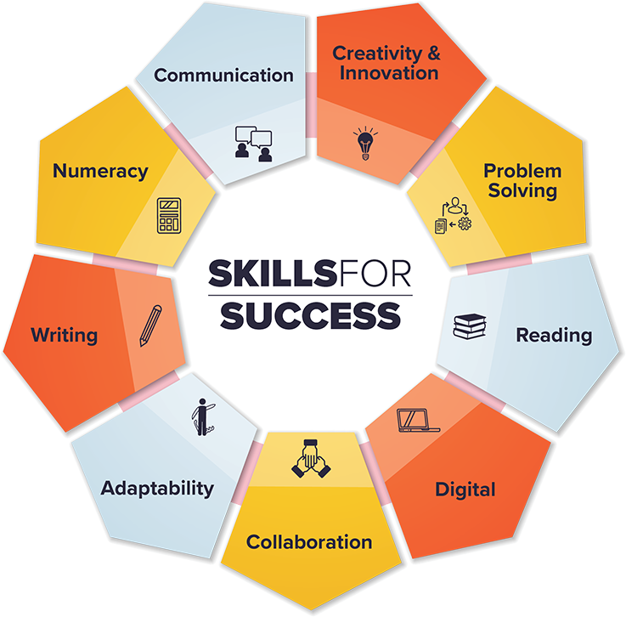 [4]

Bibliography

[1] | C. B. Today, 2019. [Online]. Available: https://www.colorado.edu/today/2019/04/17/10-essential-skills-youll-need-career-success?utm_source=chatgpt.com.
[2] | Talent500, 18 09 2023. [Online]. Available: https://talent500.com/blog/essential-skills-for-career-success/?utm_source=chatgpt.com.
[3] | C. G. Academy, 10 9 2023. [Online]. Available: https://www.crimsonglobalacademy.school/us/blog/power-of-soft-skills-in-academic-and-career-success/?utm_source=chatgpt.com.
[4] | G. o. Canada. [Online]. Available: https://www.canada.ca/en/services/jobs/training/initiatives/skills-success/understanding-individuals.html.

