12/20/2024
Assessment 2
Practical and Professional Development of the Proposed Project

Module NaMe: Changemakers, Creativity and Value creation
Module Code: ACCA 5033
Student NAME: Oneil CLARKE
Student ID: 2409936
Lecturer: Koushik Modak
Trinity saint david University of Wales (London Campus)

Name:
Student ID:
Table of Contents
Introduction 2
Main Body 2
Task 1 2
Project management Planning 2
Task 2 8
Enterprise 8
Task 3 10
Project Reflection 10
Conclusion 12
Reference 13
Appendices 14

Introduction
The purpose of this assessment module is to enable me to develop key skills to identify opportunities and produce innovative ideas, undertake a research analysis, think critically and provide valuable contributions to society. Over the course of the assignment I will investigate how research and design thinking interact as an intersection and therefore how this integration may create opportunities for insight that can positively impact both the individual and community. The assessment module will prepare me for the Emerging Trends and Independent Project modules in my final year.

Main Body

Task 1

Project management Planning
Q1
Project aim and proposed solutions
The goal of the AI Questionnaire Builder Application is to give users who are researchers, professionals or policymakers a new way to build dynamic questionnaires that assess the impacts of AI on both society and individual lives by utilizing AI to adaptively create and process questionnaire based upon NLP and machine learning to analyze data for an assessment of societal impacts of AI and identifying emerging trends related to its social impact in research, professional or policy environments.
This application will also utilize machine learning algorithms to help identify emerging trends in the social implications of AI to assist in providing actionable data to support research, professional and policymaking environments.
Required Technology and Resources
- A front end technology: Either React.js or Angular to create a highly interactive user experience.
- Back End Technology: Either Python (Flask/Django), or Node.js to provide the service for APIs.
- Data Store: Either PostgreSQL or MongoDB as a database to store your users' questionnaires and their answers.
- AI/NLP Model(s): Use pre trained transformer based model(s) such as BERT, GPT etc. for creating questions, and sentiment analysis of answers.
- Cloud Infrastructure: Either Amazon Web Services (AWS), or Microsoft Azure to support large scale deployments.
- Collaboration Tools: GitHub to manage code changes; either Jira/Trello to manage projects.
- People: AI Engineers, Software Developers, User Experience Designers, Sociology Experts, and Policy Experts.
Project Schedule and Timeline
The timeline for an AI project will be approximately 16 weeks for an initial release based upon standard timelines within the AI industry [1].
Weeks 1–2: Requirements Analysis — Define the scope of the project, stakeholders, and data sources that are available for use in this project.
Weeks 3–5: Design — Develop the design elements of the project including wireframes, overall system architecture, and data flow diagrams.
Weeks 6–12: Development — Develop the application components which include both the front end and back end, as well as the AI component of the application.
Weeks 13–15: Testing — Test each of the individual components of the application (unit testing), test how they interact with one another (integration testing), and test the entire application from a user perspective (user acceptance testing).
Weeks 16: Deployment — Deploy the minimum viable product (MVP) to the cloud-based platform for production use.
Post Deployment: Evaluation & Maintenance — Continue to evaluate the performance of the application, continue to update and improve the model(s) used in the application, and continue to make improvements and enhancements to the features of the application [2].

Limitations/Constraints
1) Availability of data: There is a potential lack of available datasets in relation to the societal impacts of AI.
2) Ethical constraints: In generating questions we are required to ensure that our generation is bias-free as well as avoid using question frames that could potentially influence the decision-making process in an unfair manner.
3) Financial limitations: The cost associated with cloud computing infrastructure and the training of AI models may be prohibitively expensive.
4) Time constraints: Due to the experimental nature of AI, iterative testing may take longer than initially anticipated.
Development Method
The Hybrid Agile methodology will be used in this research project Agile sprints of a short duration of two weeks for continuous iteration and testing. Scrum framework of daily stand-up meetings, sprint review meetings, and retrospective meetings for continuous adaptation. Waterfall elements of fixed milestone based development of requirements and design phases for clarity. Using a Hybrid Agile methodology will allow for continuous stakeholder feedback and adaptation while still maintaining a project that is on track and follows the original scope of the project.
Q2
Project Design Choices
For this part of the assignment I will be choosing 2 pieces of design methods which will support my chosen project. The First design type will be wireframe as it emphasizes usability, data-driven insights, and AI-powered customization [3].
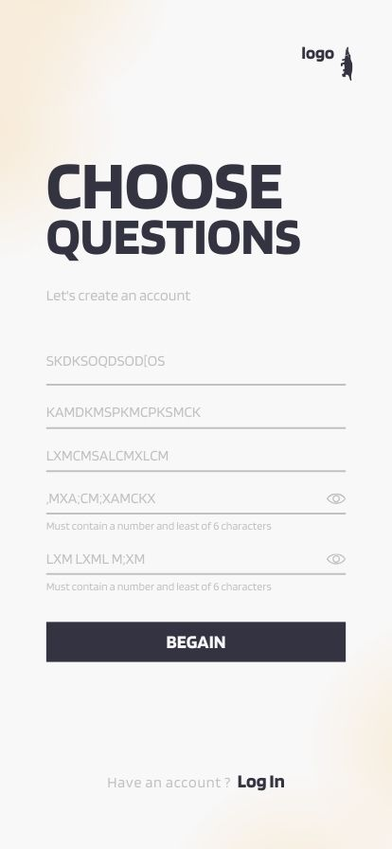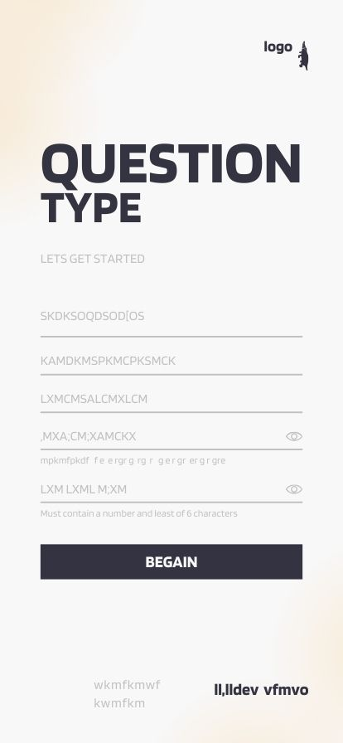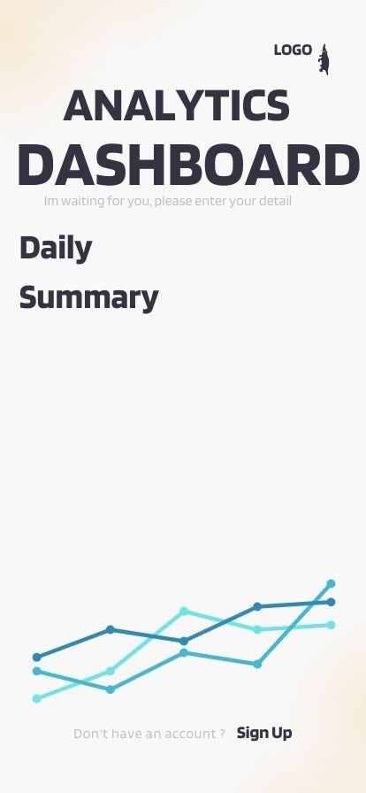

As for my second choice, I decided to create An app design layout table to help me distinguish each roles displayed in an orderly manner.
Screen | Key Elements | AI Features | Purpose
Home | CTA, Templates, AI Suggestions | Personal templates | Quick start
Build | Drag-Drop, Question types, Logic | AI Phrasing, bias detector | Create questionnaire
Respondent  interface | Progress bar, Accessibility | Clarification assistant | Collect responses
Analysis | Charts, Sentiments, Export | AI clustering, insights | Analyse data
Settings | Privacy, Collaboration | AI compliance checks | Manage app

Task 2

Enterprise
After searching rigorously I came across a few companies with similar ideas and goals as my chosen project. There are several organizations that have a similar focus to what I am researching (the influence of AI in today's world, and possible impacts for the future). Some of these organizations are also research based and some are also corporate. Several of these organizations may be used as examples or referenced in my study. The main company I chose to research in depth is Mackinsey Global Institute (MGI) This company mainly highlights future work partnerships between humans and AI agents.
Q1
When analyzing MGI through a lens of both PEST and SWOT. The major external factors that could affect the future of the company include technology, regulations and global economic conditions. In terms of the internal environment, there are several factors that contribute to MGI's strengths including its reputation as a premium brand, as well as the ability of the organization to conduct extensive research. There are however, a number of factors that will negatively impact MGI in the future, for example reputational risk and a structure that is extremely costly to maintain when compared with some of their competitors in the same industry space.
Politics
Regulatory Environment and Global Economy MGI operates globally which means it has to comply with a wide range of different laws, regulations and codes of conduct related to data privacy, artificial intelligence ethics and professional standards. The increasing level of scrutiny being applied to consulting firms by governments increases the risks faced by MGI [4].
Politics Geopolitical Tensions differences in trade policy between countries and the changing nature of international alliances have affected MGI's ability to help multinational clients develop global strategy [4].

Economics
Macro-Economic Conditions changes in inflation rates, interest rates and the global economy generally can impact demand for consulting and research services provided by MGI. MGI provides advice to both government and corporate clients which means that it is directly impacted by the fluctuations of the global economy and therefore faces risks associated with macro-economic conditions [4].
Economics Digital Transformation Investment. There is a high level of investment in companies developing their use of artificial intelligence, automation and sustainable practices, which presents MGI with an opportunity to provide insights and solutions to those companies [4].
Society
Workforce Expectations clients are demanding greater inclusion and socially responsible approaches when developing strategies for their businesses. MGI will need to include environmental, social and governance (ESG) considerations in all of its research projects going forward [5].
Society Talent Acquisition, Recruiting the best students from leading universities remains critical for MGI however, there is now increased competition for talented graduates who have the skills required to support MGI's growing needs in artificial intelligence and data science [4].
Technology
Disruption Through Artificial Intelligence, Artificial intelligence has the potential to replace traditional consulting analysis through the application of machine learning algorithms to large datasets, this means that MGI will need to transition its business model to be based on technology enabled solutions [4].
Technology Data Analytics of MGI's primary source of competitive advantage comes from its ability to analyze large datasets of economic data to provide insightful recommendations to clients. MGI will need to continue to invest in more advanced forms of data analytics if it is to maintain that advantage in the future [4].

SWOT Analysis
As for my SWOT Analysis I chose to display this in a simple table in order for a better understanding.
Strength | Weakness | Opportunities | Threats
Global brand recognition and credibility | High-cost structure limiting agility | Expansion into AI-driven, tech-enabled solutions | AI commoditizing consulting analysis
Access to elite talent and C-suite relationships | Reputational risks from controversies | Growing demand for ESG and sustainability consulting | Intense competition from other consulting firms
Strong research base through MGI publications | Dependence on traditional consulting revenue | Leveraging global trade and digital transformation trends | Regulatory scrutiny and geopolitical instability

In conclusion, based upon MGI's PEST and SWOT analyses, it is evident that MGI is a highly influential organization with an abundance of intangible assets; however, it also faces many potential threats to its long-term viability such as the increasing risk of job displacement due to the rapid development and widespread adoption of artificial intelligence (AI), the increasing regulatory pressure being placed on consulting firms, and the associated reputational risks of those pressures. In order for MGI to continue to be competitive in the future, the company will need to effectively leverage technological innovation and sustainability trends while continuing to provide valuable insights into how they affect their clients' global business strategies for the purpose of this analysis research.

Task 3

Project Reflection
Developing New Skills
AI and Machine Learning Integration. The application of NLP and machine learning models to create and improve the survey questions is essential when developing an app, this develops your ability to build, train and deploy AI systems.
No-code/Low-code platforms. Most AI App Builders (Figma Make, Lovable, Musely.ai) offer no-code/low-code environments where you can rapidly prototype and develop applications as well as learning how to use modern development processes and UI/UX design methods.
Data Analytics, when collecting responses from users, you'll be able to develop your analytical and interpretive abilities of large data sets using statistical methods and visualizations that are essential in evidence based decision making [2].
Analytical & Research Skills, Survey Development and Methodologies. In order to create an effective questionnaire you need to understand biases, validity and reliability. This project will help me to develop my knowledge and ability to develop valid and reliable instruments to collect useful information [2]. Evaluating Critical Thinking about the Effects of AI on Society Because the app assesses the effects of AI on society, I will develop my ability to evaluate the ethical, social, and economic impacts of new technologies.
Professional & Interdisciplinary Skills, policy and Academic Uses. If I apply the app in research or policy-making environments, I will have developed my ability to convert technical results into actionable recommendations.
Collaborative and Communicative Work. My work with developers, researchers and other stakeholders to develop the app will strengthen My project management and inter-disciplinary communication skills.
Innovation and Entrepreneurship, creating a product that addresses societal issues, will foster an entrepreneurial way of thinking and problem solving.
Strategic Value will help by developing an app that uses AI and has value to society, places me in the intersection between technology, society and governance, and enables me to contribute to the ongoing debate regarding AI ethics, regulations and adoption. With this knowledge, I will possess a wide range of transferable skills that enable me to apply myself in the areas of academia, business, and government.
Positive impact and contributions
The development of a questionnaire builder application (based on artificial intelligence) will have the ability to positively affect society by making it easier to be able to get access to research tools, make better decisions with data, create more inclusive and therefore better academic policy insights.
Societal contributions, access to research tools and survey design. Is typically a time consuming and costly process that limits involvement in research to schools and universities with large budgets, or other large funded institutions. The use of AI, as in the case of Jotform and forms.app, for creating surveys simplifies the design process for educators, non-profit groups, and small business owners to collect useful data without the need for specialized technical knowledge [6].
Data quality improvement, the use of AI for optimizing questions used in surveys decreases biases and increases the number of people who complete surveys. This provides organizations, researchers, and government agencies with more accurate information to support their policies and decisions.
Impact on Policy & Governance, AI societal impact assessment tools are used by policy makers to assess the potential economic, ethical and social impacts of new technologies. Therefore, when the tool is integrated into the questionnaire builder, the builder will enable policy makers to develop evidence based decisions and ensure the responsible implementation of AI [2].
Civic engagement, AI community impact reports from companies like Tasked illustrate how AI can be used to enhance civic engagement and promote sustainable development. Likewise, the questionnaire builder will provide communities with the opportunity to express their views, and thus influence public policy [7].
Development of skills for Innovators, designing and utilizing the application will foster the development of technical, analytical, and ethical skills in users, which will prepare them to responsibly utilize AI across various sectors.
Therefore, not only will this project improve the personal capabilities of users, but it will also contribute to the progress of society by promoting greater inclusivity in research, improved accuracy in data collection and improved governance through the implementation of AI.
Risks and Challenges
The use of a questionnaire builder app based on artificial intelligence (AI) is risky and will involve some challenges, however, there are ways to proactively address these risks and challenges.
Main risks, challenges, data protection and privacy. Gathering user answers creates data privacy risk including non-compliance with regulations like GDPR and CCPA [8].
Ai model bias, there is a high chance that ai generated question may contain implicit biases from culture or language resulting in reduced accuracy and reliability.
Adoption by users and trust, user adoption and trust of the tool could be impacted if stakeholders do not understand how the methodology of the tool is transparent.
Tech complexity, the integration of natural language processing (NLP), machine learning and other technologies require a higher level of technical knowledge than most developers have today, which would likely impact development time [9].
Ethical Issues, the misuse of the collected insight could create a continued stereotype, commercial exploitation of the insight.

Conclusion
This project will serve two goals to enhance users' individual abilities, and to advance society as a whole by enabling more inclusive participation in research, collecting data with increased precision and enabling better governance through the application of artificial intelligence (AI).

Reference

[1] | “servicenow,” 2025. [Online]. Available: https://www.servicenow.com/uk/accessibility-statement.html.
[2] | “infotech,” 2025. [Online]. Available: https://www.infotech.com/sem/lp2/build-your-ai-strategy-and-roadmap?utm_source=bing&utm_medium=cpc&_bt=81638877749277&_bk=generative%20ai%20strategy&_bm=b&_bn=o&_bg=1306220987445546*&msclkid=805d152f71fe1a3a0c527c16bb08393e&utm_campaign=AI&utm_term=genera.
[3] | Naveed, “uxpilot,” 2025. [Online]. Available: https://uxpilot.ai/blogs/best-wireframing-tools.
[4] | Mckinsey, “mckinsey,” 2025. [Online]. Available: https://www.mckinsey.com/featured-insights/year-in-review/year-in-insights.
[5] | K. Shah, “iide,” 2016. [Online]. Available: https://iide.co/case-studies/swot-analysis-of-mckinsey/.
[6] | A. Tank, “Jot Form,” 2006. [Online]. Available: https://www.jotform.com/?utm_source=bing&acc=main&utm_campaign=261241648&utm_medium=cpc&adgroup=1148989652520875&matchtype=p&bid_match_type=bp&device=c&utm_term=jotform&utm_content=71811941269557&extension_id=&target_id=kwd-71811861128631:loc-188&network=.
[7] | Z. T. W. A. L. A. I Solaiman, Evaluating the social impact of generative ai systems in systems and society, 2023.
[8] | L. Y. W. H. H Li, The impact of GDPR on global technology development, 2019.
[9] | J. H. Cole Stryker, “IBM,” 2025. [Online]. Available: https://www.ibm.com/think/topics/natural-language-processing.
[10] | “servicenow,” 2025. [Online]. Available: https://www.servicenow.com/uk/lpdem/demonow-generative-ai.html?&msclkid=72a90ad170231d95e28a63e8b9f5eab3&utm_source=bing&utm_medium=cpc&utm_campaign=BING_EMEA_ALL_EN_DEMANDGEN_SPMT_PRSP_NonBrand_PHR_UKI-PAITW2-GAI-Gen-AI-BUs&utm_term=artificial%20intellig.

Appendices

