Assignment 1

Fundamentals of construction

Swansea Mumbles Road Development
Reeve Thomas
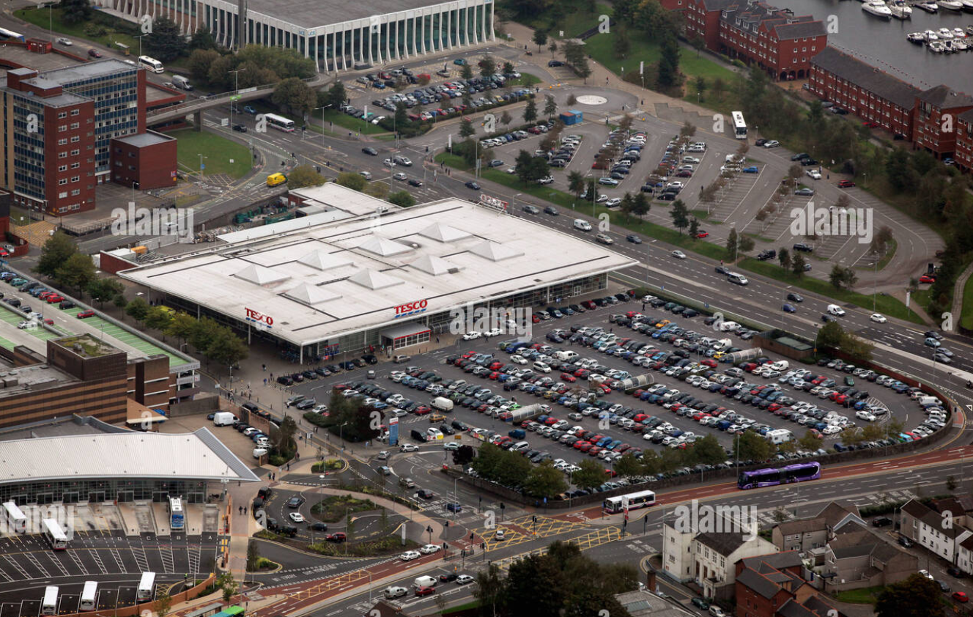

Produced by D Legakis for Alamy, Produced on (16th September 2024) Aerial view of The Tesco Marina supermarket store in Swansea City centre in south Wales [Online] Available at: https://www.alamy.com/stock-photo-aerial-view-of-the-tesco-marina-supermarket-store-in-swansea-city-49092160.html?imageid=131305B9-190D-49D9-878B-7CC09C13AB0A&p=130214&pn=1&searchId=8702a43dca193cf21ca9188b1e392370&searchtype=0 [Accessed 10th January 2025]

Contents

- Site Features
- History of the site
  - What was on the existing factory site
- Geological Investigations
  - Coal Deposits
  - Sandstone
- Environmental features
  - Existing Railway
  - Flooding
  - Flora Risks
  - Fauna Risks
- Borehole Survey
- Dealing with existing factory chemicals
  - Methods of Ground contamination Testing
- Archaeology
- Choosing the Ideal Foundation
  - Drawing

Site Features
This Site is located on the edge of Swansea city, it is known for its easy access for cars and vans, it also holds a beautiful views of Swansea marina best fit for a 5 storey, 400-bedroom Hotel. At the minute the 80,000 square foot site is known for a Tesco with a functional car park. This building was fully constructed in February 2000 and the project budget was £13.5 Million. The only disadvantage of the site is the access for the site deliveries as both roads leading into the site are narrow and will be difficult for the lorry to turn the tight bends as you can see from the image below taken from google maps. To resolve this, we will have to make a new road for the deliveries to safely enter the site.
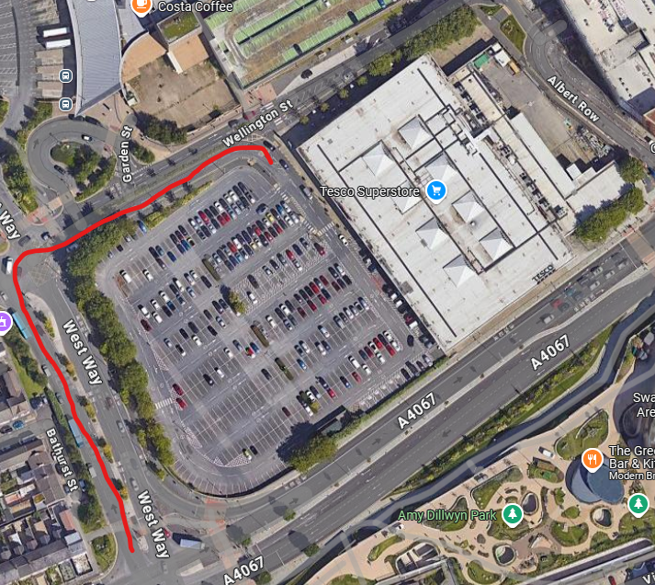

Produced by Google for Google Maps, Produced on (June 2022) Google maps Image [Online] Available at: https://www.google.co.uk/maps/@51.6167505,-3.9438515,340m/data=!3m1!1e3?entry=ttu&g_ep=EgoyMDI1MDEwNy4wIKXMDSoASAFQAw%3D%3D [Accessed 10th January 2025]

Where the site is there is also an ongoing construction site. The constriction site that is near to our project is a residential flat building. In the building there will be 33 Apartments. The client for this site is Pobl Group in case we need to contact them in a emergency. When the project has been handed over to the residents, we then need to make sure that if we receive any updates for the site, and consequently affecting the residents surrounding the site, we need to make sure that they are contacted either by phone call or letter. On the letter there needs to be a contact for the project manager of the site, so that he can deal with any questions they may have.

There is also a major arena shown in the image above, opposite the site. The arena can be very busy when an event is on. Because of the events that go on in the arena we will have to make sure that the site if fully kitted up with the best health and safety options this can include, Heras fencing placed around the border of the site, perfectly visible signs in all sizes and a glow in the dark material.

History of the site
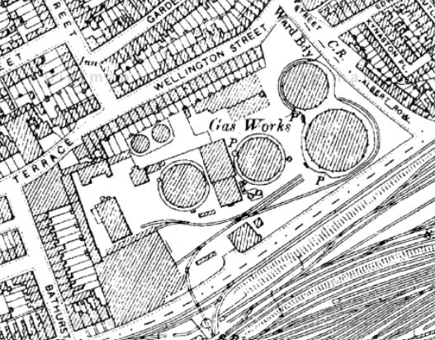

Produced by Digi Maps for Digi Maps, Produced on [Online] Available at: https://digimap.edina.ac.uk/roam/map/historic [Accessed 10th January 2025]

Firstly, as you see from the snip it image above that I have inserted in, from the archival source, there was a factory on the site that we are looking, the factory was there for producing gas by consequently burning coal. The factory was creating gas for 81 years until it stopped in 1922. When the factory stopped creating gas it then turned into a facility to issue gas all round the Uk until the date of 1949. The land was sold in year 1924
What was on existing Factory site
The existing factory consisted of 2 gasometers that stored the gas that they produced, a Retort House where they burn the coal to make the certain gas, Refining House, Boiler house, and much more buildings that also help on creating the gas. There was also a train track built in the surrounding area, taking certain materials in and out to create the gas that they wated to make.

Geological investigations
Underneath the ground of the site that we are looking to build on, there is a mixture of different ground types such as artificial ground, superficial deposits, and bedrock. As the site is known as for the beach being very close to the site, we will be having sand blown over when the weather has created a storm or even when its windy. When the sand hits the building over time it can make the building materials erode, damage to the finishes of the building for example making the building not as good of a spec as it was built. The sand can also be known for entering different systems within the building and consequently causing trouble. Blown sand can also be very expensive as over time you will have to employ special teams in to clean the building as it will need maintenance at least every month in the winter and not so much in the summer.
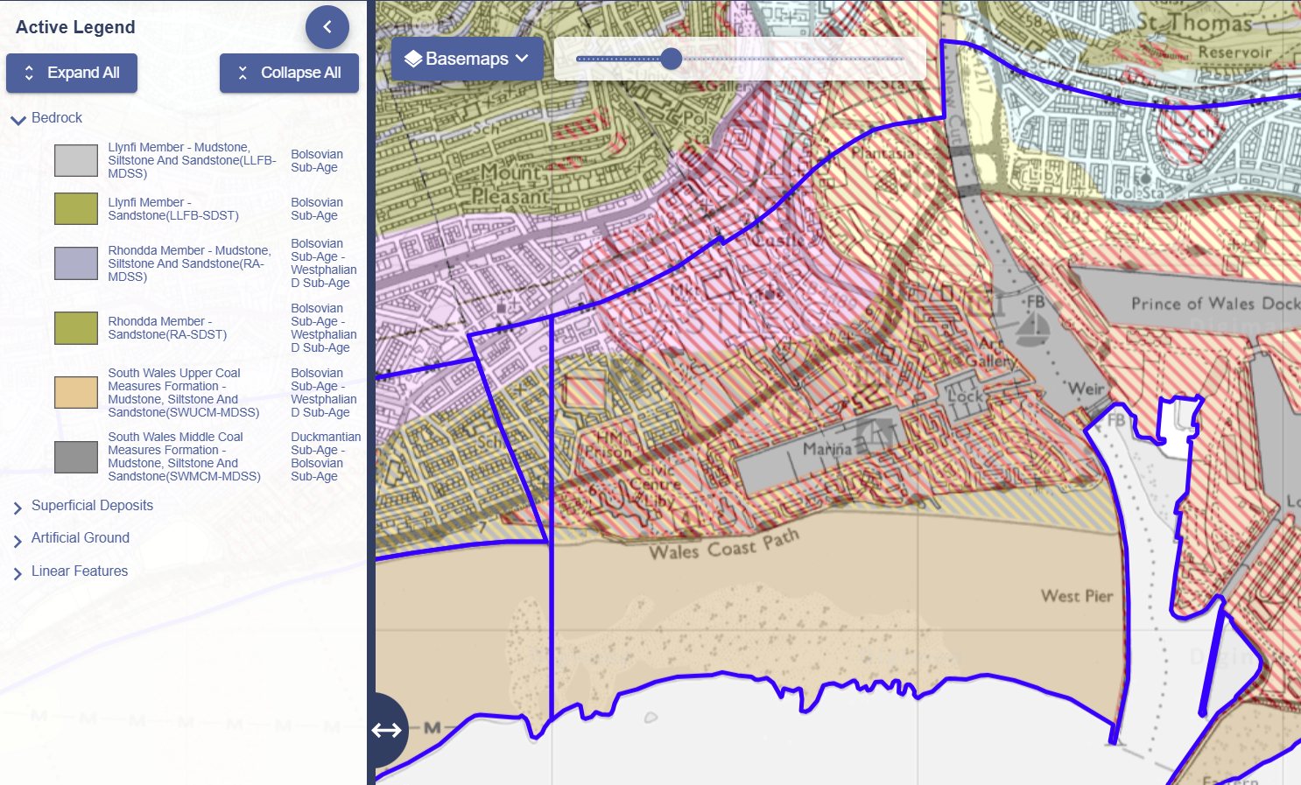
Produced by Digi Maps for Digi Maps, Produced on [Online] Available at: https://digimap.edina.ac.uk/roam/map/geology [Accessed 10th January 2025]

Coal deposits
As you can see from the image above in the surrounding area and inside of the site there is also coal underneath the known area. This can create a lot of problems as there is coal in the area, it can be a chance of old mines that are located underneath the site. This can create a number of problems for example the stability of the ground, subsidence this is when the ground falls and can create potential structural problems for the new building. Before we start any work on the site a full survey of the site needs to be put together to answer our question if there is a mine located underneath the site.
Sandstone
Underneath the site the archival software that I am using also shows a possibility of sandstone in the area. This also can be a problem for the site as sandstone can erode more quicker and easily than the other rock types. If the sandstone is not cemented well enough that can also lead into big issues like the stability of the soil.

Environmental issues
As I have stated up above in the history of the site, I know by using an archival software that the site has been known for a gas factory. Because of the gas factory the ground might still be contaminated, so we will have to do a number of tests to see if it is true. As explained in the geology part there is a lot of coal located underneath the site. This then leads to coal mines, if there is coal mines located under the site then that can also lead to the ground being contaminated. As the mining process itself can cause harmful substances like sulphur to leach into the soil and groundwater. And the second problem of mining is the waste of the coal as if it is not managed then it can release harmful gasses. When we are excavating the land, we also need to make sure that we have the correct PPE on as there can be harmful gasses underground like hydrogen sulphide, carbon dioxide, methane and Radon, these 3 gasses can create major health problems or even life-threatening problems.
We also need to be carful with the noise pollution that we are creating from the site. We need to make sure that the site is not producing any noise from 7:30am to 6pm. As there is a currently a block of flats being constructed next door to the site this has been stated in the site features section of the report. There is also residence on the opposite side of the block of flats that is not under construction, that we need to think about.
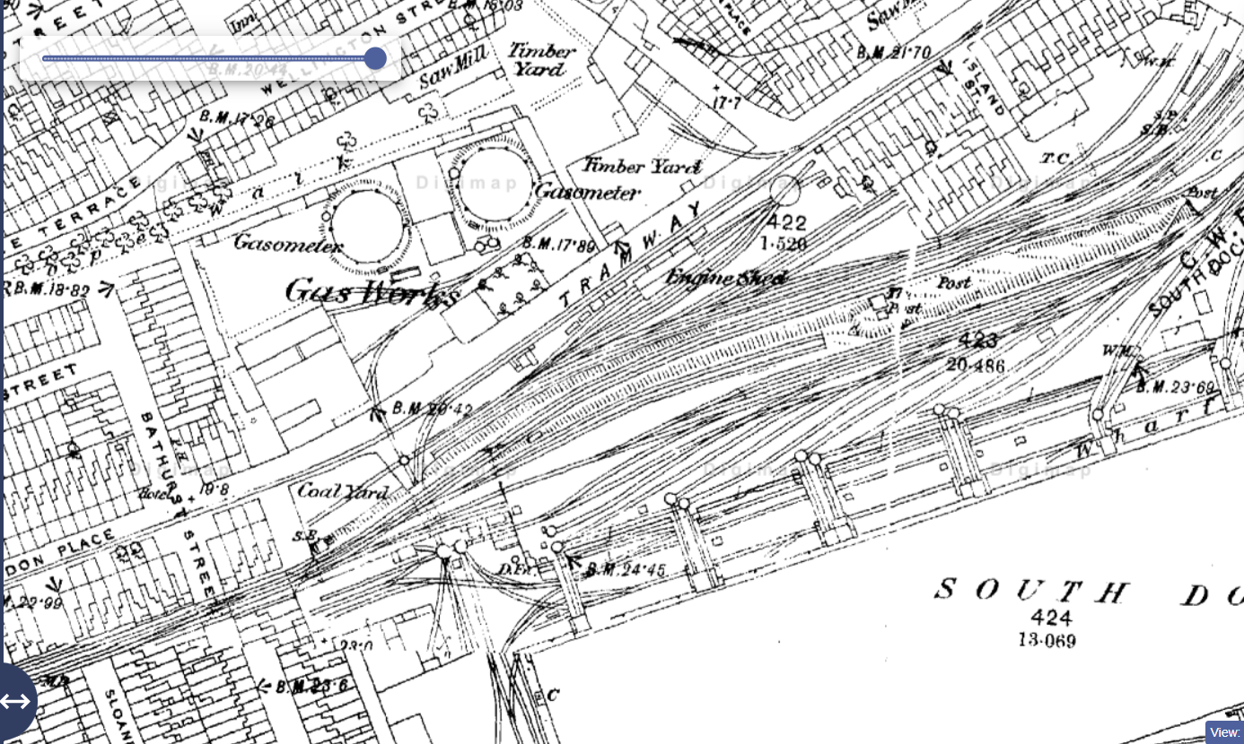
Produced by Digi Maps for Digi Maps, Produced on [Online] Available at: https://digimap.edina.ac.uk/roam/map/historic [Accessed 11th January 2025]

Railway
Also stated in the history of the site I have mentioned a railway track that was built when the gas factory was in function. The tracks where located next door to the site and may have entered into the site boundary we have today. We will have to make sure that there is no old railway track underground as it could create problems for the site, for instance the ground stability, contamination or any infrastructure conflicts like the foundations.

Flooding
173.5m away from the site there is also a marina that is docked over 100 boats. This can create a floods for the site. The floods can be caused from the marina changing the natural flow of water. But as the marina has a lot of boats and infrastructure around it, that can also contribute to major flooding in the area. It can also flood due to bad weather warnings in the area for example very heavy rain and strong winds that make the water more dangerous that it can flow onto the land. And the main example for flooding in long term actions, is climate change, rising see levels can also create flooding. 0.3 miles away is also Swansea beach. That barely rises up to the top of the bay but is also a concern when climate change makes a difference to the sea level. Overtime the sea will rise up to the top of the beach and consequently cause major flooding for the fully constructed project.
Flora risks
In the image below you can see that there is also a few plantation located around the site wall and the site wall lasts for a very long time. We still have not looked into it but there could be a possibility of Japanese knotweed. This can cause a lot of problems for the site as it grows very swiftly and can spread very quickly around the site, Japanese Knotweed also can create a lot of legal issues for the site this means that you have to be extra careful when removing it and managing it. As this is located on this site it will also cause a delay in the timeline so the project handover might be a little later than expected for the site. We also have to make sure that there are trees over 5 cubic metres as we will have to have a licence to cut those trees down. We also need to make sure that the trees are not protected otherwise we could risk breaking a law for cutting down one wrong tree.
Fauna risks
Surrounding the site there are a lot of trees, these trees could have a lot of habitats, we will have to make sure there are no chicks in the birds nests if there are some located in the trees of the site. this can also increase the budget and timeline of the site. If there are nested birds in the area, we will also need to gain planning permission this will prolong the construction project timeline. When conducting the construction works to the site, we will have to make sure that we create a less noise pollution as there is an apartment block that is located next door to the site stated in the Site Features. When we arrive onsite, we will also make sure if there are any bat nests located inside the existing building, as it is under the Wildlife and Countryside act and the environment Act of 2021.

Borehole survey
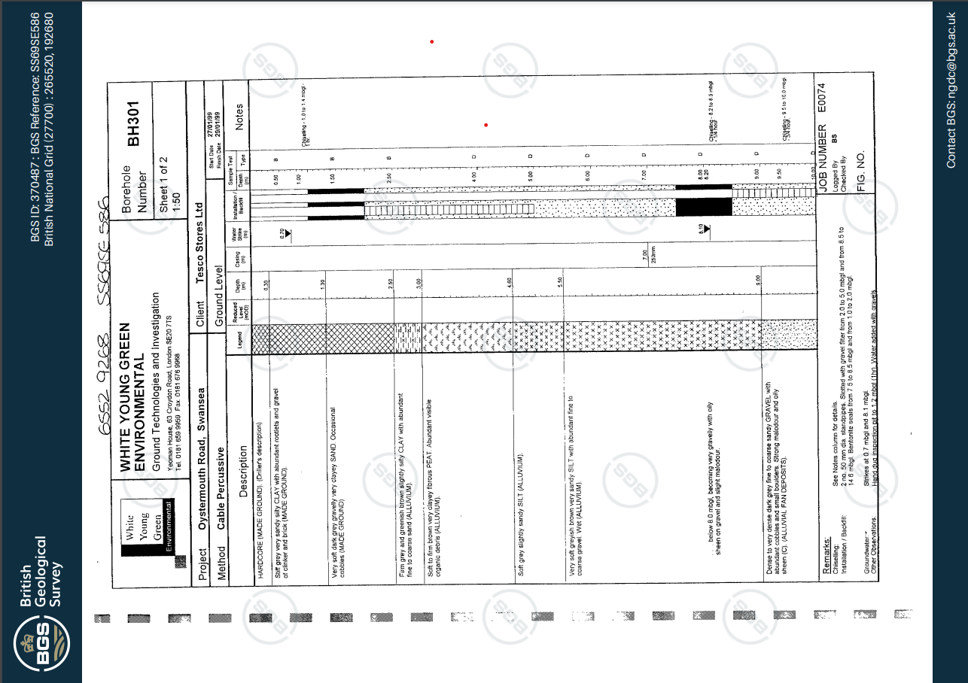
Produced by BGS for BGS, Produced on (29th January 1999) Oystermouth Road, Swansea [Online] Available at: https://api.bgs.ac.uk/sobi-scans/v1/borehole/scans/items/370487 [Accessed 11th January 2025]

As you can see from a borehole survey that has already been conducted on the site when Tesco’s was under construction. There are multiple materials that consist under the sites ground. From the information on the borehole drawing above I can see that there is gravel and clay located under the site. Clay can be a bad substance as in the summer the clay can expand in hot weather and condense when the material is cold. Gravel can also be a problem as it is not a solid material. The material can create the building to be subsided causing cracks in the walls and floors. There is also substances of siltstone this can be bad for construction as it has a very low strength also can cause subsidence in the building.

Dealing with Existing Factory Chemicals and Methods
The gas works factory can cause a number of problems which include harsh chemicals underground and even old gas pipes that can cause heavy damage to your immune system, these can be exposed by digging or excavating the ground. As of this we will need to make more special precautions this can include different work permits or even having to reroute the pipes. If a reroute needs to be completed so that the foundation can be inserted in it can cause a big delay in the construction project consequently adding costs onto the project.
Methods of Ground contamination Testing
If the ground is rightfully contaminated from the gas works held, we will need to be thoroughly cleaned out. This can have a few methods of conducting this side of work firstly you need to find where the contaminated ground is this includes using methods like a trial pit test and revalidation methods. This can include taking samples of the ground before any works start on site. Once you have a positive sign of ground contamination, we then need to circle the area to see which part of the site that is contaminated.

Archaeology
Underneath the site, judging from the archive software that I am using cannot see any signs of archaeology under the site. I get a suspicion of fossils as it was a beach before a commercial area, but as Swansea Bay is not known for any rocks, I cannot say that there is any archaeology known for being located here. There is also sandstone that I have stated, located underneath the site. Fossils are most commonly found in sandstone so there could be signs of archaeology. Overall, the site has a very unlikely hood of having and locating any archaeological aspects.

Choosing the Ideal Foundation
Once this has all been completed, we can then begin to finally excavate the known area for the 400-bedroom hotel foundations. The foundations that I have chosen for this job will be Pile foundations as it thrives in commercial, large-scale, high-rise buildings. It also is ideal for the soil conditions of the project. it is also known for its strength as consists of materials like steel and reinforced concrete to make sure that the building is stable for a very long time. As the site has not got the best materials underneath the ground the pile foundations can save money on excavating all of the materials that contribute to the problem.
The foundation is easy to install and can provide a strong and solid foundation for the high-rise hotel. When delving deeper into the pile foundation it can withstand any stress that is underneath the ground making the foundation ideal for various, different geological materials. As I said about the pile foundation saving money on excavation it is also known to be very cost effective, saving the project a lot of money.
Another advantage for this foundation is that the installation time is very swift and can be put up in a number of days, they also even have a very small carbon footprint. Making the site a lot more sustainable than the other foundations that you can pick for this project.
Drawing


