Amina Meah 2237650
University of Wales Trinity Saint David
Changemakers: Creativity and Value Creation - Smart Recipe Recommendation System REPORT

Table of Contents
Introduction 3
Task 1: Project Management 3
1.1 Project Management and Planning 3
Project Scope 3
Proposed Solution 3
Technologies and Resources 3
Project Timeline 3
Schedule and Constraints 4
Gantt Chart (Appendix A) 4
Development Method 4
1.2 Project Design 4
Wireframe (Appendix B) 4
Flowchart (Appendix C) 5
Task 2: Enterprise and Innovation 5
2.1 PEST and SWOT Analysis – IBM (Appendix D) 5
2.2 Legal and Ethical Considerations 6
2.3 NutriMatch Tech Start up Concept 6
Mission Statement 6
Objectives 7
Business Strategy 7
Funding Initiatives 7
Task 3: Project Reflection 7
Conclusion 8
Appendices 9
Appendix A – Project Timeline and Gantt Chart 9
Appendix B – Wireframe 9
Appendix C – Flowchart Diagram 10
Appendix D – PESTEE and SWOT Analysis (IBM) 11
PESTEE Analysis – IBM 11
SWOT Analysis – IBM 12
Appendix E – Online Learning 13
References 15

Introduction
The purpose of this report is to document the planning, design, enterprise considerations, and reflection for a Smart Recipe Recommendation System. This follows on from the initial project proposal and research strategies developed in Assignment 1, where the aim, objectives, and methodological approach for the system were defined. The system leverages machine learning and image recognition to provide personalised recipe suggestions based on users’ available ingredients, dietary preferences, and nutritional goals [1][2]. The project aligns with computing, data management, and information systems principles and explores innovation and enterprise aspects in a practical and scalable application. The report addresses project management, design, enterprise strategy, and personal reflection on skill development and societal impact.

Task 1: Project Management

1.1 Project Management and Planning

Project Scope
The project focuses on creating a self-service Smart Recipe Recommendation System. Users can upload images of ingredients, which are processed by a machine learning model to identify food items [2]. The system then matches detected ingredients to relevant recipes while considering dietary preferences and nutritional goals.

Proposed Solution
- A cross-platform, web and mobile application
- Machine learning image recognition for ingredient identification
- Recommendation engine for recipe matching
- Customisable dietary filters

Technologies and Resources
- Backend: Python, Flask or Django
- Frontend: React.js [6]
- ML Frameworks: TensorFlow and Keras [5]
- Databases: SQL or NoSQL
- Version Control: GitHub
- Cloud Services: AWS or Azure for hosting and model deployment

Project Timeline
Planned over 12 weeks, divided into: requirements analysis, design, development, testing, and deployment.

Schedule and Constraints
- Limited access to diverse datasets for ingredient recognition
- Limited computational resources for model training
- Ensuring GDPR compliance for user data [4]

Gantt Chart (Appendix A)
A 12-week Gantt chart has been developed to plan and track project activities from initiation to deployment. The chart outlines the sequence and duration of key phases:
- Weeks 1–2: Requirements gathering to identify user needs, datasets, and system constraints.
- Weeks 2–3: System design, including user interface wireframes, UML flowcharts, and database structure (ERD).
- Weeks 3–5: Backend development, building the database and server-side functionality.
- Weeks 4–6: Machine learning model training for ingredient recognition and recommendation.
- Weeks 5–7: Frontend development, creating a responsive web and mobile interface.
- Weeks 7–9: Integration and testing, connecting frontend, backend, and ML modules, with iterative bug fixing.
- Weeks 7–9: User feedback and iteration, incorporating pilot test results into refinements.
- Weeks 9–12: Final deployment, documentation, and project review.
This visual timeline ensures milestones are met in sequence while overlapping tasks (such as testing and feedback) allow for agile, iterative development. The detailed tabular version in Appendix A accompanies the chart for clarity.

Development Method
Agile methodology will be used to allow iterative development, frequent testing, and rapid incorporation of user feedback, ensuring the final product is user centred [3].

1.2 Project Design
Two primary design artefacts have been created to guide the development of the Smart Recipe Recommendation System:

Wireframe (Appendix B)
The wireframe illustrates the planned user interface flow: Home → Upload Ingredients → View Recipe Suggestions → Select Recipe → Save/Favourite.
It focuses on simplicity and accessibility for both technical and non-technical users. Key design considerations include:
- Clear navigation with minimal clicks to reach recipe results.
- Prominent “Upload Ingredients” button on the home screen.
- Recipe results displayed with thumbnail images and brief nutritional info.
- Save/favourite feature for easy retrieval of recipes.

Flowchart (Appendix C)
The flowchart represents the high-level system architecture:
- User input (image upload or manual ingredient entry) flows into the Dietary Filters stage, where any user-defined preferences are applied.
- The input then passes into the Image Recognition Module, which identifies ingredients from uploaded images.
- These recognised items are checked against the Ingredient Database, which retrieves nutritional data and verifies ingredient validity.
- The data is passed to the Recipe Matching Engine, which applies nutritional goals and ranking algorithms to identify the most suitable recipes.
- Finally, the curated recipe list is presented to the user via the User Interface, with options to view details, save/favourite recipes, generate shopping lists, or share with others.

Task 2: Enterprise and Innovation

2.1 PEST and SWOT Analysis – IBM (Appendix D)
IBM operates in a dynamic technological and regulatory environment. Politically, the company must comply with data protection regulations like GDPR [4]. Economically, IBM benefits from the rapidly expanding AI and cloud services market. According to IDC’s latest public forecast, global spending on AI and Generative AI is expected to grow from around $235 billion in 2024 to over $631 billion by 2028, reflecting a strong industry growth trajectory [7]. Social trends favour increased demand for personalised AI solutions, and technological advances in hybrid cloud and quantum computing provide competitive opportunities [8]. Environmental commitments and sustainability reporting influence operations, with AI adoption increasingly linked to sustainability outcomes [9]. Transparency obligations for AI further affect governance and customer communications [10].
In terms of SWOT, IBM’s strengths include its brand, R and D capabilities, and partnerships. Weaknesses include slower adaptation compared to more agile start ups. Opportunities exist in AI for sustainability and healthcare, while threats include rapid technological change, cybersecurity risks, and evolving regulations [7][8].
A detailed PEST and SWOT analysis is provided in Appendix E.

2.2 Legal and Ethical Considerations
- Data protection, ensure full compliance with GDPR, CCPA and other regional privacy regulations to protect user data [4].
- Intellectual property, safeguard proprietary software, AI models and patents from infringement. To ensure intellectual property is managed responsibly when using generative AI tools, the project will follow guidance outlined by WIPO to assess potential IP risks and safeguards [11].
- Algorithmic fairness, implement measures to detect and prevent bias in AI outputs, ensuring equitable treatment of all users [12].
- To comply with emerging best practice, the system will aim to explain its AI-driven decisions transparently to users, following guidance by the ICO and the Alan Turing Institute
- Security, protect systems and stored data against cyberattacks and unauthorised access using robust controls in line with NIST CSF 2.0 [13].

2.3 NutriMatch Tech Start up Concept
Business Name: NutriMatch
Business Type: Private Limited Company, Ltd
Logo: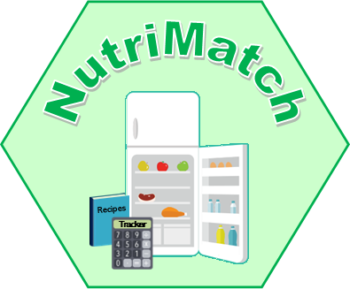

Mission Statement
To empower individuals to make healthier, more sustainable food choices by providing AI driven recipe recommendations based on available ingredients, dietary needs and nutritional goals [14].

Objectives
1. Develop an accurate ingredient recognition AI model to identify over 95 percent of common household food items.
2. Build a secure, user friendly platform integrating recipe recommendations with dietary filters.
3. Partner with local supermarkets and online grocers for seamless ingredient purchasing.
4. Promote sustainability by reducing food waste through optimised ingredient use. Households in the UK generated approximately 6 million tonnes of food waste in 2022, around 210 kg per household or 88 kg per person, of which 73% was edible, emphasising the potential societal impact of NutriMatch in reducing waste [15].

Business Strategy
NutriMatch will operate on a freemium model. The free tier offers basic recipe suggestions, ingredient recognition and favourites. The premium tier provides advanced nutrition analytics, custom meal planning and fitness tracker integrations. Partnerships with grocery retailers will support in app promotions and ingredient delivery. Marketing will use targeted social media, influencer partnerships and search optimised recipe content.

Funding Initiatives
- Crowdfunding platforms such as Kickstarter, which publishes transparent success statistics. Kickstarter has seen over $9 billion (Approx £6,639,616,377) pledged across approximately 284,000 successfully funded projects, with a success rate of 42% overall. The Games category alone has a success rate of 52%, indicating high user engagement in creative domains [16].
- Equity crowdfunding via platforms such as Crowdcube.
- Angel investors via UK networks including the UK Business Angels Association [17].
- Innovate UK programmes and university grants, subject to current funding availability.
- Government Innovation Grants: Apply for Innovate UK Smart Grants to fund AI development.
- University Support: Apply for UWTSD £500 Start-Up Grant to fund prototype testing.

Task 3: Project Reflection
This project provided the opportunity to develop technical, project management and enterprise skills. From a technical perspective, the work deepened understanding of machine learning model development using TensorFlow and Keras, including dataset preparation, image preprocessing, training and validation [5]. It also improved full stack development proficiency, including integrating a machine learning API with a React based front end [6]. From a project management standpoint, applying Agile allowed iterative development and user centred design [3]. The project’s societal contribution includes reducing food waste and promoting healthy eating which align with sustainability and wellness initiatives promoted by organisations like the WHO [14][15]. Risks include data privacy, algorithmic bias and user adoption. Mitigations include encryption and access control, balanced datasets and fairness testing, and usability testing with iterative improvements [4][12][3][13].

Conclusion
The Smart Recipe Recommendation System demonstrates how computing, data management and enterprise principles can address real world challenges. Building on the research and methodology from Assignment 1, this report set out the project management plan, system design, enterprise strategy and personal reflection. With attention to legal, ethical and user adoption considerations, the system has potential to deliver societal value, support sustainability and scale commercially.

Appendices

Appendix A – Project Timeline and Gantt Chart
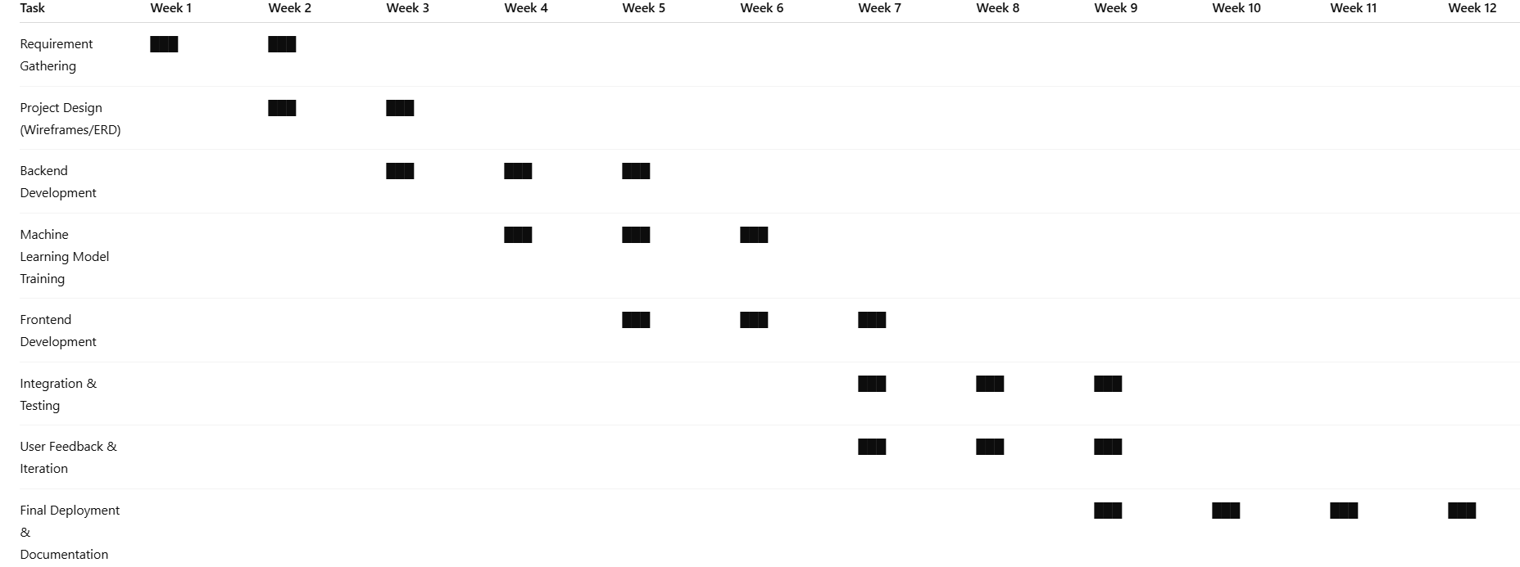

Appendix B – Wireframe
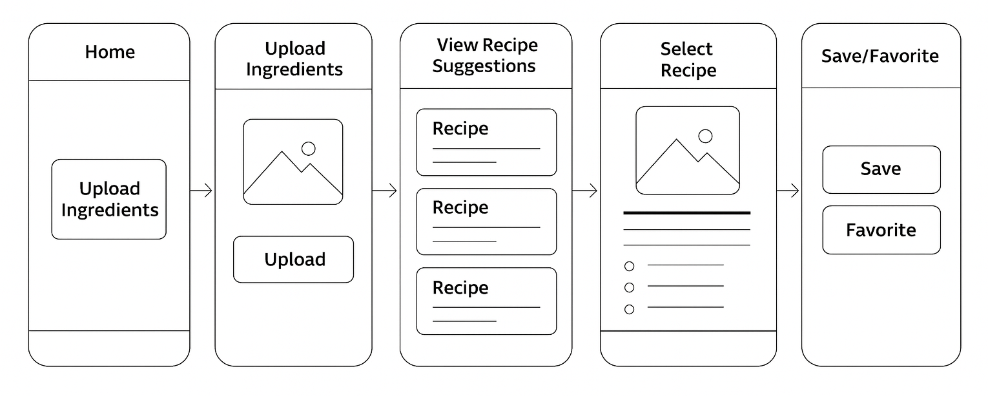

Appendix C – Flowchart Diagram

Appendix D – PESTEE and SWOT Analysis (IBM)

PESTEE Analysis – IBM
Factor | Key Points
Political | Compliance with global data privacy laws, GDPR, CCPA, AI governance frameworks, international trade rules and intellectual property protection.
Economic | Growth in AI and cloud services markets, currency fluctuations, competitive pressures and investment in emerging markets.
Social | Increasing demand for personalised AI in health, education and sustainability, workforce diversity, public scrutiny of ethical AI.
Technological | Advances in quantum computing, hybrid cloud and AI automation, strong R and D investment for scalable AI applications.
Environmental | Commitment to decarbonisation, use of energy efficient data centres and sustainability reporting.
Ethical | Responsible AI, bias mitigation, transparency and maintaining user trust.

SWOT Analysis – IBM
Strengths | Weaknesses
Established global presence and brand reputation  Strong R and D and patents portfolio  Partnerships with governments and enterprises | High competition in AI and cloud computing sectors  Slower to adapt than agile start ups  Legacy systems can hinder innovation speed
Opportunities | Threats
Expansion into AI powered sustainability and personalised health solutions  Growing demand for hybrid cloud solutions  Partnerships with universities and start ups | Rapid technological change can render services obsolete  Cybersecurity threats and potential data breaches  Regulatory change increasing compliance costs

Appendix E – Online Learning
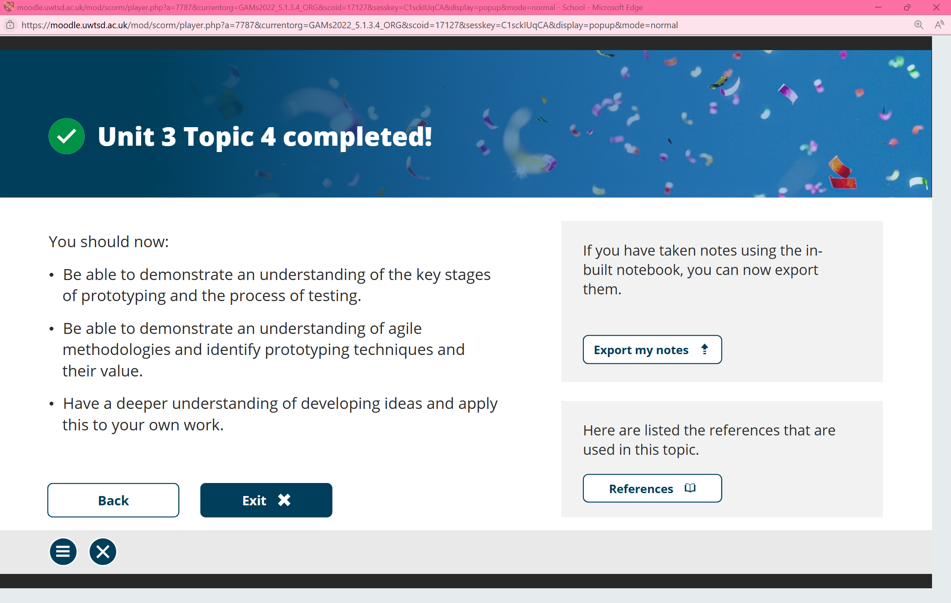
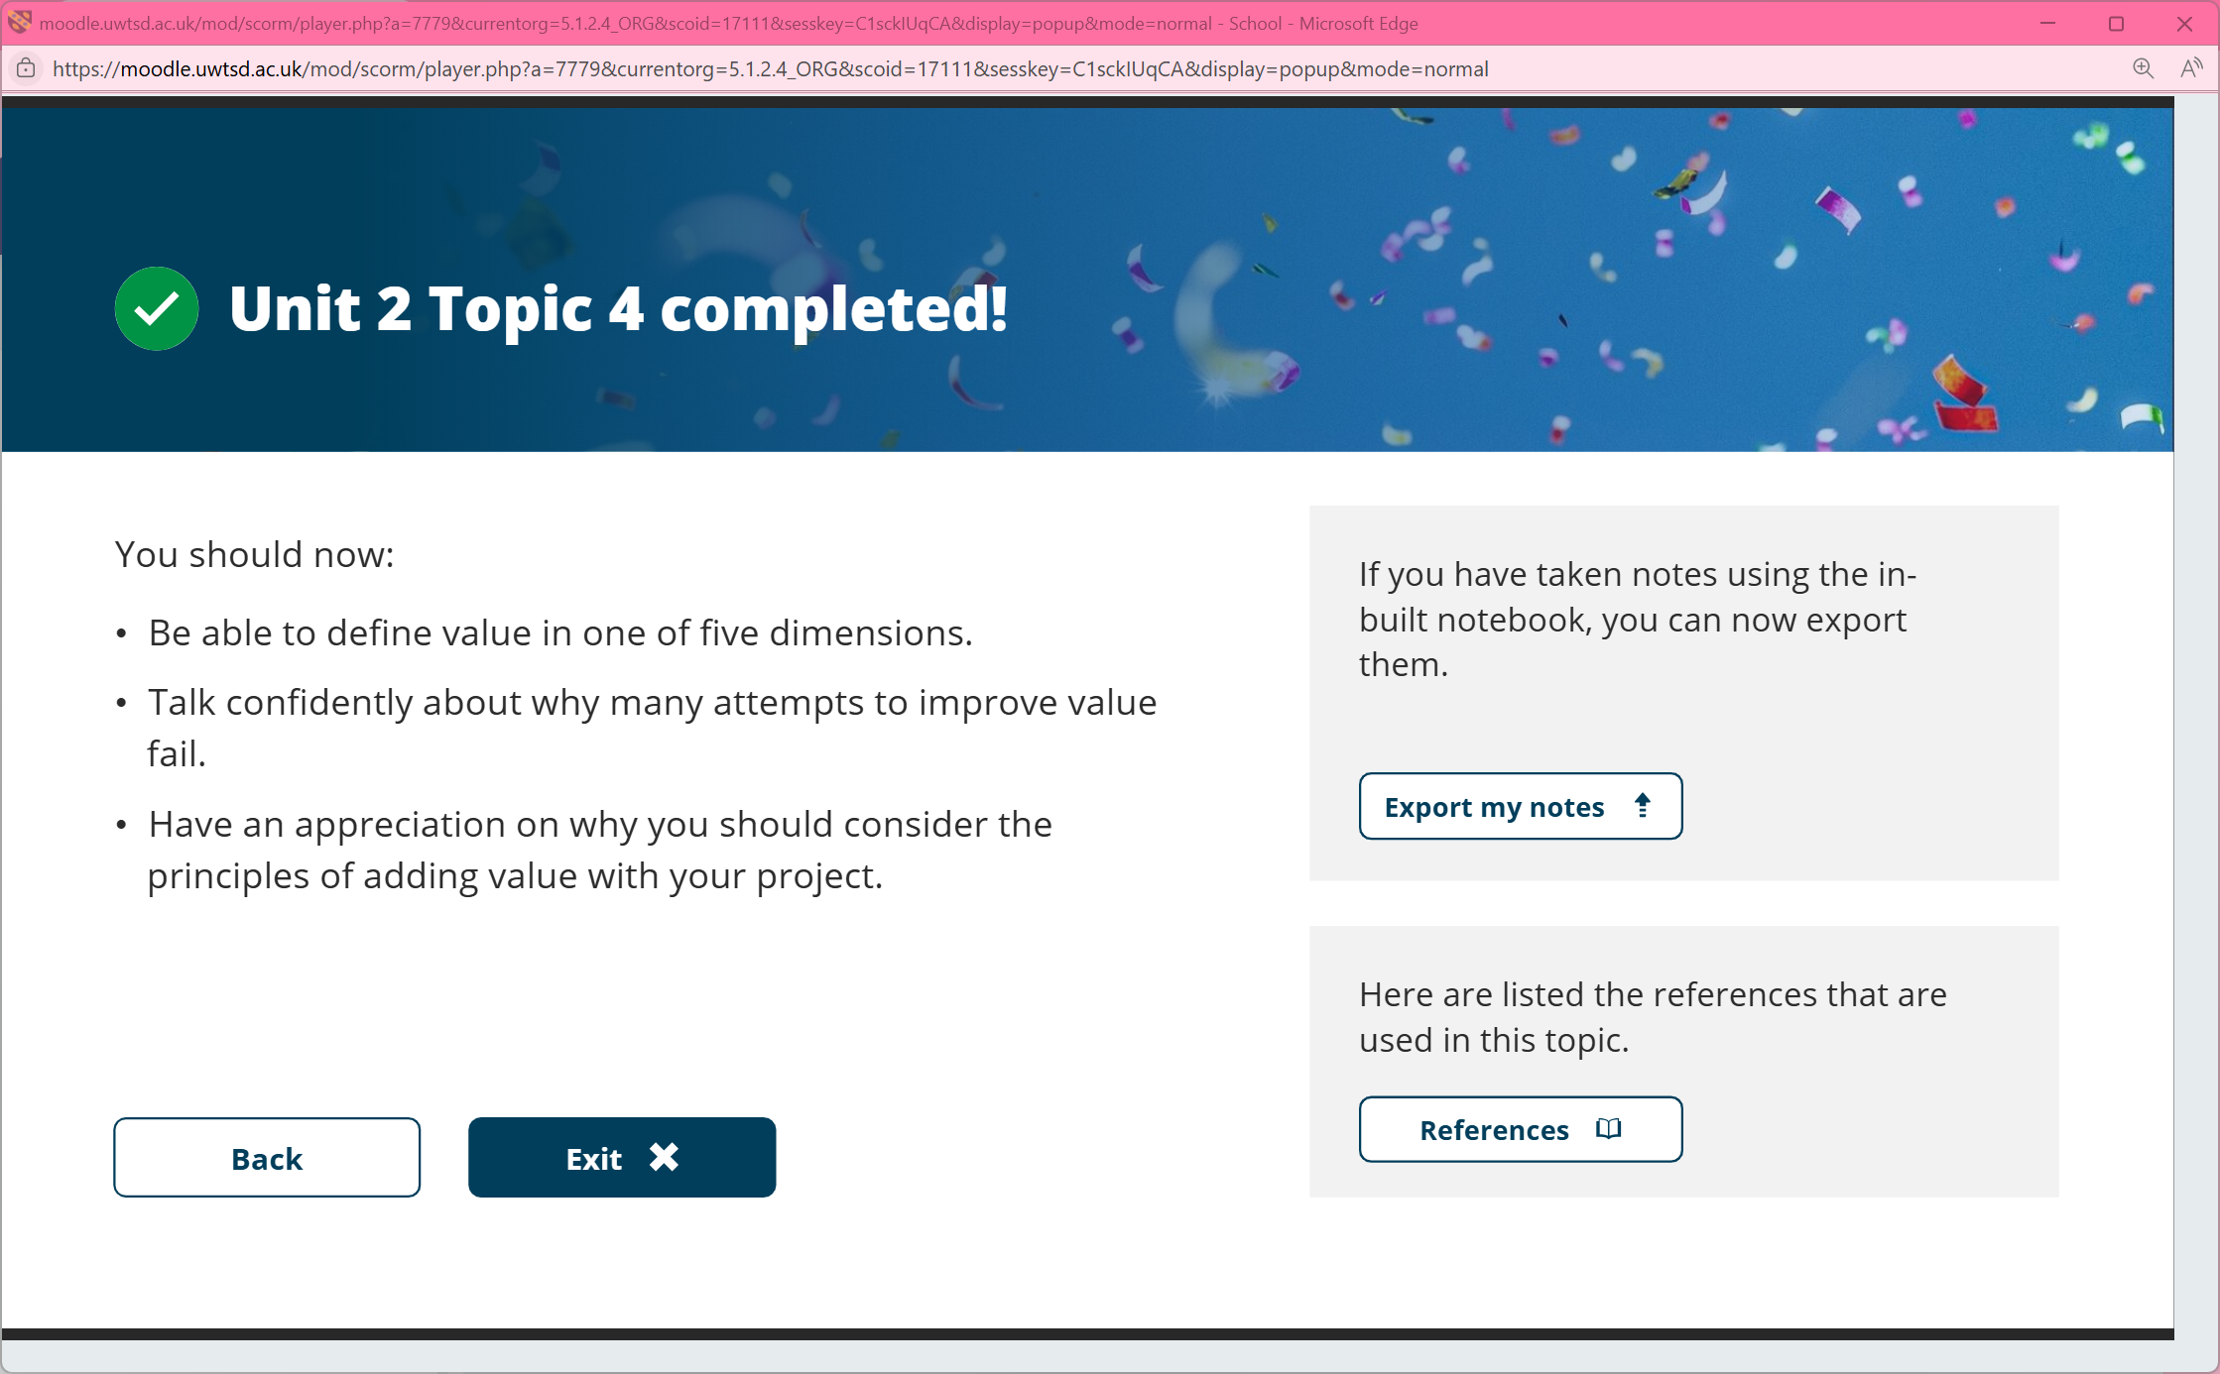
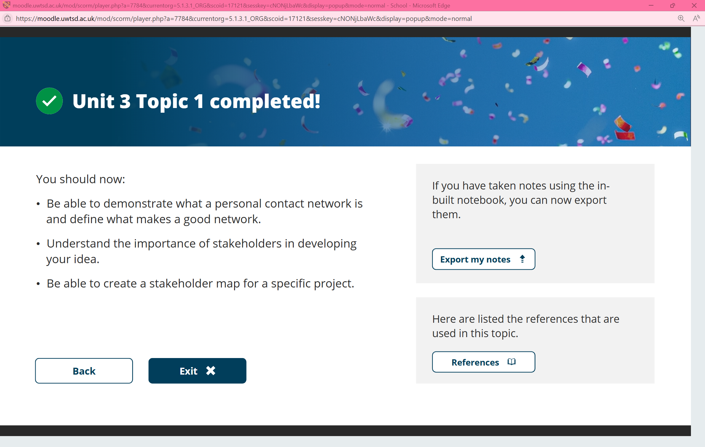

References
[1] J. N. Bondevik, K. E. Bennin, Ö. Babur, and C. Ersch, “A systematic review on food recommender systems,” Expert Systems with Applications, vol. 238, p. 122166, Mar. 2024.
[2] ] L. Bossard, M. Guillaumin, and L. Van Gool, “Food-101—Mining discriminative components with random forests,” in Proc. European Conf. on Computer Vision (ECCV), 2014, pp. 446–461.
[3] Schwaber, Ken, and Jeff Sutherland. "The scrum guide." Scrum Alliance 21.1 (2011): 1-38.
[4] Regulation, P. (2016). Regulation (EU) 2016/679 of the European Parliament and of the Council. Regulation (eu), 679(2016), 10-13.
[5] TensorFlow Project, “Keras: The high-level API for TensorFlow,” TensorFlow, 2023. [Online]. Available: https://www.tensorflow.org/guide/keras
[6] React documentation, “React: A JavaScript library for building user interfaces,” React, 2025. [Online]. Available: https://react.dev/
[7] IDC, “Worldwide AI and Generative AI Spending – Industry Outlook,” IDC blog, Aug. 21, 2024. [Online]. Available: https://blogs.idc.com/2024/08/21/idcs-worldwide-ai-and-generative-ai-spending-industry-outlook/
[8] IBM, “Financial reporting,” IBM Investor Relations, 2025. [Online]. Available: https://www.ibm.com/investor/financial-reporting.
[9] IBM, The State of Sustainability Readiness Report 2024, IBM Think. [Online]. Available: https://www.ibm.com/think/reports/sustainability-readiness.
[10] Information Commissioner’s Office & Alan Turing Institute, Explaining decisions made with AI, GOV.UK, Jan. 27, 2025. [Online]. Available: https://www.gov.uk/data-ethics-guidance/explaining-decisions-made-with-ai
[11] World Intellectual Property Organization, Generative AI: Navigating intellectual property, WIPO, 2024. [Online]. Available: https://www.wipo.int/publications/en/details.jsp?id=4713.
[12] Information Commissioner’s Office, Guidance on AI and Data Protection, ICO.gov.uk, Mar. 15, 2023. [Online]. Available: https://ico.org.uk/for-organisations/uk-gdpr-guidance-and-resources/artificial-intelligence/guidance-on-ai-and-data-protection/
[13] C. Pascoe, S. Quinn, and K. Scarfone, The NIST Cybersecurity Framework (CSF) 2.0, NIST Cybersecurity White Papers (CSWP 29), National Institute of Standards and Technology, Feb. 2024. [Online]. Available: https://doi.org/10.6028/NIST.CSWP.29
[14] World Health Organization, Healthy diet – key facts, WHO, 2020. [Online]. Available: https://www.who.int/news-room/fact-sheets/detail/healthy-diet.
[15] WRAP, Household Food and Drink Waste in the UK 2022, WRAP, 2 July 2025. [Online]. Available: https://www.wrap.ngo/resources/report/household-food-and-drink-waste-uk-2022.
[16] Kickstarter, "Stats", Kickstarter Help, 2025. [Online]. Available: https://www.kickstarter.com/help/stats (kickstarter.com).
[17] UK Business Angels Association, "About UKBAA," UKBAA, 2025. [Online]. Available: https://ukbaa.org.uk/

