James Turner - 2304088

Network Operating Systems and Services
ACCA5023

Contents
Task 1 1
Hypervisors 1
IP addressing 2
Task 2 4
Hypervisor Choice 4
Download and Initial Setup 5
IP configuration and testing 7
Task 3 9
Reflection 9

Figure 1: Successful install for Windows 2022 Server Desktop experience at 12:48pm on the 6th of February 5
Figure 2: Successful instal of Windows 10 Client at 11:51AM on the 13th of February 6
Figure 3: Successful install of Debian Linux Client at 14:38PM on 25th of February 7
Figure 4: Successful install of Debian Linux Server CLI at 14:39PM on 25th of February 7
Figure 5: Successful connection between both Windows machines 8
Figure 6: Successful connection between both Linux machines 8
Figure 7: Successful connection between the Windows and Linux servers 9

Task 1

Hypervisors

Hypervisors are a type of software that allows the user to create and run virtual machines, which allows the use of multiple operating systems to run concurrently on a single machine. This allows for the creation of isolated environments for testing purposes, running software specific for different operating systems, as well as the ability to run legacy software inside of new operating system. [1]
There are two types of hypervisors, aptly named type 1 hypervisors, commonly referred to as Bare-metal hypervisors, and type 2 hypervisors, or hosted hypervisors.
Type 1 hypervisors are referred to as bare-metal hypervisors for the fact that they are installed directly onto the host computers hardware. This provides higher performance, increased security for the installed VMs as they are separated from the original operating system, as well as the ability for great scalability. This makes them great options for companies who require data centre storage. While AWS (Amazon web service) [2] states that “type 1 hypervisors offer greater performance to their VMs”, both types of hypervisors require modern CPUs equipped with assisted virtualisation techniques, and require enough RAM to effectively run multiple VMs. As discussed by Barham P, et al [3], memory management is one of the most difficult parts of running a hypervisor, and emphasises the use of software managed TLB(Translation lookaside buffer) to efficiently run the hypervisor. Some examples of these hypervisors would be Microsoft Hyper-V, Linux KVM and VMware’s ESXi.
Typer 2 hypervisors refer to hypervisors that run on top of existing operating systems as software applications, generally being easier to install and manage, but with some performance downsides compared to type 1 hypervisors. For this reason, type 2 hypervisors act as better testing environments, as well as VMs being isolated offering an extra layer of security for the system, however, will not compare efficiency wise to type 1 hypervisors for data centre work. Some popular examples of type 2 hypervisors include Oracle VirtualBox and VMware, which provide the ability to run several different OS types such as Linux and macOS on windows and vice versa.

IP addressing

IP, or Internet Protocol [4] is the backbone of our data communication. Without IP addressing, the internet as we know it does not exist. Our internet relies on a well organised system, managing the IP addressing and IP routing. These systems all rely on IP addresses, unique identifiers for each device, ensuring that data is sent to the correct location, across the fastest path.
Data travels around the world in small chunks of data called “packets”. When data is sent, the data is split into many data packets, each with a destination IP address and sender IP address. This ensures that the data is sent to the right place, and can be identified for security and logistical purposes. Each packet also has a number, showing its place in the data order, and allowing data requests to be made if certain packets are missing.
Routers and switches are the hardware components that allow for IP addressing and routing. Routers are the hardware pieces that work to connect different networks together, and as the name suggests uses routing tables and different protocols to direct packets through the network. This is the device you would use to connect to the internet from your home network. A switch however is used to connect devices together in a local network, and ensures that data is sent to the correct device. These devices work together to ensure that data is able to be sent and received across both local and global networks. [5]
In today’s world, IP addressing is established using two main types of schemes, known as IPv4 and IPv6. IPv4 is the older scheme and 4th version of the Internet Protocol, and uses 32-bit addresses in dotted decimal notation. [6]. This however provided limited address space and other tools were often used to optimise the address use. IPv6 is the 6th and newer version, using 128-bit addresses shown in colon separated hexadecimal. This allows for vastly more unique addresses currently, and allows for future proofing with the sheer number of available addresses.
With these addressing schemes, larger networks tend to become overwhelmed and are less manageable than smaller networks. This is where subnets are introduced, as they divide larger networks into smaller sub-networks, increasing overall network performance while providing an easier management scheme [7].

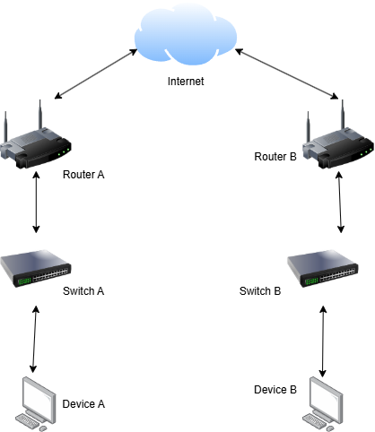
In this diagram, data can travel from device A to device B, with the switches forwarding the data to the router, which then forwards the data towards the Internet. From there, router B can grab the data and send it to switch B, finally landing at device B. Each of these steps requires IP addressing to ensure that the required data is sent securely to the correct location.
While IP addressing may be the backbone of data communication, routing protocols are fundamental to this process. This is because they control the paths data packets travel through to get to a desired destination. The two most common types of routing are static and dynamic, each with their own advantages and disadvantages depending on the networks needs. Static routing uses manually configured routes to direct traffic flow, providing strict paths that packets follow. This type of routing lends itself to smaller networks, where changes to the network are rare and only a few specific links need to be made. However, as they are manually configured, they have little ability to adapt to network changes, and need to be changed each time a network change is made which can lead to unexpected downtime within the network.
For larger networks, dynamic routing is more common. This routing type uses several different protocols, such as RIP (Routing Information Protocol) and OSPF (Open Shortest Path First) [8]. These protocols use algorithms to determine the best path for data transmission, and with some large multi-national companies, these algorithms become essential for daily operation. OSPF is a common protocol within large companies, known for its ability to recalculate routes quickly when faced with network topology changes [9]. For smaller companies, RIP provides the necessary features to run a network, with the advantage of it being simple to set up and requiring little maintenance, making it the perfect candidate.

When transferring data over the internet, VPNs are often used to create secure connections between networks. They provide encrypted tunnels, allowing uses to connect safely to private resources, and are a common place for those who work-from-home, meaning even if data is intercepted, the encryption will hopefully prevent the exploitation of the obtained data. VPNs should be monitored with regular audits, as they can be exploited to use the encrypted tunnels to gain access to sensitive data.
DHCP, or Dynamic Host Configuration Protocol, is the protocol used to automatically assign IP address and other network settings to devices. This helps reduce human error, and as its automatic, requires little input from the administrator. Some of DHCPs features include the ability to lease out IP addresses, while “saving” other IP addresses for specific devices. Some of the best practices for DHCP include regular monitoring of the lease durations to reduce the chance of running out of IP addresses, as well as ensuring that static addresses are blacklisted from being used, to try avoiding security risks and ensure standard network operation.
Active Directory Domain Services is a service for windows networks that manages specific users identities, authentication procedures, and resource access. This tool ensures that employees are given access to the proper materials needed for their job, while providing security to those same materials to prevent unauthorised access. These services do however need to be maintained, and regular backups and implementing strict access rules help to prevent access to sensitive materials.
Finally, we have Certificate Authorities, which help ensure secure network communications via assigned certificated. These certificated validate the users identity, which brings trust in data transactions. Again, these services need to be maintained, and adequate renewal processes and verification help to reduce risk chance and improve trust within the network.

Task 2

Hypervisor Choice

For the proposed network topology that we are given, we had the option to chose between a type 1 and a type 2 hypervisor to complete the assignment. This option would also follow along into coursework 2, where we will manage the different network services in the hypervisor. For this coursework 1, and therefore also coursework 2, I have chosen to use the type 2 hypervisor Oracle VirtualBox. This is because of a few main reasons, which I will explain now. Firstly, type 1 hypervisors generally require a greater understanding of virtual machines compared to type 2 hypervisors, which require downloading and ISO and using a program to run the virtual machine. Another reason would be that while I could be working with Microsoft azure, offering a cloud-based solution, it would require me to go through the university itself, and if there are any challenges with the azure service it could take a few business days to resolve itself, which could slow down and hinder my coursework development. Finally, there is the learning/experience curve to consider. While I am new to both type 1 and type 2 hypervisors, there is significantly more available information for type 2 hypervisors and its configurations compared to the offered type 1 hypervisor by the university. This shows type 2 hypervisors to be a better choice as the learning curved is lessened and any problems that could occur have been experienced plenty of times by others and have since developed solutions on forums and dedicated websites.

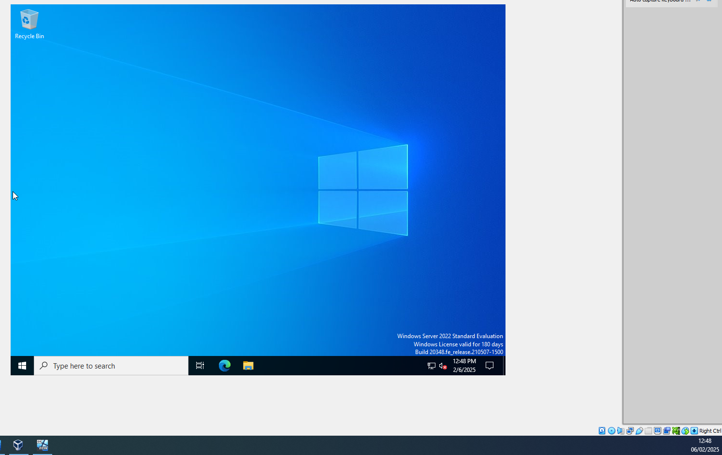
Download and Initial Setup
Figure 1: Successful install for Windows 2022 Server Desktop experience at 12:48pm on the 6th of February

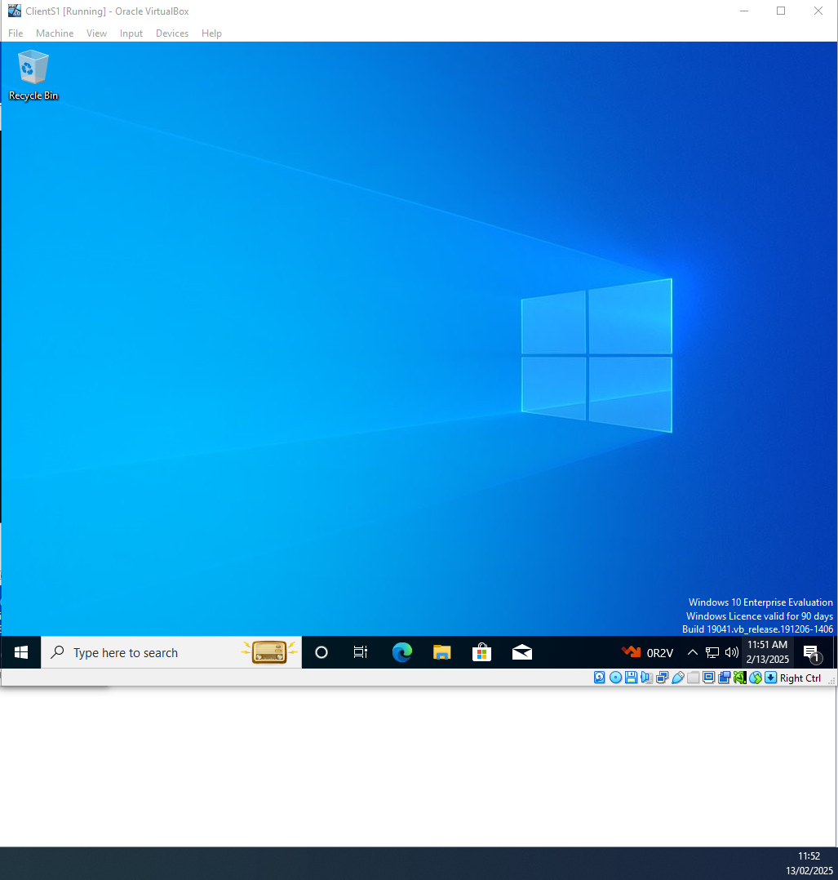
Figure 2: Successful instal of Windows 10 Client at 11:51AM on the 13th of February

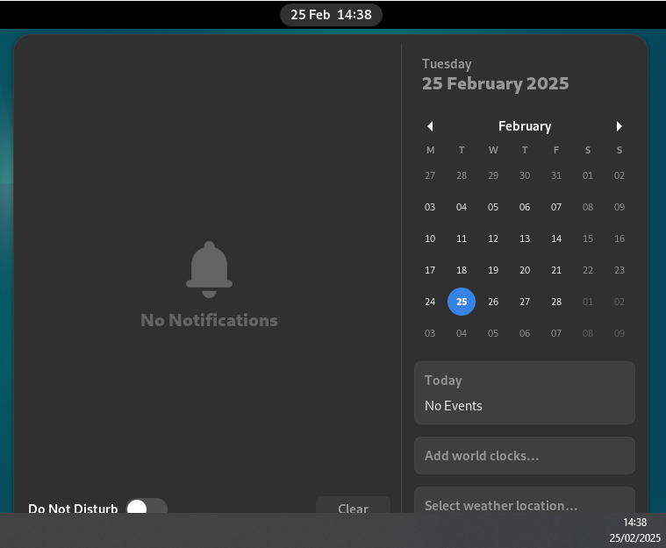
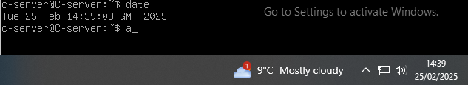
IP configuration and testing
Figure 3: Successful install of Debian Linux Client at 14:38PM on 25th of February
Figure 4: Successful install of Debian Linux Server CLI at 14:39PM on 25th of February

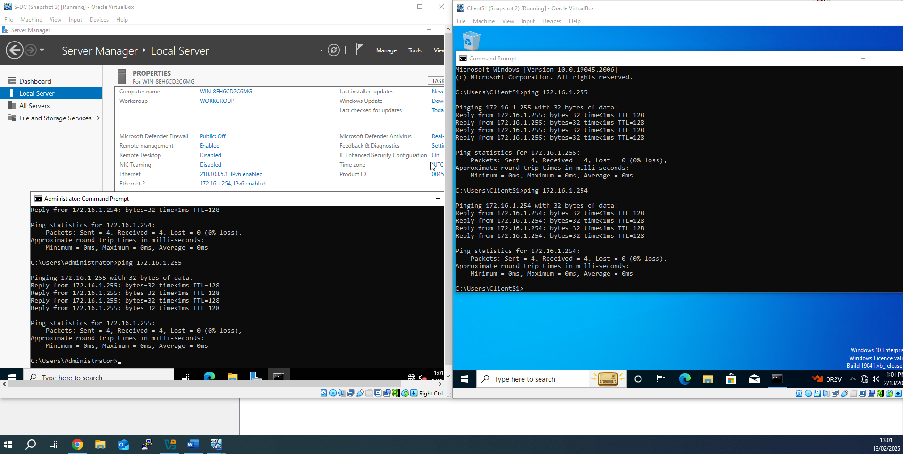
For the windows machines, I used 172.16.1.254 for the windows server connecting to the client, with the client itself being 172.16.1.255
Figure 5: Successful connection between both Windows machines

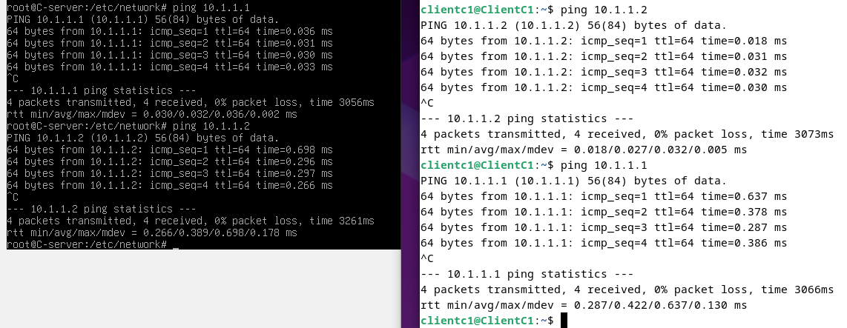
Same idea as with the windows machines, however referring to the topology given, the server was assigned an IP address of 10.1.1.1 with the client being assigned 10.1.1.2
Figure 6: Successful connection between both Linux machines

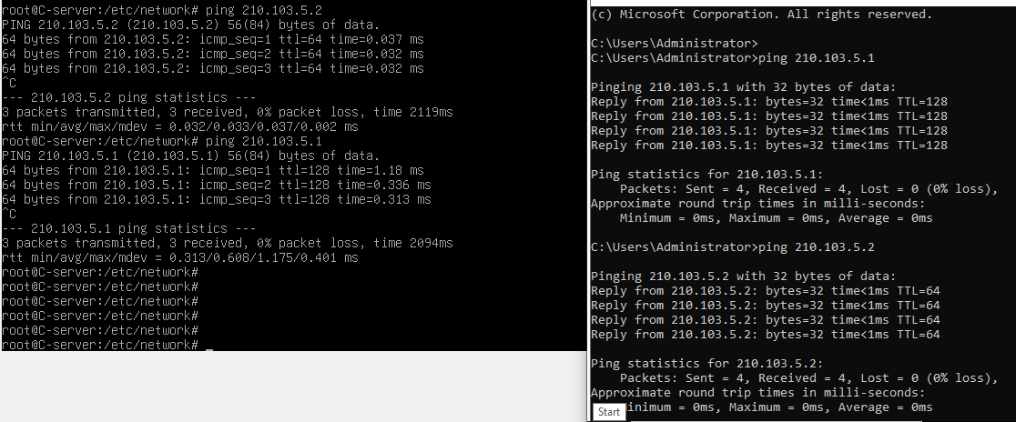
Figure 7: Successful connection between the Windows and Linux servers
With both servers being configured, I was able to connect and ping the other machine, referring to the topology given I assigned the windows server 210.103.5.1 and the Linux server 210.103.5.2.

Task 3

Reflection

While I managed to succeed in deploying a working network topology, there were a few challenges that needed to be overcome. The first challenge was the firewall, which blocked ping requests from the windows machines. In the end I disabled the firewalls for those 2 machines so that I could test connectivity with the machines, with the hope of providing a successful configuration later. I had also struggled with configuring the addresses on the Linux systems, as they were a new environment and was unfamiliar with the settings. However, after watching the videos provided by my lecturer, I managed to correctly configure the Linux machines

