

University of Wales Trinity Saint David (UWTSD)

Module Title: Principles of Health and Social Care Practice

Module Code: BMHP5016

Assessment: Component 1 - Written Assignment (Reflective Report)

Student Name: Prince Jimoh Isidahomen

Student Number: 2509813

Lecturer’s Name: Dr. Kennedy Obohwemu

Table of Contents

Contents Page Number
Introduction 3
Task 1: Reflection on the Importance of Principles 3
Task 2: Practical Example in Practice 4
Task 3: Self-Reflection as a Health and Social Care Professional 6
References 9

Introduction
Good health and social care depends on care that reflects what matters to the individual, coordinated effort across professionals and services, and sound ethical judgement (Beauchamp and Childress, 2019; Doornebosch, Smaling and Achterberg, 2022; Care Quality Commission, 2025). These requirements correspond to person-centred care (PCC), partnership working and ethics, which UK legislation and guidance expect of practitioners (Care Act 2014; NICE, 2021). The principles are not always easy to apply together. Respecting a person’s choices can conflict with duties to protect them from harm, and cooperation between organisations can fail when responsibilities are unclear. Reviews also show that PCC is interpreted unevenly and constrained by routines and organisational culture (Moore et al., 2017; Byrne, Baldwin and Harvey, 2020). Understanding how the principles operate in real situations is therefore essential to professional practice.
This report aims to examine the importance and limits of the three principles, to apply them critically to Robyn’s NHS England personal health budget case, and to consider how they shape the writer’s professional development.

Task 1: Reflection on the Importance of Principles
PCC, partnership working and ethics are essential for good health and social care because they help ensure that care reflects people’s needs and preferences, involves them in decisions and supports informed choices about their care (NICE, 2021; Care Quality Commission, 2025). Together they form an interdependent framework. PCC places the person’s needs, values and preferences at the centre of care (Care Quality Commission, 2025), partnership working coordinates professionals, organisations and families around those needs (Doornebosch, Smaling and Achterberg, 2022), and ethics supplies the principles for resolving conflicts between competing interests (Beauchamp and Childress, 2019). The quality of care depends on how practitioners balance them.
In individual care, Rogers’ (1951) person-centred approach holds that people flourish when met with empathy, unconditional positive regard and congruence. Kitwood (1997) applied this to dementia care, arguing that personhood is sustained or undermined through relationships, and that routines which ignore or infantilise people erode identity, which he called malignant social psychology. In practice, this means starting from what matters to the person rather than from the diagnosis or the service routine. Byrne, Baldwin and Harvey (2020) found that PCC is widely valued but inconsistently defined, while Moore et al. (2017) found that implementation depends on leadership, supportive systems and adaptation of established routines. NICE (2021) guideline NG197 responds by promoting shared decision-making. Elwyn et al. (2017) argue that shared decision-making demands shifts in the power and control of consultations, so consulting people after a decision has been made falls short of it.
In collaboration, a person with diabetes, reduced mobility and social isolation may need a GP, nurse, pharmacist and social worker, alongside family. The Care Act 2014 places duties of cooperation and integration on local authorities and partners, and the Health and Care Act 2022 placed integrated care systems on a statutory footing, bringing NHS bodies, local authorities and voluntary organisations together. Doornebosch, Smaling and Achterberg (2022) found that collaboration in long-term care depends on team, organisational and information-sharing conditions, and that improving one without the others limits progress. Schot, Tummers and Noordegraaf (2020) add that collaboration depends on professionals negotiating role boundaries. Where these conditions fail, assessments are duplicated and the person becomes the subject of professional discussion rather than a participant in it.
In ethical decision-making, Beauchamp and Childress’s (2019) principlism offers four principles, namely autonomy, beneficence, non-maleficence and justice. They give practitioners a shared language but are not ranked, so judgement is required. Relational accounts also challenge individualistic readings of autonomy, locating decisions within the relationships through which people receive support (Gómez-Vírseda, De Maeseneer and Gastmans, 2019). Here autonomy and beneficence can pull apart. For example, a person with capacity may decline a care package that a professional considers necessary. Under section 1(4) of the Mental Capacity Act 2005, a person is not to be treated as unable to make a decision merely because it is unwise, so autonomy is protected while professionals still explain risks and reduce avoidable harm. Even so, Güney, Karadağ and El-Masri (2021) found that staffing, training and managerial support shape whether staff can practise PCC, so principles improve care only where systems allow practitioners to apply them.

Task 2: Practical Example in Practice
Robyn’s case shows the difference between keeping someone safe and supporting them to live a life they value. Following a spinal injury she required 24-hour assistance, yet in 2014 alone 36 personal assistants provided her care. Some assistants could not drive or work around animals, although horses and an active social life were central to her identity (NHS England, n.d.c).
Person-centred care was absent at first. Kitwood (1997) argued that personhood is undermined when routines override the individual, and here staffing availability, not Robyn’s goals, shaped her support. The position changed through a personal health budget (PHB). A PHB nurse explored what was not working and what she wanted to achieve, and the budget allowed her to employ regular assistants who knew her needs, alongside work, care of her animals and an active social life. This reflects shared decision-making, combining professional knowledge and public resources with Robyn’s expertise about her own life (NICE, 2021). It also reflects Regulation 9, which requires care to meet people’s needs and reflect their preferences (Care Quality Commission, 2025). Continuity also supported safety, as assistants who knew her could anticipate potential issues. For professionals, the PHB nurse continues to explore ways to increase her independence, such as delegating further health tasks to her assistants to reduce reliance on community nursing (NHS England, n.d.c).
Partnership working involved her jointly funded social care and NHS Continuing Healthcare teams and the local Personal Budget Support Service, which supported recruitment and employment and processed her payroll. Doornebosch, Smaling and Achterberg (2022) found that collaboration depends on interacting team, organisational and information-sharing conditions, and the case shows both strengths and gaps. Practical support made choice workable, but the process took 18 months with long periods without updates, suggesting weak communication and accountability. Robyn’s initial plan also did not represent her, and she eventually rewrote it herself. This fell short of Regulation 9’s expectation that care is planned collaboratively with the person (Care Quality Commission, 2025). In Arnstein’s (1969) terms, the process was closer to tokenism than partnership until she took control. A personalised budget therefore did not guarantee a personalised planning process.
Ethically, the case shows principles in tension (Beauchamp and Childress, 2019). Autonomy increased as Robyn gained control over who supported her and how she lived, while beneficence extended beyond avoiding injury to improving her quality of life. Her autonomy was also relational, because it depended on her relationships with assistants, nurses and support services (Gómez-Vírseda, De Maeseneer and Gastmans, 2019). Choice carried responsibility, however. As an employer she needed payroll support and backup cover, which served non-maleficence by keeping care competent and reliable. Justice required accountable, needs-based use of public funds, yet the time taken to approve the arrangement prolonged an unsuitable one.
A named contact, scheduled updates, earlier co-produced planning, peer support from experienced budget holders and clear contingency arrangements could have shortened the 18-month process and reduced its burden. These measures would strengthen communication and accountability and give Robyn control over her plan from the outset, higher on Arnstein’s (1969) ladder. Success depended on continuity and suitable assistants, so the approach will not work equally well for everyone, particularly where workforce instability or bureaucracy causes delay.

Task 3: Self-Reflection as a Health and Social Care Professional
Gibbs’ (1988) reflective cycle was used to structure this reflection from description to action plan. It is divided into 6 stages as seen in Figure 1 below.
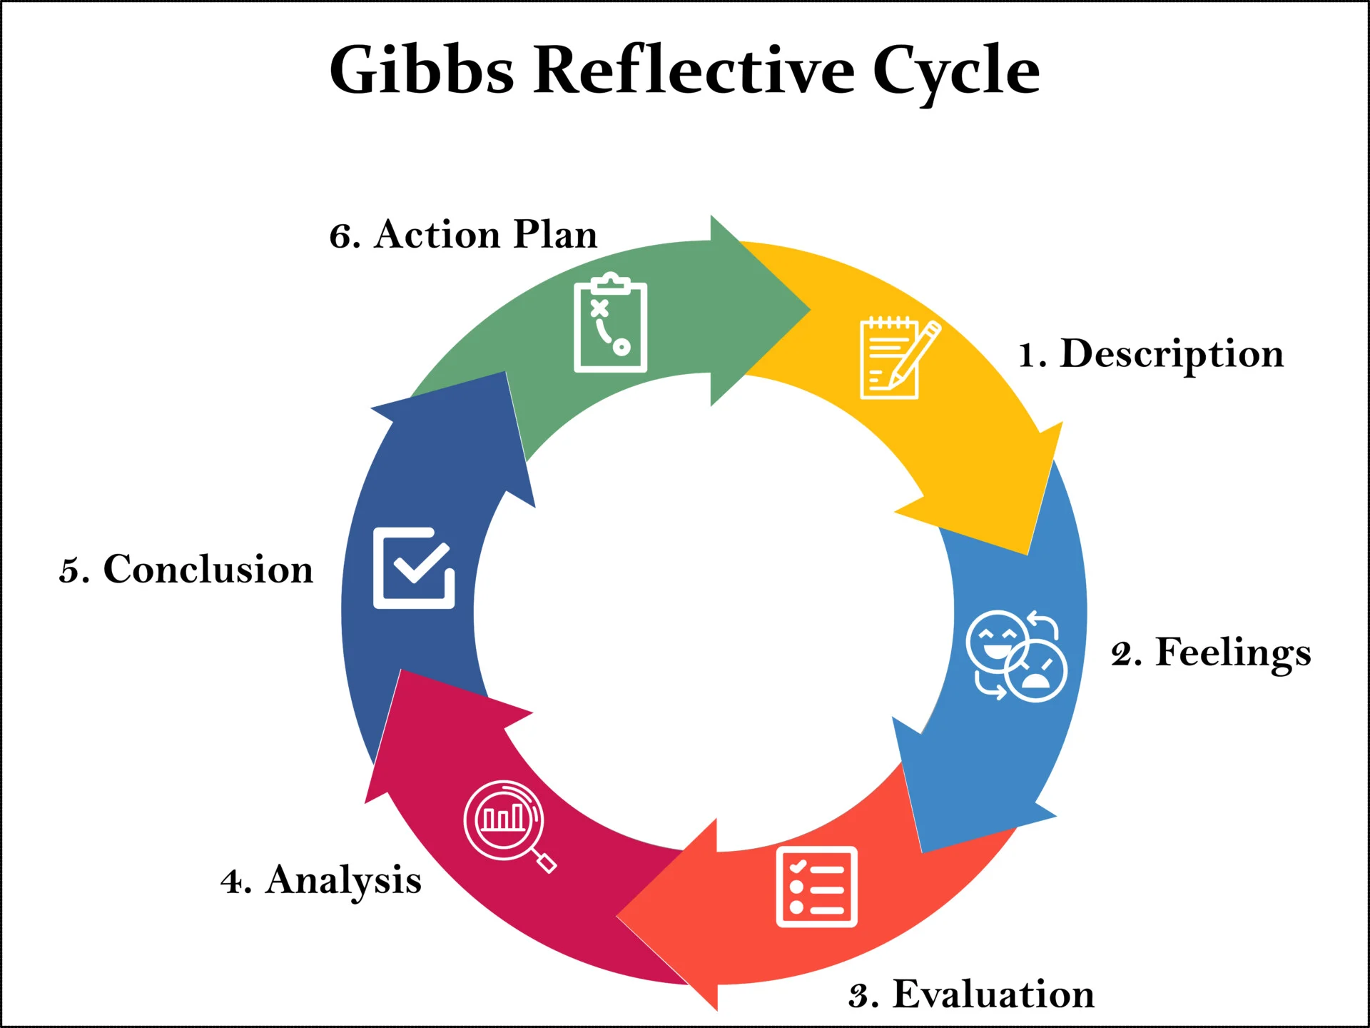
Figure 1: Gibbs Reflective Cycle
Source: McLeod (2025) adapted from Gibbs (1988)
Description
I supported an adult with type 2 diabetes and chronic leg ulcers on an acute medical ward who refused high-compression bandaging because it felt too tight, disturbed his sleep and prevented him from wearing his usual shoes. My first response was to explain the clinical purpose of compression and the risks of refusing. Once I listened more closely, I worked with the tissue viability nurse to offer lower-compression hosiery, which he agreed to try during the day, with a review after one week. For discharge, I coordinated the referral, clarified the dressing regime with the tissue viability nurse, confirmed a 14-day dressing supply with pharmacy and telephoned the district nursing hub for a clinical handover. The district nursing team received the electronic referral late on a Friday afternoon and key safe details were unconfirmed, delaying the first home visit.
Feelings
I felt anxious about infection, delayed healing and tissue deterioration, while recognising his right to decide. My responsibility to preserve safety made the recommended treatment feel like the priority, so I assumed he did not understand its importance. This was my limitation, because my assumption, not his understanding, was the barrier. The discharge delay made me aware that I had treated sending the referral as completing my responsibility.
Evaluation
My strength was communication and problem-solving. I used open questions, listened without interrupting and checked understanding, which kept him involved in decisions while reducing avoidable risk. Communication within the team also worked well because the tissue viability nurse provided clear photographic wound documentation and a rationale for the plan. Collaboration was weaker, since I should have contacted the community team 24 to 48 hours before discharge to confirm receipt and practical arrangements.
Analysis
Technically correct care is not necessarily person-centred care. PCC involves sharing power and supporting informed involvement through planning that considers the whole person (NHS England, n.d.a; NHS England, n.d.b). Elwyn et al. (2017) place team talk, which supports the person and elicits their goals, before option talk, whereas I began by explaining risks. The patient had full capacity but declined four-layer compression and clinic attendance. The Mental Capacity Act 2005 requires capacity to be presumed and assessed for the specific decision, and does not allow an unwise choice to be treated as proof of incapacity. I explained the risks without coercion, and we agreed lower-compression hosiery with twice-weekly home reviews. Using Beauchamp and Childress (2019), autonomy supported his right to refuse, while beneficence and non-maleficence required me to keep seeking an acceptable option that reduced harm. The Nursing and Midwifery Council (2018) Code likewise requires nurses to respect and document a person’s right to accept or refuse care and treatment. I must guard against paternalism by separating “Do I agree with this choice?” from “Can this person understand, retain, use or weigh relevant information and communicate a decision?”
Under the Care Act 2014 duty of cooperation, timely confirmation of discharge arrangements is a shared responsibility, and following Schot, Tummers and Noordegraaf (2020), I must distinguish multidisciplinary presence from genuine coordination. Organisational conditions also affect PCC (Güney, Karadağ and El-Masri, 2021), and when my workload is high, I focus on tasks and give less attention to shared planning. This does not remove my accountability, so I will prioritise essential communication, record unmet needs and raise recurring barriers in supervision.
Reflective Conclusion
My strengths are communication and problem-solving, and my areas for improvement are testing assumptions, confirming handovers early and applying capacity law with confidence. In similar situations, I would begin with the person’s priorities, use teach-back to check understanding and confirm community responsibility before discharge.
Action Plan
Within four weeks, I will complete Mental Capacity Act and consent training and discuss one anonymised scenario with my supervisor. For four weeks, I will keep a weekly reflective log recording the person’s goal, my assumptions and what I would change. I will request structured feedback on one multidisciplinary handover and review progress with my supervisor at six weeks using my training record, reflective entries and feedback. Success will mean documented confirmation of receipt for every discharge I coordinate.
Conclusion
PCC, partnership working and ethics operate together to create care that is safe, coordinated and genuinely shaped by the individual. PCC identifies what matters to the person, partnership working brings together the professionals and organisations needed to act on those priorities, and ethics provides a framework for resolving tensions, protecting rights and ensuring fairness. Robyn’s story illustrated how personalised planning, shared responsibility and balanced risk‑taking improve continuity, autonomy and quality of life. The self‑reflection highlighted that applying these principles relies not only on policy knowledge but also on the practitioner’s communication, assumptions and early coordination with others. Consistent practice therefore requires supported participation, clear roles and organisational cultures that enable staff to uphold PCC, collaborate effectively and make ethical decisions. When these elements work together, care becomes respectful, safe and meaningfully shaped by the people who use it.

References
Arnstein, S.R. (1969) ‘A ladder of citizen participation’, Journal of the American Institute of Planners, 35(4), pp. 216–224. doi: 10.1080/01944366908977225.
Beauchamp, T.L. and Childress, J.F. (2019) Principles of biomedical ethics. 8th edn. New York: Oxford University Press.
Byrne, A.-L., Baldwin, A. and Harvey, C.L. (2020) ‘Whose centre is it anyway? Defining person-centred care in nursing: an integrative review’, PLOS ONE, 15(3), e0229923. doi: 10.1371/journal.pone.0229923.
Care Act 2014, c. 23. Available at: https://www.legislation.gov.uk/ukpga/2014/23/contents (Accessed: 28 September 2026).
Care Quality Commission (2025) Regulation 9: Person-centred care. Available at: https://www.cqc.org.uk/guidance-regulation/providers/regulations-service-providers-and-managers/health-social-care-act/regulation-9 (Accessed: 5 October 2026).
Doornebosch, A.J., Smaling, H.J.A. and Achterberg, W.P. (2022) ‘Interprofessional collaboration in long-term care and rehabilitation: a systematic review’, Journal of the American Medical Directors Association, 23(5), pp. 764–777.e2. doi: 10.1016/j.jamda.2021.12.028.
Elwyn, G. et al. (2017) ‘A three-talk model for shared decision making: multistage consultation process’, BMJ, 359, j4891. doi: 10.1136/bmj.j4891.
Gibbs, G. (1988) Learning by doing: a guide to teaching and learning methods. Oxford: Further Education Unit.
Gómez-Vírseda, C., De Maeseneer, Y. and Gastmans, C. (2019) ‘Relational autonomy: what does it mean and how is it used in end-of-life care? A systematic review of argument-based ethics literature’, BMC Medical Ethics, 20, 76. doi: 10.1186/s12910-019-0417-3.
Güney, S., Karadağ, A. and El-Masri, M. (2021) ‘Perceptions and experiences of person-centered care among nurses and nurse aides in long term residential care facilities: a systematic review of qualitative studies’, Geriatric Nursing, 42(4), pp. 816–824. doi: 10.1016/j.gerinurse.2021.04.005.
Health and Care Act 2022, c. 31. Available at: https://www.legislation.gov.uk/ukpga/2022/31/contents (Accessed: 28 September 2026).
Kitwood, T. (1997) Dementia reconsidered: the person comes first. Buckingham: Open University Press.
McLeod, S. (2025) Gibbs’ reflective cycle [Online Image]. Available at: https://www.simplypsychology.org/gibbs-reflective-cycle.html (Accessed: 24th October 2026).
Mental Capacity Act 2005, c. 9. Available at: https://www.legislation.gov.uk/ukpga/2005/9/contents (Accessed: 28 September 2026).
Moore, L., Britten, N., Lydahl, D., Naldemirci, Ö., Elam, M.J. and Wolf, A. (2017) ‘Barriers and facilitators to the implementation of person-centred care in different healthcare contexts’, Scandinavian Journal of Caring Sciences, 31(4), pp. 662–673. doi: 10.1111/scs.12376.
National Institute for Health and Care Excellence (NICE) (2021) Shared decision making (NICE guideline NG197). Available at: https://www.nice.org.uk/guidance/ng197 (Accessed: 5 October 2026).
NHS England (n.d.a) About shared decision making. Available at: https://www.england.nhs.uk/personalisedcare/shared-decision-making/about/ (Accessed: 28 September 2026).
NHS England (n.d.b) Personalised care and support planning. Available at: https://www.england.nhs.uk/personalisedcare/pcsp/ (Accessed: 28 September 2026).
NHS England (n.d.c) Robyn’s story. Available at: https://www.england.nhs.uk/personalisedcare/comprehensive-model/case-studies/robyns-story/ (Accessed: 5 October 2026).
Nursing and Midwifery Council (2018) The Code: professional standards of practice and behaviour for nurses, midwives and nursing associates. London: NMC. Available at: https://www.nmc.org.uk/standards/code/ (Accessed: 23 October 2026).
Rogers, C.R. (1951) Client-centered therapy: its current practice, implications and theory. Boston: Houghton Mifflin.
Schot, E., Tummers, L. and Noordegraaf, M. (2020) ‘Working on working together: a systematic review on how healthcare professionals contribute to interprofessional collaboration’, Journal of Interprofessional Care, 34(3), pp. 332–342. doi: 10.1080/13561820.2019.1636007.

