Gemma Thomas
Student Number: 1801533
Assignment title: Critically reflect on your pedagogical progress demonstrated through required elements of the Professional Learning Passport, identifying a specific area for professional development and justifying next steps for improvement.

 | Targets | What I have done in this assignment...
Targed/Target 1 | More detailed critical engagement with a wider range of literature, including competing perspectives | Tried to expand on each point I make, stating the effects.
Targed/Target 2 | Ensure that the words and ideas of others are acknowledged and referenced correctly. | Followed the University Harvard Referencing Guide
Targed/Target 3 | Proofread to avoid written inaccuracies and loss of clarity | Proofread work.

Contents page

Subject Knowledge Development 3-4

Reflection on planning for progression template 1 4-6

Reflection on planning for progression template 2 6-7

Reflection on planning for the four purposes template 1 7-8

Reflection on planning for the four purposes template 2 9-11

Part 2 – Critical reflection. 11-14
References 15-16
Appendix 17-21

Skills Knowledge Development
- Literacy
Write Dance
Asset- https://uowtsd-my.sharepoint.com/:v:/g/personal/1801533_student_uwtsd_ac_uk/EdupTcGQ4TZOuiKrsn36MTUBJ_pRBSyEHC3h1gyLn5Htyw?e=j28TrY
During my first week of placement, my class teacher gave me documents/training on a programme called ‘Write Dance’. Write Dance is an approach that is used to develop skills needed for handwriting. It develops pupil’s skills through music and dance (Write Dance Training, 2021) The documentation explained the benefits, action plan and some strategies used to support pupils with mark making. After reading the documents, I wanted to put theory into practice and use the knowledge that I had learnt. I created a support video for the pupil’s online learning which aimed to help pupils develop their fine motor skills. Write Dance use the term ‘scrimbling’ for mark making so I used this strategy in my video. I created a sensory mark making video using shaving foam on a baking tray and asked pupils to practice drawing and writing in it. I gave them some ideas of things to practice such as their name and numbers.

- Numeracy
Pie charts
Asset
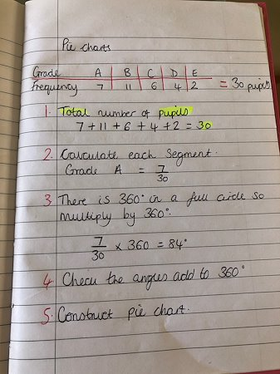

I was planning a lesson on Pie Charts for year 6. I wanted to revise pie charts to ensure my knowledge was up to date and that I was familiar the maths skills needed. I did some revision on the steps to create a pie chart. I went to BBC Bitesize and engaged with the resources on there. I engaged with an example on BBC Bitesize and practiced creating the pie chart including working out each segment and then drawing it. Also, my class teacher showed me how to draw them accurately, using a protractor. This was really important as he informed me that some pupils may find that part difficult, so I needed to be confident in using this skill. I used my notes to help me create a success criteria to use during my pie charts lesson. The pupils found this really useful as I created a large written version which was stuck onto the whiteboard for pupils to follow throughout the lesson.

- Expressive Arts (Art and Design)
Susie Grindey Artwork
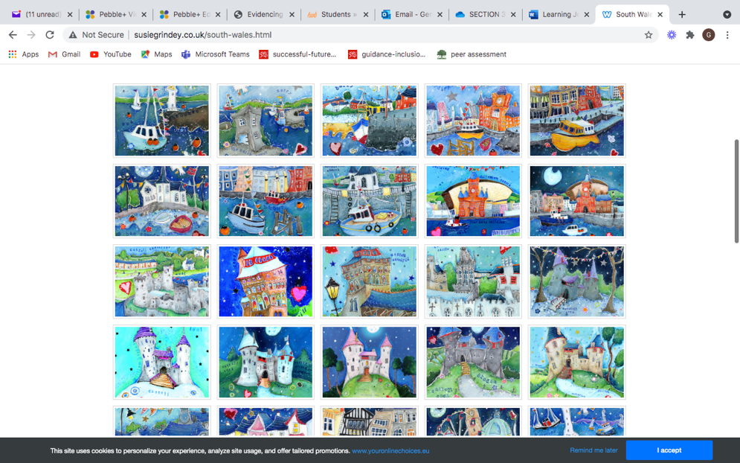
Asset

As part of St. David’s Day, I planned an art lesson based on a Welsh artist. I needed to develop my knowledge of Art and Design. I had to research Welsh artists to find one that was suitable to use as inspiration for the task. I had to find an artist who used bright colours in their work so that it would be appealing for the pupils but also ensuring that the work style was not too complicated for the pupils to interpret. I decided to go with Susie Grindey. I researched to find out about her as an artist including some background information about her. I found her website which had many images of her artwork. I spent some time looking at some of her work that she has produced based on places in Wales. She paints Welsh coastlines so I knew this would be relevant to the pupils in this school as they are close to a beach. It has been a while since I taught a lesson that was fully focussed on art and design, so I had to familiarise myself with the curriculum skills again. I used the Welsh Government Foundation Phase framework to decide what skills were going to be developed in this lesson. I had a discussion with my class teacher about what resources were available in school so that I could plan appropriate activities. I had to familiarise myself with resources and equipment that I could use for different parts of the lesson to allow the pupils to produce their best piece of work. I also had to decide what resources would best support them in developing particular skills.

Reflection on planning for progression
Professional Learning Template 1, relating to different AOLEs.
Professional Learning Template- Literacy, Language and Communication- Phonics
Pedagogy Standard: Advancing: Progression in Learning

What did you do and why?

This week, I planned and taught my first week of phonics on this placement. I was responsible for planning and delivering phonics sessions to two groups (combined). The sound they were learning for this week was ‘ow’. I planned four sessions/activities (Tuesday-Friday) for the pupils based around the ‘ow’ sound.
During the first session, I introduced the sound and supported this with a video clip from 'Epic Phonics'. The video introduced a number of words with the ‘ow’ sound in. After this, we worked as a whole group to create a mind map of as many ‘ow’ words. Some pupils struggled with this and some were more confident. I played the video again to support them further and give them more ideas. For the pupils to be able to use these words, I asked them to choose one of the ow words, draw a picture to support it and then practice writing the word (See appendix 1)

The topic for the week was the Three Little Pigs (World book week) so as part of the guided reading for this week we sequenced the story. Once we had done this, I asked pupils to describe each part of the story for me. We practiced writing short sentences explaining each part of the story. The pupils did well at this and bounced off each other's ideas. We did this on whiteboards and the pupils really enjoy using these.

On Thursday, I set up a treasure hunt for the pupils in the school hall. I had hidden 15 words around the hall, some were fake words, and some were real words, all including the ‘ow’ sound (See appendix 2) The pupils went on a hunt for the words and then we came back together to continue the session as a whole group. Each pupil came up to show the words they had found. We practised breaking down the words and sounding them out. This helped pupils to identify if they were to go in the bin (fake word) or if they were to go in the treasure box (real word) I think this was a real turning moment for the pupils as there were lots of new ‘ow’ words introduced which developed their knowledge of ow sound words. The pupils told me how much fun they had during that session.

For the final session on Friday, we did another mind map of ‘ow’ words. There were lots more confident pupils who were able to share ow words that they had seen and learnt from throughout the week. This was to check their understanding. Welsh Government recommend mind mapping as a tool to activate prior skills, knowledge and understanding (Welsh Government, 2010)
I included an activity on tricky words so that they were developing these words too. They had a colour by words activity which they really enjoyed (See appendix 3) As an extension task, I asked pupils to get out their whiteboards and practice writing as many ‘ow’ words as they could. Pupils were really proud of their work.
Pupils also looked for ‘ow’ words when they were in the reading area. They were looking through books to find and write down words with ‘ow’ in. (See appendix 4)

What have you learned?

From previous teaching experiences, I found that the mind mapping and introduction videos worked really well. However, I was unsure if it would work for this group of pupils and luckily it did. I saw the positive impact it had on their learning. Also, I learnt that using the whiteboards in phonics is a really good strategy to use. It is good for quick fire questions and activities as well as practicing writing the words to help them learn them. In addition, I found that pupils learnt a lot from the practical session which was the treasure hunt. I think it is as important to make phonics fun even if it is a shorter session as it increases the engagement of the pupils. Phonics is closely linked to the behaviourist theory (Skinner) as it is believed that for children to be able to read, they must learn a series of isolated skills. An example of this is phonics as the learners associate letters with sounds which helps them develop their reading skills.
Finally, I saw that pupils had progressed in their learning because they were all much more confident in using and identifying ow words throughout the week. My class teacher also told me that when she had been working with a focus group, they were identifying ow words in different things. This showed that the pupils were able to use this skill across other areas of learning.

What next?
I will continue to use strategies that I know work well when I plan phonics for these groups again. However, I would like to explore other strategies that might work better when working with future classes. I would also like to become more familiar on the phonics phases. If I have the opportunity, I would like to be involved in phonics training.

Reflection on planning for progression
Professional Learning Template 2, relating to different AOLEs.
Professional Learning Template- Mathematics- Time
Pedagogy Standard: Advancing: Progression in Learning

What did you do and why?
Over a half term, the pupils had been learning about time in Numeracy. Due to online learning, pupils were following learning grids and there were separate learning grids for year 1 and year 2. Both year 1 and 2 progressed in their learning of time and usually had looked at a similar aspect each week. Sometimes, year 1 looked at a different aspect of time compared to the year 2's who were more familiar with time.
Firstly, the year 2's began looking at analogue clocks. They would have had learnt about time during year 1 so this was not a new topic for them. They had the opportunity to look at different clocks and had a go at creating their own analogue clocks using natural resources. They had to include all parts of the clock including the numbers and hands of the clock. The following lesson was introducing 5-minute intervals (See appendix 5) I created support videos for the pupils to help them with the tasks. Firstly, I had to explain the importance of being able to count in 5's when it comes to telling the time and then explained how the 5's showed us how many minutes had past the hour and how many minutes there was until the next hour. I did a video reminding them how to count in 5's, I used cut outs of hands (5 fingers) to help them. The pupils then completed an activity where they had to use their natural clock to show me a number of different times, for example 20 minutes past 8 (See appendix 6)
After this, the pupils progressed from analogue to digital clocks. The pupils hadn't had much experience working with digital clocks, so it was only 12-hour digital clocks that were introduced to the pupils. For this, I created introduction videos explaining the link between an analogue and digital clock (See appendix 7) I used lots of resources, props and real-life contexts to help pupils understand the link between the two. The pupils then completed an activity sheet where they had to look at analogue clocks and then put them into digital times (See appendix 8)
Finally, during my introduction videos for digital times I introduced some vocabulary to the pupils such as AM and PM. To support them with the understanding of AM and PM I filmed a video explaining the meaning of the words and set the pupils an extension challenge. I asked the pupils to see if they could add AM and PM to their answers to give them an extra challenge.
What have you learned?
I have learnt how teachers provide progression for pupils. As I was involved in a whole topic of work in Numeracy, I was able to see how the teachers slowly increased the difficulty of the work and challenge each week to help pupils progress at a steady pace. Through planning meetings, I also learnt that the pupils must be pushed at to an appropriate level and that it is important to ensure that pupils have fully understood each skill before introducing the next skill. This will mean that pupils will be able to use skills they have learnt to tackle the next skill and task in their learning.

What next?
I will carefully consider the progression that should be made in future practice. This is so that the pupils are making steady progress where they can link skills so that there is not a massive jump from one activity to the next which may have an impact on a pupil's confidence. I will ensure that I use AFL to check pupil's understanding of a skill before introducing the next one as I have understood how important it is.

Reflection on planning for the Four Purposes
Professional Learning Template 1, relating to a different four purpose
Professional Learning Template- Healthy, confident individuals
Pedagogy Standard: Advancing: Four Purposes for learners

What did you do and why?

Blended Learning Experiences
During this week, pupils were given tasks in Literacy, Numeracy and Topic which they are expected to complete every week. However, the topic and all of the missions were then linked to Children's Mental Health week. The theme this year was express yourself so as a year 1/2 team we thought of how to incorporate this into the children's work. Each mission and piece of work was designed in a way that would help them to express themselves. E.g What activity do you do to express your feelings, like colouring etc. The literacy task for the pupils was to write down how we feel about ourselves and the compliments that other people give us (See appendix 9 and 10) The combination of pupil's uploading work to portfolios, engaging with resources online and using pen and paper gave them a blend of learning experiences.

Four Purposes
As it was Children's Mental Health week, we were focusing particularly on one of the four purposes "healthy, confident individuals" (Welsh Government, 2020) There was a focus on developing pupils mental and emotional well-being and encouraging them to express themselves in whichever way suits them. I also wanted to make pupils aware that mental health isn't just about feelings but about things such as keeping safe, fit and well. I posted a video which showed them how to keep safe and well and this is one of the elements proposed by Welsh Government in developing healthy, confident individuals.

Challenge and Expectation
Due to the mixed class, for home learning, there have been separate learning grids for year 1 and 2. I have had to plan different activities for year 1 and year 2. The pupils are both learning about time at the moment, but the activities and lesson focus are different. Year 2 are more advanced whilst year 1 and learning the basics of time. When I was responsible for dojo last week, I was giving feedback on pupil’s work. I asked my class teacher for the year 1/2 groupings so that I could set a small target for the pupils on their work suitable to their age/ability. This way, I knew if I was setting a suitable challenge for each pupil.

Managing the Learning Environment
Due to the current circumstances of home learning, the learning environment for the pupils at the moment in Class Dojo. Last week, I had full responsibility for dojo for three whole days. For these days, I decided what I wanted to post and at what time, I created a weekly plan for this. I was posting important messages for pupils and parents as well as support videos for their tasks. As well as this, I was marking and giving feedback on pupil's work when they were uploading it to their portfolio.

Working with in school colleagues
As part of my dojo responsibility, I had to involve my teaching assistant by asking her to post two things during the week. I spoke to her on Monday morning and asked her if she could do a video about expressing herself as well as a sensory activity for the pupils. I took responsibility for leading and working with my colleagues.
What have you learned?

Blended Learning Experiences
I have learnt that it can be difficult for pupils of this age to interact with online resources and physical resources such as pen and paper, depending on the circumstance in the home. This is why I found that it was important to provide a range so that everyone would be able to access something.

Challenge and Expectation
Pupils were always well engaged with my feedback and comments and most of the time they reply to a target or question I have sent them on their work. I think the class list really helped me set suitable targets and questions for pupils.

Managing the Learning Environment
My teacher and I agreed that I had worked hard on managing dojo. I had set a plan which showed that I had thought thoroughly about what I wanted to post and when. I ensured that what I was positing was closely linked with the theme of children's mental health. I was posting about 3/4 times a day and giving feedback.

Four Purposes
I found that the four purposes really linked well to the theme of mental health. It was a great opportunity to try and develop pupil’s confidence and resilience to ensure they become healthy, confident individuals. It was lovely to see pupils engaging with the activities and enjoying them. My placement school think growth mindset and mental health is really important and this is reflected in their school.

Working with in school colleagues
I learnt that by having the discussion with my teaching assistant early on in the week, I was able to plan better for my dojo days. I was then able to make an accurate plan of when her videos would be done by to then post them for the children. I worked well with my teaching assistant and the videos were successful.

What next?

I am excited to find out about what strategies and interventions my placement school use to promote growth mindset and positive mental health. I will observe these and incorporate them into my teaching practice.
Next week, I am taking over dojo for 3 days again and so I will be creating a plan again to help decide what to post and when. I will also be interacting with my teaching assistant again to decide what videos she will record this week.

Reflection on planning for the Four Purposes
Professional Learning Template 2, relating to a different four purpose
Professional Learning Template- Ambitious, capable learners
Pedagogy Standard: Advancing: Four Purposes for learners

What did you do and why?

Differentiation
For both the probability and independent tasks I differentiated. Due to the fact that two of the groups were swapping over during this lesson I needed to ensure that I had differentiated the tasks because both groups were different abilities. Although the tasks were differentiated the both groups still got to engage in an independent task and probability which were both differentiated to their levels of ability (See appendix 11) For the independent task, I created 3 problems for LA, MA and HA which had the same context but I just changed different numbers within them (See appendix 12a and 12b) For the probability, the groups had the same task but as they were working with the TA it was differentiated in the way that each group had different levels of scaffolding throughout the activity.

Four purposes for learners
I believe that the independent tasks were a great way to show that the pupils in the class were using the four purposes as a driver for their learning. The independent tasks were included in every maths lesson in year 6 and all pupils would have the opportunity to do engage in the independent task when it was their time on that station of the carousel. The independent tasks were always based around problem solving which links closely with the four purposes. One of the four purposes is to encourage children to be ambitious capable learners. Within the Successful Futures document, it states under this purpose that ambitious, capable learners are those who are questioning and enjoy solving problems. It also says that ambitious capable learners are those who have a body of knowledge in which they can use skills to connect and apply their knowledge in different contexts (Donaldson, 2015) For example, each independent task was a slightly different context, but they were able to apply their skills to help solve the problems. The RUCSAC strategy was also encouraging pupils to explain their ideas and concepts as they worked through the problem. Finally, an ambitious, capable learner interprets data and applies mathematical concepts which is the main component of these independent tasks. Pupils also become enterprising, creative contributors who are able to think creatively to reframe and solve problems.

Managing the learning environment
During this lesson, I had the class split into three groups and they were each doing a different activity. One group was working with myself doing pie charts, another group was working with the TA doing probability and then the final group were working on an independent task focusing on problem solving. After break, the TA group and the independent group swapped over. I believe I managed the learning environment well as I was able to set all groups an engaging and beneficial task and throughout the lesson, I checked on each group to ensure they were getting on with the work ok. The independent group had a problem-solving task to do in which they had to solve the problem by using a strategy called RUCSAC. The school used this strategy and therefore I adapted it and included it in my lessons. RUCSAC stands for Read, Understand, Choose, Solve, Answer, Check. The pupils on the independent task were required to set out their work using the RUCSAC as subheadings and work through the task. They should read the task and understand it. They should then choose a method they think is suitable to make the calculations and then solve it. Finally, they will answer the question and then check it using an inverse method.

Leading colleagues, projects and programmes
My TA was very much involved in this lesson and was in charge of leading a group at a time on probability. Previous to the lesson, I sat down with my TA and discussed with her my intentions of the lessons and what I wanted the outcome of the lesson to be. I explained the lesson I had planned to include introduction, main task and plenary. I talked her through the lesson and showed her the resources which were for each part of the lesson so that she was confident in leading the probability task. I also informed her on how I had differentiated the task and what my expectations were for each ability group. I ensured that the TA was confident in and understood what I had explained to her and asked her if there was anything, she was unsure about and wanted to ask me before the lesson took place. Throughout the lesson, the TA was confident to ask my any questions about the task when she got stuck on something, but these were very minor issues.
What have you learned?

Differentiation
From this experience I learnt that even though there is a lot of work going on in the classrooms and even different topics, it is still so important for the tasks to be differentiated for each group. As a result of this, I learnt that in order to give the pupils the best opportunity to meet the lesson objective the work must be suited to their needs in all topics. I did find that it was quite a lot of work to differentiate for different topics and abilities for a few lessons taking place within one lesson. I learnt that it was easier to focus on one topic at a time and so that I could plan the differentiation thoroughly. Due to the differentiation in work, all pupils were able to meet my intended outcome and complete the tasks well.

Four purposes for learners
I have learnt that the four purposes which are included within the new curriculum for Wales are a great source to use to plan lessons and activities which will ensure that children are gaining a wide range of opportunities. Just by doing this lesson, I have realised how easy it can be to include so many different aspects of the four purposes within different areas of learning.

Managing the learning environment
I learnt that when managing the learning environment when the lesson is set up as a carousel it is important to check on all groups, even the groups who are being supported by a TA. This is to ensure that all pupils are on task and remain on task even if they are working independently. It also helps to learn of any issues the pupils have and then they can be supported, or you can guide them on where to go for help. I learnt of a strategy the school had adopted just a few days before the lesson. It is called S.N.O.T which stands for self, neighbour, other, teacher. I learnt that this strategy helped, particularly when pupils worked independently. They were able to seek support and advice off their peers before going to the teacher.

Leading colleagues, projects and programmes
I learnt that it was really beneficial for me to talk to the TA through the lesson beforehand. It helped her to understand the lesson aims, activities and plenary before the lesson began. It ensured that the TA was able to effectively support the pupils she worked with throughout the lesson. If I had not explained this prior to the lesson it may have caused disturbances in her group work and mine due to the TA asking questions due to uncertainty. As a result, the pupils were able to have a good lesson that flowed well, and the TA was confident in supporting the pupils.

What next?
In the future, I would like to adapt this strategy of managing the learning environment where the class is working in three different areas. Two which are supported by members of staff and one which helps pupils to develop their level of independence. I have seen that it works well if it is organised effectively and particularly for older pupils within the school. I would also like to start planning more lessons based around using the four purposes as the main focus for my lesson as this is something that is going to be happening in every lesson in Wales in 2022 and beyond as our curriculum changes so I want to ensure I am experienced in doing this before it becomes an essential part of planning.

Part 2

PLP Link: https://v3.pebblepad.co.uk/spa/#/public/kwhG4ZWfqfxd5yMxbwy4hyytsc

I have chosen to critically reflect on the standard ‘The four purposes’ and in particular ‘healthy confident individuals. In my Professional Learning Passport (PLP), I have demonstrated that I can plan for the four purposes. I planned activities to develop healthy, confident individuals during Children’s Mental Health Week. I also planned independent tasks to develop ambitious, capable learners. However, I would like to incorporate more opportunities for learners to develop as health, confident individuals. According to Child and Adolescent Mental Health Services- CAMHS, one in ten children who have mental health conditions in Wales access support from CAMHS (Welsh Government, 2020)

Well-being can be defined as a “state of complete physical, mental and social well-being and not merely the absence of disease or infirmity” (WHO, 2012, p.2). Mental health is “a state of well-being in which every individual realises his or her own potential, can cope with the normal stresses of life, can work productively and is able to make a contribution to his or her community” (WHO, no date, p.1). Bad mental health would oppose this definition, for example, one who cannot cope with the normal stresses of life.

The estimated 3 children in every class suffering from a mental health problem indicates an increasing mental health crisis. According to the Young Minds charity, this figure can rise when emotional stress in considered. Mental health problems can arise for children as they face challenges of a changing world. They may struggle to deal with personal aspects of their life resulting in mental health problems (Cowburn and Blow, no date). As a result of these figures, schools must support pupils in providing safe and positive environments for children to learn and play in. Within this document, Young Minds have made some recommendations to the Government in the hope that health and well-being will be considered more in schools. To ensure that there is greater emphasis on the importance of health and well-being, it is believed there should be a change in the Ofsted Inspection Framework. Consequently, schools will be inspected on how they promote mental health and well-being as well as other aspects of school life. They suggest that the framework should provide explanation of how schools can promote positive learning environments (Cowburn and Blow, no date) Potentially, this could decrease numbers of young people with mental health conditions and support them in a healthy development.

Pet therapy is a strategy that can be used in schools to promote health and well-being. The purpose of pet therapy is “to help someone recover from or cope with a health problem or a mental disorder” (Giorgi, 2017) Cariad Pet Therapy is a non-profit organisation who provide a pet therapy service across South and West Wales. They visit schools to support pupil well-being. It is usually dogs that are involved in pet therapy with pupils because humans can become calm and relaxed around dogs. As a result, heart rate decreases as well as stress hormones so both the human and dog feel good. The dog interacts and engages with the human which enables movement and communication too. The pet therapy can relieve anxiety, lower stress, boost mood and lower depression and aid self-esteem and self-worth. All these benefits are favourable in helping pupils have control over their mental health. More control over mental health means more ability to cope with daily life struggles overall resulting in better mental health (Cariad Pet Therapy, 2020)

“Mindset is a set of attitudes and beliefs about abilities, such as intelligence” (Robinson, 2017, p.18) The terms ‘fixed’ and ‘growth’ mindset originated from psychologist Carol Dweck (2006) Pupils who have a fixed mindset believe that they are born with their abilities and intelligence and it is not changeable (Robinson, 2017) In opposition to this, pupils with growth mindset believe they can improve their abilities when practiced. Dweck (2006) believes that your mindset impacts your behaviour. Those who have a fixed mindset are likely to give up when faced with challenges and pupils with growth mindset often put their best effort and energy into facing challenges (Robinson, 2017) Dweck believes that the type of language that you use can help to promote growth mindset in the classroom. She discussed a scenario where pupils had to have a certain percentage to pass but those who failed were given a grade ‘not yet’. This was supported by Dweck as she said, “because when you fail, you’re nowhere but if you get the grade ‘not yet’ you’re on a learning curve” (Dweck, 2014) The phrases used to promote growth mindset should be encouraging and supportive. It is important to reassure the pupils that they will achieve, even if it is not yet, and finding alternative strategies to support them. At the hand of this, it will increase pupil’s self-esteem and improve self-concept leading to better mental health. Rogers (1951) backed this concept with his invention of self-actualisation and believed that everyone can achieve their goals, wishes and desires in life when self-actualisation took place (McLeod, 2014) Developing growth mindset in classrooms would support pupils in improving the view of themselves so that they could practice self-actualisation in the future.

Class teachers may include emotional check-ins within their daily routines. This is a process where pupils will ‘check-in’ with their teacher and share how they are feeling. It can be incorporated into morning/afternoon routines, registers or throughout the school day. There are many different ways to present the check in as it can be verbal, using words or pictures. Younger pupils and ALN pupils may find it difficult to put into words or writing about how they feel so it is better to use images. A popular strategy is the use of emojis. Many young people are familiar with emoji’s so if they can use these to show how they are feeling they will experience the benefits of a check-in. Whilst providing a check-in twice daily it can help teachers to identify pupils who may have different feelings throughout the day, it also highlights to pupils that it is normal to have lots of different feelings in a day and that it is ok to feel low sometimes. The daily check-in teaches children how to identify feelings and how to express them. As pupils grow up, they will also be able to identify other people’s feelings. Having the ability to identify feelings can help children to decide how to deal with these feelings. Pupils being able to deal with feelings appropriately is a sign of good mental health. The check-in also supports the role of a teacher as they can establish pupils who are down or uncomfortable. This opens the opportunity for the teacher to investigate and resolve the situation as well as supporting the pupil before the situation escalates (Shackleton, 2017) If negative feelings are identified and dealt with appropriately by teacher and pupil, it can help pupils in improving their mental health.

School based counselling is delivered by qualified practitioners to support pupils to understand their difficulties in a safe and confidential environment. The Welsh Government fund a school-based counselling statutory service which is accessible for all secondary aged pupils, 11-18 as well as year 6 pupils. This is significant compared to England as many children do not have access to a counsellor in their school and their provision is inconsistent (BACP, 2015) “Research indicated that school based counselling is perceived by children and pastoral care staff as highly accessible, non-stigmatising and effective form of early intervention for reducing psychological distress” (Cooper, 2009 in BACP, 2015, p.4) This means that counselling services are helping to identify and tackle mental health problems early on in life which will ensure good mental health from a younger age. Counselling encourages pupils to share their worries and problems so that they can then build their confidence and self-esteem. Counselling uses operant conditioning (Skinner, 1937) to help people change undesirable behaviours that originate from their mental health problem.
Increased confidence and self-esteem mean a reduced chance of developing new or further mental health problems. However, “only a minority benefit from therapeutic services” (BACP, 2015, p.7) in primary schools. This could be because of their age and their lack of ability to verbally express how they feel.

Having individual approaches can be beneficial when looking for bespoke strategies for individuals. A mental health assessment can help practitioners to decide the most appropriate approach that is most tailored to the individual. However, Welsh Government imply that a “piecemeal adoption of strategies, important as each of them might be, is less effective in terms of the impact on pupils and staff than a whole school approach and is less sustainable over the longer term.” (Welsh Government, 2010, p.22) This signifies that the use of individual approaches will not benefit pupil’s mental health over a long period of time. Schools want to be able to educate pupils on how to deal with their mental health and teach them skills they can use throughout their life and Welsh Government believe that the most effective way to promote health and well-being is through whole-school approaches.

The Welsh Network of Healthy School Schemes (WNHSS) aim to promote the health of children and young people. There are local schemes that are set up which are responsible in supporting the schools within that area. “The WNHSS describes a health promoting schools as one which actively promotes, protects and embeds the physical, mental and social health and well-being of its community through positive action” (WNHSS, no date, p.1) This can be attained through school development plans, policies, curriculum and relationships with the community (Public Health Network Cymru, no date) WNHSS have designed 11 criteria which show examples of a whole school approach to supporting mental and emotional health and well-being.

A whole school approach could include having appropriate policies in place. For example, anti-bullying and positive behaviour management policies. This would ensure that expectations of staff and pupils are clearly outlined to encourage a positive learning environment for all. A positive learning environment allows pupils to achieve and be confident in their learning so this will reduce the chances of developing a mental health problem. There is a need for whole staff training on mental and emotional health and well-being. If staff are trained, they can approach and deal with mental health situations appropriately. The training will support staff in make informed decisions about how to resolve an issue which is likely to stop a pupil’s mental state declining (Welsh Government, 2010)

Making links with the community and engaging with local and national initiatives are really beneficial strategies. When pupils engage with community projects and initiatives it can create a sense of belonging and make them feel valued which is critical to improving mental health (Welsh Government, 2010)

In Canada, there were fourteen studies carried out which analysed the effects of a whole-school anti-bullying approach. The Canadian researchers found that the results were “too inconsistent to justify adopting a whole-school approach over other anti-bullying programmes” (Smith et al, 2004, p.3) This suggests that perhaps a whole-school approach does not always work when promoting health and well-being, specifically when looking at healthy relationships. In addition, it implies whole- school approaches may only be effective in certain areas of health and well-being.

After considering various strategies from literature relating to promoting wellbeing and healthy confident children, I have identified a number of ways, what I may improve upon this aspect of pedagogy in my future practice. Based on my findings from the literature review, one strategy, that I will incorporate into my future practice is daily check in’s. Research says that daily check ins provide a “specific opportunity to empower pupils to reflect on how they’re feeling” (Shackleton, 2017) allowing them to begin recognising their feelings and finding ways to deal with them appropriately. Having reflected on my experience and contextualised through wider reading I have become more aware of some pupils struggling to express their feelings through words, and therefore to avoid this, I will ensure that I explore various ways that pupils can represent their feelings, for example, through pictures or emoji’s. I believe I will know which strategies would be more effective once I get to know the class I work with.

In my opinion, asking pupils to talk about their feelings can highlight challenges. Some pupils may only feel comfortable expressing their feelings in certain environments with certain staff members. A lack of confidence can mean pupils shy away from talking about their problems and also a pupil not understanding their feelings, which is likely at a young age, means they cannot talk about their issues.

Finally, I would like to help work towards the 7 well-being goals proposed in the Well-being for Future Generations Act (2015) one of which is to see that people’s “physical and mental well-being is maximised” (Welsh Government, 2015, p.6) I’d like to do this by engaging with relevant training so that I can support pupils with their emotional and mental well-being. The National Assembly for Wales believe that all who work with children and young people should be trained in emotional and mental health awareness. Hopefully, this will open more opportunities for me to receive training, in which I can use the knowledge in my future classroom.

References

British Association for Counselling and Psychotherapy (2015) School counselling for all. Available at: https://www.bacp.co.uk/media/2127/bacp-school-based-counselling-for-all-briefing-dec15.pdf (Accessed 19th April 2021)

Cariad Pet Therapy (2020) About us. Available at: https://www.cariadpettherapy.co.uk/about (Accessed 15th April 2021)

Cowburn, A. and Blow, M. (no date) Prioritising Well-being in Schools. Available at: https://youngminds.org.uk/media/1428/wise-up-prioritising-wellbeing-in-schools.pdf (Accessed 14th April 2021)

Donaldson, G. (2015) Successful Futures. Available at: https://gov.wales/sites/default/files/publications/2018-03/successful-futures.pdf (Accessed 30th April 2021)

Dweck, C. (2014) Developing a Growth Mindset with Carol Dweck [video] Available at: https://www.youtube.com/watch?v=hiiEeMN7vbQ&t=27s (Accessed 15th April 2021)

Giorgi, A. (2017) What is pet therapy? Available at: https://www.healthline.com/health/pet-therapy (Accessed 15th April 2021)

Holtom, D. and Iqbal, H. (2020) Review of Evidence on all-age Mental Health Services. Available at: https://gov.wales/sites/default/files/statistics-and-research/2020-06/review-of-evidence-on-all-age-mental-health-services-summary.pdf (Accessed 14th April 2021)

McLeod, S. (2014) Carl Rogers. Available at: https://www.simplypsychology.org/carl-rogers.html (Accessed 15th April, 2021)

National Assembly Wales (2018) Mind over Matter. National Assembly for Wales Commission Copyright: Cardiff. Available at: https://senedd.wales/laid%20documents/cr-ld11522/cr-ld11522-e.pdf (Accessed 19th April 2021)

Public Health Network Cymru (no date) Welsh Network of Healthy School Schemes. Available at: https://www.publichealthnetwork.cymru/en/social-determinants/education/welsh-network-of-healthy-school-schemes-wnhss/ (Accessed 14th April 2021)

Robinson, C. (2017) Growth Mindset in the classroom, 41(2), pp.18-21. Available at: https://search.proquest.com/openview/3320caa09bcbde834e12840c6575793d/1?pq-origsite=gscholar&cbl=36017 (Accessed 15th April 2021)

Shackleton, E. (2017) The benefits of ‘checking in’ with your pupils. Available at: https://beaconschoolsupport.co.uk/newsletters/benefits_of_checking_in#:~:text=So%20the%20benefits%20of%20'checking,to%20understand%20and%20support%20them. (Accessed 15th April)

Smith, J. D., Schneider, B. H., Smith, P. K., & Ananiadou, K. (2004). The effectiveness of whole-school anti-bullying programs: A synthesis of evaluation research. Available at: https://www.prevnet.ca/sites/prevnet.ca/files/research/PREV-Smith-etal-2004-Communique-strengths-weaknesses.pdf (Accessed 15th April 2021)

Write Dance Training (2021) Welcome to Write Dance Training. Available at: https://writedancetraining.com/ (Accessed 6th April 2021)

Welsh Government (2010) Thinking Positively. Available at: https://gov.wales/sites/default/files/publications/2018-12/thinking-positively-emotional-health-and-well-being-in-schools-and-early-years-settings.pdf (Accessed 14th April 2021)

Welsh Government (2010) How to develop thinking and assessment for learning in the classroom. Available at: https://hwb.gov.wales/api/storage/663d00fd-9c3b-4003-9a1f-0012bad39fad/how-to-develop-thinking-and-assessment-for-learning-in-the-classroom.pdf (Accessed 30th April 2021)

World Health Organisation (2012) WHO and Well-being at work. Available at: https://www.hsl.gov.uk/media/202146/5_kim_who.pdf (Accessed 14th April 2021)
Welsh Government (2015) Well-being of Future Generations (Wales) Act (2015)
Available at: https://www.futuregenerations.wales/wp-content/uploads/2017/02/150623-guide-to-the-fg-act-en.pdf (Accessed 19th April 2021)

Appendix
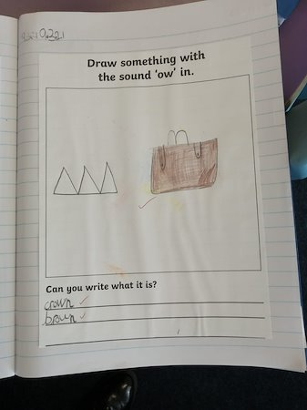

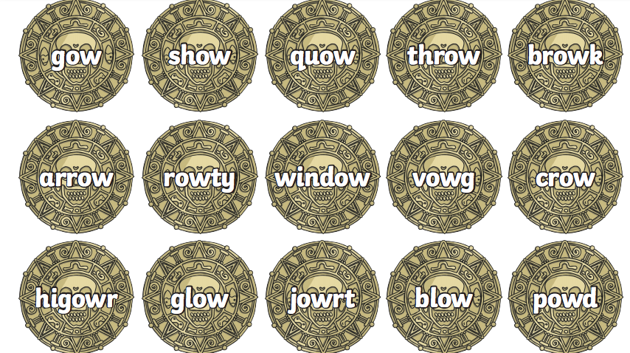

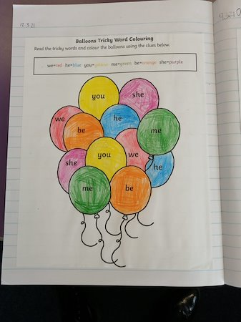

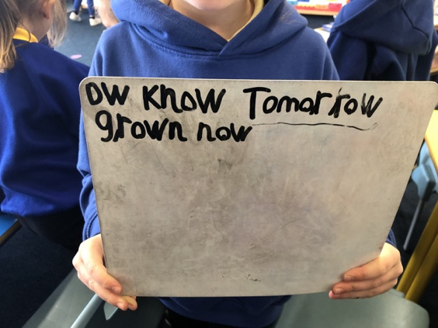

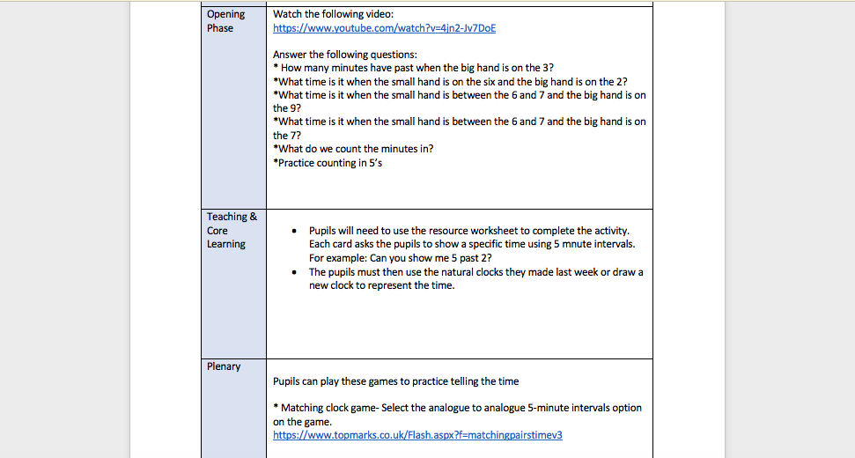

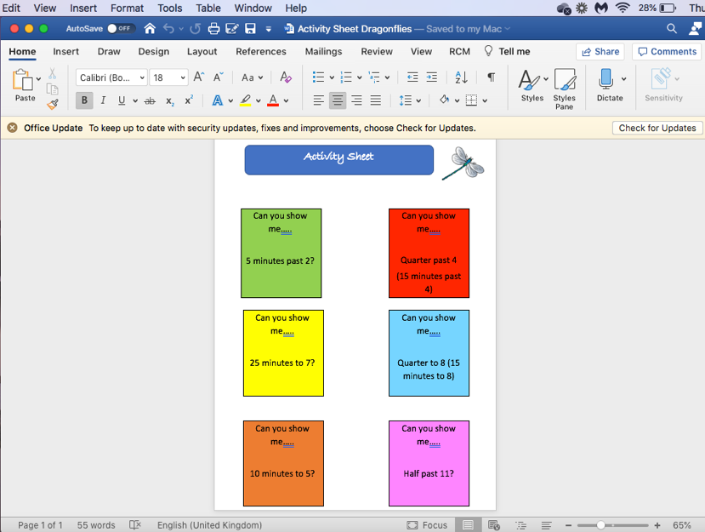

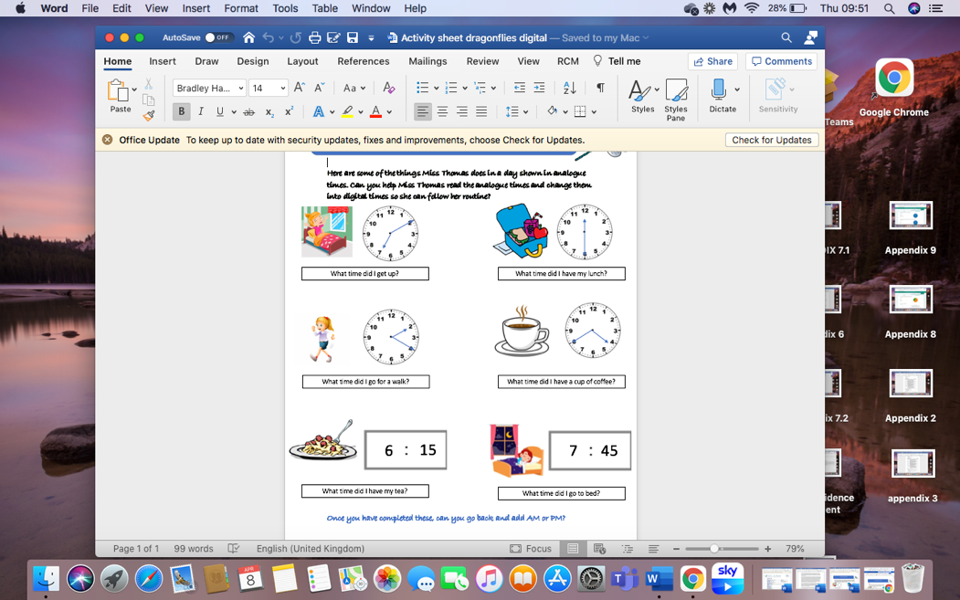
- Introduction Video- https://uowtsd-my.sharepoint.com/:v:/g/personal/1801533_student_uwtsd_ac_uk/EfAif3hF_P5Jo4z_lHNkdqsBKkPtrStYPEbd-CksvnmKSg?e=ttBF01

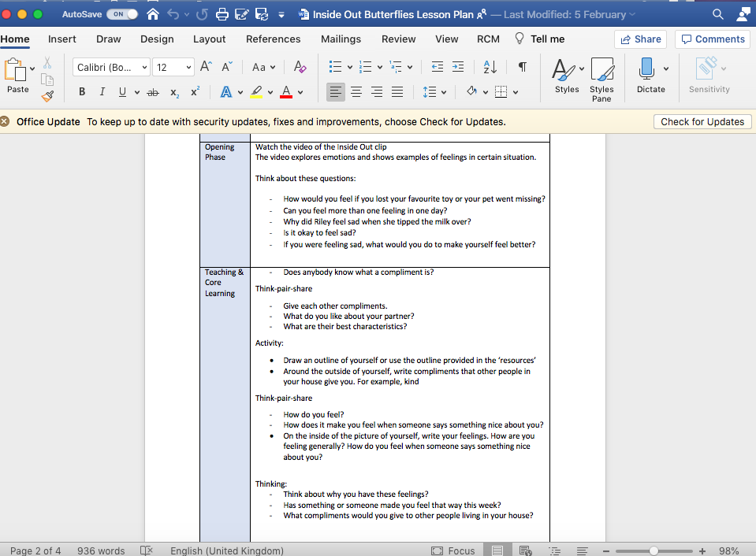

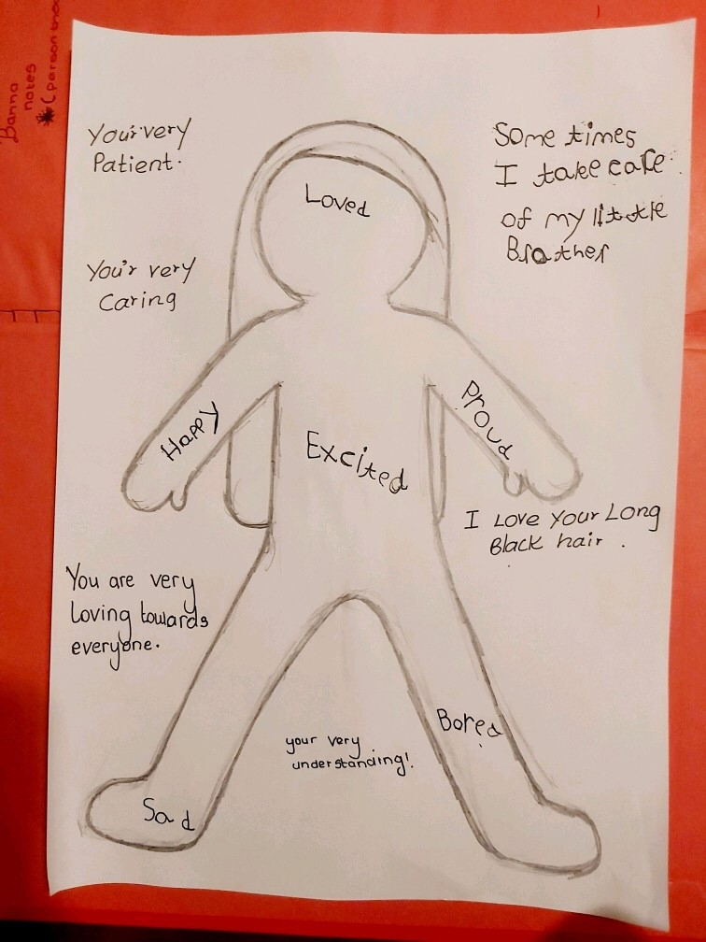



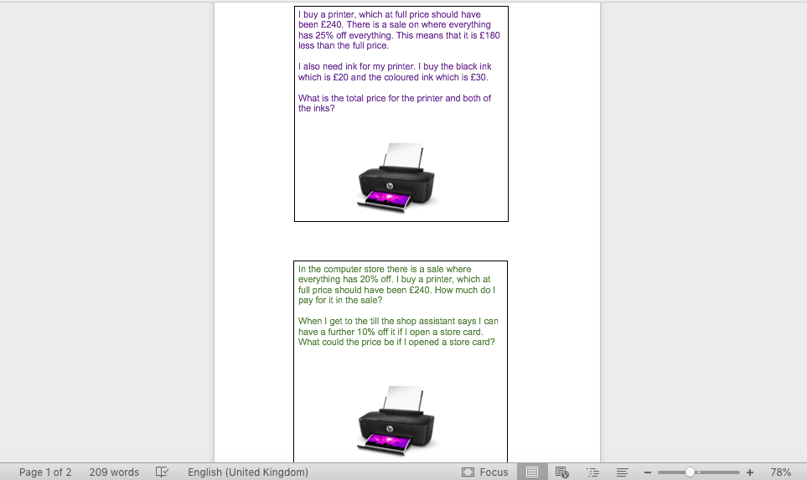
12a.

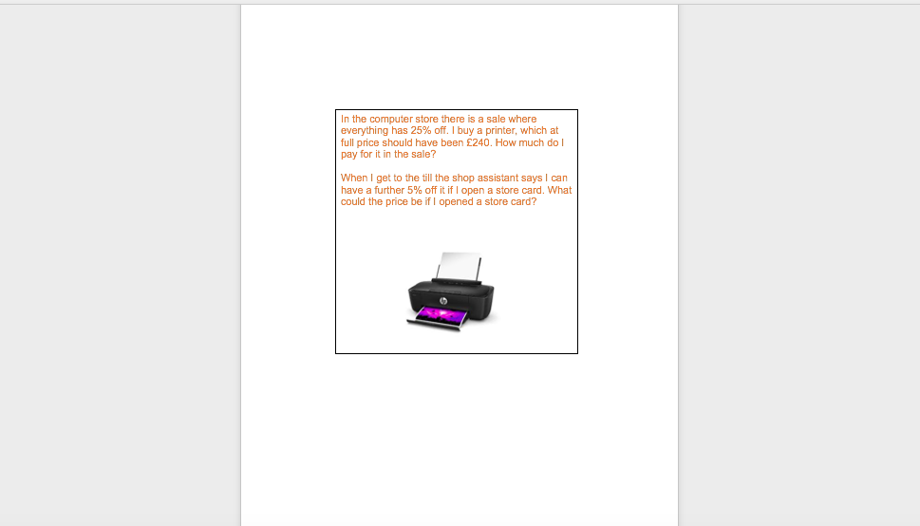
12b.

