

An Investigation Into The Perceived Impact Factors That Police Officers Feel Are The Causes Of Poor Mental Health Within The South Wales Police Force And Their Perspectives On The Effectiveness Of Organisational Wellbeing Support.

Gareth Thomas
Student Number: 2031242

University Of Wales Trinity Saint David

Police Constable Degree Apprenticeship (PCDA) – BSc (Hons) Professional Policing Practice.

Acknowledgements

I would like to thank my dissertation supervisor Fay Cosgrove for the support and guidance that she has given throughout this research project. Without Fay’s help, completing this project would have been far more challenging.

I would also like to thank my work colleagues and all participants who have taken time to contribute to this dissertation making this study possible.

Finally, I would like to thank my family, namely my wife Claire, my daughters Mali and Freya, and my parents, for the endless support and encouragement that they have given during the completion of this research project and throughout the three years that I have studied with the university. I am truly grateful.

Declaration

- Declaration: This work has not previously been accepted in substance for any degree and is not being concurrently submitted in candidature for any degree.
Signed: 
Date: 25th March 2024

- Statement 1: This dissertation is being submitted in partial fulfilment for the degree of BSc.
Signed:
Date: 25th March 2024

- Statement 2: This dissertation is the result of my own independent work/investigation, except where otherwise stated. Other sources are acknowledged by footnotes giving explicit references. A bibliography is appended.
Signed:
Date: 25th March 2024

- Statement 3: I hereby give consent for my dissertation, if accepted, to be available for photocopying and for interlibrary loan, and for the title and summary to be made available to outside organisations.
Signed:
Date: 25th March 2024

- Statement 4: I hereby give consent for my dissertation, if accepted, to be available on the university’s IT system for those who have consent to use the system.
Signed:
Date: 25th March 2024

Abstract

Policing is widely regarded as an occupation that carries a high level of stress due to the demands of the role and the frequent exposure to traumatic incidents. Police officers are vulnerable to suffering from poor mental health with officers twice as likely to suffer from anxiety and depression than members of the general population (Stevelink et al., 2020). Several past studies have been carried out with regards to the link between policing and the poor mental health of officers, however, there have been fewer studies conducted with regards to identifying the actual impact factors that negatively affect the mental health of officers. This study aimed to identify the main perceived impact factor that police officers within the South Wales Police Force believed was the main cause for poor mental health due to the nature of the occupation and aimed to identify if this was of a Socioeconomic, Organisational or Personal factor. It is believed that no other study has been carried out with regards to the identification of the impact factors for the poor mental health of police officers within the South Wales Police force specifically.

An online survey, as a quantitative method of research, was created and made available to all warranted serving police officers within the force to identify what they believed were the main causes of poor mental health due to the occupation. Participants identified several factors, however the Socioeconomic factor of ‘Budget Cuts’ affecting staffing levels, increased working hours and an increased workload for officers was selected by the majority as the main factor that impacted the mental health of officers. The result of the study allows South Wales Police to understand as a police force the factors that their officers believe are the causes for poor mental health and creates learning opportunities for the force to create a more effective support structure. The study also creates opportunities for other police forces to build on this study through the identification of mental health impact factors within their force specific areas which may assist them in developing improved means of support for officers.

Contents Page

Chapter 1: Introduction…………………………………………………………… 7
  - Background…………………………………………………………….…….. 7
  - Objectives…………………………………………………………………….. 8
  - Structure………………………………………………………………………. 8
Chapter 2: Literature Review………………………………………………..……. 9
2.1 Introduction…………………………………………………………………. 9
2.2 Mental Health in Policing……………………………………..…………… 9
2.3 Maladaptive Coping Mechanisms……………….………………………. 11
2.4 Mental Health Impact Factors……………………………………………. 12
2.5 Mental Health Support for Police Officers in the UK…………………… 13
2.6 Conclusion….………………………………………………………………. 14
Chapter 3: Research Methodology………………………………………………. 15
3.1 Introduction………………………………………………………………….. 15
3.2 Quantitative and Qualitative Methods of Research….………………….. 15
3.3 Research Approach………………..…………………………………..…… 16
3.4 Population and Sample……………………….…………………………..…17
3.5 Ethical Practice………………………………………………………..…….. 19
Chapter 4: Analysis of Results……………………………………..……..…….… 20
4.1 Introduction……………………………….………………………………….. 20
4.2 Demographics and Descriptive Statistics………………….……………… 20
4.3 Questionnaire Findings………………………………………………….……22
4.3.1 Mental Health Within Policing………………………………..……....… 22
4.3.2 Work Related Mental Health Impact Factors…………..………....….. 23
4.3.3 Organisational Support……...………………………………...…...…… 24
4.4 Conclusion…………….……………………………………………………….27

Chapter 5 Conclusions and Recommendations……………………………….. 28
5.1 Introduction…………………….……………………………………..……. 28
5.2 Main Findings………………………………………………………………. 28
5.3 Recommendations……………..………………………………………..… 29
5.4 Limitations………………………….……………………………….………. 30
5.5 Further Research…………………………….…………………………….. 31

Reference List……………………………………………………………………. 32 - 37

Appendices…………………………..………………………………………………… 38
Appendix 1: Survey Questions and Results…………………………… 38 - 44
Appendix 2: Ethics Form……………………………………………….... 45 - 62

Chapter 1: Introduction

1.1: Background

Policing is a challenging and stressful occupation which often exposes officers to traumatic events which most people in society will never have to encounter in their lifetime. NHS (2023) explains that stress is the body’s reaction to feeling threatened or under pressure. Police officers are faced with stressful situations daily by means of incidents that they are dealing with and the decision-making outcomes that they must make, with these decisions being paramount in the safeguarding of others. The stresses of these incidents can often have a detrimental effect on the mental health of officers.

Figures show that 1,965 police officers in England and Wales were on long-term sick leave as of March 2021, which is the equivalent of 1.5% of all full-time police officers (GOV.UK, 2021) with officer mental health playing a significant part in these absence figures (Polfed, 2022). It has been found that rates of Post Traumatic Stress Disorder (PTSD) in the police are almost 5 times higher than in the general population with Dr Jess Miller of the University of Cambridge describing this as “A clinical and public sector crisis” (BBC, 2019).

But what are the perceived impact factors that officers believe are the causes for poor mental health? What organisational support is available to police officers within the South Wales Police force for their mental health? How effective do officers feel that this organisational support is? Research carried out by Deschenes et al., (2018) in Quebec, Canada, identified several perceived impact factors that were categorised as Socioeconomic, Organisational and Personal factors that police officers believed affected their mental health. With the geographical difference between Canada and South Wales, this study will compare the results obtained from this research with that of the study by Deschenes et al., (2018) to identify if the perceived impact factors for officer mental health are the same or differ in any way. This is the first study of this kind that will carry out a comparison such as this between both South Wales Police and a police force in Quebec, Canada.

The study aims to allow the researcher to understand the effectiveness of the organisational support from the perspective of officers within the South Wales Police force. Gaining this understanding through the analysis of the data obtained in the study will allow the researcher to present recommendations that may aid in improved mental health support for South Wales Police officers where necessary going forward.
1.2: Objectives

- Objective 1: To identify the perceived mental health impact factors that police officers feel are the causes of poor mental health within the South Wales Police force.

- Objective 2: To understand the perspectives of police officers on the effectiveness of organisational wellbeing support for poor mental health.

1.3: Structure

This research project will be presented in five chapters to ensure the completion of the study in achieving the set objectives with this introduction being the first chapter.

Chapter two of the study will present the literature review, where past academic studies will be explored and analysed to gain a greater understanding regarding the relationship between policing and mental health.

Chapter three, the Methodology chapter, will outline the approach and research techniques used by the researcher to achieve the objectives of this study.

Chapter four will present an analysis of the data results collected from the proposed research method outlined in chapter three of the study. This data analysis will attempt to identify common themes and gain a greater understanding of the subject area to achieve the set objectives.

Following on from this, chapter five will discuss the main findings of this research project. The chapter will conclude with recommendations from the researcher based on the observations from this academic study and will outline areas of opportunity for future research.
Chapter 2: Literature Review

2.1: Introduction

This chapter will review current academic research which has been completed with regards to the subject of the impact on the mental health of police officers due to factors associated with the occupation and will provide an overview of arguments from past studies. The chapter will consider impact factors identified in previous research as causes for the deterioration of officer mental health and will seek to highlight areas where further research is required to gain additional understanding on this subject. The identification of available organisational support services to officers will be undertaken through reviewing the available literature.

This Literature Review will be completed through the analysis of a wide range of sources obtained using the University of Wales Trinity St. David’s online library, the academic search engine Google Scholar and through trusted online websites. These methods will provide access to relevant books, journals, articles, and websites which will provide access to academic research which has previously been completed on the subject in question.

2.2: Mental Health in Policing

Policing is widely regarded as an occupation that carries high levels of stress which, as a result, can often have a detrimental effect on the mental wellbeing of police officers. GOV.UK (2021) figures show that as of March 2021, 1,965 police officers in England and Wales were on long term sick leave, which equates to 1.5% of all full-time police officers in England and Wales. It also states that 4,005 police officers were on long term absence during the same period, which equates to 3% of all full-time police officers in England and Wales. Due to the nature of policing where officers are exposed to a multitude of various traumatic incidents, work absence due to the mental health of police officers plays a significant part in the absence figures recorded above (Polfed, 2022).

Mental Health is a state of wellbeing that enables a person to deal with the stresses of life, reach their full potential, learn, and work effectively and is a crucial aspect of health and wellbeing in every individual’s life (World Health Organisation, 2022). To achieve positive emotional and psychological wellbeing, physical activity, healthy eating, and sleep is widely promoted for our wellbeing. However, The Mental Health Foundation (2023) states that approximately 8 – 10% of adults in England and Wales will suffer from anxiety or depression in their lifetimes, and one in six adults having a form of common mental disorder. Research has found that negative psychosocial characteristics such as psychological distress, limited emotional support, social isolation, financial hardship, and negative social interactions all have detrimental effects of a person’s mental health and wellbeing (Steptoe et al, 2008). However, the true extent of the effects of mental health on society is difficult to measure and fully understand with Bonanno (2004) stating that research carried out with regards to the mental health effects of individual trauma and the way that adults cope with traumatic experiences has mainly been derived from individuals who have actively sought treatment or have suffered significant psychological problems. This raises the question as to whether in fact the number of individuals suffering with a mental health condition is far higher than reported with many not having sought professional help.

The mental health charity Mind (2023) explains that trauma is when a person experiences a very stressful, frightening, or distressing event. These experiences can affect an individual both emotionally and psychologically and can have long-lasting harm on a person. The effects of trauma may affect a person quickly after the event or may appear a long period of time following an incident. Traumatic experience may consist of the death of a loved one, being involved in a serious traffic accident or being the victim of a traumatic assault as well as other serious incidents. Avon and Somerset Police Federation Chair Iain Prideaux stated that most members of the public will experience between three of four traumatic events during their lifetime. However, each police officer is likely to encounter between 400 to 600 traumatic events during their careers (Polfed, 2021). Clearly this demonstrates that due to the increased exposure that police officers have to traumatic events, the level of risk to their mental health increases significantly. Studies found that police officers who had been exposed to traumatic events in the past six months were six times more likely to suffer from Post-Traumatic Stress Disorder (PTSD) than those who had not experienced recent trauma exposure and were twice as likely to suffer from anxiety and depression (Stevelink et al., 2020). Research carried out by Padilla (2016) drew comparisons between police officers and military personnel due to the exposure of both occupations to perceived combative environments and found that while soldiers often received up to two years of down time following deployment, police officers do not receive any significant amount of time to deal with what they have experienced or seen because of the occupation.

However, Hartley et al., (2011) argue that the deterioration of the mental health of police officers goes further than purely experiencing traumatic events and goes on to state that the role of a police officer is one of the most mentally challenging occupations contending with rotating shift patterns, the constant exposure to threats of violence, an increased need for hyper-vigilance, and a lack of support from the public and media. This argument is also supported by Baughman et al., (2014) and Bond et al., (2013) who found that the rotating shift patterns of police officers leads to a lower psychological resistance to stress due to inadequate sleep. However, this also raises the question for further research into other front line emergency services such as paramedics and fire fighters who also experience multiple traumatic incidents, the requirement for hyper-vigilance, shift patterns that vary due to the demands of the occupations, and how their roles affect the mental wellbeing of these front-line employees, with an opportunity to compare research findings with those of police officers.

2.3: Maladaptive Coping Mechanisms

It has been found that due to the stressful and traumatic environment that police officers work under, many will adopt Maladaptive Coping Mechanisms to deal with the psychological effects of their experiences. Maladaptive Coping Mechanisms are a person’s cognitive response to dealing with negative emotions through thought avoidance of the situation and adopting strategies that they initially deem to be of help to their wellbeing, however, have a harmful long-term effect in their psychological and emotional wellbeing (Seiffge-Krenke, 2004). Studies by both Padilla (2016) and McCarty et al., (2007) found that common Maladaptive Coping Mechanisms adopted by police officers include alcohol and substance abuse, regular outbursts of anger, emotional numbing, and avoidance of social situations away from the work environment. Huey and Ferguson (2022) in their study on adults that go missing found that similar Maladaptive Coping Mechanisms were identified in a significant number of individuals prior to them going missing due to the negative effects that the strategies had on their mental health. Research was carried out by the University of Liverpool in 2021 into the relationship between heavy alcohol consumption and mental health in serving UK police officers, using existing data from a study conducted by Imperial College London in which they collected data from 40,986 serving UK police officers between 2006 and 2015 (Elliot et al., 2014). This study found that over a third of police officers met the threshold of hazardous alcohol use as per Government guidelines for safe alcohol consumption (Policing Insight, 2023). These results were higher than those of the general population for both males, with 40% of officers versus 24% of the general population, and females, with 19% of officers versus 11% of the general population. The study also found that police officers who met the criteria for probable depression, anxiety and PTSD were twice as likely of consume alcohol harmfully than their colleagues who did not meet the mental health criteria. This research demonstrates how serving UK police officers often adopt heavy alcohol usage as a Maladaptive Coping Mechanism compared to that of the general population. Given that the data analysed was up to 2015, further research would need to be carried out with more up to date data to establish if these figures are still representative of today’s police officers.

2.4: Mental Health Impact Factors

Although a significant number of studies have been carried out into the mental health of front-line police officers due to their exposure to continued traumatic events, there have been far less studies carried out with regards to the psychological factors that lead to the deterioration of the mental health of officers because of the occupation. Research carried out by Deschenes et al., (2018) specifically focused on the psychological impact factors that were identified as being detrimental to the mental health of police officers in Quebec, Canada. Although this study was not carried out in the UK, due to the research being focused on police officer mental health and was conducted in a country of similar economic and social development, this work provides an insight into police mental health impact factors in another country and provides the opportunity to research and question if these same factors are prevalent in a UK police force. This study identified that the mental health impact factors affecting police officers could be categorised into 3 categories: Socioeconomic Factors, Organisational Factors and Personal Factors. Examples of Socioeconomic Factors identified were budget cuts and social pressures such as police officer image and the fear of making mistakes leading to public scrutiny. Organisational Factors identified were police culture and leadership instability and Personal Factors identified being sense of self-efficacy, disillusionment, and emotional skills. This research identified that although the policing occupation is regarded as high risk with regards to physical safety and psychological health due to the number of critical incidents attended by officers, participants identified that the organisational context such as perceived poor leadership within the force was more detrimental to their mental health rather than the operational context (Deschenes et al., 2018). This study supports research carried out by Burke and Mikkelsen (2006) and Alexander (1999) who also identified organisational factors as being the main cause of ‘burn out’ for police officers.

Further factors have been identified as being impactful on the negative mental health of modern-day police officers. Negative media coverage directed at the police, in particular during high profile events which in effect damages police-community relationships is a factor which can lead to increased stress and de-motivation for officers (Nix and Wolfe, 2017). The development of technology has seen social media sharing of negative police video footage reach a far wider audience at the click of a button, often reaching a younger generation with research finding that regular consumption of negative police media on the internet is associated with the police being viewed as less legitimate (Intravia et al., 2020). This creates a challenge to officers to continuously attempt to maintain positive community relations and to remain hyper-vigilant with regards to actions in the public domain. It is common practice for members of the public to immediately film police officer interactions on their mobile phones in the hope of the footage capturing negative actions by officers, and to antagonise and intimidate officers with the presence of their phones being directed towards them (Kilgallon, 2019).

This study, which has been inspired by that of Deschenes et al., (2018) will aim to identify the impact factors that officers in the South Wales Police force believe are the main causes affecting their mental health and will identify if these are Socioeconomic, Organisational or Personal factors.

2.5: Mental Health Support for Police Officers in the UK

Policing in the UK is an occupation that exposes police officers daily to traumatic and dangerous incidents thus having a negative impact on the mental health of many police officers. This raises the question as to what support is available to police officers in the UK both internally and externally to aid in the support of officer wellbeing?

There are a number of external charity funded mental health agencies available to police officers. Charities such as Police Care UK and Thin Blue Line UK are examples of charities that offer mental health support. However, as these are charitable causes, the support that these can offer is limited by the monies raised. The mental health charity Mind created a programme specifically aimed at supporting employees of the emergency services in 2021, however this programme which was known as The Blue Light Programme ended in 2023 due to insufficient funds to maintain the service. Most police wellbeing charities in the UK are classed as micro or small sized charities based on their annual income (King et al., 2020), which demonstrates the challenges faced to provide an effective service to its users. The requirement for available support services for police officers is essential due to the increased risk of mental health illness as a result of the occupation. Research carried out by the Royal Foundation (2020), a foundation set up to support members of the emergency services found that although there were organisations available to support the mental health of emergency workers, very little was known with regards to the effectiveness of these services. The study found that emergency workers or first responders were at an elevated risk of psychological issues compared to the general population, however there was a reluctance for workers to seek support for their symptoms. The report recommended, amongst other recommendations, a greater collaboration and partner working between mental health charities to offer greater support and sharing of best practice, the development and upskilling of managers in providing wellbeing support, and the creation of mental health support ‘champions’ in emergency response organisations to promote peer support (Sharp et al., 2020).

Internal and organisational support for police officers in the UK is available, however its true effectiveness is unclear. Trauma Risk Management (TRiM) is an organisational protocol which identifies individuals who have attended a traumatic event or have accumulated several traumatic incidents in a short space of time (Kent Police, 2023). TRiM is implemented to reduce the risk of long-term mental health illness and PTSD in officers who have experienced traumatic incidents. Strategies are implemented to support officers through this service and officers are also signposted to partner agencies such as Oscar Kilo which is the National Police Wellbeing Service. However, the report carried out by the Royal Foundation (2020) found that TRiM, whilst being proactive in identifying mental health issues, were lacking in signposting officers to relevant agencies regarding PTSD with only 5 UK police forces with these provisions in place (Sharp et al., 2020). Research carried out by Haugen et al., (2017) found that officers were reluctant to engage with organisational services due to fears around confidentiality, negative career impact, scheduling concerns and not knowing where to get the help.

Further to this, in 2023 the Home Secretary confirmed significant investment in a new mental health hotline for police officers which will be implemented in 2024 through the National Police Wellbeing Service, Oscar Kilo in recognition of the greater support required to support police mental health (College of Policing, 2023).

2.6: Conclusion

Having reviewed the academic literature of research carried out regarding impact factors which are perceived to be the causes of poor mental health of police officers, there are varying arguments regarding the true causes. As well as regular exposure to traumatic incidents, socioeconomic factors such as budget cuts affecting police numbers and resources, and organisational factors such as the effectiveness of leadership have been identified as causes for poor mental health. Further research has been identified as to whether other emergency services who work in similar organisational structures are affected in a similar way. The literature has also provided an opportunity for this research project to identify the impact factors which affect police officer mental health in a force specific area, being South Wales Police.

This literature review has identified several support agencies both internally and externally available to police officers in support of their mental health, however further research is required as to how police officers in South Wales Police actually perceive the support offered to them, which may explain any reluctance to accept this support.

Chapter 3: Research Methodology

3.1: Introduction

This chapter will outline the research methods carried out in this project and will explain why these methods were chosen to reach the set objectives of this dissertation. The methods utilised to achieve the objectives of identifying the mental health impact factors that police officers feel are the causes of poor mental health within the South Wales Police force, and to identify the perspectives of officers on the effectiveness of organisational wellbeing support were considered to be the most effective and ethical following the identification of the gap in research found in existing work during the literature review.

3.2: Quantitative and Qualitative Methods of Research

The process of research creates new knowledge, with research being the logical consequence to the emergence of a question that has not yet been answered. Research can analyse and develop pre-existing work that has been carried out or can approach a completely new identified area of study (Graue, 2015).

The two most common methods of research are Quantitative and Qualitative approaches which provide varying results based on either structure. Bell et al., (2022) state that a researcher’s decision with regards to a quantitative or qualitative research approach are based on their well-founded epistemological beliefs, with both methods being effective in academic research.

Numerical data is gathered, and statistical techniques are used for analysis in Quantitative research. Producing quantifiable and numerically stated empirical data is the outcome of this approach. This method allows the researcher to make predictions, identify patterns and test hypothesis as a result of the data obtained. Qualitative research gathers non-numerical data such as words, images and sounds through the exploration of subjective experiences, beliefs, and attitudes, which are often gathered through interviewing and observations. The goal of Qualitative research is to produce in-depth explanations of the studied topic as well as identifying new insights and interpretations (Garbarino and Holland, 2009). If the object of a person’s research is to obtain richness, complexity and outcomes that cannot easily be translated into scaled numbers, a Qualitative data analysis approach would be beneficial. However, for clarity and numerical measurement, a Quantitative data analysis approach would be recommended. Although it is argued that both methods of research analysis are equally scientific (Taylor, 2005).

A mixed-method approach was carried out for the purpose of this research. This approach allowed the researcher to combine the obtained data from both a quantitative and qualitative approach to obtain a greater understanding into the perceived impact factors that South Wales Police officers believed were the causes of poor mental health amongst officers, and their perspectives on the effectiveness of organisational wellbeing support available to police officers within the force. Ivankona and Creswell (2009) found that with its emphasis on the meaningful integration of both quantitative and qualitative data, mixed methods research can offer depth and breadth that a single technique may not be able to deliver alone.

3.3: Research Approach

For this research, a Web Survey was created to obtain quantitative data through responses from the identified sample group. Pre-set questions to achieve the first objective of this dissertation, which was to identify the impact factors that were the causes of poor mental health in police officers in South Wales Police, were shared in this survey. Web Surveys are a method of systematic data collection resulting from the responses of a targeted sample of interest to a standardised questionnaire (Fowler, 2014). Through obtaining this quantitative data, the researcher was able to identify numerical patterns through the responses received with regards to Objective 1 of the project. The Web Survey contained an optional text box which enabled participants to expand on their answer which provided essential qualitative data capture with regards to Objective 2 of the project, which was to understand the officer’s perceived effectiveness of organisational wellbeing support available to police officers. This additional text box allowed participants to provide detailed responses with regards to their feelings and opinions, and provided additional data that may not have been available in the survey set questions. This invaluable qualitative data provided a greater understanding of how participants perceived the impact factors responsible for poor mental health and their beliefs around the organisational wellbeing support available.

The research was carried out using a Web Survey. This method of research was identified as being the most beneficial due to the ease of online access for participants and ease of survey sharing with officers. The sharing of the survey through the South Wales Police internal communication intranet channel allowed a far wider audience capture of police officers working in different departments that the researcher would not otherwise reach. This allowed the responses received to the survey to be from officers from numerous departments within the force providing a more accurate and true reflection of officer’s beliefs around mental health impacts due to working within the police.

The survey also allowed anonymity to those participating in the survey which provided participants to answer questions openly and honestly without any fear of re-percussions. Rogelberg et al., (2006) found that participants who responded to surveys that were perceived to not be anonymous were influenced in their response intentions. However, Nayak and Narayan (2019) identified several challenges around online surveys with regards to the maintenance of confidentiality, ethical issues, response rates and response accuracy. The researcher in this study, having applied for Ethical Approval prior to beginning, has attempted to avoid these challenges through their transparency regarding how any personal data obtained would be held securely. Clear communication with participants around their anonymity when completing the survey was met with the survey providing no options for participants to leave personal details.

The researcher did consider carrying out interviews as a method of research, as these can provide an excellent means of capturing qualitative data. Answers to interviews can be further probed and expanded on to obtain a greater insight into the subject. However, this means of research was not carried out due to the researcher preferring a quantitative data capture method through an online survey with options for participants to provide text comments. It has been found that interviews are more time consuming for the researcher and can result in interview bias where the interviewer identifies their own opinion which can influence that of the interviewee (Phellas et al., 2001). Due to the research subject being mental health focused, it was also decided not to carry out interviews as disclosures from interviewees prompted by the sensitive nature of the interview questions may be made with no professional expertise held by the researcher to provide the necessary support.

3.4: Population and Sample

The researcher identified that the population represented within this project were all warranted police officers currently serving within the South Wales Police force. This population was identified as the researcher aimed to understand the perceived mental health impact factors that were the cause of poor officer mental health from differing operational roles and of officers of differing rank seniority. This project, having been inspired by earlier research carried out by that of Deschênes et al., (2018), who analysed the impact factors affecting the mental health of police officers in Quebec, Canada, aimed to identify the impact factors affecting officers of varying departments rather than being focused solely on one department such as response for example. This decision was made with the intention of capturing a greater diversity of opinion of mental health impact factors, as being solely focused on one department may provide a false representation.

The Web Survey created was shared and presented through the South Wales Police internal intranet social media page making this available to all serving police officers. Participating officers were required to confirm their eligibility as a warranted police officer to complete the survey through the form of a confirmation tick box at the beginning of the survey. The target sample were between 30 – 40 participants as a representative of South Wales Police to achieve the researchers’ objectives. A portion of the population chosen to be representative of the broader population is referred to as a “Sample”. This sample must be sufficiently large and representative of the entire population. By selecting a representative sample, we can cut down on the expenses, research time, and labour required to complete the study (Acharya et al., 2013). With almost 3000 serving police officers within South Wales Police (South Wales Police, 2023), a sample representative of this population was selected to carry out this research. The targeted sample of serving police officers were invited to participate through the availability of the survey on the front page of the South Wales Police intranet social media page and through the researcher directly asking officers currently working in varying departments and of varying ranks of seniority to participate in the web survey. To ensure that those participating in the research were eligible to participate, the researcher implemented a confirmation at the beginning of the survey where participants were required to confirm their eligibility by ticking a confirmation box to the following statement – “I can confirm that I am a warranted police officer currently employed by South Wales Police”.

Limitations were identified by the researcher prior to the distribution of the web survey. Due to the web survey being made available on the internal social media page of South Wales Police, it was not clearly known if the sampling group objective of 30 – 40 respondents would be achieved, or even if the number of respondents would surpass this number significantly which may influence the outcomes. By having too few responses, the researcher was aware that this may not provide a clear representation of police officers when attempting to identify the impact factors affecting officer mental health. Although the web survey was also made available to current serving police officers in all departments and of all ranks of seniority, it was also unclear if responses would be received from the majority of departments or ranks or if only certain departments, for example Response, would participate, which in itself may distort the actual outcome of the objectives around the impact factors that affect the mental health of police officers in the South Wales Police force as a whole. A question was created within the survey asking participants which department they worked in which allowed the researcher to understand the departmental representation of participants.

3.5: Ethical Practice

When conducting the research for this dissertation, the importance of ensuring that all work carried out was conducted with fair, ethical practice was essential. The term “Ethics” is defined by Britannica (2023) as “the discipline concerned with what is morally good and bad and morally right and wrong”. Ethical practice ensures that all research is carried out in a transparent and impartial manner leading to honest, non-bias results. Ethical research must be conducted responsibly, with ethical decisions being made at the outset of the research idea and throughout the publication (Wester, 2011). When conducting Ethical research, Emanuel et al., (2000) found that 7 requirements systematically elucidate a coherent framework for evaluating the ethics of clinical research studies: Value, Scientific validity, Fair subject selection, Favourable risk-benefit ratio, independent review, Informed consent, and Respect for enrolled subjects. All respondents to this research project were made aware of any ethical issues that may arise and were made aware that participation would be carried out in a confidential manner, with collected data being stored securely. A statement to confirm the consent of the respondent to participate in the survey was implemented at the beginning of the web survey with the respondent required to place a tick in a consent box to confirm the following statement – “I consent to taking part in this survey about the mental health impact factors that police officers believe are the causes of poor mental health within the South Wales Police force and the perspectives of officers on the effectiveness of organisational wellbeing support”.

Prior to this study being carried out, an application for ethical approval was completed through the submission of an Application for Ethical Approval Form to the University of Wales Trinity Saint David. This application outlined the objectives of the proposed study, the method in which the study would be conducted, and the targeted respondents that would be invited to complete the study. The application also provided an overview of how personal data obtained from the study would be held securely, and how the web survey carried out would clearly explain to respondents from the beginning that their participation would be anonymous with no option on the web survey to submit personal detail other than those required to assess the representativeness of the sample. Cambridge University, (2023) state that research ethics committees, when assessing applications, will look for the benefits of a research application to outweigh the risk of harm, and a clear demonstration of the intent to respect the autonomy of individuals involved in the research.

The research methods of this dissertation have now been outlined with the importance of conducting the research in an ethical manner explained. Following the distribution of the Web Survey for this project, the following chapter will analyse the results obtained and will discuss the findings.

Chapter 4: Analysis of Results

4.1: Introduction

This chapter will present and analyse the data and present the results obtained from the research carried out in meeting the following objectives:

- To identify the mental health impact factors that police officers feel are the causes of poor mental health within the South Wales Police force.

- To understand the perspectives of police officers on the effectiveness of organisational wellbeing support for mental health.

Data was obtained through the creation of an online survey which was made available to South Wales Police officers through internal and external social media channels. The survey received 25 responses providing key data for the researcher to analyse in understanding the set objectives.

4.2: Demographics and Descriptive Statistics

Questions 1 – 4 of the survey identified the participant demographic through their perceived gender, time served as a police officer with South Wales Police and their working department within the organisation. The targeted sample for this survey were warranted police officers who were currently employed by South Wales Police. These would aid the researcher in identifying the impact factors that are perceived to be the cause of poor mental health for police officers. The commencement of the survey asked participants to confirm that they were warranted police officers currently working for South Wales Police and asked for confirmation of their consent to participate in the survey. This question required a compulsory “Yes / No” answer before proceeding to the next question. If participants answered “No” to this question, they were then unable to proceed in the survey as it was imperative that those participating were of the correct sample criteria for the researcher to obtain the most accurate data to complete the set objectives.

Respondents were then asked of what gender were they, with 60% answering that they were male, 32% were female, 4% answered Other and 4% preferred not to say.

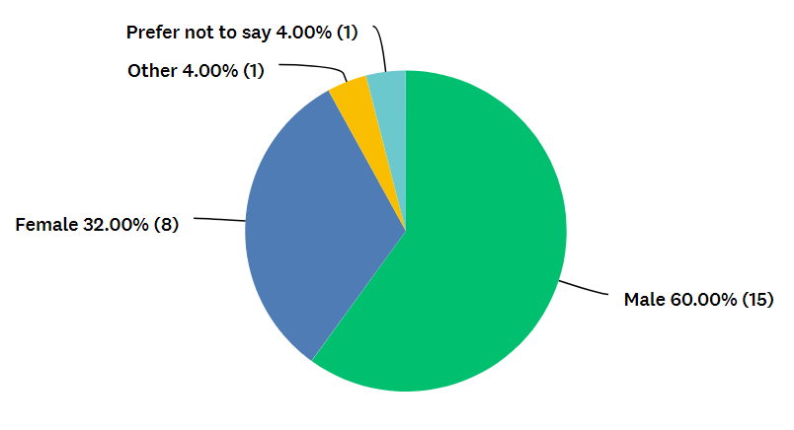
Figure 2: Gender of Participants

Question 3 asked participants to state that length of service that they had worked for South Wales police with this question aiming to identify if the time served as a police officer affected their beliefs on the impact factors that affected the mental health of police officers and their views on the organisational support available. The question found that most participants were relatively new in service with 56% confirming that they had worked for South Wales Police between 0 – 5 years, 24% answered 6-10 years, 8% answered 11-15 years, 4% answered 16-20 years and 8% having served 21+ years.
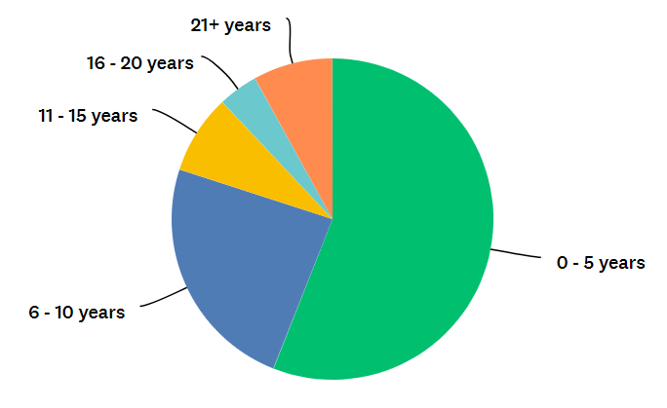
Figure 3: Length of Service

To further understand the demographics of the respondents to the survey, question 4 asked in which department did the participants work within South Wales Police. This question was included to understand if the police officer’s perspective on the impact factors that cause poor mental health in the police force was influenced by the department within which they worked. 68% of participants stated that they worked on Response, 20% worked within the investigative departments of CID/RIT/HUB, with 4% of respondents each working for the Roads Policing Unit, Firearms and Specialist Crime.

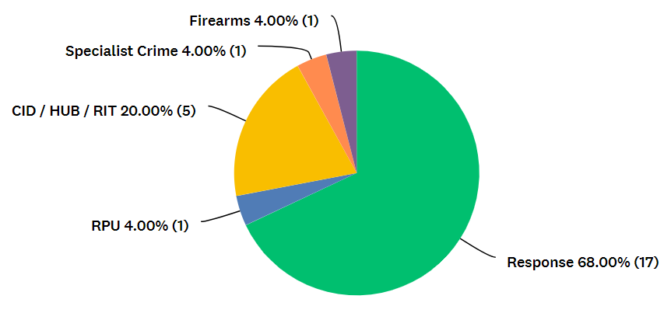
Figure 4: Department the Participants Work

4.3: Questionnaire Findings

4.3.1: Mental Health Within Policing

Question 5 of the survey asked participants if they believed that their role as a police officer had had an adverse effect on their mental health since working for South Wales Police. 24 participants responded to this question. The study found that 75% of respondents answered that they felt that their mental health had been affected since being a police officer due to the job role. The researcher included this question to identify the scale of the issue and the data obtained confirmed that work related mental health issues was significantly higher for police officers when compared to the general public. Mind (2024) state that 1 in 4 people in England and Wales will experience a mental health issue of some kind each year, however this study found that those affected by their mental health within the police was three times higher. These results support previous research carried out by Stevelink et al., (2020) who found that police officers were more than twice as likely to suffer from anxiety and depression than the general population.

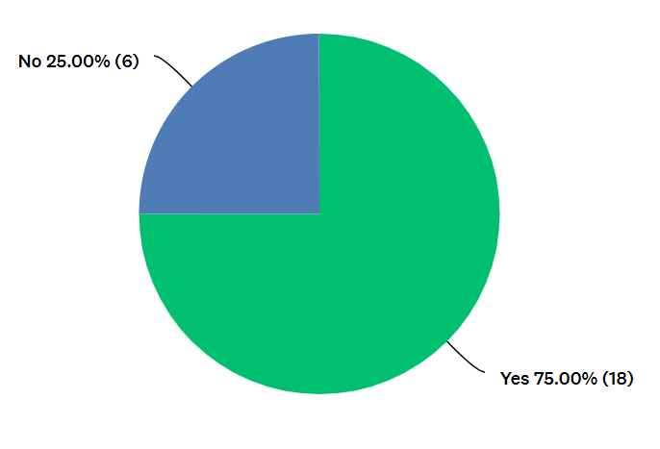
Figure 5: Adverse Mental Health Due to Job Role

4.3.2: Work Related Mental Health Impact Factors

Question 6 was identified as being a key question in this project and would provide a significant understanding to the researcher around the first objective of the study being to identify the mental health impact factors that police officers believed were the causes of poor mental health within South Wales Police. The survey offered several options to the participants from Socioeconomic, Organisational and Personal factors. The options that were available to participants were Shift patterns, Frequent exposure to traumatic incidents, Budget cuts, Police culture and behaviour, Poor leadership, Lack of support from the public and media, Managerial instability, Lack of recognition, None of the above. Of the 25 respondents to this question, 56% choose Budget Cuts as being the main impact factor that they believed affected the mental health of police officers within South Wales Police.

Participants were provided an option to expand on this answer with many identifying that a shortage of police officers due to budget cuts increased individual workloads for officers in an already demand increasing environment. Examples of respondents’ comments were “Staffing levels make the response role unmanageable and unsustainable”, “Having to work more with less staff and increased workloads” and “Not enough officers cause higher workloads and stress”. This Socioeconomic factor identified in this question as being the main cause of poor mental health for police officers within South Wales Police differs from the findings of research carried out by Deschenes et al., (2018) who found that Organisational Impact factors were the main cause for poor mental health amongst police officers in Quebec, Canada such as poor leadership and lack of support within the organisation. An opportunity for further research would be available here to attempt to understand why the perceived impact factors vary when comparing two police forces in countries with a significant geographical difference but of a similar economic and social development.

The data obtained from this question also presented that 16% of respondents believed that frequent exposure to traumatic incidents was the main cause for poor officer mental health, 12% stated the shift patterns, 8% stated the lack of support from the public and media, 4% stated poor leadership and 4% stated none of the above. In comparison to these findings, Budget Cuts as the main impact factor was over three times higher than the next highest impact factor identified.

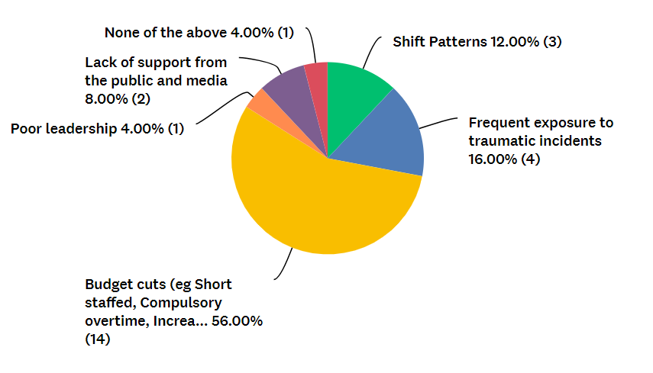
Figure 6: Mental Health Impact Factors

4.3.3: Organisational Support

Question 7 asked participants if they believed that there was sufficient available support from South Wales Police for officers suffering with their mental health. This question did not obtain a clear definitive answer with 36% answering ‘yes’, 28% answering ‘no’ and 36% answering ‘I don’t know’ if they believed that the support available was sufficient. The question also provided the respondents an opportunity to comment outlining their feelings on this, with comments provided showing participants knowledge of available support, but a lack of clarity around how to access the support. Comments such as “TRIM exists but is only really offered after experiencing a traumatic event and doesn’t make it feel inclusive to all mental health”, “The waiting list for support is ridiculous” and “Have not accessed support however services such as TRIM are not always routinely offered” demonstrate a lack of faith from officers in the available organisational support. This upholds previous research by Sharp et al., (2020) who found that police forces in England and Wales did not have the relevant provisions in place to signpost officers to required support agencies in a timely manner following the need identification process of TRIM.

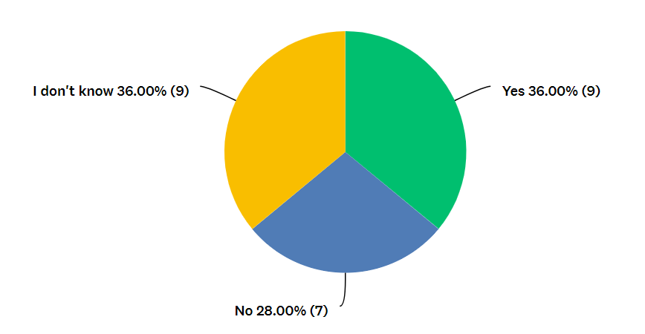
Figure 7: Sufficient Organisational Support

Question 8 asked participants if they had received any support from South Wales Police regarding their mental health. 92% of the 25 respondents answered that they had not, with only 8% stating that they had received mental health support. However, when asked in Question 9 how effective this support for their mental health was, all respondents who answered that they had received mental health support in the previous question answered, “Not so effective” from the possible answers of “Not at all effective”, “Not so effective”, “Somewhat effective”, “Very effective” and “Extremely effective”. There was also an “N/A” option here for those who had stated in question 8 that they had not received any support with all. All 23 participants who had answered “No, they had not received mental health support” in Question 8 choose this “N/A” option in Question 9. Although respondents were provided an opportunity to comment on this question regarding the effectiveness of the organisational support, the 8% who answered “Not so effective” did not comment leaving the item blank. This raises an opportunity for further research into why officers who have received organisational mental health support feel that the service was not effective. This also raises further questions as to why so few had accessed mental health support, with 75% of respondents in question 5 stating that they believed that their role as a police officer had had an adverse effect on their mental health, however only 8% of respondents in question 8 had stated that they had received organisational support for their mental health. This supports research by Bonanno (2004) who found that it was difficult to understand the true effects of mental health on society as past research carried out in this area had mainly been derived from individuals who had actively sought treatment or had suffered significant psychological problems.

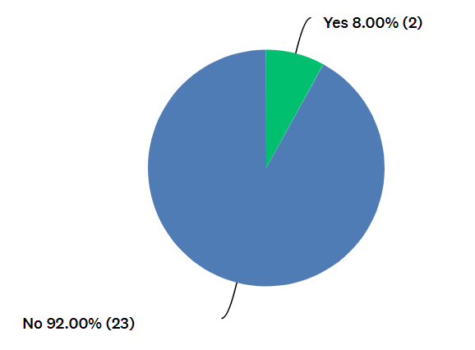
Figure 8: Participants Who Have Received Organisational Mental Health Support

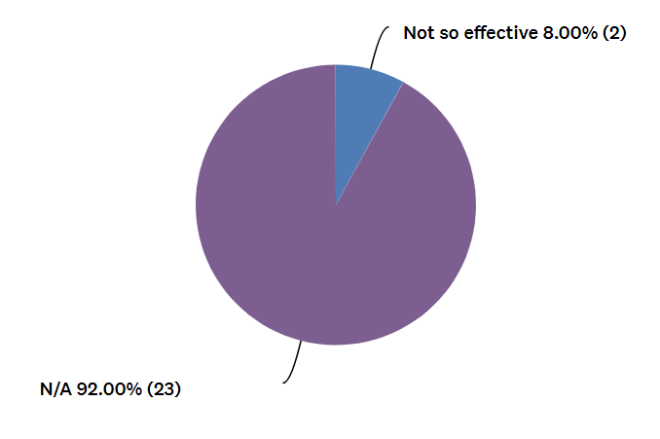
Figure 9: Perceived Effectiveness of Organisational Support

Data obtained from participants, when asked in Question 10 if they believed that South Wales Police could improve their support for police officers suffering with their mental health, showed that 68% answered “Yes” to this question, with the remaining 32% answering “No”. Participants were invited to expand on their answer in a comments box made available if they wished to do so. Participants stated that they believed that online self-referrals would be beneficial, as would reduced waiting times for support and an increased awareness and guidance from the organisation for officers as to where they could access this support. The feedback from participants around the want for increased awareness on how they can access available help supports the study carried out by Haugen et al., (2017) who found that officers were reluctant to engage with organisational services due to not knowing where to access this help.

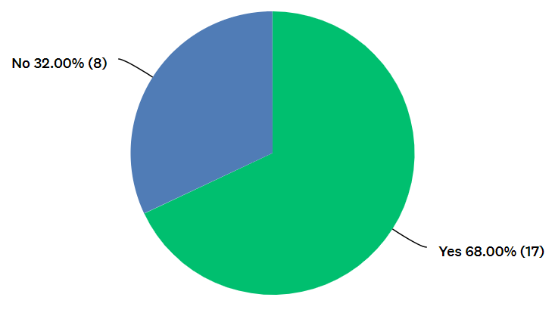
Figure 10: Perspectives on Could the Organisational Support be Improved.

4.4: Conclusion

This chapter has successfully obtained the relevant data from the targeted sample group allowing the researcher to analyse this information to meet the set objectives of identifying the impact factors that police officers believed were the causes of poor mental health within South Wales Police, and to understand their perspectives on the organisational wellbeing support available to officers for their mental health. Socioeconomic factors in the form of budget cuts were identified as being the main impact factor identified by police officers, with understaffing creating an increased workload in an already demanding occupation. Data obtained found that 3 in 4 officers had stated that their mental health had been affected due to their occupation, however only 2 participants had received organisational support raising questions as to why they had not engaged with available support.

The final chapter of this study will discuss the findings and will provide recommendations for further research in this area.

Chapter 5: Conclusions and Recommendations

5.1: Introduction

This chapter will review the main findings of the research carried out in this project. It will re-visit the objectives of the study outlined at the beginning of the study and will aim to identify if these have been met. Research into this subject area carried out by fellow academics and referenced in the Literature Review section of this project will be re-visited to identify if the result of this study corroborates or contradicts the findings of their results The chapter will then discuss recommendations for further research around the subject area.

The following objectives were set by the researcher at the beginning of this research project:

- To identify the mental health impact factors that police officers feel are the causes of poor mental health within the South Wales Police force.

- To understand the perspectives of police officers on the effectiveness of organisational wellbeing support for mental health.

5.2: Main Findings

This study has created valuable insights into the impact factors that police officers believe are the causes for poor mental health within the South Wales Police force. Survey results from 25 participants in the study support the findings of Hartley et al., (2011) in that that the condition of the mental health of police officers goes further than purely experiencing traumatic events. Several Socioeconomic, Organisational and Personal impact factors were identified with 56% of officers stating that they believed that the Socioeconomic factor of budget cuts which leads to less staffing resources, increased working hours through overtime and increased workload was the main impact factor for poor officer mental health. This finding contrasts with that of Deschenes et al., (2018) who’s study in Quebec, Canada found that Organisational impact factors were the main cause of poor mental health amongst its officers. These findings may be due to the geographical variance between both studies although the perceived economic and living standards of both countries are similar.

The study also identified that 75% of police officers believed that having worked for South Wales Police, the job role has had an adverse effect on their mental health. However, only 2 police officers stated that they had received any organisational support for their mental health with both officers stating that the support received was not effective. This supports the findings of Sharp et al., (2020) who found that although there was an elevated risk of psychological issues to first responders due to the nature of their job roles, there was a reluctance for officers to seek support from organisational support services. In this study, it was found that a lack of clarity around where officers could obtain mental health support was a key reason as to why South Wales Police officers had not accessed organisational support. This supports the findings of Haugen et al., (2017), who also found the reluctance of officers to engage with support services due to not knowing where to obtain help.

This project is believed to be the first study focused on the South Wales Police force specifically having been inspired by the work of Deschenes et al., (2018) in Quebec, Canada.

5.3: Recommendations

Upon completion of this research project and having reported the findings of the study, the following recommendations have been identified with regards to improving the identified impact factors that South Wales Police officers believe are the causes of poor mental health, and the ongoing effectiveness of organisational support for poor mental health:

- The first recommendation would be to advise both South Wales Police and the government of the findings of this study and to increase financial investment into policing to support the mental health of police officers. This is due to the Socioeconomic impact factor of budget cuts being identified as the main cause of poor mental health for police officers. Increased investment into police forces would reduce the pressures placed on officers through an increase in staffing, a reduced workload, and a reduction in increased working hours. However, the researcher is aware that any force or governement increase in significant financial investment would require further research on a far larger scale than this study alone.

- The second recommendation would be for South Wales Police to raise the awareness amongst officers as to where and how they can access organisational mental health support. Feedback collated from this study identified that officers were aware that the police force offered mental health support, however many were unaware how they could access this support. This recommendation is considered important with 75% of police officers stating that they believed that policing had had an adverse effect on their mental health, however only 8% had received any organisational support.

- The third recommendation would be an investment from South Wales Police into improving the service that they provide to those officers receiving organisational support for their mental health. Although only 8% of the respondents of this study stated that they had received mental health support, the feedback provided was that these officers felt that the service that they had received was not effective and that improvements could be made. An improved service would effectively help those receiving mental health support and would encourage a greater number of officers to seek the support that they require.

5.4: Limitations

Through the development of this research project, limitations were identified by the researcher.

The original target sample of between 30 – 40 respondents to the survey carried out for this study was not met due to a limitation on the online survey platform ‘SurveyMonkey’ which only allowed a maximum of 25 respondents to participate. This resulted in a reduced sample group from the original desired number which limited further data and feedback from officers.

It was identified that although the survey created by the researcher was made available to all warranted police officers within the South Wales Police force, 68% of respondents stated that the department that they currently work on was ‘Response’. With such a large percentage of respondents being from a single department, this may have influenced the outcomes of the study rather than obtaining a broader result from the force as a whole. This would also apply to the gender of participants in this study, where 60% of the respondents stating that they were male which again may have had an impact on the outcome of the results.
5.5: Further Research

The study carried out by the researcher which was inspired by the work of Deschenes et al., (2018) study on police mental health impact factors in Quebec, Canada now offers opportunities for further research.

It has been identified that within the South Wales Police force, further research opportunities exist with a larger sampling group of respondents and feedback from further departments within the force than this study has received. Through carrying out this research, a further understanding may be obtained into to the perceived impact factors of police officer mental health, and the perspectives of officers into the effectiveness of organisational support.

Opportunities exist for further studies in this field with regards to carrying out research through a qualitative method of approach. Although this study has met the research aims through a quantitative method, the clarification around participants feelings and observations have raised further questions that were not met. Through a qualitative approach via interviews being conducted in further research, a greater understanding would be obtained into the views of participants.

Finally, research around the mental health impact factors and organisational wellbeing support could be developed further through research being carried out in neighbouring police forces. This study was carried out force specifically, being South Wales Police, and opportunities for further research exist to gain a greater understanding around the subject on a larger scale.

Reference List

Acharya, A.S., Prakash, A., Saxena, P. and Nigam, A., (2013). Sampling: Why and how of it. Indian Journal of Medical Specialties, 4(2), pp.330-333.

Alexander, C., 1999. Police psychological burnout and trauma. Police trauma: Psychological aftermath of civilian combat, pp.54-64.

Baughman P, Fekedulegn D, Charles LE, Gu JK, Ma C, Violanti JM, Wirth M, Mnatsakanova A, Hartley TA, Andrew ME and Burchfiel CM (2014), “Shift work and health consequences in policing”, in Violanti JM (Ed.), Dying for the Job: Police Work Exposure and Health, Charles C. Thomas, Springfield, IL, pp. 73–92.

BBC. (2019). PTSD at crisis levels among police officers. [Online]. BBC News. Available at: PTSD 'at crisis levels' among police officers - BBC News [Accessed 2 April 2024].

Bell, E., Bryman, A. and Harley, B., (2022). Business research methods. Oxford university press.

Bonanno, G. A. (2004). Loss, Trauma, and Human Resilience: Have We Underestimated the Human Capacity to Thrive After Extremely Aversive Events? American Psychologist, 59(1), 20–28. https://doi.org/10.1037/0003-066X.59.1.20

Bond J, Hartley TA, Sarkisian K, Andrew ME, Charles LE, Andrew ME and Violanti JM (2013), “Association of traumatic police event exposure with sleep quality and quantity in the BCOPS study cohort”, International Journal of Emergency Mental Health, Vol. 15 No. 4, pp. 255–266.

Britannica. (2023). Ethics - Philosophy. [Online]. Britannica. Available at: Ethics | Definition, History, Examples, Types, Philosophy, & Facts | Britannica [Accessed 12 December 2023].

Burke, R. J., & Mikkelsen, A. (2006). Burnout among Norwegian police officers: Potential antecedents and consequences. International Journal of Stress Management, 13(1), 64–83.10.1037/1072-5245.13.1.64

Cambridge University. (2023). Research ethics / ethics application guidance. [Online]. University of Cambridge. Available at: https://www.research-integrity.admin.cam.ac.uk/research-ethics/ethics-application-guidance/applying- [Accessed 13 December 2023].

College of Policing. (2023). Mental health crisis hotline launched by our National Police Wellbeing Service. [Online]. Available at: https://www.college.police.uk/article/mental-health-crisis-hotline-launched-our-national-police-well [Accessed 27 October 2023].

Deschênes, A.A., Desjardins, C. and Dussault, M., 2018. Psychosocial factors linked to the occupational psychological health of police officers: Preliminary study. Cogent psychology, 5(1), p.1426271.

Elliott, P, Vergnaud, A-C, Singh, D, Neasham, D, Spear, J and Heard, A (2014) The Airwave Health Monitoring Study of police officers and staff in Great Britain: rationale, design and methods. Environmental Research 134, 280–285.

Emanuel, E.J., Wendler, D. and Grady, C., (2000). What makes clinical research ethical?. Jama, 283(20), pp.2701-2711.

Fowler, F. J. (2014). Survey Research Methods. 5th ed. Thousand Oaks: CA: SAGE.

Garbarino, S. and Holland, J., (2009). Quantitative and qualitative methods in impact evaluation and measuring results.

GOV.UK (2021) Police Workforce, England and Wales: 31 March 2021 Second edition GOV.UK. Available at: https://www.gov.uk/government/statistics/police-workforce-england-and-wales-31-march-2021/police-workforce-england-and-wales-31-march-2021 (Accessed: 13 August 2023).

Graue, C., (2015). Qualitative data analysis. International Journal of Sales, Retailing & Marketing, 4(9), pp.5-14.

Hartley, T.A., Burchfiel, C.M., Fekedulegn, D., Andrew, M.E. and Violanti, J.M., 2011. Health disparities in police officers: comparisons to the US general population. International journal of emergency mental health, 13(4), p.211.

Haugen, P.T., McCrillis, A.M., Smid, G.E. and Nijdam, M.J., 2017. Mental health stigma and barriers to mental health care for first responders: A systematic review and meta-analysis. Journal of psychiatric research, 94, pp.218-229.

Huey, L. and Ferguson, L., 2022. ‘Going missing’as a maladaptive coping behavior for adults experiencing strain. Deviant behaviour, 43(1), pp.17-29.

Intravia, J., Thompson, A.J. and Pickett, J.T., 2020. Net legitimacy: Internet and social media exposure and attitudes toward the police. Sociological Spectrum, 40(1), pp.58-80.

Ivankova, N.V. and Creswell, J.W., (2009). Mixed methods. Qualitative research in applied linguistics: A practical introduction, 23, pp.135-161.

Kent Police. (2023). Trauma Risk Incident Management Protocol. [Online]. Kent Police. Available at: https://www.kent.police.uk/foi-ai/kent-police/Policy/human-resources/trauma-risk-incident-management [Accessed 27 October 2023]

Kilgallon, A., 2019. Police interaction and Notting Hill carnival. Policing and society.

King, H., Harrison, V. and Pike, G., 2020. A glimpse into the realm of police wellbeing charities.

McCarty, W.P., “Solomon” Zhao, J. and Garland, B.E., 2007. Occupational stress and burnout between male and female police officers: Are there any gender differences?. Policing: an international journal of police strategies & management, 30(4), pp.672-691.

Mental Health Foundation. (2023). Depression statistics. [Online]. . Available at: https://www.mentalhealth.org.uk/explore-mental-health/statistics/depression-statistics [Accessed 20 October 2023].

Mind. (2024). Mental Health Facts and Statistics. [Online]. Mind. Available at: https://www.mind.org.uk/information-support/types-of-mental-health-problems/statistics-and-facts-abo [Accessed 1 February 2024].

Mind. (2023). What is trauma?. [Online]. . Available at: https://www.mind.org.uk/information-support/types-of-mental-health-problems/trauma/about-trauma/ [Accessed 31 October 2023].

Nayak, M.S.D.P. and Narayan, K.A., (2019). Strengths and weaknesses of online surveys. technology, 6(7), pp.0837-2405053138.

NHS (2023) NHS choices. Available at: https://www.nhs.uk/every-mind-matters/mental-health-issues/stress/ (Accessed: 13 August 2023).

Nix, J. and Wolfe, S.E., 2017. The impact of negative publicity on police self-legitimacy. Justice quarterly, 34(1), pp.84-108.

Padilla, K., 2016. Stress and maladaptive coping among police officers. Arizona State University.

Phellas, C.N., Bloch, A. and Seale, C., (2011). Structured methods: interviews, questionnaires and observation. Researching society and culture, 3(1), pp.23-32.

Police Federation of England and Wales. (2021). Capture data on traumatic incidents. [Online]. . Available at: https://www.polfed.org/avonsom/news/news-articles/capture-data-on-traumatic-incidents/#:~:text=He%20 [Accessed 20 October 2023].

Police Federation. (2022). Mental health-related absences soar to record highs. [Online]. Police Federation. Available at: https://www.polfed.org/news/latest-news/2022/mental-health-related-absences-soar-to-record-highs/ [Accessed 15 March 2024].

Policing Insight. (2023). Under the influence: Heavy drinking and mental health problems among UK police. [Online]. . Available at: https://policinginsight.com/feature/analysis/under-the-influence-heavy-drinking-and-mental-health-pr [Accessed 25 October 2023]

PTSDUK. (2023). PTSD Explained. [Online]. PTSDUK. Available at: https://www.ptsduk.org/what-is-ptsd/ptsd-explained/ [Accessed 15 August 2023].

Rogelberg, S.C., Spitzmüeller, C., Little, I. and Reeve, C.L., (2006). Understanding response behavior to an online special topics organizational satisfaction survey. Personnel Psychology, 59(4), pp.903-923.

Seiffge-Krenke, I., 2004. Adaptive and maladaptive coping styles: Does intervention change anything?. European Journal of Developmental Psychology, 1(4), pp.367-382.

Sharp, M.L., Harrison, V., Solomon, N., Fear, N., King, H. and Pike, G., 2020. Assessing the mental health and wellbeing of the emergency responder community in the UK.

South Wales Police. (2023). About Us - Overview. [Online]. South Wales Police. Available at: https://www.south-wales.police.uk/police-forces/south-wales-police/areas/about-us/about-us/overview/ [Accessed 11 December 2023].

Steptoe, A., O'Donnell, K., Marmot, M. and Wardle, J., 2008. Positive affect, psychological well-being, and good sleep. Journal of psychosomatic research, 64(4), pp.409-415.

Stevelink, S.A., Opie, E., Pernet, D., Gao, H., Elliott, P., Wessely, S., Fear, N.T., Hotopf, M. and Greenberg, N., 2020. Probable PTSD, depression and anxiety in 40,299 UK police officers and staff: Prevalence, risk factors and associations with blood pressure. PLoS One, 15(11), p.e0240902.

Taylor, G.R. ed., (2005). Integrating quantitative and qualitative methods in research. University press of America.

Wester, K.L., (2011). Publishing ethical research: A step‐by‐step overview. Journal of Counselling & Development, 89(3), pp.301-307.

World Health Organisation (2022) Mental health. Available at: https://www.who.int/news-room/fact-sheets/detail/mental-health-strengthening-our-response (Accessed: 23 October 2023).

World Health Organization. (2022). Mental Health. [Online]. World Health Organization. Available at: https://www.who.int/health-topics/mental-health [Accessed 13 August 2023].

Appendices

Appendix 1: Survey Questions and Results

Question 1 – Consent and Eligibility

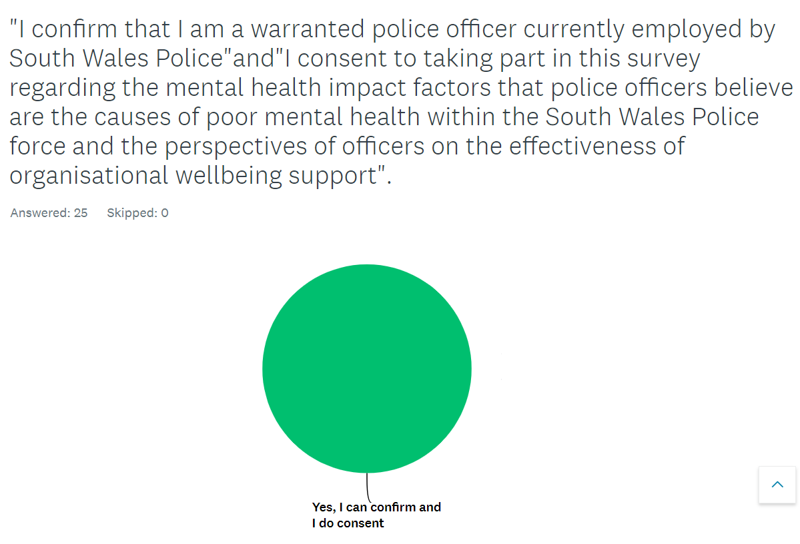
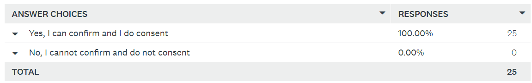

Question 2 –

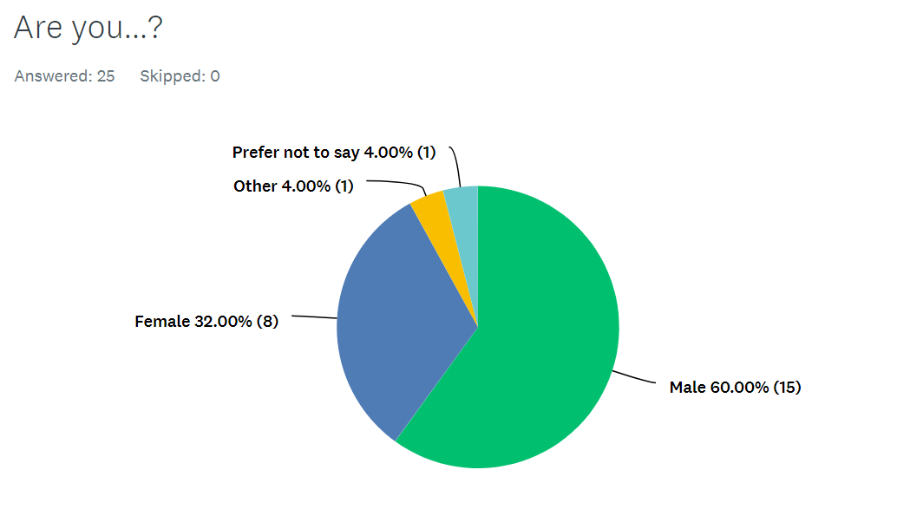
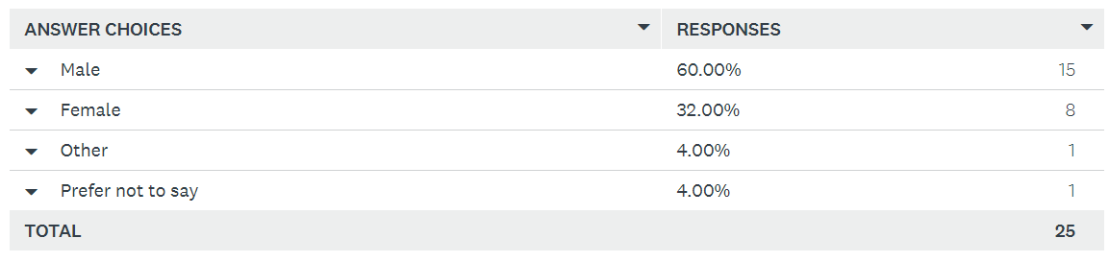

Question 3 –

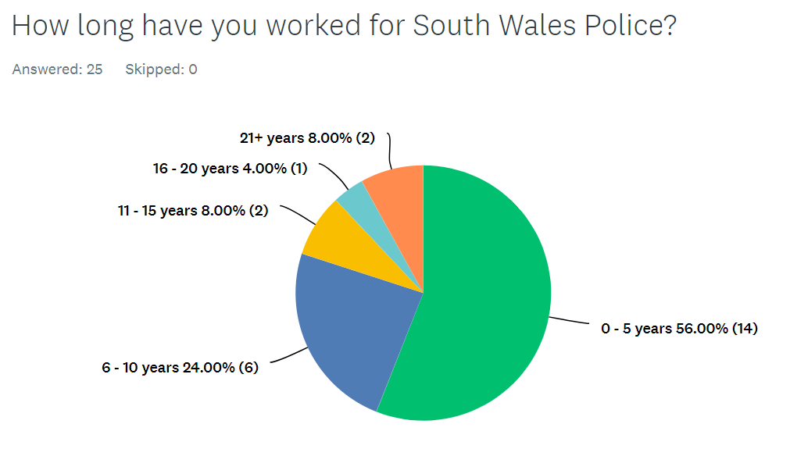
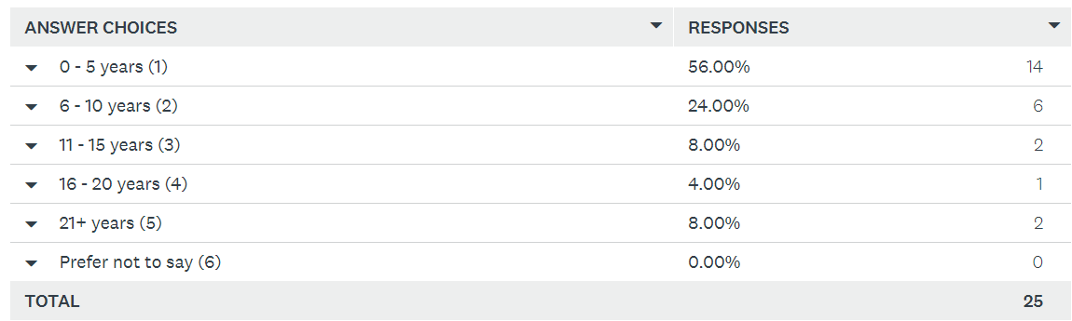

Question 4 –

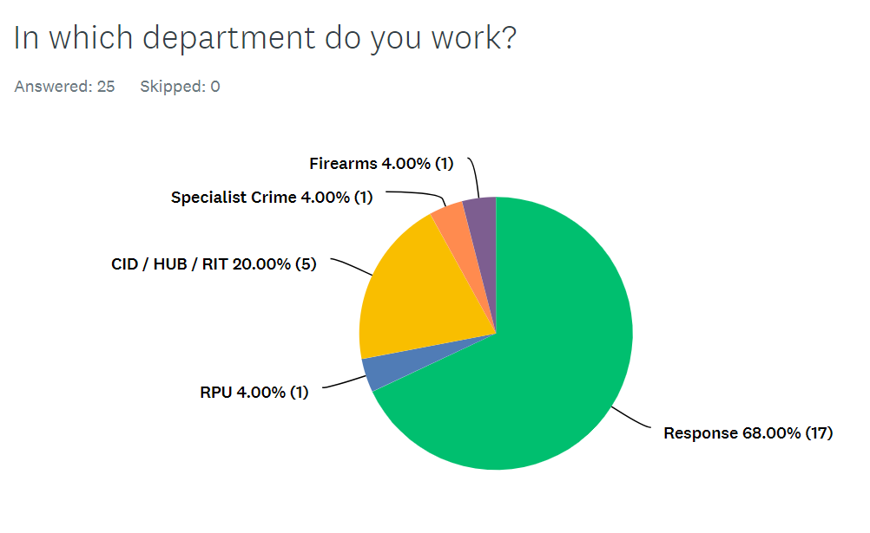
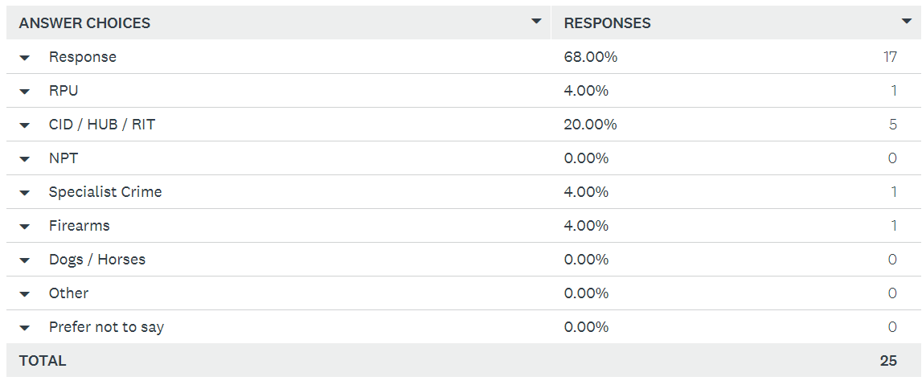

Question 5 –

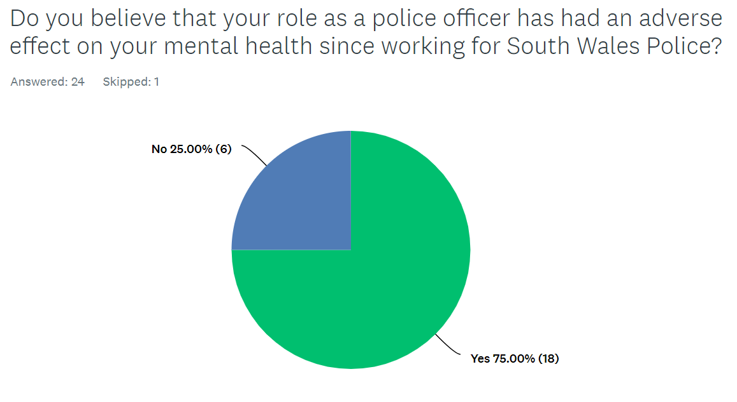
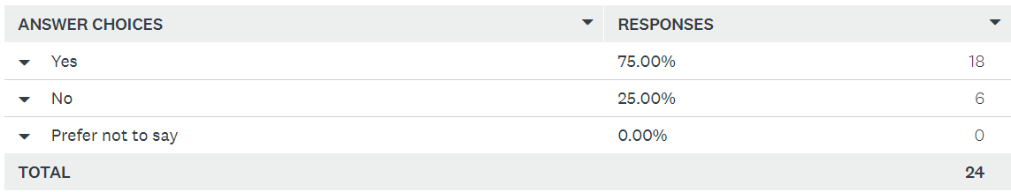

Question 6 –

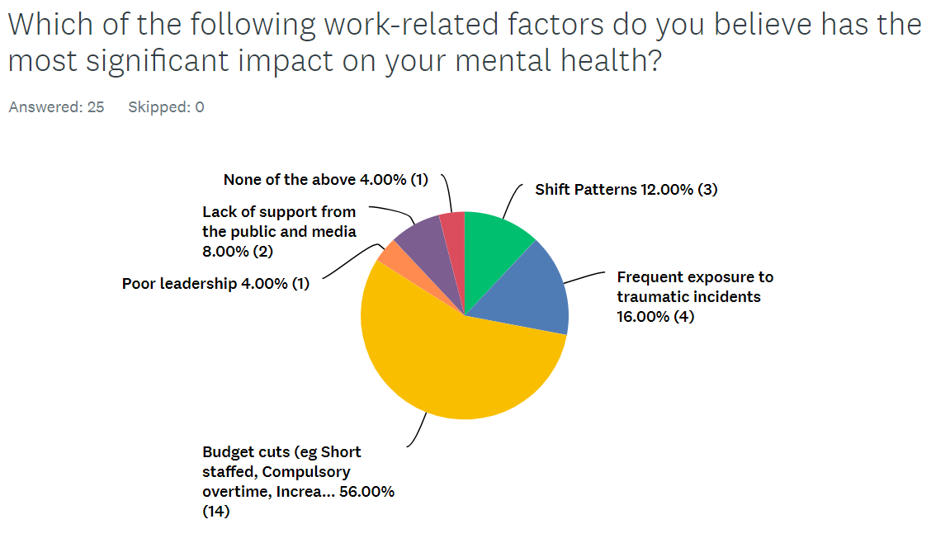
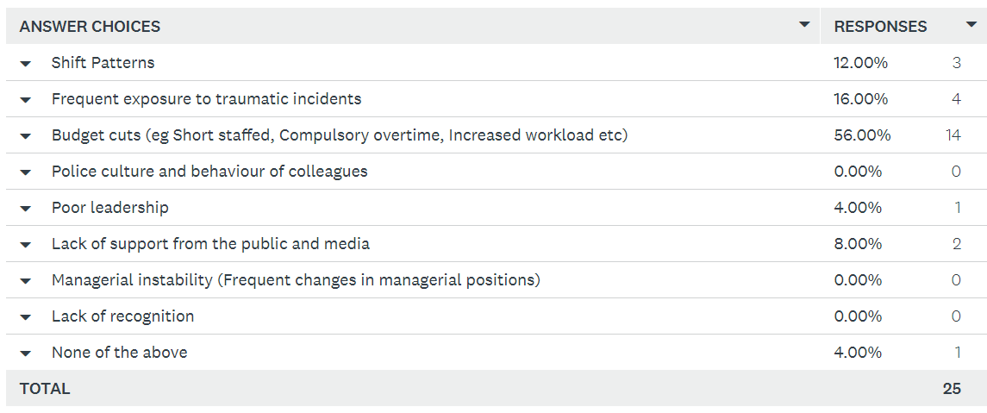

Question 7 –

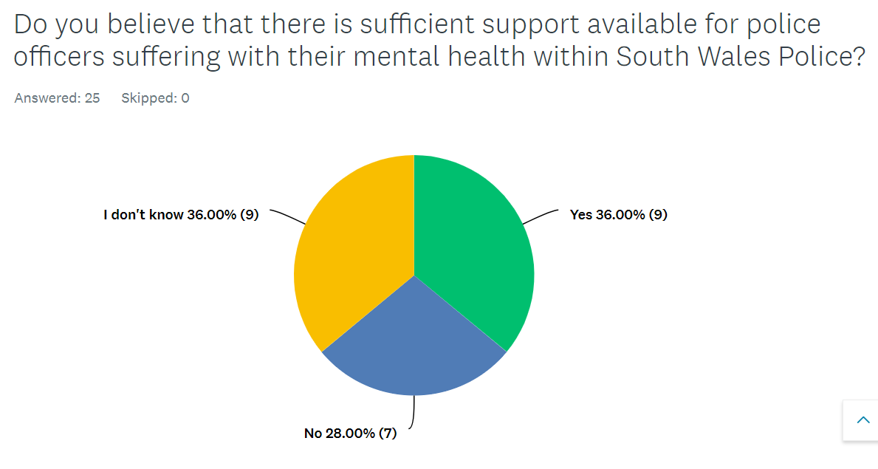
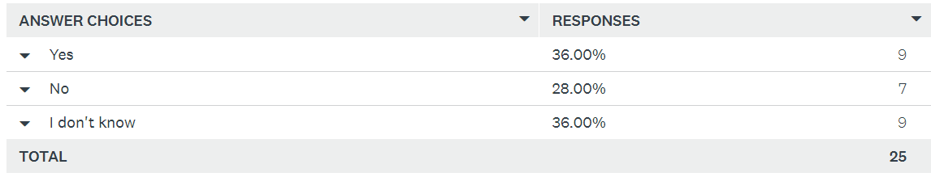

Question 8 –

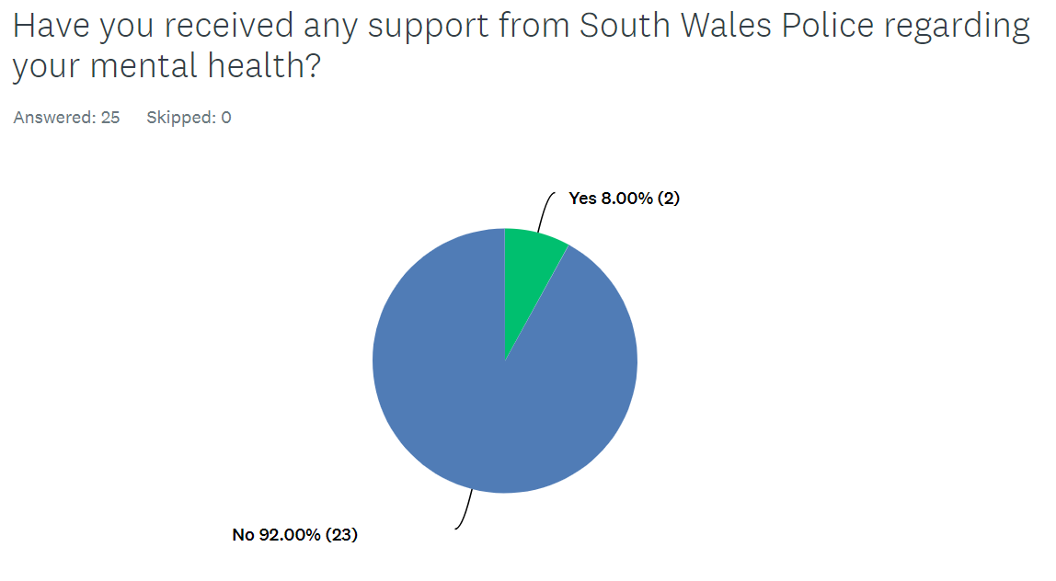
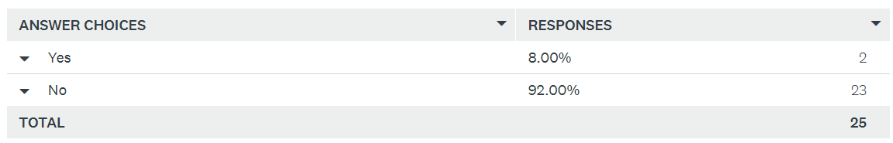

Question 9 –

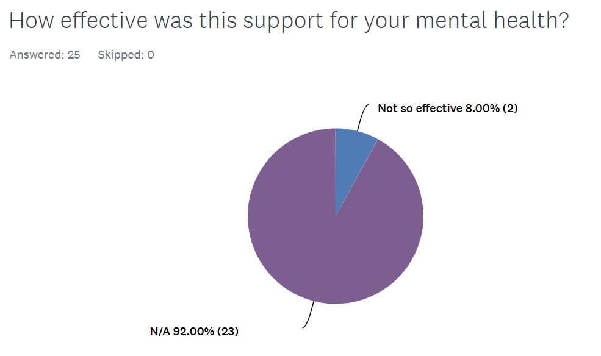
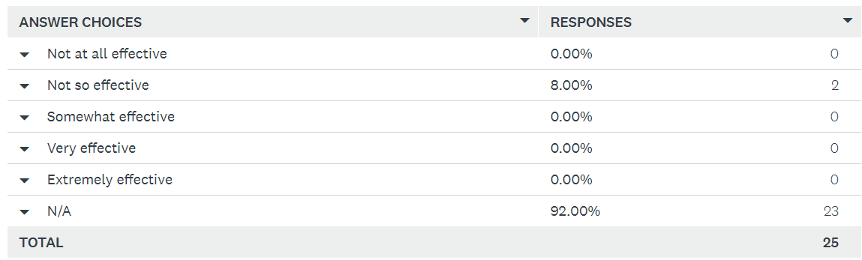

Question 10 –

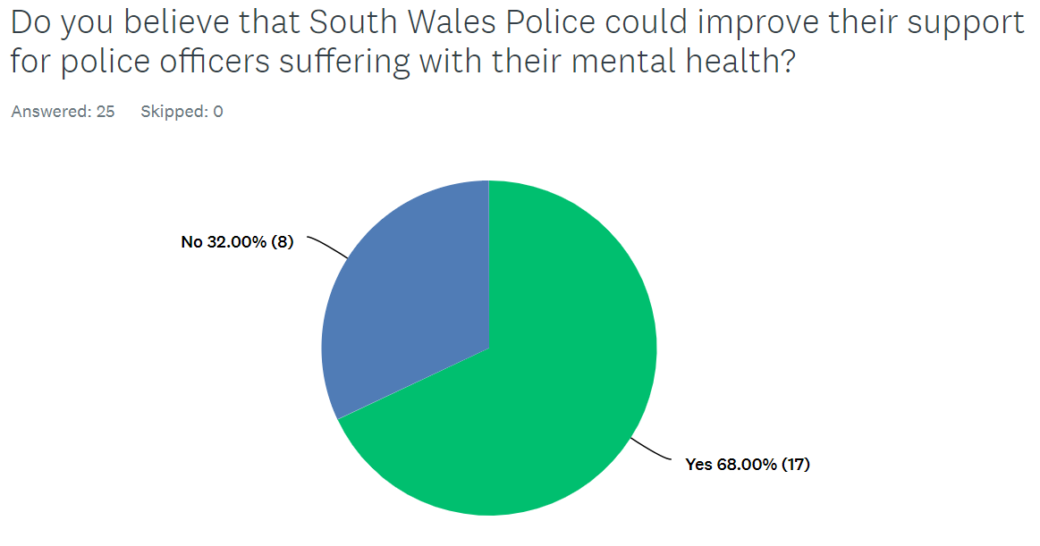
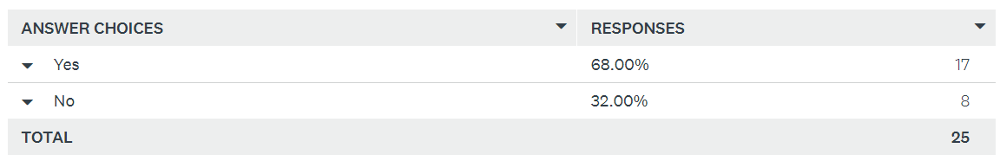

Appendix 2: Ethics Form

APPLICATION FOR ETHICAL APPROVAL

In order for research to result in benefit and minimise risk of harm, it must be conducted ethically. A researcher may not be covered by the University’s insurance if ethical approval has not been obtained prior to commencement.

The University follows the OECD Frascati manual definition of research activity: “creative work undertaken on a systematic basis in order to increase the stock of knowledge, including knowledge of man, culture and society, and the use of this stock of knowledge to devise new applications”. As such this covers activities undertaken by members of staff, postgraduate research students, and both taught postgraduate and undergraduate students working on dissertations/projects.

The individual undertaking the research activity is known as the “principal researcher”.

Ethical approval is not required for routine audits, performance reviews, quality assurance studies, testing within normal educational requirements, and literary or artistic criticism.

Please read the notes for guidance before completing ALL sections of the form.

This form must be completed and approved prior to undertaking any research activity. Please see Checklist for details of process for different categories of application.

SECTION A: About You (Principal Researcher)
1 | Full Name: |  | Gareth Thomas
2 | Tick all boxes that apply: |  | Member of staff: | ☐ | Honorary research fellow: | ☐
 | Undergraduate Student | ☒ | Taught Postgraduate Student | ☐ | Postgraduate Research Student | ☐

3 | Institute/Academic Discipline/Centre: | University of Wales Trinity Saint David
4 | Campus:
5 | E-mail address: | 2031242@student.uwtsd.ac.uk
6 | Contact Telephone Number: | 07866689569
 | For students:
7 | Student Number: | 2031242
8 | Programme of Study: | Batchelor of Science : Professional Policing Practice
9 | Director of Studies/Supervisor: | Fay Cosgrove (Supervisor)

SECTION B: Approval for Research Activity
1 | Has the research activity received approval in principle?  (please check the Guidance Notes as to the appropriate approval process for different levels of research by different categories of individual) |  | YES | ☐ | NO | ☒
 |  |  |  |  | Date
2 | If Yes, please indicate source of approval (and date where known): Approval in principle must be obtained from the relevant source prior to seeking ethical approval | Research Degrees Committee |  | ☐
2 |  | Institute Research Committee |  | ☐
2 |  | Other (write in) |  | ☐

SECTION C: Internal and External Ethical Guidance Materials
 | Please list the core ethical guidance documents that have been referred to during the completion of this form (including any discipline-specific codes of research ethics, location-specific codes of research ethics, and also any specific ethical guidance relating to the proposed methodology). Please tick to confirm that your research proposal adheres to these codes and guidelines. You may add rows to this table if needed.
1 | UWTSD Research Ethics & Integrity Code of Practice | ☒
2 | UWTSD Research Data Management Policy | ☒
3 | [List any other relevant documents here] | ☐

SECTION D: External Collaborative Research Activity
If there are external collaborators then you should gain consent from the contact persons to share their personal data with the university. If there are no external collaborators then leave this section blank and continue to section E.
1 | Institution
2 | Contact person name
3 | Contact person e-mail address
4 | Is your research externally funded? |  | YES | ☐ | NO |  | ☒
5 | Are you in receipt of a KESS scholarship? |  | YES | ☐ | NO |  | ☒
6 | Are you specifically employed to undertake this research in either a paid or voluntary capacity? | Voluntary | YES | ☐ | NO | ☒
7 |  | Employed | YES | ☐ | NO | ☒
8 | Is the research being undertaken within an existing UWTSD Athrofa Professional Learning Partnership (APLP)? | If YES then the permission question below does not need to be answered. | YES | ☐ | NO |  | ☒
9 | Has permission to undertake the research has been provided by the partner organisation? | (If YES attach copy)  If NO the application cannot continue | YES | ☐ | NO |  | ☒

Where research activity is carried out in collaboration with an external organisation
10 | Does this organisation have its own ethics approval system? | YES | ☐ | NO | ☒
 | If Yes, please attach a copy of any final approval (or interim approval) from the organisation (this may be a copy of an email if appropriate).

SECTION E: Details of Research Activity
1 | Indicative title: | A study into the perceived psychological factors that affect the mental health of police officers within South Wales, and the organisational support departments available to officers.
2 | Proposed start date: | 3rd July 2023 | Proposed end date: | 8th April 2024
Introduction to the Research (maximum 300 words per section)
Ensure that you write for a Non-Specialist Audience when outlining your response to the points below:
- Purpose of Research Activity
- Proposed Research Question
- Aims of Research Activity
- Objectives of Research Activity
Demonstrate, briefly, how Existing Research has informed the proposed activity and explain
- What the research activity will add to the body of knowledge
- How it addresses an area of importance.
3 | Purpose of Research Activity  The purpose of this research is to identify the impact factors that current serving police officers within the South Wales Police force believe are the main causes of poor mental health as a result of the occupation. The research will identify a number of Socioeconomic, Organisational and Personal factors which have a negative effect on officer mental health, and will aim to recognise which of these factors officers believe are the main causes to poor mental health.  The study will then seek to understand the perspectives of serving police officers within the South Wales Police force on how effective they believe that the organisational wellbeing support within the force for mental health is.  (this box should expand as you type)
4 | Research Question  - What are the impact factors that police officers feel are the causes of poor mental health within the South Wales Police force?  - What are the opinions of South Wales Police officers on the effectiveness of organisational wellbeing support for mental health?  (this box should expand as you type)
5 | Aims of Research Activity  This research study will aim to identify the impact factors that serving police officers believe have the most detrimental effect on the mental health of officers in the South Wales Police force. The study will then aim to understand if the identified factor is of a Socioeconomic, Organisational or Personal category and will then seek to propose recommendations based on the findings of the study.  The study will then aim to obtain and understand the opinions of serving police officers within the South Wales Police force on how effective they believe the organisational support is for officers with poor mental health.  The study will aim to add to the body of knowledge of research carried out with regards to the impact factors that influence the mental health of officers by focusing on an area specific of officers, being the South Wales Police force, to establish if the factors that have a detrimental affect on mental health are the same or are different from past research carried out on officers in a study in Quebec, Canada.  (this box should expand as you type)
6 | Objectives of Research Activity  - OBJECTIVE 1 – To identify the impact factors that police officers feel are the causes of poor mental health within the South Wales Police force.  - OBJECTIVE 2 – To understand the perspectives of police officers on the effectiveness of organisational wellbeing support for mental health.  (this box should expand as you type)
Proposed methods (maximum 600 words)
Provide a brief summary of all the methods that may be used in the research activity, making it clear what specific techniques may be used. If methods other than those listed in this section are deemed appropriate later, additional ethical approval for those methods will be needed. You do not need to justify the methods here, but should instead describe how you intend to collect the data necessary for you to complete your project.
7 | This research activity will aim to use a number of methods throughout the course of the proposal.  The first method used will be to conduct research related to the area of study that will be carried out in this proposal. This literature searching will be carried out through online research, past studies and present studies relating to police officer mental health and the factors which are identified as having negative impacts on mental health.  I will carry out research to identify the factors that impact the poor mental health of officers in South Wales through creating a survey that will be made available to officers within the South Wales Police force. I will actively encourage a wide range of officers to complete this survey through word of mouth and through an open invite to all warranted officers within the force to complete the survey via an online link on the internal force communication platform. I believe that the greater engagement from officers will provide a greater insight and I will evaluate the results of the survey in my research. This survey will be made available to warranted officers in all departments of the force. The results of the survey will provide a collection of data that will assist my research in this proposal.  I will approach police organisational support services to identify support available to officers who are suffering with poor mental health and will aim to obtain the opinions of serving officers as to how effective they believe the organisational support for poor mental health is.  The methods identified above will provide useful data in the field that I am researching in this proposal and will assist in carrying out this project to completion.  (this box should expand as you type)
Location of research activity
Identify all locations where research activity will take place.
8 | The research activity will be carried out with warranted police officers and organisational departments within the South Wales Police force.  (this box should expand as you type)
Research activity outside of the UK
If research activity will take place overseas, you are responsible for ensuring that local ethical considerations are complied with and that the relevant permissions are sought. Specify any local guidelines (e.g. from local professional associations/learned societies/universities) that exist and whether these involve any ethical stipulations beyond those usual in the UK (provide details of any licenses or permissions required). Also specify whether there are any specific ethical issues raised by the local context in which the research activity is taking place, for example, particular cultural and/or legal sensitivities or vulnerabilities of participants. If you live in the country where you will do the research then please state this.
9 | N/A  (this box should expand as you type)

10 | Use of documentation not in the public domain: Are any documents NOT publicly available? | NO | ☒
10 |  | YES | ☐
11 | If Yes, please provide details here of how you will gain access to specific documentation that is not in the public domain and that this is in accordance with the current data protection law of the country in question and that of England and Wales.  (this box should expand as you type)

 | Does your research relate to one or more of the seven aims of the Well-being of Future Generations (Wales) Act 2015? | YES | NO
12 | A prosperous Wales | ☐ | ☒
13 | A resilient Wales | ☐ | ☒
14 | A healthier Wales | ☐ | ☒
15 | A more equal Wales | ☐ | ☒
16 | A Wales of cohesive communities | ☐ | ☒
17 | A Wales of vibrant culture and thriving Welsh language | ☐ | ☒
18 | A globally responsible Wales | ☐ | ☒
19 | If YES to any of the above, please give details:
 | (this box should expand as you type)

SECTION F: Scope of Research Activity
 | Will the research activity include: | YES | NO
1 | Use of a questionnaire or similar research instrument? | ☒ | ☐
2 | Use of interviews? | ☐ | ☒
3 | Use of focus groups? | ☐ | ☒
4 | Use of participant diaries? | ☐ | ☒
5 | Use of video or audio recording? | ☐ | ☒
6 | Use of computer-generated log files? | ☐ | ☒
7 | Participant observation with their knowledge? | ☐ | ☒
8 | Participant observation without their knowledge? | ☐ | ☒
9 | Access to personal or confidential information without the participants’ specific consent? | ☐ | ☒
10 | Administration of any questions, test stimuli, presentation that may be experienced as physically, mentally or emotionally harmful / offensive? | ☐ | ☒
11 | Performance of any acts which may cause embarrassment or affect self-esteem? | ☐ | ☒
12 | Investigation of participants involved in illegal activities? | ☐ | ☒
13 | Use of procedures that involve deception? | ☐ | ☒
14 | Administration of any substance, agent or placebo? | ☐ | ☒
15 | Working with live vertebrate animals? | ☐ | ☒
16 | Procedures that may have a negative impact on the environment? | ☐ | ☒
17 | Other primary data collection methods. Please indicate the type of data collection method(s) below. | ☐ | ☒
 | Details of any other primary data collection method:  (this box should expand as you type) | ☐ | ☒
If NO to every question, then the research activity is (ethically) low risk and may be exempt from some of the following sections (please refer to Guidance Notes).

If YES to any question, then no research activity should be undertaken until full ethical approval has been obtained.

SECTION G: Intended Participants
If there are no participants then do not complete this section, but go directly to section H.

 | Who are the intended participants: | YES | NO
1 | Students or staff at the University? | ☐ | ☒
2 | Adults (over the age of 18 and competent to give consent)? | ☒ | ☐
3 | Vulnerable adults? | ☐ | ☒
4 | Children and Young People under the age of 18? (Consent from Parent, Carer or Guardian will be required) | ☐ | ☒
5 | Prisoners? | ☐ | ☒
6 | Young offenders? | ☐ | ☒
7 | Those who could be considered to have a particularly dependent relationship with the investigator or a gatekeeper? | ☐ | ☒
8 | People engaged in illegal activities? | ☐ | ☒
9 | Others. Please indicate the participants below, and specifically any group who may be unable to give consent. | ☐ | ☒
 | Details of any other participant groups:  (this box should expand as you type) | ☐ | ☒

Participant numbers and source
Provide an estimate of the expected number of participants. How will you identify participants and how will they be recruited?
10 | How many participants are expected? | The research questionnaire will aim to have approximately 30 – 40 participants who will be warranted police officers within the South Wales Police force.  (this box should expand as you type)
11 | Who will the participants be? | Warranted Police officers within the South Wales Police force from all departments will be invited to participate in order to obtain an understanding of the impact factors for poor officer mental health as a whole rather than department specific.  (this box should expand as you type)
12 | How will you identify the participants? | Participants will be identified through the internal police communications media account which is available to all officers. This communications account is accessed by officers of all ranks and departments and will provide an opportunity to obtain participation from a wider scope of participants. I will also be actively encouraging fellow colleagues to participate in the research through word of mouth.  (this box should expand as you type)

 | Information for participants: | YES | NO | N/A
13 | Will you describe the main research procedures to participants in advance, so that they are informed about what to expect? | ☒ | ☐ | ☐
14 | Will you tell participants that their participation is voluntary? | ☒ | ☐ | ☐
15 | Will you obtain written consent for participation? | ☐ | ☐ | ☒
16 | Will you explain to participants that refusal to participate in the research will not affect their treatment or education (if relevant)? | ☐ | ☐ | ☒
17 | If the research is observational, will you ask participants for their consent to being observed? | ☐ | ☐ | ☒
18 | Will you tell participants that they may withdraw from the research at any time and for any reason? | ☒ | ☐ | ☐
19 | With questionnaires, will you give participants the option of omitting questions they do not want to answer? | ☒ | ☐ | ☐
20 | Will you tell participants that their data will be treated with full confidentiality and that, if published, it will not be identifiable as theirs? | ☒ | ☐ | ☐
21 | Will you debrief participants at the end of their participation, in a way appropriate to the type of research undertaken? | ☒ | ☐ | ☐
22 | If NO to any of above questions, please give an explanation
 | (this box should expand as you type)

 | Information for participants: | YES | NO | N/A
24 | Will participants be paid? | ☐ | ☒ | ☐
25 | Is specialist electrical or other equipment to be used with participants? | ☐ | ☒ | ☐
26 | Are there any financial or other interests to the investigator or University arising from this study? | ☐ | ☒ | ☐
27 | Will the research activity involve deliberately misleading participants in any way, or the partial or full concealment of the specific study aims? | ☐ | ☒ | ☐
28 | If YES to any question, please provide full details
 | (this box should expand as you type)

SECTION H: Anticipated Risks

Outline any anticipated risks that may adversely affect any of the participants, the researchers and/or the University, and the steps that will be taken to address them.

If you have completed a full risk assessment (for example as required by a laboratory, or external research collaborator) you may append that to this form.
1 | Full risk assessment completed and appended? |  | Yes | ☐
1 |  |  | No | ☒
2 | Risks to participants  For example: sector-specific health & safety, emotional distress, financial disclosure, physical harm, transfer of personal data, sensitive organisational information
 | Risk to participants:  No risk identified  (this box should expand as you type) | How you will mitigate the risk to participants:  (this box should expand as you type)
3 | If research activity may include sensitive, embarrassing or upsetting topics (e.g. sexual activity, drug use) or issues likely to disclose information requiring further action (e.g. criminal activity), give details of the procedures to deal with these issues, including any support/advice (e.g. helpline numbers) to be offered to participants. Note that where applicable, consent procedures should make it clear that if something potentially or actually illegal is discovered in the course of a project, it may need to be disclosed to the proper authorities
N/A

(this box should expand as you type)
4 | Risks to the investigator  For example: personal health & safety, physical harm, emotional distress, risk of accusation of harm/impropriety, conflict of interest
 | Risk to the investigator:  No risk identified.  (this box should expand as you type) | How you will mitigate the risk to the investigator:  (this box should expand as you type)
5 | University/institutional risks  For example: adverse publicity, financial loss, data protection
 | Risk to the University:  No risk identified.  (this box should expand as you type) | How you will mitigate the risk to the University:  (this box should expand as you type)
6 | Environmental risks  For example: accidental spillage of pollutants, damage to local ecosystems
 | Risk to the environment:  No risk identified.  (this box should expand as you type) | How you will mitigate the risk to environment:  (this box should expand as you type)

 | Disclosure and Barring Service
 | If the research activity involves children or vulnerable adults, a Disclosure and Barring Service (DBS) certificate must be obtained before any contact with such participants. | YES | NO | N/A
7 | Does your research require you to hold a current DBS Certificate? | ☐ | ☒ | ☐
8 | If YES, please give the certificate number. If the certificate number is not available please write “Pending”; in this case any ethical approval will be subject to providing the appropriate certificate number.

SECTION I: Feedback, Consent and Confidentiality

1 | Feedback  What de-briefing and feedback will be provided to participants, how will this be done and when?
There will not be any personal feedback or de-briefing to participants publicly as confidentiality of participants will be essential in their participation in completing the survey and questionnaire which will encourage more participants and will provide effective data for this research. However, de-briefing will be made available on request via e-mail reporting the overall findings although no data will be disclosed that could lead to any participants being identified.

(this box should expand as you type)
2 | Informed consent  Describe the arrangements to inform potential participants, before providing consent, of what is involved in participating. Describe the arrangements for participants to provide full consent before data collection begins. If gaining consent in this way is inappropriate, explain how consent will be obtained and recorded in accordance with prevailing data protection legislation.
The online survey that participants will be asked to complete will have an opening page that will explain the purpose of the research and will state that their participation will be confidential. It will explain that each question will have an option whereby the participant will be able to not answer that question if desired and it will be explained that they can exit the survey at any time.

(this box should expand as you type)
3 | Confidentiality / Anonymity  Set out how anonymity of participants and confidentiality will be ensured in any outputs. If anonymity is not being offered, explain why this is the case.
The data collection that I will carry out will not have an option for the participant to identify themselves which will ensure confidentiality throughout this proposal.

The proposal will not name any participants throughout or the department that they work in. This will be made clear to all participants from the beginning.

The study will not report any data that could lead to the identification of any participants.

(this box should expand as you type)

SECTION J: Data Protection and Storage

 | Does the research activity involve personal data (as defined by the General Data Protection Regulation 2016 “GDPR” and the Data Protection Act 2018 “DPA”)? | YES | NO
1 | “Personal data” means any information relating to an identified or identifiable natural person (‘data subject’). An identifiable natural person is one who can be identified, directly or indirectly, in particular by reference to an identifier such as a name, an identification number, location data, an online identifier or to one or more factors specific to the physical, physiological, genetic, mental, economic, cultural or social identity of that natural person. Any video or audio recordings of participants is considered to be personal data. | ☐ | x
 | If YES, provide a description of the data and explain why this data needs to be collected:
2 | (this box should expand as you type)
 | Does it involve special category data (as defined by the GDPR)? | YES | NO
3 | “Special category data” means sensitive personal data consisting of information as to the data subjects’ –  (a) racial or ethnic origin,  (b) political opinions,  (c ) religious beliefs or other beliefs of a similar nature,  (d) membership of a trade union (within the meaning of the Trade Union and Labour Relations (Consolidation) Act 1992),  (e) physical or mental health or condition,  (f) sexual life,  (g) genetics,  (h) biometric data (as used for ID purposes), | ☐ | x
 | If YES, provide a description of the special category data and explain why this data needs to be collected:
4 | (this box should expand as you type)

 | Will data from the research activity (collected data, drafts of the thesis, or materials for publication) be stored in any of the following ways? | YES | NO
5 | Manual files (i.e. in paper form)? | ☐ | ☒
6 | University computers? | ☐ | ☒
7 | Private company computers? | ☐ | ☒
8 | Home or other personal computers? | ☐ | ☒
9 | Laptop computers/ CDs/ Portable disk-drives/ memory sticks? | ☐ | ☒
10 | “Cloud” storage or websites? | ☐ | ☒
11 | Other – specify: | ☐ | ☒
12 | For all stored data, explain the measures in place to ensure the security of the data collected, data confidentiality, including details of backup procedures, password protection, encryption, anonymisation and pseudonymisation:
 | (this box should expand as you type)

 | Data Protection
 | Will the research activity involve any of the following activities: | YES | NO
13 | Electronic transfer of data in any form? | ☒ | ☐
14 | Sharing of data with others at the University outside of the immediate research team? | ☐ | ☒
15 | Sharing of data with other organisations? | ☐ | ☒
16 | Export of data outside the UK or importing of data from outside the UK? | ☐ | ☒
17 | Use of personal addresses, postcodes, faxes, emails or telephone numbers? | ☐ | ☒
18 | Publication of data that might allow identification of individuals? | ☐ | ☒
19 | Use of data management system? | ☐ | ☒
20 | Data archiving? | ☐ | ☒
21 | If YES to any question, please provide full details, explaining how this will be conducted in accordance with the GDPR and Data Protection Act (2018) (and any international equivalents, where appropriate):
The online survey created for this study will be made available to warranted police officers within the South Wales Police force via an internal communications media page. This will be conducted in accordance with the GDPR and Data Protection Act (2018) and no personal data of participants will be made public as will no data be reported that could lead to the identification of any participant.

(this box should expand as you type)
22 | List all who will have access to the data generated by the research activity:
Throughout the proposal, I will not be sharing data gathered with any other person and all work will be carried out on a South Wales Police laptop which is password protected. I will be the only person that will have access to the data generated as a result of this research.

(this box should expand as you type)
23 | List who will have control of, and act as custodian(s) for, data generated by the research activity:
I will be the only person that will have access to the data generated as a result of this research.

(this box should expand as you type)
24 | Give details of data storage arrangements, including security measures in place to protect the data, where data will be stored, how long for, and in what form. Will data be archived – if so how and if not why not.
All data generated will be confidential and will be stored on my South Wales Police issued laptop which is password protected. Data will be stored until the completion of this proposal of which it will then be disposed of by myself.

(this box should expand as you type)
25 | Please indicate if your data will be stored in the UWTSD Research Data Repository (see https://researchdata.uwtsd.ac.uk/ ). If so please explain. (Most relevant to academic staff)
No

(this box should expand as you type)
26 | Confirm that you have read the UWTSD guidance on data management (see https://www.uwtsd.ac.uk/library/research-data-management/) | YES | ☒
27 | Confirm that you are aware that you need to keep all data until after your research has completed or the end of your funding | YES | ☒

SECTION K: Declaration
The information which I have provided is correct and complete to the best of my knowledge. I have attempted to identify any risks and issues related to the research activity and acknowledge my obligations and the rights of the participants.

In submitting this application I hereby confirm that I undertake to ensure that the above named research activity will meet the University’s Research Ethics and Integrity Code of Practice which is published on the website: https://www.uwtsd.ac.uk/research/research-ethics/
1 | Signature of applicant: | Gareth Thomas | Date: 25/08/2023

For STUDENT Submissions:
2 | Director of Studies/Supervisor: |  | Date:
3 | Signature: |  | Date:

For STAFF Submissions:
4 | Academic Director/ Assistant Dean: |  | Date:
5 | Signature: |  | Date:

Checklist: Please complete the checklist below to ensure that you have completed the form according to the guidelines and attached any required documentation:
☒ | I have read the guidance notes supplied before completing the form.
☒ | I have completed ALL RELEVANT sections of the form in full.
☒ | I confirm that the research activity has received approval in principle
☐ | I have attached a copy of final/interim approval from external organisation (where appropriate)
☐ | I have attached a full risk assessment (where appropriate) ONLY TICK IF YOU HAVE ATTACHED A FULL RISK ASSESSMENT
☒ | I understand that it is my responsibility to ensure that the above named research activity will meet the University’s Research Ethics and Integrity Code of Practice.
☒ | I understand that before commencing data collection all documents aimed at respondents (including information sheets, consent forms, questionnaires, interview schedules etc.) must be confirmed by the DoS/Supervisor, module tutor or Academic Director.

RESEARCH STUDENTS ONLY
Once complete, submit this form via the MyTSD Doctoral College Portal at (https://mytsd.uwtsd.ac.uk).

RESEARCH STAFF ONLY
All communications relating to this application during its processing must be in writing and emailed to pgresearch@uwtsd.ac.uk , with the title ‘Ethical Approval’ followed by your name.

STUDENTS ON UNDERGRADUATE OR TAUGHT MASTERS PROGRAMMES should submit this form (and receive the outcome) via systems explained to you by the supervisor/module leader.

