Web Development Report
Module: Introduction to Web and Database Concepts (ACCA4023)
Assignment: HTML & CSS Web Development
Student Name: Mohamed Fahith Mohamed Najath
Student ID: 2533542
Course: CertHE Computing Skills for Workplace
Website Link: https://mo-faith.github.io/my-life/
Submission Date: 13/08/2026

Table of Contents
Table of Contents
Table of Contents 2
1. Introduction 2
2. Requirements 2
3. Implementation 3
4. Evaluation 13
5. Conclusion 14
6. References (IEEE Format) 14
7. Appendices 14

1. Introduction
This report was made to showcase the website that I have created based off my hobbies that I have and what interest that I have. This website was made from various codes through the use visual studio code which has allowed me to create the website and design. I have used some help from some external websites to help me with the codes. One of those coding websites being W3school. I also used ai to teach me ways to improve the codes that I have used and explain the use of each improved code to better my work for my website. The report would showcase the codes I have used, and I would be further explaining the codes in its respective area.

2. Requirements
As mentioned previously, the intended purpose for the website I have created is for the main idea of showcasing my hobbies and interest. The website consists of 4 pages, one login page, one homepage, 2 hobby pages. These pages have their respective information to showcase to the audience. The pages have information of why I do those hobbies and why it interests me. The targeted people would be people that also have the same interest or have something similar that they can relate to.

3. Implementation

Login page: Website and code
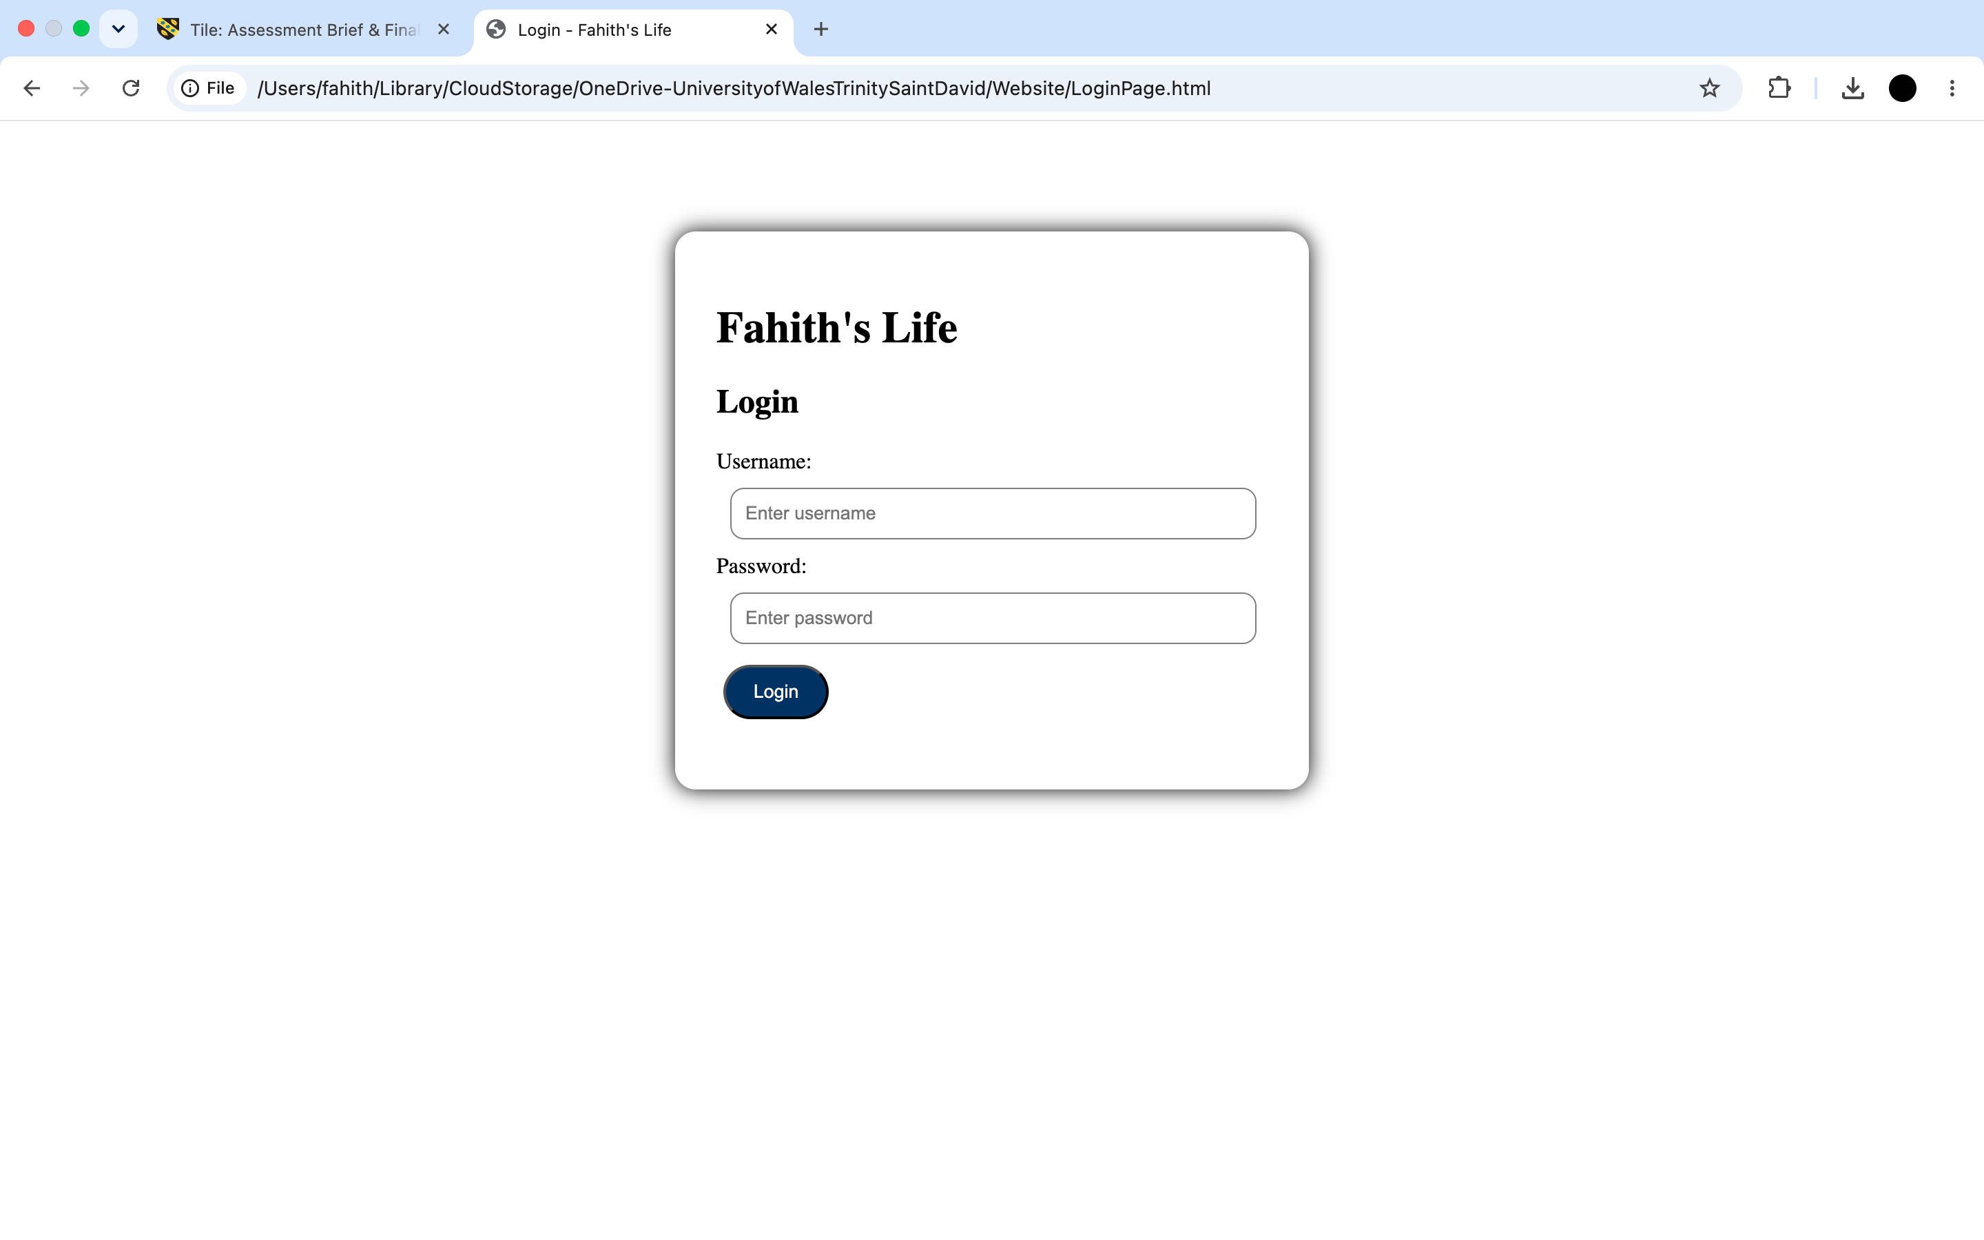
This is the first page that would be sent to when you open up the loginpage.html. In this part of the website, I have designed it to make a certain username “Fahith” and password “12345” can work to access the rest.
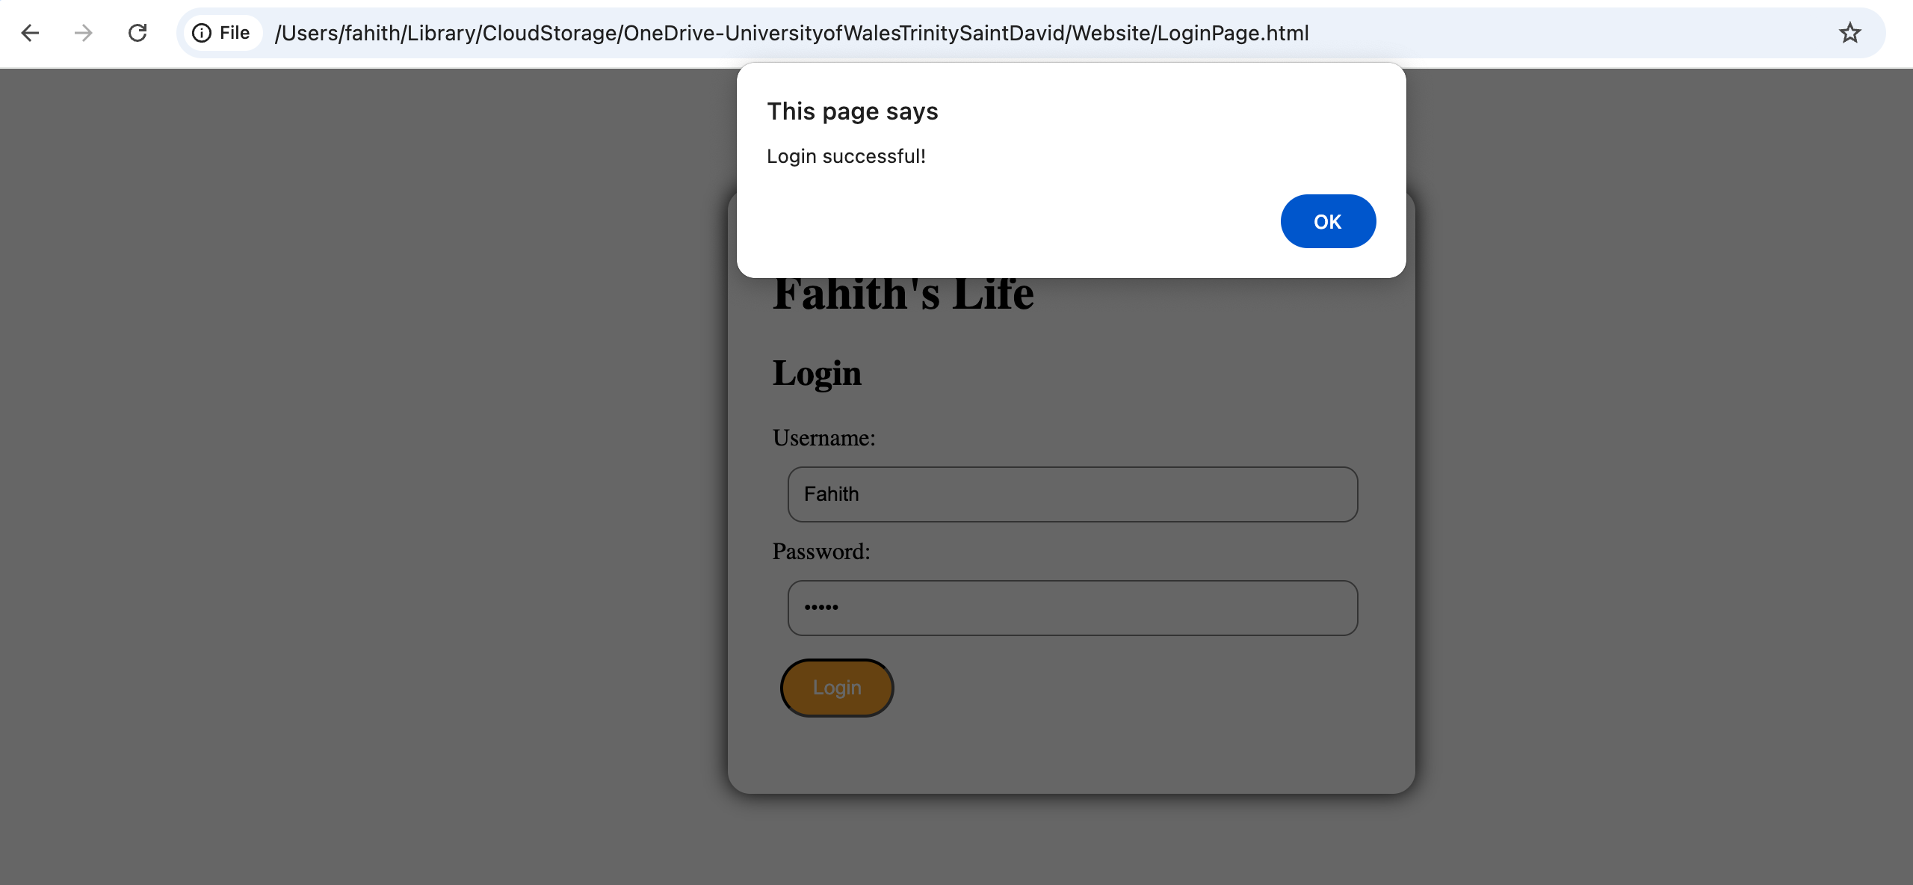
When you enter the correct username and password and press the login button, the page would show this saying “login successful”. By pressing ok, it would take you to the rest of the website.
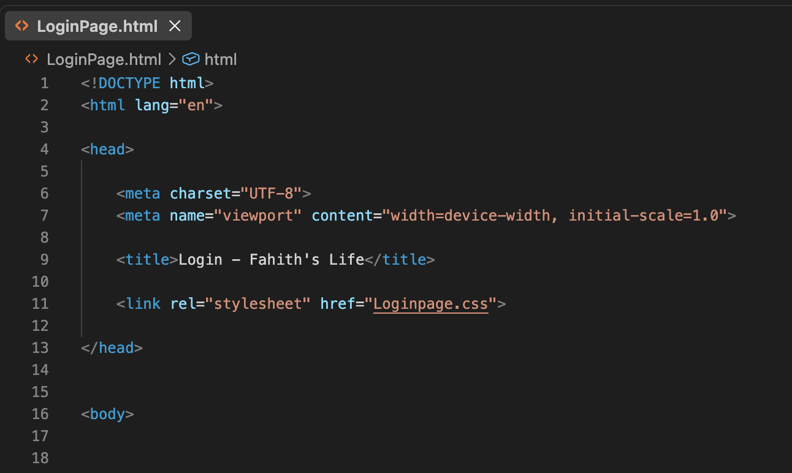
This is the first part of the code for the login page. As you can see, the title was established as Fahith’s Life. This would on top of the login section. At the top of the code, “<html lang=”eng”>” was used. This was used to help tell the website that it is English. The use of <meta name= “viewport” content= “width=device-width, initial-scale=1.0”> allows other devices like a phone, tablet or even computer to have its website look normal rather zoomed in or zoomed out. The use <link rel="stylesheet" href="Loginpage.css"> allows the HTML file to link with the CSS file. Below is the CSS file that helps create the background and the colours and design work for the login page.
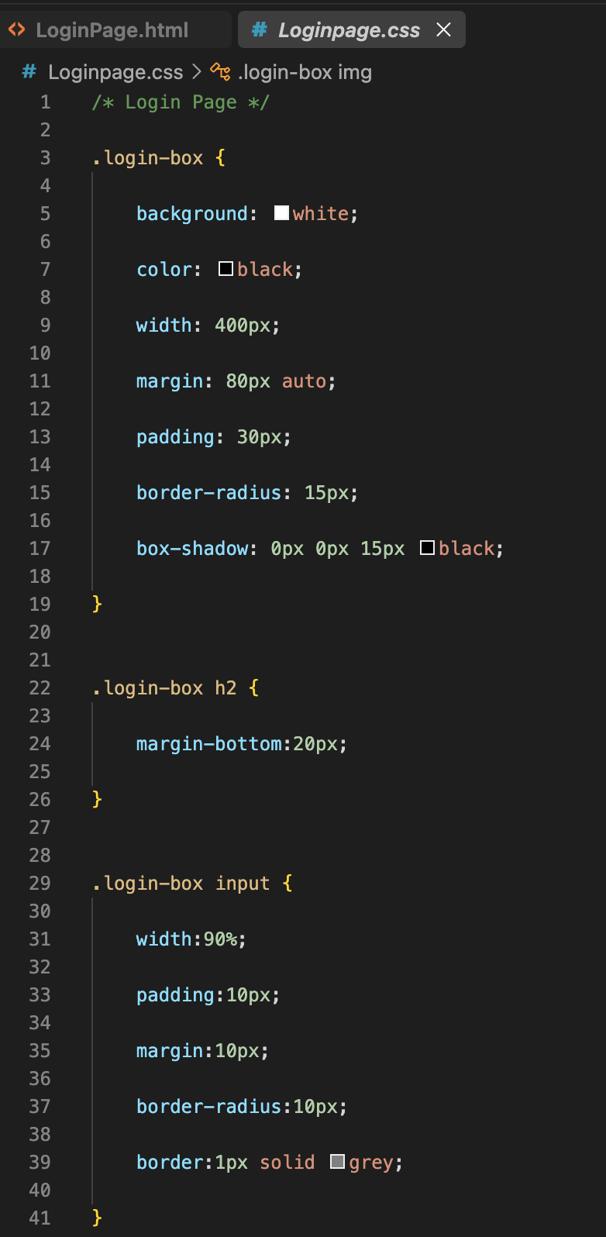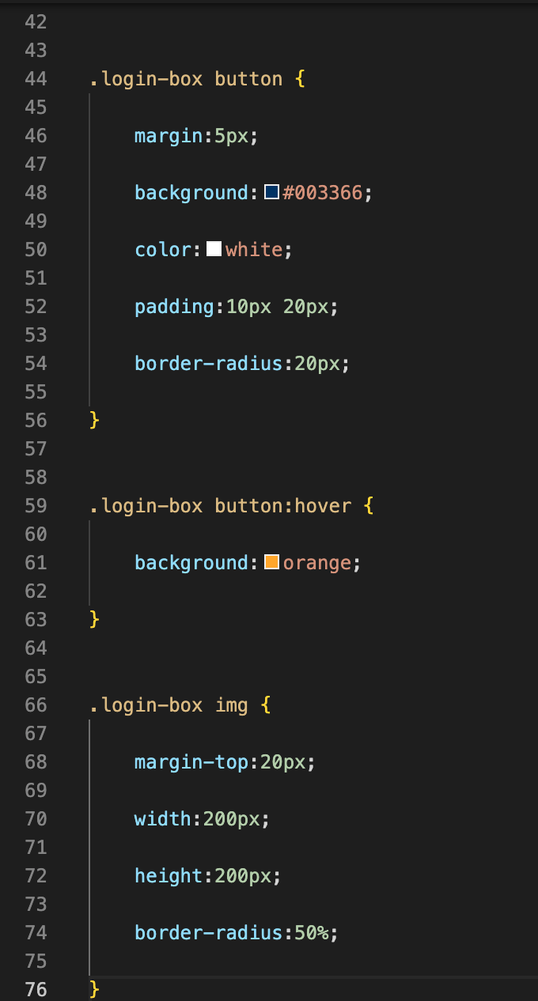

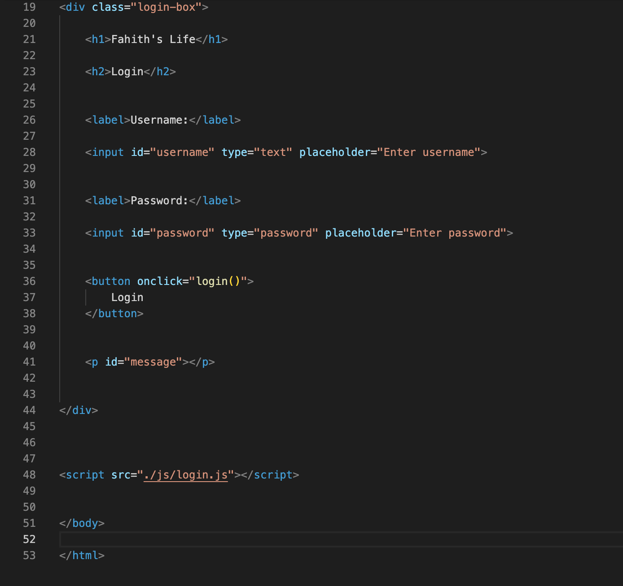
The above part of the code from the login page has the code to make the username, password and login button. At the bottom where it states
“<script src= “./js/login.js”></script> allows the java script and html file to connect to make them create the login page functions

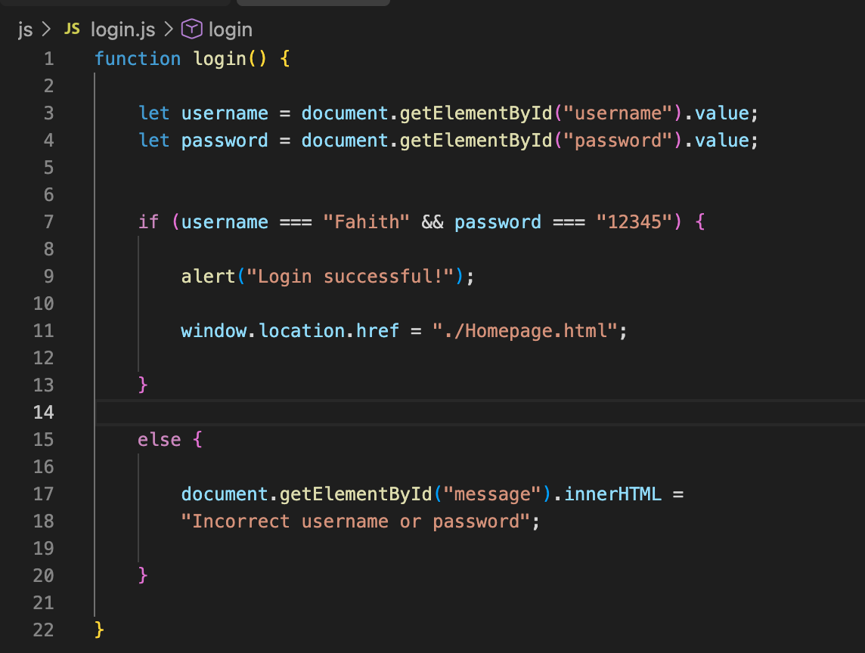
The above java script allows the idea of entering a username and password to enter into the website. When the username and password is correct, a secondary page would appear with a message saying, “Login successful!” and would allow the user to continue into the website. If by entering the wrong username and password, it would respond by saying, “Incorrect username or password” in which the user would have to redo the username and password so that they can enter.

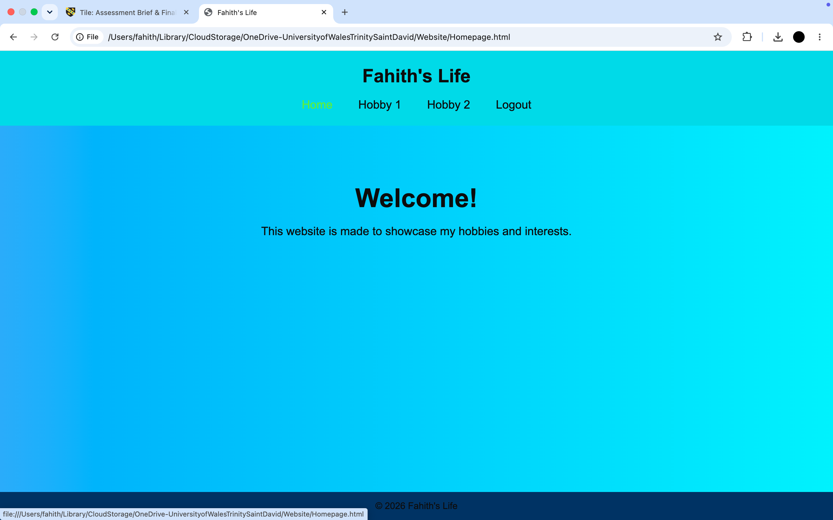
This is the homepage.
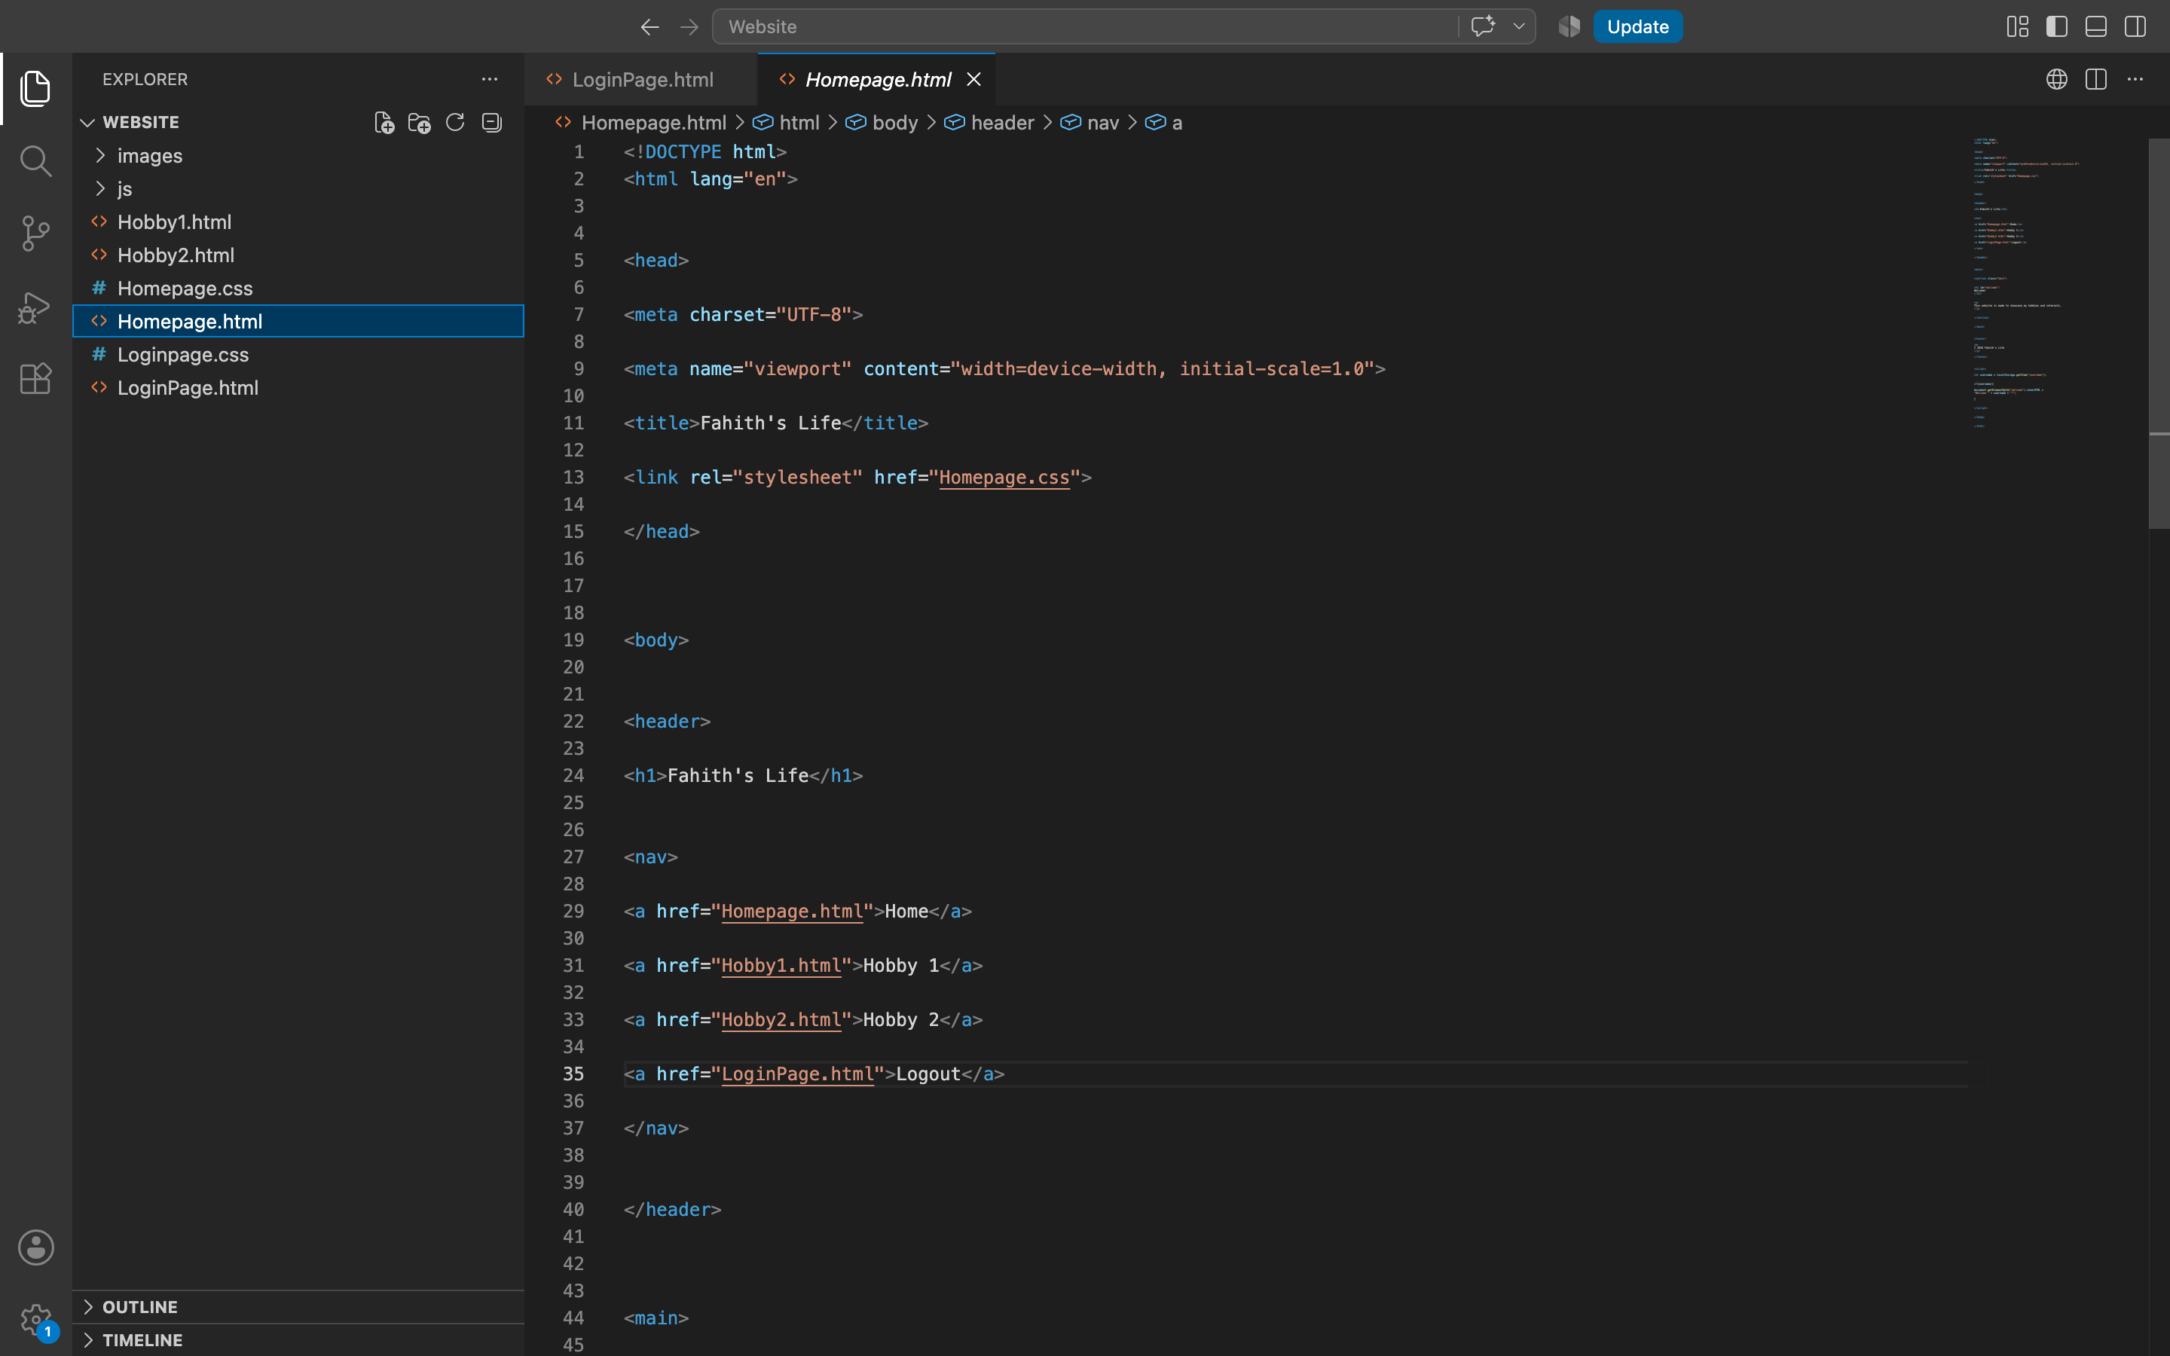
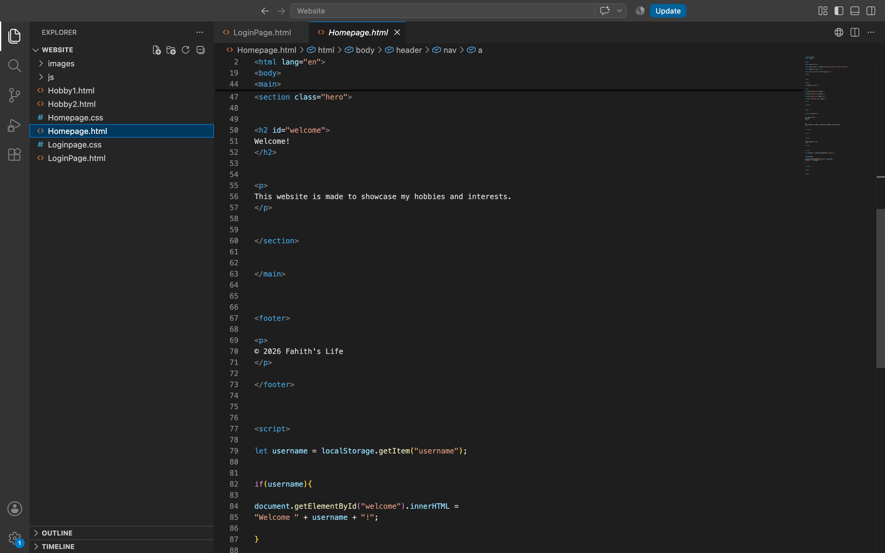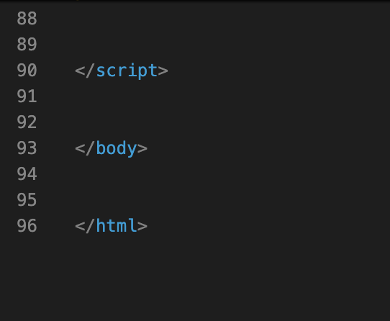
The above code is for the homepage with each of the subpages connected with the code.

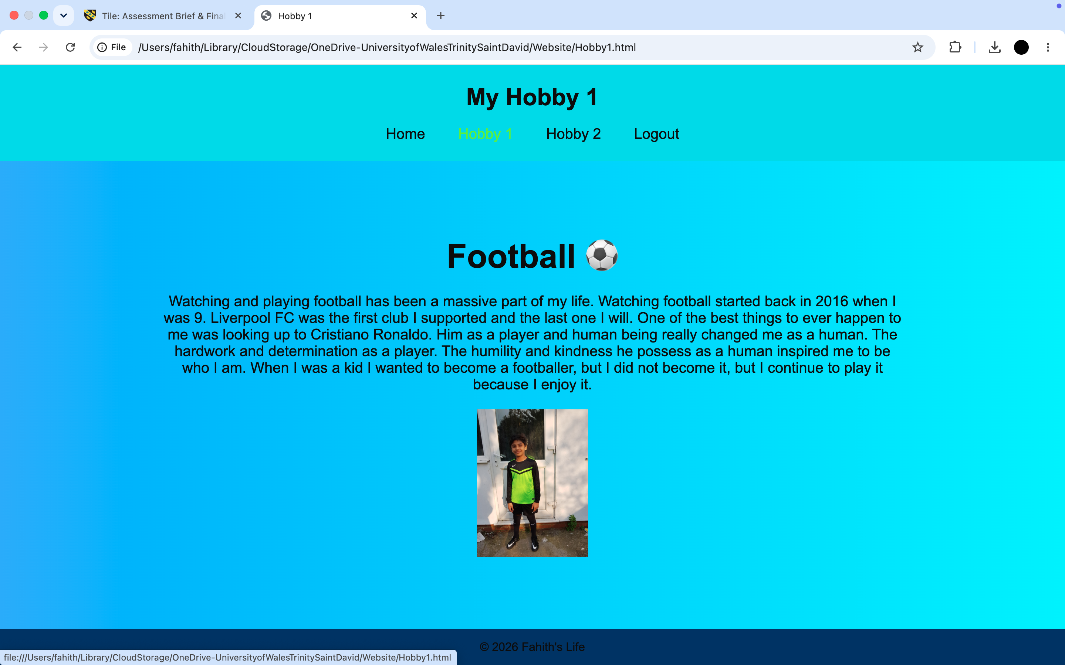
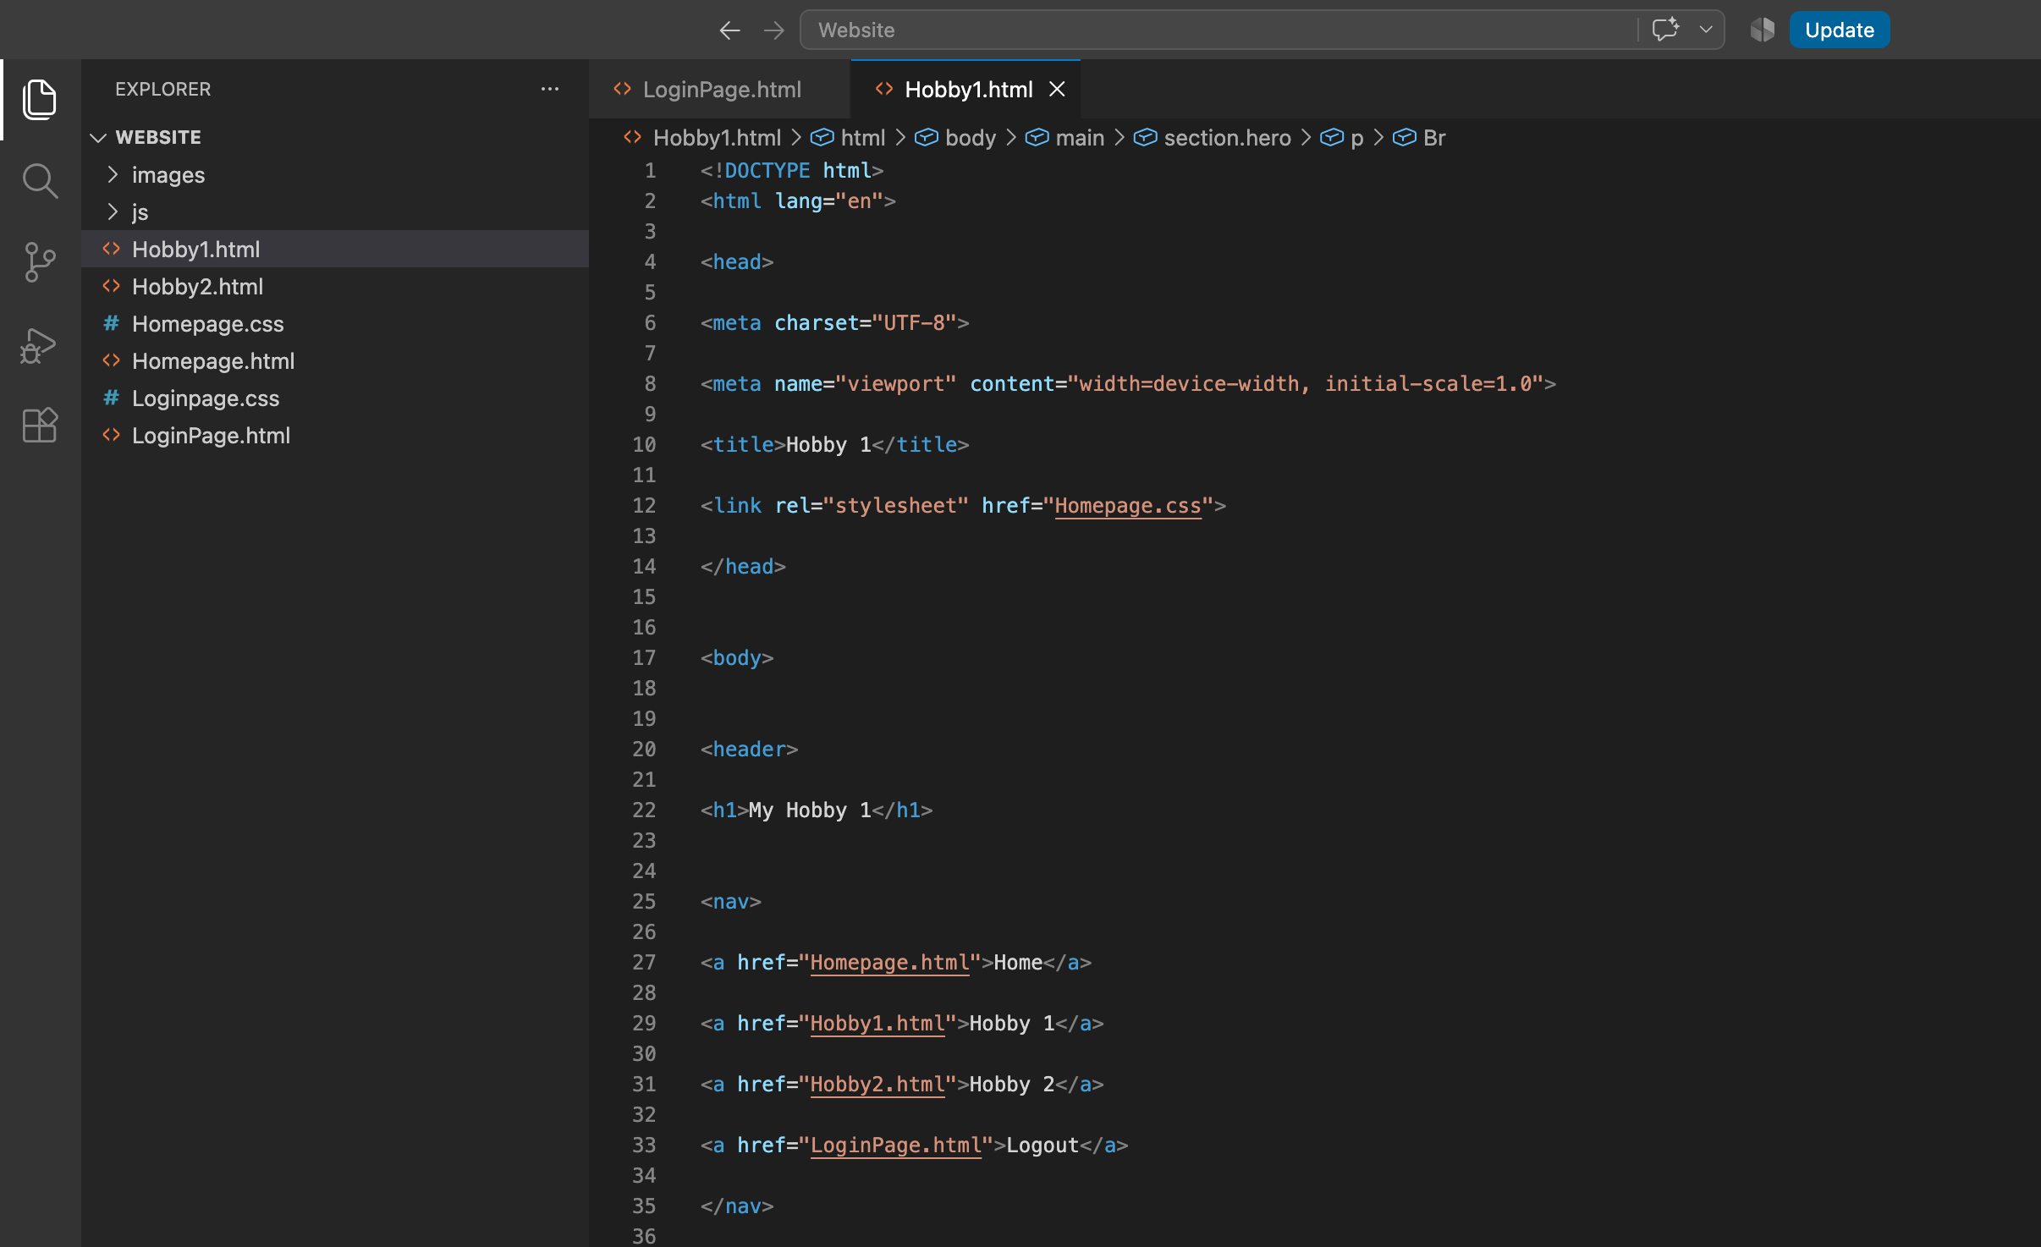
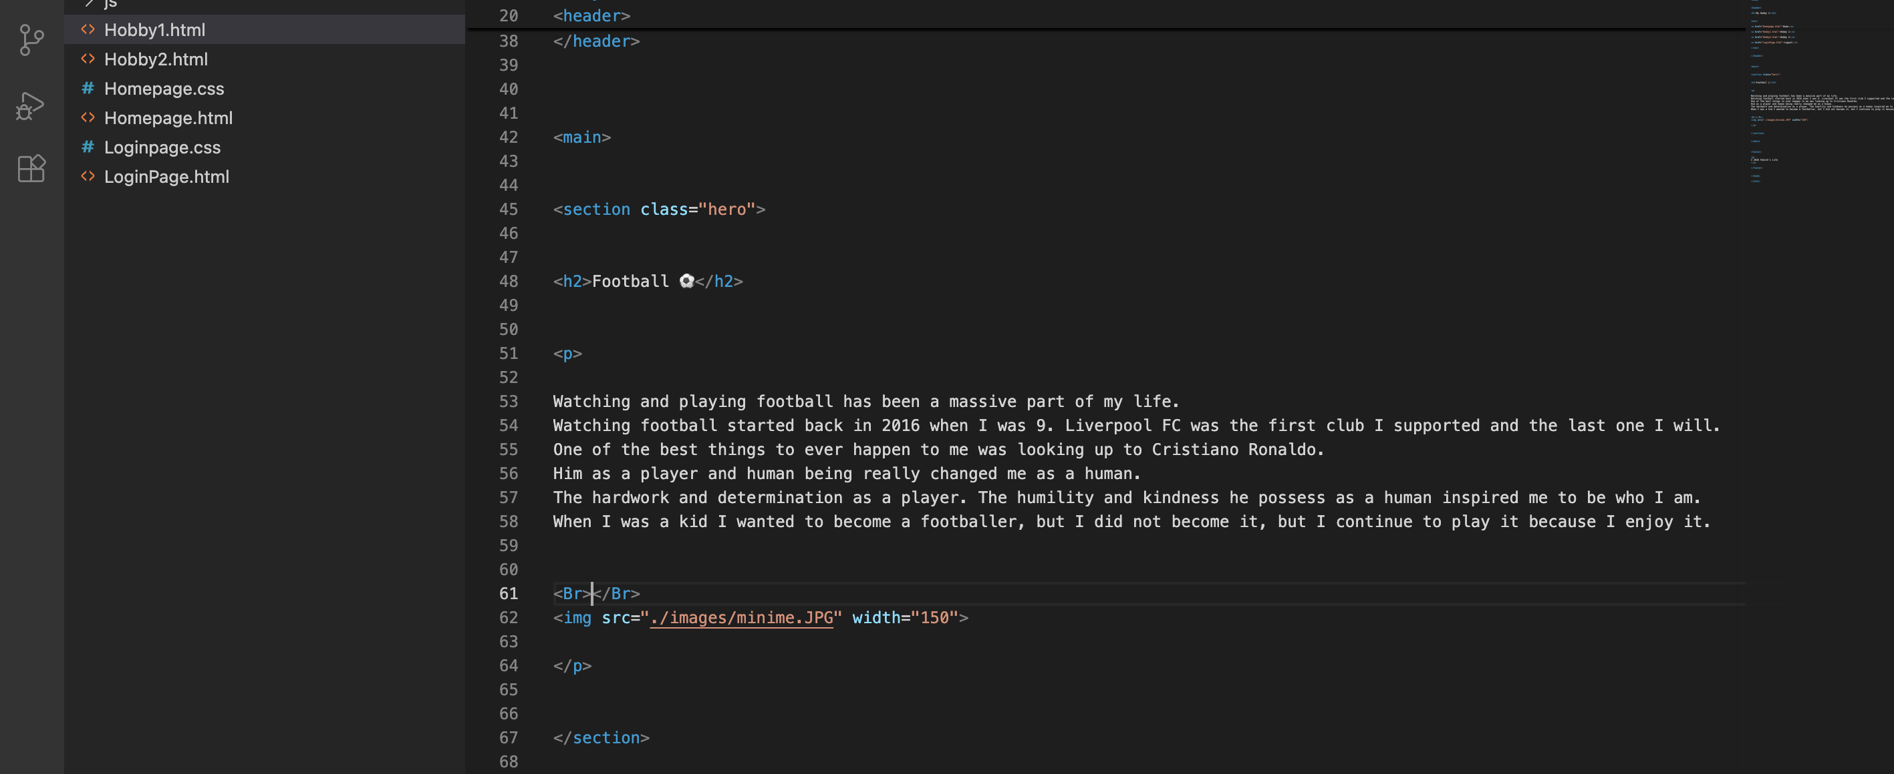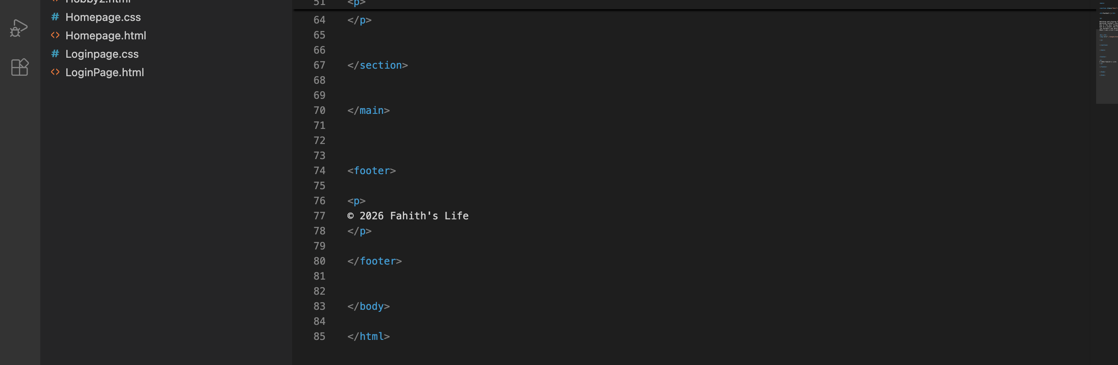

The above code was used for the creation for my first hobby’s page. It has everything in terms of text and pictures that explain the reasoning of my interest in the particular hobby.

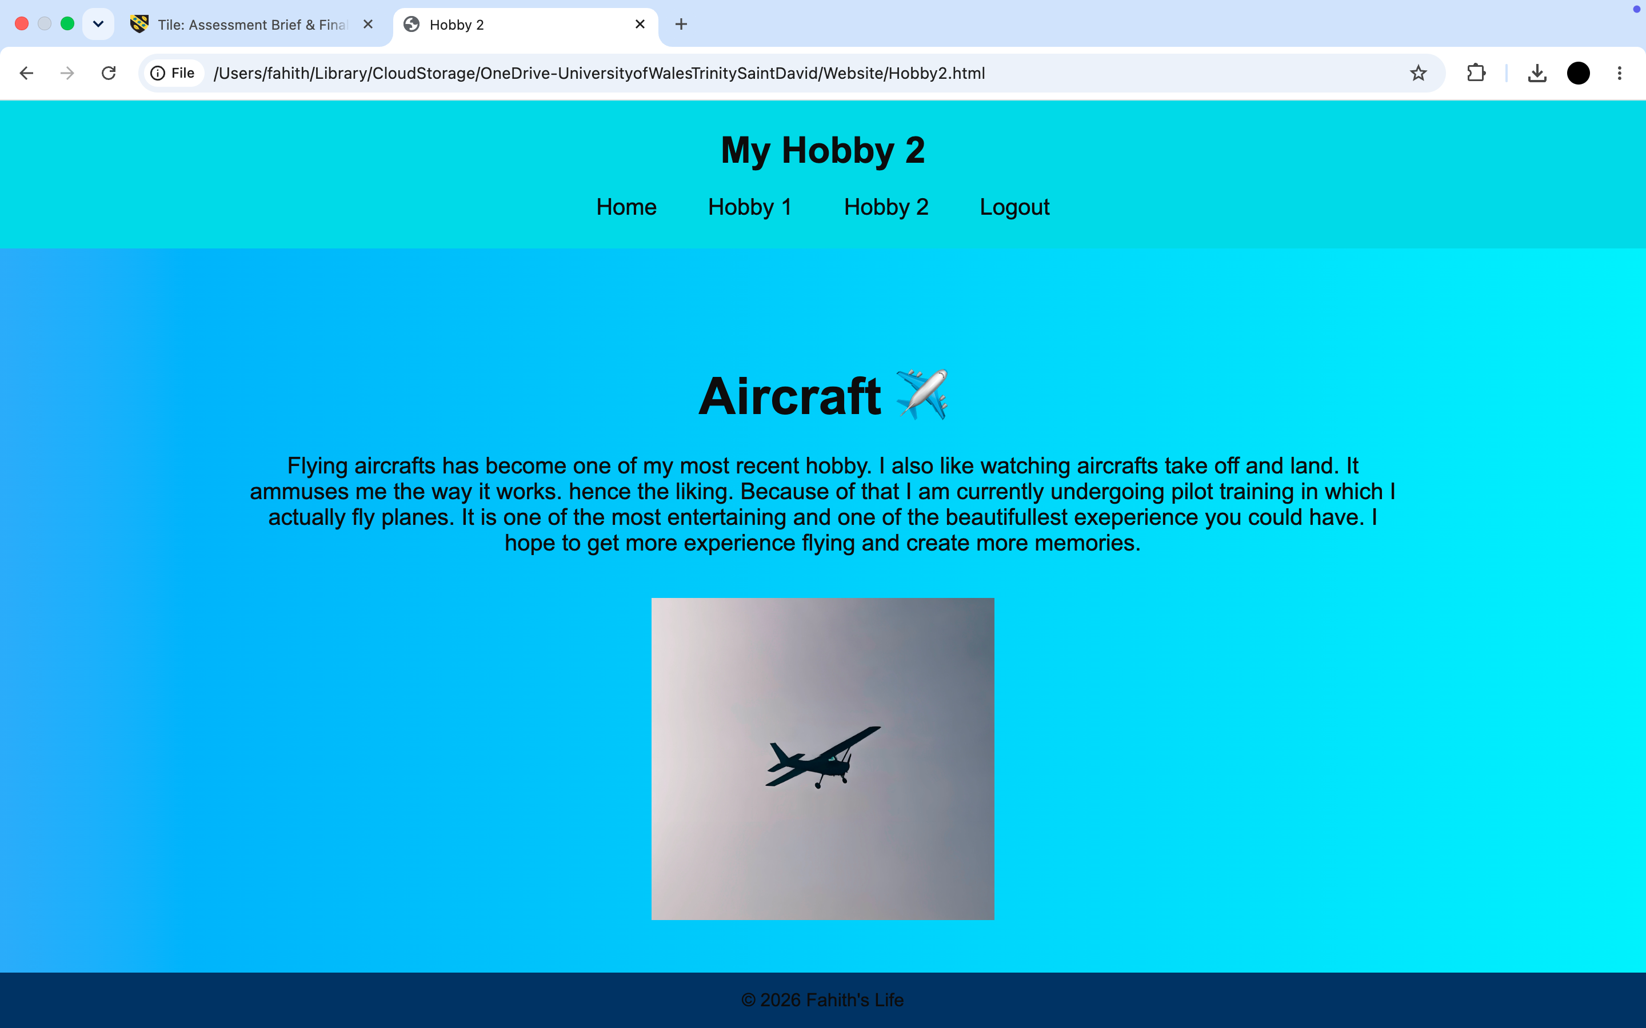
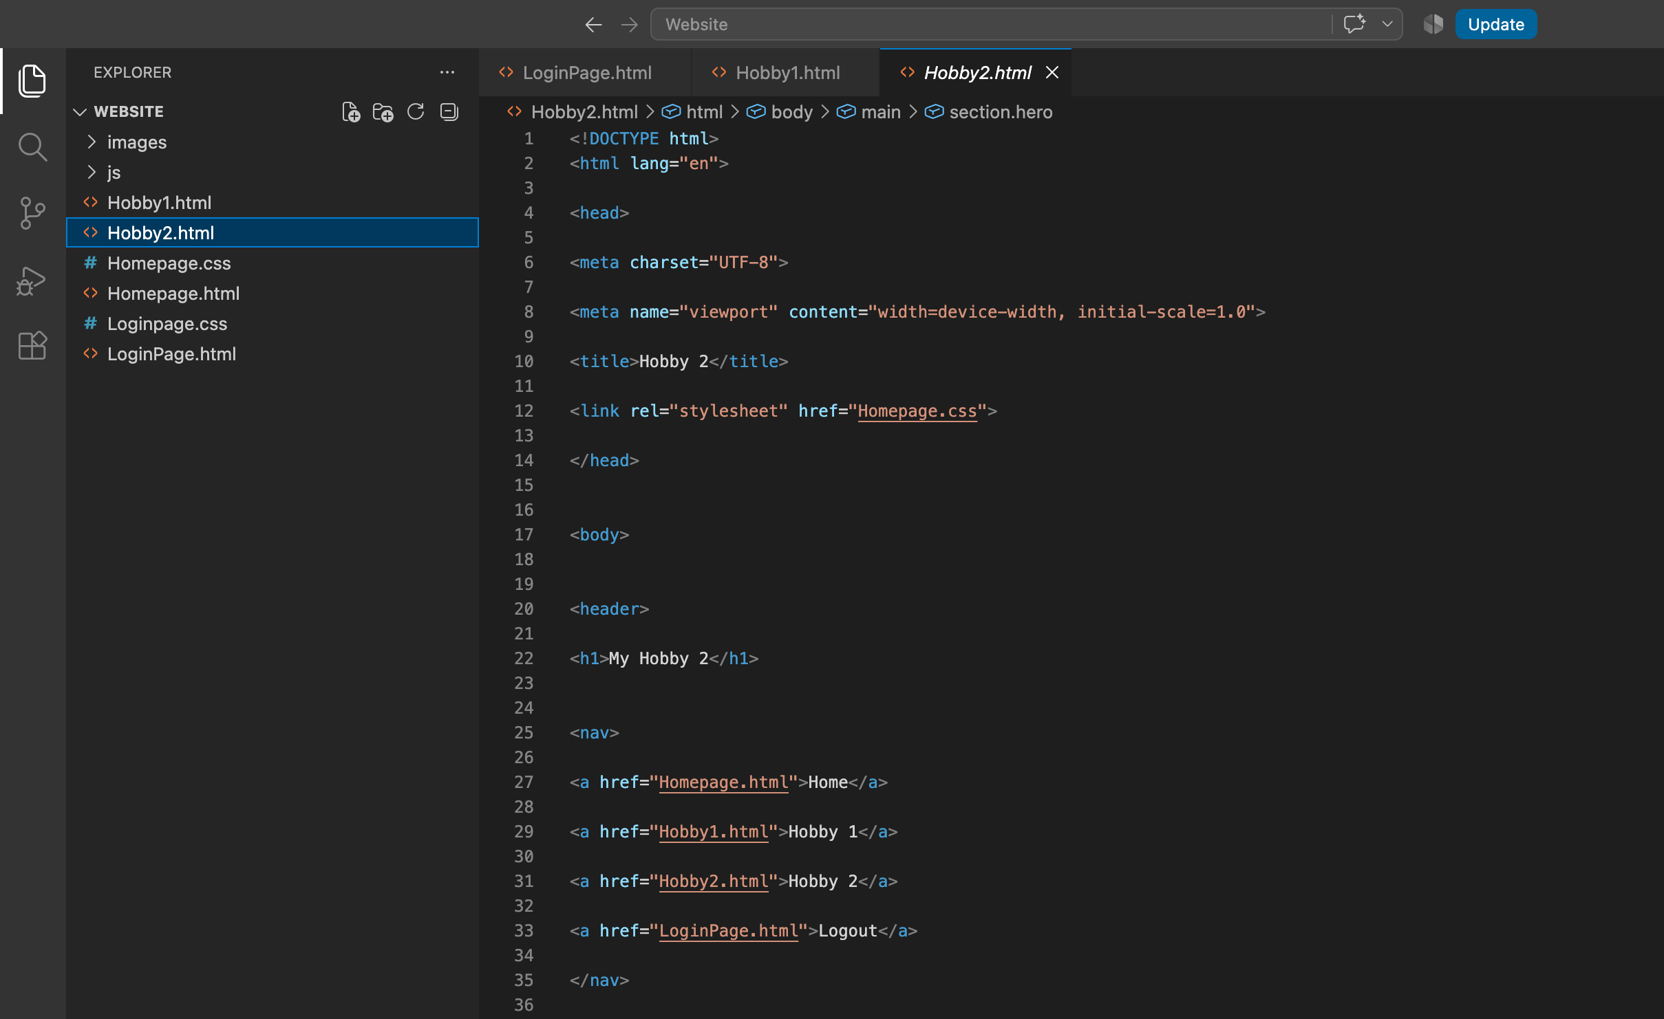
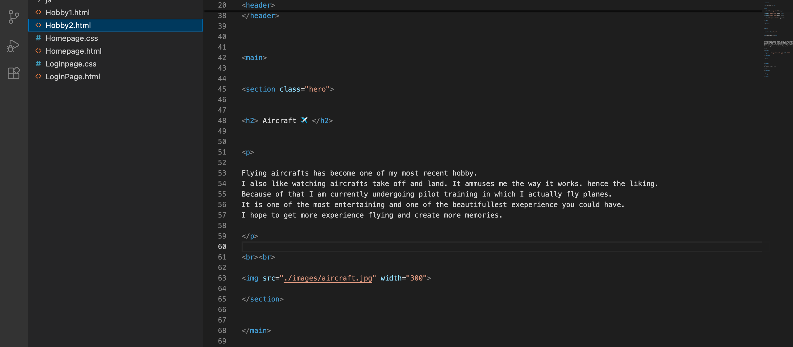
The above code was used for the creation for my second hobby’s page. It has everything in terms of text and pictures that explain the reasoning of my interest in the particular hobby.
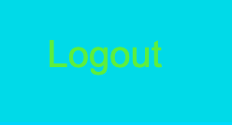
Ive also added in the logout button in the homepage to allow user to logout after they finish with the website.

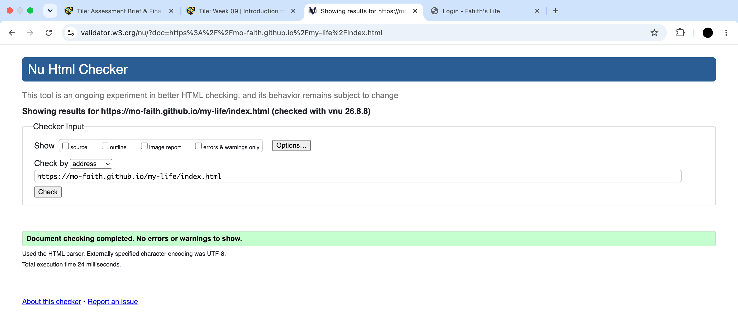
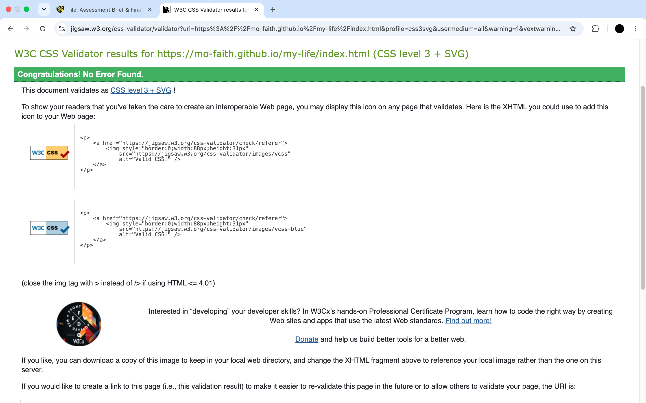
I tested the website out after creating it into a public website by going to GitHub and creating my website through my mac files into an online website. It came out saying there was not errors or warnings. So, there was not fixing to do.
However, when I was creating my website through GitHub, there was few minor tweaks I had to do to make my website work. Those tweaks were like the index.html not connecting properly with the login.js. The pictures not connecting with its respective pages. I found those by inspecting the pages in chrome when I opened it in there. It allowed me to make the changes to help my website better.
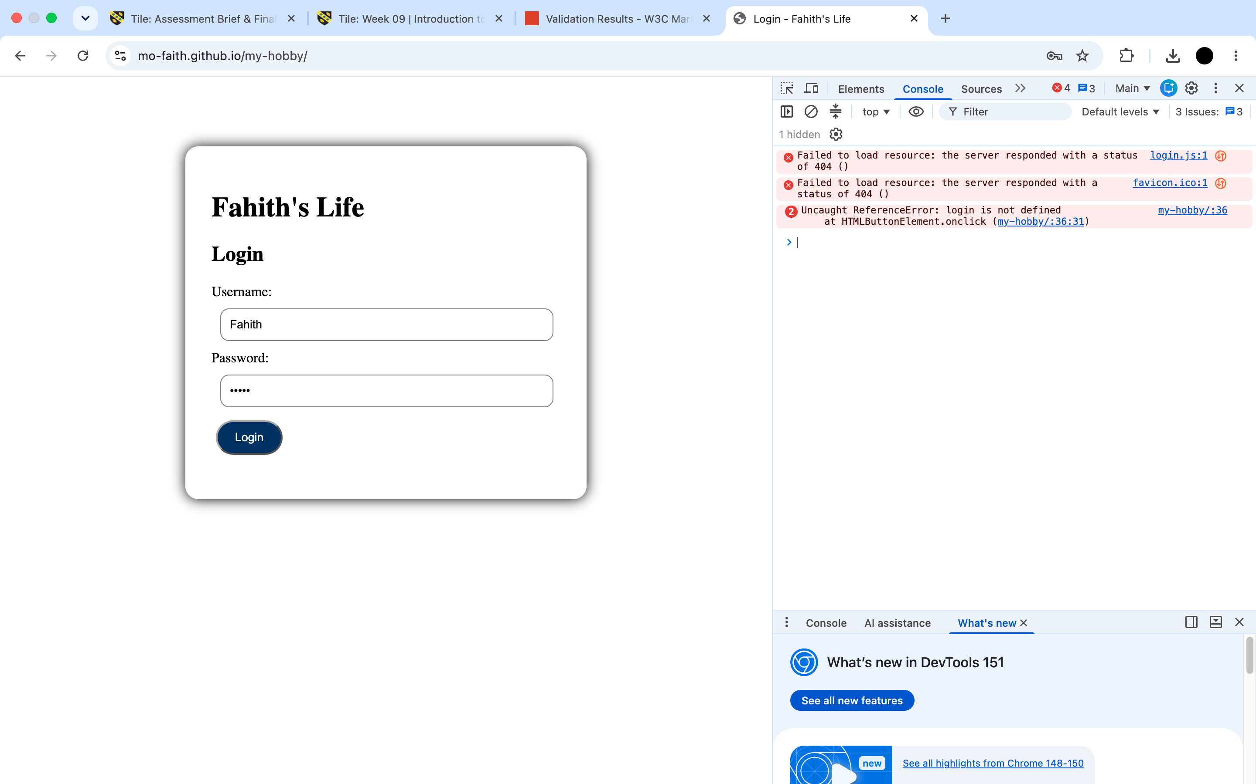

4. Evaluation
Research:
Usability – Usability is the idea of seeing who the duration of the website being used by the people across the world . It is to see if they access what they want without having problems. This is very important when it comes to running businesses and creating websites. The idea of technology improving and become wireless has improved the business market substantially. This allows more and more customers and user to be able to access the internet easily to look up or go to websites of their own interest. Websites can be seen as a backbone to growing businesses. This is because it is seen as a low cost solution for them to use it to exchange service related information to their users or customers. There are numerous services, websites, technology, mobile applications, etc. They are around the world as it helps increase the business market due to its usefulness and ease. [1]
Accessibility – Accessibility is the idea of users being able to use websites with ease. They can access what they want without having problems. This is very important when having a business or in a workplace environment or even for general people across the world. This is because they need to be able to access what they want without needing to be constantly asking others of what to do and how to it. By making it easily accessible it allows the people to use whatever website, internet, technology, mobile apps with ease. When creating websites or web tools, it has to be created so that everyone can use so that people that may struggle can find it easy to use without constantly needing someone else to help them with it. That’s where accessibility comes into play. By having a website, internet connection, new technology, mobile apps there can be lots of problems that can arise if they are not made with people in need in mind. If they are made hard for people to use, it would be even harder for people that struggle with understanding to use it. This makes businesses lose a very big part of their customers as they can not comprehend it. it becomes harder for them to understand making their customers or users turn away from their business. “Making the web accessible benefits individuals, businesses, and society. International web standards define what is needed for accessibility.” [2]
SEO – SEO is said to be a search rule from the search engine. This is optimised by the structure of the website, the key words of a website, the title of the website, the links within a website and so forth with whatever is on the website. The SEO helps improving the placing of the website when a user searches for it by improving the placing of it in the ranking in the search engine. By doing this, it allows the users find what they are searching for it quicker and helps ease out their search. It also helps improve the visit count of the website if more users visit it due to the ranking of when it searched. This would also help businesses improve their websites by optimising their webpages. [3]

Website Evaluation:
SEO Techniques Used: I would say the SEO techniques that I have used to make my website look better so that it can be seen more are quite a bit. For example, I have used Page titles, headings and linked each page to another. This gives users the idea of being impressed with the website can do. I also have images to attract more users to read. The website can also work on mobiles which allow more widespread users to use it allowing my website to be seen more and used more.
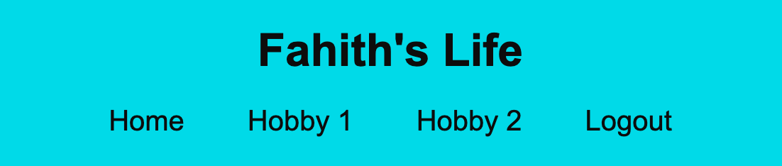

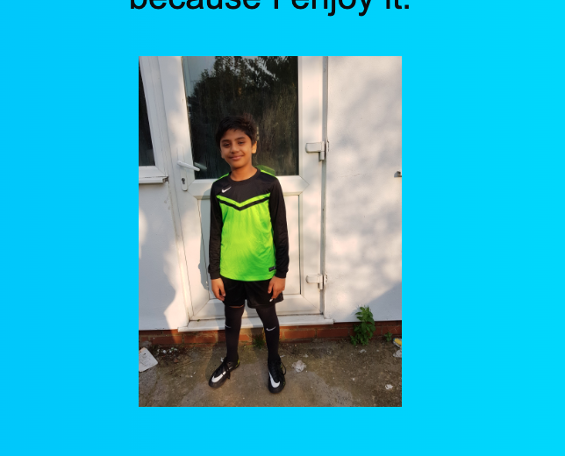
I would say that I could improve in terms on adding more techniques to improve it more. For example, to add more pictures with my interest so that they can be hooking more users. Could add more relevant content but should be careful as too much can bore the users.
Usability & Utility – When it comes to usability and utility, I would say I have ticked off many points to make sure its easily accessible and easy to understand. I have provided simple navigation through the clear headings which are buttons that can be used to take to their respective pages. Throughout my website I have kept the design consistent and clear and did not overdo the colours to make it look weird. The layout of the website is very clear, easy to understand, concise and straightforward. The layout has not been overly done so that users may not understand it. The only problem I would say I have is that I should add a clearer message in the login page when the username is incorrect and have to be typed in again.
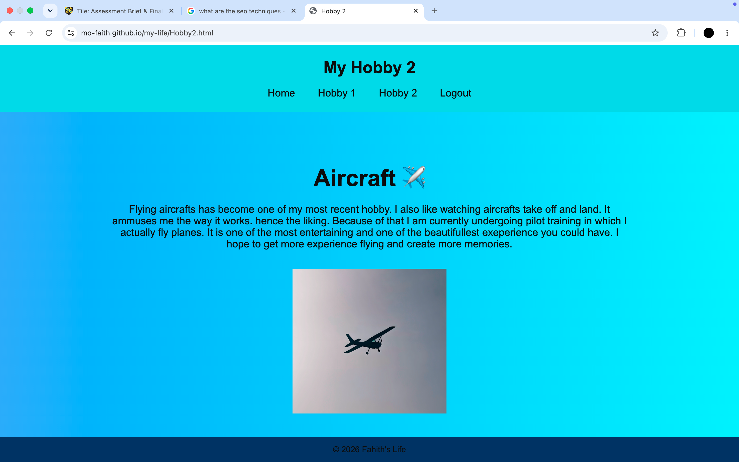
Accessibility (WCAG 2.1):
Perceivable – I have images to make users understand it. But I should more make it more engaging. The colours of my websites are clear and not overly done or too dark with dark writing. The colours are all good for people to see and understand. The content written in text is well done in terms of the correct content. It easy to read and easy to understand.
Operable – The navigation links allow the users to enter the pages with their respective buttons that I have placed at the top of the page. The buttons on the page clearly show what they are and what it’s use is.
Understandable – The headings on the top of the page when it is clicked can make the users easily understand what the content is about without needing to overly think about it. As mentioned, the navigation is simply straightforward and easy to understand and use. The login section clearly shows where to write username and password. This makes it easier for users to use.
Robust – The website has been built across 3 codes (HTML, CSS, JavaScript). This is useful as it helps with the modern technology (like newer browsers, websites and apps) as it is compatible with them.

c) Website Comparison - https://www.hirekevinmiddleton.com/
Usability/Accessibility/SEO – When I compare my website to the one below, the below one has many more features than I do. Everything in terms of presentation to the how well designed the website is. The website has all the qualities that are needed for usability/accessibility/SEO. They have everything it needs to attract users to its page whilst also making it easy to navigate through the sub headers and the content. Lots of pictures to attract users. One thing he has that caught my eye is contact me which is good to connect with people with the same interest. [4]
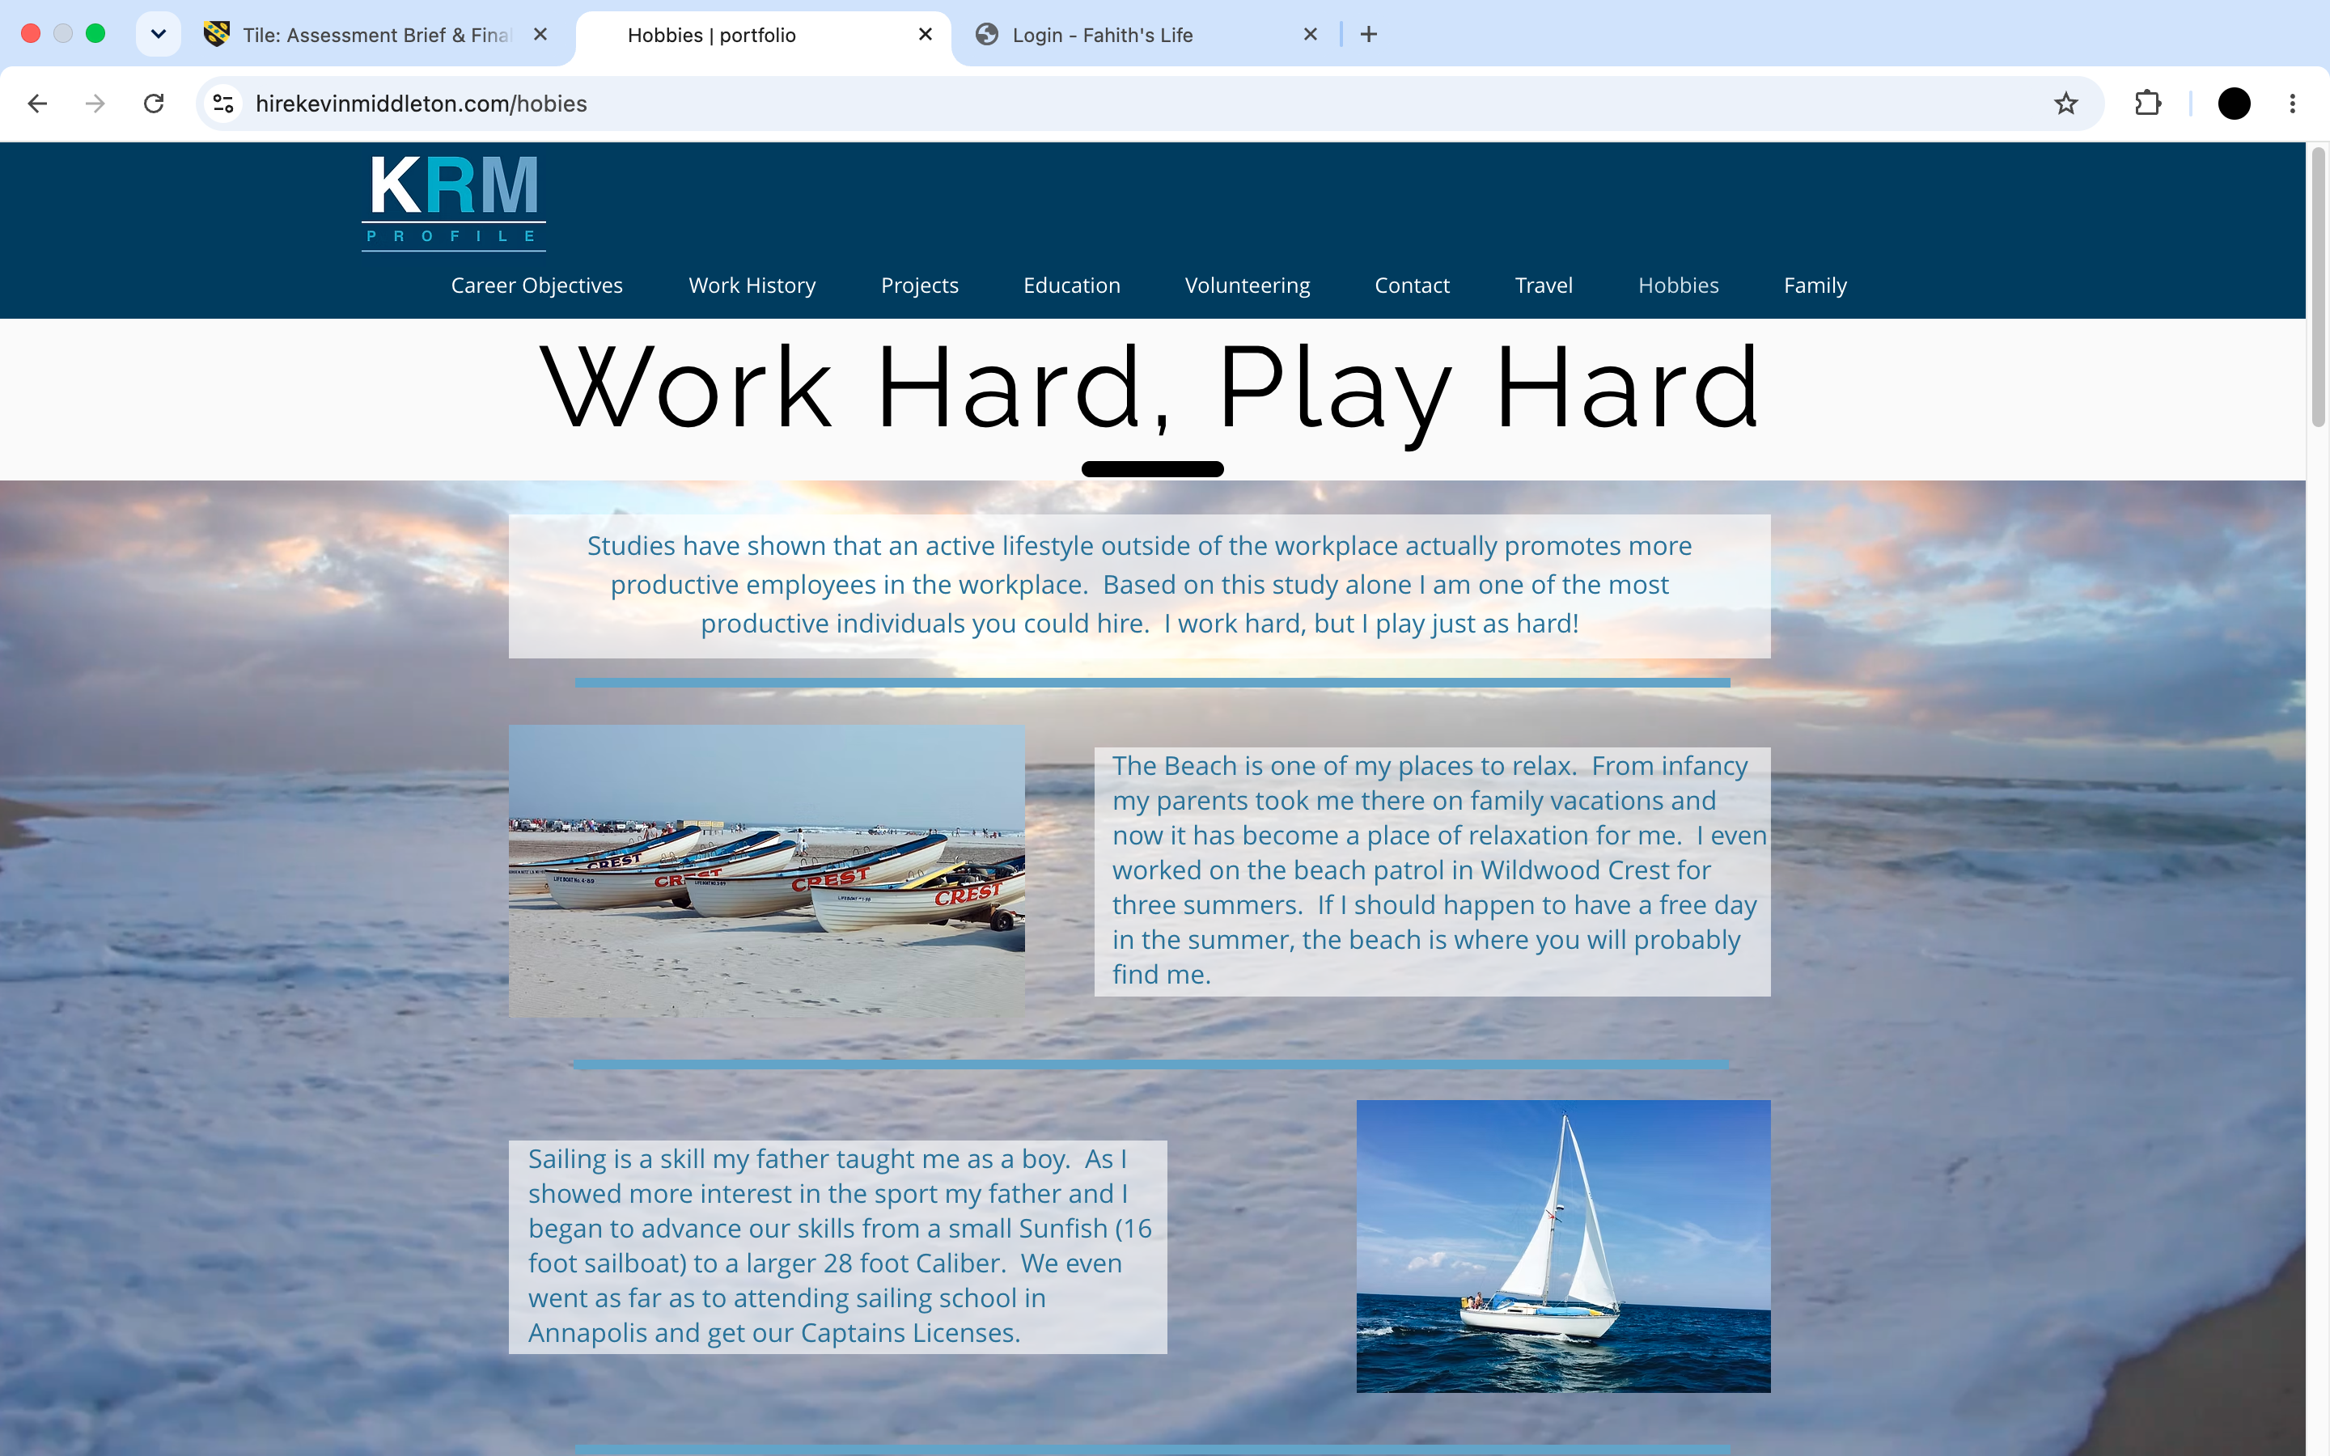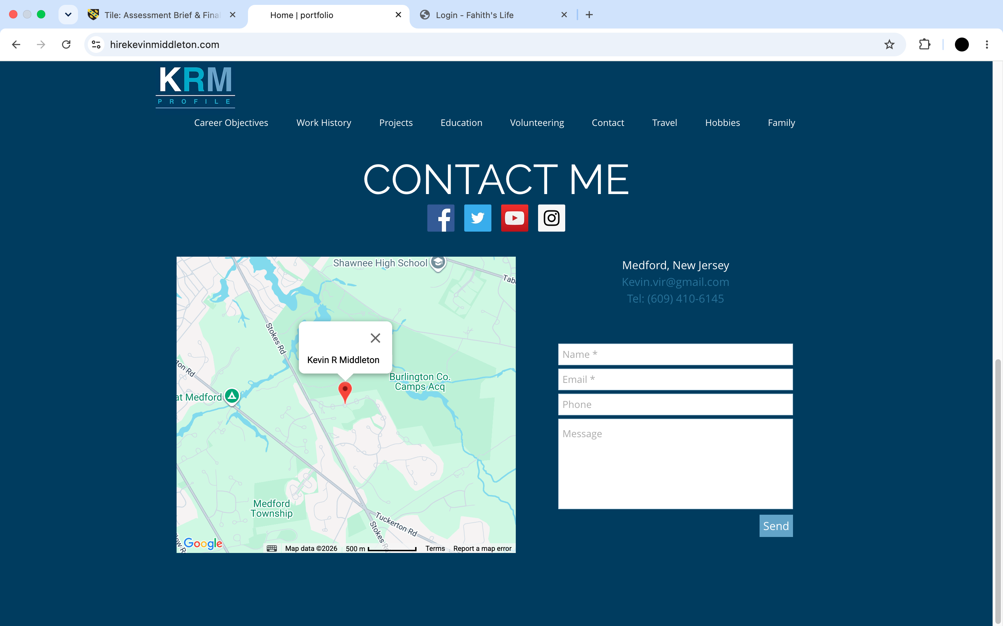

Mobile Friendliness – The website is very mobile friendly and easy to navigate as well. Everything in the desktop website is in the mobile one to.
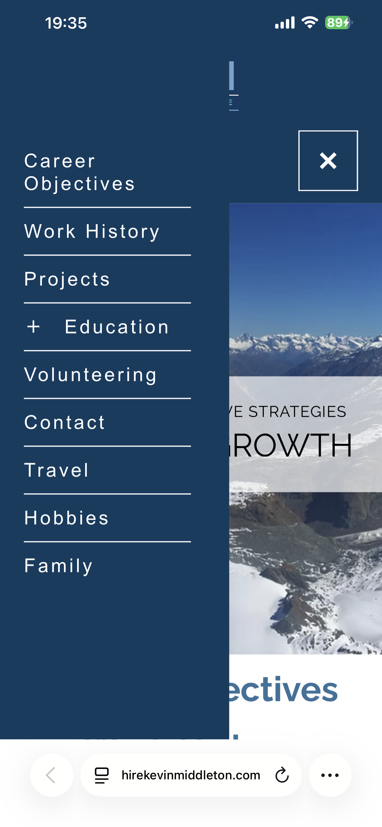
Conclusion – In conclusion I would say the above website is better in terms of attracting users as it has everything needed for an attractive website. If I had more time and more knowledge on website creations, I would certainly do it like the above.

5. Conclusion
In conclusion I would say that the report talks about everything that needs to be covered. From the code I have used to create my website. The overview of my website. How my website looks and the advantages and disadvantages of it. I have also talked a little comparison of my website and another person’s. I have learnt what I need to do and what I have done well.

6. References (IEEE Format)

Bibliography

[1] | M. Gul, "IEEE explore," IEEE, 22-23 February 2020. [Online]. Available: https://ieeexplore.ieee.org/document/9048205.
[2] | S. L. Henry, "w3.org," 3 February 2026. [Online]. Available: https://www.w3.org/WAI/fundamentals/accessibility-intro/.
[3] | B. Bian, "IEEE explore," IEEE, 06-08 May 2011. [Online]. Available: https://ieeexplore.ieee.org/document/5886993.
[4] | K. R. Middleton, "hirekevinrmiddleton," [Online]. Available: https://www.hirekevinmiddleton.com/career-objectives.

7. Appendices
Index HTML: <!DOCTYPE html>
<html lang="en">

<head>

<meta charset="UTF-8">
<meta name="viewport" content="width=device-width, initial-scale=1.0">

<title>Login - Fahith's Life</title>

<link rel="stylesheet" href="index.css">

</head>

<body>

<div class="login-box">

<h1>Fahith's Life</h1>

<h2>Login</h2>

<label>Username:</label>

<input id="username" type="text" placeholder="Enter username">

<label>Password:</label>

<input id="password" type="password" placeholder="Enter password">

<button onclick="login()">
Login
</button>

<p id="message"></p>

</div>

<script src="./js/login.js"></script>

</body>

</html>

Login CSS: /* Login Page */

.login-box {

background: white;

color: black;

width: 400px;

margin: 80px auto;

padding: 30px;

border-radius: 15px;

box-shadow: 0px 0px 15px black;

}

.login-box h2 {

margin-bottom:20px;

}

.login-box input {

width:90%;

padding:10px;

margin:10px;

border-radius:10px;

border:1px solid grey;

}

.login-box button {

margin:5px;

background:#003366;

color:white;

padding:10px 20px;

border-radius:20px;

}

.login-box button:hover {

background:orange;

}

.login-box img {

margin-top:20px;

width:200px;

height:200px;

border-radius:50%;

}

@media (max-width: 600px) {
.login-box {
width: 90%;
padding: 20px;
}

input {
width: 100%;
box-sizing: border-box;
}

button {
width: 100%;
}
}

Login JS: function login() {

let username = document.getElementById("username").value;
let password = document.getElementById("password").value;

if (username === "Fahith" && password === "12345") {

alert("Login successful!");

window.location.href = "./Homepage.html";

}

else {

document.getElementById("message").innerHTML =
"Incorrect username or password";

}

}

Homepage HTML: <!DOCTYPE html>
<html lang="en">

<head>

<meta charset="UTF-8">

<meta name="viewport" content="width=device-width, initial-scale=1.0">

<title>Fahith's Life</title>

<link rel="stylesheet" href="Homepage.css">

</head>

<body>

<header>

<h1>Fahith's Life</h1>

<nav>

<a href="Homepage.html">Home</a>

<a href="Hobby1.html">Hobby 1</a>

<a href="Hobby2.html">Hobby 2</a>

<a href="index.html">Logout</a>

</nav>

</header>

<main>

<section class="hero">

<h2 id="welcome">
Welcome!
</h2>

<p>
This website is made to showcase my hobbies and interests.
</p>

</section>

</main>

<footer>

<p>
© 2026 Fahith's Life
</p>

</footer>

<script>

let username = localStorage.getItem("username");

if(username){

document.getElementById("welcome").innerHTML =
"Welcome " + username + "!";

}

</script>

</body>

</html>

Homepage CSS: *{

margin:0;

padding:0;

box-sizing:border-box;

font-family:Arial;

}

body{

background:linear-gradient(to right,#4facfe,#00f2fe);

color:rgb(13, 12, 12);

text-align:center;

}

header{

background:#0ddae9;

padding:25px;

}

nav{

margin-top:20px;

}

nav a{

color:rgb(13, 12, 12);

text-decoration:none;

margin:20px;

font-size:20px;

}

nav a:hover{

color:rgb(116, 239, 9);

}

.hero{

margin-top:100px;

}

.hero h2{

font-size:45px;

margin-bottom:20px;

}

.hero p{

font-size:20px;

width:70%;

margin:auto;

}

footer{

position:fixed;

bottom:0;

width:100%;

background:#003366;

padding:15px;

}

.login-box{

background:rgb(178, 169, 169);

color:black;

width:350px;

margin:120px auto;

padding:30px;

border-radius:15px;

}

.login-box input{

display:block;

width:100%;

padding:10px;

margin:15px 0;

}

button{

background:#41949f;

color:white;

padding:12px 30px;

border:none;

border-radius:20px;

cursor:pointer;

}

button:hover{

background:rgb(237, 171, 49);

}

Hobby 1 HTML: <!DOCTYPE html>
<html lang="en">

<head>

<meta charset="UTF-8">

<meta name="viewport" content="width=device-width, initial-scale=1.0">

<title>Hobby 1</title>

<link rel="stylesheet" href="Homepage.css">

</head>

<body>

<header>

<h1>My Hobby 1</h1>

<nav>

<a href="Homepage.html">Home</a>

<a href="Hobby1.html">Hobby 1</a>

<a href="Hobby2.html">Hobby 2</a>

<a href="index.html">Logout</a>

</nav>

</header>

<main>

<section class="hero">

<h2>Football ⚽</h2>

<p>

Watching and playing football has been a massive part of my life.
Watching football started back in 2016 when I was 9. Liverpool FC was the first club I supported and the last one I will.
One of the best things to ever happen to me was looking up to Cristiano Ronaldo.
Him as a player and human being really changed me as a human.
The hardwork and determination as a player. The humility and kindness he possess as a human inspired me to be who I am.
When I was a kid I wanted to become a footballer, but I did not become it, but I continue to play it because I enjoy it.

<Br></Br>
<img src="./images/minime.JPG" width="150">

</p>

</section>

</main>

<footer>

<p>
© 2026 Fahith's Life
</p>

</footer>

</body>

</html>

Hobby 2 HTML: <!DOCTYPE html>
<html lang="en">

<head>

<meta charset="UTF-8">

<meta name="viewport" content="width=device-width, initial-scale=1.0">

<title>Hobby 2</title>

<link rel="stylesheet" href="Homepage.css">

</head>

<body>

<header>

<h1>My Hobby 2</h1>

<nav>

<a href="Homepage.html">Home</a>

<a href="Hobby1.html">Hobby 1</a>

<a href="Hobby2.html">Hobby 2</a>

<a href="index.html">Logout</a>

</nav>

</header>

<main>

<section class="hero">

<h2> Aircraft ✈️ </h2>

<p>

Flying aircrafts has become one of my most recent hobby.
I also like watching aircrafts take off and land. It ammuses me the way it works. hence the liking.
Because of that I am currently undergoing pilot training in which I actually fly planes.
It is one of the most entertaining and one of the beautifullest exeperience you could have.
I hope to get more experience flying and create more memories.

</p>

<br><br>

<img src="./images/aircraft.jpg" width="300">

</section>

</main>

<footer>

<p>
© 2026 Fahith's Life
</p>

</footer>

</body>

</html>

