BMIH4002

2118712

lecturer's name:Jaliya De Silva

Our restaurant concept involves the offering of a very diverse and quite appealing menu that is able to cater a wide range of preference of dietary which include vegetarian vegan and gluten free options. We aim to be able to provide a very welcoming and very inclusive dining experience for individuals who prioritize their health flavorful and sustainable food choices our target audience consists of health conscious individuals vegetarians vegans and those seeking flavorful options for their dietary needs. There are many different reasons behind each and every single one of their menu choices

For the starters we believe in utilizing locally sourced ingredients to ensure freshness and to be able to support the local farmers the dishes combine the deliciousness of grilled bread with the colorful medley of seasonal vegetables creating a satisfying and quite unique appetizer. for our stuffed Portobello mushrooms we wanted to be able to offer a vegetarian star that is not only just nutritious but also full of flavors.

When it came to the mains we wanted to offer a variety of spices and flavors this tagine displays seasonal vegetables chickpeas and different kind of spices resulting in a very heartwarming healthy main course served with couscous and sauce it offers a complete and satisfying meal,

The grilled chicken sandwich was then catered to those who wanted a rich protein option, in the chicken Caesar salad we offered the classic salad with a little twist creating a balanced and fulfilling main course.

For the desserts we have chosen A flourless chocolate cake which is a descendant dessert caters to chocolate lovers while accommodating gluten free diets.
We also added a seasonal pool fruit tart which provides A delightful balance of textures and flavors appealing to those seeking A fruity and light dessert

When it came to beverages we decided to offer a selection of refreshing first fulfilling beverages to be able to complement the dining experience we added freshly squeezed citrus juice to be able to provide a tangy and zesty flavor that accompanies the food that we are providing while contrarily offering a mint lemonade which offers a cool and invigorating drink.
In addition we also provide a range of soft drinks which would be catered towards people who are not of age to drink alcohol while also providing alcohol such as red and white wines for those who prefer alcohol beverages.

Overall the menu choices our aim to be able to provide a all rounded world dining experience catering to different kinds of dietary preferences without having to compromise on having less quality or less taste. Being able to focus on having fresh seasonal ingredients and being able to offer a large number of favorable options we strive to be able to make an inclusive but also enjoyable dining experience for our target audience.


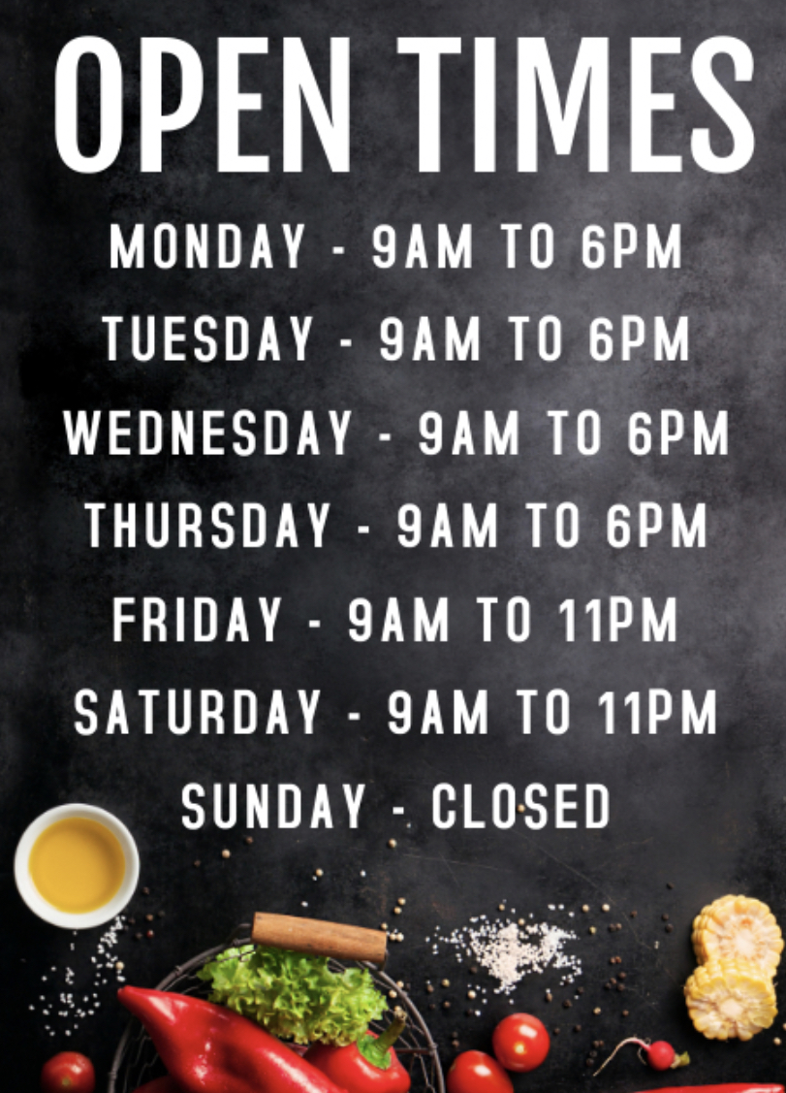

Menu

Starters
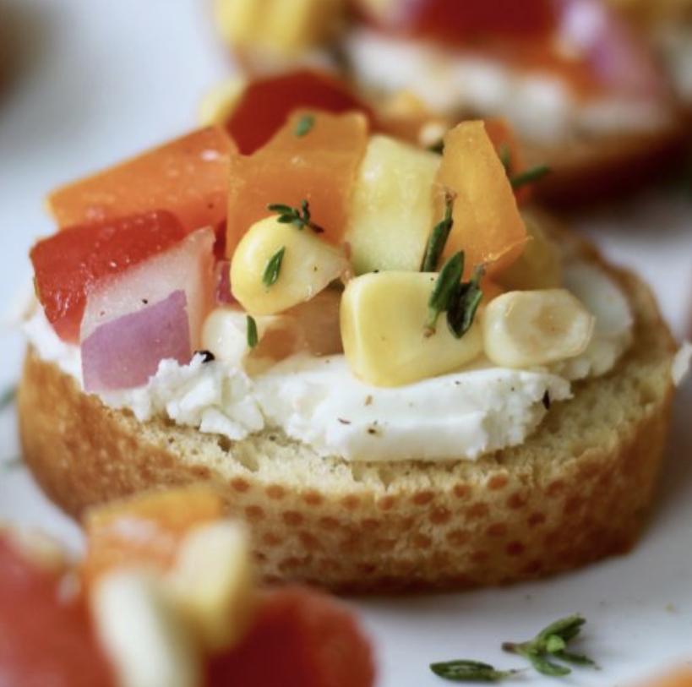
Seasonal Vegetable Bruschetta – Freshly grilled bread topped with a medley of locally sourced seasonal vegetables, drizzled with a balsamic glaze. £10.95

Quinoa Stuffed Portobello Mushrooms - Roasted Portobello mushrooms filled with a flavorful mixture of quinoa, roasted vegetables, and herbs, served with a side of mixed greens. £9.95

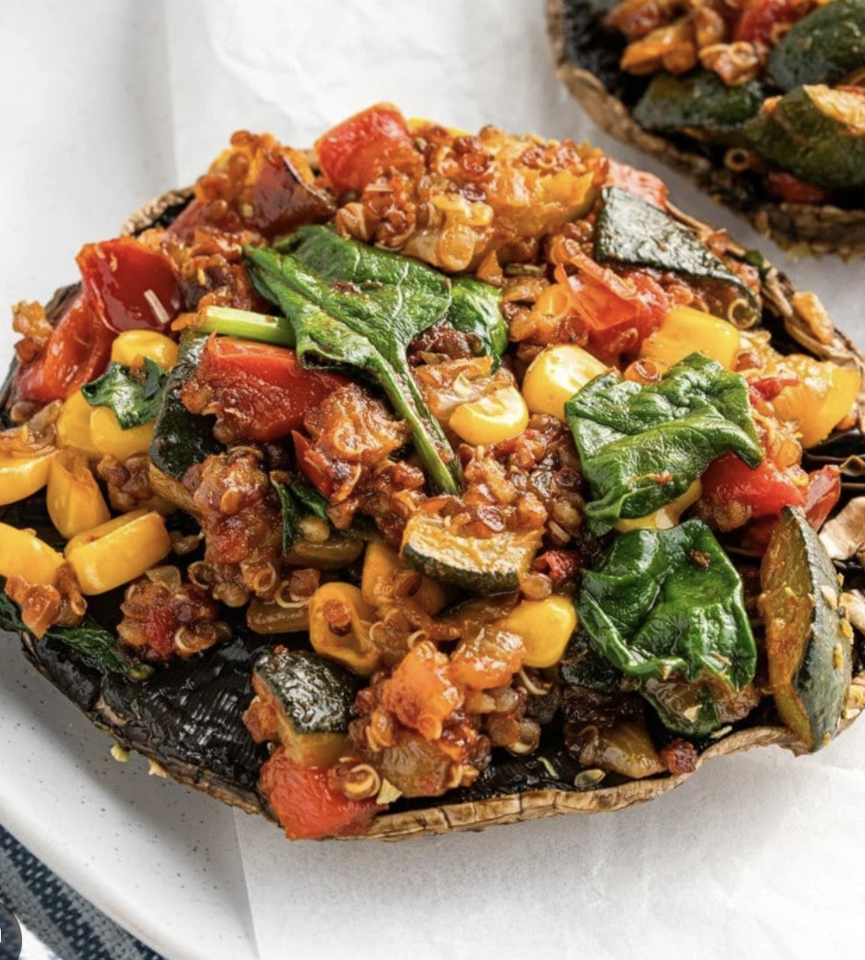

Mains
Vegetarian Tagine - A beautiful Moroccan stew made with seasonal vegetables, chickpeas, and flavourable spices, served with couscous and a side of harissa sauce. £24.95
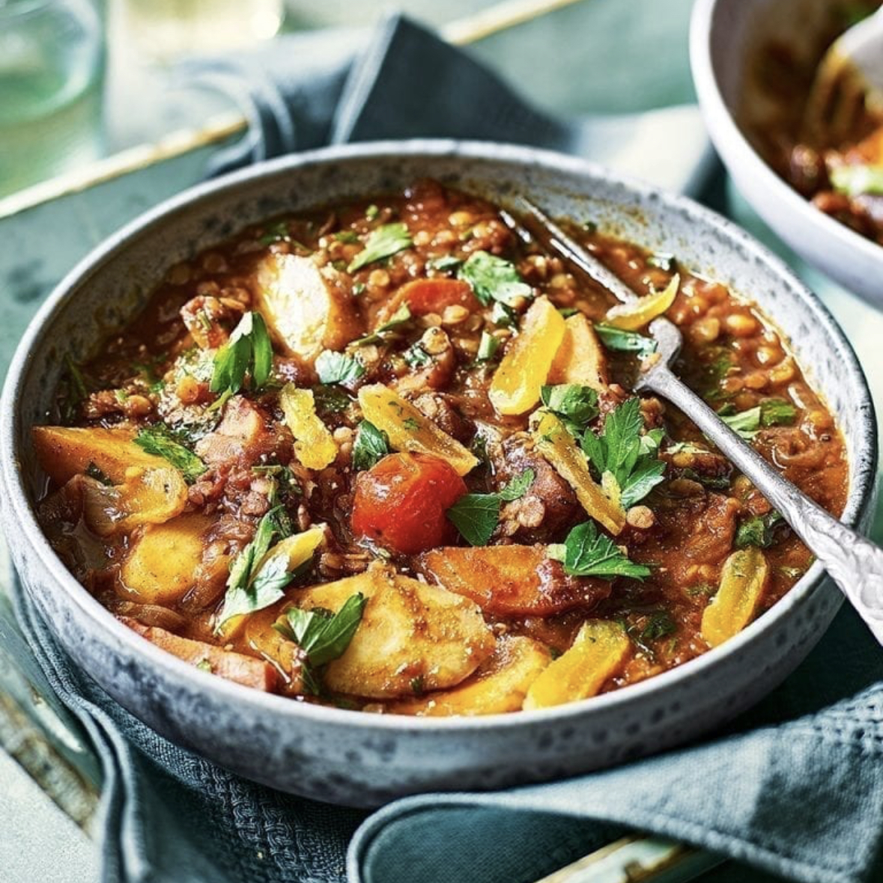

Grilled Chicken Caesar Salad - Grilled chicken breast laid out on a crisp crunchy lettuce, thrown in a zesty Caesar dressing, topped with fluffy blue cheese and croutons. £22.95

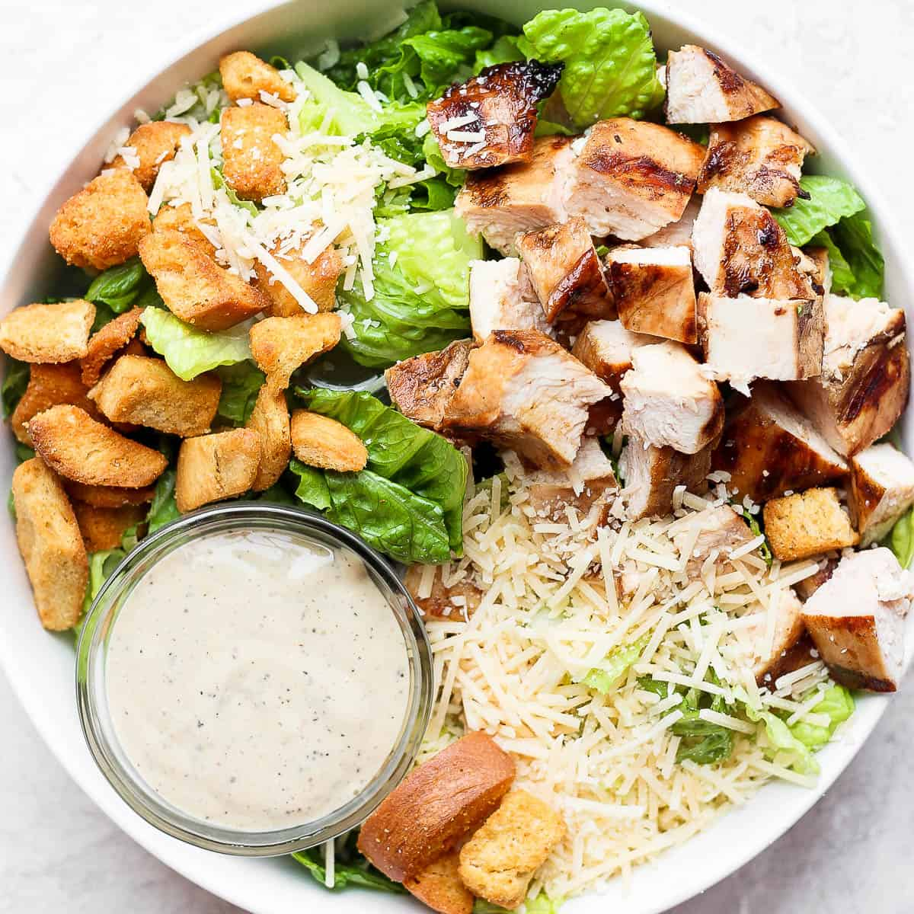

Desserts

Flourless Chocolate Cake - A rich and strong flourless chocolate cake made with top end dark chocolate, served with a scoop of vanilla bean ice cream and fresh berries. £8.95

Seasonal Fruit Tart - A buttery tart outside filled with a viscous vanilla cream with an assortment of fresh seasonal fruits added on top. £8.95



Vegan Coconut Mango Panna Cotta - A creamy coconut milk-based panna cotta mixed with mango flavors, served with a zesty mango coulis. £8.95

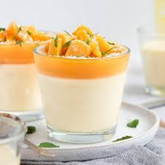

Beverages
Freshly Squeezed Citrus Juice - A refreshing blend of orange, grapefruit, and lemon juices, served over ice. £7.50
Organic Mint Lemonade - A thirst-quenching drink made with freshly squeezed lemon juice, muddled mint leaves, and organic cane sugar. £7.50
Soft Drinks- Coke, Sprite, Fanta (dietary drinks available) £7..50
White wine- Chardonnay: gives of hints of green apple, lemon zest and grapefruit when unoaked. oaked aromas finishes with astonishing buttery notes of spice and vanilla. £22.00
Red wine- Cooper’s Hawk Red: Australian Shiraz, Sonoma Zinfandel, and Châteauneuf-du-Pape are examples of this style, which is characterised by ripe, rich fruit and an abundance of spices. £20.00



Please let us know if there are any dietary requirements.

References:
- BBC. “BBC Good Food.” BBC Good Food, 2017, www.bbcgoodfood.com/.
- “How to Calculate Your Restaurant’s Food Costs (with Examples).” Lightspeed, www.lightspeedhq.com/blog/how-to-calculate-restaurant-food-costs/#:~:text=in%20each%20restaurant.-. Accessed 9 June 2023.
- WebstaurantStore. “Menu Engineering: The Science behind Menu Psychology.” WebstaurantStore, WebstaurantStore, 19 Aug. 2019, www.webstaurantstore.com/article/89/menu-psychology-the-science-behind-menu-engineering.html.
- TOURISM AND HOSPITALITY RESEARCH http://thr.sagepub.com/ New Editorial Team. (2012). Tourism and Hospitality Research, 12(4), pp.171–171. doi:https://doi.org/10.1177/1467358413505795.
- Management 2020 (https://modernrestaurantmanagement.com), M.R. (n.d.). Modern Restaurant Management (MRM). [online] Modern Restaurant Management. Available at: https://modernrestaurantmanagement.com/ [Accessed 25 May 2023].
- BBC Good Food. (n.d.). Chicken caesar salad. [online] Available at: https://www.bbcgoodfood.com/recipes/chicken-caesar-salad/amp [Accessed 9 Jun. 2023].
- ‌ Hargreaves, S.M., Raposo, A., Saraiva, A. and Zandonadi, R.P. (2021). Vegetarian Diet: An Overview through the Perspective of Quality of Life Domains. International Journal of Environmental Research and Public Health, [online] 18(8), p.4067. doi:https://doi.org/10.3390/ijerph18084067.
- BBC Good Food. (n.d.). 65 vegan dessert recipes. [online] Available at: https://www.bbcgoodfood.com/recipes/collection/vegan-dessert-recipes/amp [Accessed 9 Jun. 2023].
- ‌Tavares, R. (2018). Defining Your Restaurant Target Market. [online] RestoHub. Available at: https://www.restohub.org/gb/operations/planning/defining-your-restaurant-target-market/.
‌

