https://www.mixprize.org/story/tale-two-captains-making-case-universal-applicability-leaders-everywhere

STORY:
A TALE OF TWO CAPTAINS: MAKING THE CASE FOR THE UNIVERSAL APPLICABILITY OF LEADERS EVERYWHERE
By Charlie Kim & David Marquet
Focus the work of management on a higher purpose
Reinvent the means of control
Redefine the work of leadership
SUMMARY
A decade apart and a continent away, two stories in dramatically different settings reinforce the idea that “leaders everywhere” is a universally applicable construct. One story takes place onboard the nuclear powered submarine USS Santa Fe, stationed in Hawaii. There, captain David Marquet (pronounced mar-kay) was forced to dramatically rethink the command and control leadership approach he’d been taught. The other story takes place at the Internet startup Next Jump, headquartered in New York City, where Founder and CEO Charlie Kim reinvented his approach to leadership -- and challenged the way businesses should be run.
Serendipitously, David and Charlie each recognized a need for a different type of follower: followers who took initiative, thought deeply about their actions, and aligned their decisions to the goals of the organization. In short, they needed followers who acted, who were leaders – leaders who could consistently make the right decision under enormous pressures. While from two different disciplines, military and business, the common threads were the same: both were essentially forced to adopt new approaches when constraints proved business as usual would not work.
Both fundamentally thought afresh about what the role of the traditional leader was, and freed their people from thinking about themselves as followers.
Both focused on shaping the environment, developing mechanisms, practicing the new behaviors, measuring outcomes, and then reflecting deeply about what they were learning.
Their personal development and investment in a Leader-Leader type framework led to very unexpected outcomes, which they are now sharing together as a team with others across the world. And yet, as leaders they could not dictate or legislate leader-leader (or leadership), they have to invest to setup the right environment for those behaviors to naturally occur.
Here are their stories.
CONTEXT
135 officers, chiefs, and sailors comprise the crew of a nuclear powered submarine. Operating in the depths of the ocean, in potentially hostile waters, and with dangerous equipment, the environment is unforgiving. A similar unforgiving environment, 200 people work in the fast-paced highly competitive pre-IPO tech world where Next Jump competes.
Control is built in to the leadership philosophy of both the submarine force and Corporate America. For the submarine force, control is needed to ensure predictable outcomes when operating complex equipment with potentially catastrophic accident outcomes such as the nuclear reactor, missiles, and torpedoes. For corporate America, capital constrained or capital inflated companies innovate differently. Says Randy Befumo (former head of investment research and private equity investments at Legg Mason), “In all the years, there was a repeated pattern in companies that succeeded versus those who didn’t. In almost every case, the companies that succeeded were capital constrained. This led to them having to innovate and eventually succeeded. On the flip side, companies with excess capital consistently failed.” Capital constrained companies understand -- to innovate requires enormous levels of leadership, at all levels.
Hierarchy is built into the navy system with ranks, roles, and titles. The pervasive leadership structure is one of “leader-follower.” Some lead, most follow. Corporate employees are segmented into lower, middle and upper management, executing (or not executing on) objectives and measured strictly on outcomes. Not meeting goal can be detrimental both to the organization and to an employee’s career. Some employees lead, most follow. In both cases (military and business), subordinates become incredibly reliant on their superiors for tasking – resulting in an army of extremely proficient followers with low levels of initiative, involvement, and ownership. In addition to the human costs, these structures trade away resilience and adaptability for the perception of predictability and control. In reality, they are trading small errors at the edge for the potential of massive failure at the core.
Yet, while there is significant physical work that happens on a submarine (moving torpedoes, disassembling and repairing equipment) and significant mental work that happens in corporations (raising funds, strategizing, managing teams), the discriminator between good and great is individual thinking and the underlying decisions.
Operating the nuclear reactor and operating a submarine beneath the ocean in potentially hostile waters would seem an unlikely place to invent a philosophy of “giving control, create leaders” as opposed to “take control, attract followers” yet that is exactly what happened when David issued an impossible order and his crew tried to follow it. And Charlie found that in the intensely competitive environment of Internet startups, he could craft Next Jump into a truly human organization putting the long-term interests of employees over quarterly profits. With the pregnancy of his top executive’s second child, his philosophy was tested.
TRIGGERS

David’s Trigger
David Marquet acted like any other captain until, one day, he unknowingly gave an impossible order, and his crew tried to follow it anyway. When he asked why, the answer was, “because you told me to.” In that moment there was something akin to an earthquake in his brain. He realized that everything he had been taught about leadership was about getting people to do stuff, to do what they were told. He was leading in a culture of followers trained in compliance, and they were all in danger unless they fundamentally changed the way they did things. What he needed more importantly than doing and compliance was thinking.
David’s constraint was that he was shifted to take command from one submarine to a different one just two weeks ahead of time. The Santa Fe was one of the newest submarines in the fleet and the specific equipment on board was different that what he’d spent the last year training for. Further, he inherited the worst performing worst morale submarine in the fleet.
Despite knowing that he was no longer the technical expert and a desire to allow his people to lead, old habits die hard – hence his impossible order.
At this point he had to rethink everything about what he thought about leadership. Instead of followers he wanted leaders. Instead of compliance he wanted challenges; instead of doers he wanted thinkers. Instead of “taking control” he needed to “give control.”
With the many specific mechanisms he implemented each member of the crew became a leader and assumed responsibility for everything he did, from clerical tasks to crucial combat decisions. The crew became fully engaged, contributing their full intellectual capacity every day, and the Santa Fe started winning awards and promoting a highly disproportionate number of officers to submarine command.
What he had done was create an environment where people strived for greatness, and many achieved it. They called it leader-leader to differentiate it from the standard leader-follower.

Charlie’s Trigger
Next Jump’s Founder and CEO Charlie Kim, is not your ordinary CEO. As an entrepreneur, Charlie has always believed that his greatest investment was that which he made in his people. Even back in 1994 when he founded Next Jump, Charlie started the company not to go from rags to riches, but to maintain a long distance relationship with his high school sweetheart. Those who worked for him at that time (and who are still by his side today) recall Charlie spending money out of his own pocket – just to care for his team.
Throughout the years, Charlie built up the company, both growing and surviving through the dot-com bubble and bust, all while raising money from angel investors and taking nothing from VC’s and private equity firms. As Next Jump continued to grow, Charlie became increasingly aware of the importance of developing his own personal mission, inspired by his father (determined to end world hunger and is one of the world’s most famous corn scientists). When Charlie met Simon Sinek, author of Start With WHY, he instantly tied his own personal mission to Next Jump’s story. Charlie and Next Jump’s WHY is: To Do the Little Things that Allow Others to Do the Great Things that They Are Meant to Do. This mission has transferred into every part of the business, changing the culture of the company, and the way people care about people. Today, the company’s culture is one where employees exist to help others.
And so, when Charlie’s right hand and Chief of Staff, Meghan Messenger, learned she was pregnant with her second child, Charlie didn’t hesitate to tell her, “…we will make this work.” Meghan was thankful, and yet, wondered how they were actually going to make it work when she and Charlie essentially ran the business. They ran every aspect of it... Meghan thought: “How could I keep the same pace? How could I not only keep my post but add value to the business while being a good Mom and taking care of my kids?”
Charlie’s and Meghan’s calendars were packed: they reviewed every business decision, meeting with most leads in the company multiple times per day. And in the evening, they put their minds together to pursue work of their own. The problem with this schedule (besides the amount of hours in a day) was that employees awaited Charlie’s and Meghan’s feedback before acting. Every employee awaited their final decision. Charlie and Meghan knew this was not sustainable for them – and their own people would suffer as a result.
Charlie’s constraint was Meghan’s pregnancy and the realization that the “Charlie and Meghan Show” was going off air. It happened by accident that Meghan’s maternity leave was both the best thing for her family and Next Jump’s leadership model. For one, Meghan and Charlie realized that not only would they “make it work,” they needed it to work to be better parents themselves, and grow better leaders at the company – employees who could think and act like CEOs and consistently make the right judgment call under pressure. In essence, Charlie and Meghan needed more people to own more things so they wouldn’t have to do it all. And in that process, would grow the best leaders the company had ever seen.
KEY INNOVATIONS & TIMELINE
The beauty of these two tales is the subtle unspoken similarities. Charlie and David came from two separate worlds and yet created similar environments... Environments where people become leaders, in a world where following is the norm.

Chapter 1: On Board the Santa Fe
In the depths of the Pacific Ocean off the coast of Hawaii, one of the most modern submarines was moving silently. The USS Santa Fe, an improved Los Angeles class submarine was designed and operated as a stealthy deterrent to would-be aggressors. Armed with missiles and torpedoes, Santa Fe’s mission was to find and sink enemy ships. In peacetime, she would gather information that would later be useful. There was nothing that distinguished this particular day from any other particular day, nothing that presaged the leadership revolution to come.
The crew of the Santa Fe was troubled. People were doing what they were told, initiative was non-existent and fear of making mistakes paralyzed most decision makers into inaction. They had lost sight of the connection between their day-to-day actions and their mission to protect the Constitution. Plagued with poor morale and operational problems, almost every sailor who could was leaving the navy. Having only reenlisted three sailors from a crew of 135 the previous year, retention was at the bottom of the fleet. Officers were resigning their commissions and the previous captain had quit.
A hasty diversion from his previously assigned submarine had placed Commander David Marquet captain of Santa Fe just two weeks prior. Now Santa Fe was at sea for the first time with its new captain. Because the Santa Fe was a newer and different submarine than the submarine he was originally assigned to command, most of the equipment in the control room looked foreign to the new skipper. Still, David fell into the mode he was trained for: giving orders. Well anyway, isn’t that what captains of submarines do?
“Conn, maneuvering, reactor scram!” The engineer had inserted the reactor shutdown deliberately, testing his department's ability to find and repair a simulated fault.
In the control room, the Officer of the Deck, the ship’s senior department head, was doing all the right things. He had shifted propulsion from the main engines to an auxiliary electric motor, the EPM, to turn the propeller. The EPM can only power the ship at low speed and draws power from the battery.
At this point, David nudged the Officer of the Deck and suggested an increase in speed from “ahead 1/3” to “ahead 2/3.” This would drain the battery faster and create a greater sense of urgency for the trouble-shooters. After all, this was the worst performing submarine in the fleet and the crew needed some toughening up.
“Ahead 2/3.” The Officer of the Deck gave the command.
Nothing happened.
The helmsman who should have executed the order was squirming in his chair. No one said anything and several awkward seconds passed. When asked the helmsman reported, “There is no ahead 2/3 on the EPM!”
The captain had made a mistake. Unlike every other submarine he’d been on, there was only a 1/3 speed on the EPM on the Santa Fe, this newest class. This was the equivalent of asking someone to shift into 6th gear on a car that only has 5 speeds.
But what about the most senior department head? Well, he also knew there was no 2/3 speed setting for the EPM. When asked why he ordered it, he replied, “Because you told me to.”
That was the moment of truth. As the Captain, David embodied the traditional leader and had perfected the ability to get people to “do stuff.” This was the point of everything taught about leadership after all; exploit the people to further the mission of the organization. But a modern nuclear submarine is much too complicated and activity takes place in too many places to be controlled by one person. What Santa Fe had was too much compliance, too much doing, and not enough thinking.
The officers gathered in the wardroom and set to turn this around. From then on the captain stopped issuing orders. The officers, for their part, stopped asking permission and began stating intentions with “I intend to…” Although a simple turn of language, this created ownership in the mind of the officer, and they all started the path toward thinking like the captain.
It turns out that “tell me what to do” thinking was pervasive and often disguised. The check lists of tasks department heads maintained for their division officers are “tell me what to do.” Briefings conducted prior to events such as loading torpedoes was “tell me what to do.”
The Ladder of Control is a way to think about this. At the bottom is “tell me what to do.” Somewhere in the middle is “request permission to…” and just above that is “I intend to…” Listen to your people interacting with each other and with you. Identify where they are on the ladder and move them up, one rung at a time. It all starts at the bottom by asking them what they think.
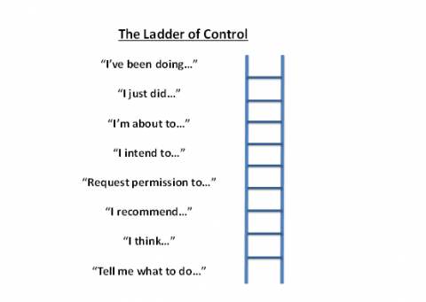
The general rule is this: if you want people to think, give intent, not instructions.
The crew came up with a host of mechanisms to allow subordinates to exercise control and many of them focused on language. Another example was “think out loud.”
The submarine was entering Pearl Harbor, driving on the surface. The officer of the deck who gives the actual maneuvering orders felt the navigation team had indicated it was time to turn to the next course leg a few seconds early and so withheld the order. Standing silently, with the microphone in his hand, the officer knew he was about to order the turn…but the captain didn’t.
It was at this point that David intervened with “aren’t you going to turn?” The officer of the deck was deflated. He had lost initiative and the confidence of his boss.
The antidote was to think out loud. Officers practiced stating their thinking out loud. In this case, “I think the navigation team has marked the turn early and I intend to turn in 5 seconds.” Other areas where these naval officers needed to learn how to talk included diverse opinion, dissenting opinion, ambiguity, uncertainty, and gut feelings.

Chapter 2: Getting into Next Jump
Today, Next Jump teaches other companies how to attract and retain talent. A few years ago, the company took its turnover from 40% to 1%, and became one of the most challenging organizations to get into. In 2012: Next Jump only accepted 35 new hires out of almost 18,000 applicants (a 0.2% acceptance rate). Compared to Harvard’s acceptance rate in 2012 of 5.9, Next Jump managed to be tougher to get into than the top school in the country.
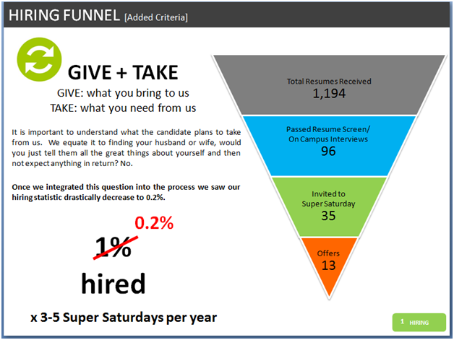
For Next Jump, getting to this point took years of analysis; it took years of building the right environment, an environment that produces leaders who consistently make the right judgment call under pressure.
Where It All Began
Currently, the whole Next Jump family is a part of the hiring process – from receptionist to senior management. Everyone not only wants to have a stake in who becomes part of the family – they also know it is crucial to actively be part of the decision process; else, the company would be destined to fail.
But it didn’t begin that way. Prior to 2007, all of Next Jump’s hires came into the company via a traditional route: a phone screen, a few rounds of interviews, perhaps an efficiency test, followed by a potential offer. During that time, the majority of the company consisted of business people versus engineers. For an Internet company, this didn’t seem to work. A member of Next Jump’s board told Charlie that “…to become a top Internet company where engineers would want to be, you have to start recruiting from colleges, just like Google and Facebook.”
Beginning of 2007, Next Jump decided to follow this advice and went to college campuses, recruiting top engineers. But with one catch. Although, they were told by many advisors that it would be impossible to recruit engineers to the East Coast (that most engineers had their sights set on Silicon Valley), Next Jump decided to headquarter in New York City, where they spent years improving their recruiting and hiring processes.
To start, Next Jump decided to try their very first Super Saturday, fall of 2007. Super Saturday is an event typically held by investment banks, where job candidates from a variety of schools come into the bank to interview with employees. Next Jump took the traditional Super Saturday and made it their own by creating a 10-hour company-wide event, bringing in top talent from top schools, all previously screened prior to walking through the door.
The candidate is put through rigorous skills testing, rounds of interviews, team building presentations, and has multiple opportunities to meet with employees of Next Jump at meals and intermittent snacks. Candidates have many meaningful conversations with employees, a chance to hear varying stories and take in different perspectives. This offers a fuller picture of what’s to come should the candidate be hired, versus a pre-packaged story by the company’s marketing team. There is a 2:1 ratio of employee to candidate – meaning, with about 60+ candidates, almost the entire company comes together to screen who they want as fellow employees. A typical organizational chart and schedule will usually include close to the entire company.
Next Jump employees stay late into the night deliberating over candidates, for whom they want to make an offer. Similar to a long car ride, it’s either love or hate after spending the entire day together, and the feeling is usually mutual. The company sends offers to those they love the following Monday.
Transferring the Reins of Captainship
In 2007, the Super Saturday process started with Charlie heading the entire event, which was not sustainable as the process grew. Moving forward, every Super Saturday, it was one person’s job as the event coordinator, along with a full team of leads, to spend the day looking for ways to improve.
At that time, Charlie recognized that after being a lead of Super Saturday, he learned many lessons he could eventually share with someone else in his shoes – someone who could take those lessons and learn new lessons, too. At that point, he realized: helping others could only come after being in a leadership role. He said: we need more leaders to feel the pain, to teach others, and pass down knowledge. This prevented the same mistakes being repeated and offered a chance to pass lessons learned from one Super Saturday to the next.
For the next Super Saturday, also that same year, Charlie’s Senior Vice President, Greg Kunkel, captained the day. Charlie (in the coaching role) was now able to step back and observe how Greg operated. He was able to provide Greg with some mistakes he had made, and Greg was able to run the event even better than Charlie had the previous time, since he learned lessons from Charlie he couldn’t have otherwise received.
From this coaching-captain framework, a new process was born that would eventually bleed into all areas of the company when it came to developing leaders and distributing power across the company. Eventually, those in a coaching role realize that to make something better – be it products or events – relinquishing control was the way to not only get better results, but also teach others in the process.
The “FLO,” Leadership Framework
From Super Saturday spurred a new leadership framework that helped leaders step back, get less tactical, and facilitate new leaders to grow, take risks and take ownership. Next Jump called this model THE FLO (FOLLOW-LEADER-ORGANIZATION) MODEL. Multiple iterations and multiple captains of Super Saturday had the day down to a science. The day became more than just a recruiting event: Super Saturday became a platform to develop leaders in the company. Super Saturday became the first practice ground of the FLO MODEL.
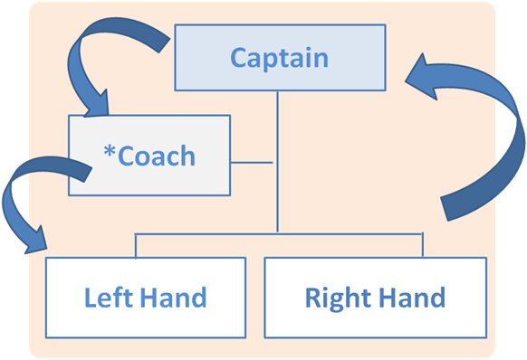
*The primary focus of the coach is to help build a better leader and captain
This organizational framework helps distribute power such that “orders” cannot come from the top-down, but instead, lessons learned from previous leaders are applied from the bottom up, and cycle. For example, in the case of Super Saturday, employees clamor for the honor to lead an enormous company-wide effort and learn leadership at scale, all while being coached and mentored by his or her predecessor, and while having “Multiple Hands” to help take ownership and make executive calls before, during and after the event.
Charlie doesn’t interview applicants of Next Jump anymore. He used to... But found that a group decision is more powerful when structured correctly. The classic notion is that founders are the best at selecting talent. However, Next Jump came up with a better, more scalable and sustainable solution. The rigorous decision about who “gets in the door” is in the hands of his employees. Consistently, employees are making the right judgment call time and again.
For example, driven people don’t necessarily come with a desire to help others. The smartest candidates don’t necessarily have the most humble attitude. The combination of smart, driven, humble and a true desire to give back to the world and help others is hard to come by. In a few interviews, can one truly determine how a new hire will be if hired?
Quickly, Next Jump learned that it would take an army of people to recruit, attract and retain talent. Throughout the day, Next Jumpers make it a point to rate candidates at lunch or in the hallways, if they held the doors, or if they were kind to the coat-check employee – as these little signs would be indicative of a later successful individual at the company. Below is a sheet that every Next Jumper receives that has the thumbs up and thumbs down score next to a candidate's name, even before the candidates walk through the door for Super Saturday.
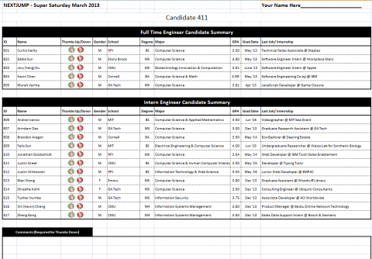
In the end, Executive Leaders are not making the final decisions, as every interaction with a candidate counts, whether via interview, at lunch, or just walking in the hall and seeing if the candidate will hold a door open. Any employee can rate a potential candidate. Is the candidate humble? Did they work well in their team exercise? Throughout the day, there is a dynamic “scoreboard” in what Next Jump calls, “The War-Room,” where employees can see a real-time shift in a candidate’s performance and as multiple checkpoints come through, employees can see the new data pop out based on employee candidate feedback.
Below is an example of the data-driven results, run by employees:
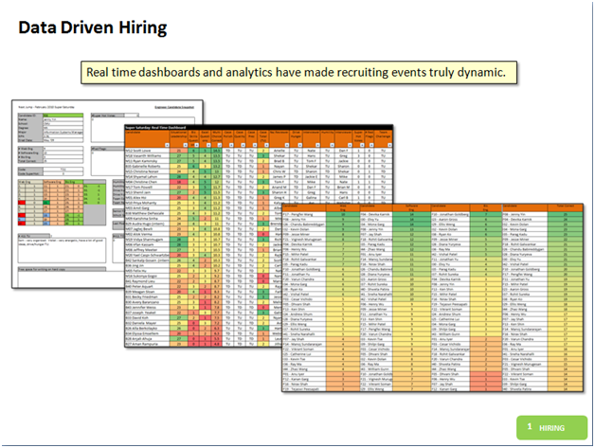
The day is so much more than recruiting – the company relies on all Next Jumpers to make informed decisions.

Chapter 3: A Snapshot on board the Santa Fe
“Fire, Fire, Fire!”
A fire on a submarine was one of the most life-threatening accidents there were. Not only would thick black smoke force the crew to wear emergency air breathing (EAB) devices; the visibility would be reduced to near zero. Unchecked, the fire would grow in size, and the contained atmosphere in the boat would result in heat and pressure increases that would make human existence impossible.
The key time was 2 minutes. Studies showed we needed a fire hose applying water to the fire within 2 minutes.
As was the prerogative of the captain, David was observing this exercise just forward of the crew’s mess when the fire alarm rang. The closest fire hose on Santa Fe was in the passageway just forward of the crew’s mess, about 50 feet from the fire’s location. It should have been easy. The entire engineering department, forty people, was conducting training in the crew’s mess.
The fire was detected and the alarm was sounded. What happened next?
Well, the engineers scattered, running right by the hose and leaving it hanging on the bulkhead. The crew members assigned to that particular hose couldn’t even get to the hose because there were so many people in the way. Why didn’t the crew just take the hose, lay it out, pressurize it, and end the whole thing in 60 seconds?
Because they hadn’t been trained that way. They had been trained to follow the procedure to put out the fire which assigned men to specific roles. They were marked down if they didn’t show up for their assignments (hose man, ax man, thermal image operator and so on) so this became the objective, not putting the fire out. Further, response was directed from Damage Control Central by officers who issue specific instructions to the crew based upon reports they received.
On board Santa Fe all that changed.
First, the objective changed from following the established set of best practices to putting the fire out. They stationed observers to measure the time that it took to put the fire out. This was determined to be the one single overriding metric that mattered. It was scientifically based. It was made clear to the crew that this was the objective, and it didn’t matter who was on the hose. The sailors responded brilliantly, and Santa Fe significantly improved their response time. Now when the alarm sounded, the closest men self-organized to achieve the goal. Santa Fe would later receive awards for their damage control responses.
It might strike you as odd that given a choice people choose to follow a procedure rather than take the steps necessary to accomplish the goal of the procedure yet this happens all the time. We live in a world where more and more rules, regulations, and ordnances are enacted to get people to behave in certain ways. Compliance with the rules becomes the unstated objective even when the rules are clumsy, are written for general cases, and don’t incorporate the latest thinking or technology. No one gets fired for following the rules.
Second, on board Santa Fe, they changed from issuing instructions to providing information. The officers who manned damage control central controlled the ship’s response to casualties. In the old way, DC central would issue orders such as “Senior Chief Worshek, report with the thermal imager to the engine room.” This changed to “A thermal imager is needed in the engine room.” It was information. DC central would not specify who or how. The crew figured it out. The man with the thermal imager would head to the auxiliary room and, as he passed a phone talker, report, “Senior Chief Worshek with the thermal imager proceeding to the auxiliary room.”
This “decentralized” approach to DC central ended up being much more resilient and effective. Now, if Senior Chief Worshek were ready and available, he would pick up the thermal imager and go toward the fire. However, if he weren’t available, another crew member would step into his place.
This places a greater training burden on the organization, though. Previously only Senior Chief Worshek and a backup would be trained on the use of the thermal imager. Now, everyone of the crew needed to know how to operate it.

Chapter 4: What it's Like to Be an Employee of Next Jump
Ever wonder what it would be like if your employer recognized and rewarded you for being a good person? That is what the employees of Next Jump get to experience every day. As employees enter and leave the building, they see the following sign:
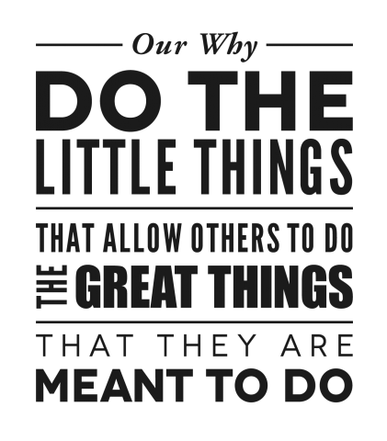
The sign is a constant reminder that the company seeks a higher purpose, which is “To use business as a platform to build people of higher character.” For example, employees are recognized not for being the best salesperson, but instead, for helping another employee with a project or for helping others in their community. Living in this kind of work environment not only teaches employees a better way to interact with each other (including how they interface with clients, friends and family), but also how to better oneself, so as to help others more effectively. The belief is that one can only help another to the limits that one can help his or herself, which led to the development of the Next Jump Formula: BETTER ME + BETTER YOU = BETTER US.
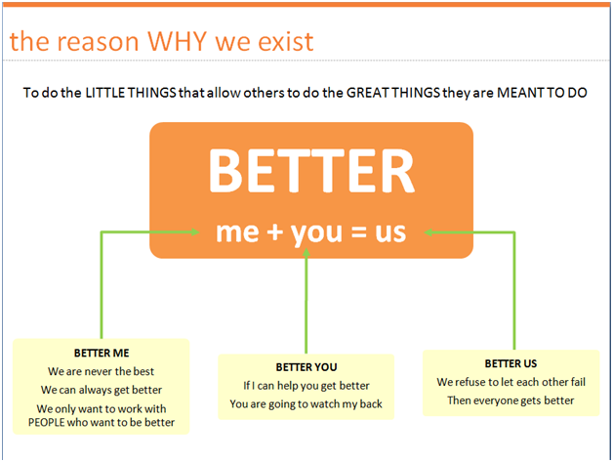
Better Me
There are two important parts of the Better ME philosophy – physical and mental.
Physical begins with good health to ensure enough energy to grow and learn when stressed and mentally depleted. Energy (comprised of sleep, nutrition and exercise) is the foundation for growth. With a strong physical foundation, employees are better equipped to handle pressures. The company believes that if one continually upgrades his or her physical self, he or she can tackle mental challenges. When the cup doesn’t “runneth over” it’s impossible to help others (or want to) when physically depleted. This is why Next Jump invested in a full-fledged wellness program, with a fitness center, fitness competition, and a nutritious 24-7 Food Service Program.
The second part of Better ME is around mental growth. Everyone wants to succeed, however people are caught in a form of repeated errors, poor decisions, and poor judgment calls. So the question Next Jumpers ask each other is: “what is your backhand?” The “backhand” is the weak side – it is the imbalanced character trait that emerges at the point of stress. Next Jump recognized that thematic errors are rooted in this imbalance of character muscles.
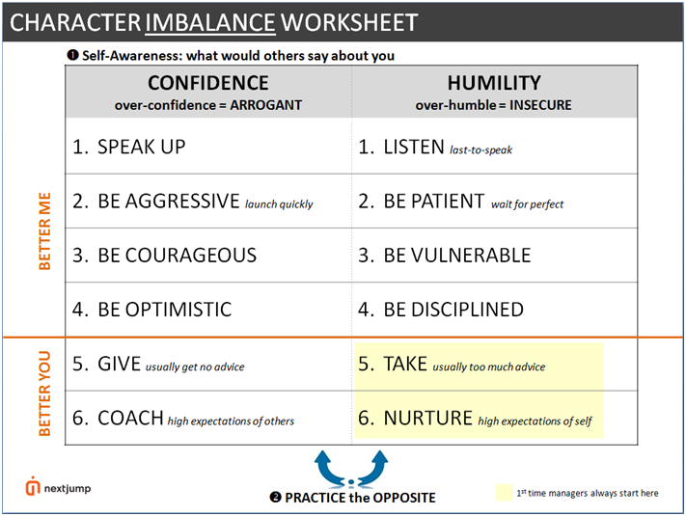
By working toward “character balance,” Next Jumpers minimize the repetition of thematic errors. Next Jump discovered that most people err on the side of a specific category: confidence or humility. When too swayed to the confidence side, one is arrogant. When too far on the humble side, one is insecure. Working to correct the imbalance through training and practice under stress is critical. This is where practicing the backhand comes into play, for which there are BETTER ME programs available. As character becomes more balanced, a person can make better judgment calls and become a more competent leader.
Practicing the backhand is only possible in a safe practice ground where people can experiment, take risks, invest in loss and consequently grow through failing. Having a “No Fire Policy” at the company, implemented a year ago, impacted the ability for employees to take more risks, feel what it is like to fail, and know that their manager is truly trying to help them succeed. The place to practice “failing forward” is through what Next Jump calls culture initiatives, or “above the water line (per David Marquet)” a practice ground, because if an employee “blows a hole in the ship,” it won’t sink.
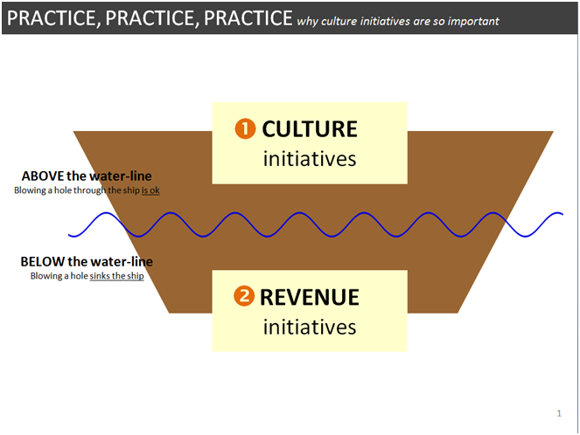
Better You
The Better YOU part of the equation is around purpose. Who YOU helped, what YOU gave back. Next Jump gives in an area of their strengths. So for example, giving back to charity isn’t something they do with money (although that is certainly an option present in the company). Giving back with expertise is how the company felt they could help others most and have leaders begin to emerge. They started with “Code For A Cause (CFAC),” giving away expertise, something better than money. As with other cultural initiatives, a Captain, Coach, Right Hand and Left Hand allows for team leadership at all levels.
Other Better YOU programs that also have the FLO model incorporated are: Vendor Appreciation Day for holiday gifts, contributing an optional 10% of their salaries to the forgotten population during Hurricane Sandy, as well as becoming one of the largest contributors to DonorsChoose.org and visiting some of the schools they impacted. These were all ideas that came out of the team FLO model, and wouldn’t have been possible with just one person making the calls.
Most recently, Next Jump offered office space to a non-profit, Summer Search, becoming the first for-profit corporation to “adopt-a-nonprofit.” Employees are learning from the Summer Search team how to be more empathetic and give back.
Better Us is not as tangible as Better ME and Better YOU – Better US is the vision that Next Jumpers strive to attain, constantly out of reach.
Better Me Program: Fitness Competition
A good example that shows leadership from the ground up is the internal Fitness Competition. The competition was started in 2008 to get better participation in the on-site free gym for employees. The whole company was and currently still is divided into five teams that change every year, both in players and in its captains. In the very start of the competition, the executive leadership team led the company as the five captains. But participation did not climb. It was only when the company peer-nominated captains that an organic sense of leadership started to surface and teams felt a sense of pride that was unsurpassed. In 2010, the first team hit their first-ever “100% conversion” where every member worked out on the team at least 2x per week.
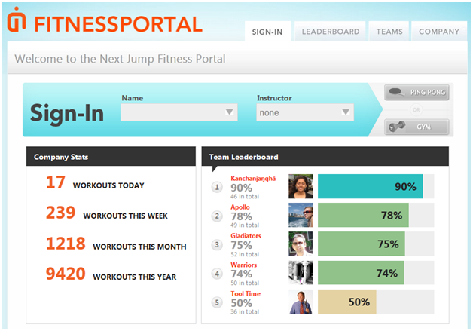
Motivated by their team, members can check on anyone’s “fit-rank” at any time to see exactly how far they’ve come. This is a big motivator as fitness is not just about letting oneself down, but also others. In a sense, fitness at Next Jump is both helping oneself and others.
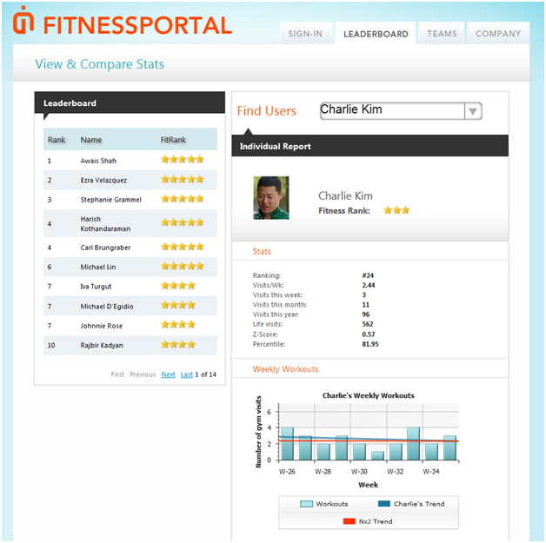

Better You Program: Bigger Hearts
“It’s like a hot potato. Except I take it seriously. When the phone rings, I literally jump over the desks just so I can get to the phone before anyone else. I love talking to customers, even angry ones. I learn a lot from them about how to make the site easier to use. When the call’s over, I’ll say, ‘If you have any follow-up questions, my name is Paul English; I’m the co-founder of the company.’ I’ll give out my personal cell-phone number. Only one out of 20 people might actually call, but they’re blown away when I do that.” – Paul English of Kayak, featured in INC Magazine.
The above quotation is the way Next Jump feels about customer service, which they call: Customer Success (CS). The “Bigger Hearts” program began when one of the company’s software engineers recognized a customer service issue and instead of forwarding the problem onward, he took the time to understand the situation and solve it himself. This extreme love and care spawned the Bigger Hearts movement. Now, the whole company partakes in “Bigger Hearts,” to help build muscles of empathy, listen intently, and serve customers at the highest level. But it did not start that way…
CS was historically led by the top down, where executive leaders would help a small CS team insulate and solve symptoms of problems as they occurred. Engineers continued to build -- sometimes not knowing what issues they were solving. How could we get engineers involved in user iddues and help them truly understand what was at stake?
Because those who work at Next Jump are immersed by a culture of helping others, it was no surprise when Kim saw CS as an opportunity to build better empathy in all his employees -- and give employees another chance to step up and lead. CS became the ultimate platform to help employees grow their "empathy muscle" and become better people.
One of Next Jump's top engineers, Lokeya, never helped a customer before – she never needed to. After solving a few tickets through the Bigger Hearts program, Lokeya shared a story with the executive leadership about how Bigger Hearts helped her with travel product ownership and in making the actual product better.
“We are trying to find patterns of issue which are occurring in travel and trace the root cause of the issues/bugs and fix them at the source,” said Lokeya. Here is her story about how Bigger Hearts ended up helping her team trace a major bug in the system, but more importantly, how she took ownership of the product:
“We saw an issue from a user who booked a flight and on the day of her travel she went to the airport and she figured out that she actually didn’t have a booking. She was going to a wedding and she was going to do the hair styles for all the bridesmaids and so she was freaking out and she had to book another flight, pay for it, and travel.
“She wrote a very angry email to the travel team. Without reporting the issue up, Xuelan and Mike immediately begun to look into the issue and discovered out a bug that had been making bookings for one particular org in QA environment. The bug had been there for a year or so but the travel offer was suppressed for that org till this May when the suppression was removed and users started booking.
As soon as the bug was fixed we also noticed 6 users who had flights booked from same org and proactively reached out to them to help them rebook. If we had not to obsess over this issue this bug would still be out there for months and users would be facing very bad experiences of not having bookings.
Bigger Hearts helped bring in the ownership of the product to next level and the bugs like these can get addressed quickly.”
The difficulty in finding bugs should not be overlooked. If it were not for the team’s understanding that in this particular organization, they should not give up, they should think for themselves and continue to push until the issues are rectified, these bugs would still be floating in the system.
As of today, Bigger Hearts is companywide, and each employee can see their "Empathy Rank," on a transparent leaderboard. Everyone owns the product and the results.
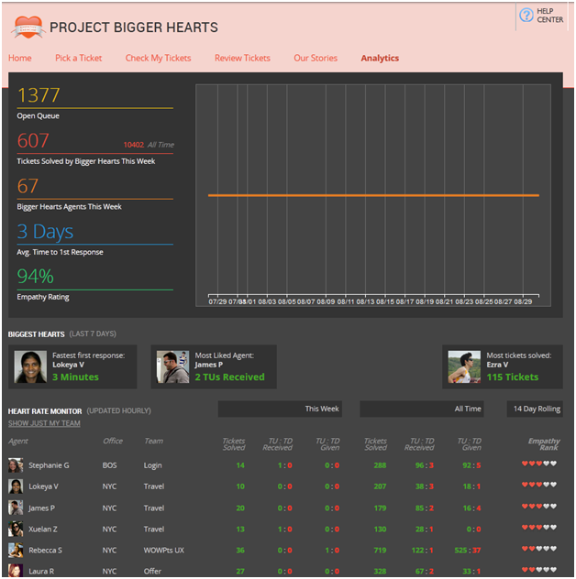
Motherhood at Next Jump
It is disruptive to think of business as a way to help people become better people. But as shown, that is exactly what Next Jump aims to do. When Meghan became pregnant with her second child, it became a chance for Next Jump to practice both Better ME + Better YOU. Next Jump could help Meghan take the time she needed as a mother (Better YOU), plus help others on her team learn aspects of her job that only she could do, helping them become better leaders (Better ME).

To make motherhood work for the business and at home, Meghan and Charlie realized that they needed more leaders, employees who could think for themselves, make the right judgment call, and take ownership of revenue and culture initiatives. “We needed more people to own more things so we wouldn’t have to do it all,” says Meghan. “A sustainable system where everyone contributes to the bottom line and to our culture.”
A year later…the shift in leadership seemed to be working for the business and for Meghan as a working mom, plus Charlie as a working dad BECAUSE OF the investments in leadership that were made throughout the years. A greater discussion of challenges are listed below.
CHALLENGES & SOLUTIONS

David’s Lessons
On board the USS Santa Fe, early 1999, in the waters off Hawaii. A tactical inspection is under way. 6 officer of the Santa Fe war council crowded around the chart table with me.
Where was the enemy going? I scanned the chart and it came to me. I saw that they were likely heading for some congested waters near Maui.
“Here, we need to be here at 0600.” I tapped the chart with the butt end of the flashlight at a spot in the Maui basin. If the enemy were indeed heading toward those congested waters, this location, upslope from them, looking into the deeper, quieter water, would be the spot from which we would launch our attack.
It was midnight. I was exhausted.
I looked around. Heads nodded. Any questions? There were none. “Okay, call me if anything comes up that interferes with this plan or may make us want to reconsider it.”
We had been implementing “I intend to…” and pushing authority and decision making but tired as I was, I reverted back to type.
When I got up at 0500, I was dismayed to find that we were several miles out of position. Not only that, we were headed in the wrong direction, away from the enemy! Now the enemy was likely to be upslope of us! It would take several hours to reverse the situation, a tactical blunder that would result in a down check during an inspection but could spell death during combat. The watch team had allowed a series of short-term contacts and navigational issues to drive them rather than driving the ship to an optimal tactical position. We were still letting things happen to us rather than proactively making things happen.
The biggest challenge, again and again, to giving control and building a team of leaders instead of followers was me. As long as things were going well, it was easy to delegate authority but under stress, when tired or hungry, my instinct was to revert to command and control leadership. I’m in control and I’m giving the commands. I found I needed to suppress these instincts. It could be that our cultural norms for leadership are embodied in the Great Leader of the Achilles, Beowulf, or Patton type. It could also be our human instincts that drive us toward establishing our own place high on the hierarchy. Whatever the reason, I found myself time and time again resisting the impulse to issue orders, give solutions, and tell people what to do.
The solution, if it can be called one, for me was simply to recognize the need to act counter to those impulses: to give control rather than take control, to take risk and my people.
Should you decide to continue down this path I believe that this will be your challenge, and at the same time, greatest success. Giving control and creating environments where others bring their full passion, energy, and mental faculties to work will result in the greatest achievement of all: the cultivation of greatness in your people.
Finale: Marquet joins Next Jump.

Charlie's Lessons
Reprinted with permission from the Huffington Post Blog, my recent article entitled "Why Have Tech Companies Stopped Trying to Solve Big Problems," explains the challenges I've faced and the rewards I've seen when investing in true leadership.
Today, most tech companies try and solve problems in 12-14 months, boast their success, then try and exit.
How did this happen?
To better understand why tech companies stopped trying to solve big problems and opted for easier, faster payouts, look at the human capital -- most are run by young engineers.
This is best understood when looking at other industries, particularly sports and entertainment. We know these stories well from the tabloids: the young athlete, the quick rise to fame of adolescent celebrities and their quick descent as these stars turn, seduced by the dark side of power, fame and money often losing sight of their early ambition.
There is that famous quote from Spider Man, "With great power comes great responsibility."
There is an imbalance in tech companies and therein lies the problem. Power without responsibility corrupts.
Engineers are powerful. They are arguably the most powerful form of human capital today, creating life-changing products that can touch the lives of many, quickly. And they are often young. The younger and less experienced professionals are more easily corruptible and seduced by the dark side. Starting in universities, these promising engineers are trained and given more POWER. Guided by their drive and smarts they start a job, sometimes a company, where they are given more POWER. They are constantly learning and creating new technologies.
But nobody is focused on teaching these rising leaders responsibility. A famous 19th century historian, Lord Acton, said, "Power corrupts and absolute power corrupts absolutely."
At Next Jump, we have invested in teaching responsibility since the beginning. What we mean by responsibility is to be "responsible for others." We've balanced the importance of continued personal growth with emphasis on learning to prioritize helping others. How do you help people care for others? We teach listening and communication skills, help to cultivate humility for the arrogant and strengthen confidence for the insecure. We invest in programs to grow empathy, overcome fear and build grit, then we train leaders to coach others to pass along their learned skills.
We faced immense push back, but our outcome five years later is profound.
The process of investing in leadership had an outcome that showed up five years later. Recently, I sat at a lunch with some of our best engineers as they hit their five-year anniversary with the company. I listened to them talking to each other, discussing products, strategy and even how to help the newly-appointed leadership team. Kalyan said, "They have a lot of questions, we should hold a training session to help onboard them." Right then, I had a profound "aha" moment... these kids are now leaders. They have both great power and great responsibility.
We put a name to this process: "Better ME + Better YOU = Better Us." Great Power + Great Responsibility = A Better World.
We are still learning and experimenting and we would love to hear what others are doing.
http://www.huffingtonpost.com/charlie-kim/why-have-tech-companies-stopped-trying-to-solve-big-problems_b_3839524.html
BENEFITS & METRICS
Marquet
- Awarded Arleigh Burke Award in 2000 for the most improved naval ship, submarine, or squadron in the Pacific
- Awarded Submarine Squadron Seven Battle “E” award for 2001 for most combat effective submarine.
- 10 officers selected to command, a highly disproportionate number.
- “Most empowered workplace. Ever.” – Stephen R. Covey
- Highest retention in submarine force, 1999.
Next Jump
- Top destination of engineering talent from east coast universities [Which led to turnover of 40% from talent poaching]
- Turnover reduced from 40% to 1% in months
- Over 90% ratings in surveys on Engagement and employees stating “Love their Job”
- Five year revenue growth of 25% increased to over 60%
- Awarded a Fit-Friendly Workplace by the American Heart Association, 2013
- Shortlisted for Employee Benefit Awards, 2013
- “Virtually no employer is helping their employees take care of their physical selves both mind and body better, so that they can breathe life into their jobs and into their families.” – Jim Loehr.
LESSONS
Here are several ways in which Marquet and Next Jump reframed out thinking about leadership.
Leaders before followers. Everyone needed first to think of themselves as leaders. However, embedded within the leader-leader paradigm is the concept of follower-follower. In this case, both the “leader” and the team are following a common purpose and set of principles.
People before production. The framework is that we are creating better people, and, oh by the way we operate a nuclear submarine. We exploit the resources of the organization to create better people, not the other way around.
Happiness before productivity. With low morale and low performance we accidentally learned that by focusing on happiness first, performance improved much more rapidly that it could have had we focuses strictly on performance. See the video “Happiness Comes First.
Principle before personality. Embedded within the concept of leader-leader is the concept of follower-follower. While each person thinks of themselves as leaders in the sense that they take responsibility and aspire to achieve greatness connected with a higher purpose, we are all also followers: followers of the mission, followers of the purpose we’ve signed up to, followers of the group.
CREDITS
AUTHORS
David Marquet
Charlie Kim
Managing Editor: Marissa Beck, MS, RD
WEBSITES
davidmarquet.com
nextjump.com
BOOKS
- Simon Sinek, Start with Why.
- Jim Loehr, The Only Way to Win.
- L. David Marquet: Turn the Ship Around, Penguin, Portfolio, 2013, New York.
ARTICLES
- Fast company, A Submarine Captain on the Power of Leadership Language, July 2012.
- Leader to Leader Journal, Summer 2013, Create Empowered employees by David Marquet.
- Best Employee Perks: Fringe Benefits that Make a Difference
- Greatist, The 44 Healthiest Companies to Work For, October 25, 2012. The 44 Healthiest Company
- Founders of Institute, Startup Mentor Superheroes: The Top Founder Institute Mentors for 2012, May 20, 2013, Founder & CEO Charlie Kim highest rated mentor in Eastern US: The Top founders Institute Mentors
- New York Times, By Deadline, 7 Bids in Science School Contest, October 31, 2011 By Deadline, 7 Bids in Science School Contest by Patrick McGeehan
- Tech Crunch, Everything you want to know about the most secretive Startup in the world, January 14th, 2010 Everything you want to know about the most secretive startup by Erick Schonfeld
- BBC News, What if you got paid to play games at work?, 28th February, 2012. What if you got paid to play games at work? By Fiona Garham
- FastCompany, Beyond Bogus Corporate Responsibility: It’s time to get your hands dirty, July 10, 2013 Beyond Bogus Corporate Responsibility by Shane Snow
VIDEOS
- Book trailer with Verne Harnish. 3 min chat about the ideas in “Turn the Ship Around.” “Happiness Comes First.” 17 min talk in Copenhagen about this story.
- David Marquet Interview with Jonathan Fields. 37 min interview discussing objective, aspects and mechanisms of leader-leader.
- New York Times, Gaming Workplace Workouts: Next Jump, December 25, 2012, Gaming Workplace Workouts
- Next Jump YouTubes: http://www.youtube.com/user/OfficialNextJump
BLOG POSTS
- Learning from our Mistakes is key to Continuous Improvement. Here’s a 7 step process.
- No Fire Policy at NextJump.
- Next Jump Blog: http://blog.nextjump.com/
MATERIALS
The FLO MODEL is integrated as a leadership style for Next Jump’s “Above-the-Waterline” initiatives, a practice ground where “blowing holes in the ship,” won’t sink the company. Next Jump’s cultural initiatives are its “Above-the-Waterline” practice ground. Revenue efforts are considered “Below the Waterline,” i.e., the real game. There, employees are equipped to handle the stressors they experience given their FLO practice and experience in the cultural arena. We adopted this idea of “Above and Below the Waterline” from David Marquet, in the literal sense.

