The Impact of Work-Family Conflict on Overall Quality of Life and Life Satisfaction of Mothers working in Information Technology Sector
QUANTITATIVE RESEARCH METHODS

Contents
The Impact of Work-Family Conflict on Overall Quality of Life and Life Satisfaction of Mothers working in Information Technology Sector of Pakistan 2
Abstract 2
Introduction 2
Work-Family conflict 4
Theories and Models 4
Sex differences Model 4
Literature review 5
Quality of Life 8
Life satisfaction 9
Aims and Objectives 10
Hypothesis 10
Methodology 10
Research Design 10
Sampling Strategy 10
Participants 11
Procedure 11
Data Collection 12
Work Family Conflict Scale 13
Life Satisfaction 13
Data Analysis 13
Ethics and Risk Assessment 14
Results 14
Descriptive statistics: 14
Correlation Analysis 15
Regression Analysis 16
Discussion 17
Conclusion 18
Recommendations 19
References 20
Appendix 23
Questionnaires 28

The Impact of Work-Family Conflict on Overall Quality of Life and Life Satisfaction of Mothers working in Information Technology Sector of Pakistan

Abstract
This study is designed to investigate the issue of work-family conflict faced by working mothers which is a significant predicament and it should be studied in detail in order to remove the hurdles which restrict the growth of women in underdeveloped countries. This study will investigate the impact of work-family conflict on overall quality of life and life satisfaction of working mothers who belong to information technology industry of Pakistan. Study was conducted on a sample size of 50 working mothers. these variables were empirically tested. The findings of the study present a negative relationship between work-family conflict and overall quality of life of these women. Similarly, work-family conflict is also negatively related to life satisfaction. Results show that 65% of variation in quality of life can be explained by work-family conflict. Whereas 58.8% variation in life satisfaction of working mothers can be explained by work-family conflict.

Introduction
Globalization and modernization have evolved trends in eastern countries. western countries are much advance and developed in comparison to eastern part Therefore, women have been working in almost every field in the job market in western world. Whereas in countries like Pakistan this trend is new, women have started to enter in corporate world for some time now but still entry and survival of a woman in job market is stimulated by various factors. Few of these factors are educational level of women, job opportunities, financial pressure, and family restraints. These reasons sometimes hinder their growth and success in their career. Working mothers have been a centre of more complications due to responsibility of more dependents. Due to family responsibilities and financial pressures women are prone to undergo work-family conflicts and imbalances. The conflict between two roles creates imbalance in their life. This conflict is one of the causes of bad psychological health, increased stress, emotional fatigue, high anxiety levels, depression, and loss of appetite (Frone, 1996, Allen, 2000; rose 2007). All these factors determine the quality of life of a person.
The concept of Work-family has been a recent topic of interest for many researchers as it is determined by number of concepts that are related to two crucial realms of a person’s life. These concepts include accommodation, financial resources, segmentation, work-family conflict, work-family integration also work-family balance (Barnett, 1998; Edwards &Rothbard, 2000; Friedman & Greenhaus, 2000; Greenhaus & Beutell, 1985; Lambert 1990). Work-family conflict has been used quite often in researches. This conflict arises because work role of person interferes in the performance of family role or vice versa. The responsibilities of one role of persons life hinders full concentration and attention in other role of life which creates imbalance in their lives. Moreover, it is best for any human being to lead a balanced life hence being overburdened by work or family can be dangerous to human health and for the organizational performance. It has been reportedly stated that work-family conflict affects employee performance at work. Excess of work-family conflicts causes burnout for many employees.
Perceived quality of life is the mixture of feelings and beliefs that people have about their life and their attitude towards their own lives (Rice et al., 1985b). these attitudes can be towards the overall life or individual components like quality of work life or quality of family life. Measure of happiness and satisfaction are used to estimate the quality of overall life (Andrews and Withey, 1976; Diener, 1984). As research suggest work-family conflicts influences the physical and mental health of individual. It is also adversely related to life satisfaction of a person. All these factors determine the quality of life of a person.
Information technology is one of the fields in which employees have to work odd hours. Since they are dealing in technology and internet, so they are connected to different parts of the worlds remotely. Therefore, they are called to work at any hour. Also, our lives are dependent on technology that even a single disruption in internet, phones, banking can cause a loss of millions and chaos in every one’s life. Hence, IT people can be called anytime for any interruption of technology or maintenance or updating software. Therefore, it hard to maintain a balance in life with such odd office hours and work life. In such condition the responsibilities of working mothers are doubled and they more susceptible to work-family conflicts which can potentially impair their performance and affects their quality of life. It is in interest of organizations to understand the reasons that are contributing to the deteriorating performance of employees. Mental and physical wellbeing of employee is necessary for better performance. It is in best interest of individual to live a balanced life in order to perform well in both spheres of life i-e family and work (Kofodimos, 1993). This study will determine the influence of work-family conflict on quality of life of working mothers in IT sector of Pakistan. Due to limited time resources a sample of fifty respondents i-e mothers working in IT sector have been selected. The study will find the impact and relationship of work-family conflict on quality of life of working mothers and their life satisfaction.

Work-Family conflict
Work-family conflict was first defined by Greenhaus and Beutell (1985) as “a type of conflict that arises between two roles in which the stress caused by role from work and family domain are considered to as a certain extent irreconcilable” (p. 77).
The resraches related to work-family conducted suggest that it can be one one-dimensional or bi-directional which means roles of family hinders in the work role or stress from work role interferes with the performance of family role (Cooke & Rousseau, 1984; Googins & Burben 1987). The two dimensions of work-family conflict can be of two different types (Adams, King & King, 1996).
- Work to family Conflict
- Family to work conflict
Work to family conflict is defined as the stress and job responsibility adversely affects the family life of individual
Family to work conflict is referred as the family related performance and responsibility negatively affects the work performance. Work-family has been calculated using questionnaire based on Likert Scale 1 to 7. The total score of work-family conflict is the independent variable in this study.

Theories and Models

Sex differences Model
An elaborate and holistic model was presented by Duxury, Higgins and Irving (1992) which was an extended and revised version of role conflict model. Teo additional variables role expectations and role involvements were added in the new version. In order to get more accurate results, the family and job satisfaction were substituted by quality of life of the individual. In this model gender differences were also considered in booth dimensions of work-family conflict. Hene this model supports this study because it opened new areas of research to study how gender influences the work-family conflict.
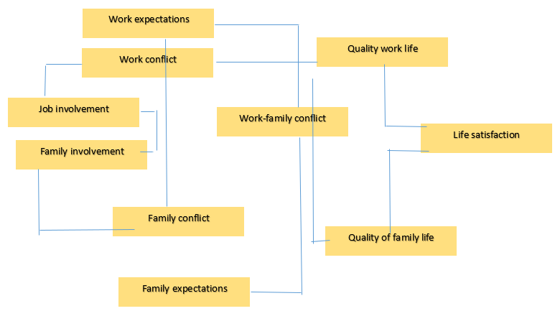

Literature review
The trend of two earning hands is increasing than before. The reason for this new trend is women specially mothers, as more and more women are entering into the corporate world (Piotrokowski Rapoport & Rapoport, 1987; Mathews & Rodin, 1989; Dalton, 1989; Duffy & Pupo, 1992). Reserchers have also discovered the entrepreneurial initiatives of women all around the world (Key, Gunterberg, Holz & Wolter, 2003; CIBC, 2004; Jahanshashi, Pitamber & Nawaser, 2010. Developing countries are also following the same trend. The reasons for such a trend include increased education of women, financial pressure and trend to improve one’s lifestyle (Malik et al 2020). The women are still considered the primary child carer even after entering the corporate jobs and men are still the prime bread winners of the family (Hochschild, 1989). Due to this reason researchers want to explore independence of work and the role of family because having a reasonable work-family balance has an effect on the well being of the society (Edwards and Rothbard,2000) and physical health (Frone at el., 1997). Western researchers have studied work-family balance and work life conflict concept (Berg at el., Frone, 2003; 2001; Marcinkus et al.,2007; young 1999) however this topic has not been researched enough in Pakistan (Aycan et al.,2000) and there is a need to research the multiple social issues that have developed due to the changing trends, which has created a problem of managing the corporate jobs along with the domestic household related affairs efficiently as in Pakistan’s culture the women are responsible of taking care of the household affairs and the male has to act as the bread winner. Different researches have been conducted on life satisfaction in the past and its factors have been conducted (Sirgy el at 2006). A number of economic, institutional and ecological elements have been found that impact the life satisfaction (Bjørnskov et al., 2005, Helliwell 2003; Umer and Zia-ur-Rehman). The effects of work family conflicts on life satisfaction is not tested widely (Matysiak et al, 2010), but few researches on this topic were conducted by Greenhaus et al. (2003), Saraceno et al. (2005) and Wallace et al. (2007). Majority of the researches have been conducted in fully developed countries, but the conditions and situations are very different in the developing countries (UNIDO, 2001;2003). The effect of work life balance and work life conflict on women’s life satisfaction has to be explored as it could be helpful for the women, individuals, society as well as organizations. The purpose of this research is to study and explore the work life conflicts in Pakistan by studying how working mothers of Pakistan in IT industry are affected by work life balance and work life conflicts and impact of this on their daily household affairs.
Work life conflict and work family conflict appears when the demands from an individual's position at work interferes with the family time and vice versa (Greenhaus & Beutell, 1985). Kahn et al (1964), described work family conflict as “a form of inter role pressures from the work and family domains are mutually incompatible in some respect”. Literature shows that there are three types of work-family conflicts that include a behaviour-based conflicts, strain-based conflicts, and time-based conflicts. the present literature discusses the elements and factors which can instigate work-life conflict which includes household responsibilities, office environment and financial responsibilities. Bigger families are more challenging than smaller families in terms of time demand. In bigger family the person will have more household responsibilities therefore, women with big families are susceptible to high work-family conflict (Catwright, 1978; Keith and Schafer 1980). The causes of work-family conflict have been explored by researchers. Some of the reasons identified by Lu et al., (2009) are childcare responsibilities, working hours, monthly income, companies’ flexible policies. Pleck et al., (1980) stated the various types of work family conflict are created because of psychological or physical fatigue. A positive relationship between work-family conflict and the hours worked per week has been established by few researches (Burke et al., 1980; Keith &Schafer, 1980; Pleck et al., 1980; Bohen & Viveros-Long, 1981). Inflexible working hours can create work-family conflicts (Pleck et al., 1980; Gyllstrom, 1977). Moreover, work-family conflicts can be influenced and determined by following work stressors which composes of rate per hour, environment changes, communication stressors and being focussed to work. Work-family conflicts can be caused or strengthened by the domestic conflicts of the family of employees (Kopelman et al., 1983). The supporting family and co-operative partners support each other from facing high-level work-family conflict (Holahan & Gilbert, 1979). According to Jones & Butler (1980) work family can formulated by less leadership and management support and less interaction to the employees. High social status of spouse can be indicated by the income levels, education, and occupational status. High status means that it is easier to delegate the mundane house chores or get them done (Huber and Spitze, 1983). Women are more accountable for household responsibilities and to take care of the family as compared to men but with fast pacing world women are working at same level as men hence they are left with less time to perform usual duties especially younger women (Robinson, 1988). The reason due to which they are able to give less time to their usual household activities is that their paid hours have increased (Ross, 1987). It has also been established by the study conducted by Peck et al., (1980) that time conflict arises because of the excessive working hours and conflict with family time which creates role overload (Kahn et al., 1964). Role overload is created by uneven time distribution among two roles of women. Then, work family conflict was explored by use of different variables. Social status, number of employed family members in the house, single parent, or female headed house may bring different change in the work-family conflict (Menaghan and Parcel, 1999). Working mothers underwent extreme trouble to achieve balance between work and family responsibilities. In order to maintain the balance, they face huge stress as compared to non-working mothers (Sultana. 2012).
Many researchers have determined that work-family conflict causes psychological distress among employees. Since psychological well-being is also a part of quality of life and life satisfaction. High work-family conflict levels can reduce the quality of life of the person (Bromet, dew& Parkinson, 1990). Work family also influences the life satisfaction of working women (Aryee, 1992, Bedeian Burke &Moffett, 1988). Researchers have also found association between work-family conflict and physical symptomology (Frone et al., 1991, Guelzow, Bird & Koball, 1991). The relation between work-family conflict and career satisfaction have also been identified (Nieva, 1985).
Work and family life must be balanced. If the work and family roles are conflicting with each other it creates imbalance in person’s life. Hudson (2005) defined work-family balance as the fit between different roles in an individual's life. Women are working entering into all fields of life due to which they have less hours to commit to their families and their responsibilities have doubled (Mathew & Panchanatham, 2009). The empirical evidence from a study carried by Peters, Montgomery, Baker and Schaufeli (2005) suggest that cumbersome and demanding schedules of work and family causes conflict and imbalance in life. Also, the factors than can increase the role conflict are work overload, more dependents to care for, ineffective time management and social support. Working women are more likely to face role overload from their families because mostly women are caretaker and responsible for many household duties like taking care of a child, parent, daily chores, social appearances, and community services. Along with these responsibilities they have to take care of their mental and physical health, but they are often neglected due to overload, insufficient time and conflicts. similar results were concluded by another study conducted by Galinsky and Stein (1990) that most crucial problems faced by working women are childcare, look after elders, office work, work hours, job transfers, job demands, relationship with management and organizational cultures. These issues aggravate the role conflict which in return creates imbalance in women’s life (Mathew, 1987). These conflicts and imbalance are enhanced due to scarcity and shortage of time (Lewis & Cooper, 1987). Employed mothers can receive social support from supervisors and organizations to deal with financial issues (Kofodimos, 1993; Antonucci and Akiyama, 1987; Carlson and Perrewe, 1994). Hence, they can have better mental and physical health with help of social support (Cohen and wills, 1985). Social support is grouped into two categories including Organizational support and family support (Brough and Pears, 2004).

Quality of Life
As described earlier quality of life is referred as ability of person to live a health life. Quality of life is determined by mental health, education level, recreation, leisure time, family life and social life (Veenhoven, 1996). There are two different approaches of quality of life one is happy life expectancy and the other one is happiness. The subjective measure of happiness is combined with an objective measure that is life expectancy of an individual. According to the model suggested by Ralpal et al., (1996), quality of life is the extent to which a person enjoys the possibilities of his/ her life. This model has further characteristics. The model consists of free domain being, belonging and becoming. Each characteristic is further divided into three sub domains. First main component is Physical which is subdivided into physical health second is psychological that deals with mental health. Third subdimension is spiritual that is related to personal and moral values.
The next division is belonging deals with person sitting in particular environment which can be home, workplace, social is family and friends whereas community is income, health. Third dimension is becoming which further divided into three components which is purposeful activities to achieve goals, practical domain deals with day to day activities to relax and reduce stress (Veenhoven, 1996). overall quality of life is the dependent variable in that research. Numerous researches presented that work-family conflict is negatively related to overall quality of life. Increase in work-family conflicts reduces the perceived quality of life for an individual (Bedeian, Burke and Moffett, 1988; Cooke and Rousseau, 1984; Greenhaus and Beutell, 1985; Greenhaus and Parasuraman, 1986; Hall, 1990).
Organization should adopt policies to resolve work-family conflicts and create balance in their employee’s lives (Hall, 1990). They proposed a change approach to promote balance between work and family life to increase the quality of life (Cummings, 2001; Fisher, 2001 &Withers, 2001). Literature suggest that high requirements or demands results in fatigues. Also, lack of resources results in involvement in other role of life. Burnout plays mediating role on relation between life satisfaction and working conditions of individuals (Demerouti, Bakker, Nachreiner &Schaufeli, 2000). Social interactions and family interaction facilitate life satisfaction than work and mundane activities and income has less influence on it (Kapteyn, Smith & Soest, 2009). The benefit of less work-family conflict yields positive impact on quality of life. Investing equal amount of time in family and work reduces work-family conflict which results in better quality of life of an individual. Eventually a balance between work and family results in less stress and conflict which results in well-being of individual (Frone, Russell &Cooper, 1992).

Life satisfaction
Multiple-Discrepancy theory (Alex Michalo, 1986) defines the concept of satisfaction as “the difference between how things are than how they should be”. Life satisfaction is also defined as the personal assessment of individual regarding the positivity of his / her life as a whole or his assessment of an individual part of life such as family life, work life or education life (Diner, Suh, Lucas & Smith, 1999). Another definition of life satisfaction is presented by Anseagus, Campbell et al., (1976) states life satisfaction Is the gap between our wants and what we have. Life satisfaction has been studied in respect in respect to various other variables, but it has not been widely studied in the light of work-family conflict. Some reaserches are related to life satisfaction and work-family conflict. Greenhaus et al., (2003), Saracenoet al., (2005) and Wallace et al., (2007) used EQLS data to empirically test work-family conflict, gender, and household status as well as country of residence with family life satisfaction. They did not find any relationship between them. Individual with young children face more difficulties because work and childcare but these difficulties does not affect satisfaction of family life (Saraceno, et al., 2005). Wallace et al., (2007) found a slight negative relationship between two variables.
The literature review suggests that both work-family conflict and quality of life are not studied in detail for third world countries. In south east Asia there are a lot of cultural barriers which hinders the growth of women in their professional lives. in Pakistan most of the families are strongly dependent on the female members of the family specially mothers for day to day household activities. Moreover, there are cultural and social barriers that affects their decisions. These factors are likely to increase for working mothers. although these constraints have lessened over past few years but still these factors determine the entry and exit of women in corporate world. In fields like information technology where working hours are not fixed; it is difficult for women to balance between work and family life which leads to work-family conflict. As literature states work-family conflict can affect the physical and mental wellbeing of person and it affects the quality of life and life satisfaction level of a person. Therefore, it is essential to analyse how work-family conflict affects quality of life and life satisfaction of working mothers is this industry. This will help the organizations to develop strategies to improve the quality of life and life satisfaction of these women because healthy and satisfied employees produce better results. Also, dynamic workforce yields better results.

Aims and Objectives
To identify the relationship between work-family conflict and life satisfaction of mothers working in IT industry of Pakistan
To investigate the relationship between work-family conflict and total quality of life of mothers working in IT industry of Pakistan
To measure the effect of work-family conflict on overall quality of life of these women
To measure the impact of work-family conflict on life satisfaction of these women.

Hypothesis
Based on the aim and objectives and research questions following hypothesis have been drawn. To test these hypotheses statistical analysis will be used.
H1: There is negative correlation between work-family conflict and life satisfaction
H2: The work-family conflict and quality of life are negatively correlated
H3: The work-family conflict has an impact on life satisfaction of mothers working in IT sector of Pakistan
H4: The work-family conflict has an impact on quality of life of mothers working in IT sector of Pakistan

Methodology

Research Design
This is a quantitative study, conducted in order to explore the impact of work – family conflict on life satisfaction and quality of life of working mothers in IT industry of Pakistan. This study was aimed to use the correlation design in order to examine the nature of relationship between the respective variables of the study.

Sampling Strategy
Non- probability purposive sampling was conducted for the study to gather data from the participants. Also, only those organisations were chosen which specialised in information technology and were based in Pakistan.

Participants
The current study selected information technology specialist participants. Over 50 participants were approached for this research specifically from Pakistan and only women (working mothers) were included, keeping in mind the nature and aim of the study to determine the impact of work family conflict on the quality of life and life satisfaction of working mothers. The participants were selected using purposive convenient sampling in order to enhance the generalizability of the results of this study. Participants had to fulfil the following inclusion criteria in order to be selected to participate in the current study:
- Participants must be working professionally in the information technology sector
- Participants should have at least of three years of work experience
- Respondents should have a minimum educational qualification of graduation in their specific field.
- Participants must be currently being employed or work in collaboration with an IT firm.
- Participants with at least one dependent child

Procedure
The data for this study has been collected via online survey. Every Single participant was contacted using the researchers’ personal contacts especially utilising social forums. Also, they were provided with consent form with the respective terms and conditions including the participants’ right to participate in the study or even rights to withdraw from the study. Demographic information was gathered keeping in mind that cultural difference of the targeted population could be an influential factor when exploring the results of the current research and from the literature found.
The study was divided into two parts. Initially a pilot test was conducted with 20 participants where they were requested to fill out the online survey. Reliability tests were run on the data gathered. Strong reliability scores of all three scales 0.66 (Work family conflict), 0.79 (work family conflict) and 0.71 (life satisfaction) provided the strong bases to continue the study with the same scales. The main study consisted of the collection of data from 30 more participants using online surveys once again via personal connections or social forums with similar demographics of previous participants.

Data Collection
Participants were provided with the demographic section first as part of the online survey gathering information about specific areas of their lives which might have a direct impact on the area under scrutiny in the current study including: age, education, working professional experience, number of children and family dynamics.

VARIABLES | PERCENT | FREQUENCY
Age  20 – 29 years  30 – 39 years  40 – 49 years  50 and above | 32.0  62.0  4.0  2.0 | 16  31  2  1
Education  Bachelors  Masters  PhD | 68.0  30.0  2.0 | 34  15  1
Work Experience  0 – 10 years  11 – 20 years  21 – 30 years | 70.0  28.0  2.0 | 35  14  1
No. of Children  1 – 2 kids  2 – 4 kids  5 or more | 88.0  10.0  2.00 | 44  5  1
Family dynamics  Joint Family  Nuclear Family | 54.0  46.0 | 27  23

Apart from the demographic form, three more questionnaires were used to gather data, including:

Work Family Conflict Scale
The scale was developed by the researcher herself to measure the extent of work family conflict being experienced by the participants. This scale had 11 items using a 7-point Likert scale rating from one to seven with seven standing for Very strongly agree and one standing for very strongly disagree. The Cronbach’s alpha for the measure was calculated to be 0.66 which was satisfactory on the reliability scores (0 – 1).
Quality of Life Scale
This scale was developed by the researcher in order to investigate the overall quality of life of participants. This questionnaire had seven items with 5-point Likert scale including rating from one to five with one standing from very poor to five standing for very good. The reliability score (Cronbach’s alpha rate) for this measure was 0.79.

Life Satisfaction
Researcher developed this scale to investigate the extent of life satisfaction the participants are experiencing. Researcher utilised a total of five items to measure this variable with a seven-point Likert scale rating from one to seven with seven standing for strongly agree and one standing for strongly disagree. The Cronbach’s alpha for this measure was calculated to be 0.71 providing strong reliability.

Data Analysis
In order to get relevant findings, number of different analysis was run on the gathered data. Correlation analysis was conducted in order to investigate whether there is an impact (including positive or negative impact or even presence/no presence of any relationship) of work family conflict on the quality of life and life satisfaction of working mothers who belong to the information technology sector in Pakistan. In order to measure the impact regression analysis was conducted. This analysis provided us insight into the predictive nature of the obtained results directing us towards future direction of study in the near future such as considering cultural differences as an influential factor when measuring the same variables.

Ethics and Risk Assessment
The participants were completely assured regarding the strict confidentiality clause of the consent form at the beginning of the data collection procedure. This was made sure that all the necessary information was made available to the participants via consent form. The consent form clearly stated the main aims and purpose of the study and what this study hopes to achieve from the data gathered. For the benefit of the participants, they were made aware of the rights they have while participating the current study. Participant rights included disclosure of their demographic information, participating with full free will, withdrawing from the study at any point during the study or even discontinuing in the middle of the data collection.
It was made sure that if due to any unforeseen circumstances the participants are provided with any form of help, professional aid was accessible and referred.

Results
The objective of this study is to find the relationship between work-family conflict and life satisfaction (LS) of mothers working in IT sector of Pakistan. This study will also calculate the impact of work-family conflict on the quality of life (QL). In order to test and quantify the impact of WF on both variables correlation and regression analysis have been used.
In order to run regression analysis first we have to check the normality of variables. To check normality of data Kolmogorov -Smirnov test and Shapiro-Wilk test have been used. Shapiro-Wilk test is considered more reliable when sample size is small. The significance value of Shapiro-Wilk test for QL is 0.082, WF is 0.072 and for LS is 0.44. The results are shown in table 2 in appendix. the significance value for Kolmogorov- Smirnov test for QL, WF and LS are 0.2, 0.144 and 0.20, respectively. The null hypothesis for both these tests is that data for these three variables is normally distributed. If p<0.05 we reject null hypothesis; Since significance values are more than 0.05, we fail to reject null hypothesis assuming normal distribution for these three variables. Histograms for each variables are attached in appendix.

Descriptive statistics:
The descriptive statistics of quality of life indicates a high standard deviation 8.52705 which reduces the reliability of data because the higher standard deviation suggest that data is widely spread from the mean value which is 87.06. This standard deviation is higher because values are distributed over larger range of values (30). The standard deviation of work-family conflict is 2.89658 which indicates data is evenly spread. The mean value for WF is 52.24. Similarly, the standard deviation of Life satisfaction is 3.7747 which indicates that data is fairly distributed. The mean value of life satisfaction is 22.58.
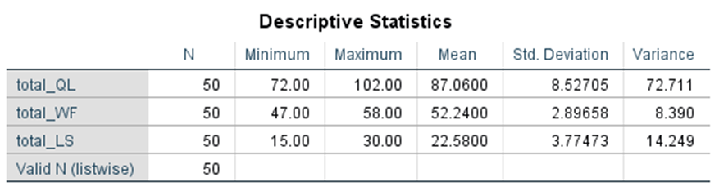

Correlation Analysis
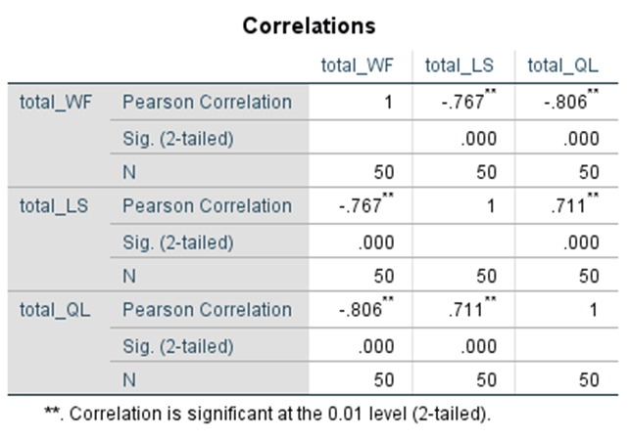
After the normality tests correlation analysis is done in order to test the association between work-family conflict and life satisfaction of working mothers. correlation determines the degree to which two variables are associated. The correlation coefficient of WF and LS is -0.767 at 0.01 significance level. Correlation coefficient is between +1 and -1. Values closer to +_ 1 indicates stronger association. This value 0.767 suggests fairly strong association between the two variables. the result shows a significant negative relationship between work-family conflict and life satisfaction. It can be described as work-family conflict are increasing life of satisfaction of individual is decreasing. Higher the work-family conflicts are lower the life satisfaction will be. This proves the first drawn hypothesis.
The correlation coefficient of WF and QL is -0.806 (at 0.01 significance level) which suggest strong significant negative association between the two variables. The higher the increase in work-family conflicts lower the quality of life of mothers is. This proves the second hypothesis that work-family conflict and quality of life of working mothers are negatively correlated. As the conflicts increases the quality of life is decreasing
The scatter plot of WF, QL and LS are attached in appendix. These plots were drawn with the line of best fit in order to confirm the linear relationship of these variables.

Regression Analysis
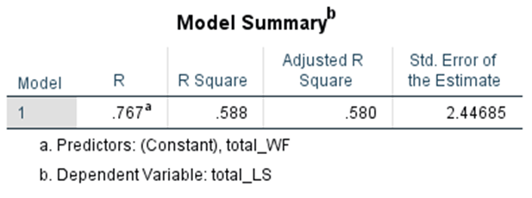
To measure the impact of work-family conflict on life satisfaction of working mothers, regression analysis has been performed. The independent variable in the model is work-family conflict and the dependent variable is life satisfaction. (refer to table in appendix for complete analysis). The regression coefficient is measure of goodness of fit. The significance of regression model used is determined by F statistic. The F-stat value is 68.614 and sig = 0.000. sig-value less than 5 percent is an indication of significant model. Hence, the model used is significant. The work-family conflict can be used to predict the life satisfaction of mother working in IT industry. The regression coefficient is 0.588 which means that 58.8% variation in dependent variable is explained by independent variable. In other words, 58.8% variation in life satisfaction of working mother can be predicted by work-family conflict. The coefficients table is used to test the significance of beta. The t-test value -8.283 and sig value (p-value) is 0.000 at 95% confidence interval which proves that this beta is significant and negative. Coefficient of work-family conflict is statistically significant. It means the increase in work family conflict score will decrease the life satisfaction score. Based on results the equation is written as follows
LS (Life satisfaction score) = 74.80 – 1.0 *(work-family conflict).
If work-family conflict score increases by 1 point, then life satisfaction score will decrease by 1 point.
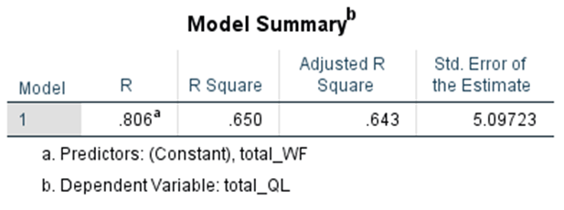
The second regression analysis is conducted for H4 which is to check the impact of work-family conflict on quality of life of working mothers who belong to IT profession. The dependent variable is quality of life and work-family conflict is independent variable. (refer to appendix for complete table)
Similarly, in this test too the significance of the model is assessed by the ANOVA table (F-statistic). The F-statistic value 89.128 and sig value (p-value) is 0.000. if p-value of F statistic is less than the significance level then model used is significant. In this case the model used is statistically significant. Therefore, it shows that R² coefficient of determination is 0.650 which shows that 65% variations in dependent variable can be explained by independent variable. 65% variations in quality of life score working mother can be explained by the work-family conflict score.
The coefficient table is used to determine the significance of beta and the sign of coefficient indicates that its impact will be positive or negative. The p-value of T-statistic should be less than significance level in order to reject null hypothesis (which says beta =0). In this case the variable WF is statistically significant. This assures that change y x be explained by change in X. the equation can be stated as follows:
QL= 211.042- 2.373*(WF)
It can be said if work family conflict score changes by 1-point quality of life score will reduce by 2.373 points.

Discussion
The findings of the study prove a significant negative relationship between work-family conflict and quality of life of working mothers. Moreover, the results also indicate a significant negative impact of work family conflict on life satisfaction of working mothers who belong to It industry of Pakistan. Work-family conflict explains 58.8 percent variation in the life satisfaction of these women. Similarly work-family conflict can predict 65% variation in the quality of life of these women. Pearson Correlation depicts that more the work-family conflict will be the lower the quality of life and life satisfaction will be. These results are consistent with findings of previous researches by Bromet, Dew and Parkinson, (1990) in which they presented a negative impact of work-family conflict on quality of life of an individual. This study was not conducted on working mothers. Moreover, the results are also consistent with a study that investigated the impact of work family conflict and family-work conflict on job satisfaction and life satisfaction of employees of public universities in Pakistan. They found a negative relationship of work-family or family-work conflict with both life satisfaction and job satisfaction of employees. Although this research is different in some regards which includes it is not gender specific. Another study revealed similar results that 43.8 % variation is life satisfaction was explained by work-family conflict and work-family imbalance. This study was conducted on women working in academics (Umer & Zia-ur-Rehman, 2013) The negative relationship between overall quality of life and work family conflict has also been predicted in another study conducted by Robert.W, and Frone (1991). They found a negative relationship between these two variables even after controlling ten sociodemographic covariates. The strong negative relationship between work-family conflict and quality of life can be due to many reasons. As the literature suggested women have more household responsibilities, childcare responsibilities, taking care of elders and family and all these factors enhance work-family conflict. In countries like Pakistan these issues are more serious because women are usually the sole caretaker of child husband and other family members in case of combined family system. Therefore, if a woman is a working mother then these conflicts are likely to increase. Hence when the conflict rises it results in physical and emotional exhaustion, stress, anxiety, depression, and loss of appetite (Allen, 2002). All these aspects contribute in the quality of life and life satisfaction of one person. Moreover, the field of information technology is demanding and requires working odd hours depending on the crisis situation or client preferences because they are remotely connected to global clients and they have to work according to their time choices as well. As mentioned earlier working hours also contribute to work-family conflict. Besides that, odd routines also impair the physical wellbeing and mental health of working mothers as they already have double responsibilities. As in Pakistani culture women are liable and expected to prioritize their families first and then if they can manage, they can work alongside. It is difficult for them to balance work and family life in such conditions. This imbalance can be a cause of chronic work-family conflict (Marks & MacDermid, 1996), which reduces the life satisfaction of working mother. There are very less families who are supportive enough to let them work according to their will. All these factors can explain the negative relationship between these variables. These findings are also consistent with the results drawn by Chandra (1991) Hisrich and Brush (1988).

Conclusion
gender diversity is vital for any organization. inclusion of women in corporate world is important for the success if organization, advancement of country and enhancing the quality of family life. Diverse workforce is beneficial for organizations because they get to benefit from different point of views and skill set. Also, if they are working, they are contributing towards the financial needs of a family. Because of added responsibilities they suffer from work-family conflicts and imbalance in life which eventually affects their quality of life and life satisfaction. It is of dire need for the families to support their women so they can contribute more, and it is also necessary for organizations to adopt strategies that reduce the work-family conflict. They can provide resources and facilities to counsel such employees so they can perform better.

Recommendations
During this study researcher identified few gaps in literature which can be addressed in future. This study was conducted in Pakistan which is an underdeveloped country and has more cultural biases. The relationship between work-family conflict and quality of life on working mothers can be studied in different demographics. The study can be conducted in any western country where gender is not a bigger barrier. The relationship between WF conflict can also be studied against all sub-components of quality of life instead of overall quality of life. These variables can be studied again with the inclusion of mediating and moderating variable such as family system, education, and financial income of the family.

References
Afzal, S. and Farooqi, Y.A., 2014. Impact of work family conflict/family work conflict on job satisfaction and life satisfaction: A case study of a public sector university, Gujranwala Division, Pakistan. International Journal of Multidisciplinary Science and Engineering, 5(8), pp.31-36.
Aryee, S., 1992. Antecedents and outcomes of work-family conflict among married professional women: Evidence from Singapore. Human relations, 45(8), pp.813-837.
Berg, P., Kalleberg, A.L. and Appelbaum, E., 2003. Balancing work and family: The role of high‐commitment environments. Industrial Relations: A Journal of Economy and Society, 42(2), pp.168-188.
Bromet, E.J., Dew, M.A. and Parkinson, D.K., 1990. Spillover between work and family. In Stress between work and family (pp. 133-151). Springer, Boston, MA.
Brough, P. and Pears, J., 2004. Evaluating the influence of the type of social support on job satisfaction and work related psychological well-being. International Journal of Organisational Behaviour, 8(2), pp.472-485.
Chandra, S.K., 1991. Development of Women's Entrepreneurship in India: A Study of Public Policies & Programmes. South Asia Books.
Cohen, S. and Syme, S.L., 1985. Issues in the study and application of social support. Social support and health, 3, pp.3-22.
Dalton, G.W., 1989. Developmental views of careers in organizations. Handbook of career theory, 89, p.109.
Diener, E., Suh, E.M., Lucas, R.E. and Smith, H.L., 1999. Subjective well-being: Three decades of progress. Psychological bulletin, 125(2), p.276.
Duffy, A. and Pupo, N., 1994. Part-time paradox: connecting gender, work & family//Review. Canadian Journal of Sociology, 19(3), p.283.
Frone, M.R., Russell, M. and Cooper, M.L., 1994. Relationship between job and family satisfaction: Causal or noncausal covariation? Journal of Management, 20(3), pp.565-579.
Frone, M.R., 2003. Work-family balance. Handbook of occupational health psychology, 7, pp.143-162.
Frone, M.R., Russell, M. and Cooper, M.L., 1997. Relation of work–family conflict to health outcomes: A four‐year longitudinal study of employed parents. Journal of Occupational and Organizational psychology, 70(4), pp.325-335.
Greenhaus, J.H. and Beutell, N.J., 1985. Sources of conflict between work and family roles. Academy of management review, 10(1), pp.76-88.
Hall, D.T., 1990. Promoting work/family balance: An organization-change approach. Organizational Dynamics, 18(3), pp.5-18.
Kofodimos, J.R., 1990. Why executives lose their balance. Organizational Dynamics, 19(1), pp.58-73.
McDonald, P. and Bradley, L., 2005. The case for work-life balance: Closing the gap between policy and practice. Hudson Global Resources 20: 20 Series.
Marcinkus, W.C., Whelan-Berry, K.S. and Gordon, J.R., 2007. The relationship of social support to the work-family balance and work outcomes of midlife women. Women in management Review, 22(2), pp.86-111
Mathew, R.V. and Panchanatham, N., 2009. Work life balance issues among the women entrepreneurs in South India. Emerging entrepreneurial strategies for self development and skill development, pp.46-57.
Peeters, M.C., Montgomery, A.J., Bakker, A.B. and Schaufeli, W.B., 2005. Balancing work and home: how job and home demands are related to burnout. International Journal of Stress Management, 12(1), p.43.
Pleck, J. H., Staines, G. L. & Lang, L. (1980). ‘‘Conflicts between work and family life’’, Monthly Labor Review, 103(3), pp. 29-32.
Rice, R.W., Frone, M.R. and McFarlin, D.B., 1992. Work—nonwork conflict and the perceived quality of life. Journal of Organizational behavior, 13(2), pp.155-168.
Rossi, A.S. ed., 2001. Caring and doing for others: Social responsibility in the domains of family, work, and community. University of Chicago Press.
Saraceno, C., Olagnero, M. and Torrioni, P.M., 2005. First european quality of life survey. Families, work and social networks (pp. 1-118). European Foundation for Improving Working and Living Conditions, Luxembourg, Office for Official Publication of the European Commission.
Umer, R. and Zia-ur-Rehman, M., 2013. Impact of work life balance and work life conflict on the life satisfaction of working women: A case study of higher education sector of twin cities of Pakistan. Academic Research International, 4(5), p.445.
Young, M.B., 1999. Work-family backlash: begging the question, what's fair?. The ANNALS of the American Academy of Political and Social Science, 562(1), pp.32-46.
Marks, S.R. and MacDermid, S.M., 1996. Multiple roles and the self: A theory of role balance. Journal of Marriage and the Family, pp.417-432.

Appendix
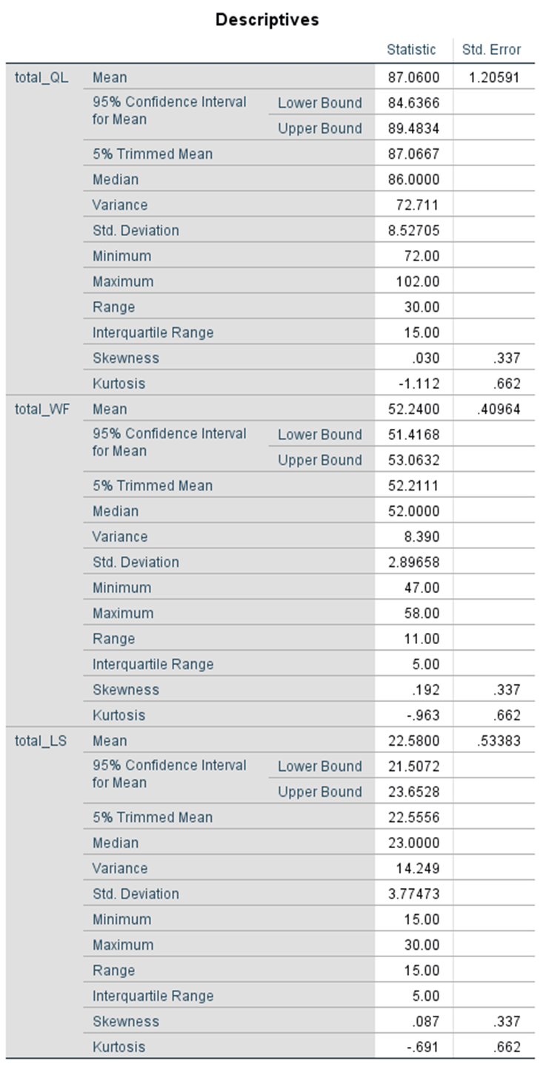
Table 1 descriptive statistics

Table 2: Tests of normality
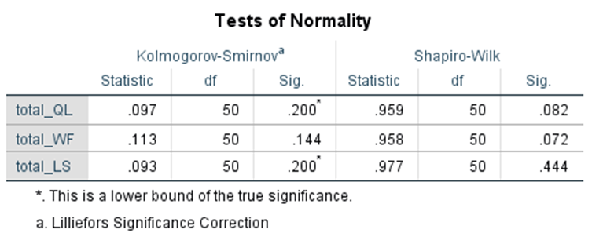

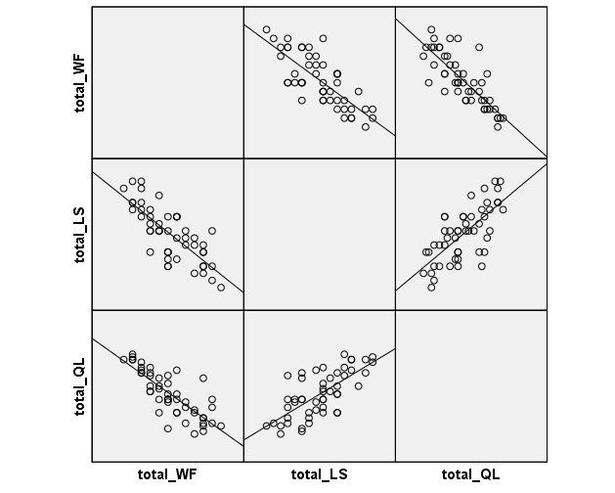
Table 2
Scatter Plot

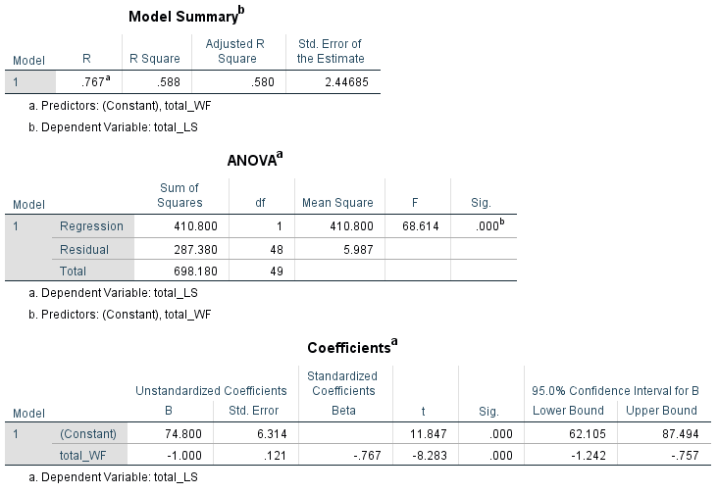Regression analysis between Work family conflict and life satisfaction.
Regression analysis between Work-family conflict and overall quality of life
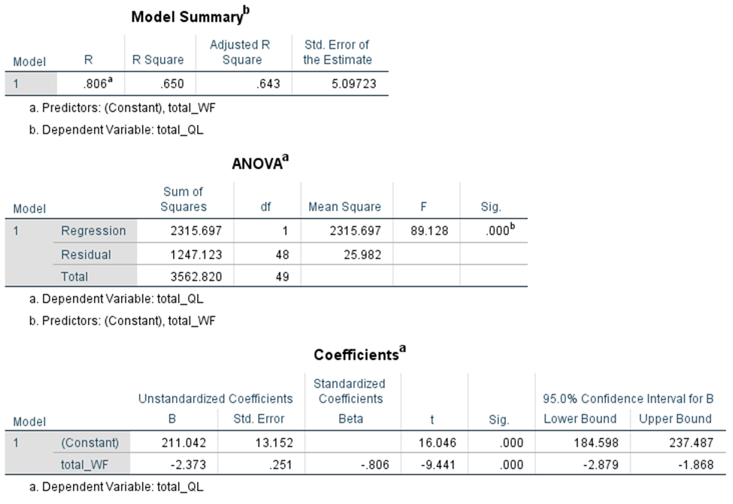
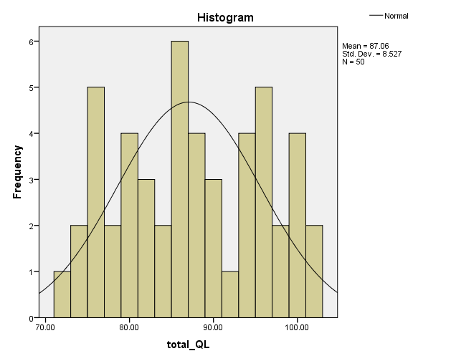

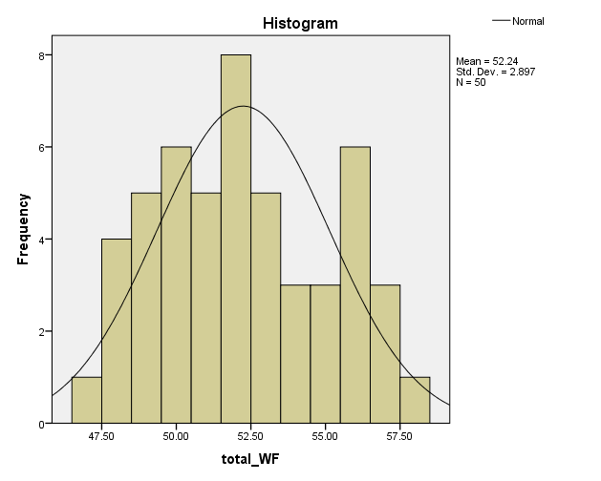
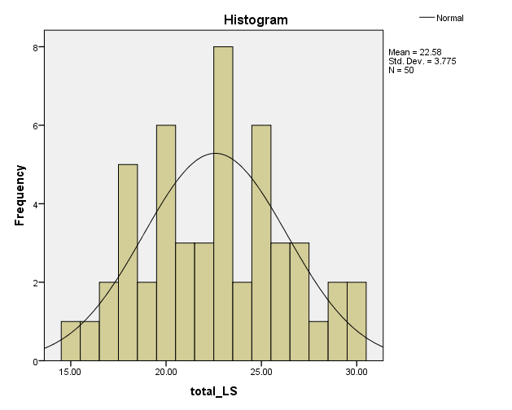

Questionnaires
This questionnaire has been designed to collect data for fulfilment of my coursework. This study is designed to check the impact of work-family conflict on the overall quality of life and life satisfaction of mothers working in Information technology industry of Pakistan. Your response in this regard would be highly appreciated. Kindly fill these questionnaires and return it to me on email id 1806920@student.uwtsd.ac.uk
Age
- 20-29 years
- 30-39 years
- 40- 49 years
- 50 and above
Education level
- Bachelors
- Masters
- PhD or higher
Work experience
- 0-10 years
- 11-20 years
- 21-30 years
Number of children
- 1-2 children
- 2-4 children
- 5 and more
Family Dynamics
- Neutral
- Joint family

Scale the following statements by how much you agree, 7 being very strongly agree and 1 being very strongly disagree.
- Very Strongly Disagree
- Strongly Disagree
- Disagree
- Neither Agree or Disagree
- Agree
- Strongly Agree
- Very Strongly Agree
1 | I cannot have a quality time with my family due to work pressure | 1 | 2 | 3 | 4 | 5 | 6 | 7
2 | I do not have any time left for day to day activities outside of work including leisure activities and chores. | 1 | 2 | 3 | 4 | 5 | 6 | 7
3 | I miss out on most of family activities because of my work | 1 | 2 | 3 | 4 | 5 | 6 | 7
4 | My family life is impacted by my work. | 1 | 2 | 3 | 4 | 5 | 6 | 7
5 | I feel irritated and short tempered at home after work. | 1 | 2 | 3 | 4 | 5 | 6 | 7
6 | Due to my personal and family commitments my work performance suffers. | 1 | 2 | 3 | 4 | 5 | 6 | 7
7 | I am distracted at work due to family related concerns and responsibilities. | 1 | 2 | 3 | 4 | 5 | 6 | 7
8 | I did be a better employee if I did not have a family. | 1 | 2 | 3 | 4 | 5 | 6 | 7
9 | My family negatively affects my day to day work duties. | 1 | 2 | 3 | 4 | 5 | 6 | 7
10 | It is hard to concentrate at work because I am exhausted by family responsibilities, | 1 | 2 | 3 | 4 | 5 | 6 | 7
11 | I am totally satisfied with my work-life balance. | 1 | 2 | 3 | 4 | 5 | 6 | 7

QUALITY OF LIFE SCALE
 |  | Very poor | poor | Neither poor nor good | good | Very good
1 | How would you rate your quality of life? | 1 | 2 | 3 | 4 | 5
 |  | Very dissatisfied | Dissatisfied | Neither satisfied nor dissatisfied | satisfied | Very satisfied
2 | I am satisfied with my health conditions | 1 | 2 | 3 | 4 | 5
 |  | Not at all | A little | A moderate  amount | Very much | An extreme amount
3 | I have a physical pain that causes hindrance in day to day tasks | 1 | 2 | 3 | 4 | 5
4 | I require medical assistance in order to carry on my daily physical activities. | 1 | 2 | 3 | 4 | 5
5 | How much you enjoy your life? | 1 | 2 | 3 | 4 | 5
6 | Is your life meaningful? | 1 | 2 | 3 | 4 | 5
 |  | Not at all | A little | A moderate  amount | Very much | Extremely
7 | Can you concentrate in your daily life? | 1 | 2 | 3 | 4 | 5
8 | Do you feel safe in your life? | 1 | 2 | 3 | 4 | 5
9 | Do you have a healthy physical environment? | 1 | 2 | 3 | 4 | 5
 |  | Not at all | A little | Moderately | Mostly | Completely
10 | Do you have enough energy for daily routine? | 1 | 2 | 3 | 4 | 5
11 | Do you readily accept your physical appearance? | 1 | 2 | 3 | 4 | 5
12 | Do you have enough finances to fulfil your needs? | 1 | 2 | 3 | 4 | 5
13 | How convenient is it to access information you need on regular basis? | 1 | 2 | 3 | 4 | 5
14 | Are you able to avail opportunities for your leisure activities? | 1 | 2 | 3 | 4 | 5
 |  | Very poor | poor | Neither poor nor good | good | Very good
15 | How easily are you able to move around? | 1 | 2 | 3 | 4 | 5
 |  | Very dissatisfied | dissatisfied | Neither satisfied nor dissatisfied | satisfied | Very satisfied
16 | Are you satisfied with your sleep? | 1 | 2 | 3 | 4 | 5
17 | Are you satisfied with your ability to complete your daily activities? | 1 | 2 | 3 | 4 | 5
18 | How satisfied are you with your capacity to work? | 1 | 2 | 3 | 4 | 5
19 | Are you totally satisfied with yourself? | 1 | 2 | 3 | 4 | 5
20 | To what extent do you feel content with the relationships in your personal life? | 1 | 2 | 3 | 4 | 5
21 | Are you satisfied with your sexual life? | 1 | 2 | 3 | 4 | 5
22 | Are you satisfied with the support you get from your peers? | 1 | 2 | 3 | 4 | 5
23 | How satisfactory is your accommodation? | 1 | 2 | 3 | 4 | 5
24 | How satisfactory is your access to medical services | 1 | 2 | 3 | 4 | 5
25 | How satisfied are you with your transport? | 1 | 2 | 3 | 4 | 5
 |  | Never | Seldom | Quite Often | Very Often | Always
26 | How often do you experience feeling of despair, anxiety, depression, blue mood etc? | 1 | 2 | 3 | 4 | 5

LIFE SATISFACTION SCALE
Using the 1 – 7 scale below, indicate your agreement with each item by placing the appropriate number in the line preceding that item.

1 = Strongly Disagree
2 = Disagree
3 = Slightly Disagree
4 = Neither Agree nor Disagree
5 = Slightly Agree
6 = Agree
7 = Strongly Agree

1. I find my life close to ideal in a lot of ways | 1 | 2 | 3 | 4 | 5 | 6 | 7
2. My life conditions are considered to be excellent | 1 | 2 | 3 | 4 | 5 | 6 | 7
3. I am completely satisfied with my life | 1 | 2 | 3 | 4 | 5 | 6 | 7
4. I have been able to achieve things that I wanted in my life till now | 1 | 2 | 3 | 4 | 5 | 6 | 7
5. If I have the chance to change anything in my life, I would change nothing  I will not change anything in my life even if I have a chance to.. | 1 | 2 | 3 | 4 | 5 | 6 | 7

