

Student name: BERNICE NWAGBO
Student ID: 2323240
Module name: CHANGEMAKERS: BUILDING YOUR PERSONAL BRAND FOR SUSTAINABLE EMPLOYMENT.
Module code: BMHP5015
Lecturer name: BRIAN MASHUMBA

Table of contents
Introduction…………………………………………………………………………………3
The Job Description and Person Specification………………………………………………….3a
A real job vacancy in NHS………………………………………………………………………….4
Key Employability Skill………………………………………………………………………………5
Employability skills frameworks……………………………………………………………………5a
Reflection on your current skills, strengths and areas……………………………………………6
Health and Social Care Experience and Qualifications…………………………………………6a
Future Development……………………………………………………………………….6b
Development of personal skills ……………….………………………………………….7
What value could I add to this Role……………………………………………………………….7a
Resources for skill development……………………………………………………………………8
Action plan and timeline……………………………………………………………………………..9
Communicating My Skills to Employers…………………………………………………………..10
Conclusion…………………………………………………………………………………………...11
References…………………………………………………………………………………………..12

Introduction
Oncology Nurse Roles in the NHS and Care Home Sector In the UK.
I want to pursue a career in oncology nursing within health and social care in the UK because I can positively impact the lives of cancer patients by offering hope and holistic care. This role involves delivering medical treatment alongside emotional, psychological, and social support, ensuring patients and their families receive compassionate, comprehensive care throughout their journey. (Macmillan, 2025).
Responsibilities include administering therapy, monitoring patients, advocating for them, and collaborating with professionals from various fields. My professional choices are guided by core principles of empathy, resilience, and advocacy, highlighting the rewarding blend of scientific knowledge and patient interaction during challenging times (NHS England, 2012).
The report incorporates Bandura’s Self-Efficacy Theory, the SMART framework, and SWOT analysis to outline plans for professional development (Bandura, 1997). It also examines the expectations for NHS positions and aligns with NHS values. It emphasizes the unique ability to deliver compassionate care and adapt in stressful situations, while addressing all aspects of care, physical, emotional, spiritual, and mental. Ultimately, this approach aims to enhance patient outcomes through continuous professional growth and interdisciplinary teamwork (NHS England, 2015).
The Job description of the selected job.
NHS oncology nurses provide specialised cancer care, including chemotherapy, radiotherapy, symptom monitoring, patient education, and emotional support, while maintaining infection control. Effective interdisciplinary teamwork requires strong communication, resilience, empathy, and technical skills. Acute Oncology Nurse responsibilities include managing cancer-related complications, administering systemic therapies, offering professional advice, collaborating with specialists, and contributing to audits and research (Macmillan Cancer Support, 2025).
Person Specification
Oncology nurses in the NHS must hold NMC registration, a BSc in Nursing, and GCSEs in Maths and English, with postgraduate oncology training desirable. The role requires competence, clinical knowledge, and prior oncology or acute care experience. Essential attributes include teamwork, communication, resilience, empathy, advocacy, digital literacy, and evidence-based practice, supported by DBS clearance. Employers also expect adaptability and commitment to continuous professional development, with readiness to pursue further specialist oncology training (NHS Jobs, 2025).
A real Job Vacancy from the NHS
Below is a current NHS vacancy for an Oncology Support Nurse (Band 6) at Oxfordshire Hospitals NHS Foundation Trust, Oxford. The role involves supporting cancer patients throughout their treatment journey, coordinating care plans, and working within a multidisciplinary team to deliver compassionate, evidence-based care.
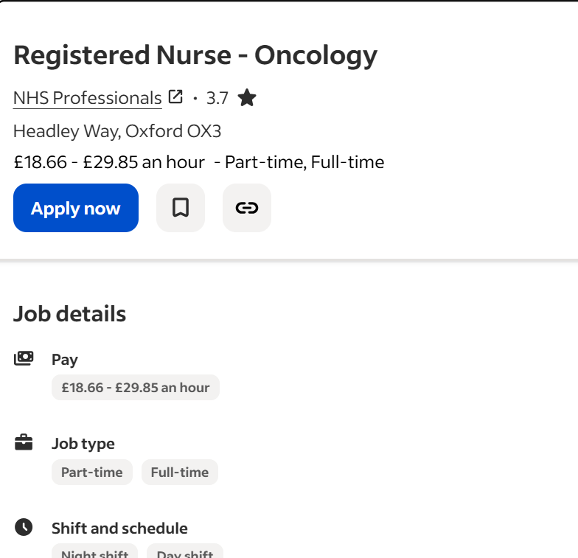
What will you be doing?
As an oncology nurse, you will administer chemotherapy, provide supportive treatments, accurately document clinical data, monitor and report adverse events, and build strong relationships with patients and carers. Similarities across oncology nursing roles include fostering supportive patient-carer relationships, maintaining precise clinical documentation, and ensuring safe, high-quality care through continuous learning and compliance with policies.

Benefits
NMC fees paid for
25 days of annual leave plus bank holidays
Contribution-based pension scheme
Employee benefits platform (retailer discounts and much more)
Life insurance
Private medical insurance (after qualifying period)
Ongoing learning and development opportunities
Annual company event
Yearly pay reviews (Indeed, 2025).

Key Employability Skills
Oncology nurses in the NHS specialize in cancer treatment, delivering chemotherapy and radiotherapy, monitoring patient progress, guiding families through care, and providing psychological support while ensuring infection control. Effective communication, resilience, empathy, and technical expertise are vital for safe, interdisciplinary teamwork. Acute oncology nurse roles include managing complex cancer-related issues, administering systemic therapies, offering professional advice, collaborating with specialists, and contributing to audits and research. Both positions emphasize symptom management, patient education, and compassionate emotional support (NHS England, 2012).
The Employability Skills Framework
Oncology nursing requires transferable skills such as problem-solving and adaptability. Nurses often face unpredictable scenarios, including adverse treatment reactions, which require quick decision-making. Competence develops through practice and observation, as explained by Bandura’s Self-Efficacy Theory. For example, I observed my mentor set up a syringe driver, then completed the task independently under supervision, applying learned skills effectively.

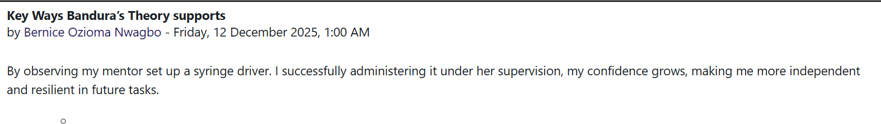
Reflect on your current skills, strengths, and Areas for Development
I assess my skills through reflection, feedback, and structured tools, recognising strengths and areas for growth. My strengths include communication, empathy, problem-solving, resilience, and teamwork, developed through health and social care practice and voluntary placements. For example, I reassured a distressed care home resident using active listening, showing emotional intelligence. Self-assessment tools (LinkedIn, 2022) highlight these strengths while identifying weaknesses such as limited digital literacy (Soft and hard skills), time management, and oncology-specific competencies.
My experience includes paid and voluntary work in hospital wards, care homes, and community health, supported by training in Basic Life Support, Infection Control, and syringe driver use. Growth opportunities such as CPD, mentorship, postgraduate study, and shadowing oncology nurses strengthen employability, while emotional demands highlight the need for resilience and self-care. These experiences and qualifications provide a strong foundation for becoming a competent oncology nurse delivering safe, compassionate, high-quality care, that in line with NHS values.
Qualifications and Experience
I hold a certificate in NVQ, English and Maths (GCSEs), in Basic Life Support, Infection Control, and Syringe Driver use, with paid and voluntary experience in hospital wards, care homes, and community health, strengthening communication and teamwork.
Future Development
I acknowledge the gaps in my knowledge of oncology and digital literacy. My plan includes CPD, mentorship, online training, and postgraduate study, framing challenges as opportunities for growth and long-term professional development.

Development of Personal Skill and Resources.
My key selling points include strong interpersonal skills, resilience, and a commitment to continuous improvement. My personal brand reflects my values, strengths, and career goals, consistently presented in professional and academic settings. I leverage these qualities to build my brand and align with industry standards using resources such as LinkedIn, networking, NHS frameworks, and Skills for Care guidance.
Feedback from mentors, supervisors, lecturers, and colleagues provides valuable advice, enhances knowledge and skills, and helps set focused goals. It also offers insight into how others perceive me, which strengthens and shapes my professional identity (Redeker. et al., 2012).
I enhance my brand by networking with professionals, sharing knowledge at conferences, and remaining active on LinkedIn and Twitter to demonstrate my passion for oncology nursing. Continuous feedback and evaluation highlight areas for growth, while SMART and FAST goal frameworks guide balanced development. Networking provides new knowledge, perspectives, and opportunities to advance my career. These strategies ensure my brand reflects competence, compassion, and technical training in Basic Life Support, Infection Control, and syringe driver use (Gibson. et al., 2014).
Understanding and developing your skills.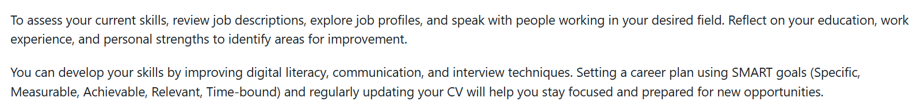
Value Added to the Role
I am committed to continuous improvement, and my unique selling point is the ability to remain calm and empathetic in challenging situations. This enables me to provide compassionate support to patients and families while maintaining professional focus. For example, during a hospital ward placement, I supported an anxious patient before a procedure by explaining the process clearly, offering reassurance, and using active listening to reduce distress and build trust. Alongside these interpersonal strengths, I bring technical training in Basic Life Support, Infection Control, and syringe driver use. By applying the 6Cs in nursing (Baillie, 2015). I combine emotional intelligence with technical competence to deliver safe, high-quality, patient-centred care while contributing positively to the team and organisation.
Resources for Skill Development
To attain the skills required for this role, I will engage in structured learning, practical experience, and professional development. Specialist courses in oncology nursing, palliative care, and advanced communication will strengthen my clinical knowledge, while NHS training and CPD modules will ensure my competencies remain current. Voluntary work in hospices and care homes, combined with clinical placements and shadowing experienced oncology nurses, will provide valuable hands-on experience. A framework of mentorship, guidance from lecturers, and feedback from supervisors and colleagues will refine my professional identity. Networking through conferences and platforms such as LinkedIn will keep me connected to new knowledge, perspectives, and career opportunities, supporting continuous growth and readiness for oncology nursing practice (Klinge, 2015).
I will attend oncology and chemotherapy courses, phlebotomy, complete CPD in digital health and advocacy, volunteer in hospitals, attend networking meetings, talk to people, and join conferences to strengthen practical skills and remain updated. I will join the Royal College of Nursing,

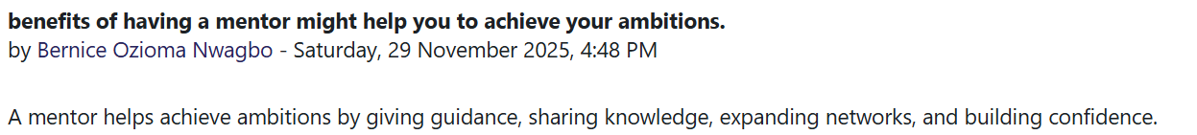

Action Plan and Timeline for Skill Development
Time frame | Action Plan | Expected Outcome
Year 1 | To complete CPD, courses in Basic Life Support, Infection Control, and Safeguarding. Get voluntary placements in hospices or care homes. | Build clinical skills, patient safety awareness, and empathy.
Year 2 | Undertake advanced training modules (e.g., syringe driver use, palliative care). Shadow experienced oncology nurses. | Gain technical competence, observe best practice, and strengthen reflective learning.
Year 3 | Secure extended clinical placements in oncology wards. Engage in mentorship programs. | Apply skills independently, develop confidence in patient-centred care, and receive constructive feedback.
Year 4 | Join the Royal College of Nursing and engage in LinkedIn professional groups. | Build networks, access mentorship, and increase professional visibility. Stay updated, continue to develop.
Year 5 | Attend national and international healthcare conferences. | To update on best practices, expand professional connections, demonstrate competence, and align with NHS values.

Communicating My Skills to Employers
I communicate my skills through multiple platforms to present a clear, professional identity. My CV and cover statement highlight my updated qualifications, CPD courses, voluntary placements, and certificates, including Basic Life Support, Infection Control, and syringe driver training, supported by relevant job descriptions. On LinkedIn, I use a professional headline like “Oncology Nursing Trainee Compassionate, Resilient, Reflective Practitioner” and showcase education, placements, and certificates, while sharing posts on CPD activities, conferences, and reflections to demonstrate ongoing development. A personal website or portfolio, if developed, will include a biography, CV, reflective accounts, CPD evidence, mentor feedback, and a blog documenting growth, aligning with NHS values and providing employers with a comprehensive view of my competence and commitment to patient-centred care.

Conclusion
My career goal is to become a future oncology nurse dedicated to patient-centred, compassionate, and resilient care. Currently, my profile demonstrates commitment through CPD courses, voluntary placements, and certificates such as Basic Life Support, Infection Control, and Safeguarding. These experiences provide a strong foundation, although I recognize the need to further develop advanced clinical skills, expand professional networks, and strengthen reflective practice to fully meet the demands of the role. My strengths include empathy, resilience, reflective practice, and alignment with NHS values, while my weaknesses involve limited specialist oncology experience and the need to build stronger professional connections. Opportunities exist through CPD courses, mentoring, conferences, and networking platforms, whereas threats include high competition for specialist roles and the challenge of balancing study, work, and personal commitments.
My five-year action plan supports these goals by combining structured CPD, mentoring, volunteering, and networking opportunities, leading toward the consolidation of expertise and future leadership. This process has clarified the importance of aligning personal development with career frameworks and reinforced my passion for working with vulnerable adults. This journey motivates me to pursue oncology nursing with determination, resilience, and a clear vision for professional growth.

References
Baillie L. (2015). Perspectives: We need to talk about the 6Cs: perspectives on a recent debate. Journal of Research in Nursing. 2015;20(4):331-336. doi:10.1177/1744987115585642
Cancer Research UK (2023) The role of nurses in cancer care. Available at: https://www.cancerresearchuk.org (Accessed: 28 October 2025).
Gibson, C., et al. (2014).’ Understanding the role of networking in organizations’, Career Development International, 19(2), pp.146-161.
Hubby, K. (2023) Getting SMART About Your Oncology Professional Development Goals. Available at: https://www.cancernursingtoday.com/post/getting-smart-about-your-oncology-professional-development-goals (Accessed: 16 December 2025).
LinkedIn (2022) The Best 6 personal Swot Analysis Examples for Students. Available at: https://www.linkedin.com/pulse/best-6-personal-swot-analysis-examples- (Accessed: 16 December 2025).
Macmillan Cancer Support (2025) Nurses working in cancer care. Available at: https://www.macmillan.org.uk/healthcare-professionals/cancer-careers/nurses-working-in-cancer (Accessed: 11 December 2025).
National Health Service (2025) Registered Nurse-Oncology. Available at https://www.jobs.nhs.uk/candidate/jobadvert/M0042-25-1411 (Accessed: 28 October 2025).
NHS England (2022) Working in partnership with people and communities: Statutory guidance. Available at: https://www.england.nhs.uk/long-read/working-in-partnership-with-people-and-communities-statutory-guidance/ (Accessed: 16 December 2025).
Royal College of Nursing (2025) Job description guidance. Available at:
https://www.rcn.org.uk/professional-development/nursing-support-workers/become-a-nursing-associate/job-description-guidance (Accessed: 28 October 2025).
Royal College of Nursing (2025) Reflections on supporting oncology in 2025. Available at: https://www.rcn.org.uk/news-and-events/Blogs/reflections-on-supportive-oncology-in-2025-141025 (Accessed: 16 December 2025).

