 | Targed/Target | Yr hyn yr wyf wedi'i wneud yn yr aseiniad hwn  What I have done in this assignment...
Targed/Target 1 | You often use your academic sources individually and they stand alone, try to link them into paragraphs together to support/contradict each other’s findings. This will help the flow of your ideas. | When developing arguments, I have linked several academic sources to demonstrate supporting/contradicting findings.
Targed/Target 2 | Stronger links between theory and practice really do ensure that you are hitting the higher levels of the mark scheme. You are developing this well with your reflections but need to further refine this throughout your work rather than just in the conclusion. | Where applicable I feel that I have made strong links between theory and practice and provided examples regarding future improvement in relation to the school-community project in part A (i.e., additional methods of evaluation, engagement of all stakeholders etc) as well as reflecting on the school improvement process and how the theory links to practice.
Targed/Target 3 | Only 2 targets given | N/A

A report which critically reflects the actions, impact and evidence base of one aspect of a Schools’ Improvement Plan

Introduction

This purpose of this report is to critically examine the development of a School Improvement Plan (SIP) for an English medium primary school. In line with BERA (2018) guidelines and the UWTSD (2022) ‘Research Ethics and Integrity Code of Practice’ principles to protect the anonymity of the school it will be referred to as School X. School X is an English medium primary school with 389 pupils on roll, with 34.7% of them qualifying for free-school meals – a tool used by schools to measure “socio-economic disadvantage” (BERA, 2017; Taylor, 2018; Welsh Government, 2022a) – over a three-year period, which is significantly higher than the national average in Wales of 23% (Estyn, 2023). Additionally, 27.7% of pupils in School X have additional learning needs (ALN), which is also higher than the national average in Wales at 16.1%.

The SIP data shows a significant drop in attendance for pupils eligible for FSM and/or ALN pupils, a concern which has been recognized across Wales, as highlighted by the Welsh Government (2023a).

FSM attendance figures has long identified impact of poverty on attendance (Senedd Research, 2023a; Senedd. Wales, 2022; BERA, 2017; Taylor, 2018; Welsh Government, 2022a). Poverty has been linked to having a detrimental effect on the health, wellbeing, and develop of children and young people in addition to poorer educational attainment and life chances (Bandyopadhyay et al, 2023). Egan (2017) argues that whilst poverty is not a result of schools, the academic decline of children and young people eligible for FSM between the ages of three and sixteen, suggests inequity within the Welsh Education system and the need for further action.

The decrease in school attendance of pupils with ALN is just as concerning as the educational attainment of learners with ALN has been identified as being “poor compared to the rest of the learner population” (Welsh Government, 2018). According to the Department for Education (2023) attendance promotes the educational, economic and social outcomes for children and young people which has a significant impact of their academic attainment, development and wellbeing which in turn influences their life chances (Department for Education, 2023; Education Committee, 2023). Therefore, the impact of poor attendance could result in pupils with ALN being doubly disadvantaged (Department for Education, 2023; Education Committee, 2023).

As a result, I have chosen to critically examine how School X is aims to ‘improve pupil attendance particularly for FSM and ALN pupils’ – one of their identified improvement priorities (IP) – through one of their action point (AP) to develop effective pupil participation to improve school attendance. This is particularly important, as pupils are considered as key stakeholders and Engaging with all stakeholders on matters which involve them is key to achieving school improvement (Welsh Government, 2021b).

Literature Review

The Welsh Government's School Improvement guidance (2022b) is a "framework for evaluation, improvement, and accountability" (Welsh Government, 2022b) for schools, aligning with the new Curriculum for Wales.

Previous Welsh Government guidance (2014) used the term ‘School Development Planning’ and whilst both can be used interchangeably, current Welsh Government guidance (2022b) refers to this process as ‘School Improvement Planning’ as it was decided that this term clearly emphasizes that the goal is to enhance learner outcomes and learning experiences, which is the overarching purpose (Welsh Government, 2022b; CSCJES, 2017). Fundamental to this is learners’ realisation of The Four Purposes of the Curriculum for Wales, which outlines what all schools in Wales aspire their learners to become in order to lead healthy and fulfilling live able to access lifelong learning and thrive in society (Welsh Government, 2022b; Welsh Government, 2022c).

The literature emphasizes the significance of effective leadership throughout all stages of school improvement. (Estyn, 2016a; Davies and Ellison, 2003; Senedd Research, 2017). During the initial stages, the headteacher and the governing body have crucial responsibilities (Estyn, 2016a; Gov.Wales, 2021a; Legislation.gov.uk, 2014). The headteacher is responsible for identifying IP, formulating appropriate aims and objectives and informing this through effective self-evaluation (Welsh Government, 2014; Gov.Wales, 2021a). Whilst the governing body – which often also includes the headteacher – plays a strategic role by critically considering the self-evaluation date and the headteacher’s proposals, and the developing the SIP covering a 3-year period with annual monitoring (Welsh Government, 2022b; Gov.Wales, 2021a; Legislation.gov.uk, 2014). This process reduced the workload on headteachers, allowing them to focus on their additional responsibilities within the school. Shared decision-making between the headteacher and the governing body in school improvement planning is suggested to reduce the likelihood of bias and ensure the SIP reflects the needs of the whole school context (DeMatthews and Wang, 2023; Welsh Government, 2014).

However, within the SIP responsibilities will be further delegated creating opportunities for the allocation of additional leadership roles. It is crucial that schools build the capacity of staff within these positions – through appropriate support and training addressed within SIP (Welsh Government, 2022b) – to develop effective leadership across the school and maximise outcomes of the SIP (Estyn, 2016a).

Addressing the professional learning needs of staff within the SIP is crucial to promote effective leadership, collaboration between all stakeholders and high quality research informed teaching and learning in order to raise educational standards and develop schools as learning organisations, the shared vision of all schools in Wales (Welsh Government, 2017; Senedd Research, 2017).

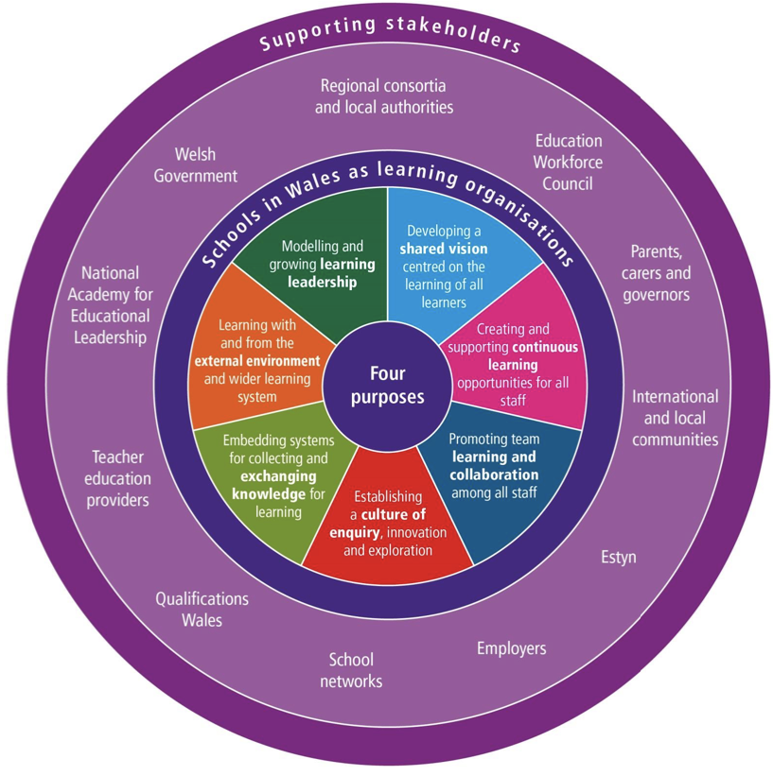

Figure 1: “Schools in Wales as Learning Organisations” (Welsh Government, n.d., p.2)

Another fundamental element of the school improvement process is effective self-evaluation. There is global debate regarding the terminology, definitions and frameworks for self-evaluation (Chapman and Sannons (2013). To provide clarity this report uses the definition provided by Chapman and Sannons (2013), which defines self-evaluation as “a process by which members of staff in a school reflect on their practice and identify areas for action to stimulate improvement in the areas of pupil and professional learning” (Chapman and Sannons, 2013, p.2). According to Welsh Government (2021a) “robust evaluation and accountability arrangements to support self-improving system is one of the four enabling objectives of the new curriculum” (Welsh Government, 2021a, p.1). This highlights the Welsh Government’s commitment to developing a “self-improving school system” in partnership with the schools and regional consortia (Egan and Grigg, 2018) which requires school leaders to develop and embed a culture of self-evaluation throughout the school (Estyn, 2020).

Estyn (2020) highlighted the importance of self-evaluation and planning for improvement in schools during the 2010-2017 inspection cycle. As a result, the "National Resource: Evaluation and Improvement" was created to promote effective school improvement procedures and collaboration between schools. It provides various approaches to self-evaluation and case studies to support schools in carrying out meaningful and rigorous self-evaluation. The resource also helps schools understand accountability and identify IP, enabling effective planning and monitoring of actions to measure their success and impact (Estyn, 2020; Welsh Government, 2022b; Welsh Government, 2021a). The development of self-improving schools through effective self-evaluation and accountability among stakeholders creates a sustainable and ongoing approach to the school improvement process (Estyn, 2020; Welsh Government, 2022b; Welsh Government, 2021a).

According to Welsh Government’s (2022b) school improvement guidance when school leaders carry out self-evaluation as part of the “school [improvement] planning cycle” (Welsh Government, 2014) there are 3 “overarching areas” that school leaders need to consider (Welsh Government, 2022) including:

- Vision and leadership
- Curriculum, learning and teaching
- Well-being, equity and inclusion

Within the ‘vision and leadership’ area there are several priorities one of which is tackling the impact of poverty on educational attainment (Welsh Government, 2022b), which links to the AP identified in School X’s SIP develop effective pupil participation to improve school attendance.

Despite being key stakeholders and enablers of school improvement, learners are often underutilized within the planning process (Welsh Government, 2021b; Pulis, 2016). It is evident among research that pupil participation has been linked to improved communication between pupils and schools, enhanced pupil-teacher relationships and the creation of the ideal environment for the “school community to become a learning community” (Pulis, 2016), supporting the development of schools as learning organisations (Welsh Government, 2021b).

Additionally, effective implementation of pupil voice ensures that schools are respecting children’s right to have their views valued, respected and considered regarding matters which affect them in accordance with Article 12 of the UNCRC (Unicef, 2019). This has been found to promote engagement of learners and instil a sense belonging within the school, which is linked to improved attendance (Welsh Government, 2023b).

Corcoran (2023) emphasises that in order to improve attendance it is crucial to fully understand all factors that contribute to pupil absence. Pertinent to this is gaining the viewpoints and perspectives of pupils themselves, as well as those of their families (Corcoran, 2023). Not only does this provide pupils with greater ownership but also the opportunity to express their views on a matter which affects them ensuring that schools are respecting children’s right to have their views valued, respected and considered in accordance with Article 12 of the UNCRC (Unicef, 2019). Furthermore, it enables schools to develop an enhanced understanding of families circumstances and needs to better support them – including those who are considered ‘hard to reach’ – through access to “specialist or support services” as a result of engagement with appropriate stakeholders within the community, which in turn will support the health, wellbeing and progression of learners to maximise pupil outcomes. which is linked to improved attendance (Welsh Government, 2021b). Additionally, where an ethos towards pupil participation is strong it has been found promote engagement of learners and instil a sense belonging towards school, which is linked to improved attendance (Welsh Government, 2023b). However, according to Corcoran (2023) pupil participation is often done in a superficial or symbolic manner, without genuinely incorporating the views of pupils into the decision-making processes.

Developing an Action Point

This next part of the report will examine how School X developed their AP. To guide this examination, the Welsh Government’s (2014) school improvement cycle will be adopted.
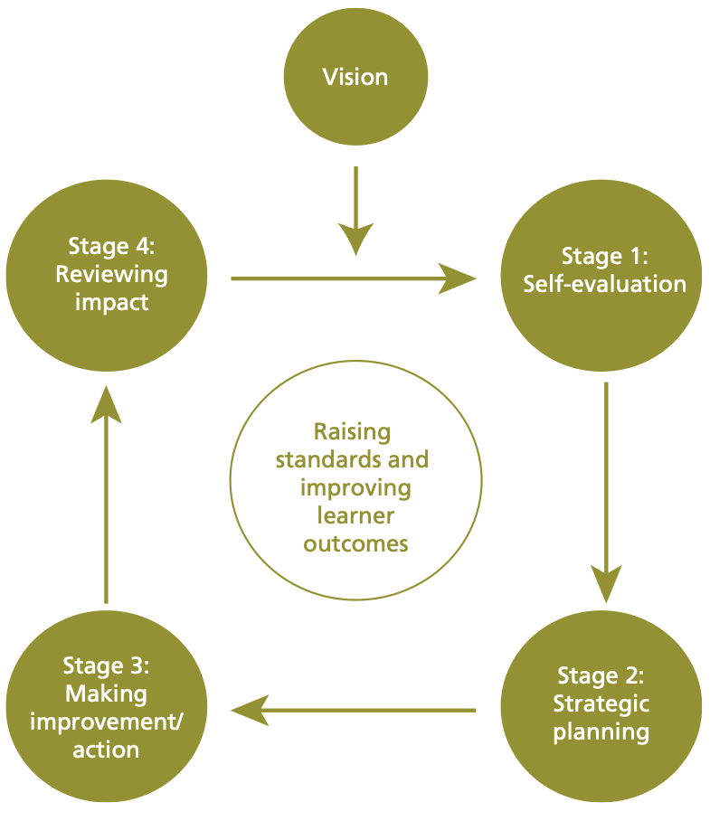

Figure 2: School Improvement Cycle (Welsh Government, 2014)

Stage 1: Self-Evaluation

Identification of the IP was a result of ongoing monitoring of attendance carried out by the attendance team (AT) which consists of the headteacher, school office manager (staff), an LEA governor and the Education Welfare Officer.

Prior to the COVID-19 pandemic whole school attendance was 94.22% however, this fell to 89.6% in the 2021-2022 academic year and remained static throughout 2022-2023. Additionally, the AT identified that during the 2022-2023 academic year attendance of ALN pupils (85.43%) and FSM pupils (84.43%) was significantly lower than NFSM pupils (91.89%). These results raised concerns amongst the AT regarding learning loss and the impact this would have on the educational attainment of pupils (Welsh Government, 2023b), which led to the headteachers proposal to ‘improve pupil attendance particularly for FSM and ALN pupils’.

Following consideration of the data collected by the AT presented in the headteachers self-evaluation, the priority to ‘improve pupil attendance particularly for FSM and ALN pupils’ was accepted by the governing body as an improvement priority (IP) within the SIP (Welsh Government, 2022b; Gov.Wales, 2021a; Welsh Government, 2014).

Improving school attendance (Welsh Government, 2023c) and “reducing the impact of poverty on pupils’ progression and attainment” (Welsh Government, 2022b) which as stated in the literature strongly links to attendance (Welsh Government, 2023b) are both national priorities. When carrying out self-evaluation the Welsh Government (2022b) school improvement guidance states that governing bodies must take into account national priorities, which aligns with the IP identified School X’s SIP.

Stage 2: Strategic Planning

According to Davies and Ellison (2003) strategic planning is most effective when a school has a clear vision of what they want to achieve and a clear understanding of the steps they need to take to get there, appropriate resources and the ability to assess the outcomes in relation to pre-set success criteria. According to Welsh Government (2014) school improvement guidance, strategic planning should involve all stakeholders to provide clarity regarding IP and the roles and responsibilities they have in addressing these to “promote a sense of ownership” (Welsh Government, 2014) and support effective collaboration towards achieving school improvement. From the SIP it is clear that School X has taken this on board and outlined the involvement and accountability of all relevant stakeholders including the headteacher and senior leadership, school staff, governors, pupils, parents and the education welfare officer in addition to relevant outside agencies and support services within the community, through scheduled meetings, parents evenings and school assemblies. Thus, highlighting best practice of School X in regard to the strategic planning element of the school improvement process.

Stage 3: Making Improvement/Action

The next element of the school improvement cycle refers to the implementation of actions described in the SIP.

Actions outlined in the SIP to develop effective pupil participation include setting up a ‘School Council Pupil Attendance Team’. According to Estyn (2016b) the main goal of a School Council is to give all pupils the opportunity to participate in matters which affect them - in line with Article 12 of the UNCRC (Unicef, 2019) – which includes the school improvement process. As it is the School Councils duty to ensure that pupil voice is fairly represented regarding such matters (Estyn, 2016b). The SIP states that the School Council Pupil Attendance Team will have monthly meetings to review and develop strategies to improve attendance. Additionally, they will attend half termly monitoring meetings alongside the headteacher, deputy headteacher and the attendance link governor to evaluate progress towards improving attendance particularly for FSM and ALN pupils. This demonstrates how School X is ensuring the active involvement and representation of pupils regarding school improvement and matters which affect them (Estyn, 2016b).

Additionally, the SIP also outlines that the Pupil Attendance Team will be responsible for creating plans to increase attendance and informing their peers - through presentations and regular feedback – and parents – through the development of leaflets and sharing information via Dojo, Schoop and the school website – regarding the importance of attendance. The Pupil Attendance Team will also be involved in developing reward systems such as a raffle system whereby pupils whose attendance improves and those with 100% attendance will be entered.

The impact and outcomes of pupil voice are maximised where schools adopt a positive ethos towards pupil participation and where representatives are involved in the strategic planning of school improvement (Estyn, 2016b), which is clear within School X’s SIP.

Stage 4: Reviewing Impact

In terms of reviewing the impact of the AP outlined to determine the success and impact on school improvement regarding the IP identified, it was difficult. When speaking with the member of staff leading the School Council Pupil Attendance Team it was revealed that it had not been set up as of yet, therefore there was no evidence to review. However, based on the practice of another school – who developed and implemented a very similar approach – identified in the Estyn (2016b) pupil participation best practice guide, there is evidence to suggest that if implemented effectively according the actions outlined in the SIP the AP will have a successful impact on the IP to improve pupil attendance. Furthermore, according to the Welsh Government (2014) school improvement guidance schools are required to update their SIP annually and/or following an Estyn inspection – if that comes first – to ensure IP reflect the current needs of the school. This would suggest that whilst there is no evidence to review the effectiveness of the AP in action, there would have been a clear need for greater pupil participation to improve attendance identified within the self-evaluation process when developing the SIP.

Furthermore, within the SIP it is states that the headteacher and deputy headteacher will attend half term cluster meetings to support their ability to monitor and review impact and success of the AP through listening to and sharing good practice and responding accordingly. Linking back to the literature this demonstrates how School X is developing as a learning organisation to maximise school improvement (Welsh Government, 2017; Senedd Research, 2017).

Reflection and Evaluation

Upon reflection it is clear from the SIP that School X has demonstrated rigorous self-evaluation to identify and inform school improvement priorities that reflect the needs of the school context as well as national priorities, which in this case appeared to coincide. Additionally, School X demonstrated a clear vision regarding what they want to achieve, accountability in relation to roles and responsibilities and a clear outline of the actions required to promote improvement in relation to the IP identified. Particularly in relation to the AP examined throughout this report, it was clear that the Pupil Attendance Team were given accountability for representing pupil voice at monitoring meetings and educating their peers and parents through the creation of appropriate resources regarding the importance of attendance. However, an issue identified within the strategic planning stage is the lack of information regarding training and professional development.

According to the Estyn (2016b) best practice guide to pupil participation providing training to develop the knowledge and understanding of pupil representatives regarding their responsibilities and relevant matters such as attendance, is crucial to support them to educate their peers and effectively carry out their role (Estyn, 2016b). As stated in the school improvement guidance the SIP should provide clear details regarding training and professional development; however, it is unclear whether the lead member of staff of the Pupil Attendance Team or pupils involved have or will receive such training which could reduce the impact and success of the AP on the IP identified (Welsh Government, 2014). This would suggest an area for improvement regarding the AP to maximise its ability to improve pupil attendance.

Finally, whilst it was difficult to review the impact of the AP due to fact that the Pupil Attendance Team had yet to be set up. It is clear from the SIP that School X has appropriate arrangements in place to effectively monitor and review the impact and success of the AP to improve pupil attendance particularly FSM and ALN pupils.

Conclusion

In regard to my own practice – in line with the Professional Standards for Teaching and Leadership - engagement with this assignment has developed my understanding of my role and corporate responsibility as a teacher to contribute to school improvement in order to enhance the learning experiences and maximise the outcomes of all pupils (Welsh Government, 2019; Welsh Government, 2022b; Welsh Government, 2022c). Additionally, it has provided me with a thorough understanding of each stage of the school improvement process and the importance of engaging in rigorous self-evaluation and reflection to maximise the impact and success of my own practice to promote school improvement, particularly through the consideration and sharing of good practice (Chapman and Sannons, 2013; Welsh Government, 2021a; Estyn, 2020; Welsh Government, 2022b).

References

Bandyopadhyay, A., Whiffen, T., Fry, R. & Brophy, S. (2023) How Does the Local Area Deprivation Influence Life Chances for Children in Poverty in Wales: A Record Linkage Cohort Study. SSM-Population Health, Volume 22.

British Education Research Journal [BERA] (2017) Revisiting free school meal eligibility as a proxy for pupil socio-economic deprivation. British Educational Research Journal, 43(2), pp. 253-274.

British Educational Research Association [BERA] (2018) Ethical Guidelines for Educational Research, fourth edition, London.
Available at: https://www.bera.ac.uk/publication/ethical-guidelines-for-educational-research-2018-online
[Accessed: 29 February 2024].

Chapman, C. & Sammons, P. (2013) School Self-Evaluation for School Improvement: What Works and Why?.
Available at: https://files.eric.ed.gov/fulltext/ED546801.pdf
[Accessed: 4 March 2024].

Corcoran, S. R. (2023) Extended School Non-Attendance: Pupil Experiences and Development of a Local Authority, Multi-Agency Approach to Supporting Regular Attendance.
Available at: https://pure.manchester.ac.uk/ws/portalfiles/portal/280564163/FULL_TEXT.PDF
[Accessed: 10 March 2024].

CSCJES (2017) Central South Consortium Joint Education Service: Guidance to Support School Improvement Planning.
Available at: https://www.cscjes.org.uk/api/storage/2f1b1673-dc31-4fe3-98b8-bbf11ac2b25f?preview=true#:~:text=governing%20body%20will%20work%20with,achieve%20the%20school%27s%20strategic%20priorities.&text=Is%20it%20a%20School%20Development,it%20a%20School%20Improvemen
[Accessed: 3 March 2024].

Davies, B. & Ellison, L., (2003) The New Strategic Direction and Development of the School: Key Frameworks for School Improvement Planning. 2nd Edition ed. Oxford: Routledge: Taylor and Francis Group.

DeMatthews, D. E. & Wang, Y. (2023) How Can Principles Lead in the School Improvement Planning Process? Reducing Biases in Shared Decision Making. The Clearing House: A Journal of Educational Strategies, Issues and Ideas, 96(2), pp. 43-51.

Department for Education (2023) The Education Hub: Why is school attendance important and what support is available?.
Available at: https://educationhub.blog.gov.uk/2023/09/28/what-are-ghost-children-and-why-is-school-attendance-important/
[Accessed: 29 February 2024].

Education Committee (2023) Persistent Absence and Support for Disadvantaged Pupils, London: UK Parliament.
Egan, D., 2017. After PISA: A Way Forward for Education in Wales?.
Available at: https://www.bevanfoundation.org/wp-content/uploads/2017/01/After-PISA-Report.pdf
[Accessed: 6 March 2024].

Egan, D. & Grigg, R. (2018) Editorial: Education Research in a Self-improving Education System. University of Wales Press, 20(1), pp. 1-4.

Estyn, 2016a. Leadership and Primary School Improvement.
Available at: https://www.estyn.gov.wales/system/files/2020-07/Leadership%2520and%2520primary%2520improvement%2520-%2520new%2520links_0.pdf
[Accessed: 3 March 2024].

Estyn (2016b) Pupil Participation: A Best Practice Guide.
Available at: https://www.estyn.gov.wales/system/files/2022-01/Pupil%2520participation_0.pdf
[Accessed: 10 March 2024].

Estyn (2020) Supporting a Self-Improving System.
Available at: https://www.estyn.gov.wales/sites/www.estyn.gov.wales/files/2020-08/Supporting_self_improving_%20system_2018_2019_en.pdf
[Accessed: 4 March 2024].

Estyn (2023) A Report on Crynallt Primary by Estyn, His Majesty's Inspectorate for Education and Training in Wales.
Available at: https://www.estyn.gov.wales/system/files/2023-10/Inspection%20report%20Crynallt%20Primary%202023.pdf
[Accessed: 29 February 2024].

Gov.Wales (2021a) Governing Bodies: Their Powers, Duties and Relationships.
Available at: https://www.gov.wales/sites/default/files/publications/2021-10/2021-chapter-2-governing-bodies-their-powers-duties-and-relationships.pdf
[Accessed 4 March 2024].

Gov.Wales (2021b) Governing Body Constitution.
Available at: https://www.gov.wales/sites/default/files/publications/2021-10/2021-chapter-3-governing-body-constitution.pdf
[Accessed: 4 March 2024].

Legislation.gov.uk (2014) The Education (School Development Plans) (Wales) Regulations 2014. Available at: https://www.legislation.gov.uk/wsi/2014/2677/contents/made [Accessed: 4 March 2024].

Pulis, A. (2016) Pupil Voice in Quality Assurance of Schools.
Available at: https://www.bera.ac.uk/blog/pupil-voice-in-quality-assurance-of-schools
[Accessed: 6 March 2024].

Senedd Research (2017) Leadership in Education.
Available at: https://research.senedd.wales/research-articles/leadership-in-education/
[Accessed: 4 March 2024].

Senedd Research (2023) Increased school absence - How did the pandemic affect school attendance.
Available at: https://research.senedd.wales/research-articles/increased-school-absence-how-did-the-pandemic-affect-school-attendance/
[Accessed: 6 March 2024].

Senedd.Wales (2022) Welsh Parliament: Children, Young People and Education Commitee.
Available at: https://senedd.wales/media/jcvef0z5/cr-ld15456-e.pdf
[Accessed: 6 March 2024].

Taylor, C. (2018) The Reliability of Free School Meal Eligibility as a Measure of Socio-Economic Disadvantage: Evidence from the Millennium Cohort Study in Wales. British Journal of Educational Studies , 66(1), pp. 29-51.

Unicef (2019) A Summary of the UN Convention on the Rights of the Child.
Available at: https://www.unicef.org.uk/wp-content/uploads/2019/10/UNCRC_summary-1_1.pdf
[Accessed: 10 March 2024].

University of Wales Trinity Saint David (2022) Research Ethics & Integrity Code of Practice.
Available at: https://www.google.com/url?sa=t&rct=j&q=&esrc=s&source=web&cd=&ved=2ahUKEwiS-KXM-8uEAxXvUUEAHXbdB3kQFnoECBkQAQ&url=https%3A%2F%2Fwww.uwtsd.ac.uk%2Fmedia%2F2041%2Fdownload%3Fattachment&usg=AOvVaw2dqYdHyxRvIuouJ30mmQT8&opi=89978449
[Accessed: 29 February 2024].

Waters-Davies, J. et al. (2018) Exploring the Impact of the COVID- 19 Pandemic on Learners in Wales. A Collaboration between the University of Wales Trinity Saint David/Aberystwyth/Bangor universities.
Available at: https://repository.uwtsd.ac.uk/id/eprint/1827/3/Waters-Davies%2C%20J%20FINAL%20Exploring%20the%20Impact%20of%20the%20COVID-19%20Pandemic%20on%20Learners%20in%20Wales_.pdf
[Accessed: 6 March 2024].

Welsh Government (2014) School Development Plans.
Available at: https://www.gov.wales/sites/default/files/publications/2018-03/school-development-plans.pdf
[Accessed: 3 March 2024].

Welsh Government (2017) Education in Wales: Our National Mission: Action Plan 2017 - 21.
Available at: https://www.gov.wales/sites/default/files/publications/2018-03/education-in-wales-our-national-mission.pdf
[Accessed: 4 March 2024].

Welsh Government (2018) Additional Learning Needs (ALN) Transformation Programme.
Available at: https://www.gov.wales/sites/default/files/publications/2018-09/additional-learning-needs-aln-transformation-programme-v2.pdf
[Accessed: 6 March 2024].

Welsh Government (2018) Additional Learning Needs and Education Tribunal (Wales) Act.
Available at: https://www.gov.wales/sites/default/files/publications/2018-04/additional-learning-needs-and-education-tribunal-wales-act-2018-explanatory-memorandum.pdf
[Accessed: 10 April 2023].

Welsh Government (2021a) Consultation - Summary of Response: School Improvement Guidance: Framework for Evaluation, Improvement and Accountability.
Available at: https://www.gov.wales/sites/default/files/consultations/2021-06/summary-of-responses-school-improvement-guidance.pdf
[Accessed: 4 March 2024].

Welsh Government (2021b) Engaging with stakeholders - Part of National Resource: Evaluation and Improvement.
Available at: https://hwb.gov.wales/evaluation-improvement-and-accountability/the-national-resource-evaluation-and-improvement/evaluation-and-improvement-principles/engaging-with-stakeholders
[Accessed: 6 March 2024].

Welsh Government (2022a) Wellbeing of Wales, 2022: Children and Young Peopls's Wellbeing.
Available at: https://www.gov.wales/wellbeing-wales-2022-children-and-young-peoples-wellbeing-more-equal-wales-html
[Accessed: 29 February 2024].

Welsh Government (2022b) School Improvement Guidance: Framework for Evaluation, Improvement and Accountability.
Available at: https://hwb.gov.wales/evaluation-improvement-and-accountability/school-improvement-guidance-framework-for-evaluation-improvement-and-accountability
[Accessed: 3 March 2024].

Welsh Government (2022c) Developing a Vision for Curriculum Design. [Online]
Available at: https://hwb.gov.wales/curriculum-for-wales/designing-your-curriculum/developing-a-vision-for-curriculum-design
[Accessed: 3 March 2024].

Welsh Government (2023a) National Effort Needed to Increase School Attendance Post Pandemic - Education Minister Says.
Available at: https://www.gov.wales/national-effort-needed-increase-school-attendance-post-pandemic-education-minister-says#:~:text=Prior%20to%20the%20pandemic%2C%20there,this%20has%20risen%20to%2010.5%25.
[Accessed: 29 February 2024].

Welsh Government (2023b) Belonging, Engaging and Participating: Guidance on improving learner engagement and attendance.
Available at: https://www.gov.wales/sites/default/files/publications/2023-10/improving-school-attendance-guidance_0.pdf
[Accessed: 6 March 2024].

Welsh Government (2023c) National Effort Needed to Increase School Attendance Post Pandemic - Education Minister Says.
Available at: https://www.gov.wales/national-effort-needed-increase-school-attendance-post-pandemic-education-minister-says
[Accessed: 10 March 2024].

Welsh Government (2019) Professional Standards for Teaching and Leadership.
Available at: https://hwb.gov.wales/api/storage/19bc948b-8a3f-41e0-944a-7bf2cadf7d18/professional-standards-for-teaching-and-leadership-interactive-pdf-for-pc.pdf
[Accessed: 10 March 2024].

Welsh Government (2024) Absenteeism from Primary Schools: September 2022 to August 2023.
Available at: https://www.gov.wales/absenteeism-primary-schools-september-2022-august-2023-html
[Accessed: 6 March 2024].

Welsh Government (n.d.) Developing Schools in Wales as Learning Organisations.
Available at: https://hwb.gov.wales/api/storage/651c6224-2ca4-4580-b073-814ea5f94554/schools-in-wales-as-learning-organisations-powerpoint-presentation.pdf
[Accessed: 4 March 2024].

